Footprints in Time
The Longitudinal Study of Indigenous Children
Key Summary Report from Wave 3
Initiated, funded and managed by the Australian Government
Department of Families, Housing, Community Services and Indigenous Affairs
ISBN
Print 978-1-921975-54-7
PDF 978-1-921975-53-0



With the exception of the Commonwealth Coat of Arms and where otherwise noted all material presented in this document is provided under a Creative Commons Attribution 3.0 Australia (http://creativecommons.org/licenses/by/3.0/au/) licence.
The details of the relevant licence conditions are available on the Creative Commons website (accessible using the links provided) as is the full legal code for the CC BY 3.0 AU licence (http://creativecommons.org/licenses/by/3.0/au/legalcode).
The document must be attributed as the Footprints in Time The Longitudinal Study of Indigenous Children Key Summary Report from Wave 3.
The photos of families and children used in the Report are taken from families participating in the study. Written permission to use these photos has been obtained in all instances.
Aboriginal and Torres Strait Islander peoples are warned that this report may contain photos of deceased persons.

Contents
Foreword 5
Introduction 7
Important notes on reading this report 7
PART A—ANNUAL UPDATE 9
It’s a child’s life 10
Learning 10
School, child care and playgroup 10
Child readiness for school 13
Language development 15
Learning ‘the three Rs’ 17
The learning environment 18
Growing up 19
Nutrition 19
Sleeping difficulties 20
Dental health 21
General health 23
Disability 23
Hospitalisation 24
Physical abilities 24
Family life 29
Family structure and housing 29
Family structure 29
Parents living elsewhere 32
Housing 35
House amenities 36
Homelessness 38
Education and employment 39
Parental education 39
Employment 39
Employment status of the primary carer’s partner 41
Jobless and two-earner families 42
Parental leave 43
Income and finance 45
Income 45
Income management 46
Financial situation 47
Financial stress 49
Primary carer health and wellbeing 51
Emotional wellbeing 51
General health 52
Smoking 52
Living as a family 53
Relationships in the family 53
Parental warmth and discipline 53
Major life events 54
Culture and community 56
Neighbourhood characteristics 56
Indigenous languages 59
Indigenous identity 59
Racism, discrimination and prejudice 61
Trust 63
PART B—feature articles 66
Parent and child directed activities 66
Social and problem gambling: preferences and participation 72
Social and emotional development: Indigenous children’s strengths and difficulties 76
English language acquisition: relationship of language outcomes to language environment 82
Mothers’ educational aspirations for their Indigenous children 90
Acknowledgements 91
Appendix A 92
Background to the study 92
Wave 3 fieldwork and response 94
Wave 3 fieldwork 94
Response and non-response 95
Appendix B 100
Steering Committee and Subcommittee 100
Access to the data 101
List of abbreviations 102
References 103

Foreword
Every child deserves to be given the best start in life—to have a good education, to have healthy food to eat and choices for their future. It is the responsibility of all of us to make sure children are given the opportunities to grow up to lead healthy, happy and successful lives, in whatever they choose to do.
Footprints in Time mothers have told us how important education is in helping to give their children a strong start to life and the Government is committed to working in partnership with Indigenous families to deliver better education opportunities.
This is part of our unprecedented investments to close the gap and eliminate the unacceptable disadvantage Aboriginal and Torres Strait Islander children still face. We are also delivering improved services, better houses, and safer and healthier communities through initiatives such as the Stronger Futures package which provides a $3.4 billion investment over ten years across the Northern Territory.
The Government is working to support families with playgroups, crèches, youth workers and safe houses in communities. We are also significantly increasing the number of Communities for Children sites which provide services such as early learning and literacy programs, parenting and family support programs and child nutrition advice.
The Government is also providing additional funding for the Home Interaction Program for Parents and Youngsters to better prepare disadvantaged Indigenous children for school though a home-based parenting and early childhood program in 100 sites across Australia.
These improved services are beginning to change the lives of Aboriginal and Torres Strait Islander families. However, they will take time and a sustained effort is needed. We also must be prepared to evaluate, adapt and focus our efforts on what works.
Footprints in Time paints a picture over time of the early lives of Indigenous children, including their health and education, parenting, and their social and demographic situation across remote, regional and urban Australia. This evidence is invaluable in helping us develop good policy and well-targeted programs that tackle entrenched disadvantage in the long term to help Indigenous children grow up strong. It not only enables us to determine where to target our efforts, but it also helps us evaluate the success of policies and programs in Indigenous communities.
The Footprints in Time team interviewed parents and carers of more than 1400 Indigenous children aged between 2½ and 7. I want to thank every one of them for giving up their time to take part in this research and giving us a strong basis for future policies and programs that will give all Indigenous children a better future.
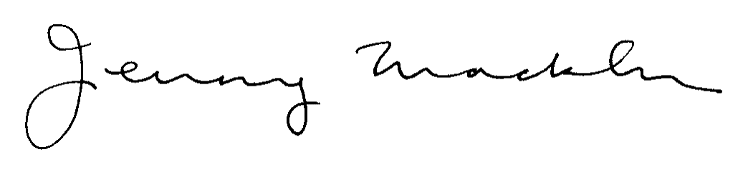
The Hon Jenny Macklin MP
Minister for Families, Community Services
and Indigenous Affairs
Footprints in Time depends on the dedication and generosity of families who participate in this ground-breaking research. With three waves of data now available, the study has become an increasingly rich and valuable source of information about Aboriginal and Torres Strait Islander children and their families over time.
This is a significant achievement, and our heartfelt thanks go to the 1,404 families who were interviewed for this wave by our Indigenous Research Administration Officers, as well as to those teachers and child care providers who completed questionnaires.
Longitudinal data is arguably the best source of data for policy analysis. It shows what works and which factors in early life matter for later outcomes. This publication contains results from wave 3 of Footprints in Time and marks a transition point in the study. This is the first time that we have had longitudinal data over three periods which greatly increases its statistical power.
In wave 3 primary carers were asked about each study child’s strengths and difficulties, additional assistance required because of health conditions, gambling practices, and family relationships including parents living elsewhere. This will enable researchers to identify the relative contribution of factors associated with child and family functioning, socio-economic and demographic trends, access to quality housing and positive educational experiences to later life outcomes.
Although we have seen recent improvements in areas such as early education, health, housing, schooling and employment there is still so much to achieve. Information collected from Footprints in Time focuses on strengths and confirms that Indigenous families are determined to improve their children’s lives, and build capacity and resilience to promote better health, education and employment outcomes. These are aspirations which we hold for all Australian children.
I urge governments, researchers, policy advisers and those implementing programs to draw on the rich resources of Footprints in Time in partnership with Aboriginal and Torres Strait Islander researchers who have the knowledge and understanding to interpret findings within specific local, social and cultural contexts. When used wisely, Footprints in Time will make a difference for Indigenous children and their families, now and in the future.
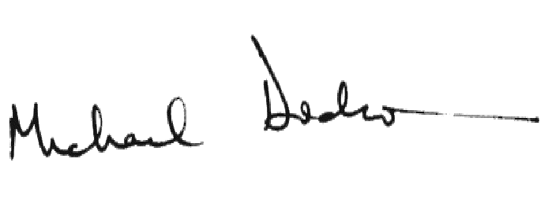

Professor Mick Dodson AM
Chair
Steering Committee

Introduction
Footprints in Time is the name given to the Longitudinal Study of Indigenous Children (LSIC), an initiative of the Australian Government. Footprints in Time is conducted by the Department of Families, Housing, Community Services and Indigenous Affairs (FaHCSIA) under the guidance of the Footprints in Time Steering Committee, chaired by Professor Mick Dodson AM. The study aims to improve the understanding of, and policy response to, the diverse circumstances faced by Aboriginal and Torres Strait Islander children, their families and communities.
This report is the third in a series of key summary reports produced for each wave of the data collection. The report provides a descriptive analysis of key findings for wave 3.
Further information about the study, including the fieldwork, is available at Appendix A of this report. Readers may wish to refer to the first two reports for more detailed information about the developmental phase of the study and for results from waves 1 and 2.

Important notes on reading this report
This report is meant only to provide a descriptive analysis of the data on a broad range of subjects. It encompasses a large number of topics to demonstrate the richness of the data available for research. As such, each article only skims the surface of the potential research that is possible and readers may find that the report raises more questions than it answers.
Analysis for this report is based on the “beta” or preliminary version of the dataset. Using the final release of the dataset may provide slightly different results.
The report has been written by non-Indigenous analysts within the Department of Families, Housing, Community Services and Indigenous Affairs. While every effort has been made to interpret the data within Indigenous contexts, there may be instances where a greater understanding of Indigenous cultures might aid interpretation. We strongly encourage potential data users to draw on the strengths of an interdisciplinary approach with Indigenous collaborators.
As you read this report, it is important to bear in mind the context in which the data is collected. Aboriginal and Torres Strait Islander children are the sample units in this study. Some data is collected directly from the children but this was limited in the early waves. Direct collection will increase as the children become older.
The children are divided into two cohorts: the B cohort and the K cohort. The original intended age of the children for wave 3 was 30 to 42 months (2½ to 3½ years) for the B cohort and 66 to 78 months (5½ to 6½ years) for the K cohort. In practice, however, the B cohort consists of children born in 2006, 2007 and 2008 and the K cohort consists of children born in 2003, 2004 and 2005. This means that most of the B cohort was 2½ to 4 years old (87.5 per cent) and the K cohort was 5½ to 7 years old (85.8 per cent) in wave 3.
In wave 3, 813 children were interviewed for the B cohort and 591 children were interviewed for the K cohort, bringing the total study sample to 1,404. Unless otherwise stated, only those children interviewed for wave 3 of the study are referred to.
The majority of information was collected by Indigenous interviewers from the ’primary carer’ and includes information about both the child and the family context in which they live. In wave 1 the primary carer was the person who had primary responsibility for the care of the child. Although this was the mother in 91.9 per cent of cases, it was sometimes the father, another relative or a foster carer. In all three waves, the same person was interviewed as the primary carer only if they continued to have significant caring responsibilities for the child. About 3 to 4 per cent of children had different primary carers from the previous interview. As you read this report, it is important to bear in mind that the term ‘primary carer’ has a broader meaning than parent.
The demographics of the sample are therefore very different from those of many other surveys about Indigenous people. The primary carers were predominantly women with an average age of about 32, looking after young children. Although all the children were Indigenous, about 16.0 per cent of primary carers in wave 3 were not.
Researchers may well be able to gather information using other datasets for many of the data items available in Footprints in Time. However, as a longitudinal survey, Footprints in Time provides a unique opportunity to follow the development of a group of children and examine the factors contributing to their individual and collective outcomes.
The data is not meant to provide a comparison between Indigenous and non-Indigenous populations. The Footprints in Time sample was not selected to be representative of the Indigenous population and there are no weights to adjust for this. For example, the Footprints in Time sample has a higher proportion of people living in areas of high or extreme isolation than is the case in the total Indigenous population. In 2008, the National Aboriginal and Torres Strait Islander Social Survey (NATSISS) (ABS 2009) found that 68 per cent of the Indigenous population was living outside major cities, 44 per cent in regional areas and 24 per cent in remote and very remote areas. By comparison, 73.25 per cent of Footprints in Time participants were living outside major cities, with 39.5 per cent in regional areas and 33.7 per cent in remote or very remote areas. It is therefore not always appropriate to make comparisons and these have been kept to a minimum. However, some have been included to highlight differences or similarities between the Footprints in Time population and the general population. Others are provided to enable comparisons of the Footprints in Time sample with data from other Indigenous surveys to provide an indication of how closely the results align with those of other studies.
This report uses a measure called the Level of Relative Isolation (LORI) to describe the geographical characteristics of families in the study. In remote areas such as the Kimberley region, the Torres Strait Islands and the Northern Peninsula Area (NPA), families were living wholly in areas of moderate or high to extreme isolation. However, the Northern Territory Top End, Alice Springs, Mount Isa and remote Western Queensland sites contained a mixture of areas of low, moderate and high to extreme levels of isolation. All the other remaining sites were made up of areas of no or low levels of isolation.
Unless specifically stated, percentages provided in this report are based on the numbers of responses and do not include the numbers of participants who refused to answer a question or responded that they did not know. For most variables, the number of missing responses was very low (less than five). The number of respondents is provided in cases where the number of missing variables may make a significant difference.
This report’s findings are presented in two parts. Part A contains short articles which provide an annual update on the changes that have occurred in the three main areas measured each wave: the child, the family and the community. While the survey is about the children and their development as they move along the path to adulthood, to understand their development it is important to look at the environment in which these changes are happening namely, their families and communities.
Part B of the report contains longer feature articles exploring the relationships between factors in the children’s development and the world in which they live.

Study terminology and definitions
Child (or plural children)—the sampling unit of the Footprints in Time study. Children are Aboriginal or Torres Strait Islander children. The study follows two cohorts of children: the B cohort and the K cohort.
B cohort—the younger group of study children. Most children in this cohort were aged from six months to
2 years in wave 1, 1½ to 3 years in wave 2 and 2½ to 4 years in wave 3.
K cohort—the older group of study children. Most children in this cohort were aged 3½ to 5 years in wave 1, 4½ to 6 years in wave 2, and 5½ to 7 years in wave 3.
Parent—refers specifically to the child’s biological, foster or step parent. The term should not be taken to have the same meaning as primary carer.
Primary carer is defined as the primary caregiver of the child who knows the child best. In most cases, the primary carer is the child’s biological mother but in some cases it is the child’s father or another guardian.
LORI (Level of Relative Isolation) is a classification of remoteness indicating the relative distance of localities from population centres of various sizes. LORI has five categories: none (urban), low, moderate, high and extreme. In this report the last two categories are combined as numbers in these areas are small. This report uses LORI rather than ARIA, as LORI has been designed to take account of Indigenous language and other culturally specific geographic characteristics.
Wave is the period of data collection. The Footprints in Time study has three waves of data available for analysis. The waves are conducted approximately one year apart. Wave 1 was collected primarily in 2008, wave 2 in 2009 and wave 3 in 2010.

A

ANNUAL UPDATE

It’s a child’s life 10

Family life 27

Culture and community 53

It’s a child’s life
Childhood is a time of rapid change and development. Each year, Footprints in Time asks children and their primary carers questions aimed at discovering how things have changed for them in the intervening period. Changes in measurements such as height and weight are relatively easy to interpret as the basis for measurement (centimeters and kilograms) is the same each year. Other measures such as learning outcomes are much more difficult to quantify and require a different basis depending on the child’s age. It is not appropriate to ask whether a 1 year child can read or a 5 year old child can walk. Therefore, questions are asked only for the period in a child’s life to which they are relevant.
This section examines school, child care and playgroup attendance, what children are learning, and their physical development.

Learning

School, child care and playgroup
For the most part, children are busy people and their time is divided between organised activities and spontaneous play. So where are children when they are not at home?
About 27 per cent of children in the B cohort attended a playgroup or other baby group. Most playgroups have a teacher or facilitator: 85.2 per cent of children in the B cohort attend such playgroups. While 21.7 per cent of primary carers did not know the qualification of the teacher in their child’s playgroup, 69.0 per cent of primary carers reported that their playgroup teacher had early learning qualifications.
The main reasons for children not attending a playgroup included the ‘child not needing it’ (32.0 per cent), ‘child attending some other child care arrangement’ (18.0 per cent), ‘child being too young’ (9.2 per cent), or ‘playgroups not being available locally’ (7.8 per cent). The relative importance of these reasons varied with the relative isolation of the area (Table1).
In the older (K) cohort, less than 4 per cent of children did not attend school at the time of the interview (Table 2), most of them under the age of 5. The majority (87.6 per cent of children in the K cohort) attended a government school, 6.4 per cent attended a Catholic school, and the remaining 2.4 per cent attended an independent or private school. The likelihood of the child attending a government school was higher in isolated areas.
Of the children in the K cohort who attended school, 56.0 per cent were in kindergarten (also referred to as prep, transition, or pre-primary level), 41.5 per cent attended Year 1 and 2.5 per cent attended Year 2. Of the children who had attended school in the previous year, 28.5 per cent changed schools. Common reasons for switching schools were moving house (25.2 per cent), finding a school closer to home or work (14.3 per cent), and academic reasons (5.9 per cent).
Table 1: Main reason the child does not attend playgroup, by LORI, per cent
Main reason child does not attend playgroup | LORI |  |  | All locations
Main reason child does not attend playgroup | None  (urban) | Low | Moderate to extreme | All locations
Child does not need it | 22.4 | 41.9 | 23.4 | 32.0
Child currently attends day care, kindergarten or preschool | 39.1 | 11.6 | 7.6 | 18.0
Child is too young | 5.8 | 6.9 | 17.2 | 9.2
Not available locally | 5.8 | 4.3 | 16.6 | 7.8
Child would be unsettled at playgroup | 5.8 | 4.0 | 11.7 | 6.4
Transport problems | 4.5 | 4.7 | 2.1 | 4.0
Primary carer too busy | 5.1 | 4.0 | 0.7 | 3.5
Number of respondents | 156 | 277 | 145 | 578
Note: The reasons shown in the table were coded by interviewers from a pre-set list of options, except for the ’child attends day care, kindergarten or preschool’ and ’primary carer too busy’ categories which were created based on the free text responses of the primary carers.

Table 2: Type of school attended by the child, by LORI, per cent
Type of school attended by child | LORI |  |  |  | All locations
Type of school attended by child | None (urban) | Low | Moderate | High or extreme | All locations
A government school | 80.4 | 89.1 | 88.1 | 97.1 | 87.6
A Catholic school | 11.1 | 4.6 | 7.5 | 2.9 | 6.4
An independent or private school | 4.6 | 1.3 | 4.5 | 0.0 | 2.4
Not in school | 3.9 | 5.0 | 0.0 | 0.0 | 3.6

The primary carers were also asked about the reasons they choose the child’s school. The most common reasons are listed in Figure 1.
Most children go to school regularly: 77.9 per cent attended school every day in the week before the interview. Of those who did not, the most common reason was illness or injury (48.8 per cent), followed by the school not being available or open (12.2 per cent) and the child not wanting to go (11.4 per cent).
About 33 per cent of children in the B cohort and 7.8 per cent of children in the K cohort attended some form of child care, day care or family day care. The most common types of child care the children attended are listed in Figure 2. Approximately 5 per cent of children spent time in more than one type of child care.
Of the 308 children who attended child care and for whom information is available about the hours spent in child care, 37.7 per cent spent less than 15 hours per week in child care, a further 32.5 per cent spent 15 to 30 hours a week there, and 29.9 per cent spent more than 30 hours a week in child care.
Children attended child care mostly because of the primary carer’s work commitments (47.7 per cent) or study commitments (5.1 per cent) or because the primary carer thought it would be good for the child’s social development (34.6 per cent). Another commonly cited reason was to give the primary carer a break or time alone (4.5 per cent).

Figure 1: Top reasons primary carer chose a particular school for the child, per cent
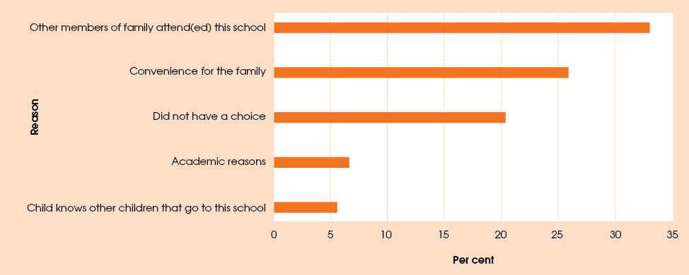

Figure 2: Types of child care attended by children, percentage of all children in child care
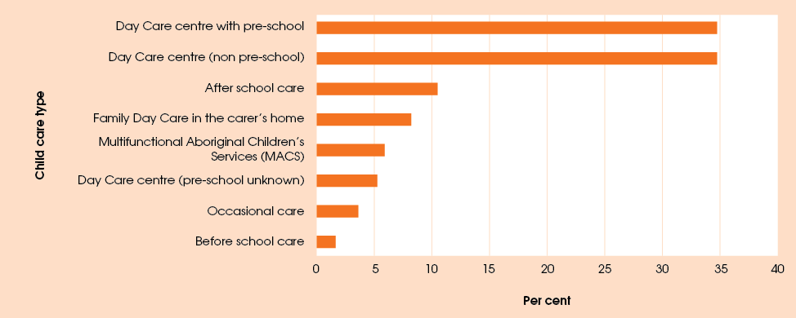
Note: Multiple response question.
Figure 3: Informal carers looking after the child, per cent
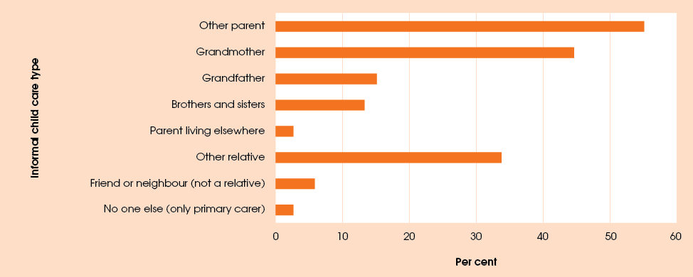
Note:’Other relative’ category includes step-parents.

Informal child care was most commonly provided by the other parent of the child (55.1 per cent of children) a grandmother (44.6 per cent), or another relative (33.8 per cent). In less than 3 per cent of cases, only the primary carer looked after the child — see Figure 3.

Child readiness for school
Quality early-childhood education is critical to ensuring young children have opportunities for early learning, development and socialisation. State, Territory and Commonwealth Governments have committed to a Closing the Gap target of 95 per cent enrolment (and attendance, where it is possible to measure) of Indigenous four-year-old children in remote communities in early childhood education by 2013. While current data are limited, the best available data source, the National Preschool Census, suggests that a high proportion of Indigenous children living in remote communities were enrolled in a preschool program in the year before full-time schooling in 2010 and that this proportion rose from 87 per cent in 2009 to 90 per
cent in 2010.
Footprints in Time data can be used to examine the relationship between preschool attendance and children’s readiness for school. Children in the K cohort were asked to complete “Who Am I?”, a direct child assessment measuring cognitive processes underlying early literacy and numeracy skills to determine readiness for learning. This assesses the child’s ability to draw and copy shapes, numbers, letters and words. The maximum score a child can achieve is 44. The children also completed the Renfrew Word Finding Vocabulary Test to assess their expressive vocabulary. The maximum score a child can achieve in the Renfrew test is 50.
Figure 4: Average “Who Am I?” scores across waves by early education attendance in wave 1
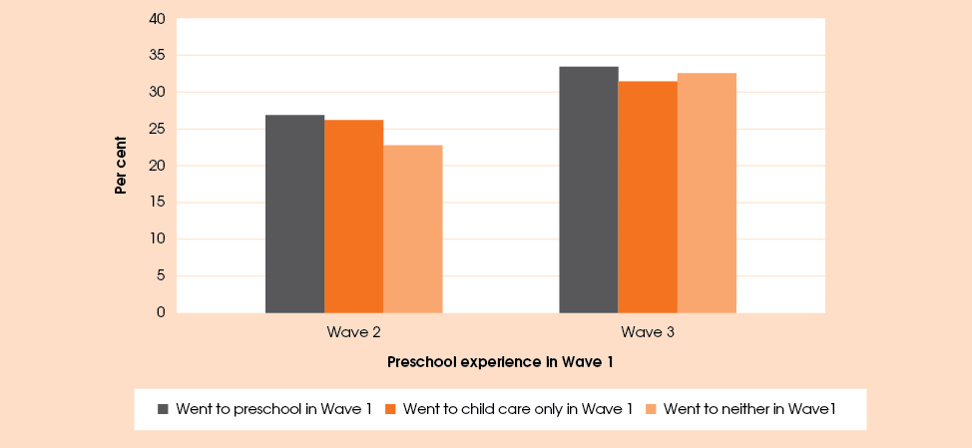

Figure 5: Average vocabulary scores across waves by early education attendance
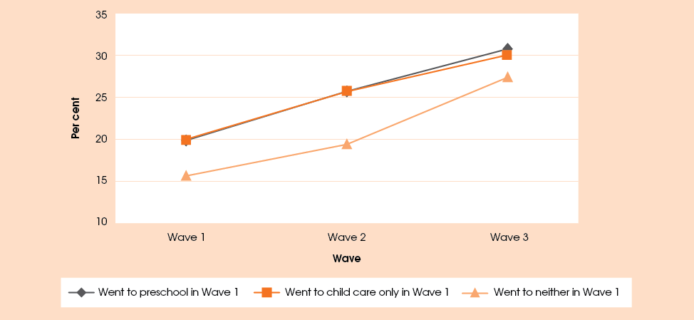

Figure 4 and Figure 5 show average scores for “Who Am I?” and the Renfrew vocabulary test by attendance in early education programs. The data was restricted to include only wave 3 children in the K cohort who were aged 4 or 5 at wave 2 and were reported to be attending a pre-year 1 program at a school in wave 2. It was further limited to children for whom there was data from the wave 1 primary carer, the wave 2 primary carer and the wave 2 child direct assessments. The “Who Am I?” sample comprised 191 children, of whom 104 attended preschool, 23 attended child care only and 64 attended neither. The vocabulary test sample comprised 216 children, of whom 119 attended preschool, 25 attended child care only and 72 attended neither. The children included in the preschool category may also have been attending child care.
Figures 4 and 5 show that preschool attendance appears to have a positive link with readiness for learning and vocabulary. The children attending child care also had higher vocabulary scores at wave 2. The differences in scores between children who attended preschool or child care and children who attended neither are statistically significant at wave 2 but not at wave 3. This may have resulted from the small sample size of children who attended child care only. It should also be noted that the characteristics or circumstances of the children prior to wave 1 may be affecting the children’s scores rather than preschool attendance as such (Biddle 2011). Future waves of Footprints in Time provide the opportunity to examine characteristics of those in the B cohort before, during and after early childhood experiences while controlling for other factors.

Language development
In all three waves, primary carers were asked if they had any concerns about their children’s language development. The questions were adapted from ‘Parent Evaluation of Developmental Status’ (PEDS), the Australian version, with the assistance of the Centre for Community Child Health (2005).
Table 3 shows the proportions of children whose primary carers indicated concerns about their receptive (understanding) and expressive (speaking) language skills in waves 1 and 3. Most primary carers did not express any concerns about their children’s language development. However more primary carers expressed concerns about their child’s speech than about their understanding.
How persistent are concerns about language development? That is, do the primary carers of the same children express concern in each wave, or are most concerns resolved by the time of subsequent interview? Table 4 and Table 5 shed some light on this by showing proportions of primary carers who expressed concerns about their children’s language development in wave 3, depending on their responses in wave 1. Of the primary carers who expressed concern in wave 1, the majority were no longer concerned by the time they were asked in wave 3, and primary carers who did not have concerns at wave 1 were less likely to express concern at wave 3. Concerns about expressive language were more likely to persist than those about receptive language. Speech concerns were also more likely to emerge in wave 3 than concerns about understanding; 13.2 per cent of the primary carers who had no concerns about their children’s expressive language at the time of the wave 1 interview expressed some concern at wave 3, compared with only 4.1 per cent for receptive language.
The main area of concern about receptive language was that the child had difficulty in understanding what the primary carer said. For those who had concerns about expressive language, the main area of concern was the clarity of speech. Difficulty putting words together and stuttering, stammering or lisping were also of concern to 4.7 per cent and 5.9 per cent of primary carers respectively.

Table 3: Primary carers’ concerns about children’s language development, waves 1 and 3, per cent
 | Wave 1 |  | Wave 3
Concern about children’s language development | Receptive language | Expressive language | Receptive language | Expressive language
No concerns | 94.3 | 84.5 | 94.4 | 82.8
Some concern | 5.7 | 12.9 | 5.6 | 17.2
Child not speaking yet | – | 2.6 | – | –
Number of respondents | 1,661 | 1,642 | 1,404 | 1,402
Note: Data are for children whose primary carers responded ’yes’, ’a little’ or ’no’ to the questions on concerns about speech and understanding. The responses ’a little’ and ’yes’ were grouped into the ’some concern’ category. The small number of cases where the primary carer was unsure or refused to answer were excluded from the analysis, hence the varying number of respondents. The total number of respondents was 1670 in wave 1 and 1404 in wave 3.

Table 4: Persistence of concerns about the child’s expressive language, waves 1 and 3
Child’s speech in wave 1 | Primary carer’s concerns about child’s  speech in wave 3, per cent |  | Number of respondents
Child’s speech in wave 1 | No concerns | Some concerns | Number of respondents
Not speaking yet | 67.6 | 32.4 | 37
Primary carer had no concerns | 86.8 | 13.2 | 1,102
Primary carer had some concerns | 58.0 | 42.0 | 169
Note: Data are for 1,308 children whose primary carers responded ’yes’, ’a little’ or ’no’ to the question ’Do you have any concerns about how the child talks and makes speech sounds?’ at waves 1 and 3, and those who indicated that the child could not yet pronounce any words they could recognise at wave 1. Responses ’a little’ and ‘yes’ were grouped together.

Table 5: Persistence of concerns about the child’s receptive language, waves 1 and 3
Child’s understanding in wave 1 | Primary carer’s concerns about child’s understanding in wave 3, per cent |  | Number of  respondents
Child’s understanding in wave 1 | No concerns | Some concerns | Number of  respondents
Primary carer had no concerns | 95.9 | 4.1 | 1,258
Primary carer had some concerns | 72.5 | 27.5 | 69
Note: Data are for 1,327 children whose primary carers responded ’yes’, ’a little’ or ’no’ to the question ’Do you have any concerns about how the child understands what you say to him/her?’ at waves 1 and 3. Responses ’a little’ and ’yes’ were grouped together.

Figure 6: Concerns about speech and understanding by children’s age, per cent
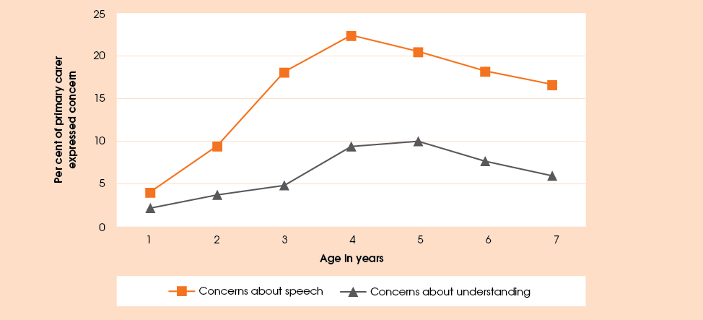
Note: As the question about speech concerns was asked in wave 2 of only new entrants and those who had expressed concerns in wave 1 interview, the data on speech concerns come from waves 1 and 3 only. The data on concerns about understanding come from all three waves.

There was a marked difference between the two cohorts. For the B cohort concerns about receptive and expressive language increased over time, while concerns about children in the K cohort decreased. This was most likely due to the age of the children and the developmental stage they had reached at the time of each interview. At the wave 1 interview, children in the B cohort were not old enough for primary carers to be concerned about language development but by the wave 3 interview these children had reached an age where problems would have become apparent. Conversely, for the older cohort, any problems would most likely have been exposed in earlier waves and rectified or resolved as the child got older.
Figure 6 provides an illustration of this. Across all three waves, it shows proportions of primary carers who expressed concerns about their children’s expressive or receptive language development by the child’s age. The figure shows that speech concerns peaked for children aged around 4 years, while concerns about understanding peaked around 4 to 5 years of age and then began to decline.
In conclusion, while concerns about children’s expressive language development were in general more prevalent and more persistent in the Footprints in Time study than concerns about their receptive language, this was strongly related to the age of the child. Most causes for concern became apparent and were resolved by the time the child started school.

Learning ‘the three Rs’
In wave 3, most children in the K cohort were beginning school or in programs preparing them to begin school. Footprints in Time asked the primary carers about their children’s interest in reading, writing and numbers.
Figure 7 shows the percentage of children in the K cohort who had an interest or ability in reading, writing and numbers. Approximately 1 to 2 per cent of primary carers indicated that they did not know or were not sure and these are included in the proportion who did not respond in the affirmative.
According to the primary carers, most children were interested in writing and practised their new-found abilities in these areas by writing their names (87.0 per cent) and copying letters (88.2 per cent). The children also showed an interest in reading (85.4 per cent): 75.0 per cent were able to read simple words such as ‘dog’ or ‘cat’ and 33.8 per cent were able to read more complex words such as ‘table’ or ‘orange’. Most of the children (85.6 per cent) had also grasped the concept of counting objects with 78.7 per cent able to count to 20.
The children were also asked whether they liked reading, writing and number work. Responses included ‘yes’, ‘no’ and ‘sometimes’. Looking at only the ‘yes’ responses, the children’s responses do not always concord with the view of their primary carers. Only 75.0 per cent of children (69.3 per cent of boys and 79.3 per cent of girls) said they liked maths and number work and 78.0 per cent said they liked writing (73.4 per cent of boys and 82.0 per cent of girls). However, including the ‘sometimes’ responses brings the children’s responses more in line with those of their primary carers. Girls were more likely than boys to say that they liked reading, writing and maths—see Table 6.
Many primary carers supported their children in their learning. Sixty-one per cent of primary carers provided help with homework at least once a week. A further 32.9 per cent said that their children were not given homework. When asked if in the last month, someone had listened to the child read or pretend to read, 83.5 per cent of primary carers of the K cohort answered ‘yes’, indicating additional involvement in their child’s education.
Children also had access to help through a variety of tutoring programs. In the previous 12 months, 18.8 per cent of children had received extra help or tutoring from someone outside the household. Of these, 77.7 per cent had received tutoring in a program organised through the school.
Figure 7: K cohort interest in literacy and numeracy, per cent
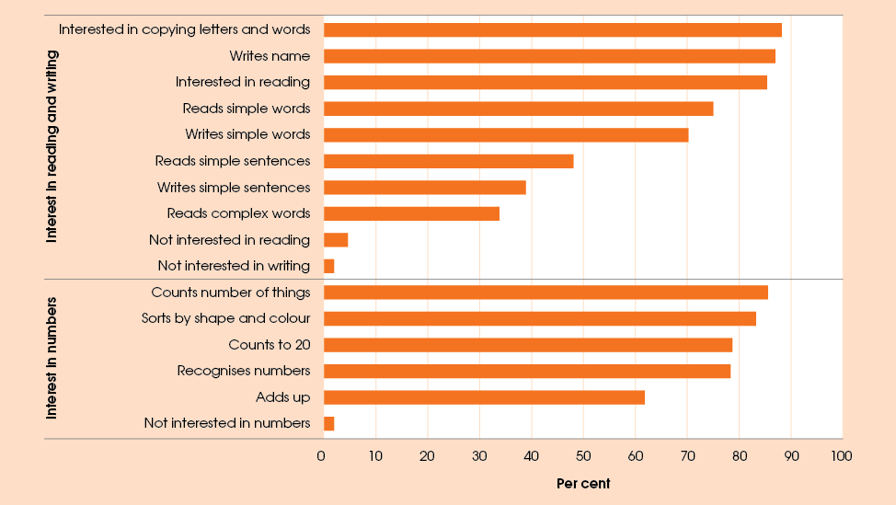

Table 6: Children’s enjoyment of reading, writing and maths by sex, per cent
Response | Reading books |  | Maths and numbers |  | Writing
Response | Boys | Girls | Boys | Girls | Boys | Girls
Yes | 74.8 | 87.6 | 70.3 | 79.6 | 73.7 | 73.7
Sometimes | 9.0 | 5.6 | 11.0 | 10.6 | 9.4 | 9.4
No | 16.2 | 6.8 | 18.6 | 9.8 | 16.9 | 9.1

The learning environment
For those children who have spent most of their time with their primary carer, the transition to school can be an anxious time for both carer and child. Anxieties may be lessened if early education becomes a three way shared experience between the child, the carer and the teacher. In wave 3, we asked the primary carer about their interaction and involvement in child’s school life.
Around 80 per cent of all primary carers believed that they could trust the local school and in many cases, the child’s teacher would be the first point of contact with the school. Footprints in Time asked about the feedback, and information and advice made available to them by the teacher.
The majority of primary carers felt they were well or very well supported by the teacher: 56.4 per cent of primary carers said that the teacher gave information or advice on how they could help the child at home; 58.6 per cent of primary carers said they thought the teacher understood the needs of families from an Indigenous background. A higher proportion of primary carers (70.6 per cent) said they were made aware of chances to be involved and take part in the school. In contrast, 41.0 per cent said that the teacher supported them well with information about community services to help the study child. This may be because they had no need for such information. Primary carers living in areas of no isolation were more than 10 percentage points less likely to say that the teacher supported them with information about community services than those living in other areas. They were also 17.8 percentage points less likely to say that the teacher understood the needs of families from an Indigenous background than if they lived in areas of low isolation and 33.2 percentage points less likely to say this than if they lived in areas of high or extreme isolation.
Primary carers were also asked about their involvement with the school. Many Footprints in Time primary carers took an active interest in their children’s education. The majority (82.7 per cent) had visited the child’s class, and 73.4 per cent had talked to parents of other children in their child’s class. Nearly two-thirds (66.4 per cent) had contacted the teacher about their child. More than one-third (34.4 per cent) of primary carers had helped elsewhere in the school such as the tuck-shop or library, volunteered in their child’s class or helped with an excursion.
The children were also asked various questions about their attitudes towards school. The majority (86.9 per cent) thought school was fun but when asked whether they were happy going to school, only 69.8 per cent said that they were. Additionally, 33.0 per cent said they wished they did not have to go and 30.4 per cent admitted to asking to stay home. The proportions of children asking to stay at home were markedly different for boys (35.5 per cent) and girls (25.3 per cent). Girls were more likely to agree that the teacher was nice to them (89.8 per cent, as opposed to 83.3 per cent for boys). Boys were more likely to say that the children at school were nice to them (70.1 per cent, as opposed to 68.7 per cent for girls) but also more likely to say that the children at school picked on them (19.0 per cent, as opposed to 16.7 per cent for girls). As the children grow up and more waves of data become available for analysis, it will be possible to judge more accurately the extent to which these results represent their general experiences as opposed to reflecting only the most recent events.

Growing up

Nutrition
Children need good food to help them grow and go about their day. The National Health and Medical Research Council (NHMRC 2011) recommends consuming a variety of nutritious foods, such as fruit and vegetables, grains, lean meat and dairy foods, and moderating the intake of saturated and trans fats, salt and added sugars.
Primary carers were asked whether their child ate selected types of food in the morning, afternoon and evening of the previous day. Over the course of the day, most children were eating a combination of foods including fruit and vegetables, grains, protein and dairy. In Figure 8, ‘other dairy’ includes dairy products such as cheese, yoghurt, and custard as well as milk added to cereal or porridge. Milk taken as a drink appears separately as ‘milk’. ‘Cereal’ refers to the generic category which includes breakfast cereals (including porridge), bread and pasta. Cereal appears to be the most popular type of food, being eaten at some time during the day by 98.5 per cent of children. Most children drank water (78.1 per cent) but soft drinks and fruit juices were also popular drinks for the children. Bush tucker was eaten by 7.1 per cent of the children.
A number of limitations should be noted with the data collected through the study. Information is only collected on the types of food each child consumed the day prior to interview and not about the amounts of each food consumed. It is therefore not possible to make assumptions about whether individual children have healthy eating patterns.
The diet of the children in the Footprints in Time sample varies to some extent by LORI, as shown in Figure 9. In the day before the interview, children in areas of high isolation were more likely to have eaten protein and bush tucker, and less likely to have eaten snacks or dairy food. One-third of all children in areas of high or extreme isolation had eaten bush tucker. They were also more likely to have drunk water and tea or coffee and less likely to have drunk juice. Figure 9 includes only selected types of food or drink for which there was a discernible pattern across LORI or where the differences between levels of isolation were statistically significant. Further analysis of the types of food reportedly eaten the day before the interview across the three waves may provide some insight into the eating patterns of individual children, but it would still be limited by the lack of data on the relative amounts of each type of food.
Figure 8: Percentage of children eating type of food by cohort
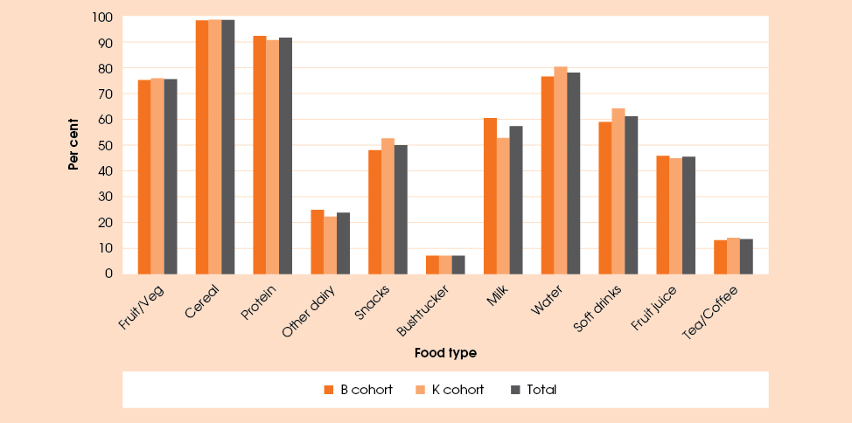

Figure 9: Percentage of children eating type of food, by LORI
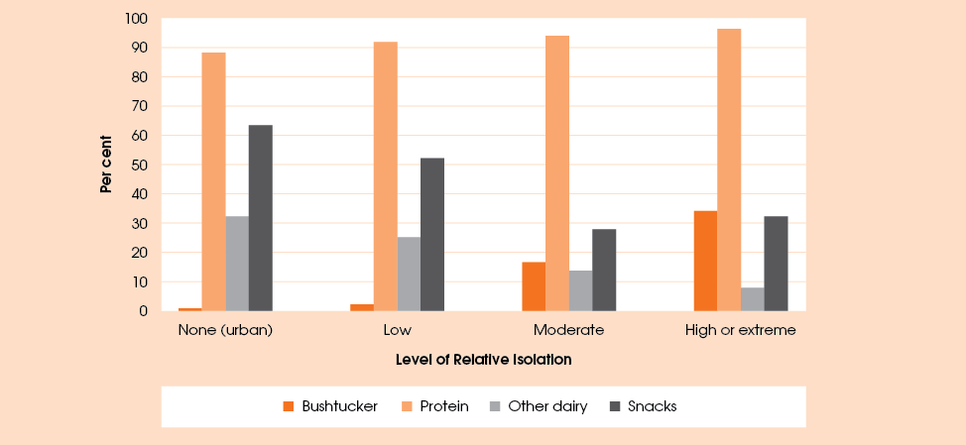

Sleeping difficulties
Primary carers were asked whether in the previous month their children had experienced any difficulties getting to sleep or staying asleep. Overall, 23.8 per cent of the children had experienced sleeping difficulties; 26.4 per cent of the B cohort and 20.2 per cent of the K cohort. Primary carers provided many different reasons for the children’s sleeping difficulties and in some cases (6 per cent of all primary carers whose children had difficulties sleeping) the primary carers were not able to identify a specific reason. Of the reasons given, the most common problem for both cohorts was that the child was overexcited or overstimulated. It was also relatively common for children in the B cohort who had slept during the day to experience difficulties sleeping during the night. Nightmares and being afraid were reasons given for the sleeping difficulties of children in the K cohort—see Table 7.
Table 7: Reasons for difficulty sleeping, per cent
 | B cohort | K cohort
Incidence of sleeping difficulties | 26.4  n=214 | 20.2  n=119
Reason, per cent*
Nightmares | 7.5 | 17.6
Afraid | 10.3 | 17.6
Goes to bed late | 8.9 | 7.6
Overexcited or overstimulated | 19.2 | 21.0
Illness, difficulty breathing, pains | 11.7 | 10.9
Had sleep during the day | 12.1 | 3.4
*Percentage of those who had sleeping difficulties

Dental health
As they are growing up, Footprints in Time children are learning how to take care of their teeth. In wave 3, the primary carers reported that 67.7 per cent of children brushed their teeth at least once a day and 5.4 per cent of children never brushed their teeth. In “Oral Health of Aboriginal and Torres Strait Islander Children” (AIHW 2007, p.vii) it was reported that ’less than 5 per cent of remote Aboriginal and Torres Strait Islander preschool children brush their teeth on a regular basis.’ Similarly, for the Footprints in Time children, the rate of brushing on a less than daily basis did increase with remoteness. However, brushing on a less than daily basis was most likely to be reported in areas of moderate isolation. In areas of moderate isolation, primary carers reported that 47.9 per cent of the children did not brush at least once a day, compared with 19.1 per cent of children in areas of no isolation. The percentage of children who brushed their teeth at least once a day increased steadily with age until the age of about five (Figure 10).
Nearly half of the children in the K cohort had seen a dentist since the previous interview. In its report “Oral health and dental care in Australia: key facts and figures 2011” the Australian Institute of Health and Welfare (AIHW) found that, in 2010, 78 per cent of Australian children aged 5 to 14 had visited a dentist in the previous year. According to Footprints in Time primary carers, nearly half (49.4 per cent) of the children in the K cohort (aged 5½ to 7) had seen a dentist or a dental nurse in the previous 12 months. Of those who had visited a dentist, 54.7 per cent saw the dentist at school. Children in the B cohort, only 12.3 per cent of whom saw a dentist, were more likely to visit a dentist at an Aboriginal Medical Service.
According to primary carer responses, over the course of the three waves, 59.5 per cent of children had no problems with their teeth (Table 8). In wave 1, many of the children in the B cohort would not have had all their teeth and only 16.3 per cent of children had experienced problems with their teeth at that time. In wave 2, 21.9 per cent of children had experienced dental problems in the period since their previous interview. By wave 3 this had further increased to 29.6 per cent.
Table 8: Number of years children had dental problems, waves 1–3
Years | Percentage of children
0 | 59.5
1 | 22.0
2 | 11.7
3 | 6.8
Note: Restricted to children whose primary carers gave responses to the dental problems question in all three waves (n=1241)
Figure 10: Children brushing their teeth at least once a day by age, percent
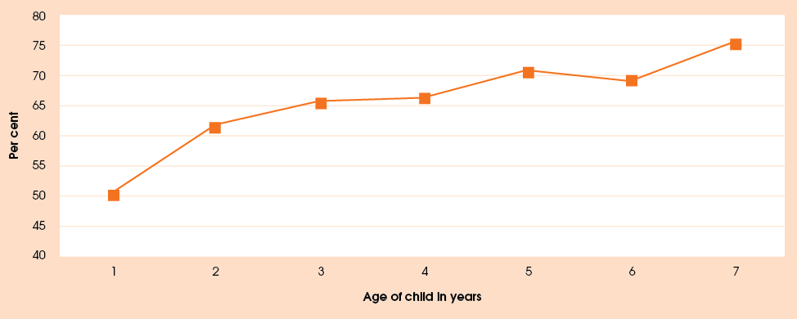
Note: The slight increase at the age of 7 is probably due to the smaller numbers of children of that age.
Figure 11: Children who had reported tooth decay by age, per cent
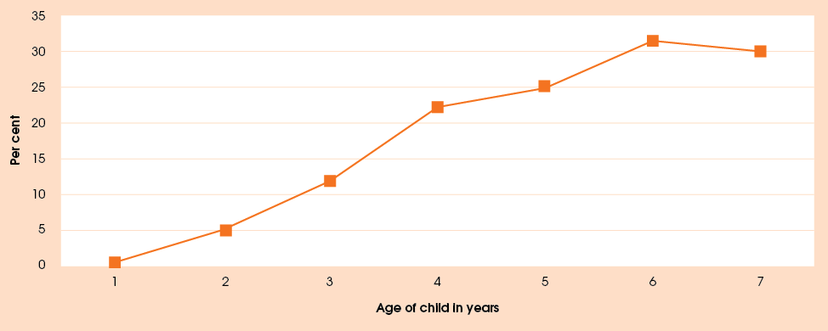
The most commonly experienced problem was tooth decay, experienced by just over one-fifth of the children in the 12 months before their wave 3 interview. Over the three interviews, 29.3 per cent of children had experienced tooth decay at least once. AIHW (2011) reported that, in 2006, the proportion of children with caries experience in their deciduous teeth ranged from 40 per cent in 4 to 5 year olds to 60 per cent in 6 to 8 year olds. Caries experience in permanent teeth ranged from 1 per cent in 5 year olds to 58 per cent in 15 year olds. Figure 11 shows the rate of tooth decay by age in the Footprints in Time children.
AIHW (2007) found that among Indigenous children, 66.6 per cent of 4-year olds and 63.1 per cent of 5 year
olds experienced caries in their deciduous teeth. Interestingly, they also found that the incidence peaked at age 6 (72.0 per cent) before dropping again to 62.8 per cent at age 7, as the deciduous teeth began to be shed. The relatively low percentage of the Footprints in Time children experiencing tooth decay may be a reflection of the low rate of visits to the dentist rather than the non-existence of tooth decay.
While there was no obvious link between dental problems and relative isolation in wave 1, in subsequent waves the percentage of children experiencing dental problems was higher in areas of high isolation. In wave 3, 31.2 per cent of children in areas of high or extreme isolation experienced dental problems as opposed to 22.9 per cent of children in areas with no isolation.

General health
Primary carers reported that more than one-third of the children (38.0 per cent) experienced no ill health in the 12 months prior to their wave 3 interview. Proportionally, more of the B cohort was reported as experiencing one or more health conditions (63.7 per cent) than the K cohort (59.4 per cent). The condition experienced most frequently by both cohorts was a cold or hay fever (24.4 per cent), followed by chest infections (13.5 per cent), runny ears (12.9 per cent) and asthma (10.8 per cent).
According to the National Aboriginal and Torres Strait Islander Social Survey (NATSISS) conducted by the ABS (2010a), 9 per cent of Aboriginal and Torres Strait Islander children aged 0 to 14 years experienced ear or hearing problems and 7 per cent experienced eye or sight problems in 2008. In comparison, Footprints in Time wave 3 data showed that 15.4 per cent of children in the study had an ear or hearing problem in the 12 months before the interview, and that just over 3 per cent of children had an eye problem. The different rates among the Footprints in Time children may be due to Footprints in Time children having poorer hearing and better sight than the children in the NATSISS but it is more likely due to the younger age range of the children. Problems with the ears are more prevalent among very young children and can often be resolved by the time children become teenagers. Sight problems are often not detected until children start school and many of the Footprints in Time children are below school age.
In 2004-05, the prevalence of ear and hearing problems among Aboriginal and Torres Strait Islander children was three times higher than for non-Indigenous children (ABS 2006a). Left untreated, ear infections can lead to hearing loss which may limit a child’s capacity to develop socially and emotionally and adversely affect educational outcomes (DoHA, 2011). The Australian Government launched a new ‘Care for Kids’ Ears: strong hearing strong start’ campaign July 2011 to target Indigenous ear disease (DoHA, 2011).

Disability
Just over 2 per cent of the children were reported to have a disability and 4.1 per cent were reported to have a developmental delay Children in the K cohort were twice as likely to have a reported disability as children in the B cohort. This is most likely because many disabilities are associated with development or are diagnosed once the child starts school. In comparison, the ABS (2011a) has reported that, in the Australian population in general, 3.9 per cent of boys and 2.8 per cent of girls aged 0 to 4 years have a disability.
Primary carers were also asked whether the child needed extra help to look after themselves (for example, with feeding or toileting), to get around at home or away from home (for example, walking) or to speak and/or hear (including needing hearing aids) as a result of one of their health conditions (excluding colds or hay fever). In total, 207 children (14.7 per cent of all children) needed one or more types of assistance due to their health. This number, however, may overstate the actual need for assistance for health reasons. As the children in the study are quite young, the primary carers’ responses may have been related to the children’s age rather than a stated health condition. For example, the need for assistance due to runny ears was reported by 11 primary carers; due to chest infections by 12 primary carers; and due to a skin infection by 7 primary carers. In all of these examples, the reported condition was the only one the child had had in the preceding 12 months. It seems unlikely that these conditions would require special assistance. However there is no data on the chronicity and severity of health problems.
Of the children who required extra assistance due to ill health, 47.3 per cent needed two or three types of assistance. Once again, this could be due to the relatively young age of the children. Children who had health conditions were more likely to need assistance if they lived in areas of higher relative isolation (42.2 to 44.2 per cent in areas of moderate to extreme isolation compared to 18.8 per cent in areas of no isolation). It is interesting to note that children in more isolated areas were no more likely to experience health problems just to need extra assistance, possibly because their health problems were more severe and/or prolonged. Boys were slightly more likely to need assistance than girls (18.9 per cent and 16.8 per cent, respectively).

Hospitalisation
Primary carers also reported that 205 of the children (14.6 per cent of the sample) had had a hospital visit during the previous 12 months. Of these, 94.6 per cent had only had one visit and the remaining 5.4 per cent had required up to four visits. Approximately one-third (34.2 per cent) of hospital visits were day-only visits and a further 23.1 per cent were for one night. The most common reasons for visits to hospital were asthma and chest infections, intestinal problems and ear problems

Physical abilities
In wave 3, primary carers were asked about their child’s ability to undertake a number of age-appropriate activities. For the B cohort, these included the ability to hold a pencil in the writing position, dress and undress (with help), button and/or unbutton large buttons, walk up stairs using only one foot on each stair, hop on one foot for three steps and catch a large ball with both hands. For the K cohort, the questions asked were whether the child could tie a bow, stay within the lines when colouring, thread a bead, run down stairs, ride a bike (without training wheels) and catch a small ball with both hands.
Response options included ’yes, can do well’, ’yes, but not well’, ’not yet’ and ’don’t know’. Children who had a disability were identified separately in the questions and are not included in the analysis. The age of the children in Table 9 and Table 10 is the age at the time of the wave 3 interview. ‘Don’t know’ is included as a valid response to these questions.
Children in the B cohort showed a greater ability with the gross motor skills (catching a large ball, hopping and walking up stairs) than the fine motor skills (dressing, buttoning and holding a pencil). The exception to this was hopping on one foot which is a gross motor skill. However, the proportion of children able to hop on one foot may be greater than indicated as many primary carers did not know whether the child could do this. Not surprisingly, the table shows a progression of ability as the children become older. It suggests that most children developed the ability to walk up stairs by the age of 2½ and to catch a large ball by the time they were 3. On the other hand only 53.3 per cent of 4 year olds were able to manipulate buttons. This is more likely to be a skill that develops at a later age or it may be a skill that many of the children do not have an opportunity to practise, as modern children’s clothing tends to have zippers and velcro rather than buttons and bows.
Table 9: Physical abilities by age (B cohort), per cent
Age in years | Age (Years) | Yes | Yes but not well | No | Don’t know
Hold a pencil | 2.5 | 54.7 | 28.0 | 14.8 | 2.5
Hold a pencil | 3 | 61.9 | 26.2 | 10.6 | 1.3
Hold a pencil | 3.5 | 62.4 | 26.6 | 9.8 | 1.2
Hold a pencil | 4 | 83.3 | 13.3 | 3.3 | 0.0
Hold a pencil | All | 60.6 | 26.3 | 11.5 | 1.6
Dress/undress | 2.5 | 58.1 | 32.2 | 9.7 | 0.0
Dress/undress | 3 | 68.2 | 27.8 | 4.0 | 0.0
Dress/undress | 3.5 | 78.6 | 20.2 | 1.2 | 0.0
Dress/undress | 4 | 83.3 | 16.7 | 0.0 | 0.0
Dress/undress | All | 68.0 | 27.0 | 5.0 | 0.0
Button/unbutton | 2.5 | 22.0 | 25.8 | 48.7 | 3.4
Button/unbutton | 3 | 35.8 | 25.5 | 34.8 | 4.0
Button/unbutton | 3.5 | 52.6 | 21.4 | 24.3 | 1.7
Button/unbutton | 4 | 53.3 | 30.0 | 13.3 | 3.3
Button/unbutton | All | 36.0 | 24.8 | 35.9 | 3.2
Walk up stairs | 2.5 | 89.8 | 6.8 | 2.1 | 1.3
Walk up stairs | 3 | 91.4 | 6.3 | 1.3 | 1.0
Walk up stairs | 3.5 | 94.2 | 2.3 | 2.3 | 1.2
Walk up stairs | 4 | 100.0 | 0.0 | 0.0 | 0.0
Walk up stairs | All | 91.8 | 5.3 | 1.8 | 1.1
Hop on one foot | 2.5 | 32.2 | 19.1 | 32.6 | 16.1
Hop on one foot | 3 | 51.5 | 18.6 | 15.9 | 14.0
Hop on one foot | 3.5 | 65.9 | 9.8 | 13.9 | 10.4
Hop on one foot | 4 | 73.3 | 13.3 | 6.7 | 6.7
Hop on one foot | All | 49.5 | 16.5 | 20.4 | 13.5
Catch a large ball | 2.5 | 76.3 | 17.4 | 5.1 | 1.3
Catch a large ball | 3 | 85.4 | 10.9 | 3.0 | 0.7
Catch a large ball | 3.5 | 87.9 | 7.5 | 3.5 | 1.2
Catch a large ball | 4 | 86.7 | 13.3 | 0.0 | 0.0
Catch a large ball | All | 83.1 | 12.3 | 3.6 | 0.9
Note: Restricted to children aged between 30 and 53 months at the time of the wave 3 interview who were not identified by their primary carer as having a disability.

Table10: Percentage of children doing activity well by age (B cohort) and sex
Age | 2.5 |  | 3 |  | 3.5 |  | 4
Activity | Boys | Girls | Boys | Girls | Boys | Girls | Boys | Girls
Hold a pencil | 48.3 | 61.2 | 56.1 | 67.5 | 54.7 | 70.1 | 78.6 | 87.5
Dress/undress | 53.3 | 62.9 | 59.5 | 76.6 | 72.1 | 85.1 | 85.7 | 81.3
Button/unbutton | 18.3 | 25.9 | 21.6 | 49.4 | 43.0 | 62.1 | 42.9 | 62.5
Walk up stairs | 90.8 | 88.8 | 90.5 | 91.6 | 95.4 | 93.1 | 100.0 | 100.0
Hop on one foot | 27.5 | 37.1 | 44.6 | 57.8 | 59.3 | 72.4 | 91.9 | 83.9
Catch a large ball | 80.0 | 72.4 | 86.5 | 84.4 | 91.9 | 83.9 | 91.9 | 83.9
Note: This is the percentage of children who according to the primary carer could do the activity well. The remainder of the sample comprises those whose primary carer responded ‘yes but not well’, ‘no’ and ‘don’t know’.

Girls were more likely to be able to do the activities involving fine motor skills and boys showed a greater aptitude with those involving gross motor skills. Again, the exception was hopping on one foot, in which girls showed a greater aptitude for their age: 72.4 per cent of 3½ year-old girls were able to do this, as opposed to 59.3 per cent of boys the same age.
As with children in the B cohort, the majority of children in the K cohort had no difficulty with activities involving stairs or balls (Table 11). A smaller proportion of children were able to ride bikes without training wheels but they were learning and improving with age. Children in areas of no isolation were less likely to be able to ride bikes, which may be a reflection of there being fewer safe open areas in which to practise.
As with the B cohort, among children in the K cohort aged between 5½ and 6½, girls were more likely to be able to do the activities involving fine motor skills and boys were more likely to be able to do those involving gross motor skills (Table 12). This was most noticeable in the different percentages of children able to tie a bow. At 6 years, 21.2 per cent of boys and 42.9 per cent of girls could tie bows. For the 6½ year-olds this increased to only 22.2 per cent for the boys but much more (56.9 per cent)for the girls.
Table 11: Physical abilities by age (K cohort), per cent
Age in years | Age (Years) | Yes | Yes but not well | No | Don’t know
Tie a bow | 5.5 | 21.7 | 19.6 | 56.0 | 2.7
Tie a bow | 6 | 31.2 | 23.7 | 43.3 | 1.9
Tie a bow | 6.5 | 39.4 | 29.8 | 28.8 | 1.9
Tie a bow | 7 | 70.0 | 5.0 | 25.0 | 0.0
Tie a bow | All | 31.0 | 22.8 | 44.2 | 2.1
Colour within lines | 5.5 | 63.6 | 26.1 | 6.5 | 3.8
Colour within lines | 6 | 74.2 | 19.8 | 5.1 | 0.9
Colour within lines | 6.5 | 76.0 | 18.3 | 4.8 | 1.0
Colour within lines | 7 | 70.0 | 25.0 | 5.0 | 0.0
Colour within lines | All | 70.7 | 21.9 | 5.5 | 1.9
Thread a bead | 5.5 | 72.3 | 8.7 | 8.7 | 10.3
Thread a bead | 6 | 72.1 | 3.7 | 9.3 | 14.9
Thread a bead | 6.5 | 79.8 | 4.8 | 9.6 | 5.8
Thread a bead | 7 | 85.0 | 10.0 | 5.0 | 0.0
Thread a bead | All | 74.2 | 5.9 | 9.0 | 10.9
Run down stairs | 5.5 | 87.0 | 5.4 | 3.3 | 4.3
Run down stairs | 6 | 89.4 | 5.1 | 2.3 | 3.2
Run down stairs | 6.5 | 92.3 | 6.7 | 1.0 | 0.0
Run down stairs | 7 | 95.0 | 0.0 | 5.0 | 0.0
Run down stairs | All | 89.3 | 5.3 | 2.5 | 2.9
Ride a bike | 5.5 | 57.6 | 8.7 | 29.3 | 4.3
Ride a bike | 6 | 67.1 | 8.3 | 22.7 | 1.9
Ride a bike | 6.5 | 69.2 | 6.7 | 24.0 | 0.0
Ride a bike | 7 | 85.0 | 5.0 | 5.0 | 5.0
Ride a bike | All | 64.9 | 8.0 | 24.6 | 2.5
Catch a small ball | 5.5 | 92.9 | 5.4 | 1.1 | 0.5
Catch a small ball | 6 | 92.2 | 5.5 | 1.8 | 0.5
Catch a small ball | 6.5 | 92.3 | 5.8 | 1.0 | 1.0
Catch a small ball | 7 | 100.0 | 0.0 | 0.0 | 0.0
Catch a small ball | All | 92.8 | 5.3 | 1.3 | 0.6
Note: Restricted to children aged between 66 and 89 months at the time of the wave 3 interview who were not identified by their primary carer as having a disability.

Table 12: Percentage of children doing activity well by age (K cohort) and sex
Age | 5.5 |  | 6 |  | 6.5
Activity | Boys | Girls | Boys | Girls | Boys | Girls
Thread a bead | 70.7 | 73.9 | 71.2 | 73.5 | 74.1 | 84.3
Colour within lines | 57.6 | 69.6 | 68.6 | 80.0 | 64.8 | 86.3
Tie a bow | 13.0 | 30.4 | 21.2 | 42.9 | 22.2 | 56.9
Run down stairs | 90.2 | 83.7 | 91.5 | 85.0 | 92.6 | 90.2
Ride a bike | 63.0 | 52.2 | 68.6 | 64.0 | 72.2 | 64.7
Catch small ball | 95.7 | 90.2 | 90.7 | 93.9 | 88.9 | 94.1
Note: This is the percentage of children who according to the primary carer could do the activity well. The remainder of the sample comprises those whose primary carer responded ‘yes but not well’, ‘no’ and ‘don’t know’. Children aged 7 years have not been included as the sample was not sufficiently large to separate by sex.

Family life
Family is important in the lives of children. What happens to a family as a whole and to individual members of the family will shape how the child feels and thinks.
As people grow and change, so do their families. Changes in the family can occur when new members join the family or when family members leave or move to another location. There are various reasons for these changes, such as the birth of a child, partnering or re-partnering, parental relationship breakdown and separation, older children leaving home and the inclusion of extended family members.
According to the Australian Bureau of Statistics (ABS), Aboriginal and Torres Strait Islander households are larger than non-Indigenous households—on average they contain 3.4 people as opposed to 2.6 people per household—and more likely to be multiple-family households (ABS 2010b). The way Aboriginal family members interact with each other is also different from that of non-Aboriginal families, and some of these differences need to be understood within historical and cultural contexts (Walker and Shepherd 2008). Aboriginal and Torres Strait Islander families are not homogenous; their structure and composition varies greatly, especially across different geographical locations.

Family structure and housing

Family structure
At the time of the wave 3 interview, about one-quarter of the study children lived in a lone-parent family with no other adults present in the household. If we combine this figure with the number of lone-parent families with other adult members present, more than one-third of the children (39 per cent) lived in households with their unpartnered parent (Table 13). This proportion decreased in comparison with the wave 1 figure, possibly because the parents had repartnered, the primary carer had changed, or there was a higher rate of attrition from the study for lone-parent families.
The predominant family type has remained couple families: the proportion of children living in such families fluctuated between 53 and 55 per cent across the three waves. The proportion of couple families where other adults were present has increased over time.
Table 13: Family type of study child, waves 1 to 3
Family type | Wave 1 |  | Wave 2 |  | Wave 3
Family type | No. | % | No. | % | No. | %
Lone parent, no other adults present | 492 | 29.5 | 405 | 26.6 | 367 | 26.1
Lone parent, other adults present | 214 | 12.8 | 193 | 12.7 | 181 | 12.9
Couple family with children, no other adults present | 714 | 42.8 | 659 | 43.3 | 590 | 42.0
Couple family with children, other adults present | 175 | 10.5 | 182 | 12.0 | 174 | 12.4
Non-parent | 75 | 4.5 | 84 | 5.5 | 92 | 6.6
Total respondents | 1,670 | 100.0 | 1,523 | 100.0 | 1,404 | 100.0
Note: ‘Lone parent’ and ‘Couple’ family types include families where the primary carer is a biological, step, adoptive or foster parent of the study child. ‘Non-parent’ carer families include families where the primary carer is a grandparent, aunt or uncle, other relative or non-relative of the study child.

Table 14: Changes in family type of the child between waves 2 and 3, for respondents interviewed at both waves, per cent
Family type in wave 2 | Family type in wave 3
Family type in wave 2 | Lone parent,  no others | Lone parent, others | Couple family, no others | Couple family,  others | Non-parent carer | Total
Lone parent, no others (n=335) | 75.5 | 9.3 | 11.6 | 0.9 | 2.7 | 100.0
Lone parent, others (n=163) | 24.5 | 62.6 | 1.8 | 8.0 | 3.1 | 100.0
Couple family with children, no others (n=577) | 8.0 | 3.1 | 79.9 | 8.7 | 0.4 | 100.0
Couple family with children, others (n=164) | 3.7 | 7.3 | 23.8 | 64.6 | 0.6 | 100.0
Non-parent carer (n=73) | 1.4 | 2.7 | 4.1 | 1.4 | 90.4 | 100.0
All family types (n=1,312) | 26.4 | 12.6 | 41.5 | 13.2 | 6.3 | 100.0
Number of respondents | 346 | 165 | 545 | 173 | 83 | 1,312

Table 15: Changes in family type of the child between waves 1 and 3, for respondents interviewed at both waves (per cent)
Family type in wave 1 | Family type in wave 3
Family type in wave 1 | Lone  primary carer,  no others | Lone  primary  carer,  others | Couple family,  no others | Couple family,  others | Non-parent carer | Total
Lone parent, no others (n=375) | 61.1 | 13.1 | 18.4 | 4.0 | 3.5 | 100.0
Lone parent, others (n=166) | 30.1 | 48.8 | 6.0 | 10.8 | 4.2 | 100.0
Couple family with children, no others (n=591) | 11.3 | 4.4 | 72.9 | 10.2 | 1.2 | 100.0
Couple family with children, others (n=139) | 5.8 | 11.5 | 33.8 | 47.5 | 1.4 | 100.0
Non-parent carer (n=62) | 3.2 | 1.6 | 3.2 | 1.6 | 90.3 | 100.0
All family types (n=1,333) | 26.7 | 13.0 | 41.9 | 12.0 | 6.4 | 100.0
Number of respondents | 356 | 173 | 559 | 160 | 85 | 1,333

Table 14 summarises changes in the family type of study children from wave 2 to wave 3. Of the children who lived in a lone-parent household at wave 2 (with or without other adults present), by wave 3 around 12 per cent lived in a couple household, and about 11 per cent of children who lived in a couple family household at wave 2 lived with a single parent by wave 3.
The probability of the child living with a non-parent carer by the wave 3 interview was higher for children living in lone-parent families at wave 2 (2.8 per cent for all lone-parent households compared to 0.4 per cent of all couple households). However this applied only to a small number of cases, regardless of family type.
If we examine the changes in family type between waves 1 and 3 (Table 15), as might be expected there is more variability in family types in the medium term than in the short term. The lone-parent family type is the least likely to persist, with more than 20 per cent of children who lived in such families in wave 1 living in couple families by wave 3. It is interesting to note that, while having another adult (not partner) in the household has a relatively high likelihood of persisting over two years, the likelihood of it persisting over three years is considerably less.
Table 16 reports the average number of children in the household, by age group and level of relative isolation. A typical household in the study contains 3 children less than 16 years of age. The families tend to be quite young. On average, there were 1.24 children per family under 5 years of age, 1.14 children aged 5 to 9 years and 0.6 children aged 10 years or older. The number of children in the household tends to increase with relative isolation.
About 9 per cent of families had had a new baby in the past year. This was more prevalent among families with children in the B cohort and less prevalent in highly or extremely isolated areas.
The children were more likely to be the only child in the household if they were in the B cohort (18 per cent as opposed to 13 per cent in K cohort), as shown in Table 17. There was, however, no discernible pattern in the children’s position in the family across levels of relative isolation.

Table 16: Number of children in household, by age group and LORI
Age group of children | LORI |  |  |  | All locations
Age group of children | None (urban) | Low | Moderate | High or extreme | All locations
0–4 years old | 1.22 | 1.23 | 1.32 | 1.27 | 1.24
5–9 years old | 1.03 | 1.19 | 1.13 | 1.21 | 1.14
10–15 years old | 0.47 | 0.64 | 0.59 | 0.76 | 0.60
All age groups | 2.73 | 3.06 | 3.04 | 3.25 | 2.99
Number of respondents | 376 | 698 | 188 | 142 | 1,404

Table 17: Position of study child among other children in the household, by cohort, per cent
Position of child  in family | Cohort |  | Both cohorts
Position of child  in family | Baby | Child | Both cohorts
Only child | 18.2 | 12.7 | 15.9
Youngest/equal youngest | 46.1 | 27.8 | 38.4
Oldest/equal oldest | 12.8 | 24.0 | 17.5
Middle | 22.9 | 35.5 | 28.2

Parents living elsewhere
General questions about parents not living in the same household as the study child were asked in all three waves of the study. Moreover, wave 3 included for the first time questions about the relationship between the primary carer of the child and the parent living elsewhere. These questions will continue in wave 4.
The ABS (2011b) reports that, in 2009–10, one in five Australian children aged 0 to 17 years (21 per cent of all children) had a natural parent living somewhere else. In wave 3 of Footprints in Time, 493 children (35.1 per cent of the sample) had a natural parent who was not living in the same household (Table 18). This number was relatively constant across cohorts: 34.4 per cent of the B cohort and 36 per cent of the K cohort fell into this category. Information about parents living elsewhere was available for 335 children, or 68.0 per cent of children who had a parent not living in the same household.

Table 18: Natural parents living elsewhere
 | Wave 1 |  | Wave 2 |  | Wave 3
 | N | per cent | N | per cent | N | per cent
Study child has a natural parent living elsewhere, by cohort
B cohort | 247 | 25.9 | 325 | 37.4 | 280 | 34.4
K cohort | 225 | 31.4 | 268 | 40.9 | 216 | 36.0
Both cohorts | 472 | 28.3 | 593 | 38.9 | 493 | 35.1
Information about parent living elsewhere is available
B cohort | 246 | -- | 235 | 72.3 | 191 | 68.2
K cohort | 224 | -- | 189 | 70.5 | 144 | 66.7
Both cohorts | 470 | -- | 424 | 71.5 | 335 | 68.0
Note: Wave 1 data should be interpreted with caution, since the questions on natural parents living elsewhere were refused by 37.5 per cent of primary carers. In wave 2, the question order was reversed so that primary carers were asked about the existence of a parent living elsewhere before permission was sought to ask for further information about them.

Figure 12: Type of natural parent living elsewhere, by cohort, per cent

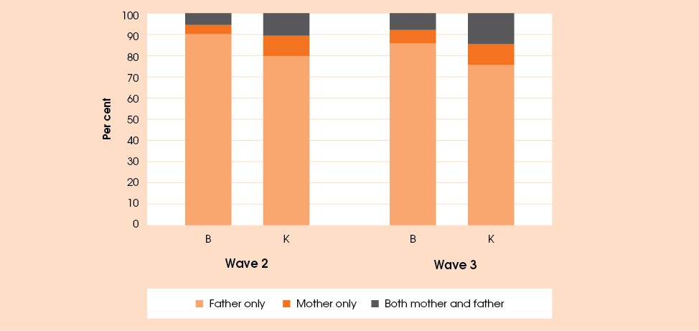

For most children living away from a parent (90 to 97 per cent of the children for whom information on the parent was available), the parent living elsewhere was the father (Figure 12). It became more common for the mother only or both the mother and father to live elsewhere as children grew up. This is evidenced both by the higher proportions of mothers living elsewhere for the children in the K cohort and by the increasing incidence of such cases in wave 3 compared to wave 2.
Of the 61 children who lived away from their mothers at wave 3 and whose primary carers provided information about the mothers, almost one-third (32.8 per cent) had contact with their mother at least once a week and about one-fifth (21 per cent) had no contact at all. Among the 309 children whose fathers lived elsewhere and whose primary carers provided information about father, about 40 per cent had at least weekly contact with the father, and 21.7 per cent had no contact at all. Furthermore, of the children who had any contact with their mother living elsewhere (49 cases), half never stayed overnight with the mother, while in the case of fathers living elsewhere but having some form of contact with the child (239 cases), 61.5 per cent did have the child stay overnight.
The primary carers of children who had a parent living elsewhere were also asked, for the first time in wave 3, about their relationship with the other parent. This information is summarised in Table 19. While 15.6 per cent of primary carers did not discuss the upbringing of the study child with the parent living somewhere else (or did not have contact with that parent), 45.8 per cent of primary carers were generally in agreement with the parent living elsewhere about the way the child was to be brought up, and 46.8 per cent of primary carers did not normally find it hard to talk to that parent.
Table 19: Relationship between primary carer and parent living elsewhere, per cent
Frequency | Relationship between primary carer and parent living elsewhere
Frequency | Disagree about bringing up the child | Have big fights | Hard to talk
Never/almost never | 32.3 | 47.7 | 35.3
Rarely | 13.5 | 20.1 | 11.5
Sometimes | 17.0 | 19.1 | 15.0
Often | 13.2 | 8.1 | 9.1
Always/almost always | 8.3 | 4.9 | 14.0
Not applicable | 15.6* | - | 15.0**
Number of respondents | 288 | 283 | 286
*The primary carer did not discuss the upbringing of the study child with the parent living elsewhere.
**The primary carer did not have contact with the parent living elsewhere.
Primary carers of children who did not live in the same household with one or both of their parents were also asked their opinion about how involved the mother or the father living elsewhere should be in the child’s life. The answers are summarised in Figure 13 below, broken down by whether the mother or the father of the child was living somewhere else. While some primary carers did not think that the parent living elsewhere should be at all involved in the child’s life—this is true for 17.2 per cent of cases where the mother of the child was living elsewhere and 12.8 per cent of cases where the father was living elsewhere—more than half of primary carers would have preferred the parent to be more involved in the child’s life.
The information on the actual and desired involvement of parents living away from their children can be compared to see whether there was a generally agreed upon ’right’ level of parental involvement. In the case of fathers living elsewhere, where a father had contact with the child at least twice a week, most primary carers (62.5 per cent) indicated that the level of the father’s involvement was about right, but a further one-third of primary carers desired more involvement from the father (Table 20). Where the father living elsewhere saw the child less often, the majority of primary carers desired more involvement. Interestingly, in the cases where the father was not at all in contact with the child, the primary carers’ responses were almost evenly split between wishing for more involvement from the father (47.5 per cent) and wishing for no involvement at all (49.2 per cent).
Figure 13: Primary carer’s attitude regarding involvement of the parent living elsewhere: ‘How involved should the parent be in the child’s life?’
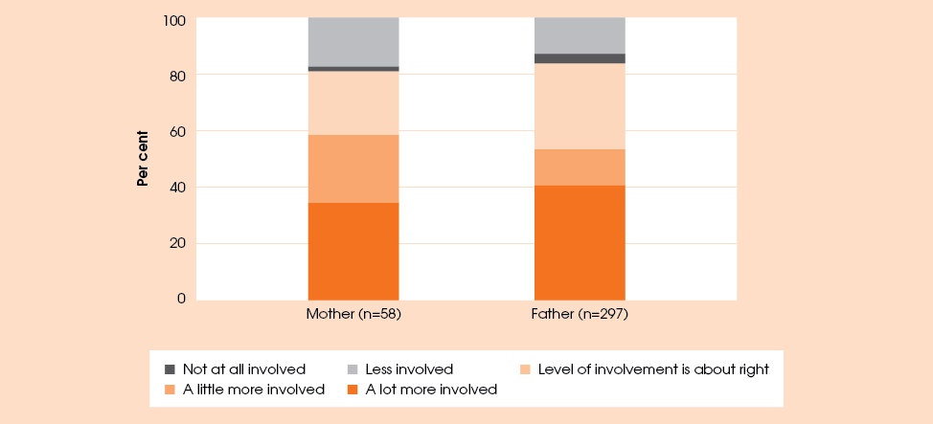

Table 20: Comparison of actual and desired contact with the child’s father living elsewhere, per cent
Frequency of father’s contact with the child | Primary carer’s desired level of the father’s involvement
Frequency of father’s contact with the child | More | About right | Less | Not at all | Total
Every day to two times per week (n=96) | 33.3 | 62.5 | 3.1 | 1.0 | 100.0
Once per week to once a fortnight (n=66) | 66.7 | 28.8 | 4.5 | 0.0 | 100.0
Once a month to once a year (n=74) | 73.0 | 12.2 | 5.4 | 9.5 | 100.0
Not at all (n=61) | 47.5 | 3.3 | 0.0 | 49.2 | 100.0

Housing
Housing affects children’s lives and development in many ways. Children living in inadequate or overcrowded housing are more likely to contract infectious diseases such as meningitis and respiratory conditions (Harker 2006) or suffer ill effects from toxicants that may continue well into adulthood (Dockery et al. 2010). Cramped or substandard living conditions can also affect mental health, create domestic tensions and increase the incidence of family violence. A lack of sufficient space for learning, relaxation and sleep and a lack of opportunities for outdoor play may negatively impact on the child’s physical development and education. Finally, frequent residential moves and especially homelessness can contribute to worse health and educational outcomes, decreased social connectedness and stress for children and their families (Dockery et al., 2010).
The housing conditions of many Aboriginal and Torres Strait Islander people, although improving, are still below the standard of those enjoyed by most people in non-Indigenous communities (ABS 2008). In 2008, 31 per cent of Aboriginal and Torres Strait Islander children and youth lived in overcrowded housing and, in remote areas this proportion was even higher, at 58 per cent (ABS 2011c). In 2008, Indigenous people were almost five times as likely as non-Indigenous people to live in overcrowded housing (SCRGSP 2011). Moreover, many of those who lived in a permanent dwelling experienced problems with the condition of their home: one-third of dwellings managed by Indigenous housing organisations in remote communities needed either major repairs (24 per cent) or replacement (9 per cent) (ABS 2008).
While the association between housing conditions and child outcomes has not been investigated directly in this report, this could be done with further analysis of the data. Also, as future waves of data become available, they will contribute to fuller understanding of the role housing plays in children’s outcomes, that is, whether poor conditions in early or late childhood, or only if prolonged, affect a child’s physical and/or educational development.
Most of the Footprints in Time children (around 90 per cent in wave 3) lived in free-standing houses. The remaining 10 per cent were divided almost equally between semi-detached houses and apartments or flats. However, the type of the dwelling was related to relative isolation: 97.0 per cent of children in highly or extremely isolated areas lived in free-standing houses, as opposed to 87.3 per cent in areas of no isolation.
Most children (61.0 per cent) lived in three-bedroom homes a further 24.0 percent in four-bedroom homes. The proportion of children living in one or two-bedroom homes tended to increase with relative isolation: 19.2 per cent of respondents in highly or extremely remote areas lived in such homes compared to only 8.3 per cent of respondents in non-isolated areas.
Any home can be viewed as big or small, depending on the size of the family living there. Table 21 reports the numbers of people per bedroom living in the house, broken down by LORI. Although more than half of respondents lived in houses with one or two people per bedroom, the situations where more than two or more than three people shared a bedroom were more common in areas with higher relative isolation. According to the Canadian National Occupancy Standard, an internationally accepted tool used by the ABS to measure the need for additional bedrooms in order to adequately house the occupants, room-sharing by more than two people is considered a sign of overcrowding.
Table 21: Number of people per bedroom by LORI, per cent
People per bedroom | LORI |  |  |  | All locations
People per bedroom | None (urban) | Low | Moderate | High/extreme | All locations
1 or fewer | 26.2 | 23.5 | 17.7 | 9.9 | 22.1
> 1 to 2 | 68.2 | 63.1 | 55.9 | 47.5 | 61.9
> 2 to 3 | 4.8 | 11.8 | 21.0 | 29.8 | 13.0
> 3 | 0.8 | 1.6 | 5.4 | 12.8 | 3.0
Total respondents | 374 | 694 | 186 | 141 | 1,395

Figure 14: Most common reasons for moving house, per cent
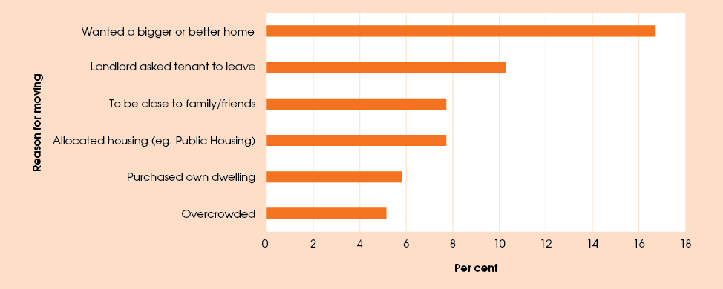
About 22 per cent of respondents moved house between their wave 3 interview and their previous interview. Among those who moved, the most commonly cited reason for changing residence was a wish to get a bigger or better home (16.7 per cent). The second most prevalent reason was the landlord asking people to leave (10.3 per cent), and equal third, a wish to be closer to family and friends or moving for reasons related to allocated housing (7.7 per cent each)—see Figure 14.

House amenities
The primary carers were asked whether the houses they lived in had a range of facilities, either individual or shared. Almost all homes had working cooking facilities, a fridge, a flushing toilet, a bath or shower, a washing machine, a kitchen sink, a laundry tub, and an air conditioner or fan (Table 22). For the most part there did not seem to be differences in the availability of these facilities depending on the LORI. The most noticeable exception was the availability of a working heater, which was much lower in the more isolated areas; however, this is most likely due to the climate differences between the least isolated (for example, Adelaide) and most isolated (for example, the Torres Strait) sites. Also notable was the lower likelihood of homes having working cooking facilities in areas of high or extreme isolation.
The 2008 National Aboriginal and Torres Strait Islander Social Survey (NATSISS) (ABS 2009) found 13 per cent of Indigenous people aged 15 years and over lived in households where one or more facilities were not available or did not work. Discounting the results for ’working heater’ and ‘working air conditioner or fan’ to allow a comparison with the questions asked in NATSISS, 11.1 per cent of the Footprints in Time sample lived in a household where one or more of the facilities were not available or did not work.
Table 23 shows proportions of primary carers who indicated that they shared various facilities with others, separated by LORI. As might be expected, families in the areas of no isolation were much less likely to share facilities than families living in more isolated areas. This relationship was particularly pronounced in the case of access to a washing machine. However, somewhat surprisingly, families in areas of moderate isolation were more likely to share facilities than families in areas of high or extreme isolation (with the exception of sharing a washing machine).
Table 22: Access to facilities, by LORI, per cent
Facility | None (urban) | Low | Moderate | High or extreme | All locations
Home has a working stove, oven or cooking facilities | 95.5 | 95.5 | 91.4 | 86.6 | 94.1
Home has a working fridge | 97.6 | 98.4 | 95.1 | 96.5 | 97.6
Home has a working flushing toilet | 97.3 | 98.4 | 96.8 | 95.1 | 97.6
Home has a working bath or shower | 96.0 | 98.3 | 98.4 | 99.3 | 97.8
Home has a working washing machine | 96.0 | 96.6 | 94.1 | 95.0 | 95.9
Home has a working kitchen sink | 97.1 | 97.7 | 97.8 | 97.9 | 97.6
Home has a working laundry tub | 96.5 | 97.7 | 97.8 | 98.6 | 97.5
Home has a working heater | 94.1 | 76.0 | 36.3 | 20.7 | 70.2
Home has a working air conditioner or fan | 93.4 | 90.1 | 95.7 | 94.4 | 92.1
All listed facilities available | 91.2 | 90.8 | 83.8 | 80.1 | 88.9
Note: The last row in the table reports percentages of households that had all of the facilities (with the exception of working heater and air conditioner or fan) available and working.

Table 23: Access to shared facilities, by LORI, per cent
Shared facilities | LORI |  |  |  | All locations
Shared facilities | None  (urban) | Low | Moderate | High or extreme | All locations
Stove, oven or cooking facilities | 1.3 | 9.9 | 16.7 | 15.5 | 9.1
Fridge | 1.3 | 9.9 | 14.5 | 12.7 | 8.5
Flushing toilet | 1.1 | 9.9 | 13.4 | 12.0 | 8.2
Bath or shower | 1.1 | 9.8 | 14.0 | 13.4 | 8.4
Washing machine | 1.3 | 10.8 | 17.7 | 21.1 | 10.2
Kitchen sink | 1.3 | 9.8 | 14.5 | 11.3 | 8.3
Laundry tub | 1.3 | 10.3 | 14.0 | 12.7 | 8.6
Heater | 1.3 | 7.4 | 8.2 | 5.0 | 5.6
Air conditioner or fan | 1.3 | 8.6 | 14.0 | 10.6 | 7.6
Sharing one or more facilities | 1.3 | 10.2 | 17.9 | 22.7 | 10.1
Note: Due to data limitations, it was not possible to determine whether the facilities were shared with other families in the same household, other households in the same dwelling, or those in other dwellings.

Homelessness
On any given day, nearly one in every 200 Australians is homeless. In 2009–10, one in every 38 Australian children aged 4 years and under spent time in a homelessness service (Homelessness Australia 2011a). Aboriginal and Torres Strait Islander people are more likely to experience homelessness than the non-Indigenous population. While Aboriginal and Torres Strait Islander people comprise 2.4 per cent of the total Australian population, they represented 10 per cent of people counted as experiencing homelessness on Census night 2006. Aboriginal and Torres Strait Islander people also represent 16 per cent of ‘rough sleepers’, and 20 per cent of people living temporarily in homeless services (Homelessness Australia 2011b).
For the first time in wave 3, the primary carers in Footprints in Time were asked to share information about any episodes of homelessness that they experienced during the five years before the interview. While 91.1 per cent of respondents had not experienced homelessness during this period, 5.0 per cent were homeless once and 3.7 per cent were homeless a number of times.
Three-quarters of all primary carers who experienced homelessness said that the study child was with them at the time. Of those who had experienced homelessness, 43.8 per cent had experienced it more than two years previously, 24.0 per cent one to two years previously, 26.5 per cent in the previous 12 months and 5.8 per cent were in temporary accommodation.
The reasons for homelessness included domestic violence (22.9 per cent of respondents who experienced homelessness), overcrowding or being asked to leave (20.3 per cent), relationship breakdown (16.1 per cent), eviction due to financial problems (7.6 per cent) or non-financial problems (9.3 per cent) or recently arriving in the area (8.5 per cent). Respondents could select more than one option if applicable. Most of those who experienced homelessness reported staying with friends or relatives (69.2 per cent), using safe houses or night shelters (18.3 per cent) or using medium to long-term supported accommodation (8.3 per cent). Just over 2 per cent of respondents who experienced homelessness (three people) reported ’sleeping rough’ while homeless.

Education and employment

Parental education
According to NATSISS in 2008 (ABS 2009), 21 per cent of Indigenous people aged 15 to 64 had completed Year 12, compared with 54 per cent of non-Indigenous people. The Footprints in Time sample showed a much higher level of schooling: 26.0 per cent of respondents had completed Year 12, an advanced diploma or a university degree. In addition, 14.4 per cent had completed a certificate course. One possible reason for this is that primary carers in the Footprints in Time sample are on average younger than respondents in the NATSISS sample. The difference in results may be a reflection of the general trend of younger generations to reach a higher level of education than older generations.
In all waves, primary carers were asked whether they were studying for an educational qualification. At the time of interview, 12.3 per cent (n=173) of primary carers indicated that they were studying and 5.8 per cent indicated that they were thinking about it. Of those who answered they were not studying in wave 2, 101 respondents had taken up study by the time of their wave 3 interview.
Of those who were studying, 39.3 per cent were studying at a TAFE or technical college and 31.2 per cent were studying at a university or other higher education institution. The proportion of primary carers who were studying was only slightly higher in less isolated areas (12.0 to 13.6 per cent) than in areas of high or extreme isolation (9.2 per cent).

Employment
Work can have a significant effect on people, their families and the wider community. Children growing up in families where no parent is employed may be at a higher risk of disadvantage, not only because of the financial implications of joblessness but also because unemployment can affect their parents’ mental health, emotional well-being, parenting style and practices. Family joblessness is the leading cause of child poverty in Australia (Whiteford 2009), the consequences of which include poor health, a higher risk of disability and lower educational attainment (Benevolent Society 2010). This, together with a lack of employed role models to follow, may increase the risk of children growing up to be jobless. However, having a non-employed parent may also positively affect children’s development—for instance, if the parent made the decision to forgo employment in order to stay at home and care for children, or if the parent is studying to improve their skills and the wellbeing of the family at a later stage. The relative benefits of employment and non-employment will vary depending on the unique situation of each family.
According to NATSISS 2008 (ABS 2009), 54 per cent of Indigenous people between 15 and 64 years were employed. From an examination of employment status of the primary carers—and remembering that not all of them are Indigenous—it appears that the Footprints in Time participants have a lower rate of employment than the national average for Indigenous people. However, many of the primary carers are mothers of young children who would be expected to have a lower participation rate than men or than women without young children. In 2008, the Household, Income and Labour Dynamics in Australia (HILDA) Survey showed that the labour force participation rate of mothers whose youngest child was between 2 and 5 years old was 62.7 per cent for partnered mothers and 60.6 per cent for lone mothers (Wilkins et al., 2011).
Table 24 summarises the employment status of the study children’s primary carer at all three waves. As might be expected, both part-time and full-time employment rates were higher for the primary carers of children in the K cohort (36.1 per cent, compared to about 29 per cent in the B cohort in wave 3). Primary carers of children in the K cohort worked on average one hour longer than those of children in the B cohort. The HILDA Survey shows that in 2008 the average weekly working hours of women with children under the age of 15 were 28.2 for partnered mothers and 30.1 hours for lone mothers (Wilkins et al., 2011). Thus, the average working hours of the Footprints in Time primary carers, most of whom are women, were very similar to those of the general population of working mothers. It is interesting to note that the average number of hours worked by primary carers of the B cohort was greater in wave 3 than that of the primary carers of the K cohort in wave 1. An examination of the different employment rates between the K cohort carers in wave 1 and the B cohort carers in wave 3 suggests that while primary carers in the B cohort in wave 3 were slightly less likely to be employed, especially part-time, than primary carers in the K cohort at wave 1, when employed they were likely to work longer hours.
Table 24: Employment status and average working hours of primary carers, by wave and cohort
Primary carer employment status,  per cent | Wave 1 |  |  | Wave 2 |  |  | Wave 3
Primary carer employment status,  per cent | B | K | All | B | K | All | B | K | All
Not employed | 74.4 | 67.2 | 71.3 | 71.1 | 65.3 | 68.6 | 70.9 | 64.0 | 68.0
Employed part-time | 17.0 | 19.7 | 18.1 | 18.1 | 19.4 | 18.7 | 16.1 | 18.4 | 17.1
Employed full-time | 8.7 | 13.1 | 10.6 | 10.7 | 15.3 | 12.7 | 13.0 | 17.7 | 15.0
Primary carer’s average working hours | 25.6 | 27.4 | 26.5 | 27.5 | 28.3 | 27.8 | 28.8 | 30.0 | 29.3
Note: Employment characteristics are derived on the basis of hours worked in all jobs. Employment is considered to be full-time if weekly hours of work are 35 hours or greater.

For 77.0 per cent of respondents their (main) job was permanent, while for 22.6 per cent it was temporary. The remaining 0.4 per cent of respondents was not sure. Additional characteristics of the primary carer’s main current job are shown in Figure 15. It demonstrates, that for almost half of all primary carers their main job was full-time, a further 30.0 per cent worked in a part-time job while 17 per cent had a main job that was casual. The proportions of primary carers who were self-employed, or whose main job was contract-based or involved shiftwork were all lower than 3 per cent.
Those 932 primary carers who reported not being employed at their wave 3 interview were asked about the main reason for not having a job. The most common reasons are shown in Figure 16 for each cohort. The most common reasons were all family-related (‘prefer to look after own children’, ‘too busy with family’, or ‘had another baby’), followed by study or health-related reasons and the unavailability of jobs.

Figure 15: Characteristics of primary carer’s main job
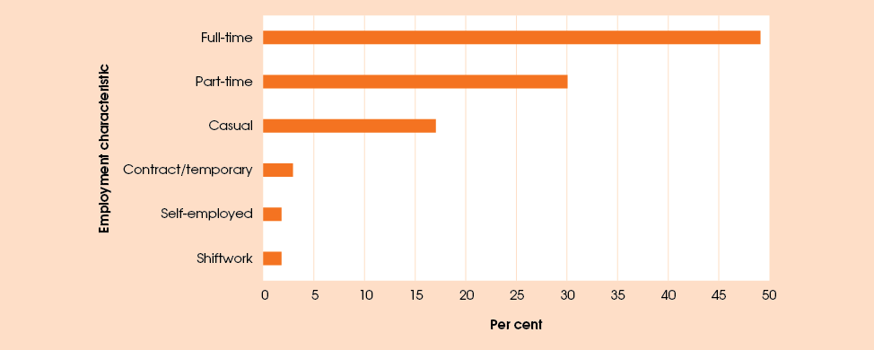
Note: The percentages are given for all employed primary carers who chose to answer questions
about their job.
Figure 16: Reasons the primary carer is not in paid job
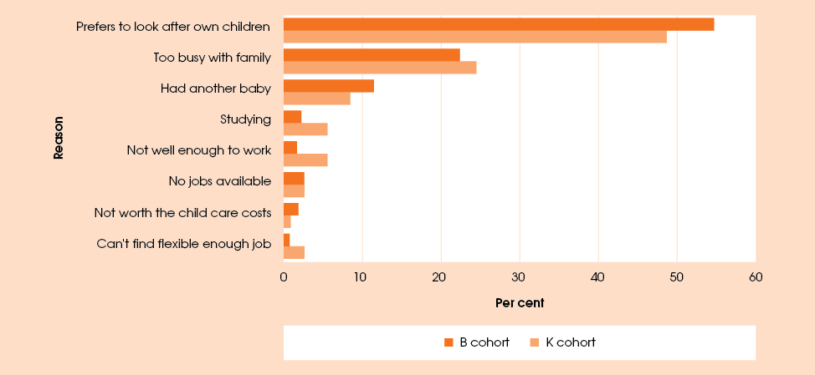

Employment status of the primary carer’s partner
Information on the employment status and working hours of the primary carer’s current partner was also collected in wave 3.
Of the primary carers who had a partner living in the household at the time of wave 3, 68.9 per cent had a partner who was employed, most of them full-time (82.2 per cent of those who had an employed partner, or 56.6 per cent of all primary carer’s partners). There was a higher incidence of non-employment and part-time employment among partners in the relatively more isolated areas (Table 25).
The reasons the primary carer’s partner was not in paid employment tended to be more job-related compared to the reasons for the primary carer’s non-employment (Figure 17). In particular, the most common reason for the primary carer’s partner not to have a job was the unavailability of jobs (29.6 per cent for both cohorts combined). Other job or career-related reasons mentioned by respondents included studying and the lack of interesting or flexible enough jobs.

Table 25: Employment status of the primary carer’s partner, per cent
Employment status | LORI |  |  |  | All locations
Employment status | None (urban) | Low | Moderate | High or extreme | All locations
Not employed | 21.4 | 37.2 | 33.3 | 30.7 | 31.1
Employed part-time | 9.1 | 9.5 | 23.7 | 16.8 | 12.3
Employed full-time | 69.5 | 53.3 | 43.0 | 52.5 | 56.6

Figure 17: Reasons the primary carer’s partner is not in paid job
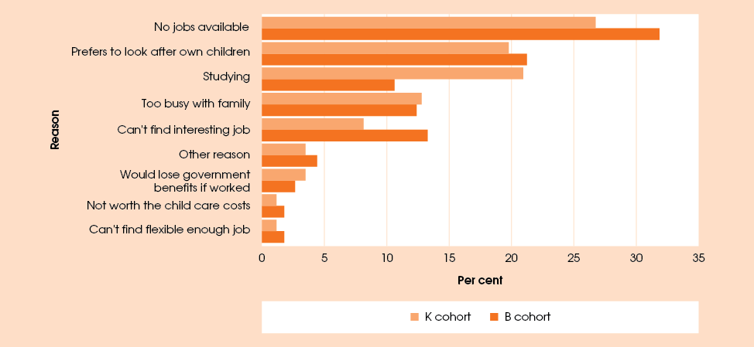

Jobless and two-earner families
If we take into account the employment status of both the primary carer and their partner (if they have one), analysis shows that at the time of the wave 3 interview 46.0 per cent of study children lived in jobless families, most of these in families where the primary carer was single. As shown in Table 26, among children whose primary carer was partnered, 24.3 per cent lived in jobless families, compared to 77.7 per cent of children whose primary carer was single. Interestingly, the joblessness rate tended to be highest in the areas with low relative isolation, particularly for the families where the primary carer was partnered (Table 27). It should be noted, however, that the study children, especially in the B cohort, are still young, and the unpartnered parent will not be subject to labour force participation requirements until their youngest child turns 6.
Of the 1,404 children in wave 3 of the Footprints in Time survey, 273 lived in families where both the primary carer and the carer’s partner were employed. This comprised one-third of families where the primary carer was partnered and just under 20 per cent of all families. The proportion of two-earner families was slightly higher for the children in the K cohort (37 per cent of families where the primary carer was partnered, as opposed to 31 per cent in the B cohort), and in areas with no relative isolation (40 per cent for families where the primary carer was partnered, compared with 27 to 32 per cent for families in other areas).
Data identifying children in jobless households may be used for further research to examine the comparative outcomes for children based on the employment status of their primary carers.

Table 26: Proportion of study children living in jobless families, by primary carer’s partnership status and child cohort, per cent
Primary carer’s partnership status | Child cohort |  | Both cohorts
Primary carer’s partnership status | B cohort | K cohort | Both cohorts
Partnered jobless | 24.3 | 24.3 | 24.3
Unpartnered jobless | 79.9 | 74.3 | 77.7
Total jobless | 47.4 | 44.0 | 46.0
Note: A jobless family is defined as one where neither the primary carer nor their partner (if applicable) was employed at the time of the wave 3 interview.

Table 27: Proportion of study children living in jobless families, by primary carer’s partnership status
and LORI, per cent
Primary carer’s partnership status | LORI |  |  |  | All locations
Primary carer’s partnership status | None | Low | Moderate | High or extreme | All locations
Partnered jobless | 17.2 | 29.8 | 25.0 | 20.6 | 24.3
Unpartnered jobless | 74.6 | 80.2 | 71.4 | 77.8 | 77.7
Total jobless | 37.2 | 53.8 | 42.5 | 35.5 | 46.0
Note: A jobless family is defined as one where neither the primary carer nor their partner (if applicable) was employed at the time of the wave 3 interview.

Parental leave
For the first time in wave 3, primary carers were asked questions about parental leave provisions in their current job, as well as the history of parental leave taken around the time of the child’s birth.
Of the 36.5 per cent of birth parents who were employed while they (or the child’s birth mother) were pregnant with the study child, just over one half (54.1 per cent) took some form of leave for the birth of the child (Table 28).
Table 29 shows the proportions of birth parents returning to the job they were employed in around the time of child’s birth and the length of time between the birth of the child and the return to work. Just over one-fifth of parents who took leave did not return to the job they were employed in at the time of the child’s birth. This proportion was almost twice as high for parents who took unpaid leave compared to parents who took paid parental leave (30.4 per cent and 15.5 per cent respectively). Of the parents who took paid parental leave, almost two in three (64.1 per cent) returned to the job within a year of the child’s birth.

Table 28: Parental leave history of birth parent around the time of the child’s birth, per cent
 | Both cohorts
Per cent of birth parents who had a job while pregnant with study child | 36.2
Of parents who had a job when pregnant with study child: | n=438
Took paid maternity/paternity leave | 32.9
Took unpaid leave | 21.2
Did not qualify for leave | 16.0
There was no leave available | 14.6
Left or resigned from their work prior to the birth* | 11.8
Other | 4.3
* This response was coded based on the birth parents’ free-text responses.
Table 29 Primary carers returning from leave taken around the time of the child’s birth,
by type of leave, per cent
Length of leave | Took paid parental leave | Took unpaid leave | Took any leave
Returned to the same job within 3 months | 9.2 | 15.2 | 11.7
Returned to the same job after 3 but before  6 months (12 weeks to 25 weeks) | 18.3 | 16.3 | 17.0
Returned to the same job after 6 but before 12 months (26 weeks to 51 weeks) | 36.6 | 23.9 | 31.3
Returned to the same job after 12 months or more | 20.4 | 14.1 | 18.3
Not returned | 15.5 | 30.4 | 21.7
Number of respondents | 142 | 92 | 230

All primary carers who were employed at the time of the wave 3 interview were asked whether their workplace had parental leave entitlements. While in just under 20 per cent of cases parental leave was not available, about three-quarters (76.0 per cent) of employed primary carers indicated they would be eligible for some form of parental leave if they had another child, and 4.3 per cent indicated that the leave was available but they would not qualify for it. More than 60 per cent of employed primary carers indicated that they would be eligible for paid parental leave (Table 30).

Table 30: Eligibility for parental leave, per cent
Percentage of primary carers employed at the time of wave 3 interview | 32.3
Of those employed, eligibility for parental leave if having another child: | n=449
Yes, paid | 53.1
Yes, unpaid | 12.3
Yes, paid and unpaid | 10.6
No, leave not available | 19.7
No, leave available but primary carer does not qualify | 4.3

Income and finance
The Footprints in Time study collects a range of data on the income and financial situation of the families in which the study children live. The set of questions asked varies across waves. However, the information on sources of income of both the primary carer and their partner (if applicable) and on whether the family is affected by income management arrangements is collected in all waves conducted and planned to date (waves 1 to 5). Wave 3 also saw the introduction of a suite of questions on financial stress, which will continue to be asked in future waves of the study, as well as a question on whether the primary carer has seen a financial counsellor in the past 12 months. Questions on the income earned were not asked in wave 3. However the primary carers were asked to describe their family’s money situation in terms of whether they made savings on a regular basis or were running out of money before payday.

Income
In wave 3, about half of all primary carer respondents reported receiving wages or a salary (Table 31); the proportion of primary carers who were receiving income from this source has increased since wave 2, possibly due to the study children growing up. More than three-quarters of primary carers reported that some of their income came from a government pension, benefit or allowance. Child support and Community Enterprise Australia (CEA) or Community Development Employment Project (CDEP) payments were less prevalent than other income sources, at 6 per cent and 5 per cent, respectively. Only two primary carers indicated that they were receiving no income.

Table 31: All sources of income, percentage of primary carers (and partners)
Source of income | Wave 1 | Wave 2 | Wave 3
Wages or salary | 42.1 | 42.2 | 49.2
Any Government pension or benefit or allowance | 69.4 | 72.7 | 78.8
CEA or CDEP payments | 5.9 | 4.3 | 4.8
Child support or maintenance | 3.7 | 2.3 | 6.1
Other | 0.3 | 0.8 | 0.9
Native title payment/ royalties from land* | -- | -- | 0.2
No income | 0.0 | 0.2 | 0.1
*Native title payment/royalties from land was introduced as an income option in wave 3.

Figure 18 and Figure 19 show how the income sources of respondents differ by LORI and the family type. Respondents in the non-isolated areas were more likely to receive wages or a salary and less likely to receive government income support when compared with those in more isolated areas. Lone parents, especially those with no other adults present in the household, were more likely to rely on government benefits or child support and less likely to receive wages than couple families.
Figure 18: Income sources by LORI, per cent
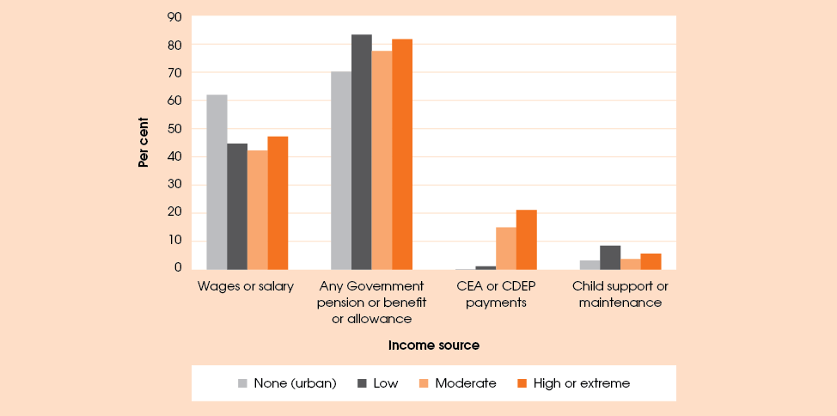

Figure 19: Income sources by family type, per cent
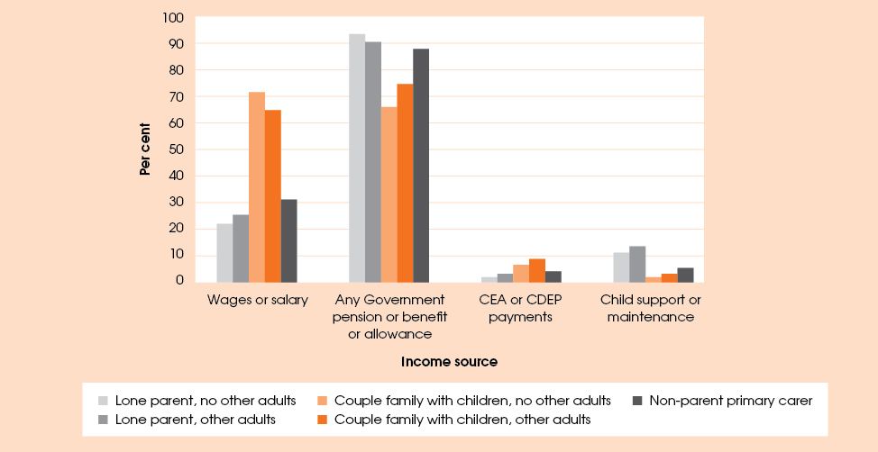

Income management
In all three waves of the study to date, the primary carers in Footprints in Time have been asked whether they have been affected by income management (income quarantining). Income management is a program designed to ensure that Centrelink payments are spent on priority goods and services. It operates by setting aside a percentage of certain income support and family payments to be spent on food, housing, clothing, education and health care. At the time of the wave 3 data collection, income management was operating in metropolitan Perth and the Kimberley region in Western Australia, across the Northern Territory, and in parts of Queensland under the Cape York Welfare Reform.
Table 32 shows that primary carers in the areas of moderate to extreme isolation were more likely to report being affected by income management. This is due largely to the limited number of areas in which income management is operating. Of the 88 primary carers in the study affected by income quarantining (6.3 per cent of all primary carers), 71.6 per cent responded that income management was good or very good for their families and 64.8 per cent thought that it brought positive changes to their communities.
Primary carers were also asked about their use of Centrepay, an arrangement for the direct payment of bills by Centrelink. Unlike income management, Centrepay is a voluntary service offered to people receiving income support payments, whereby the customers can choose to pay bills by having a regular amount deducted from their Centrelink payment. Since it is up to each person to apply for and use Centrepay, the lack of pattern across levels of relative isolation (as shown in Table 32) is not particularly surprising. Those in areas of no isolation at wave 3 may have moved from a more isolated area where income management had been implemented.
Table 32: Income management and Centrepay, by LORI, per cent
Primary carer affected by income management or Centrepay | LORI |  |  |  | All areas
Primary carer affected by income management or Centrepay | None (urban) | Low | Moderate | High or extreme | All areas
Income management/quarantining | 0.3 | 4.2 | 20.2 | 14.1 | 6.3
Centrepay (direct bill paying service by Centrelink) | 9.0 | 19.1 | 1.1 | 13.4 | 13.4
No income management or Centrepay | 90.7 | 76.5 | 78.7 | 71.8 | 80.1
Don’t know | 0.0 | 0.0 | 0.0 | 0.7 | 0.1
Refused to answer | 0.0 | 0.3 | 0.0 | 0.0 | 0.1
Note: It is possible to be on both income management and Centrepay. However, the question was asked in a single response format, therefore the figures for Centrepay may be understated.

Financial situation
In wave 3, primary carers of the study children were asked about their family’s overall money situation. Figure 20 summarises answers provided by respondents depending on the LORI of the area in which they live. People in areas of high isolation were at least half as likely to report running out of money before payday or spending more than they got than people in areas of no isolation.
Across the whole sample about 40.1 per cent of primary carers said that their money situation just allowed them to get to the next payday, and an additional 12.9 per cent reported a worse financial situation, with the family either running out of money before payday or spending more than they received. On the other hand, 31.6 per cent of primary carers reported that they were able to save some money from time to time and a further 5.6 per cent said they could save a lot.
The money situation did not seem to differ a great deal across family types (Figure 21). However couple families with children and no other adults present tended to be somewhat more comfortable in their situation and were slightly more likely to be able to save at least occasionally, while lone primary carer families with no other adults present in the household were the most likely to run out of money before payday.

Figure 20: Family money situation in wave 3, by LORI, per cent
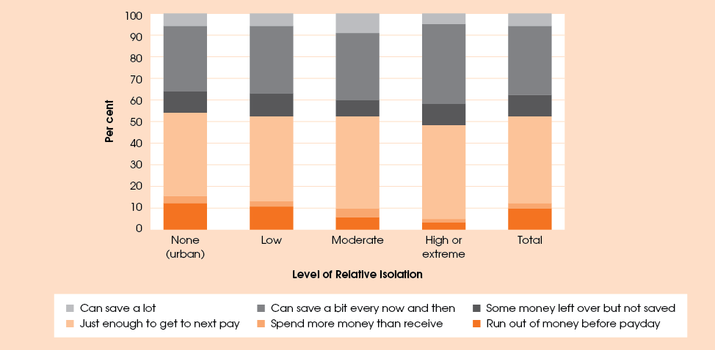Figure 21: Family money situation in wave 3, by family type, per cent
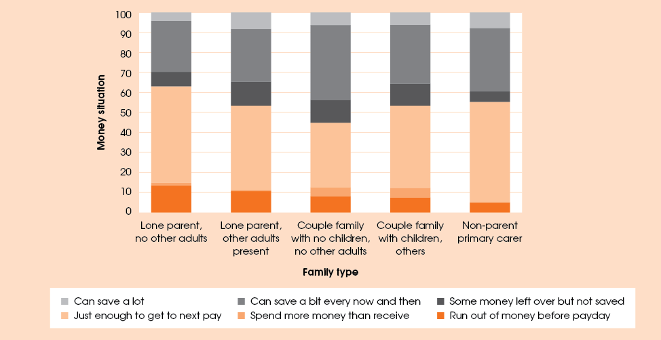

Table 33: Family money situation in wave 1 and wave 3 per cent
Family money situation in wave 1 | Family money situation in wave 3
Family money situation in wave 1 | Not enough money | Just enough money | Able to save | Total
Not enough money (n=226) | 29.6 | 47.8 | 22.6 | 100.00
Just enough (n=601) | 11.8 | 59.9 | 28.3 | 100.00
Able to save (n=442) | 7.0 | 35.7 | 57.2 | 100.00
Total (n=1,269) | 13.3 | 49.3 | 37.4 | 100.00

Information on the family money situation was also collected in wave 1. Table 33 compares the primary carers’ answers to this question at the two waves. To make the comparison easier, the six original response categories were combined into three: ‘not enough money’ (comprising ‘run out of money before payday’ and ‘spend more money than receive’), ‘just enough money’ (comprising ‘just enough to get to the next payday’ and ‘some money left over but not saved’), and ‘able to save’ (‘can save a bit every now and then’ and ‘can save a lot’). Table 33 demonstrates that families that did not have enough money in wave 1 were more likely than not to improve their situation, with just under 30 per cent reporting the same outcome in wave 3. Of the families who in wave 1 had just enough money, almost 60 per cent reported having the same situation in wave 3, and 28.3 per cent reported that they were now able to save some money. It should be noted however, that these results may be affected to some extent by the respondents’ most recent experiences rather than representative of the entire period.
About 6 per cent of responding primary carers (82 people in total) reported seeing a financial counsellor in the 12 months preceding their wave 3 interview. As might be expected, this group of respondents had a financial situation that was worse than that of the sample on average. The proportion of families who were running out of money before payday or spending more money than they received was just under 30 per cent in wave 1 but fell to 19.8 per cent in wave 3. Of the 82 respondents who reported meeting with a financial counsellor, 76 provided some information on how useful the assistance of a financial counsellor was in their circumstances, and 66 respondents (86.8 per cent of those who responded to this question) indicated that the financial counsellor helped them with budgeting and debt consolidation.

Financial stress
For the first time in wave 3, the primary carers were asked whether, in the 12 months before the interview, they had experienced money shortages that resulted in stressful occurrences for the family, such as the inability to pay bills on time or to heat or cool their home. Table 34 shows the proportion of respondents who experienced these events. While the majority (54.5 per cent) of primary carers reported no experience of financial stress, just under one-third (31.9 per cent) of primary carers experienced one or two types of stressful events in the past year, while a further 13.6 per cent reported experiencing three or more events. The most common financial stress event was the inability to pay bills on time (32.4 per cent of respondents), followed by applications to welfare organisations (18.2 per cent).
Table 34: Primary carers’ experience of financial stress

Financial stress events | Percentage of respondents
Could not pay bills on time | 32.4
Could not pay housing payments on time | 11.2
Went without meals | 8.1
Unable to heat or cool home | 8.8
Pawned/ sold something | 13.2
Asked for assistance from welfare organisation | 18.2
Did not experience financial stress | 54.5
Experienced one or two types of stress events | 31.9
Experienced three or more types of stress events | 13.6

The HILDA Survey asks similar questions, allowing comparison with the Australian population as a whole. The results from 2008 show that the experience of financial stress was higher for the Footprints in Time sample than among the general population, with 12.9 per cent of the general population experiencing one or two indicators and 4.9 per cent experiencing three or more indicators (Wilkins et al. 2011).
The experience of financial stress varied by the degree of relative isolation, and to a smaller extent, by family type. Consistent with reports on the family’s money situation, respondents in isolated areas were less likely to experience any financial stress compared with those living in the areas of no relative isolation (Figure 22). The responses to financial stress also differed depending on where the family lived. Those living in less isolated areas were more likely to postpone paying their bills to manage their money, while families living in more isolated areas were more likely to rely on forgoing meals or not heating or cooling the home. Families in the areas with no or low levels of isolation were also more likely to ask for assistance from welfare and community organisations. However, families in more isolated areas may have been less likely to seek assistance from welfare and community organisations because fewer services were available.
While lone parent families with no other adults present in the household were more likely to experience financial stress than any other family type (Figure 23), the responses to financial stress did not differ as much across family types as they did depending on the LORI. Lone parent families and families with a non-parent primary carer were somewhat more likely to apply for assistance from welfare agencies than other family types, and non-parent primary carers were less likely to miss paying bills and housing payments on time.
Figure 22: Financial stress by LORI, per cent
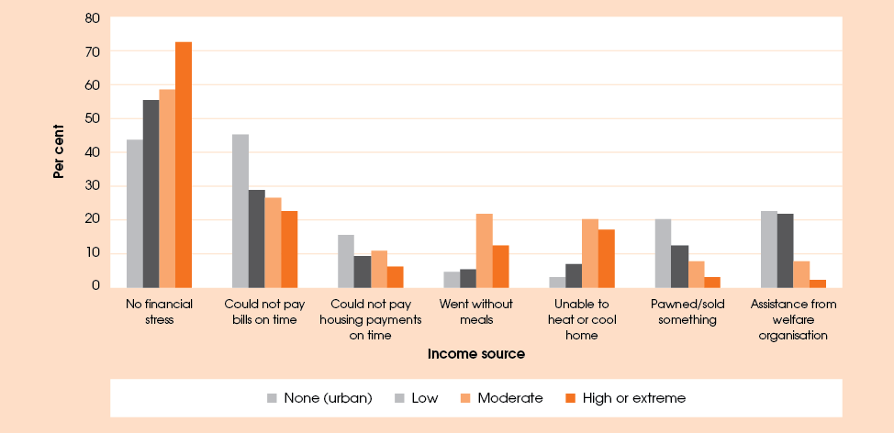
Figure 23: Financial stress by family type, per cent
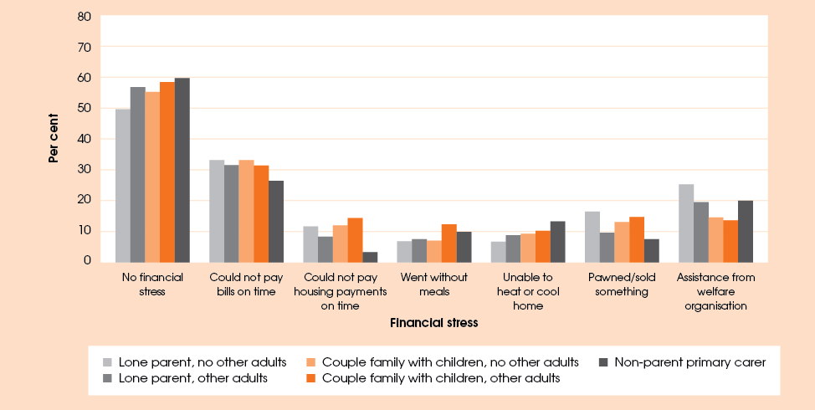

Primary carer health and wellbeing

Emotional wellbeing
Primary carers’ moods, feelings and emotional reactions have a big impact on children. In waves 2 and 3, primary carers were asked whether, in the past 12 months, they had been ’sad (blue) or depressed for more than two weeks’. In wave 3, if they answered yes to this question, they were also asked if they were getting any help for it.
In wave 3,275 (19.6 per cent) primary carers answered that they had experienced depression for a period of more than two weeks. Of these, 61.8 per cent were getting help, 33.1 per cent said they were not receiving help and 3.6 per cent said that no help was available. People indicated that they had received help from a wide variety of sources. Of those who had been getting help, 56.5 per cent had sought professional assistance from doctors, psychiatrists, psychologists, counsellors or social workers and 22.4 per cent were on medication. Many people (22.4 per cent) relied on family and friends for help. Of the people who said they had experienced depression, 18.8 per cent also answered that they had clinical depression or anxiety when asked about health conditions which made it difficult to look after the child.
It is possible to look at the persistence of depression by comparing wave 2 and 3 answers. Of the 1,065 people who responded to this question in both waves, 9.2 per cent said they had been depressed for more than two weeks over the previous 12 months in both waves, 25.7 per cent had been depressed in one of the two waves and 65.1 per cent had not been depressed in either wave.
Table 35: Emotional wellbeing of primary carers, per cent
Emotion | Wave 1 | Wave 2 | Wave 3
Get angry or wild real quick? | 20.8 | 16.1 | 13.2
Felt everything is hard work? | 19.0 | 19.9 | 15.0
Felt so worried your stomach got upset? | 16.4 | 13.2 | 14.2
Stopped liking things that used to be fun? | 15.6 | 10.0 | 9.6
Do silly things without thinking that you feel shame about the next day? | 6.3 | 4.1 | 3.5
Felt so worried it is hard to breathe? | 5.9 | 6.4 | 4.9
Felt so sad nothing could cheer you up? | 5.8 | 6.2 | 6.3
Note: The table reports the percentages of primary carers who responded ’fair bit’ and ‘lots’ to the questions above.

Primary carers were asked in each wave a number of other questions about their emotional wellbeing in the previous three months. Response options included ‘never’, ‘sometimes’, ‘fair bit’ and ‘lots’. These questions were drawn from the Strong Souls questionnaire developed to assess the emotional wellbeing of participants in the Aboriginal Birth Cohort study (Thomas et al., 2010). They provide a general indication of the possibility of depression, anxiety and impulsivity, which can be an indicator for suicide risk. Table 35 compares the percentage of people who answered ‘fair bit’ and ‘lots’ to these questions across the three waves.
With the exception of ‘felt so sad nothing could cheer you up’, the proportions of people responding ‘fair bit’ or ‘lots’ to the questions have decreased between waves 1 and 3. Restricting the sample to the same primary carers who participated in all three waves did not change the proportions substantially, indicating that people who have experienced greater mental health problems were not necessarily more likely to drop out of the study. However, without further investigation by researchers knowledgeable about mental health, it is not possible to say whether the respondents’ mental health has in fact improved over the three year period.

General health
The vast majority (88.6 per cent) of primary carers rated their general health as being ‘good’, ‘very good’ or ‘excellent’. When asked if they had experienced any health problems in the previous 12 months which had made it difficult to look after the study child, 65.6 per cent of primary carers answered no.
Of the 34.4 per cent who answered that they had experienced such a health problem, the most commonly cited problems (apart from ‘other’ at 27.3 per cent) were pregnancy and miscarriage (19.6 per cent), flu (14.2 per cent) and clinical depression or anxiety (11.1 per cent).
The percentage who said they had experienced clinical depression or anxiety equates to 3.8 per cent of the total Footprints in Time sample indicating that even though nearly 20 per cent of people had experienced depression in the previous 12 months (see previous section), the length or severity of the depression had not prevented them from taking care of the child. However, this also raises questions about the extent to which depression goes undiagnosed due to lack of awareness or access to services. This topic deserves further investigation by researchers experienced in health matters.

Smoking
It is now accepted that smoking is detrimental to people’s health whether they smoke directly or smoke passively by being around people who smoke. Protecting the health of people who decide not to smoke by ensuring they are not exposed to other people’s smoke has been the impetus for the introduction of laws in recent years. Consequently, smoking is no longer permitted in public enclosed buildings and vehicles. The recent introduction of a ban on smoking in private cars with children in them acknowledges that children need to be protected from passive smoking even in private situations.
Using the three waves of Footprints in Time, we can examine the changes in the smoking habits of primary carers. There are 1,169 cases where the same primary carer has participated in all three waves. Of these, there is missing data (non-response or refusal to answer) for one or two waves for 28 respondents. Primary carers were included as current smokers in this analysis if they reported that they smoked or were casual or social smokers. Of those primary carers who participated in all three waves, 43.7 per cent smoked in every wave and 37.1 per cent did not smoke in any of the waves. Of those who did not smoke every year, 7.5 per cent commenced smoking during the period and 5.8 per cent quit smoking. A further 3.8 per cent temporarily commenced or quit smoking. Of those who did quit in waves 2 and 3, the most common method was to go ‘cold turkey’ (in other words, just stop).
Smoking habits varied by relative isolation. Of all primary carer respondents in wave 3, those living in areas of no isolation were the least likely to smoke (49.5 per cent) while those living in areas of low or moderate isolation were the most likely to smoke (58.2 to 60.1 per cent). Those in areas of high or extreme isolation had a smoking rate of 54.3 per cent. In general, for the whole sample, the rates of smoking across the three waves were relatively stable with the exception of people in the highly or extremely isolated areas. This was possibly due to the small number of respondents in this category.

Living as a family

Relationships in the family
For the first time in wave 3, primary carers of the study children were asked about aspects of their relationships with their partners (if applicable).
Most respondents enjoyed a warm and supportive relationship with their partners, with more than
three-quarters of respondents saying that they and their partner often or always showed signs of affection for each other, and nearly 80 per cent of primary carers saying they felt that their partner supported them as a parent (Table 36). More than half the respondents said that they never or rarely disagreed with their partner about bringing up the study child (57.7 per cent), and 49.8 per cent of respondents rarely argue with their partner.
Table 36: Relationship between primary carer and their current partner, per cent
Frequency | Relationship between primary carer and current partner
Frequency | Show signs that they care for each other | Partner supports primary carer as a parent | Disagree about bringing up study child | Have arguments | Arguments include physical violence
Never | 1.7 | 1.6 | 26.9 | 14.4 | 86.2
Rarely | 3.0 | 3.0 | 30.8 | 35.4 | 10.3
Sometimes | 19.7 | 16.6 | 31.2 | 43.2 | 3.3
Often | 25.4 | 23.9 | 5.5 | 5.2 | 0.3
Always | 50.3 | 55.0 | 5.6 | 1.8 | --
Number of respondents | 768 | 767 | 769 | 769 | 769

Parental warmth and discipline
In waves 1 and 3, primary carers of children in the older (K) cohort were asked questions about parental warmth, such as hugging their children for no particular reason or praising them for doing something well. Primary carers continued to have warm relationships with their children but with appropriate adjustments for age. There were small decreases in the frequency with which primary carers hugged their children, which was most likely due to increased independence of the children in solving life’s difficulties rather than the primary carers’ decreasing willingness to hug them. Primary carers continued to praise their children when they did something well.
In wave 3 primary carers were asked additional questions about whether they enjoyed listening to their child and how often they felt close to the child when the child was happy or upset. Responses showed that 86.2 per cent of primary carers always or often enjoyed listening to their child, 96.9 per cent felt close to their child when the child was happy and 95.4 per cent felt close to their child when the child was upset.
The proportion of primary carers always making sure that their children did what was asked of them increased from 39.7 per cent in wave 1 to 45.8 per cent in wave 3. The vast majority of primary carers always asked where their children were going when they left the house (89.6 per cent) and always knew where they were when they were playing away from home and who they were with (94.0 per cent).

Major life events
Major life events have a significant impact not only on the people involved but on those around them as well; in terms of this study, events occurring to a family member may affect other or even all family members, including the child. As discussed in the Key Summary Report from wave 1, the more major life events a child experiences in a single period (in this case, the previous 12 months), the greater the risk of clinically significant emotional or behavioural difficulties. Zubrick et al., 2005 found that where fewer than three stressful events occurred, around 15 per cent of 4 to 11 year-olds were at high risk of emotional or behavioural difficulties. This increased to 25 per cent for families who experienced between three and six stressful events, while the percentage of children at risk of difficulties rose to 42 per cent in families who experienced seven or more stressful events.
In all three waves of Footprints in Time, primary carers were asked questions about events that might have caused significant stress. These events might have brought positive or negative experiences but all had a potential to cause significant impact on the family. Additionally, one event might affect each family member differently. For example, a mother might be excited about starting a new job and bringing in extra income, but the accompanying change in the life of the family as a whole might be quite unsettling for the child.
Looking at the data across the three waves makes it possible to gauge the potential effect of major life events on the Footprints in Time children. The average number of events experienced in wave 1 was 4.06; in wave 2 it decreased to 3.86; and it rose again to 4.13 in wave 3. Table 37 shows the percentage of the sample that experienced fewer than three, between three and six, or seven or more life events.
The proportions of people experiencing zero to two, three to six or seven or more events remained relatively constant across the three waves. About one-third experienced zero to two events, about half experienced three to six and about one-sixth experienced seven or more (Table 37).
Table 37: Number of major life events experienced at waves 1–3, per cent
Number of events | Wave 1 | Wave 2 | Wave 3
0 to 2 | 31.7 | 34.9 | 30.1
3 to 6 | 49.6 | 50.3 | 53.6
7 or more | 18.6 | 14.8 | 16.4
Number of respondents | 1,539 | 1,471 | 1,333

These findings raise the question of whether it is the same families falling into the same categories each year or whether families experience major life events at different rates each year. It is possible to investigate this by looking at the pattern of movement between the three categories. Of the children for whom there was data for all three waves (n=1,241), 5.4 per cent fell into different categories each year. The largest number of children (16.8 per cent) lived in families who experienced three to six events in all three years. The second largest group was those who experienced zero to two events in all years (8.8 per cent). Only 3.3 per cent experienced seven or more major life events in all three years, meaning a total of 28.9 percent were in the same category in all three waves. About one-third (32.1 per cent) experienced seven or more events in at least one year.
Table 38 shows the percentages of children who experienced these life events and the number of times they experienced them. Of the children whose parents reported they had experienced seven or more life events in any of the waves, 10.3 per cent had experienced seven or more in all three waves. Given the movement between the categories, it seems that, for most families experiencing a high number of major life events in one year was not necessarily a predictor of this happening in subsequent years.
Figure 24 shows how the prevalence of individual life events has changed between waves 1 and 3. In wave 3, respondents were more likely to report that someone they knew had passed away or been sick or hurt, although in most cases these events happened to someone not living in the house, so the child may only have been peripherally affected. The events most likely to have affected the primary carer were pregnancy or having a baby and ‘humbugging’ (being harassed for money). The Children were directly affected by family arguments and scared by other people’s behaviour.

Table 38: Number of life events by number of years experienced, per cent
Number of life events | Years experienced |  |  | Number of respondents n=1,241
Number of life events | 1 | 2 | 3 | Number of respondents n=1,241
0 to 2 | 47.3 | 37.9 | 14.8 | 738
3 to 6 | 39.1 | 41.1 | 19.8 | 1,054
7 or more | 64.1 | 25.6 | 10.3 | 398
Note: The total number of respondents is 1241 but some may be counted in more than one category.

Figure 24: Prevalence of major life events for wave 1 and wave 3, per cent
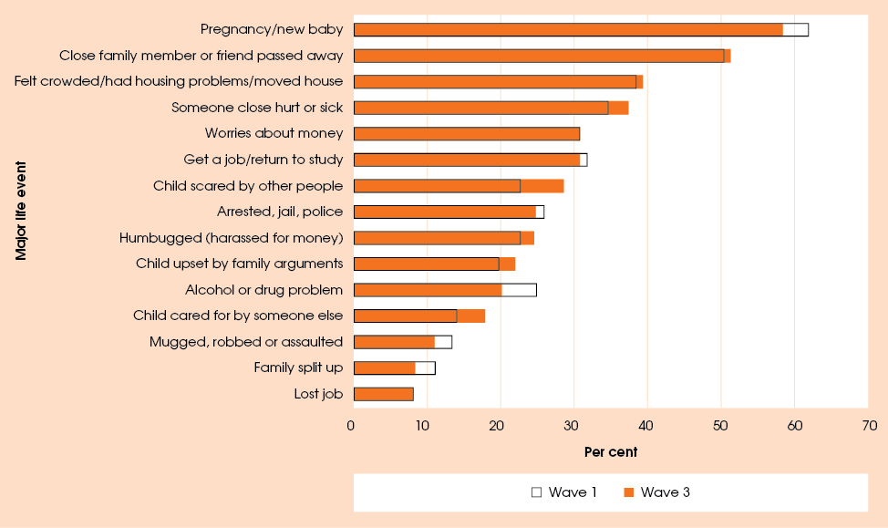
Questions about a list of major life events are also asked in the HILDA Survey. Compared to the 2008 results from HILDA (Wilkins et al., 2011), the Footprints in Time respondents seemed to experience a much higher prevalence of major life events than the general Australian population. However, the HILDA Survey asks about events that happened in the lives of respondents themselves, while the figure above includes other people close to the respondents who might have experienced the events. To allow for a more direct comparison, the Footprints in Time sample has been confined only to events that the primary carer personally experienced. The results are presented in Table 39.

Table 39: Major life events experienced by the Footprints in Time and HILDA respondents, per cent
Major life event | HILDA—(all respondents aged 15 years and older) | Footprints in Time primary carer
Fired or made redundant | 2.6 | 2.8
Victim of physical violence | 1.5 | 4.8
Serious Illness or injury | 8.0 | 4.8

Even allowing for individual experience, there is still a higher prevalence of these events among the Footprints in Time sample than the general Australian population as represented by HILDA. The exception is serious illness or injury, which may be explained by the fact that most of the primary carers are relatively young women.

Culture and community

Neighbourhood characteristics
The Footprints in Time data includes several indices classifying locations in terms of remoteness and isolation, and relative advantage and disadvantage. The Level of Relative Isolation (LORI) index classifies locations in terms of their relative remoteness and isolation from service centres. The Socio-Economic Indexes for Areas (SEIFA) uses a suite of four summary measures that allow comparison across all geographic areas in Australia in terms of advantage and disadvantage. SEIFA indexes are derived from Census variables such as low income, unemployment and Internet connections. For each index, every geographic area in Australia is given a score which shows how disadvantaged that area is compared with other areas in Australia. These rankings can then be divided into 10 equal parts to form deciles; the lower the decile, the greater the level of disadvantage.
However, in order to achieve targets for improving Indigenous socio-economic outcomes, policy makers need to understand where relative and absolute need is the greatest specifically for Indigenous people and what the particular challenges are for different regions across Australia. The Index of Relative Indigenous Socioeconomic Outcomes (IRISEO) also measures relative advantage and disadvantage but only for Indigenous people. IRISEO uses nine measures of socioeconomic outcomes across employment, education, income and housing from the 2001 and 2006 Censuses to create a single index for 37 Indigenous regions and 531 Indigenous areas. As with SEIFA, the lower the decile, the greater the level of disadvantage (Biddle 2009).
SEIFA may not adequately represent the distribution of Indigenous disadvantage, as it is based on the characteristics of the population as a whole, of which only a small proportion is Indigenous. Furthermore, one of the variables used to create the SEIFA is the proportion of the Indigenous population in the area. Therefore, by definition, any areas in which there is a large Indigenous population will be classified as more disadvantaged (Biddle 2009).

Table 40: Distribution of sample against SEIFA and IRISEO, per cent
Decile | Bottom | 2 | 3 | 4 | 5 | 6 | 7 | 8 | 9 | Top
SEIFA* | 45.8 | 13.2 | 10.4 | 8.4 | 5.6 | 5.5 | 4.8 | 3.5 | 1.8 | 1.0
IRISEO | 10.4 | 4.5 | 5.1 | 11.0 | 10.0 | 29.3 | 10.7 | 4.1 | 11.0 | 3.8
The SEIFA deciles are based on the Index of Relative Socioeconomic Disadvantage.

Table 40 shows the relative distribution of the Footprints in Time sample against the two indices. The SEIFA distribution shows that over 50 per cent of the sample is in the bottom two deciles and less than 20 per cent are in the top five deciles. In contrast, IRISEO shows that the sample is much more evenly divided across the 10 deciles, although there is some overrepresentation in the 6th decile. This may be explained by the non-randomness of the Footprints in Time sample. Alternatively, it may be because IRISEO is calculated using larger geographic areas than SEIFA is.
Primary carers were also asked their opinion about the neighbourhood in which they lived. They were asked about the level of traffic, the safety of the neighbourhood and whether it was a good place for children. These questions were asked in wave 1 and were asked in subsequent waves only if the child had changed address since the previous interview. The data has been merged to provide a picture, current at wave 3, of the level of satisfaction primary carers have of their neighbourhood in relation to the children. Table 41 shows that, while many primary carers were positive about their neighbourhoods, 12.7 per cent indicated that they were living in neighbourhoods they considered not very safe or dangerous.
The neighbourhoods in which people lived at wave 3 were not necessarily the ones in which they lived at the time of the wave 1 interview. Table 42 shows whether people were more likely to move between waves 1 and 3 if they were in a safe (‘very safe’, ‘quite safe’ or ‘okay’) or unsafe (‘not very safe’ or ‘dangerous’) neighbourhood in wave 1. While approximately 35 per cent of people had moved, people who were living in an unsafe neighbourhood in wave 1 were more likely to move, at 40.6 per cent.
Table 41: Neighbourhood characteristics at wave 3, per cent
Is this a good neighbourhood for kids? | Per cent
Very good | 35.3
Good | 33.5
Okay | 20.5
Not so good | 8.8
Really bad | 1.8
Are there good places for kids to play?
Lots of parks playgrounds | 26.5
A few places that are good | 27.5
Some places that are OK | 19.1
No, not many | 18.5
No, none | 8.5
How safe is this neighbourhood?
Very safe | 20.8
Quite safe | 36.6
Okay | 29.9
Not very safe | 10.9
Dangerous | 1.8

Table 42: Safety of neighbourhood by whether the child moved house between waves 1 and 3
Whether moved | Number or percentage | Safe in Wave 1 | Unsafe in Wave 1 | Total
Did not move house | Number | 702 | 114 | 816
Did not move house | Per cent | 65.8 | 59.4 | 64.8
Moved house | Number | 365 | 78 | 443
Moved house | Per cent | 34.2 | 40.6 | 35.2
Total | Number | 1,067 | 192 | 1,259
Total | Per cent | 100.0 | 100.0 | 100.0
Note: Restricted to study children who participated in the study in waves 1 and 3 and whose primary carer provided responses to the question on neighbourhood safety in wave 1.

Table 43 shows that of the people who lived in an unsafe neighbourhood in wave 1 and had moved by wave 3, 20.0 per cent had moved to another unsafe neighbourhood. On the other hand, 5.9 per cent of people who lived in a safe neighbourhood at wave 1 had moved to an unsafe neighbourhood. Of the respondents for whom we have data from all three waves, the proportion living in unsafe neighbourhoods decreased from 15.2 per cent in wave 1 to 13.7 per cent in wave 2 and 12.3 per cent in wave 3.

Table 43: Moving in and out of safe and unsafe neighbourhoods
Level of Safety Wave 3 | Safe in Wave 1 | Unsafe in Wave 1
Very safe | 24.0 | 12.9
Quite safe | 39.6 | 28.6
Okay | 30.5 | 38.6
Not safe | 5.3 | 14.3
Dangerous | 0.6 | 5.7
Total | 100.0 | 100.0

It is interesting to note that, although moving to a safe neighbourhood may be viewed as a positive outcome, just over 2 per cent of those who moved said the neighbourhood was the reason for their move.

Indigenous languages
Since European settlement in Australia, many Indigenous languages have been lost and, for many Aboriginal people, Aboriginal English has become the language in which they communicate with people of different language groups and with non-Aboriginal people (NSW Department of Education and Training 2010). It allows communication while still maintaining Indigenous identity. Similarly, Torres Strait Creole provides an identity marker and common language in which speakers of different Torres Strait languages communicate. However, while Aboriginal English might be intelligible for English speakers, Torres Strait Creole is not. Aboriginal English and Torres Strait Creole are the first or second languages of many Indigenous people. Kriol is another language that has developed from English to facilitate communication between Indigenous and non-Indigenous people and between speakers of different Indigenous languages.
Primary carers were asked about the languages the child spoke and, for each language identified by the primary carer, whether the language was the main language of the child, or whether the child spoke the language ‘all right’ or only some words of it. English or Aboriginal English was nearly universal: 99.3 per cent of children were able to speak it to some extent. The majority of children (86.8 per cent) spoke English or Aboriginal English as their main or only language, a further 7.8 per cent spoke it ‘all right’ and 5.4 per cent spoke some words. Torres Strait Creole and Kriol were the next most common main languages, comprising 5.5 per cent and 3.1 per cent respectively of children for whom a main language was identified. Of interest is that 26.1 per cent of children spoke more than one language, if only a few words of it.
Primary carers were also asked about the importance of their children learning an Indigenous language. This varied greatly by LORI. The greater the isolation, the more it was considered important to speak the Indigenous language. When asked whether they would like their children to learn an Indigenous language at school, only 8.7 per cent of primary carers said no. Primary carers in areas of moderate, high or extreme isolation indicated a strong preference (over 60 per cent) for their child to study an Indigenous language at school as part of a bilingual program, whereas the majority of primary carers in areas of no or low isolation preferred to see an Indigenous language available as a second language. Nevertheless, the proportion of primary carers in areas of no isolation who wanted their children taught an Indigenous language at school as part of a bilingual program was over 30 per cent. This is high considering that only 4 per cent of those children are presently learning an Indigenous language. Only 1 per cent thought that an Indigenous language should be the main language used at school and 10.2 per cent thought learning an Indigenous language should be compulsory as a second language. Primary carers were also more likely to place greater importance on Indigenous language programs if they rated being Indigenous as being important in their life, underscoring the link between language and culture.

Indigenous identity
The 1,176 primary carer respondents who identified themselves as Aboriginal, Torres Strait Islander or both were asked how important they felt being an Aboriginal or Torres Strait Islander was to them, and 1,150 primary carers chose to respond to this question. While about 80 per cent of those responding answered that being Indigenous was important to them, the importance of being Aboriginal or Torres Strait Islander increased with the LORI. In areas of high or extreme isolation, 80.7 per cent of primary carers stated that being Indigenous is central to who they were. In areas of no isolation, the response was 20.7 per cent. People in areas of no or low isolation were much more likely to feel that being Indigenous is important but not the only thing (over one-half of responses). People who lived in areas of low or moderate isolation were the most likely to say that being Indigenous as something they rarely thought about. However, these proportions were still quite low at 8.4 per cent and 7.7 per cent respectively.
All primary carers were asked what it is about Aboriginal and Torres Strait Islander culture that they would like to pass on to the child. The respondents could choose from 12 options with the opportunity of adding an alternative under ’other’. The options were based on an analysis of the most common open ended responses provided in wave 1 to the question ‘What is it about Aboriginal and Torres Strait Islander culture that will help your child grow up strong?’ Just under 4 per cent of primary carers refused to answer these questions or were not sure about the answer, and only 1.9 per cent added an ‘other’ option.
The top five cultural aspects of Aboriginal and Torres Strait Islander culture that primary carers wanted to pass on to their children were: knowing family history and heritage (63.5 per cent), showing respect (62.4 per cent), having pride in your identity, knowing who you are (58.1 per cent), knowing your country, where you are from (53.1 per cent) and finding bush tucker, hunting and fishing (41.1 per cent). When divided by LORI, combinations of these five reasons were the top two for each isolation level (Table 44).
Finding bush tucker, hunting and fishing was especially important to people in areas of high or extreme isolation where 83.8 per cent said they wanted to pass on these skills to their children. This was the highest response to any of the options across the LORI areas. Knowing traditions and ceremonies was also of greater importance to those in areas of high or extreme isolation (56.3 per cent) than to people in other areas (between 27.9 per cent and 41.7 per cent). Spiritual beliefs and storytelling were rated more highly in areas of no isolation.
The data also allows consideration of the link between language and culture. Figure 25 shows some differences between the choices made by families who classified themselves as speaking an Indigenous language in the home and those who spoke no Indigenous language.
T
able 44: Aspects of culture to pass on to child
LORI | Most important | Second most important
None (urban) | Knowing your family history and heritage | Pride in your identity
Low | Showing respect | Knowing your family history and heritage
Moderate | Finding bush tucker, hunting and fishing | Knowing your country, where you are from
High/extreme | Finding bush tucker, hunting and fishing | Showing respect

Figure 25: Relationship of cultural values and language, per cent
There were three categories which Indigenous language speakers were more likely to choose than non-speakers: 1) ‘bush tucker, hunting and fishing’; 2) ‘traditions and ceremony’; and 3) ‘speaking language’. These were all about twice as likely to be chosen by Indigenous language speakers. Interestingly, these are precisely the areas that are difficult to maintain in situations where there are diminishing numbers of speakers of the language.
On the other hand, ‘pride in identity’ and ‘family networks’ were more likely to be chosen by those who did not speak an Indigenous language in the home than by those who did. It is no surprise that families and communities whose languages have very few speakers or are no longer spoken tend also to be living in areas where they are distinctly in the minority. This could well be a factor in the choice to focus on pride in identity and family networks as essential elements of their culture to pass on to their children.

Racism, discrimination and prejudice
Racism is destructive at both the individual and community level. It devalues people’s cultural identity, preventing them from reaching their potential. It is particularly damaging for children as it holds back their social development and limits educational opportunities (NSW Department of Education and Training 2010).
Just over two-thirds (68.0 per cent) of primary carers indicated that their families never or hardly ever experienced racism, discrimination or prejudice. Table 45 shows that of the 32.0 per cent who did experience it, it was not a common occurrence. However, families were more likely to experience discrimination if they were living in areas of lower relative isolation.
Different people have different ways of dealing with incidents of racism. Table 46 shows that most people reacted in a non-confrontational way such as shrugging it off or walking away. Although nearly 30 per cent of respondents said they ‘try to correct the person’, this approach was much less common in areas of high or extreme isolation where people were more likely to walk away.
Table 45: Racism, discrimination or prejudice by LORI, per cent
Frequency of experience | None (urban) | Low | Moderate | High/Extreme | All areas
Every day | 4.8 | 2.4 | 1.6 | 0.7 | 2.8
Every week | 3.2 | 2.4 | 0.0 | 0.7 | 2.1
Sometimes | 15.5 | 16.2 | 11.8 | 6.3 | 14.4
Only occasionally | 15.2 | 14.2 | 7.0 | 6.3 | 12.7
Never or hardly ever | 61.3 | 64.7 | 79.7 | 85.9 | 68.0

Table 46: Reactions to racism, discrimination or prejudice by LORI, per cent
Reactions | None (urban) | Low | Moderate to Extreme | All areas
Try to correct the person | 36.6 | 25.9 | 28.1 | 29.7
Shrug it off | 17.9 | 24.3 | 15.8 | 21.1
Respond angrily | 6.9 | 13.2 | 7.0 | 10.3
Make a complaint | 6.2 | 5.8 | 7.0 | 6.1
Walk away | 17.9 | 15.6 | 29.8 | 18.2
Get upset | 7.6 | 4.1 | 10.5 | 6.1
Other | 6.9 | 11.1 | 1.8 | 8.5
Note: The moderate, high and extreme LORI categories have been combined due to small sample sizes.
The percentages should be used with caution as there were only 57 people in the combined category who experienced racism.

It is also important to consider the impact on people of exposure to racism, discrimination or prejudice.
Primary carers who experienced racism, discrimination or prejudice ‘every day’, ‘every week’ or ‘sometimes’ were more likely to rate their general health as being lower than those who ‘only occasionally’, or ‘never or hardly ever’ experienced it. This pattern was also true in the questions about depression. This suggests a link between both physical and mental health and racism, discrimination and prejudice. However, further work by researchers with expertise in the areas of mental and physical health would be required to determine the exact relationship between these factors.
Cross-referencing teacher-rated literacy scores with primary carers’ responses to the questions on racism showed that children in families who had experienced racism had an average score that was five points lower (of a total possible score of 50) than those whose families had not experienced it.
In his paper ’An Exploratory Analysis of the Longitudinal Survey of Indigenous Children’ (2011, p.vi), Dr. Nicholas Biddle found that ’those children who have a carer who felt they were discriminated against because of their Indigenous status are significantly less likely to be attending preschool’. Primary carers were also less likely to say that they trusted their local school if they reported that they had experienced racism every day or every week. The relationship between racism and trust is discussed further in the next section.

Trust
In wave 3 primary carers were asked a series of questions from the 2008 National Aboriginal and Torres Strait Islander Social Survey (NATSISS) about trust, including whether they trusted the local school. (ABS 2010a)
Primary carers were asked about their levels of trust of most people generally, doctors, hospitals, the police in their local area and their local schools, with results summarised in Table 47. The majority of people agreed that the institutions and professionals could be trusted. However, respondents were less willing to trust most other people. There were some differences in levels of trust depending on the LORI. People in moderately isolated areas had a greater level of distrust of people in general. People in more isolated areas were less likely to agree that their doctor could be trusted than their counterparts in areas with low levels of isolation. Conversely, they were more inclined to trust hospitals and their local schools. Of the institutions, the police attracted the lowest levels of trust. This was strongest in areas of low isolation.
Table 47: Levels of trust by LORI, per cent
 | LORI |  |  |  | All areas
Degree of trust | None (urban) | Low | Moderate | High/Extreme | All areas
Most people can be trusted
Agree | 47.3 | 39.6 | 23.4 | 41.7 | 39.7
Neither agree nor disagree | 21.2 | 22.6 | 21.7 | 22.3 | 22.1
Disagree | 31.5 | 37.8 | 54.9 | 36.0 | 38.2
Your doctor can be trusted
Agree | 84.3 | 77.0 | 67.8 | 63.1 | 76.3
Neither agree nor disagree | 10.4 | 12.5 | 15.9 | 24.8 | 13.6
Disagree | 5.3 | 10.6 | 16.4 | 12.1 | 10.1
Hospitals can be trusted to do the right thing by you
Agree | 61.5 | 58.0 | 67.9 | 72.3 | 61.7
Neither agree nor disagree | 21.9 | 20.3 | 21.7 | 19.9 | 20.9
Disagree | 16.6 | 21.7 | 10.3 | 7.8 | 17.4
The police can be trusted
Agree | 60.1 | 49.7 | 60.3 | 59.7 | 54.9
Neither agree nor disagree | 17.9 | 21.3 | 17.9 | 20.9 | 19.9
Disagree | 22.0 | 29.0 | 21.7 | 19.4 | 25.2
Your local school can be trusted
Agree | 78.9 | 78.0 | 80.8 | 91.4 | 80.0
Neither agree nor disagree | 12.6 | 12.0 | 9.9 | 5.8 | 11.2
Disagree | 8.5 | 10.1 | 9.3 | 2.9 | 8.8
Note: ‘Agree’ combines those who agreed and strongly agreed and ‘Disagree’ combines those who disagreed and strongly disagreed. It excludes those who refused or answered that they did not know.

The degree of trust respondents had for particular groups or people in general may be related to their experiences in other aspects of their lives. In Table 48, the incidences of primary carer reporting whether their family had experienced racism, discrimination or prejudice are presented broken down by their overall ‘trust’ score. The trust score was generated by adding responses to the five trust questions (for those participants who answered all five questions). Responses to individual questions ranged from 1 (‘strongly agree’) to 5 (‘strongly disagree’), so that the total score may include values from 5 to 25, where 5 indicates that the person is very trusting and 25 very distrusting. The respondents were divided into four approximately equal groups depending on their total scores: 28.2 per cent of respondents scored between 5 and 10, 26.2 per cent scored 11 or 12, 20.0 per cent scored 13 or 14 and the remaining 25.6 per cent had scores of 15 or higher. In the 2008 HILDA Survey Statistical Report (Wilkins et al. 2011), the authors found that level of trust is a significant predictor of reporting experience of discrimination in both job applications and in the course of employment. While the Footprints in Time study asked about their general experience of racism, discrimination or prejudice, the respondents were nonetheless more likely to report such experiences if they had low levels of trust (scores between 15 and 25), as presented in Table 48. The table suggests that there is a link between racism, discrimination or prejudice, and levels of trust. However, it is not possible to say whether people who have experienced discrimination are more likely to become distrusting or whether people who are less trusting are more likely to perceive and report discrimination.
Table 48: Family experiences of racism, discrimination or prejudice by level of trust, per cent
 | Overall level of trust |  |  |  | Total*
Frequency | Very trusting  (5–10) | Moderately trusting  (11–12) | Moderately distrusting  (13–14) | Very distrusting (15–25) | Total*
Every day | 1.9 | 2.0 | 3.0 | 4.7 | 2.9
Every week | 1.3 | 1.2 | 4.5 | 2.4 | 2.2
Sometimes | 10.8 | 13.6 | 15.2 | 18.6 | 14.4
Only occasionally | 13.4 | 13.3 | 8.7 | 15.3 | 12.9
Never or hardly ever | 72.6 | 69.9 | 68.6 | 59.0 | 67.6
Total | 100.0 | 100.0 | 100.0 | 100.0 | 100.0
* The Total column lists proportions of all respondents experiencing discrimination, including those for whom the trust score was not calculated.

B

feature articles

Parent and child directed activities
Most children are busy people and their time is filled with a variety of activities that allow them to explore the world around them and understand their place in it. Their activities help them to learn and discover as well as consolidate and practise what they have learnt. They are also learning how to interact and socialise with various groups of people.
This article explores how the Footprints in Time children spent their time. It looks at physical and non-physical activities and activities with and without adult involvement or organisation. Footprints in Time asks questions about various activities that fall into these categories and can be placed into the two by two matrix presented in Table 49.
Table 49: Activities matrix
Physical
 |  | No | Yes
Adult involvement | No | Watching TV | Informal playing outside
Adult involvement | Yes | Reading, drawing, telling stories etc. | Organised sport or dance

This article explores the rates of participation in the various types of activities and looks at the influence of age, gender and levels of relative isolation on the participation rates among the sample. Most questions about these activities were asked in both waves 1 and 3, allowing the responses to be compared to identify changes over time.

Non-physical with no adult involvement
—watching television
While watching television can be done in the presence of other people, it tends to be an individual activity, requiring little interaction or movement. That said, many TV programs aimed at young children talk directly to the child and encourage movement such as dancing and responses to questions. However, the fact remains that watching TV does not require the active involvement of an adult to direct the activity and is often a sedentary activity.
Footprints in Time asked primary carers in waves 1 and 3 how many hours a day on average their child spent watching the TV, DVDs or videos.
Figure 26 shows the percentage of children at each age by the number of hours spent watching TV each day. Of the 1 year old children, 47.6 per cent watched less than one hour. By the age of 2, this had dropped to 29.8 per cent and by 3 to 11.0 per cent. From age 3 around 90 per cent of children watched more than one hour a day and the percentages watching between one and four hours a day remained relatively constant. It is interesting to note however, that children aged 3 and 4 were the most likely to watch five or more hours of TV. The decrease after the age of 4 may be children have less time available once they start school or, as is discussed later, the higher likelihood of participating in other organised physical activities.

Figure 26: Time spent watching TV each day by age, per cent
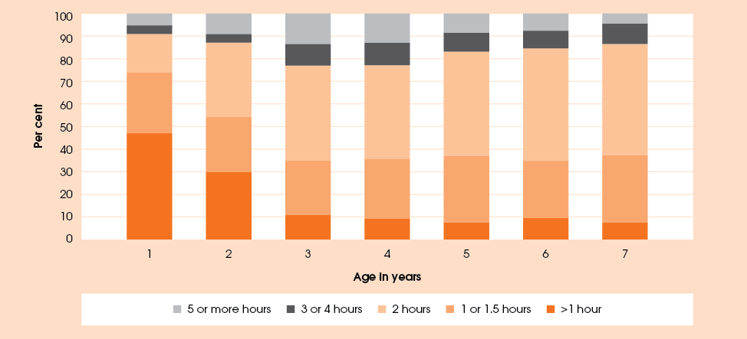

Table 50: Level of television viewing in wave 3 by sex and cohort, per cent
 | All |  |  | K cohort |  |  | B cohort
Level | Male | Female | Total | Male | Female | Total | Male | Female | Total
Low | 30.5 | 39.6 | 35.0 | 30.2 | 41.7 | 35.9 | 30.6 | 38.0 | 34.3
Moderate | 47.9 | 42.4 | 45.2 | 54.7 | 41.7 | 48.3 | 42.9 | 42.8 | 42.9
High | 21.7 | 18.1 | 19.9 | 15.1 | 16.6 | 15.8 | 26.5 | 19.2 | 22.9

The amount of time children spend watching television is different for boys and girls. Table 50 shows the percentage of children in wave 3 with low, moderate and high levels of television viewing. ‘Low’ includes those who watched less than one and a half hours of TV per day; ‘moderate’ includes those who watched two or three hours; and ‘high’ includes those who watched four or more hours. In both cohorts, girls were more likely to watch low levels of television than boys, however this was more pronounced in the older K cohort. Overall, boys were more likely to watch four or more hours a day. The higher likelihood of the girls watching high levels in the K cohort is due largely to small sample size.
The fact that boys were more likely to watch longer hours of television is possibly because they enjoy it more. In wave 3, children in the K cohort were asked whether they liked watching television. The responses showed a marked difference between boys and girls (Table 51). Of all the activities children were asked about, this was the only activity boys liked more than girls did.
Table 51: Children’s enjoyment of TV, per cent
 | Yes | No | Sometimes
Boys | 89.1 | 6.8 | 4.1
Girls | 81.5 | 10.9 | 7.6

Table 52: Level of television viewing in wave 3 by LORI, per cent
Level | None (urban) | Low | Moderate | High/ Extreme | Total
Low | 32.0 | 29.3 | 47.6 | 53.9 | 35.0
Moderate | 50.8 | 43.4 | 44.4 | 39.7 | 45.2
High | 17.2 | 27.3 | 8.0 | 6.4 | 19.9

Table 53: Activities children participated in with family in the last week, per cent
Activity | Baby cohort |  | Child cohort |  | Both cohorts
Activity | Wave 1 | Wave 3 | Wave 1 | Wave 3 | Wave 1 | Wave 3
Listened to the child read  (past month)* | N/A | 73.3 | N/A | 83.5 | N/A | 77.6
Drawing, art or craft | 61.4 | 82.9 | 82.6 | 77.7 | 70.5 | 80.7
Tell a story (not from a book) | 63.9 | 73.6 | 72.2 | 71.5 | 67.5 | 72.7
Read a book | 74.7 | 81.5 | 79.6 | 81.9 | 76.8 | 81.6
*Question not asked in wave 1.
As well as differences inherent in the children themselves, location seemed to play a part in determining the level of television viewing. Table 52 shows the percentage of children by LORI by the previously defined three levels of viewing. Children in areas of no or low isolation tended to watch more television than children in areas of high isolation. Children in areas of high or extreme isolation were the most likely to watch less than two hours and the least likely to watch four or more hours. This may be due to the limited availability of television in general or to an increased inclination to find other means of entertainment or occupation.

Non-physical activities with adult involvement
Primary carers were asked about four activities that they or other family members had done with their children in the last week. These were reading a book to their child, telling them a story (not from a book), drawing pictures or doing other art or craft with the child, and listening to the child read or pretend to read.
In wave 3, 96.5 per cent of children had participated in one or more of these activities with a family member in the week prior to interview (Table 53). Overall, the percentage of children engaging in each of these activities had increased from wave 1. The increases have largely occurred within the B cohort rather than the K cohort. Interestingly, however, although the proportion of the children in the B cohort in wave 1 participating in each of the activities was relatively low, all of them had engaged in one of the three activities. The older children, on the other hand, were less likely to have participated in these activities in wave 3 than they were in wave 1.
For each activity that the child engaged in, the primary carers were asked who joined the child in the activity—(the results are summarised in Table 54). This question is not limited to a single response as children may have undertaken the activities with different people on different occasions. Of the children who engaged in these activities, the adult most likely to join them was the mother. Fathers also took an active part in activities for their children but not to the same extent as mothers. This may be explained by the availability of time with their children as fathers are more likely to be at work during the day or not live in the same household as the child. The activity fathers were the least likely to do with children was art and craft. After the mother, a sister was the most likely to engage in this activity. On the whole, female relatives were more likely to undertake activities with children than were their male counterparts. These results may in part reflect that the majority of primary carers who provided the information were women and rely on their knowledge or recall of the child’s activities.
Storytelling provides an opportunity to pass on Indigenous language and culture. For 25.3 per cent of children who had a story told to them in the past week, the story included at least some words in an Indigenous language. For 9.6 per cent of children this meant listening to a story told to them in an Indigenous language, and for another 15.7 per cent, the story included some Indigenous words. Some of the other activities also provided a chance for exposure to an Indigenous language with 13 to 16 per cent of participating children doing the activities using at least some words in an Indigenous language. Of the four activities, grandparents were most likely to engage in storytelling, which may be the reason for the higher use of Indigenous languages in this activity.
Table 54: Family members who participated in activities with children, per cent
Family member | Read a book | Told a story | Art/Craft | Listened to SC read (past month)
Mother | 73.4 | 60.7 | 61.0 | 85.5
Father | 23.8 | 28.7 | 18.8 | 30.3
Grandmother | 12.9 | 19.0 | 9.1 | 15.6
Grandfather | 3.4 | 8.1 | 2.4 | 5.2
Auntie | 7.1 | 8.0 | 7.3 | 8.7
Uncle | 1.3 | 2.9 | 2.4 | 3.2
Sister | 16.4 | 10.9 | 25.3 | 16.6
Brother | 7.0 | 7.7 | 17.3 | 11.2
Cousin | 1.9 | 2.5 | 5.5 | 3.7
Friend | 1.1 | 0.7 | 3.3 | 1.7
Other | 0.4 | 0.4 | 1.4 | 0.5
Note: Restricted to primary carers who indicated that the child engaged in the selected activity in the last
week (month).

With the exception of storytelling, children were more likely to undertake these activities in areas of lower levels of isolation (Figure 27). Children in areas of higher isolation were 13.6 percentage points more likely to have had a story told to them than those in areas of no or low isolation. Children whose primary carer had a higher level of education (a university qualification or Year 12 certificate) were as likely to have had a story told to them in the previous week regardless of the level of isolation. However, the children of parents with lower levels of education were more likely to have a story told to them if they lived in areas of moderate to extreme isolation. Interestingly, the number of children’s books in the household (reported in wave 2) did not make a significant difference to the likelihood of children having a story told to them. However, it did make a difference in the uptake of the other three activities. Children who did not participate in the other activities were more likely to have on average fewer books in the house than those children who did participate.
A comparison of the likelihood of engaging in these activities with the number of hours of television watching shows that there is no significant impact. Children who engaged in one or more of these activities tended to watch similar levels of television as shown in the previous section. Furthermore, children who did not engage in any of these activities were also found to watch television in the same proportions across low, moderate and high levels of viewing as those who did undertake the activities.
In a separate set of questions, children in the K cohort were asked directly whether they liked various activities. Table 55 shows that girls were much more likely than boys to enjoy reading books and drawing but both boys and girls enjoyed making things.
Figure 27: Percentage of children doing activities by LORI, per cent
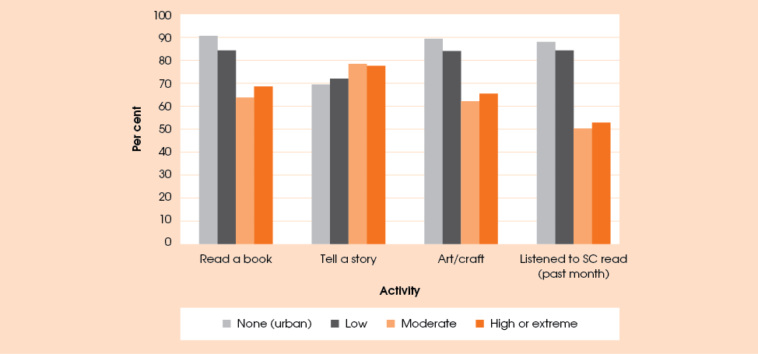

Table 55: Study children’s enjoyment of non-physical activities, per cent
 | Yes |  | Sometimes |  | No
Activity | Boys | Girls | Boys | Girls | Boys | Girls
Making things | 90.2 | 91.7 | 4.6 | 4.9 | 5.3 | 3.4
Drawing pictures | 85.7 | 93.2 | 7.2 | 5.3 | 7.2 | 1.5
Reading books | 74.8 | 87.6 | 9.0 | 5.6 | 16.2 | 6.8

Physical activities with adult involvement
There is only one question in Footprints in Time about organised physical activities: ‘In the past month has the study child done any organised sport or dancing?’ This was asked for the first time in wave 3.
Overall, 24.1 per cent of children had participated in an organised physical activity. However, only 10.3 per cent of the B cohort had undertaken these activities while 43.1 per cent of the K cohort had participated. There was a big jump in participation from 13.2 per cent of 4 year olds to 34.8 per cent of 5 year olds. While this may be related to age, it is more likely to be related to school attendance. When primary carers were asked to specify the activity their child participated in, many of them referred to school sporting activities. Of the children in the B cohort who participated in organised physical activities, 24.1 per cent went swimming and 33.7 per cent were learning dance. About one-third of the primary carers who responded that their child was learning dance specified that they were learning traditional Indigenous dancing. For the children in K cohort, 11.5 per cent had participated in a swimming activity and 21.7 per cent had been dancing, with about one-fifth learning traditional Indigenous dancing. Dancing was not restricted to the girls; one-third of children who had been dancing were boys. Other popular activities in which the children were involved included athletics, gymnastics, martial arts and team sports such as soccer, cricket and basketball.
Different patterns emerge for the two cohorts for levels of relative isolation. For the B cohort, children in areas of no isolation were the most likely to be involved in organised sporting activities (16.1 per cent), followed by children in areas of high or extreme isolation (12.5 per cent). For the K cohort, this pattern is reversed with children in this cohort having the highest involvement rate (60.9 per cent) in areas of high isolation, followed by children in areas of no isolation (49.7 per cent). The involvement rates were lowest in areas of moderate isolation.

Physical activity without adult involvement
When asked whether their child liked participating in physical activity or exercise, 91.3 per cent of primary carers indicated that their child ‘liked it a lot’. A further 7.4 per cent indicated that they ‘liked it a bit’ as opposed to neither liking it nor disliking it’, and ‘disliking it a lot’. For the K cohort, this question was also asked in wave 1; the primary carers of children in the B cohort were asked this question for the first time in wave 3. There is little difference between the cohorts or between the waves for the K cohort. Different levels of isolation also make little difference to the response rates of whether children enjoy physical exercise.
This enjoyment of physical activity is confirmed by the fact that, in wave 3, 57.0 per cent of primary carers also responded that given the choice, children would choose to do something physical in their free time. This has decreased since wave 1 when 63.7 per cent of primary carers indicated that their child would choose to do something physical. However, in wave 3 a further 29.6 per cent indicated that their child would be just as likely to choose a physical activity as a quiet activity, an increase from 21.5 per cent in wave 1. When divided between the cohorts, children in the K cohort were 4.2 percentage points more likely to choose a quiet activity than the B cohort. Table 56 shows the changes in the choices K cohort children usually made regarding their activity type in wave 1 and wave 3. It shows that 37.2 per cent of children for whom there are responses in both waves usually chose to do something active and 10.6 per cent chose something either quiet or active in wave 1 but chose to do something active in wave 3.

Table 56: Types of activities chosen by children, wave 1 and wave 3
 | Wave 3
Wave 1 | Active | Quiet | Either | Total
Active | 37.2 | 7.5 | 17.4 | 62.1
Quiet | 6.2 | 4.8 | 4.4 | 15.4
Either | 10.6 | 5.1 | 6.8 | 22.5
Total | 54.0 | 17.4 | 28.6 | 100.0
Note: Only includes children for whom there was a response in both wave 1 and wave 3.

Children in areas of high or extreme isolation were the most likely to choose a physical activity (68.3 per cent, compared to 50.5 per cent in areas of no isolation). Children in areas of no isolation were the most likely to choose a quiet activity (16.2 per cent compared to 9.1 per cent in areas of moderate isolation) or to be just as likely to choose a quiet activity as a physical one (33.2 per cent, compared to 19.0 per cent for children in areas of high or extreme isolation). Boys were slightly more likely to prefer to do something physical and girls were more likely to choose something quiet or either but the difference was not statistically significant
(Table 57).
Table 57: Type of activities by gender, per cent

Activity type | Male | Female | Total
Active | 58.9 | 55.0 | 57.0
Quiet | 12.7 | 14.1 | 13.4
Either | 28.4 | 30.9 | 29.6

Table 58 shows the levels of television viewing by the preferred type of activity. It is not surprising that
children who would usually choose a quiet activity were more likely to watch a higher number of hours of television. However, it is not possible to say whether children tended to choose quiet activities because they liked watching television or whether they were more likely to watch television because they preferred
quiet activities.

Table 58: Type of activities by level of TV watching, per cent
Activity type | Low | Medium | High | Total
Active | 38.4 | 43.8 | 17.9 | 57.1
Quiet | 24.9 | 47.6 | 27.6 | 13.3
Either | 32.9 | 46.7 | 20.3 | 29.6

Conclusion
The Footprints in Time children had a high level of participation in a wide range of activities, both physical and non-physical and both guided and self-organised.
Nearly all children enjoyed physical activity and the majority chose a physical activity over a quiet activity but they tended to become more likely to engage in organised physical activities once they commenced school.
On the whole, children tended to watch less TV and were more likely to engage in physical activity if they lived in areas of relatively high isolation. Younger children watched fewer hours of TV up to the age of about 3.
Most children had the opportunity to interact with a family member or friend through a quiet activity such as reading, drawing or storytelling and were willing participants in such activities.

Social and problem gambling: preferences
and participation
Gambling is an issue at the forefront of the Australian social policy agenda. While most people can enjoy some level of gambling as a pleasant and socially acceptable activity, for some, gambling can develop into a serious problem, with a significant detrimental effect on financial situation, health, and family life. According to Breen et al (2010) little is known about Indigenous Australian gambling despite the introduction of card games by Macassan traders over 300 years ago and the fact that card rings are still a widespread acceptable form of social recreation in many Indigenous communities (McMillen and Donnelly 2008, in Breen et al 2010).
More generally, the 2010 Productivity Commission’s report on gambling classified 115,000 Australians as problem gamblers and a further 280,000 as moderate-risk gamblers. It is estimated that, for each problem gambler, at least five other people are affected by their addiction (Productivity Commission 1999): family members suffer from increased levels of stress, depression and anxiety, financial hardship, social isolation, relationship breakdown, and poor work or study performance. The children of problem gamblers can also be affected by their parents’ problems, feeling angry, anxious or depressed, having poorer attendance or performance at school, developing behaviour problems, experiencing social withdrawal and isolation, and having poorer emotional, mental and physical health (SA Department for Families and Communities 2008). Moreover, the propensity to gamble, like other behaviours and attitudes, may be passed from one generation to the next: research shows that children with parents who are problem gamblers are up to 10 times more likely to become problem gamblers themselves than their peers (Problem Gambling Treatment and Research Centre 2010).
For the first time in wave 3, primary carer respondents were asked a series of questions about gambling, including card games and lotteries. Of the respondents who answered these questions, 46.4 per cent indicated that they did not gamble at all.
Card games were particularly popular. About one-fifth of all respondents reported playing card games (Table 59). This pastime was more prevalent in areas that were relatively more isolated; 28.3 to 32.4 per cent of primary carers in regions with moderate to extreme isolation reported playing cards at least once a year, compared with 20.8 per cent in areas with low isolation, and only 10.9 per cent in non-isolated areas.
It is worth noting that playing cards is not necessarily a form of gambling. Even when it does involve betting, it may be for very low or nominal amounts of money or for some kind of token with no monetary value. Playing cards may represent an opportunity for entertainment and social interaction rather than gambling, especially in isolated areas where other forms of entertainment may not be readily available. Table 60 provides some evidence to support this theory. The proportion of respondents who did not spend any money on gambling activities was higher in the moderately to extremely isolated areas than in the areas with no or low isolation.

Table 59: How often primary carer plays card games, by LORI, per cent
Frequency | LORI |  |  |  | All areas
Frequency | None (urban) | Low | Moderate | High or extreme | All areas
Every day | 0.0 | 0.4 | 2.1 | 0.7 | 0.6
A few times a week | 0.3 | 0.7 | 2.1 | 5.8 | 1.3
About once a week or on the weekend | 1.3 | 3.6 | 10.1 | 9.4 | 4.4
About once a fortnight | 1.9 | 3.6 | 4.3 | 2.9 | 3.1
About once a month | 1.6 | 4.2 | 3.7 | 6.5 | 3.6
A few times a year | 5.9 | 8.3 | 10.1 | 2.9 | 7.4
Not at all | 89.1 | 79.2 | 67.6 | 71.7 | 79.6
Number of respondents | 376 | 697 | 188 | 138 | 1,399

Nevertheless, cards was the form of gambling on which the most money was spent in highly or extremely isolated areas (as selected by 88.4 per cent of respondents who gambled last month), as well as in moderately isolated areas, as selected by 64.2 per cent of those who gambled last month. The activity on which respondents in areas with no or low isolation tended to spend the most money was poker machines (41.4 to 44.3 per cent of those who gambled last month), followed by Lotto and Scratchies. These two categories combined represented the most money spent for 39.4 per cent of recent gamblers in the non-isolated areas.
Most respondents who engaged in gambling activities in the month before the interview did this occasionally: about 76 per cent of recent gamblers engaged in the activity that cost them the most money from once a year to once a fortnight. These activities were also generally considered recreational or social by respondents (Table 61): about 57.6 per cent of all those who gambled in the last month did so mainly to have fun or spend time with family and friends. Another common reason was ‘winning money for extras’ (17.2 per cent), followed by ‘going out to a safe, relaxing place’ (8.7 per cent).
The reasons the respondents engaged in gambling and related activities varied depending on the type of activity. As shown in Table 61, common reasons to play cards were ‘spending time with family and friends’ (48.1 per cent of respondents who, out of all gambling activities, spent the most money on cards) and ‘having fun’ (19.3 per cent), although ‘winning money for extras’ (21.5 per cent) and ‘winning money to live on’ (9.6 per cent) were also important reasons. ‘Going out to a safe, relaxing place’ and ‘escaping problems and stresses’ were more prevalent reasons among respondents whose major gambling activity was playing poker machines.
About one-quarter of primary carer respondents (26.2 per cent) reported that either they or a close family member had a gambling problem. This number was slightly higher in the areas with no to moderate level of isolation (26.3 to 27.9 per cent) compared to highly or extremely isolated areas (21.9 per cent), but the difference was not statistically significant.
Table 60: Gambling activity primary carer respondents spent the most money on last month, per cent
 | LORI |  |  |  | All areas
 | None (urban) | Low | Moderate | High or extreme | All areas
Per cent who don’t gamble at all | 46.4 | 40.6 | 55.6 | 63.3 | 46.4
Per cent who didn’t gamble last month | 14.9 | 12.3 | 8.6 | 5.8 | 11.9
Of those who gambled last month gambling activity most money spent on, per cent: | n=145 | n=325 | n=67 | n=43 | n=580
Cards | 3.4 | 15.4 | 64.2 | 88.4 | 23.4
Pokies (poker or gaming machines) | 41.4 | 44.3 | 16.4 | 4.7 | 37.4
Bingo | 8.3 | 12.0 | 1.5 | 0.0 | 9.0
Keno | 2.8 | 5.5 | 0.0 | 0.0 | 3.8
Lotto | 22.8 | 12.3 | 13.4 | 0.0 | 14.1
Scratchies | 16.6 | 5.8 | 3.0 | 2.3 | 7.9
Bets on horses or dogs | 4.1 | 3.4 | 1.5 | 4.7 | 3.4
Bets on sports (other than horses or dogs) | 0.7 | 0.6 | 0.0 | 0.0 | 0.5
Other types of gambling | 0.0 | 0.6 | 0.0 | 0.0 | 0.3

Table 61: Main reason to play cards or gamble, by selected gambling activity, per cent
 | Cards | Pokies | Lotto | All activities
Having fun | 19.3 | 39.5 | 29.3 | 36.0
Spending time with family or friends | 48.1 | 17.7 | 3.7 | 21.6
Escaping problems and stresses | 0.0 | 8.8 | 0.0 | 3.7
Going out to a safe, relaxing place | 0.7 | 16.3 | 1.2 | 8.7
Winning money for extras | 21.5 | 7.4 | 40.2 | 17.2
Wining money to live on | 9.6 | 0.9 | 14.6 | 4.9
Other | 0.7 | 9.3 | 11.0 | 8.0
Number of respondents | 135 | 215 | 82 | 575
Note: The gambling activity refers to the one the respondent spent most of their money on during the month before the interview.

Of the people with a gambling problem, less than one-fifth (18.8 per cent) lived in the same household as the child. Of 322 respondents who experienced a gambling problem or had a close family member affected by it, 9.3 per cent reported that the affected person had received some help with the problem; a further 53.4 per cent reported that the affected person knew where to get help but would not get it. The remainder responded that the person with the gambling problem would not want help (25.5 per cent), wanted help but did not know where to get it (5.3 per cent) or knew where to get help but no services were available in their area (3.1 per cent). Figure 28 shows that, for people in the areas with low or no isolation, the majority of problem gamblers knew where to get help but did not want it while, in the moderately to extremely isolated areas people were more likely to not know where to get help, or not to have services available in their area.

Figure 28: ‘Does the person with a gambling problem know where to get help?’ by LORI, per cent
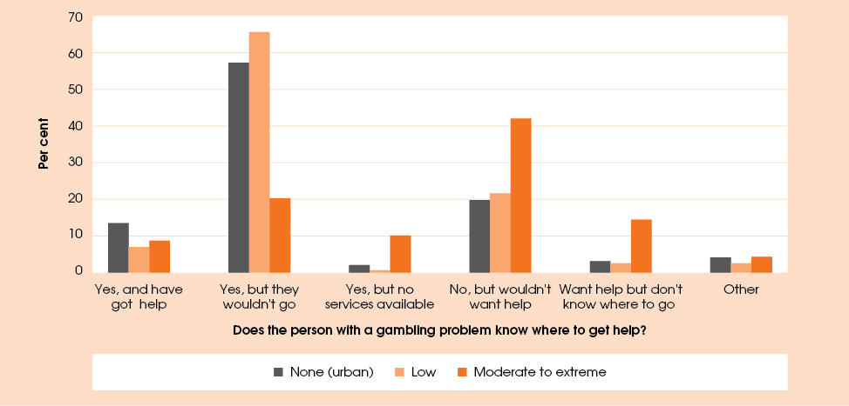
Note: The percentages refer to 322 primary carers who said that they or someone close to them had a gambling problem and who did not respond ’don’t know’ to the question whether the person affected knew where to get help.

Social and emotional development:
Indigenous children’s strengths and difficulties
In wave 3, primary carers were asked a set of 25 questions about children’s social and emotional behaviour. This set of questions, referred to as the Strengths and Difficulties Questionnaire (SDQ), was developed by Robert Goodman for the behavioural screening of 3 to 16 year-olds (Goodman 1997). The SDQ is used in social research, clinical assessments, epidemiology, evaluations of outcomes of everyday practice, and specific interventions in child and adolescent mental health services. The SDQ is widely used in Europe, Asia and the United States, and has been used in other surveys in Australia, most notably in the Longitudinal Study of Australian Children (LSAC) and the Western Australian Aboriginal Child Health Survey (WAACHS)
The SDQ provides valuable information about children’s behaviour, and can be used as a major outcome measure of children’s emotional development. While this report presents only a brief analysis of this measure, further research would be beneficial to shed more light on how this behavioural measure is related to children’s social functioning and academic performance, and broader factors such as family characteristics, life events and parental background and attitudes. Future waves of data collection may also provide more information about how the children are progressing, what factors affect their emotional development and how the measure impacts on other aspects of their lives.
The SDQ allows attribution of a score for the child’s social and emotional behaviour across five domains, or scales: emotional symptoms, conduct problems, hyperactivity, peer problems, and prosocial behaviour. The first four scales measure various aspects of behavioural difficulties, while the prosocial scale measures strengths. An explanation of the aspects of behaviour measured by each scale is presented below:
- Emotional symptoms scale measures the general level of confidence, and is based on such indicators as the child having many worries or fears, often being unhappy, downhearted or tearful, being nervous or clingy in new situations and easily losing confidence.
- Conduct problems scale consists of items related to conduct and compliance, such as whether the child often loses their temper; whether he/she is generally well behaved and usually does what adults request; or whether the child often fights with other children or bullies them.
- Hyperactivity scale measures perseverance and attention span, and includes questions on whether the child is restless, overactive and can be easily distracted; or whether he/she can stop and think things out before acting, and can see tasks through to the end.
- Peer problems scale measures ability to develop and maintain relationships with peers, and includes questions that ask respondents to identify whether the child tends to be solitary or whether he/she has at least one good friend; whether the child is generally liked by other children or is picked on and bullied by them.
- Prosocial behaviour scale summarises the child’s propensity to engage in actions that benefit others, such as helping, donating and volunteering. This scale reflects whether the child is considerate of other people’s feelings, helpful if someone is hurt or upset, and kind to younger children, and whether the child shares readily with other children or often volunteers to help.
The score for each scale is based on five questions. For each question, the primary carers rated the behaviour of children on a three-point scale (coded 0 for ‘Not true’, 1 for ‘Somewhat true’ and 2 for ‘Certainly true’). The scores for individual questions were added to create the five subscale scores. For the first four subscales, higher scores indicate a greater risk of problems in each area. The prosocial scale provides a score for strengths, so higher scores indicate less risk.
The scores for emotional symptoms, conduct problems, hyperactivity and peer problems scales were added together to provide an overall difficulties score. The prosocial scale is analysed separately.
As this set of questions is designed for children aged 3 years or older, all children under 3 were excluded from the analysis. It is worth noting that, while the SDQ is usually self-administered (that is, parents mark their answers on a sheet of paper), in Footprints in Time the questions were posed orally to primary carers in a face-to-face interview. Due to the potentially sensitive nature of the questions, some primary carers might have been reluctant to provide responses to the SDQ. However, of the 1,108 Footprints in Time children aged 3 years or older at the time of the wave 3 interview, the data necessary to create a total SDQ score were missing for only five, and the prosocial score was missing for two. Some questions appeared relatively more difficult for primary carers to respond to: in particular, the question about whether the child could stop and think things out before acting was not completed by 43 primary carers (3.9 per cent) who indicated that they did not know. Other questions had lower rates of non-response (less than 1 per cent for 21 out of 25 questions).
The average scores are summarised below by cohort and sex of the child. Table 62 shows the average scores in the four difficulties subscales by cohort. Emotional symptoms and peer problems were relatively rare – the average scores of around 2 indicate that primary carers on average responded ‘Somewhat true’ to two out of five questions for each of these scales, or ‘Certainly true’ to one question. Conduct problems and especially hyperactivity were more prevalent in the sample as a whole, with an average score for hyperactivity of 4.6 (meaning that primary carers on average responded ‘Somewhat true’ to at least four out of five questions in this scale, or ‘Certainly true’ to two or three out of five questions).

Table 62: Average scores for difficulties subscales, by cohort
Difficulties subscale | B cohort (n=514) | K cohort  (n=589)
Emotional symptoms | 2.25 | 2.42
Conduct problems | 3.82 | 2.41
Hyperactivity | 4.66 | 4.60
Peer problems | 2.17 | 2.06

There were no significant differences in emotional symptoms, hyperactivity or peer problems between cohorts. In contrast, the average conduct problems score for the younger (B) cohort was much higher than for the older (K) cohort. However, two of the items included in conduct problems scale were different for the two cohorts. The difference for these two items was quite significant, and the examination of raw responses indicates that these items contributed the most to cohort differences.
Because of the significant difference in the conduct problems scores, the overall difficulties score was also significantly lower for the K cohort (Figure 29). This could potentially indicate a lower risk of problem behaviours among the older children but was still driven by the different questions in the conduct problems subscale.
Figure 29: Strengths and Difficulties Questionnaire scores, by cohort
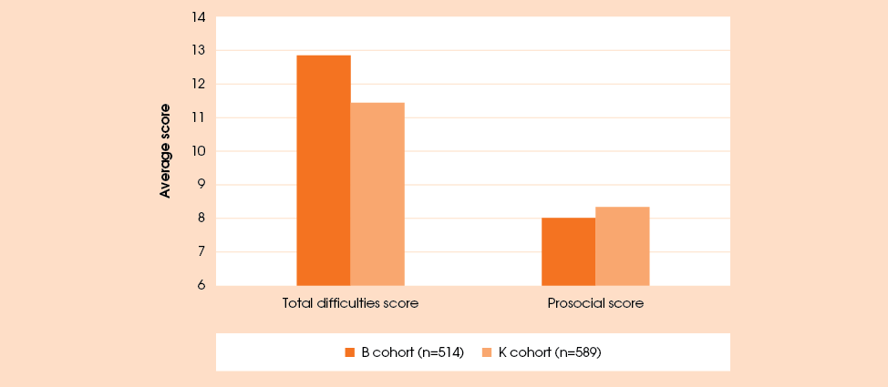
The prosocial scores were significantly higher for the older cohort, indicating a lower risk of behavioural problems (Figure 29). This could suggest that children develop this type of behaviour as they grow up. As further waves of data become available, it will be interesting to see whether the scores of children in the B cohort ’catch up’ by the time these children reach the current age of the K cohort (4½ to 7 years).
Table 63 and Figure 30 summarise average SDQ scores for boys and girls. Consistent with the findings of other Australian studies, girls in the Footprints in Time study had significantly lower hyperactivity and peer problem scores than boys, indicating a potentially lower risk of development of problems in those areas, and had significantly higher prosocial scores than boys, indicating a greater strength in that domain. Similar gender differences were found in the analysis of LSAC data (AIFS 2011) for 4 to 5 year-olds across Australia, and by Hawes and Dadds (2004) for 4 to 6 year olds in a Brisbane-based study.
The total difficulties scores of 12.7 for boys and 11.6 for girls were higher than those obtained in some other Australian studies. For example, Hawes and Dadds (2004) found that in a sample of 4 to 6 year-old children living in Brisbane, the average total difficulties score was 9.0 for boys and 7.5 for girls. Mellor (2005), for a sample of 7 to 10 year-old children in Victoria, obtained similar scores of 9.9 for boys and 7.7 for girls. While these studies may not be directly comparable to Footprints in Time, as they focused on children from one city or state only and on different age groups (the Footprints in Time SDQ analysis included children aged 3 to 7 years), the higher apparent risk of emotional and behavioural difficulties in an Indigenous sample compared to a non-Indigenous sample was also found in WAACHS (De Maio et al. 2005). However, psychological studies show that the response styles of individuals may be affected by cultural differences, and that people from some countries and cultural backgrounds may be more inclined to pick extreme response categories over the middle ones. Further research is needed on whether cultural differences contributed to the observed disparity in the SDQ scores.
Table 63: Average scores for difficulties subscales, by child’s sex
Variable | Boys (n=550) | Girls (n=553)
Emotional symptoms | 2.37 | 2.31
Conduct problems | 3.13 | 3.00
Hyperactivity | 5.00 | 4.25
Peer problems | 2.24 | 1.98

Figure 30: Strengths and Difficulties Questionnaires scores, by child’s sex
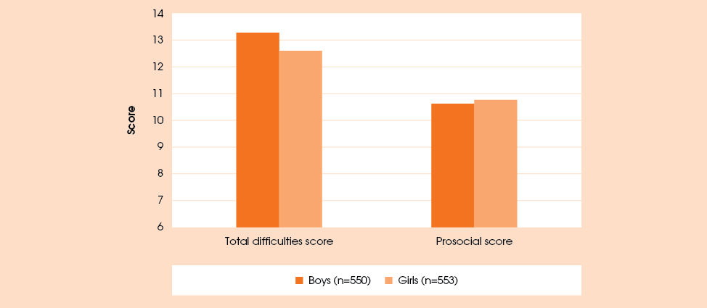
The total difficulties scores may also be analysed by grouping them into three categories or ranges—normal (0 to 13), borderline (14 to 16) and abnormal (17 to 40) (Goodman 2012). These groups correspond to low, raised and high risk of developing clinically significant problems in social and emotional behaviour. While the average total difficulties score for the Footprints in Time sample falls within the ‘normal’ category, 15.9 per cent of children have scores falling within the ‘borderline’ range and a further 22.5 per cent have scores putting them in the high-risk category. In comparison, WAACHS found that in their (somewhat older) sample of Aboriginal children aged 4 to 11 years, 26.3 per cent were at high risk of clinically significant behaviour problems, compared to 16.9 per cent of Western Australian non-Aboriginal children of that age (De Maio et al. 2005). At the same time, data collected by the New South Wales Department of Health (2005) showed that 22.9 per cent of New South Wales Aboriginal children aged 5 to 15 years were at a high risk of emotional or behavioural difficulties. The Footprints in Time results are thus not very different from results obtained in other Indigenous samples.
On the prosocial scale, the average scores of 8.1 for boys and 8.3 for girls (out of a possible 10) were quite high, suggesting that the children on average were willing to act in ways to benefit other people. These scores were somewhat higher than those found in the LSAC study (AIFS 2011) and by Hawes and Dadds (2004), possibly indicating greater strength in this area but probably also affected by cross-cultural differences in response style.
The difficulties and prosocial scores of the Footprints in Time children did not differ significantly by the primary carer’s partnership status, primary carer type, or presence of other adults in the household (Table 64). One of the few significant differences in the scores across different family types was the higher emotional symptoms score for children living in lone parent families with other adults in the household and higher hyperactivity score for children living with non-parent primary carers. Children living in couple families with no other adults present had significantly lower conduct problem scores. Children in the lone-parent family types, whether with or without other adults present in the household, appeared to have higher prosocial scores than children in couple families or living with a non-parent primary carer. However, these differences were not statistically significant.
The analysis also revealed that only children tended to be more hyperactive; the average hyperactivity score for an only child was 5.1 while the scores for youngest, middle and eldest children were within the 4.5 to 4.7 range. There were no significant differences based on the child’s birth order for any of the other scales.
The results presented in this section are fairly consistent with expectations and findings in the literature.
Of some concern is the fact that the difficulties scores were found to be higher in the Footprints in Time
sample compared to other Australian samples. More research is needed to investigate possible reasons for
this disparity.

Teacher—primary carer comparison
In addition to primary carer responses, the SDQ was completed for some of the children by a teacher or centre-based carer, depending on where the child spent most of their day. Throughout this subsection, teachers and centre-based carers are referred to as teachers for the purposes of brevity.
In wave 3, teacher-based SDQ scores were available for 267 out of 1,108 children over the age of 3. The reasons for this relatively low response rate and the extent to which they contributed to the contraction of the study sample are summarised in Figure 31. The most important reason was the low rate of questionnaire completion by the teachers. While just over 40 per cent (218 out of 535) of children in the K cohort had a teacher return the completed questionnaires, the corresponding figure in the B cohort was lower, at 29.0 per cent. Another reason, especially important for the B cohort, was that less than half of the children (351 out of 813, or 43.2 per cent) were attending school, preschool or child care at the time of the wave 3 interview. The probability of a child attending school or child care did not vary significantly with the primary carer’s marital status or the number of adult members of the household (who could alleviate the need for child care by providing informal child care services). However children were less likely to attend if they were younger, living in areas of greater relative isolation, or in families with many children.
Figure 32 provides average scores across the four difficulties scales (emotional symptoms, conduct problems, hyperactivity and peer problems), the total difficulties score, and the prosocial behaviour score, as provided by both primary carers and teachers. All average scores (with the exception of the primary carer reported conduct problems score) were within the ‘normal’ range’.
Figure 31: Teacher-based SDQ sample
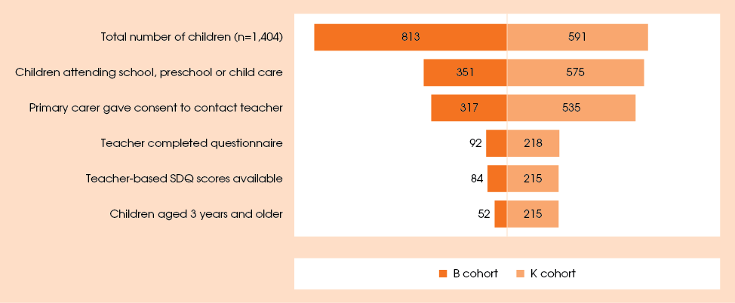

Figure 32: Comparison of teacher-—and primary carer-based Strengths and Difficulties Mean Scores
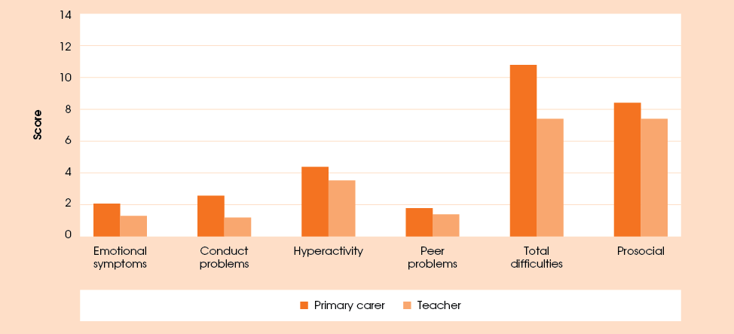
Note: The comparison scores are given for 266 children who had both the primary carer and the teacher provide responses to the SDQ.

Consistent with other studies, teacher scores were lower than primary carer scores. As reported earlier in this section, 22.5 per cent of all children over the age of 3 were at high risk of developing behavioural or emotional problems according to their primary carers. Among 266 children who had both teacher-based and primary carer-based SDQ scores, 13.5 per cent of children were in the high-risk category according to their primary carers and 11.7 per cent were in this category according to their teachers. The reduction in the primary carer-based scores may in part be explained by the fact that most children for whom both scores were available were in the K cohort, who were shown earlier to have lower difficulties scores.
The disparities between teacher and primary carer-based scores highlight the differences in perceptions, experiences and expectations. Children may behave differently at home and school. Teachers may have different expectations of the children’s behaviour or may have learnt how to limit the exhibition of some behaviours. Regardless, these results demonstrate that this series of questions relies on the opinions of one or two people.
How close were teachers’ and primary carers’ assessments? That is, did teachers and primary carers rate the same children as low-or high-risk on various behavioural scales, or did teachers see problem behaviours in some groups of children and primary carers in others? More than half of the children (56.2 per cent) had scores within the ‘normal’ range from both primary carer and teacher on the total difficulties scale, and most children (78.1 per cent) were rated by both groups of respondents as not being in a high-risk category (that is, within ‘normal’ or ‘borderline’ range). A further 10.2 per cent were rated as high risk by primary carers but not teachers, 8.3 per cent were rated as high risk by teachers but not primary carers, and only 3.4 per cent were rated as high risk by both teacher and primary carer. This discrepancy between teacher and primary carer-based scores could be due to different expectations and perceptions of teachers and primary carers but could also stem from a range of other factors that would need to be investigated separately.

Conclusion
The overall findings on the social and emotional behaviour of children in Footprints in Time were consistent with existing studies about both Indigenous and non-Indigenous children. Girls were found to have lower hyperactivity and peer problems scores, indicating a lower risk of developing problems in these areas, and to be on average more prosocial than boys. Age was also found to be a factor in the prosocial domain, with older children less likely to have problems. While the younger cohort appeared to have significantly higher scores in the conduct problems domain, differences in question wording may have contributed to this disparity.
Of some concern is the finding that Aboriginal and Torres Strait Islander children in the study had higher difficulties scores than those obtained in studies not specifically focusing on Indigenous children. However, the proportion of the Footprints in Time children whose scores put them into a high-risk category for developing clinically significant behavioural problems (22.5 per cent) was similar to numbers obtained in other Australian studies which analysed Indigenous children separately. Further research could contribute to our understanding of whether cultural response preferences and other factors have played a role.
The strengths and difficulties scores collected from primary carers were also compared to those provided by the children’s teachers or centre-based carers. Overall, the teacher-based scores were found to be lower than those based on primary carers’ responses. The teachers and primary carers of more than 78 per cent of children gave them scores below the high-risk range, and only 3.4 per cent of children were rated by both their primary carers and teachers as having a high risk of significant behavioural problems.
The analysis presented above has only briefly summarised the emotional and behavioural development of children, and has not touched on many other factors that could influence it. It is hoped that the richness of the data will allow for much more detailed research in the future.

English language acquisition: relationship of language outcomes to language environment
Children do not need to be explicitly taught to speak their language. Cross-cultural studies show examples of cultures where primary carers make no attempts to correct their children’s grammar and pronunciation, or to use baby talk to assist the children, and yet their children acquire the language just as easily as those whose primary carers continually correct them (Bavin 1995).
What children do need is a language rich environment so they can hear a wide range of language pronounced by a variety of speakers. Exposure to new and complex words and concepts in one or more languages is generally all that is needed for children to learn to speak.
But what does the language environment of an Indigenous child actually look like? This article looks at the impact of primary carer education on language acquisition, the type of English spoken in the home, whether the child is being read to, health conditions and emotional development.
Small children learn to speak from their families first, so a range of family characteristics have the potential to influence children’s language acquisition. Primary carers in Footprints in Time for the most part had a Year 10 to 12 high school qualification (around 60 per cent). Sixteen per cent had not progressed as far as that in school. Fifteen per cent had a TAFE certificate or similar and 9 per cent had a diploma, degree or postgraduate degree. Primary carers in areas of no isolation (that is, in urban areas) were more likely to have achieved a post-school qualification than those elsewhere, but a consistently similar proportion had a Year 9 or lower level of education compared to primary carers in more rural and remote areas.
Sometimes the kind of English spoken at home is different from what children are taught at school. Aboriginal English is a recognised dialect of English, just as Australian English and American English are. There is a small amount of variation within Aboriginal English, and it is sometimes classified as heavy or light, depending on the prevalence of distinctive features in accent, grammar, words and meanings. The difficulty in identifying a home dialect in a survey situation is that recognition of Aboriginal English is generally low and it is often dismissed as ’bad English’ (Eades 2012).
To overcome this difficulty, the Footprints in Time study included a question focusing on whether the English spoken in the home was mixed with lots of Aboriginal or Torres Strait Islander words, sometimes mixed with a few words or only used English words. Mixing Indigenous words into an English sentence is one of the most obvious aspects of Aboriginal English for speakers and is often used as an expression of identity. Eighteen per cent of respondents identified as speaking “heavy” Aboriginal English in the home, 30 per cent as speaking ‘light’ Aboriginal English and 52 per cent as speaking Standard Australian English (SAE). As expected, the proportions speaking SAE and ‘heavy’ Aboriginal English were essentially reversed in areas of no isolation and high isolation, with the proportion speaking ‘light’ Aboriginal English held fairly consistent at 30 per cent across Australia (see Figure 33).

Figure 33: Type of Aboriginal English spoken by primary carers, by LORI, per cent
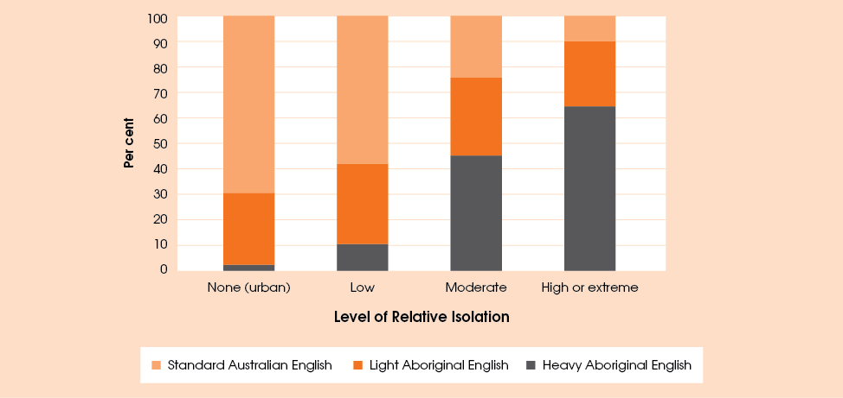
Table 65: Change in MacArthur Bates vocabulary scores, wave 1 to wave 3, B cohort, per cent
 | Wave 1 score quartiles
 | Q1 | Q2 | Q3 | Q4
Wave 3 score quartiles:
Q1 | 41.0 | 23.8 | 13.2 | 10.3
Q2 | 28.6 | 32.6 | 27.6 | 15.4
Q3 | 18.0 | 25.6 | 38.2 | 34.6
Q4 | 12.4 | 18.0 | 21.1 | 39.7
Total | 100 | 100 | 100 | 100

Families speaking more than one language in the household were asked how often they spoke each language, rated from ‘lots’ to ‘never’. (Families speaking only English were coded as speaking it ‘lots’.) Eighty-five per cent of families reported speaking English ‘lots’ in the household, but again, this varied by LORI. In areas of no or low isolation, English was almost entirely spoken ‘lots’ in the household, but in areas of moderate isolation it was spoken ‘lots’ in 62 per cent of households and this figure fell to 35 per cent in areas of
high isolation.
Book reading is often linked to language development. Primary carers were asked whether someone in the household had read a book to the study child in the previous week. Overall, 82 per cent of families reported reading to the child and this also varied by LORI; book reading was more common in urban areas than remote areas, although book-reading families were in the majority across all categories.
Every year children’s English language development is assessed in Footprints in Time. Different assessments are conducted depending on the age of the child and these give the child a vocabulary score. The MacArthur Bates Communicative Development Inventory is a vocabulary measure for babies, in which primary carers view a word list and report whether their child says each word.
Before looking at the relationship between language development and language environment, it was important to see how consistent (or persistent) these results were over time. For most children, the language environment will not change dramatically in their early years, but children do progress at different paces, so before drawing too many conclusions, it was necessary to know whether many children who got a low score in one year were likely to get a much higher score the following year or vice versa. This table compares wave 1 B cohort MacArthur Bates vocabulary scores with their wave 3 scores (two years later), based on where the scores fell in comparison to the other children in the sample, by quartile (Table 65). Close to 40 per cent of children were in the same quartile in both waves. Moreover, if they did go up or down, their scores were more likely to go up or down by one quartile than by two or three (Table 65 and Table 66). This shows quite strong consistency in scores over time.
Table 66: Proportions of children showing an improvement or a decline in their vocabulary score quartiles from wave 1 to wave 3
Quartile change | Per cent
-3 | 3.1
-2 | 9.4
-1 | 19.0
No change | 37.8
1 | 21.4
2 | 6.9
3 | 2.5
Total | 100

Using the MacArthur Bates vocabulary test scores in wave 3, it was possible to look at the relationship between this outcome and possible predictors or influencing factors in the child’s language environment (Table 67). Given that the children were mostly aged 2 or 3 years in wave 3 (an actual range of 27 to 47 months was used for this analysis) it is necessary to control for age when comparing the relationship between vocabulary scores and other variables. As expected, vocabulary scores (out of 100) improved by around 1.5 points for each month the child aged.
Primary carers’ having a level of education of Year 10 and above was significantly associated with an improved vocabulary score of between 8 and 10 points.
The type of English to which a child is exposed in the home might be expected to have an impact on the type of vocabulary acquired, and we see this here. Children in homes where families spoke Aboriginal English scored nearly six points lower. This might indicate a cultural bias in the test, suggesting that children learning other dialects of English might not perform as well in this type of assessment. Another possibility is that some children are learning Aboriginal English as a second language.
While Standard Australian English speaking homes always used a lot of English in the household, the reverse was not necessarily true. Around half the homes where Aboriginal English was spoken also used lots of English in the household, and half did not, so this has been controlled for separately. If a child is not hearing English in the home all the time, we would definitely expect to see an impact on English vocabulary acquisition as children who are acquiring another language at the same time cannot learn twice as many words as other children in the same time frame and often need a little longer to catch up (Pearson 2009). This is what we see here. If the family indicated that they used English less than ’a lot’, children scored around 23 points lower.
Primary carers were asked whether someone in the family had read a book to the study child in the last week. Books are an excellent way for children to expand and diversify their vocabularies and this is evident in this analysis. Children who had been read to were likely to score over 11 points higher.
There was also a link with the “difficulties” score based on the SDQ. Children with some types of difficulties can sometimes also exhibit language delays. For each point increase in the difficulties score, children’s vocabulary scores were likely to decrease by 0.6.
Children who had had problems with their ears or hearing in the past three years also showed scores that were lower by about six points.
The Renfrew word finding vocabulary test is used for the older cohort, where the children look at picture cards and say what the picture is (receiving a score out of 50). When the Renfrew score is used as the outcome, we see many of the same trends, even though this is quite a different vocabulary test and is a direct assessment rather than a primary carer assessed test (Table 68).
For the older cohort, we see some differences. For example, lower outcomes related to speaking Aboriginal English have been largely ironed out. Problems with ears and hearing also had no effect on Renfrew scores and were excluded. Children’s English vocabulary scores were higher if their primary carers had achieved a diploma or higher level of education.
Table 67: Factors affecting MacArthur-Bates Vocabulary Score (wave 3), children aged 2 to 3 years
Predictors | Coefficient
Age in months | 1.5**
Female | 3.1
Compared with parent’s education of Year 9 or below:
Year 10-12 education | 8.1**
Certificate | 10.4*
Diploma or higher | 9.2*
Aboriginal English spoken in the home | -5.8*
English not used ’a lot’ in the home | -23.3**
Child was read to last week | 11.3**
Difficulties score (SDQ) | -0.6**
Problems with ears or hearing (over 3 years) | -5.5*
*The coefficient is statistically significant at 5 per cent.
**The coefficient is statistically significant at 1 per cent.

Table 68: Factors affecting Renfrew vocabulary score, wave 3, children aged 5-6 years
Predictors | Coefficient
Age in months | 0.4*
Female | 0.1
Compared with parent’s education of Year 9 or below:
Year 10-12 education | 1.4
Certificate | 2.0
Diploma or higher | 5.5*
Aboriginal English spoken in the home | -0.8
English not used “a lot” in the home | -4.2*
Child was read to last week | 4.1*
Difficulties score (SDQ) | -0.2*
* The coefficient is statistically significant at 1 per cent.

Children growing up in households where English was not spoken all the time had much lower scores on their vocabulary tests, suggesting that their needs on starting school would be quite different to those of Indigenous children from predominantly English-speaking families.
The majority of Aboriginal and Torres Strait Islander families read books to their children, and this significantly impacted on their English language acquisition.
These findings demonstrate the robustness of both these instruments, as well as the strength of the relationships between language environment and language acquisition.

Mothers’ educational aspirations for their Indigenous children
Further to the article on mothers’ expectations for their child’s education in the Key Summary Report from wave 2, this article uses the qualitative data collected in wave 2 to explore female primary carers’ opinions on what constitutes a ’good education’. Previous research has (using wave 1 data) shown that the main aspiration primary carers stated for their child was to receive a good education—in fact close to half mentioned it. Good education included such aspects as finishing Year 12, going to a good school, having good teachers, going to boarding school, going to university and completing another type of qualification. Other aspirations expressed by primary carers are illustrated in Figure 34.

Good education
The analysis includes only the responses of women as most of the primary carers in the study were women (97 per cent). Female primary carers’ views might be different from those of male primary carers. In total, 1,352 female primary carers answered the education question in wave 2. In this article, the term mother is used to refer to female primary carers from the Footprints in Time study.
Building on the finding that most mothers aspire for their children to have a good education, this report examines what mothers believed a good education to be. In wave 2, mothers answered the open-ended question ‘What would a good education be for [the study child]?’. Mothers could talk about as many things as they liked in their response, resulting in a number of themes being coded to each response. At interview, responses were recorded in writing by the interviewer and may contain their paraphrasing.
A two-step process was used to analyse mothers’ responses to this question. Two researchers analysed the text responses and identified emergent themes. Based on their analysis of the themes, the researchers agreed on a coding frame. A third researcher coded all of the text responses against the themes in the coding frame. An iterative process was used during analysis so that codes were refined as necessary and new codes were added as themes emerged during the analysis.
The themes were grouped into four main categories shown in Figure 35: (1) the level of education the child achieves (depicted in dark orange), (2) school and teacher qualities (depicted in light orange), (3) learning outcomes (depicted in grey), and (4) the child’s future (depicted in black).

Figure 34: Mothers’ aspirations for their children, per cent
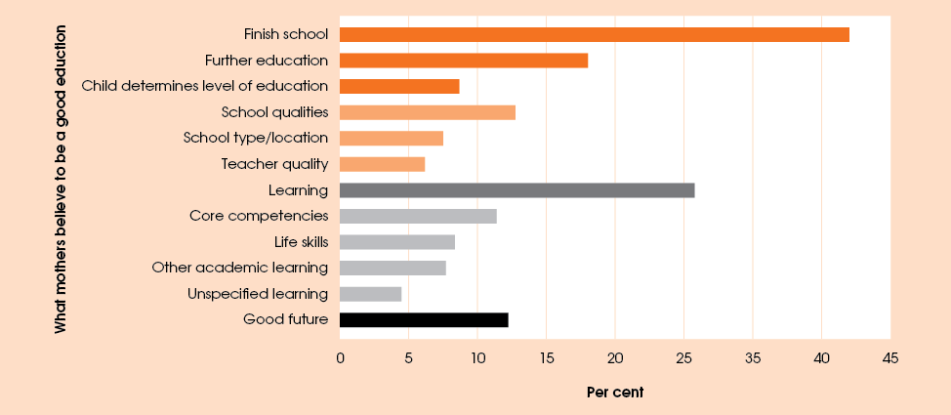
Figure 35: What mothers believed a good education to be for their children, per cent

1. Level of education
The level of education encompassed finishing school, going on to further education and the child determining the level of education they would like to attain. Mothers said finishing or completing school was an important aspect of a ‘good education’: 42 per cent of mothers included it in their answer. In talking about their child finishing school, mothers often discussed their desire for their child to complete Year 12 specifically or gave broader descriptions about the levels they hoped their children would attain.
Go all the way through school.
Complete his whole school level to help him get an apprenticeship.
Other types of education were also seen as important for a good education. One in five mothers mentioned they would like their children to receive further education after school. Nearly three-quarters of the mothers who mentioned further education talked about their child completing university studies.
Complete Year 12 and would be very proud if she goes on to further education.
Love for her to go to university, but definitely finish her schooling.
Vocational education, such as TAFE or an apprenticeship, was another form of further education that mothers thought was important for a good education. Over one-fifth of mothers who discussed further education specifically referred to vocational education.
While many mothers had aspirations for their child to achieve a high level of education, mothers often attached the disclaimer that this would depend on what their child wanted to do. Mothers wanted the level of education their child attained to be determined by their child and to be based on the child’s own personal goals and interests. For example, while mothers may have expressed a preference for their child to go on to university, they felt this was their child’s decision. However, some mothers saw finishing school as not negotiable. In these cases it would be after high school that their child would receive more autonomy to make decisions about their education.
Go to school, depends on the child, can’t judge until older. Happy for him to see how he goes and make that decision. Don’t want to put pressure on him.
To enjoy her schooling and to at least finish year 12 and then I’ll support whatever decision she makes after that, whether it’s to go to uni or not.
A common theme was that mothers wanted their children to do the best they could and go as far as they could in the education system.

2. School and teacher qualities
Another major theme that emerged as essential for a good education was the qualities of the school and/or teachers, as well as the location or type of school the child attends. Qualities identified by mothers included a supportive and a safe environment (free from bullying and racism), a school that had resources and facilities, and that provided opportunities for their child. Other school qualities that were mentioned included teaching the mainstream curriculum, stable schooling (only attending one school), and schooling being affordable or the family having access to scholarships to support school expenses.
Good school environment, good teachers, offer a diverse range of experiences, I’d like that he has the Christian input.
Be in a place where he will feel safe, with good teachers and resources and a good school community where he will feel safe.
Almost one-quarter of mothers who spoke about this theme mentioned the qualities of teachers and said that having a good teacher was important for a good education. They said that teachers needed to support the children by giving them adequate teaching attention and one-on-one teaching or extra help if required (for example, tutoring) and that to be able to do this the school needed to have a good teacher to student ratio.
Definitely a bit more one-on-one teacher/student time. Probably a lot more opportunities such as excursions to museums, places of interest.
Some mothers expressed the belief that teachers should know different teaching styles, be able to teach in a fun and engaging way, and be able to tailor teaching to suit individual children’s needs and abilities, enabling children to work at the right pace and be challenged without being pushed beyond their level.
A good understanding of different ways of teaching and it would be good if they can at least learn one Indigenous language.
A few mothers also mentioned the need for teachers to communicate with parents and provide feedback on their child’s progress. As discussed in the section entitled ‘The learning environment’, the majority of primary carers indicated that they were well supported by the teachers. Having Indigenous teachers in the school was seen as important. Some mothers felt that having a good education would be assisted by the presence of Indigenous teachers or teacher aides.
Another subtheme mentioned by a few mothers was the importance of the school and teachers respecting children’s Indigenous culture.
To be within a school that respects Indigenous culture, would also like him to finish school and will support him in his interests.
Around one-quarter of the mothers also provided responses that discussed the type of school or location of the school they would like their child to attend. Of these mothers, one-third said they would like their child to attend a private or religious school. Some mothers preferred their child to attend private or religious schools, as they felt these schools would offer better educational outcomes and have better resources. Other respondents said they wanted their child to attend a boarding school or a school outside of the community and others were happy for their child to attend a local, public, mainstream or community school.
Catholic education cause I’ve been to Catholic and non-Catholic schools and I’ve found that the Catholic school are more concerned about your learning and encourage you more.
Learn more than is up here, the boarding schools down south are better and teach more.
In the end it was about choice. Mothers of Indigenous children wanted to be able to choose the school for their child based on what they considered to be important.

3 Learning outcomes
Another key aspect of a good education, mentioned by more than one-quarter of mothers, was children being able to develop a wide variety of competencies through their education. In figure 35 the specific types of learning mothers mentioned were grouped into core competencies, other academic skills and life skills.
Mothers commonly referred to literacy (reading, writing, ABC, good spelling or understanding and reading books), numeracy (maths or counting), science, learning English, or ‘knowing the basics’ as being important areas of learning. These have been grouped together in Figure 35 as core competencies. Other areas of academic learning that were mentioned included sport, languages (including Indigenous languages), learning about Indigenous culture, computers and technology, art, music or other activities.
All I want is him to learn how to read and write, basics so when he finishes school able to use these skills. And to be able to add up.
Somewhere that involves, good literacy and numeracy programs, learn more about the Australian history, like it if she had more time with the teachers with one on one stuff—smaller class rooms.
Mothers also felt their child needed to learn a range of life skills and social skills from their education. Mothers also hoped that education would help their children to improve their communication skills, including learning to communicate with others, being able to be understood by others, learning to speak and learning to listen. Mothers also mentioned that they hoped a good education would provide their child with social skills, such as learning how to interact and play with other children. They also stated education was important for children to develop confidence, self-esteem, moral values, respect for others, and tolerance.
Prepare to function in the world and having the building blocks for higher education.
Have good communication skills to get on with other people. Confidence to have the right to be part of society.
Learn life skills—form a relationship with other people, learn how to cope with conflict.
Mothers viewed education as an opportunity to provide their children with a variety of skills to aid them in all areas of their lives.

4 Good future
Another common theme, although mentioned less frequently than the others was the importance of education in providing children with a good future. Employment was the main future prospect mothers associated with a good education, with four out of five of the good future responses referring to employment. Mothers discussed how obtaining an education leads to having a good job in the future, improves job prospects and the chances of having a career or trade.
Another commonly stated aspiration that mothers had for their children was for the children to be able to support themselves by earning a good wage rather than being reliant on government benefits.
Complete school and get a job, not to rely on Centrelink.
A good education to broaden his prospects for getting a good job, through continuing on to university or getting educated in health.
In thinking about their children’s education, the mothers in the study were preparing their children for their future lives.

Conclusion
Indigenous mothers wanted the best for their children and many saw education as the key way for their child to get the best from life. Even from an early age, finishing schooling was seen as an essential part of a child’s education. Mothers described different types of educational pathways and frequently noted that they wanted their child to achieve the level of education that matched the child’s goals and aims for his or her life. Education was seen as being able to provide academic skills and learning as well as life skills to help children navigate their world. Mothers described education as a key way to secure a good future, including providing a pathway into work. Like all children, Indigenous children need to be supported through education to ensure there are positive long-term educational outcomes. Mothers clearly see education and learning as the key to lifelong success.

Acknowledgements
Footprints in Time—the Longitudinal Study of Indigenous Children (LSIC) would never have been possible without the support and trust of the Aboriginal and Torres Strait Islander families who opened their doors to the researchers and generously gave their time to talk openly about their lives. Our gratitude goes to them, and to the leaders and Elders of their communities who are active guardians of their people’s wellbeing.
A special thanks goes to the LSIC Steering Committee and the Subcommittee members, past or present, who, under the committed leadership of the Chair Professor Mick Dodson AM, actively participated in grappling with the many challenges the study has faced in its development. Many of the members gave their time freely outside the committee meetings to provide expert advice to assist the study’s development.
This report has been written by Anastasia Sartbayeva and Deborah Kikkawa from the Research and Analysis Branch of FaHCSIA. The article on mothers’ educational aspirations for their Indigenous children was written by Anna Davies, Eleanor Bettini and Megan Shipley from the Parental Payments and Family Research Branch. The article on the relationship of language outcomes to language environment was written by Laura Bennetts Kneebone from the Research and Analysis Branch.

Appendix A

Background to the study
Commencing in 2008, Footprints in Time data has been collected on an annual basis from around 1500 Aboriginal and Torres Strait Islander children and their families. Footprints in Time employs an accelerated cross-sequential design, involving two cohorts of Indigenous children with a target age from 6 months to 2 years (B cohort) and from 3 years, 6 months to 5 years (K cohort) at the time of wave 1 collection. The design allows the data covering the first nine or 10 years of Aboriginal and Torres Strait Islander children’s lives to be collected in six years. The two-cohort design also facilitates the comparison of the cohorts when their ages overlap in order to detect any changes due to different social conditions and policy initiatives.
Eleven sites are included in the study, which span all states and territories except the Australian Capital Territory and Tasmania. Of the sites, three are considered primarily urban (Adelaide, Brisbane and Western Sydney), four are considered primarily regional (Darwin, Dubbo, Shepparton and the New South Wales South Coast) and four are considered primarily remote (Alice Springs, the Kimberly Region, Mount Isa and the Torres Strait). The sample is not meant to be representative of the Australian Indigenous population and conclusions should not be extended to the whole population. The fieldwork was conducted by FaHCSIA’s Research Administration Officers (RAOs) who are all Aboriginal or Torres Strait Islanders.
The survey is designed so that each child in the study is tracked and interviewed during each wave. However, the other participants interviewed may change depending on family and situational relationships. Interviews are conducted with the person who has the primary care of the child at the time. Teachers and centre-based carers may also answer questionnaires about the child, themselves and their school or centre.

Objective
The main objective of the study is to provide high quality quantitative and qualitative data that can be used to provide a better insight into how Indigenous children’s early years affect their development. It is hoped that this information can be drawn upon to help close the gap in life circumstances between Indigenous and non-Indigenous Australians.
Footprints in Time has four key research questions, formulated under the guidance of the Steering Committee, which were designed to achieve this objective. These are:
- What do Indigenous children need to have the best start in life to grow up strong?
- What helps Aboriginal and Torres Strait Islander children to stay on track or get them back on track to become healthier, more positive and strong?
- How are Aboriginal and Torres Strait Islander children raised?
- What is the importance of family, extended family and community in the early years of life and when growing up?
Also of interest is the role that service use and support plays in the lives of Aboriginal and Torres Strait Islander children:
- How can services and other types of support make a difference to the lives of Aboriginal and Torres Strait Islander children?
The study provides information for individuals, families, communities, service providers, researchers and governments to design and implement culturally appropriate policies and programs to improve outcomes for Indigenous children.

Topics covered
As a longitudinal study, a large number of questions in Footprints in Time are asked in every wave. Answers to the same questions from the same people over time can tell us about persistence and recurrence (for example, how long people remain poor, unemployed or receive income support), relationships (for example, the impact of life events on health) and outcomes. This kind of data allows us to watch a ’film’ of people’s lives rather than look at a single photograph. A photograph only tells the story of a point in time, not what happened before or after.
As Footprints in Time follows children, it is also important to capture information about the changes and developments that occur as they grow older. The study includes questions appropriate to the children’s age. This will allow researchers to identify possible causal relationships (for example, do children learn to read more quickly if they were read to when younger). When they reach the same age, the B cohort will be asked the same questions as the K cohort were asked at that particular age, thereby allowing comparisons of outcomes between the cohorts.
Information collected by Footprints in Time can be grouped into the following six areas:
- household information—the number of people in the household, their age, sex, Aboriginal and Torres Strait Islander status and relationship to the primary carer with whom the interview is being conducted
- child health—maternal health and care, alcohol, tobacco and substance use in pregnancy, birth, early diet and feeding (for younger children), nutrition (for older children), dental health, health conditions, injury, hospitalisation and the child’s sleeping patterns
- primary carer health—contains information about the primary carer on their health conditions, social and emotional wellbeing, smoking habits and exposure
- child and family functioning—social and emotional development of the child, primary carer concerns about language and development, parental warmth, major life events and parents who live elsewhere
- socioeconomic and demographic information about the family—language, culture, primary carer education and work, income and financial stress, housing and neighbourhood, child care and early education and children’s activities
- assessment of children’s development using a range of child outcome measures
New topics and questions added in wave 3 include:
- additional assistance needed by child due to health conditions
- gambling
- primary carer’s relationship with their partner
- child’s strengths and difficulties
- age appropriate physical abilities
- languages spoken in the home
- identity with Indigenous and non-Indigenous groups
- experiences with prejudice and racism
- what it means to be Aboriginal or Torres Strait Islander
- primary carer work characteristics
- financial counselling
- financial stress
- homelessness and housing
- trust
- schooling (K cohort only)
- primary carer interaction with child’s schooling
- activities the child likes
Some series of questions are asked in alternate years of the two cohorts.

Wave 3 fieldwork and response

Wave 3 fieldwork
Interviewing in wave 3 began on 8 March 2010 and finished on 23 December 2010. Ideally, participants are interviewed at 12 month intervals. The mean and median length of time between wave 2 and wave 3 interviews was 12 months, a more preferable inter-wave gap than the nine to 12 month gap between wave 1 and 2 primary carer interviews. Figure 36 shows the number of months between wave 2 and 3 interviews. Over 60 per cent of wave 3 interviews were conducted between 10 and 14 months after the wave 2 interview.
Roy Morgan Research estimated that the average length of the interviews with the primary carer for the B and K cohorts was 52 and 57 minutes respectively. The estimated average length of the developmental assessment of the study child was 10 minutes for the B cohort and 19 minutes for the K cohort.
Figure 36: Lapsed time between wave 1 and 2 interviews
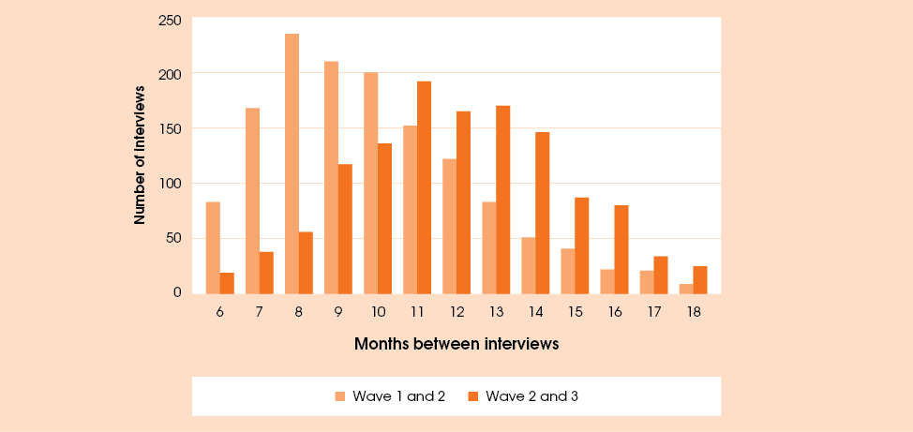

Other participant interviews
In addition to the interviews with the study child’s primary carer, a number of assessments of the child were carried out using a selection of child outcome measures. These included, for the B cohort, an Australian version of the MacArthur-Bates Short Form Vocabulary Checklist (Levels I and II). For the K cohort, the Renfrew Language Scales Word Finding Vocabulary Test and the Who Am I? Developmental Assessment (assessing school readiness) were used. These are discussed in more detail in the appendix of the Key Summary Report from wave 2.
In wave 3 no additional surveys aimed at fathers were conducted.
Information was also collected from teachers for the K cohort and centre-based carers for the B cohort. In wave 3, 231 children in the K cohort and 98 children in the B cohort had a teacher or centre-based carer complete the questionnaire.

Response and non-response

Response rates
The wave 3 sample consisted of 1,716 families comprising 193 interviewed in wave 1 only, 1,435 interviewed in both wave 1 and 2 and 88 who were new entrants in wave 2. Of these, a total of 1,404 families were interviewed including 1,241 who had also been interviewed in waves 1 and 2, 92 who had been interviewed in wave 1 only and 71 new entrants at wave 2. The response rates are provided in Table 69.
Table 69: Wave 3 response rates
Response rate description | Calculation | Response rate, per cent
Original wave 1 responding sample | 1,333/1,670 | 79.8
Previous wave responding sample | 1,312/1,523 | 86.1
Available sample this wave | 1,404/1,716 | 81.8
Table 70 shows the wave 3 response rate by site. The sites with the highest response rates from the available sample were Alice Springs (93.7 per cent), Adelaide (92.2 per cent) and Dubbo (91.6 per cent). Footprints in Time struggled in more remote sites such as Mount Isa (68.4 per cent) and the Kimberley region (68.9 per cent).
Table 70: Wave 3 response rates by site
Site | Percentage of original wave 1 responding sample* | Percentage of previous wave responding sample** | Percentage of available sample this wave
Adelaide | 84.9 | 94.6 | 92.2
Alice Springs | 90.5 | 91.4 | 93.7
South East Queensland | 84.2 | 86.8 | 88.1
NT Top End | 76.8 | 85.1 | 79.7
Dubbo | 89.0 | 92.9 | 91.6
Kimberley region | 64.0 | 79.6 | 68.9
Mount Isa & remote Western Queensland | 68.6 | 74.5 | 68.4
Greater Shepparton | 77.3 | 87.8 | 83.8
NSW South Coast | 83.3 | 89.1 | 79.4
Torres Strait Islands & NPA+ | 72.5 | 81.7 | 77.4
Western Sydney | 90.7 | 92.9 | 88.3
Total | 79.8 | 86.1 | 81.8
*Based on wave 1 site.
**Based on wave 2 site.
+NPA means Northern Peninsula Area.

Non-response in wave 3
Of the 1,716 families in the wave 3 sample, 312 families (18.2 per cent) did not respond. Of these 100 had been interviewed in wave 1 only, 194 had been interviewed in both the previous waves and 18 were new entrants in wave 2. There were 196 families who were unable to be contacted, 72 who refused this wave and 29 who have withdrawn from the study.

Non-response bias
If the characteristics of families who drop out of the study are different from the characteristics of families who continue to participate, attrition (drop-out) may become a problem. Table 71 reports the proportions of children whose primary carers participated in all three waves of Footprints in Time and proportions who participated in wave 3, out of the total number of wave 1 respondents. Of the 1,670 children whose primary carers participated in wave 1 of the study, 1,333 participated in wave 3 and 1,241 participated in all three waves, bringing the total re-interview rates to 79.8 per cent and 74.3 per cent respectively. The table also shows re-interview rates by selected characteristics of children and their primary carers in wave 1 to investigate whether certain groups of children were more or less likely to continue with the study.
Re-interview rates were lower in remote sites, namely the Torres Strait Islands and the Northern Peninsula Area, the Kimberley region, and Mount Isa and remote Western Queensland. Consistent with this finding, those who were identified as Torres Strait Islander children or both Aboriginal and Torres Strait Islander children were less likely to continue participation than children who were identified as Aboriginal.
In terms of characteristics of primary carers, children were more likely to remain in the study if the wave 1 primary carer was male, although this finding may not be particularly robust due to a small number (41) of male primary carers in wave 1. Children with non-Indigenous wave 1 primary carers were the most likely to participate in subsequent waves, and children whose wave 1 primary carer identified as both Aboriginal and Torres Strait Islander were the least likely. Children whose wave 1 primary carer was a single parent were less likely to continue to participate. The re-interview rates of 70.8 per cent and 76.6 per cent for primary carers who were lone parents are both lower than the average of 74.3 per cent and 79.8 per cent for the three waves and wave 3, respectively. Children whose primary carer was employed in wave 1 or owned or was purchasing their home were more likely to continue to participate in the study.
Table 71: Percentage of wave 1 respondents re-interviewed, by selected characteristics
Site | In all waves | In wave 3
Adelaide | 80.2 | 84.9
Alice Springs | 84.1 | 90.5
South East Queensland | 79.4 | 84.2
Dubbo | 83.9 | 89.0
Kimberley region | 57.6 | 64.0
NT Top End | 68.2 | 76.8
Mount Isa & remote Western Queensland | 64.5 | 68.6
NSW South Coast | 80.5 | 83.3
Greater Shepparton | 70.9 | 77.3
Torres Strait Islands and NPA* | 63.4 | 72.5
Western Sydney | 88.2 | 90.7
Child characteristics
Male | 74.5 | 80.1
Female | 74.1 | 79.5
Aboriginal | 75.2 | 80.5
Torres Strait Islander | 69.1 | 78.2
Both Aboriginal and Torres Strait Islander | 67.0 | 71.1
Primary carer characteristics
Male | 82.9 | 85.4
Female | 74.1 | 79.7
Aboriginal | 73.7 | 79.2
Torres Strait Islander | 68.2 | 76.4
Both Aboriginal and Torres Strait Islander | 59.2 | 63.4
Indigenous | 72.5 | 78.2
Non-Indigenous | 86.4 | 91.5
Primary carer is the birth mother of child | 74.0 | 79.4
Primary carer is a single parent | 70.8 | 76.6
Primary carer employed | 76.8 | 81.8
Primary carer (or partner) is a home-owner** | 84.3 | 87.0
Total | 74.3 | 79.8
Number of respondents | 1,241 | 1,333
*NPA means Northern Peninsula Area
**Includes paying off the mortgage and owning outright
Note: Site and primary carer characteristics are based on the characteristics of wave 1 primary carers. The primary carer might have changed after wave 1, but if the child and his or her family continued to participate in the study they were accounted for in the re-interviewed group. The numbers in the table therefore reflect the proportions of children whose primary carers were interviewed, not the proportions of primary carers who were re-interviewed.

Appendix B

Steering Committee and Subcommittee

Steering Committee (Wave 3 members)
Professor Mick Dodson AM, National Centre for Indigenous Studies, Australian National University (ANU) (Chair)
Dr Karen Martin, Southern Cross University (Deputy Chair)
Ms Adele Cox, Consultant
Ms Carol Ey, Branch Manager, Research and Analysis Branch, FaHCSIA
Dr Jill Guthrie, Australian Institute of Aboriginal and Torres Strait Islander Studies
Dr Sarah Holcombe, National Centre for Indigenous Studies (ANU)
Dr Boyd Hunter, Centre for Aboriginal Economic Policy Research (ANU)
Mr Shane Merritt, University of New England
Ms Jane Harrison, Secretariat of National Aboriginal and Torres Strait Islander Studies
Professor Ann Sanson, University of Melbourne
Professor Sven Silburn, Menzies School of Health Research
Mr Paul Stewart, University of Melbourne
Dr Penny Tripcony, Indigenous Education Consultant
Dr Maggie Walter, University of Tasmania
Dr Margo Weir, Education Consultant and Cross-cultural Researcher
Professor Stephen Zubrick, Curtin University of Technology

Methodology Subcommittee
Dr Karen Martin, Southern Cross University
(Chair of Subcommittee)
Professor Sven Silburn, Menzies School of Health Research
Mr Paul Stewart, University of Melbourne
Dr Maggie Walter, University of Tasmania
Dr Margo Weir, Education Consultant and Cross-cultural Researcher
Dr Sarah Holcombe, National Centre for Indigenous Studies (ANU)
Ms Adele Cox, Consultant

Department of Families, Housing, Community Services and Indigenous Affairs (FaHCSIA) Footprints in Time Project Team
Branch Manager, Research and Analysis Branch
Carol Ey & Judy Schneider

Footprints in Time Section – Wave 3 and current members
Michael Barnes, Sharon Barnes, Nicole Beetson, Laura Bennetts Kneebone, Jason Brandrup, Jo-Anne Bulmer, Kay Fegan, Andrew Gibson, Vicki Hagen, Emdadul Hoque, Carole Heyworth, Laura Hidderley, Kirtrina Hocking, Deborah Kikkawa, Saovarose Lai, Grace McAndrew, Annette Neuendorf, Tess McPeake, Casey Mitchell, Ruth Pitt, Nicole Richards, Anastasia Sartbayeva, Fiona Skelton, Roslyne Thorne.

Research Administration Officers – Wave 3
Joshua Atkinson, John Blair, Tanya Carney, Jasmine Deaves, Sandra Hooper, Leanne Kum Sing, Cheryleen O’Loughlin, Cynthia O’Loughlin, Katie Parker, Lee-Anne Parsons, Rowena Puertollano, Geraldine Saunders, Karla Thompson, Leah Tratt, Christine Urbanowski, Annie Wacando, Eliza Wasaga, Joanne Wood.

Access to the data
The dataset used in this report is available to approved users for their own research. The more data users there are, the more useful the findings and the contributions of the families involved in the study will be. This wave 3 report has only skimmed the surface of the Footprints in Time data sets. We hope others will be inspired to delve deeper.
Existing and new data users can apply for a licence for Release 3.0 data by completing the appropriate deed. Copies of these, together with the Manual for Access and Use of FaHCSIA’s Longitudinal Survey Datasets can be downloaded from the Footprints in Time website:
www.fahcsia.gov.au/lsic. Appendix A of the manual provides some information on the protocols to be followed when working with Footprints in Time data.
Specific queries concerning Footprints in Time can be directed to LSICdata@fahcsia.gov.au
General queries concerning Footprints in Time should be directed to LSIC@fahcsia.gov.au
Queries about access to the Footprints in Time datasets should be directed to longitudinalsurveys@fahcsia.gov.au

List of abbreviations
ABS | Australian Bureau of Statistics
AIHW | Australian Institute of Health and Welfare
ARIA | Accessibility/Remoteness Index of Australia
CDEP | Community Development and Employment Project
CEA | Community Enterprises Australia
FaHCSIA | Department of Families, Housing, Community Services and Indigenous Affairs
HILDA | Household, Income and Labour Dynamics in Australia Survey
IRISEO | Index of Relative Indigenous Socioeconomic Outcomes
LORI | Level of Relative Isolation
LSAC | Longitudinal Study of Australian Children
LSIC | Longitudinal Study of Indigenous Children
NATSISS | National Aboriginal and Torres Strait Islander Social Survey
NHMRC | National Health and Medical Research Council
NPA | Northern Peninsula Area
RAO | Research Administration Officer
SCRGSP | Steering Committee for the Review of Government Service Provision
SEIFA | Socio-Economic Indexes for Areas
WAACHS | Western Australia Aboriginal Child Health Survey

References
Australian Bureau of Statistics (ABS), 2006a. National Aboriginal and Torres Strait Islander Health Survey, 2004-05, Cat. No. 4715.0, Canberra.
Australian Bureau of Statistics (ABS), 2006b. Mental Health in Australia: A Snapshot, 2004-05, Cat. No. 4824.2.55.001, Canberra.
Australian Bureau of Statistics (ABS), 2008. Australian Social Trends, 2008, Cat. No. 4102.0, Canberra.
Australian Bureau of Statistics (ABS), 2009. National Aboriginal and Torres Strait Islander Social Survey, 2008, Cat. No. 4714.0, Canberra.
Australian Bureau of Statistics (ABS), 2010a. The Health and Welfare of Australia’s Aboriginal and Torres Strait Islander Peoples, Oct 2010, Cat. No. 4704.0, Canberra.
Australian Bureau of Statistics (ABS), 2010b. Population Characteristics, Aboriginal and Torres Strait Islander Australians, 2006, Cat. No. 4713.0, Canberra.
Australian Bureau of Statistics (ABS), 2011a. Disability, Ageing and Carers, Australia: Summary of Findings, 2009, Cat. No. 4430.0, Canberra.
Australian Bureau of Statistics (ABS), 2011b. Family Characteristics, Australia, 2009-2010, Cat. No. 4442.0, Canberra.
Australian Bureau of Statistics (ABS), 2011c. Aboriginal and Torres Strait Islander Wellbeing: A focus on children and youth, Apr 2011, Cat. No. 4725.0, Canberra.
Australian Institute of Family Studies (AIFS), 2011. The Longitudinal Study of Australian Children Annual Statistical Report 2010.
Australian Institute of Health and Welfare (AIHW), Dental Statistics and Research Unit: Jamieson LM, Armfield JM & Roberts-Thomson KF, 2007. Oral health of Aboriginal and Torres Strait Islander children, AIHW cat. no. DEN 167, Canberra: Australian Institute of Health and Welfare (Dental Statistics and Research Series No. 35), available at: http://www.arcpoh.adelaide.edu.au/publications/report/statistics/html_files/ATSI_children.html.
Australian Institute of Health and Welfare (AIHW), 2011. Oral health and dental care in Australia: key facts and figures 2011, Cat. no. DEN 214, Canberra, available at: http://www.aihw.gov.au/publication-detail/?id=10737420710.
Bavin E, 1995. Language Acquisition in Crosslinguistic Perspective in Annual Review of Anthropology, Vol 24(1995), pp.373-396.
Benevolent Society, 2010. Unemployment and the wellbeing of children aged 5 to 10 years, Research Snapshot, October 2010.
Breen H, Hing N, Gordon A, 2010 Exploring indigenous Gambling: Understanding Indigenous Gambling Behaviour, Consequences, Risk Factors and Potential Interventions, Centre for Gambling Education and Research, Southern Cross University, available at http://www.gamblingresearch.org.au/CA256DB1001771FB/page/GRA+Research+Reports-Exploring+Indigenous+Gambling?OpenDocument&1=35-GRA+Research+Reports~&2=0-Exploring+Indigenous+Gambling~&3=~
Biddle N, 2009. Ranking Regions: Revisiting an Index of Relative Indigenous Socioeconomic Outcomes, January 2009, available at: http://caepr.anu.edu.au/Publications/WP/2009WP50.php
Biddle N, 2011. An exploratory analysis of the Longitudinal Survey of Indigenous Children, Centre for Aboriginal Economic Policy Research (CAEPR) Working Paper No. 77/2011, September 2011, available at: http://apo.org.au/node/26503.
Centre for Community Child Health, Royal Children’s Hospital 2005 Parents Evaluation of Developmental Status (PEDS), the Australian Version, adapted with permission from Frances Page Glascoe, Ellsworth and Vandermeer Press, Melbourne.
Centrelink, 2012. Eligibility (for Parenting Payment), available from: http://www.centrelink.gov.au/internet/internet.nsf/payments/parenting_eligible.htm [cited 13 February 2012].
De Maio JA, Zubrick SR, Silburn SR, Lawrence DM, Mitrou FG, Dalby RB, Blair EM, Griffin J, Milroy H, & Cox A, 2005. The Western Australian Aboriginal Child Health Survey: Measuring the Social and Emotional Wellbeing of Aboriginal Children and Intergenerational Effects of Forced Separation. Perth: Curtin University of Technology and Telethon Institute for Child Health Research.
Department of Families, Housing, Community Services and Indigenous Affairs 2011, Footprints in Time: The Longitudinal Study of Australian Children – Key Summary Report from Wave 2, FaHCSIA, Canberra.
Department of Health and Ageing (DoHA), 2011. Care for Kids’ Ears: strong hearing strong start, http://careforkidsears.health.gov.au/, launched July 2011.
Dockery AM, Kendall G, Li J, Mahendran A, Ong R, & Strazdins L, 2010. Housing and children’s development and wellbeing: a scoping study. AHURI Final Report No. 149. Melbourne: Australian Housing and Urban Research Institute.
ABS 2008, Australian Social Trends, 2008, 4102.0.
Eades D, 2012. Aboriginal English, available at: www.hawaii.edu/satocenter/langnet/definitions/aboriginal.html [cited 14 February 2012].
Harker L, 2006. Chance of a lifetime: The impact of bad housing on children’s lives, Shelter, September 2006.
Hawes DJ, Dadds MR, 2004. ‘Australian data and psychometric properties of the Strengths and Difficulties Questionnaire’, Australian and New Zealand Journal of Psychiatry, Vol. 38, pp 644-651.
Homelessness Australia, 2011a. Homelessness in Australia, Factsheet, October 2011, available from: http://www.homelessnessaustralia.org.au/site/issues.php
Homelessness Australia, 2011b. Homelessness and Aboriginal and Torres Strait Islanders, Factsheet, November 2011, available from: http://www.homelessnessaustralia.org.au/site/issues.php
Goodman R, 1997. ’The Strengths and Difficulties Questionnaire: A Research Note’, Journal of Child Psychology and Psychiatry, 38, 581-586.
Goodman R, 2012. SDQ: Scoring the SDQ [cited 2012 Feb 6]; available from: http://www.sdqinfo.org/py/doc/c0.py
Mellor, D, 2005. ‘Normative data for the Strengths and Difficulties Questionnaire in Australia’, Australian Psychologist, vol. 40, pp 215-22.
National Health and Medical Research Council (NHMRC), 2011. Australian Dietary Guidelines Incorporating the Australian Guide to Healthy Eating, draft for public consultation, December 2011, available at: https://www.eatforhealth.gov.au/sites/default/files/files/public_consultation/n55_draft_australian_dietary_guidelines_consultation_111212.pdf
New South Wales Department of Health, 2005. New South Wales Population Health Survey (HOIST) 2003 and 2004, Centre for Epidemiology and Research.
NSW Department of Education and Training, 2010. RACISMNOWAY: Anti-racism training for Australian schools, available at http://www.racismnoway.com.au/index.html
Pearson BZ, 2009. Children with two languages, in E.L.Bavin (ed.), The Cambridge Handbook of Child Language, Cambridge Handbooks in Language and Linguistics.
Productivity Commission (PC), 1999. Australia’s Gambling Industries, Inquiry Report, Commonwealth of Australia, Canberra, December 1999.
Productivity Commission (PC), 2010. Gambling, Commonwealth of Australia, Canberra.
The Problem Gambling Treatment and Research Centre, 2010. Children at risk of developing problem gambling, a report to Gambling Research Australia, May 2010.
SA Department for Families and Communities, 2008. Gambling – at what cost? available at: http://www.problemgambling.sa.gov.au/aspx/home.aspx [cited 15 February 2012].
Steering Committee for the Review of Government Service Provision (SCRGSP), 2011. Overcoming Indigenous Disadvantage: Key Indicators 2011, Productivity Commission, Canberra.
Thomas A, Cairney S, Gunthorpe W, Paradies Y, & Sayers S, 2010. ’Strong Souls: the development and validation of a culturally appropriate tool for assessment of social and emotional wellbeing in Indigenous youth’, Australian and New Zealand Journal of Psychiatry, January 2010, Vol. 44, No. 1, pp 40-48.
Walker R, & Shepherd C, 2008. Strengthening Aboriginal family functioning: what works and why?, Australian Family Relationships Clearinghouse briefing, No.7, p.2.
Whiteford, P., 2009. Family Joblessness in Australia, paper commissioned by the Social Inclusion Unit of the Department of the Prime Minister and Cabinet, January 2009.
Wilkins R, Warren D, Hahn M, & Houng B, 2011. Families, Incomes and Jobs, Volume 6: A Statistical Report on waves 1 to 8 of the Household, Income and Labour Dynamics in Australia Survey, Melbourne Institute of Applied Economic and Social Research, available at: http://melbourneinstitute.com/hilda/statreport.html
Zubrick SR, Lawrence DM, Silburn SR, Blair E, Milroy H, Wilkes T, Eades S, Antoine H, Read A, Ishiguchi P, & Doyle S,2004. The Western Australian Aboriginal Child Health Study: The Health of Aboriginal Children and Young People. Perth: Telethon Institute for Child Health Research.
Zubrick S, Silburn S, Lawrence D, Mitrou F, Dalby R, Blair E, Griffin J, Milroy H, De Maio J, Cox A, & Li J, 2005. The Western Australian Aboriginal Child Health Survey: The Social and Emotional Wellbeing of Aboriginal Children and Young People. Perth: Curtin University of Technology and Telethon Institute for Child Health Research.

For more information about LORI refer to Zubrick et al. (2004).
This question included response options ‘other parent’, ‘other parent living elsewhere’, ‘step mother’ and ‘step father’. As ‘other parent’ was the first listed option, respondents may have nominated that category regardless of whether the ‘other parent’ was living in the same household.
Note that, for each food or drink item, there are three sets of responses (morning, afternoon and evening). However there were cases where the primary carer did not know what food or drink the child had consumed, for instance, while the primary carer was at work. For the purposes of this analysis, the children were classified as not consuming a particular food or drink only if their primary carer did not select that item for any of the three time periods and they had not answered ‘don’t know’. The children whose primary carers provided at least one valid response indicating that the child consumed that item were classified as consuming that item, even if the primary carer did not provide a positive response for the other two time periods.
The children were classified as having a disability if the primary carers reported that, in the 12 months before the interview, the child had experienced total deafness, total blindness, an intellectual or learning disability, Autism Spectrum Disorder, physical or trauma-related disability, or a neurological, speech, psychiatric or other disability.
The children were classified as having a developmental delay if the primary carers reported them to have a cognitive, behavioural, speech, physical or other delay.
The definition of ‘disability’ used by the ABS may not be directly comparable to the one adopted in this report.
The only health condition that was more likely to be experienced by children in the areas of moderate, high and extreme isolation was skin infections.
Lone-parent families and couple family types include families where the primary carer is the biological, step, adoptive or foster primary parent of the child.
For further information about attrition rates in wave 3, refer to Appendix A
In most cases, this is due to the primary carer changing their partnership status, but in a very small number of cases (less than 5 per cent of the total number of study children) the change in the household type is due to the child having a new primary carer at wave 3.
The sample numbers were too small to conduct this analysis for mothers living elsewhere.
It is not possible to fully apply the standard to the Footprints in Time data, since it requires data on the marital status of all adult occupants of the dwelling which is currently available for the primary carer only.
Parents may be eligible to receive Parenting Payment until their child turns 8 years of age (if single) or 6 years of age (if partnered). Recipients of the Parenting Payment (single) have compulsory part-time labour force participation requirements from the time their youngest child turns 6. Part-time participation requirements may involve undertaking paid work or study (or a combination of the two) for at least 30 hours a fortnight, looking for a part-time
The questions about parental leave taken around the time of the child’s birth were only asked if the primary carer was the child’s birth mother or birth father.
Laws to ban smoking in cars carrying children are operating in all Australian jurisdictions except the Northern Territory.
The questions were not exactly the same and are therefore not directly comparable. However, they can be used to give a general indication.
There are 50 children whose level of English or Aboriginal English is unknown.
Torres Strait Creole and Kriol are separate languages which are both based on English but have developed differently and are spoken by different groups of people.
This may also include a child who is sufficiently older than the study child to be able to guide the activity.
For the purpose of this analysis, we have assumed that the family member joining the child in the activity is an adult as the majority of responses were in categories that by definition imply this. However, it should be noted that brothers, sisters, cousins and friends may have been of a similar age to the child.
This specifically refers to oral storytelling rather than reading a story from a written source.
LSAC is Australia’s first nationally representative longitudinal study of child development, funded by FaHCSIA and conducted in partnership with the Australian Institute of Family Studies (AIFS) and the Australian Bureau of Statistics (ABS). The survey commenced in 2004 and subsequent waves have been conducted two years apart.
WAACHS was undertaken in 2000 and 2001 by the Telethon Institute for Child Health Research. It investigated the health of 5,289 Western Australian Aboriginal and Torres Strait Islander children and young people aged 0–17. The SDQ was administered only for children aged 4 years and older.
The wording of two of the questions in this subscale was different depending on the cohort. In particular, primary carers of the older children (K cohort) were asked whether the child ’often lies or cheats’ while the primary carers of the younger (B) cohort were asked whether the English (UK) version for 3 to 4 year olds (see http://www.sdqinfo.com/py/doc/b3.py?language=Englishqz(UK) ) the child is ’often argumentative with adults’. Similarly, the question on whether ’the child steals from home, school or elsewhere’ for the K cohort was replaced with ‘can be spiteful to others’ for the B cohort.
If responses for one or two questions within a subscale were missing, the score for that domain was calculated by scaling up the sum of existing responses. In the cases where three or more questions within a subscale were not completed by the respondent the scale score was set to missing.
If one or more of the scale scores was missing, the total score was also set to missing.
This method of collection was also used in WAACHS (De Maio et. al. 2005).
Among primary carers of children in the B cohort, 23.0 per cent responded ‘Certainly true’ to the question whether the child ‘is often argumentative with adults’. For the K cohort, this question was replaced with ‘often lies or cheats’, and only 6.6 per cent of the primary carers indicated that this was certainly the case. Similarly, 18.6 per cent of primary carers in B cohort responded ‘Certainly true’ when asked if the child ‘can be spiteful to others’, while the replacement question whether the child ‘steals from home, school or elsewhere’ in the K cohort questionnaire attracted only 3.1 per cent of such responses.
LSAC average prosocial scores for 4 to 5 year olds were 7.4 for boys and 8.0 for girls; Hawes and Dadds (2005) found the averages of 7.5 for boys and 8.2 for girls in a sample of 4 to 6 year olds.
Among the 231 children in the K cohort whose teacher completed the teacher or centre-based carer questionnaire, only about 6 per cent had teachers who identified as Aboriginal or Torres Strait Islander. This number, however, may not reflect the true proportion of children with Indigenous teachers or teacher aides due to the small sample size and the unavailability of data on the presence of Indigenous teacher aides in the classroom.
Release 3.0 includes waves 1 and 2 in addition to wave 3.

