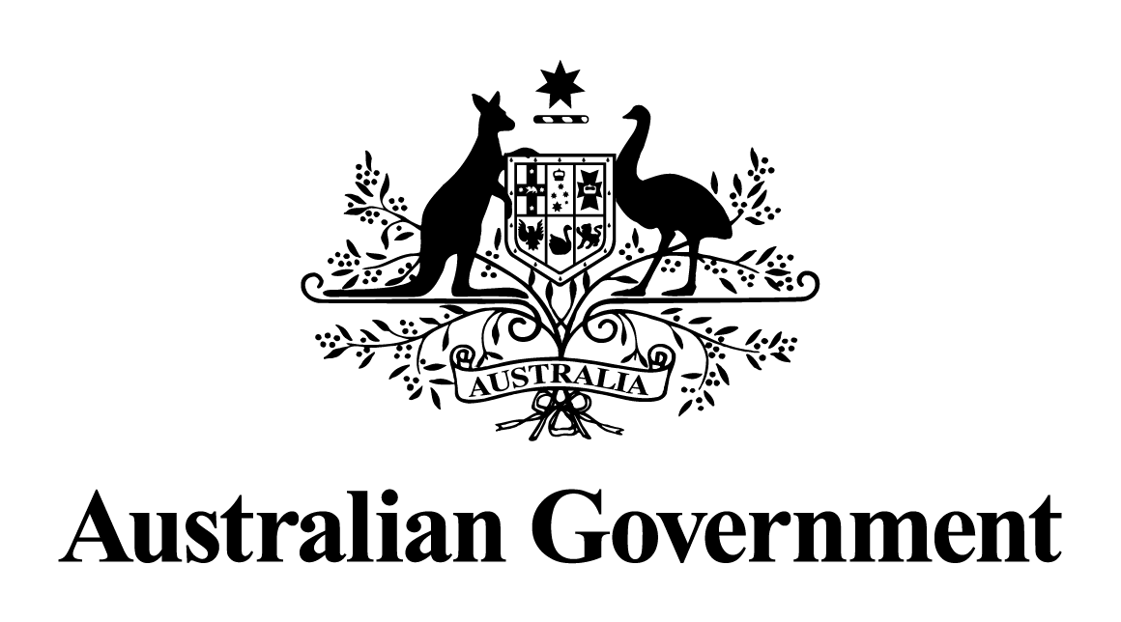

Statement by the Minister for Social Services, the Hon Amanda Rishworth MP

# Ministerial Statement on the Australian Government Response to the Final Report of the Royal Commission into Violence, Abuse, Neglect and Exploitation of People with Disability

12 August 2024

Today, I rise to table and acknowledge the release of the Australian Government response to the Final Report of the Royal Commission into Violence, Abuse, Neglect, and Exploitation of People with Disability.

The Disability Royal Commission was the most comprehensive examination of disability policy and services in Australian history.

The Disability Royal Commission held 32 substantive public hearings, with close to 10,000 people sharing their experiences.

The evidence presented to the Royal Commission was confronting, shocking and disturbing. Behaviour that has no place in Australia.

I wish to acknowledge the determined efforts of people with disability, their families and their advocates who have worked tirelessly, and continue to work tirelessly for a more inclusive Australia.

I also acknowledge, and thank the Chair of the Disability Royal Commission, The Honourable Ronald Sackville AO KC, and Commissioners Barbara Bennett PSM, Dr Rhonda Galbally AC, Andrea Mason OAM, Dr Alastair McEwin AM, and The Honourable John Ryan AM – as well as the Honourable Rosyln Atkinson AO who was appointed for the first 15 months – for their diligence, respect and care in how they conducted their inquiries.

The Final Report of the Royal Commission comprises 12 volumes, 6,788 pages and 222 recommendations.

Of these, 172 recommendations are the sole or joint responsibility of the Commonwealth. The Commonwealth Government has accepted or accepted in principle 130 in our initial response to the Disability Royal Commission released just under a fortnight ago.

For many of the recommendations accepted in-principle by the Commonwealth, work has already commenced or will be commencing shortly. And we have made investments to support this work.

I want to be really clear accepted in principle is a commitment to the policy intent of the recommendation along with the commitment to those recommendations we have accepted.

Throughout the Royal Commission, we heard countless experiences of people with disability who experienced Violence, Abuse, Neglect, and Exploitation.

As it was for Kylee, a First Nations woman in her 50s, who shared her experience of failing for 20 years to receive the right diagnosis and support for her disability.

Or Jerome, an Autistic man in his thirties, has Down syndrome and post-traumatic stress disorder, who was abused when he was in high school by a staff member at a respite home but was not believed.

And Jaylen, who is in his 50s and lives with an intellectual disability who was subjected to the inappropriate use of restrictive practices by disability service providers.

There was also Charmaine, who was told by a staff member at a disability employment service, ‘If you look blind, people won’t employ you.’ The staff told Charmaine she needed to present as though she could see.

As a Government we thank each and every person who came forward and contributed to this important inquiry.

Reliving trauma and your experiences of Violence, Abuse, Neglect, and Exploitation to pave a clear path forward, toward a safer and more inclusive Australia for people with disability was not an easy thing to do – but it will make a difference.

I want to assure the disability community that we have listened.

We are taking action and we are absolutely committed to driving progress and real change across all aspects of society.

Our Government accepts and is committed to the vision set out by the Disability Royal Commission and we are committed to enabling policy and delivering services that realise the vision of an Australian community where people with disability:

* live free from violence, abuse, neglect, and exploitation,
* where human rights are protected, and
* individuals live with dignity, equality and respect and can fulfil their potential.

This includes a future where people with and without disability can:

* live, learn, work, play, create, and engage together in safe and diverse communities;
* have the power of choice, independence, and the dignity to take risks;
* make significant contributions to communities that value their presence and treat them with respect; and
* are culturally safe and belong in families, communities, and peer networks.

The Commonwealth and states and territories jointly established the Disability Royal Commission through letters patent, and its Final Report holds all governments accountable with a comprehensive and compelling call to action.

The 222 recommendations of the Royal Commission are comprehensive and far-reaching across all aspects of society – from safety and human rights to inclusion and access to mainstream services like health and education.

The Final Report made it very clear that our response requires a co-ordinated approach across multiple portfolios and all levels of government.

The recommendations can be divided into those that are clearly the sole responsibility of the Commonwealth, clearly the sole responsibility of states and territories, and others where the Commonwealth and states and territories share a joint responsibility.

Since the release of the Royal Commissions Final Report in September, we have consulted with people with disability, their families, carers and the disability sector – and we have worked collaboratively across the Commonwealth, with 16 of my ministerial colleagues – and with states and territories across 8 different Ministerial Councils to form initial positions against the 172 recommendations that fall within the sole or joint responsibility of the Commonwealth.

And just under two weeks ago, the Australian Government released its initial response to the Disability Royal Commission.

Of course, fully responding to the Disability Royal Commission requires ongoing work, and there will be further positions taken by the Commonwealth against recommendations that fall within our sole or joint areas of responsibility with states and territories as we progress this important work.

Given the breadth and scope of the Final Report, this is the first stage of our Governments response.

We will need to take a considered and staged approach to our program of reform activity which will be aligned with broader reforms to the disability ecosystem — as well as mainstream system reforms in health, education, and housing — as this supports the ongoing involvement of people with disability and enables lasting change.

Our joint response between the Commonwealth and states and territories provides a clear commitment to the disability community that all levels of government are committed to working together to make progress against the recommendations of the Disability Royal Commission.

Volume 12 of the Disability Royal Commission’s final report emphasised the importance of putting the voices of people with disability at the heart of policy making – from designing initiatives through to delivery, monitoring and evaluation.

We are determined to do just that.

The Government is committed to implementing all of the recommendations we have accepted and accepted-in-principle.

Many of the recommendations are multifaceted and can be implemented in a variety of ways. And of course, for some of the recommendations, the Commissioners were split in their views – providing alternative options for governments to consider.

That is why we will work in partnership with people with disability to determine the most appropriate and impactful way to implement reform in response to these recommendations.

For example, recommendations 6.1 and 6.2 relate to improving national approaches to accessible information and communications and developing a strategy to increase the number of Auslan interpreters.

These two recommendations are multifaceted, with 14 distinct sub-components.

They also involve all levels of government, and in the case of Auslan, will require collaboration and cooperation with industry.

The Government has accepted these recommendations in principle to enable proper engagement with people with disability; state, territory and local governments; industry and other stakeholders on the design and implementation of effective reform, and we have committed $12.3 million to support this important work.

There are also several recommendations that are contingent on other work or require sequencing with states and territories.

For example, recommendation 11.4 is about the Australian Government establishing a national complaint pathway to direct people to independent complaint mechanisms in their state or territory. This relies on states and territories first implementing recommendation 11.3 to establish one-stop-shop complaint mechanisms in each jurisdiction.

We have therefore accepted in principle recommendation 11.4 and committed an additional $2.6 million to continue the National Disability Abuse and Neglect Hotline and Complaints Resolution and Referral Service to ensure continuity of service while we work together with states and territories to improve the accessibility and availability of complaint referral and resolution services right across the country.

For many of the recommendations accepted in-principle by the Commonwealth, work has already commenced or will be commencing shortly.

And we have made investments to support this work.

There are also 36 recommendations that require further consideration as they relate to ongoing or recently concluded inquiries or negotiations that require further consideration in consultation with people with disability, state and territory governments and other stakeholders - and 6 recommendations are noted.

A further 50 recommendations fall clearly within the responsibility of state and territory governments, and it would not be appropriate for the Commonwealth to respond to these.

All governments – Commonwealth and state and territory – have worked together to reach a common position in most cases on recommendations of joint responsibility.

We will continue to be open and transparent, working in partnership with people with disability. And the Commonwealth will remain accountable for progressing recommendations within our sole or joint responsibility through six monthly reporting on implementation progress. We will also be coordinating progress updates on recommendations we are jointly responsible for with state and territories.

Through public reporting the Commonwealth will provide updates to positions against recommendations within our sole or joint responsibility with the states and territories.

And it is understood that states and territories will undertake a similar process to provide updates on the 50 recommendations that clearly fall within the sole responsibility of states and territories.

As a Government we have not waited for the Final Report of the Disability Royal Commission to take action to improve the lives of Australians with a disability.

Our Government’s $371 million commitment towards the first phase of its response to the Disability Royal Commission builds on over $3 billion of investment over the last three Budgets to improve the lives and safety of people with disability in Australia.

We are taking action through four key pillars that reflect the areas the disability community have told us are important, including:

* better safeguarding
* promoting inclusion and accessibility
* upholding human rights, and
* recognising the unique perspectives and experiences of First Nations people with disability.

These pillars will continue to drive the focus of our Government as we progress reform toward a more inclusive Australia.

The Albanese Labor Government is committed to a national effort and working in partnership with the disability community to implement the necessary reforms to make Australia more inclusive, accessible, and safe.

The program of reform activity will be staged over several years and is aligned with broader reforms to the disability ecosystem – as well as mainstream system reforms in health, education, and housing – as this supports the ongoing involvement of people with disability and to enables lasting change.

Implementing and embedding our shared vision for an inclusive Australia requires a sustained national effort from all Australian Governments.

The Australian Government commits to strengthening safeguards, independent oversight and complaint mechanisms that will help to reduce the unacceptable levels of violence, abuse and neglect experienced by people with disability. In many instances this will require working together with state and territory governments to enhance protections and services systems nationally.

The Australian Government commits to listening to the diverse voices of people with disability and working in partnership with the disability community to design, implement and evaluate policies and programs that drive reforms to make Australia more inclusive, accessible, and safe for people with disability.

The Australian Government commits to upholding the human rights of people with disability to enable them to live with dignity, equality and respect.

And the Australian Government commits to promoting a more inclusive society where people with disability feel they belong, are respected, valued and able to fully contribute.

*Australia’s Disability Strategy 2021–2031* remains the key national policy mechanism we will use to drive reform at a national level.

In closing, our government’s response is not just about fixing problems – it's about creating a better future where people with disability are valued, respected, and supported to live their lives with dignity.

Our initial response marks the beginning of a renewed commitment by all levels of government – across areas of government – to working with people with disability to achieve the vision of the Disability Royal Commission and end the experiences of violence, abuse neglect and exploitation that have no place in Australia or anywhere.

Thank you.