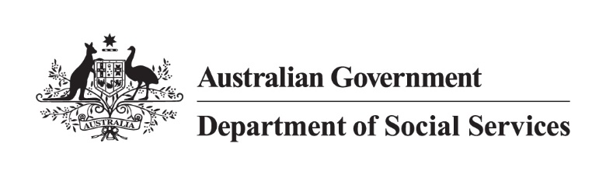

DSS 3262.02.24

Disability Support Pension

2022 Priority Investment Approach Factsheet

## Overview

This factsheet provides insights on the 758,000 people[1] receiving Disability Support Pension (DSP)   
at 30 June 2022. These figures come from the 2022 Priority Investment Approach actuarial model. For more information, please refer to the [*2022 Valuation Report*](https://www.dss.gov.au/node/68706).

## Highlights

* Of those who **started** receiving DSP in 2021-22 (44,900 people), 48.2% were not previously receiving any form of income support and 43.7% were receiving JobSeeker Payment at

30 June 2021.

* Of those who **stopped** receiving DSP in 2021-22 (36,700 people), 33.3% were not receiving any income support, 26.1% were receiving the Age Pension at 30 June 2022, and 40.2% had passed away during the year.
* The projected **average Lifetime Cost**\* for people receiving DSP at 30 June 2022 is $529,000, and the **total future Lifetime Cost** is $401 billion (7.2% of the total cost for all Australians).

* **Lifetime Cost** is the net present value of all **future** in-scope social security payments.

## The Disability Support Pension 45-54 year old cohort

The following insights focus on future **Lifetime Cost** for people on DSP aged 45-54:

Figure 1: Average Lifetime Cost for people aged 45-54 receiving Disability Support Pension 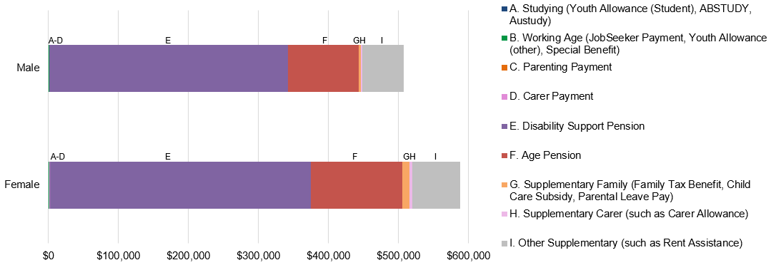

* The average age of people receiving DSP at 30 June 2022 was 51 years.
* **Lifetime Cost** varies depending on gender. For men, the projected **Lifetime Cost** is $508,000, whereas for women the projections are 15.6% higher at $588,000.
  + The largest proportion of **Lifetime Cost** for both men and women is projected to come from DSP. It is projected to make up 67.1% of future costs for men and 63.4% of future costs for women.

Table 1: Projected Lifetime Cost and percentage of time on income support before retirement for people aged 45‑54 receiving Disability Support Pension

Table 1 contains different factors or characteristics that drive Disability Support Pension usage such as primary medical condition and socio-economic area grouping. It lists each factor, the proportion of the cohort associated with the factor, their projected average lifetime cost and percentage of time on income support before retirement.  
*Figures may not add to 100% due to rounding. [**Table 1 accessible version**](https://www.dss.gov.au/node/68716).

* With the exception of people who have cancer, people aged 45-54 receiving DSP are projected to receive income support for 95% of the time before retirement.
* Of people receiving DSP aged 45-54, those with an intellectual/learning disorder ($558,000) or poorly defined cause/chronic pain ($597,000) as their primary medical condition have the highest projected **Lifetime Cost**, while people with cancer/tumour have the lowest ($376,000).
* For people receiving DSP aged 45-54, socio-economic area has very little impact on **Lifetime Cost** and time receiving income support before retirement.
  + However, there are almost four times as many people receiving DSP in the lowest 20% of socio-economic areas compared to the highest 20% of socio-economic areas.

1. Note: These figures are from the Priority Investment Approach 2022 actuarial model. These figures will not match official or published recipient data due to different data extraction rules and extraction timing. For official figures please refer to the [DSS Benefit and Payment Recipients Demographics reports](https://data.gov.au/data/dataset/dss-payment-demographic-data) or [DSS Income Support Recipients – Monthly Time Series](https://data.gov.au/data/dataset/dss-income-support-recipients-monthly-time-series) published on [data.gov.au](https://data.gov.au/data/dataset/cff2ae8a-55e4-47db-a66d-e177fe0ac6a0/resource/1188c950-542a-4ca6-9e3e-9f91f53d9314/download/dss-demographics-june-2022-final.xlsx).