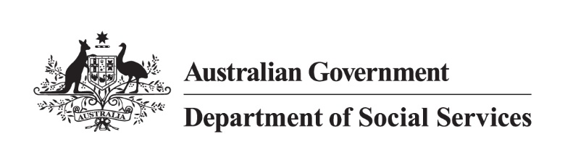

DSS 978-1-921380-85-3

Expatriate Adoption Factsheet

### Expatriate adoption

An expatriate adoption is a specific type of adoption that occurs when an Australian citizen or permanent resident living abroad for 12 months or more adopts a child in a process approved by an overseas agency or government authority. Australian adoption authorities are not responsible for expatriate adoptions, and do not assess or approve applicants for such adoptions.

*Note:* Expatriate adoption may also be referred to as national adoption in some countries.

**When an Australian adopts a child from another country without the involvement of Australian authorities, the child does not automatically have their adoption recognised in Australia.**

**The child may not meet immigration requirements to enter and remain in Australia.**

### Australia’s involvement in expatriate adoptions

The Australian Government’s involvement in expatriate adoptions is limited to determining whether the child meets immigration requirements to enter and remain in Australia on an Adoption visa.

The Australian Government does not provide any type of document that in any way supports or endorses applications by Australian expatriates undertaking domestic or private adoptions in overseas countries, such as a letter of support, a Letter of No Objection (LNO) or a No Objection Certificate (NOC). This is because these types of overseas adoptions fall outside of Australia’s approved intercountry adoption program.

Australian authorities are unable to carry out assessments of Australians living in another country and are not able to certify that Australian expatriates are eligible to adopt a child according to Australian law.

Additionally, Australian Embassies or officials are unable to witness any documents including statutory declarations and affidavits, which are for use outside of Australia and for the purpose of a domestic or private adoption in another country.

### Risks involved in adoptions not arranged through my state or territory Central Authority

* Expatriate adoption activity carries an inherently greater risk, not only of illicit or illegal practice, but of repeating inappropriate past adoption practices.
* The best interests of the child are not always the primary consideration in expatriate adoption cases.
* Appropriate consents, evaluation of the child’s adoptability, and child matching processes are not practiced to a consistent standard and are not monitored.
* Assessment of prospective adoptive parent suitability is not undertaken to a consistent standard and is not monitored.
* The assessment of a proposed child placement may not adequately apply the subsidiarity principle or consider the implications of an imminent or future international border crossing, in the best interests of the child.

Further, concerns are held that adoptive parents have not undertaken the required training, education, and assessment processes, and may not have access to, or be aware of, support services to meet the complex and changing needs of a child adopted from another country.

Some Australian citizens who have undertaken expatriate adoptions overseas have found themselves in a difficult position. This adoption pathway can result in Australian adoptive parents being unable to lawfully bring their child into Australia. These situations can cause a range of long-term issues for both the parents and the child.

### Seek legal advice

If a child has been legally adopted in an overseas country (not Australia) under that country’s law, it does not guarantee that the overseas adoption will meet the requirements of an Adoption visa (subclass 102).

It is recommended that independent legal advice is obtained, both in Australia and in the child’s country of usual residence, before proceeding with   
an expatriate adoption.

### For more information

* [Smartraveller](https://www.smartraveller.gov.au/before-you-go/activities/adoption) provides information for Australians who intend to adopt a child from overseas, via intercountry adoption or expatriate adoption. Smartraveller lists the roles and responsibilities of Australian authorities and provides tips for prospective adoptive parents before going overseas to adopt a child.
* [Intercountry Adoption Australia (IAA)](https://www.intercountryadoption.gov.au/) provides comprehensive information about the intercountry adoption process. IAA has a range   
  of resources and services to help Australians considering adopting children from overseas.
* Information about the [Hague Convention on intercountry adoption](https://www.intercountryadoption.gov.au/countries-and-considerations/countries/compliance-with-the-hague-convention/).