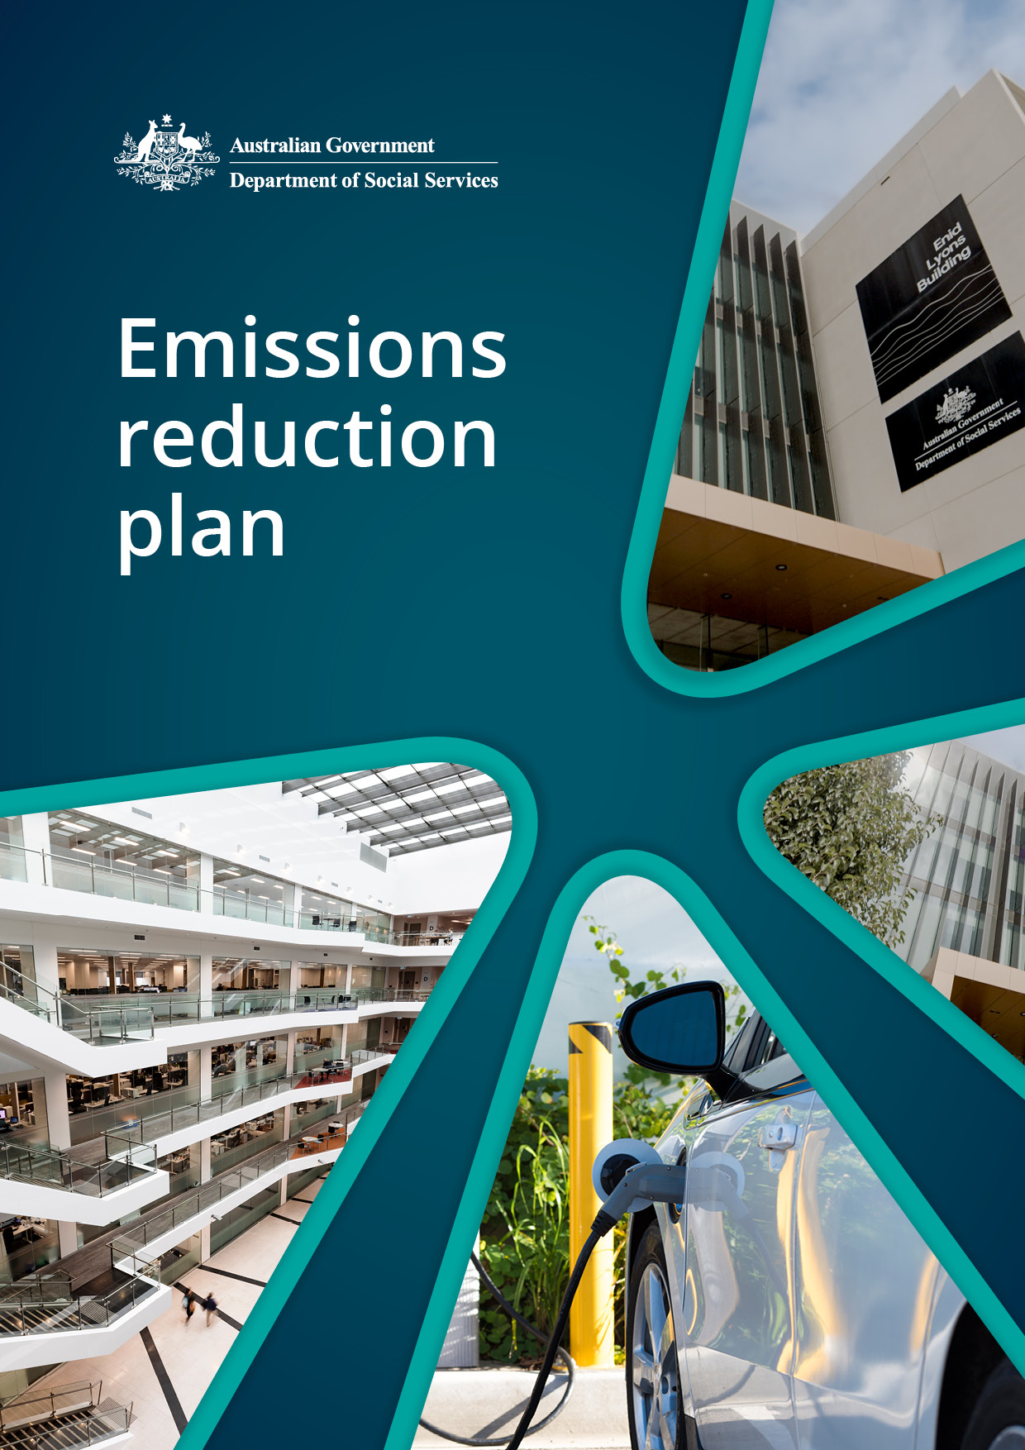

|  |  |
| --- | --- |
| Information | Details |
| Purpose: | The goal of this Emissions Reduction Plan (the plan) is to provide a pathway for the department to meet Net Zero emission targets through reduction activities. |
| Category: | Corporate |
| Applicable to: | All staff, including contractors, consultants and visitors. |
| Relevant Authority: | [*Section 516A of the Environment Protection and Biodiversity Conservation (EPBC) Act 1999*](https://www.legislation.gov.au/C2004A00485/latest/text/2)  [Annual reports for non-corporate Commonwealth entities (RMG 135)](https://www.finance.gov.au/government/managing-commonwealth-resources/annual-reports-non-corporate-commonwealth-entities-rmg-135)  [Net Zero in Government Operations Strategy and Roadmap](https://www.finance.gov.au/government/climate-action-government-operations/aps-net-zero-emissions-2030)  [Commonwealth Climate Disclosure](https://www.finance.gov.au/government/climate-action-government-operations/commonwealth-climate-disclosure-pilot) |
| Related Documents: | [Australian Government Emissions Reporting](https://www.finance.gov.au/government/climate-action-government-operations/australian-government-emissions-reporting)  [Department of Social Services Annual Report](https://www.dss.gov.au/about-the-department/publications-articles/corporate-publications/annual-reports) |
| Approved by: | Ray Griggs  Secretary  Department of Social Services |
| Review Date: | August 2025 |
| Owner: | Property Services Section; Property and Security Branch |
| First Issued: | August 2024 |
| Document Change Control: | August 2024 – Property Services Section (baseline emissions amended) |

## Acknowledgement of Country

The department acknowledges the Traditional Owners and Custodians of Country throughout Australia and acknowledges their continuing connection to land, waters, and community. We pay our respects to the people, the cultures, and the Elders past and present.

Table of contents

Acknowledgement of Country 3

Accountable Authority Sign Off 5

Emissions Reduction Plan 6

Purpose 6

Net zero greenhouse gas emissions 6

Governance and reporting 6

Department of Social Services operational context 8

Baseline emissions 8

Emissions reduction targets 9

Priorities and Actions 10

Net Zero Energy and Buildings 10

Net Zero Fleet 11

Net Zero ICT 12

Net Zero Procurement 12

Net Zero Travel 12

People, culture, and capability 13

Owner/contact officer 13

More information 13

## Accountable Authority Sign Off

The Australian Government released the Net Zero in Government Operations Strategy in November 2023, setting out the overall approach and action required by Commonwealth entities to achieve the   
APS Net Zero 2030 target.

The Net Zero in Government Operations Strategy represents a strong commitment by the Australian Government to lead by example on emissions reduction and contribute to the decarbonisation of Australia’s economy.

The Department of Social Services is committed to the achievement of the Government’s APS Net Zero 2030 target. The department is following the APS Net Zero 2030 target in full, as per the Net Zero in Government Operations Strategy.

This Emissions Reduction Plan describes the priorities and actions the department is taking to reduce our operational emissions and contribute to the APS Net Zero 2030 target.

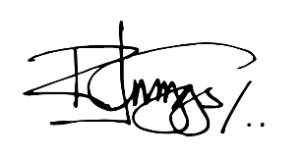

Ray Griggs AO CSC  
Secretary

## Emissions Reduction Plan

### Purpose

The department is responsible for managing and implementing emissions reduction initiatives set by the Australian Government’s [Net Zero in Government Operations Strategy](https://www.finance.gov.au/government/climate-action-government-operations/aps-net-zero-emissions-2030) (the Strategy) developed by Department of Finance. The Strategy sets out the Australian Government’s approach to achieving net zero greenhouse gas emissions from its operations by 2030 and the reinstatement of public emissions reporting.

The goal of this Emissions Reduction Plan is to provide a pathway for the department to contribute to the achievement of the APS Net Zero 2030 target through emissions reduction activities. This plan encompasses existing and new priorities and actions within the department to reduce emissions.

This Emissions Reduction Plan has been completed in accordance with the [Strategy](https://www.finance.gov.au/sites/default/files/2023-11/Net_Zero_Government_Operations_Strategy.pdf), associated guidance and reporting standards for annual emissions reporting.

### Net zero greenhouse gas emissions

APS Net Zero 2030 is the target set by the Australian Government to achieve net zero greenhouse gas emissions from government operations by the year 2030. It includes scope 1 and scope 2 emissions from activities in Australia and its territories, as described in the Strategy. The APS Net Zero 2030 target applies at the aggregate level to non-corporate Commonwealth entities and generally covers the entirety of the entity’s organisation. From an organisational perspective, this means minimising the greenhouse gas emissions that are within our control.

### Governance and reporting

Progress against actions identified within this Emissions Reduction Plan, and any additional measures adopted, will be included in our annual reports. This, combined with annual emissions reporting, will be used as a measure of the department’s progress towards reducing its emissions.

As part of the Net Zero in Government Operations Annual Progress Report, the Department of Finance will aggregate these measures to provide whole-of-Australian Government emissions reporting.

The department has appointed the Chief Operating Officer (COO) to be the Chief Sustainability Officer (CSO). The role of the CSO is to:

* champion the Net Zero in Government Operations Strategy and related initiatives that support climate action in government operations.
* represent the department in the Chief Sustainability Officer network.

**Governance diagram**

**Audit and Risk Committee**

Provides independent assurance and advice to the Secretary and EMG on the design and operation of the department’s risk, control and compliance framework, including its external accountability responsibilities.

**Net Zero Working Group**

**(Chaired by BM Property & Security Branch)**

Officer-level working group responsible for the department’s Emissions Reduction Plan and Emissions Reporting.

**DSS Property and Security Branch**

Responsible for developing and maintaining the department’s Emissions Reduction Plan and including Emissions Reporting in the Annual Report.

**Chief Sustainability Officer (CSO)**

**(Chief Operating Officer)**

Responsible for championing the department’s Net Zero by 2030 Emissions Reduction Plan.

Note: The COO is also the department’s appointed Chief Risk Officer, responsible for overseeing the department’s Risk Management Framework and governance arrangements.

**Executive Management Group (EMG)**

**(Chaired by Secretary)**

Oversees the department’s overall strategic direction, priorities, management, and performance.

Responsible for signing the department’s Emissions Reduction Plan, ensuring commitment to the net zero outcomes.

### 

### Department of Social Services operational context

The department operates in a complex, interconnected, and evolving environment that presents both challenges and opportunities. Our success is contingent on our ability to anticipate, adapt and respond to the changing environment. Our focus is on supporting individuals, families and vulnerable members of Australian communities using person-centred approaches. We use our networks, partnerships, and expertise to inform mainstream policy and programs, legislative and structural reform, and funding of priority programs.

The department operates across all Australian states and territories, with an annual staffing level around 3,000 personnel. The department has staff located in 19 sites across Australia of which ten properties are leased directly. Leasing and facilities management activities are managed under the Whole of Australian Government Property Services Coordinated Procurement Arrangements.

The department has staff located in nine properties which are sub-leased from other Government departments under Memorandum of Understanding (MoU) agreements. The department does not have operational control of MoU properties. The Domestic, Family and Sexual Violence Commission is located within the department’s tenancies and their property-related emissions are included in the department’s emissions.

The department operates a small fleet of 25 leased vehicles to support the delivery of services across all Australian states and territories, of which 8 are Zero Emission Vehicles (ZEVs) and 7 are Low Emission Vehicles (LEVs).

The provision of information technology and communication services including infrastructure, support, and maintenance of equipment, is provided by Services Australia under a shared services arrangement.

All procurement is undertaken in accordance with the Commonwealth Procurement Rules (CPRs). As at 30 April 2024, the department entered into 311 contracts with a total estimated value of $109 million.

All departmental travel is undertaken utilising the Whole of Government Travel Arrangements which includes travel management services, domestic and international air travel services, domestic accommodation, domestic vehicle rental services and travel and procurement payment services.

For the full financial year 2022-23, the department undertook 2,604 domestic and international trips and as at 30 April 2024, the department has undertaken 2,770 trips.

### Baseline emissions

Baseline emissions are a record of greenhouse gasses that have been produced in the past and were produced prior to the introduction of any strategies to reduce emissions. The baseline emissions from financial year 2022-23 are the reference point against which emissions reduction actions can be measured.

The baseline emissions for this plan focus on scope 1 and scope 2 emissions, consistent with the APS Net Zero 2030 target. Electricity-related emissions were calculated using the location-based method.   
The complete 2022-23 greenhouse gas emissions inventory tables for the department are presented in our 2022-23 annual report. Amendments made to 2022-23 emissions data can be found on the department’s website. Enhancements to the amendments reporting process is being investigated for future reporting years.

The greenhouse gas emissions below are presented in Kilograms of Carbon Dioxide Equivalents (Kg CO2e).

Department of Social Services Greenhouse Gas Emissions – Location-based method 2022-23 (Amended)[1]

|  |  |  |  |
| --- | --- | --- | --- |
| Emission Source | Scope 1  kg CO2-e | Scope 2  kg CO2-e | Total  kg CO2-e |
| Electricity (Location Based Approach) | N/A | 1,471,920 | **1,471,920** |
| Natural Gas | - | N/A | **-** |
| Fleet Vehicles | 18,793 | N/A | **18,793** |
| Other Energy | - | N/A | **-** |
| Total kg CO2-e | 18,793 | 1,471,920 | 1,490,713 |

Department of Social Services Greenhouse Gas Emissions – Market-based method 2022-23 (Amended)[2]

The electricity emissions reported above are calculated using the location-based approach. When applying the market-based method, which accounts for activities such as Greenpower, purchased LGCs and/or being located in the ACT, the total emissions for electricity, are below:

|  |  |  |  |
| --- | --- | --- | --- |
| Emission Source | Scope 1  kg CO2-e | Scope 2  kg CO2-e | Total  kg CO2-e |
| Electricity (Market Based Approach) | N/A | 440,002 | **440,002** |
| Natural Gas | - | N/A | - |
| Fleet Vehicles | 18,793 | N/A | **18,793** |
| Other Energy | - | N/A | - |
| Total kg CO2-e | 18,793 | 440,002 | 458,795 |

### Emissions reduction targets

The department is following the APS Net Zero 2030 target in full, as per the Net Zero in Government Operations Strategy. The target covers the entirety of our entity’s operations within Australia for scope 1 and scope 2 emissions, as described in the Strategy.

## Priorities and Actions

For the department to contribute to the achievement of the APS Net Zero 2030 target, targeted action on existing emissions reduction measures and the introduction of further or new measures is required. These actions are summarised in the following points, with further detail provided below:

* Procuring renewable electricity
* Improving building performance
* Transitioning the fleet passenger vehicles to low emission vehicles
* Embedding sustainability into future procurement activity
* Encouraging low-emission sources of travel
* People, culture, and capability uplift.

### Net Zero Energy and Buildings

Under the procurement of energy and management of buildings, the department will:

|  |  |  |
| --- | --- | --- |
| Activity | Actions to improve building performance | Timeframe |
| Commonwealth National Lease (CNL) | Incorporate additional environmental sustainability and emission reduction elements into the CNL template to negotiate with landlords. | Ongoing for  new leases |
| Electricity procurement | Procure renewable energy through participating in the WoAG renewable electricity procurement. | Ongoing for new contracts |
| Green lease schedule (GLS) | Review leases over 1,000m2 and 4 years duration to include the relevant version of the GLS. | 1 January 2025 |
| EV charging | Review allocated parking facilities with a fleet vehicle to support electric vehicle charging where possible. | 1 January 2025 |
| NABERS ratings | Ensure leases over 1,000 m2 and 4 years duration are working towards and can maintain a 5.5 star or higher base building and tenancy NABERS energy rating. | 1 July 2025 |
| GBCA Green Star ratings | Contracts for the purchase or construction of office spaces with a value greater than $15 million must have and maintain a 6-star NABERS energy rating and GBCA 4-star Green Star rating (minimum) which includes complying with the Climate Positive pathway. | 1 July 2026 |
| Procurement | Review contracts for the purchase or construction of office space to ensure they include all-electric where available[3]. | 1 July 2026 |

|  |  |  |
| --- | --- | --- |
| Activity | Additional Initiatives | Timeframe |
| Energy efficiency measures | * Use of energy efficient lighting solutions including sensor lights and LED. * Consider conducting audits of operational use of buildings and operation of plant and equipment by building management systems (BMS) to identify BMS tuning opportunities and resource consumption reduction. * Reduced power consumption by using technology that automatically switches off when left on and unattended. * Using new technology that allows staff to ‘wake up’ PCs that have been switched off to install software updates. | During 2024-25 |
| Minimise environmental impacts | * Minimise use of hazardous waste and materials. * Target premium Water Efficiency Labelling and Standards (WELS) rating where possible. * Environmentally friendly and low-harm products waste minimisation. | During 2024-25 |
| Reducing landfill | * Promote waste management practices. * Providing recycling bins in every site. * Incorporate organic waste contracts. | During 2024-25 |
| Support a circular economy | * Resue, repair, refurbish and use of recycled content where possible. | During 2024-25 |

### Net Zero Fleet

Under the leasing of fleet vehicles, the department will ensure the procurement and sourcing of motor vehicles is consistent with the *Commonwealth Fleet Vehicle Selection Policy[4].*

|  |  |  |
| --- | --- | --- |
| Activity | Actions for fleet transition | Timeframe |
| Fleet | Transition 25% of new passenger vehicles to  low emission vehicles. | Completed |
|  | Transition 50% of new passenger vehicles to  low emission vehicles. | Completed |
|  | Transition 75% of new passenger vehicles to  low emission vehicles. | 1 July 2025 |

### Net Zero ICT

Services Australia provides ICT services and equipment under a shared services arrangement. The department will work in partnership with Services Australia to ensure data centres are located in energy efficient premises and wherever possible participate in the whole of government digital marketplace panel.

|  |  |  |
| --- | --- | --- |
| Activity | Action by the department | Timeframe |
| ICT | Working in partnership with Services Australia to ensure new data facilities, that are sourced outside the whole-of-Government panel arrangement, are required to achieve, and maintain 5 stars NABERS rating or equivalent environmental rating, such as a Power Usage Effectiveness of 1.4 or less. | 1 July 2025 |
|  | Services Australia has confirmed the data facilities already meet the minimum standards. | Ongoing |

### Net Zero Procurement

Under the procurement guidelines the department will:

|  |  |  |
| --- | --- | --- |
| Activity | Action by the department | Timeframe |
| Procurement | Commit to supporting training and guidance, including the Government’s Sustainable Procurement Guide[5] to be embedded into the department’s procurement process, training, and templates. | 1 January 2025 |
| Paper | Purchase 100% recycled content paper for internal printers, photocopiers, and multifunction devices. | Ongoing |
| Offsets | Only where all options associated with emissions avoidance and reduction have been exhausted should residual emissions be addressed through the purchase of offsets. | When available |

### Net Zero Travel

The department will:

|  |  |  |
| --- | --- | --- |
| Activity | Action by the department | Timeframe |
| Travel | Ensure the travel policy is updated to enable and encourage low-emission sources of transport, such as trains or other land-based transport. | Completed |
|  | Work with staff responsible for booking travel to ensure they consider energy ratings in the Online Booking Tool once available under the Whole-of-Government arrangements. | Ongoing |

### People, culture, and capability

The department will develop a communication plan to support all staff, including contractors and consultants, to contribute to improving the department’s environmental performance by:

|  |  |  |
| --- | --- | --- |
| Activity | Action by the department | Timeframe |
| Communication | Appoint a Chief Sustainability Officer | Completed |
|  | Supporting and promoting APS Academy advice, guidance, tools, case studies and training programs, when available. | When available |
|  | Promoting employee engagement and staff-led initiatives such as Whole of Australian Government Environmental Contact Officer network (ECONet), when available. | When available |
|  | Update intranet pages to promote:   * Fostering a culture of environmental responsibility. * Thinking before printing. * Importance of shutting down equipment. * Effective use of blinds to optimise air conditioner and heating system efficiency. | Ongoing |

## Owner/contact officer

Chief Sustainability Officer, Chief Operating Officer, Corporate

## More information

For more information, please contact Property Services, in the Property and Security Branch by email [netzero@dss.gov.au](mailto:netzero@dss.gov.au).

1. & 2 The baseline emissions will be amended in line with APS Net Zero reporting framework and as data sources are improved.
2. The department’s nine Memorandum of Understanding (MoU) agreements which are sub-leased from other Government departments are excluded from the department’s emissions reporting.
3. This includes building heating, cooling and water heating but excludes backup generation, subject to the 2026-27 [Net Zero in Government Operations Strategy](https://www.finance.gov.au/government/climate-action-government-operations/aps-net-zero-emissions-2030) review.
4. [Commonwealth Fleet Vehicle Selection Policy | Department of Finance](https://www.finance.gov.au/government/procurement/vehicle-leasing-fleet-management/commonwealth-fleet-vehicle-selection-policy)
5. [Sustainable Procurement Guide - DCCEEW](https://www.dcceew.gov.au/environment/protection/waste/sustainable-procurement/sustainable-procurement-guide)