

A Decade of Data:
Findings from the first 10 years of Footprints in Time
Footprints in Time
The Longitudinal Study of Indigenous Children
The Footprints in Time team acknowledges all the traditional custodians of the land and pays respect to their Elders past and present.
Written permission to use the images of families and children in this report has been obtained in all instances. There is no correlation between the images shown and the accompanying text in the report.
Aboriginal and Torres Strait Islander persons are warned that this publication may include photos of deceased persons.
Creative Commons licence
With the exceptions of the Commonwealth Coat of Arms, Department of Social Services logo, photographs, images, signatures and where otherwise noted, all material presented in this publication is provided under a Creative Commons BY Attribution 4.0
https://creativecommons.org/licenses/by/4.0/legalcode
This document must be attributed as:
Department of Social Services (2020),
A Decade of Data: Findings from the first 10 years of Footprints in Time, Canberra ACT.
Cover design by Ochre Dawn Creative Industries
Designed and typeset by Giraffe
ISBN 978-1-925318-98-2 (Print)
ISBN 978-1-925318-99-9 (Online)
DSS product number 2458.08.20
A Decade of Data:
Findings from the first 10 years of Footprints in Time
Initiated, funded and managed by the Australian Government Department of Social Services
This report uses unit record data from the Footprints in Time: The Longitudinal Study of Indigenous Children (LSIC).
LSIC was initiated and is funded and managed by the Australian Government Department of Social Services (DSS) and is part of the department’s National Centre for Longitudinal Data (NCLD). The findings and views reported in this report are those of the authors and are not necessarily the views of DSS or the Indigenous people and their communities involved in the study.
Unless otherwise stated, this report has been researched and written by NCLD staff from the DSS.
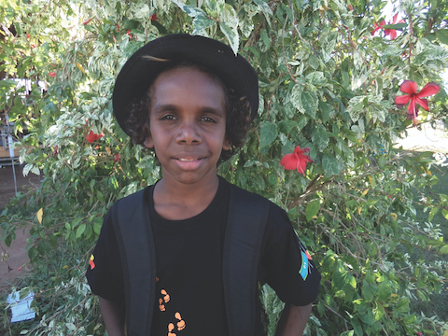

Contents
Chair’s foreword 7
National Centre for Longitudinal Data 8
Acknowledgements 10
Overview of Footprints in Time 11
Important notes for reading this report 15
What has changed for LSIC families since the first interviews? 18
References 27
Part A—Data Collection 30
1. Response rates 30
2. Why families stay in the study 34
3. Waves 6–10: What’s new, what’s different 36
4. Developing content for Footprints in Time 38
Part B—Research Findings 43
5. ‘I wish I could learn my own language’ — Aboriginal and Torres Strait Islander languages and children’s wellbeing 44
6. Factors that influence affective engagement with school: Evidence from Wave 6 of Footprints in Time 53
7. Socio-economic and dietary covariates of dental health for Indigenous children in Footprints in Time 60
8. Better literacy and numeracy in schools using the cross-curriculum priority of Aboriginal and Torres Strait Islander histories and cultures 71
9. Sleep health in Footprints in Time: The effects of stressful life events and sleep disturbance on social and emotional difficulties 77
10. Healthy lifestyle: Diet and exercise 85
11. School: Then and now 95
Glossary 101
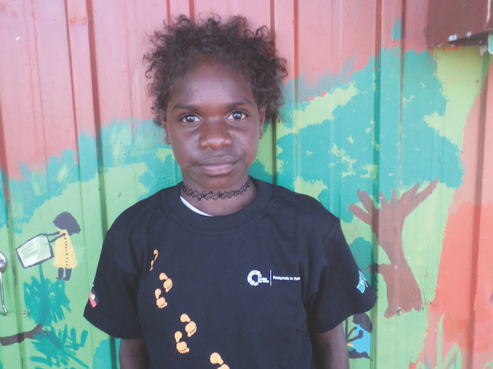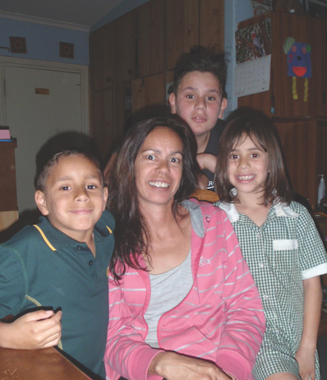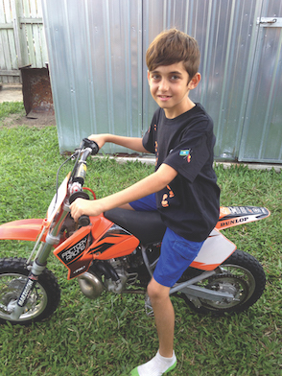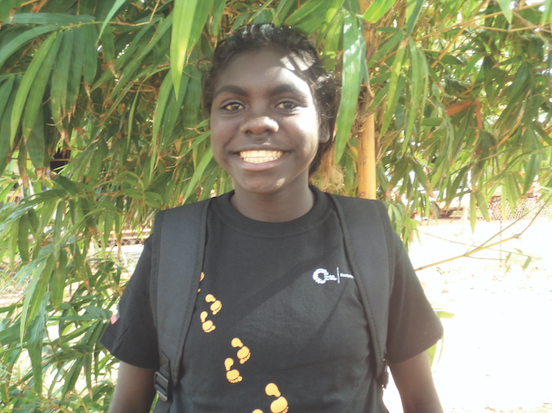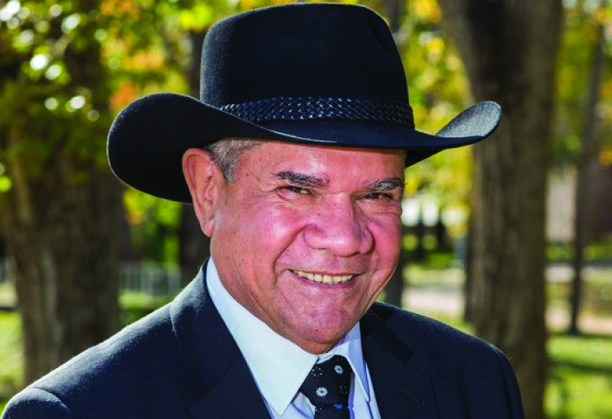

Chair’s foreword
First, before saying anything else about Footprints in Time, I want to say thank you. Thank you to all participating children and their families—we respect your commitment. Thank you, on behalf of the Steering Committee, the research team and the research community, for telling us about your lives so that we can answer the big questions about what is helping our kids succeed, as well as what is going on for those of our kids who are struggling. This study is precious for future policy approaches.
‘I love Footprints in Time.
I love to have a yarn.
I think the school being involved is just so good, and it will be good to have the teacher input’
Change is often frustratingly slow, and this is certainly true when waiting for the results of a longitudinal study. The continued faith that families have shown in the study is now being rewarded by the findings from Footprints in Time making their way into policy documents, such as the Aboriginal and Torres Strait Islander Health Performance Framework 2017 Report.
In 2015, Professor Maggie Walter organised a hands-on workshop for 22 Aboriginal and Torres Strait Islander researchers to explore Footprints in Time data, develop statistical knowledge and use expertise from their academic disciplines to interpret findings. A book using data from Footprints in Time, entitled Indigenous Children Growing Up Strong, was published in 2017. All the chapters have an Indigenous lead author.
This study is a game changer. It is, and will continue to be, an enormous resource. We see a prime example of this in the research from previous reports showing the importance of parents’ social and emotional wellbeing for children’s learning. The social and emotional wellbeing of parents tells us, with crystal clarity, that if our children’s education is important, our approaches to keeping children engaged at school must account for the long term and ensure that relevant policies treat parents’ wellbeing as an absolute priority.
We are also starting to see evidence that children have better literacy if their schools include Aboriginal and Torres Strait Islander histories and cultures in their curricula. Connecting to, and being proud of, their cultural heritage is critical to children’s education. A wider understanding of our histories and cultures through the school curricula allows a greater recognition of the skills and talents that Aboriginal and Torres Strait Islander children bring to school. It is about providing a strong cultural grounding from which to nurture and celebrate our strengths. This is the pathway not only to closing the gap, but also to realising our full potential both as individuals and as a people.
I think the best way to close this foreword and to introduce the Decade of Data report is to allow the voices of Footprints in Time primary carers to be heard. Primary carers are asked why they remain in the study from year to year. These are some of my favourite responses: ‘I love Footprints in Time. I love to have a yarn. I think the school being involved is just so good, and it will be good to have the teacher input’; and—my personal favourite—simply, ‘I think it benefits our mob. We are going to use data in the years to come. I would hope this will continue.’
Professor Mick Dodson AM
Chair
Footprints in Time Steering Committee

National Centre for Longitudinal Data
The Department of Social Services (DSS) established the National Centre for Longitudinal Data (NCLD) to advance an evidence base that could inform policies to improve the wellbeing of Australians throughout their lives.
The NCLD:
- guides future government investment in longitudinal surveys and data
- actively promotes researchers’ and policymakers’ use of longitudinal data
- manages four nationally significant longitudinal data sets
- supports increased collaboration among the developers of longitudinal surveys, researchers and policymakers
- explores new methods of linking longitudinal data sets to gain a deeper understanding of Australian society.

Our studies are as follows:

The Household, Income and Labour Dynamics in Australia (HILDA) Survey
Collected annually since 2001, with around 13,000 respondents from 7,000 households, HILDA offers insights into Australians’ economic and subjective wellbeing, the labour market and family dynamics.

Growing Up in Australia: The Longitudinal Study of Australian Children (LSAC)
LSAC commenced in 2004 with over 10,000 families participating in the first wave. It explores the contribution of children’s families and their social, economic and cultural environments to their development, adjustment and wellbeing.

Footprints in Time: The Longitudinal Study of Indigenous Children (LSIC)
LSIC is one of the largest studies of Indigenous children worldwide and follows Indigenous children and their carers over time. Almost 1,700 families from remote, regional and urban Australia participated in the first LSIC survey in 2008.

Building a New Life in Australia (BNLA): The Longitudinal Study of Humanitarian Migrants
BNLA aims to identify the factors that help or hinder the successful settlement of humanitarian migrants in Australia. The study began in 2013 with a cohort of 2,400 people who had been granted a permanent humanitarian visa in the three to six months before the commencement of the survey.

Access to the data
All NCLD data sets, including the Footprints in Time data sets used in this report, are available to approved users for research purposes. The more data users there are, the more useful the contributions of the families involved in this and other NCLD studies will be.
Researchers can apply for a licence to use Footprints in Time data (or other NCLD data sets) by completing the appropriate deed and online application form. Copies of the deeds, together with information about licensing arrangements, can be downloaded from the Australian Data Archive Dataverse website at https://dataverse.ada.edu.au/dataverse/ncld.
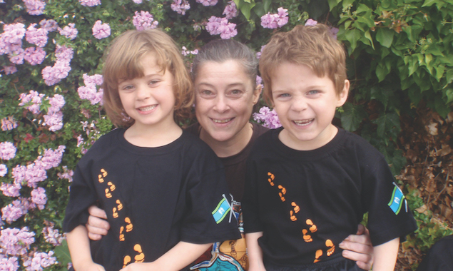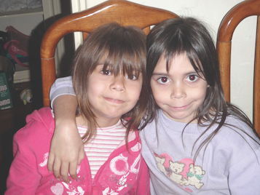

Access to published research
All researchers who have access to the NCLD data sets are required under licence to make their research publicly available, if appropriate. Researchers must upload bibliographic details of their research that used Footprints in Time, or any of the NCLD’s longitudinal studies, into a publicly available and searchable database at http:/flosse.dss.gov.au.

Contacts
Specific queries concerning Footprints in Time or other NCLD data sets and research can be directed to NCLDresearch@dss.gov.au.
General queries concerning any of the NCLD’s studies should be directed to NCLD@dss.gov.au.

Acknowledgements
DSS thanks the LSIC Steering Committee for its continuing contribution to the study. Committee members involved in the development of Waves 6–10 were:
- Professor Mick Dodson AM, National Centre for Indigenous Studies, Australian National University (Chair)
- Associate Professor Karen Martin, University of Queensland (Deputy Chair)
- Ms Samantha Faulkner, Department of the Prime Minister and Cabinet
- Mrs Romina Fujii, Torres Strait Regional Authority
- Mr Matthew James, Department of the Prime Minister and Cabinet
- Dr Shane Johnson, Department of the Prime Minister and Cabinet
- Dr Vanessa Lee, University of Sydney
- Associate Professor Raymond Lovett, Australian National University
- Mr Brendan Moyle, Department of Social Services
- Professor Lester-Irabinna Rigney, University of South Australia
- Professor Ann Sanson, The University of Melbourne
- Mr Napau Pedro Stephen, Torres Strait Regional Authority
- Mr Paul Stewart, Cricket Australia
- Professor Maggie Walter, University of Tasmania
- Mrs Patricia Yusia, Torres Strait Regional Authority
- Professor Stephen Zubrick, University of Western Australia, Telethon Kids Institute.
DSS also thanks the survey design teams who gave their time and expertise to develop and source questions for the study:
- Psychological Wellbeing design group: Stephen Zubrick (Chair), Sheree Cairney, Raymond Lovett, Ruth Nicholls, Jason Payne, Michelle Quee, Peter Radoll, Ann Sanson and Rosie Stevens
- Racism and Identity design group: Gawaian Bodkin-Andrews (Chair), Bindi Bennett, Bronwyn Carlson, Cheryl Kickett-Tucker, Karen Martin, Bob Morgan, Naomi Priest and Maggie Walter
- Health design group: John Evans (Chair), Jasmine Lyons, Tim Olds, Gurmeet Singh, Katie Thurber and Stephen Zubrick
- Education design group: Karen Martin (Chair), Clair Andersen, Nick Biddle, Gawaian Bodkin-Andrews, Michael Donovan, Gina Milgate and Grace Sarra.
DSS acknowledges the support of state and territory departments of education in the collection and analysis of LSIC data.
Unless otherwise stated, all articles in this report were written by NCLD staff members. These authors are predominantly non-Indigenous and have worked in the content design and data management teams of LSIC. Authors have backgrounds in various areas of research and analysis, including psychology, linguistics, economics, mathematics and social studies. Indigenous NCLD staff members with experience in content design contributed to some articles.

Overview of Footprints in Time
Footprints in Time is an Australian Government initiative. The study is conducted by DSS and is overseen by the Footprints in Time Steering Committee, chaired by Professor Mick Dodson AM.
The principal aim of the Footprints in Time study is to follow the developmental pathways of Aboriginal and Torres Strait Islander children to discover what helps Indigenous children ‘grow up strong’. To facilitate this, the predominantly Indigenous LSIC Steering Committee determined that the study design and research questions should be driven by Aboriginal and Torres Strait Islander ways of knowing, being and doing. A comprehensive overview of the study’s early days can be found in Chapter 3 of Walter, Martin and Bodkin-Andrews’ (eds.) 2017 book, Indigenous Children Growing Up Strong. A brief history is provided in the next section of this report.
The Footprints in Time key research questions, which were developed and endorsed by the LSIC Steering Committee, are as follows:
- What do Aboriginal and Torres Strait Islander children need to have the best start in life to grow up strong?
- What helps Aboriginal and Torres Strait Islander children to stay on track or to get them to become healthier, more positive and strong?
- How are Aboriginal and Torres Strait Islander children raised?
- What is the importance of family, extended family and community in the early years of life and when growing up?
The study provides information for individuals, families, communities, service providers, researchers and governments to design and implement culturally appropriate policies and programs to improve outcomes for Aboriginal and Torres Strait Islander children.
The principal aim of the Footprints in Time study is to follow the developmental pathways of Aboriginal and Torres Strait Islander children to discover what helps Indigenous children ‘grow up strong’

The history of Footprints in Time: ‘how’ is as important as ‘what’ and ‘why’
Footprints in Time had its genesis in an international, interdisciplinary desire to understand how early childhood contributes to later life outcomes (McCain & Mustard, 1999; National Research Council, Institute of Medicine & Committee on Integrating the Science of Early Childhood Development, 2000). At the time, the Australian Government desired a longitudinal evidence base from which to identify risk and protective factors for children and families, as well as to find ways of preventing issues or intervening early to support families. Growing Up in Australia: LSAC was funded through the (then) Department of Family and Community Services (FaCS) in the 2000–2001 Federal Budget as a nationally representative longitudinal study (Sanson et al., 2002).
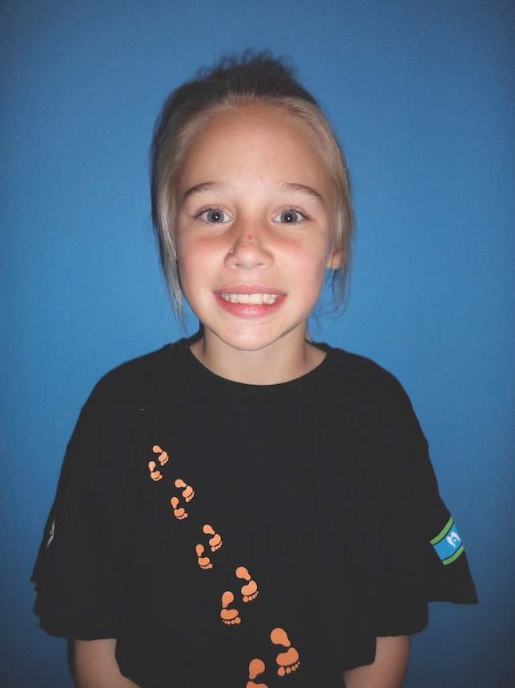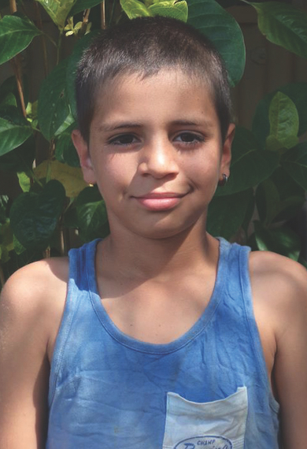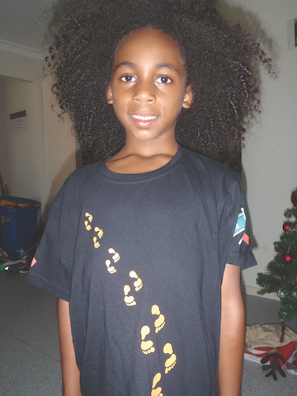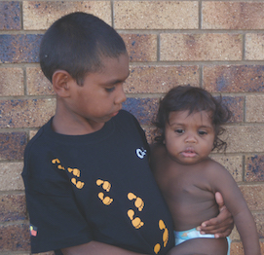
In 2003, LSAC recruited 10,000 children across Australia, of whom only a small number of Indigenous children (who comprised only 4.8 per cent of the 0–5 age population in Australia) were invited to be part of the study. Remote areas were excluded from the LSAC sample frame because only two per cent of Australian children lived in remote Australia, and interviewing costs in remote areas were (and remain) prohibitive. However, one-quarter of Aboriginal and Torres Strait Islander children live in remote areas. Crucially, the LSAC design had not included consultation about a longitudinal children’s study with Aboriginal and Torres Strait Islander peoples. The limited capacity for LSAC to report on outcomes for Indigenous children led to calls for a separate study that was intended specifically for Aboriginal and Torres Strait Islander children.
In the 2003–2004 Federal Budget, the Australian Government funded the development of a longitudinal study of Indigenous children, with two years allowed for consultation with Aboriginal and Torres Strait Islander communities and study design. Professor Dodson agreed to chair a predominantly Indigenous Steering Committee of academics and government agency representatives with expertise in Indigenous child development, health, education, families, community engagement, Indigenous studies and research design. The LSIC Steering Committee’s terms of reference are to shape the design and implementation of the study and to provide advice about:
- community engagement
- ethical and cultural protocols
- data analysis, interpretation and reporting
- how the data might address policy and service delivery issues.
The first meeting of the LSIC Steering Committee was held on 31 October 2003, with a Welcome to Ngunnawal Country provided by Ms Violet Sheridan. At the meeting, the Secretary of FaCS, Mr Mark Sullivan, acknowledged that, although the Department was accountable for the funds and responsible to the government for expenditure and outcomes, the study would rely heavily on the Committee to make ‘go’ or ‘no go’ decisions. Professor Dodson said that the onus was on the Committee to ensure research excellence via the level and quality of its advice.
In addition to establishing a Steering Committee, FaCS held a large design meeting in Canberra, engaged Professor Penman to write a literature review (Penman, 2006a), and employed Indigenous staff members to organise and conduct Australia-wide consultations. Meetings about the study were held in every capital city and in at least one regional and/or remote area of each state and territory. A comprehensive account of these meetings was published in Occasional Paper 16: Aboriginal and Torres Strait Islander views on research in their communities (Penman, 2006b). The consultations highlighted the challenges for such a study, including a lack of trust in researchers and a suspicion of the research benefits for Indigenous people. The key messages of the study design were to:
- work collaboratively with communities to build trust
- ensure Aboriginal and Torres Strait Islander involvement in every aspect of the research, particularly the interviewing
- focus on strengths, resilience, and what can lead to better futures for Indigenous children
- give the findings back to participants and their communities.
The Steering Committee was keen to focus on the ‘how’ of doing such a study as well as on what might contribute to better outcomes for Aboriginal and Torres Strait Islander children. With this context in mind, the study commenced community trials in the Torres Strait region—a very remote area—and in the ACT and Queanbeyan, NSW, an urban/regional area. These trials were conducted collaboratively with the Cooperative Research Centre for Aboriginal Health (now the Lowitja Institute) and the Telethon Institute for Child Health Research (now the Telethon Kids Institute).
They were designed to test how relationships could and should be built with communities, service providers and families to develop the practical methodologies and logistics of the study. Two reports summarise the findings and lessons that were learned from these trials (Cooperative Research Centre for Aboriginal Health, the Telethon Institute for Child Health Research & FaCSIA, 2006, 2008).
In 2006, the first pilots were conducted for Footprints in Time by the Australian Bureau of Statistics (ABS) in partnership with FaCS, which employed Indigenous community liaison officers to assist. At the same time, the Department sought to secure further funding for the first waves of the study to recruit families for a longitudinal study rather than for one interview only. The desire to include children living in remote areas and the ethical obligation to build in feedback meant that the cost of a nationally representative longitudinal study of Indigenous children was prohibitive. A revised, site-based approach was developed and funded using a model that incorporated FaCS-employed Indigenous interviewers for face-to-face (computer -based) interviewing. Sites were selected based on existing relationships that were developed through the pilots because these had sizeable populations of Indigenous children aged 0–5 years and incorporated remote, regional and urban Australia. Further information about sampling and initial recruitment can be found in the wave reports on the LSIC website and in the Indigenous Children Growing Up Strong book (Department of Social Services, 2019; Walter, Martin & Bodkin-Andrews, 2017).
The timeline in Table 0.1 shows the development of the study in the context of significant events and social policy changes for Indigenous Australians. These have occurred while the study children grew from babies to toddlers, through primary school and into high school.
Many members of the Steering Committee and the study team have been with the study for more than a decade, and LSIC is part of their life stories. Looking back and looking forward, the LSIC team pays respect to the study families and children, their Elders and communities, and the continuing cultures of Aboriginal and Torres Strait Islander peoples.

Table 0.1 Timeline of Footprints in Time
Year | LSIC events | National events
2003 | First of LSIC K cohort is born LSIC funded and Steering Committee established
2004 |  | Aboriginal and Torres Strait Islander Commission abolished
2005 | LSIC community trials in the Torres Strait and ACT
2006 | First of LSIC B cohort is born
2007 | LSIC sample recruited | - COAG commits to Closing the Gap  - National Indigenous TV launched  - Northern Territory Emergency Response
2008 | Wave 1 in field | Apology to the Stolen Generations
2009 | Wave 2 data collection | - Professor Mick Dodson named Australian of the Year  - Australia signs United Nations Declaration on the Rights of Indigenous Peoples
2010 | Wave 3 data collection | Ken Wyatt is the first Aboriginal person elected to the Australian House of Representatives
2011 | Wave 4 data collection
2012 | Wave 5 data collection | School Enrolment and Attendance Measure (SEAM)
2013 | Wave 6 data collection | Nova Peris is the first Aboriginal woman elected to the Australian Parliament
2014 | Wave 7 data collection | Adam Goodes named Australian of the Year
2015 | Wave 8 data collection
2016 | Wave 9 data collection | Linda Burney is the first Aboriginal woman elected to the Australian House of Representatives
2017 | Wave 10 data collection Indigenous Children Growing Up Strong published | Uluru Statement from the Heart
2018 | Wave 11 data collection
2019 | Wave 12 data collection | - International Year of Indigenous Languages  - Ken Wyatt appointed Minister for Indigenous Australians and first Indigenous Cabinet Minister
2020 | Wave 13 data collection | New Closing the Gap targets announced

Important notes for reading this report
The analysis in this report is based on Release 9.0 of the Footprints in Time data and on Wave 10 preliminary data. Using earlier or later releases of the data may yield slightly different results.
The report has been written primarily by non-Indigenous DSS data analysts. While every effort has been made to interpret the data within Indigenous contexts, there may be instances in which a greater understanding of Indigenous cultures might have aided interpretation. It is strongly encouraged that potential users of the data draw on the strengths of interdisciplinary approaches with Indigenous collaborators.
The various topics covered in this report highlight both the richness of the longitudinal data and the potential for further research. Part A contains information about data collection, response rates and the development of new data items. Part B consists of feature articles containing Footprints in Time research findings. Readers may also wish to refer to earlier reports for more details about the development phase of the study and for results from the first five waves.
As a longitudinal study, Footprints in Time provides a unique opportunity to follow the development of a group of Indigenous children and to examine the factors that contribute to their outcomes. The children are divided into two cohorts—previously, these had been referred to as the ‘B cohort’ and the ‘K cohort’; however, for ease of comprehension, this report uses the terms ‘younger cohort’ and ‘older cohort’, respectively. The younger cohort consists of children born in 2006, 2007 and 2008 and the older cohort of children born in 2003, 2004 and 2005 (see Table 0.2).
Due to the study’s cross-sequential design, children in the younger cohort were approximately the same age in Waves 7, 8 and 9 as those in the older cohort were in Waves 4, 5 and 6, respectively. With nine waves of annual data, this allows for the data to be merged across cohorts to examine a larger sample of children aged 3.5–9 years.
Table 0.2 Ages of children in Footprints in Time, Waves 1–10 (2008–2017)
 | Wave  1 | Wave  2 | Wave  3 | Wave  4 | Wave  5 | Wave  6 | Wave  7 | Wave  8 | Wave  9 | Wave 10
 | 2008 | 2009 | 2010 | 2011 | 2012 | 2013 | 2014 | 2015 | 2016 | 2017
Younger cohort  (born  2006–2008) | Age  0–1 | Age  1–2 | Age  2–3 | Age  3–4 | Age  4–5 | Age  5–6 | Age  6–7 | Age  7–8 | Age  8–9 | Age  9–10
Older cohort  (born  2003–2005) | Age  3–4 | Age  4–5 | Age  5–6 | Age  6–7 | Age  7–8 | Age  8–9 | Age  9–10 | Age  10–11 | Age  11–12 | Age  12–13
Most of the information in the study is collected from the study child and their primary carer (P1). If possible, interviewers return to the same P1 each year; however, sometimes the parent or carer is unavailable, has limited time or is no longer living with the study child, so a different carer is interviewed. Each year, between four and six per cent of interviews involve a different P1 from the previous interview. Although more than 85 per cent of children in Wave 10 (2017) had a P1 who was either their mother or their father, some P1s were study children’s grandparents (seven per cent), other relatives or foster parents. The P1s were predominantly women (94–98 per cent in Waves 1–10). Although all the study children are Indigenous, around 17 per cent of P1s interviewed in any given year during Waves 1–10 were not.
Although Footprints in Time was not designed based on a representative sample, it does include a sizeable population of Indigenous children and their families from urban, regional, remote and very remote areas. Two measures of remoteness are available in the data and are used in this report: the ABS Remoteness Areas (RA), and the Level of Relative Isolation (LORI), which was originally developed for the Western Australian Aboriginal Child Health Survey (Zubrick et al., 2004). Figure 0.1 compares the geographic distribution of the Footprints in Time respondents in 2016 according to these two measures and contrasts it with the Aboriginal and Torres Strait Islander population and the entire Australian population based on the 2016 Census estimates (ABS, 2018a).
Figure 0.1 Geographic distribution of Footprints in Time respondents in 2016, by RA and LORI—
per cent
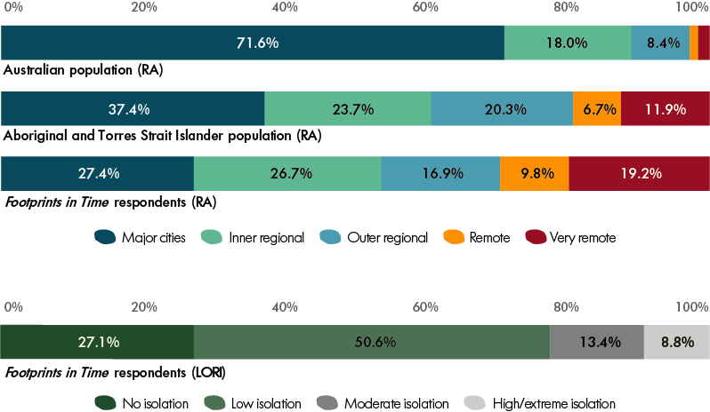
Note: Footprints in Time n = 1,264. Australian population estimates are sourced from ABS (2018), Estimates of Aboriginal and Torres Strait Islander Australians, June 2016, ABS Cat. No. 3238.0.55.001.
Very remote areas in the RA measure roughly correspond to LORI areas of moderate, high and extreme of isolation, while LORI areas of low isolation comprise RA inner regional, outer regional and (most) remote areas. The choice of the appropriate remoteness or isolation measure depends on the research topic.
Unless specifically stated, the percentages provided in this report are based on completed responses and exclude ‘don’t know’ and ‘refused’ responses. In reporting the data, the number of valid responses is provided for reference.
The terms ‘average’ and ‘mean’ are used interchangeably in this report, as are the terms ‘significant’ and ‘statistically significant’. Significance tests have been conducted where applicable and, unless otherwise stated, the term ‘significant’ may be assumed to mean a 95 per cent probability level (p < 0.05).
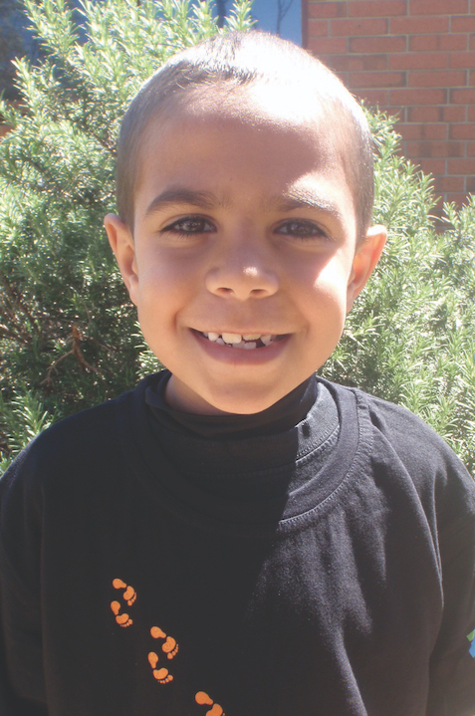

Ethics
DSS seeks national clearance each year for new questions and procedures in Footprints in Time (e.g. the distress protocol and a privacy brochure) before the pilot interviews and the main wave of data collection.
National-level ethical clearance for the study is sought from the Australian Institute of Aboriginal and Torres Strait Islander Studies (AIATSIS) Ethics Committee, which was chosen as the primary Human Research Ethics Committee (HREC) for the study after the Department of Health HREC was disbanded. AIATSIS provides national and international guidance regarding the ethical practice of research concerning Indigenous peoples across Australia.
Additionally, state and territory and/or regional ethics clearance and support have been obtained for all Footprints in Time sites through state and territory HRECs or their equivalents, in accordance with the NHMRC and AIATSIS guidelines.
State and territory departments of education and Catholic dioceses were consulted to gain permission and support for school teachers to complete questionnaires about the study children. State and territory departments managing out-of-home care were also consulted.
Participant wellbeing is extremely important to everyone involved in Footprints in Time. If at any stage of the interview parents, carers or study children are distressed, or report distress, Footprints in Time interviewers follow HREC-approved protocols to make sure participants are safe.
If you have any concerns or complaints, you can contact the Executive Officer of the AIATSIS Human Research Ethics Committee at 51 Lawson Crescent, Acton, ACT 2601, or by email at Ethics@aiatsis.gov.au.

What has changed for LSIC families since the first interviews?
Ten years can be a long time for a family. Footprints in Time babies and children are now young adults, and their family lives look different. Parents and carers have gained employment, moved house or have had more children. This section provides some insights into the changes and trends that families in Footprints in Time experienced over the last 10 years.

Primary carer education, employment and income
The most dramatic changes in the living situation of families over the 10 waves of data collection were changes in the education and employment of the primary carers (P1s).
When the study began interviewing P1s about their babies and children, many of the parents were not working. Only about one-quarter (25.8 per cent) of P1s of one-year-old study children were employed, compared to nearly one-half (49.9 per cent) of P1s of 13-year-olds (see Figure 0.2).
Figure 0.2 Employment and education of primary carers, by study child age—per cent
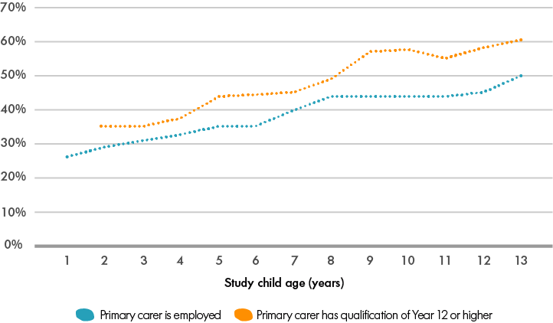
Note: These data are restricted to study children who have had the same primary carer from wave to wave. Observations for each year of age are pooled across cohorts and waves. The number of observations varies by the study child’s year of age; for the employment indicator, it is highest for 4-year-olds (n = 1,305) and lowest for 13-year-olds (n = 385); for the education indicator, it is highest for 6-year-olds (n = 1,177) and lowest for 13-year-olds (n = 382).
The level of P1s’ education also varied by the study child’s age (see Figure 0.2). Among P1s of 2-year-old study children, 34.9 per cent had a Year 12 qualification or above, compared with 59.4 per cent of P1s of 13-year-old study children. This significant increase is consistent with high proportions of P1s (on average about 13 per cent in Waves 1–9) who said they were pursuing further studies at the time of the interview.
As well as the employment status of the P1s, the main income source of the study families also varied with the study children’s age. Wages and salaries were the main source of income for 38.8 per cent of families when the study child was 1 year old, while by the time the study child was 13 years old, 59.2 per cent of families reported wages and salaries as their main source of income.

Family composition
LSIC began with a relatively young cohort of P1s: in Wave 1, the median age of P1s was 28 years. The overwhelming majority of the P1s are women, although this proportion has declined from just under 98 per cent in Wave 1 to 94 per cent in Wave 10. Single-parent families are more common among Footprints in Time respondents than the Australian population in general; in 2012, 15 per cent of families in Australia were single-parent families (ABS, 2013), compared to 40 per cent of Footprints in Time households.
The number of P1s who are the study children’s biological parents has continuously declined during the study, while the number of P1s who were otherwise related (such as grandparents and aunties) has increased (see Figure 0.3).
Figure 0.3 Proportion of primary carers by relation to study child, Waves 1–10—per cent (2008–2017)
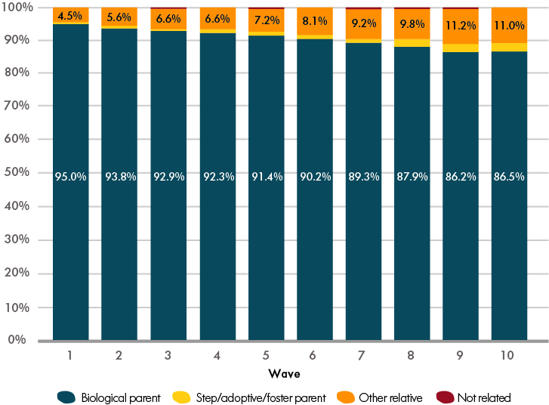

Housing and community
In each wave of data collection, primary carers were asked whether they had experienced problems with housing. In Wave 1, 38.7 per cent of primary carers said that they had experienced housing problems. Between Waves 4 and 9, there was a consistent decrease in housing problems among the study cohort; in Wave 10, however, these problems increased from 27.1 per cent to 36.1 per cent (see Figure 0.4). Although the sudden increase in housing problems in Wave 10 was statistically significant, it remains to be seen whether this represents an emerging trend. Some of these changes could also be attributed to varying rates of attrition (i.e. families with more stable housing could be less likely to move, easier to follow up for reinterview or more willing to continue participating in the study).
Figure 0.4 Proportion of families experiencing housing problems, Waves 1–10 (2008–2017)—per cent
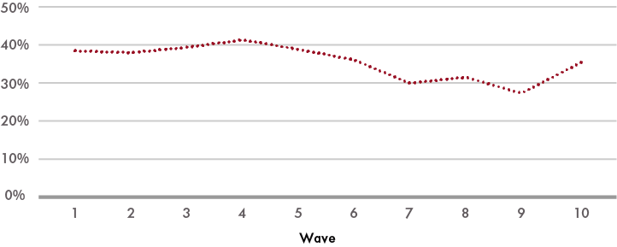
Housing tenure has also changed during the course of the study. In Wave 1, 61.2 per cent of primary carers said they were renting from a government organisation; by Wave 10, this figure had decreased to 41.3 per cent (see Figure 0.5). In line with this, the proportion of families paying off a mortgage or owning their houses outright increased from 17.1 per cent in Wave 1 to 22.5 per cent in Wave 10. Data on the proportion of families renting from Indigenous Community Housing Organisations (ICHO) was not separately collected until Wave 3, when it was added as a distinct category. Since then the proportion increased from 1.3 per cent in Wave 3 to 9.1 per cent in Wave 10.
Figure 0.5 Source of housing for primary carers, Waves 1–10 (2008–2017)—per cent
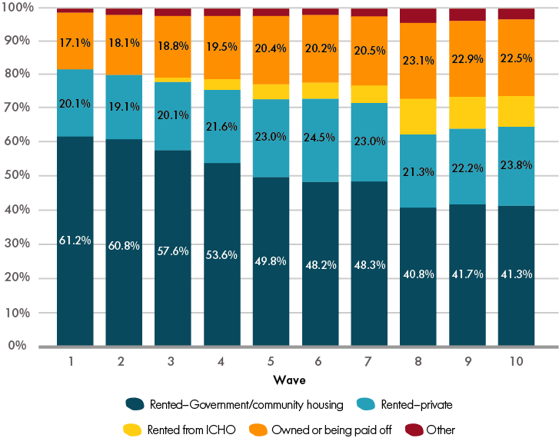
Note: Separate collection of survey data on housing rented from ICHO began in Wave 3.
There were also some changes in the proportions of families who lived in remote, regional and urban areas of Australia over the 10 years of data collection. In Wave 1, 25.9 per cent of LSIC families lived in urban areas, 38.4 per cent in inner and outer regional areas, and 35.7 per cent lived in remote or very remote locations (see Figure 0.6). By Wave 10, the proportions of urban and regional families among respondents had increased, while the proportion of families living in remote areas had fallen to 30 per cent overall.
Figure 0.6 Proportions of LSIC families living in urban, regional and remote locations, Waves 1 and 10 (2008–2017)—per cent
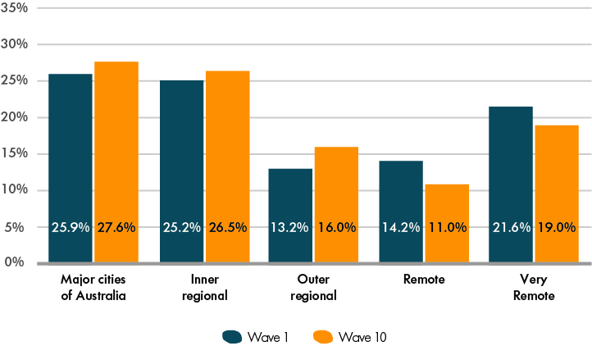
One possible explanation for this apparent increase in the proportions of families living in urban and regional areas could be the varying rates of attrition depending on area remoteness (this is discussed in greater detail in Chapter 1). Another could be families moving to locations that would provide better educational opportunities for the study children or better employment opportunities for P1s.
When asked about the reasons for moving house, the top three answers that P1s gave were ‘wanted a bigger or better home’, ‘[moved because of] allocated housing’ and ‘to be close to family or friends’. Earlier analysis using Footprints in Time data showed that the reasons for moving differed depending on whether the family stayed within their local area or moved to a new area (DSS, 2015). In particular, moving to a new area was correlated significantly with the P1 getting a new job or returning to study. At the same time, families with children who were old enough to attend school were less likely to move.
Figures 0.7 and 0.8 provide more insight into how LSIC families relocated between Waves 1 and 10. Each original study site is depicted in a different colour. Figure 0.7 displays study families’ original locations in Wave 1, while Figure 0.8 shows their locations in Wave 10. In Wave 1, study families were chosen from 11 distinct locations in remote, regional and urban areas. By Wave 10, many of the families have moved—both within the same state or territory (as can be observed by the spread of the original families from the Dubbo area in NSW) and to different states and territories (e.g. some of the families from the Alice Springs area have moved to SA, NSW and QLD).
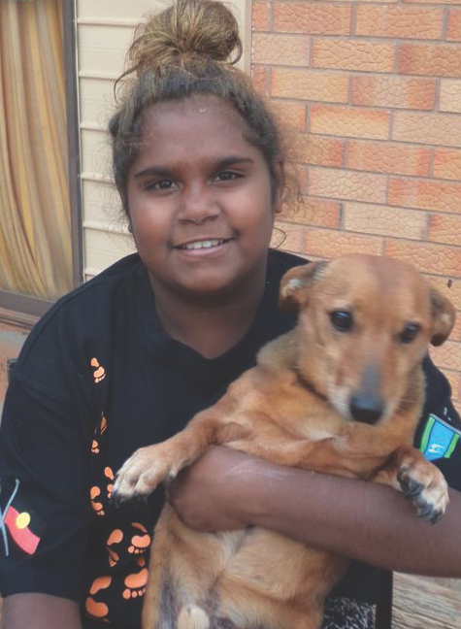
Figure 0.7 LSIC respondents by original location, Wave 1
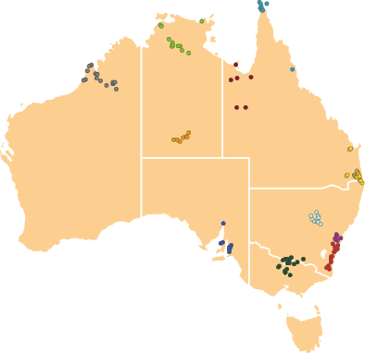
Figure 0.8 LSIC respondents’ locations, Wave 10
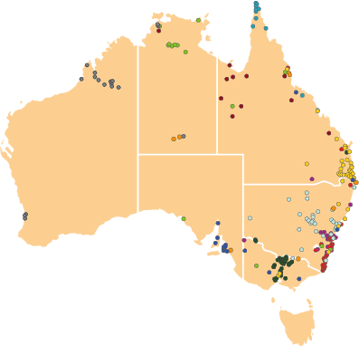

Children’s health
Overall, the study children enjoy good health, with 70–80 per cent of P1s reporting excellent or very good health for study children between the ages of 1 and 13 years. Figures 0.9–0.13 summarise the prevalence of specific health conditions that the study children experienced. For some of the conditions (such as ear problems and developmental delays), there was no significant variation in prevalence based on the age of the study child. However, for eye, skin and dental problems, age-related effects were observed.
The proportion of study children who had ear problems was relatively stable at 12–17 per cent (see Figure 0.9); a small proportion (under 5 per cent) of study children were identified by their P1s as having a developmental delay (see Figure 0.10). The frequency of eye problems increased significantly leading up to age nine and remained between 12 and 15 per cent since then (see Figure 0.11). Skin conditions were more prevalent among younger children, at 14 per cent for two-year-old children as opposed to 5 per cent among twelve-year-old children (see Figure 0.12). At the same time, there was a consistent increase in the study children’s dental problems until age eight, when dental problems began to decline (see Figure 0.13). The dental health of the study children is discussed in more depth in Chapter 7.
In the following graphs, Figures 0.9–0.13, observations for each year of age are pooled across cohorts and waves.
Figure 0.9 Proportion of study children with ear problems—per cent
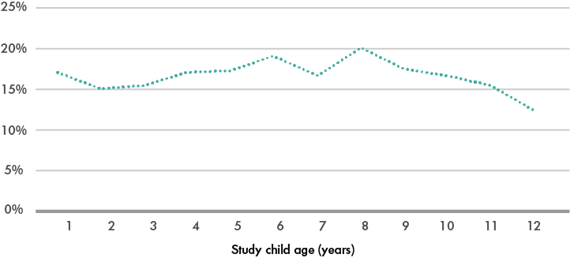
Figure 0.10 Proportion of study children with developmental delay—per cent
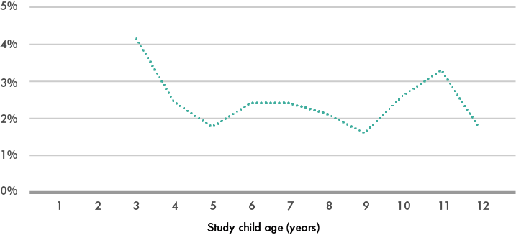
Figure 0.11 Proportion of study children with eye problems—per cent
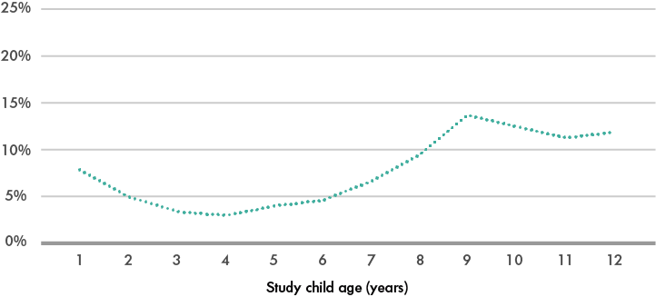
Figure 0.12 Proportion of study children with skin problems—per cent
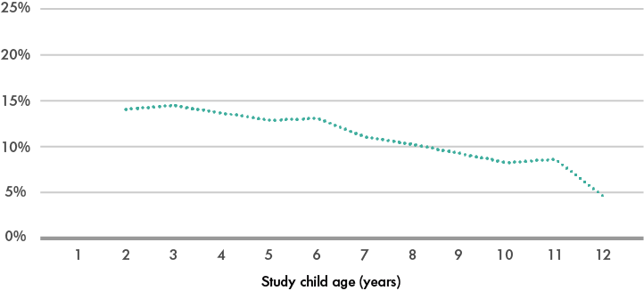
Figure 0.13 Proportion of study children with dental problems—per cent
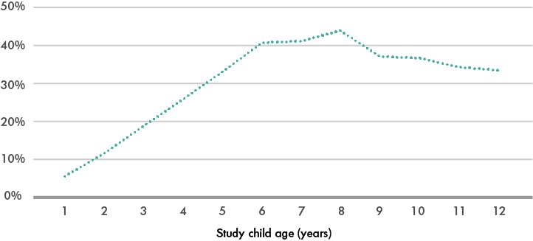

Technology
Information and communications technology is becoming increasingly integrated into many areas of Australian life. Data from Footprints in Time show that, in 2015:
- 15.6 per cent of study children had their own mobile phone
- 72.0 per cent of P1s reported that their household had internet access, compared to 97 per cent of Australian households with children under the age of 15 in 2016–2017 (ABS, 2018b)
- 95.6 per cent of study children had access to a computer (at home, school or elsewhere), but only 55.0 per cent were using a computer at home
- although children predominantly used computers to play games or watch television/movies, 39.4 per cent of children with access to a computer used it to do homework.
Figures 0.14 and 0.15 show that the use of computers and the internet by the study children at school and at home increased with school year level. The drop in rates of home internet use in Year 6 could be partly attributed to the smaller sample size for that year group.
Figure 0.14 Computer use of children in Footprints in Time by school year level, Waves 6 and 8 (2013, 2015)—per cent
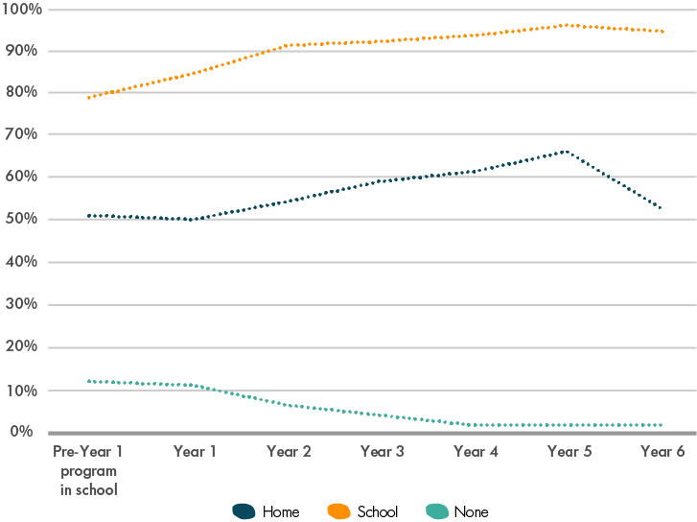
Note: The figure includes data on 1,414 study children combined across two points, with a total of 2,431 observations.
Figure 0.15 Internet use of children in Footprints in Time by school year level, Waves 6 and 8 (2013, 2015)—per cent
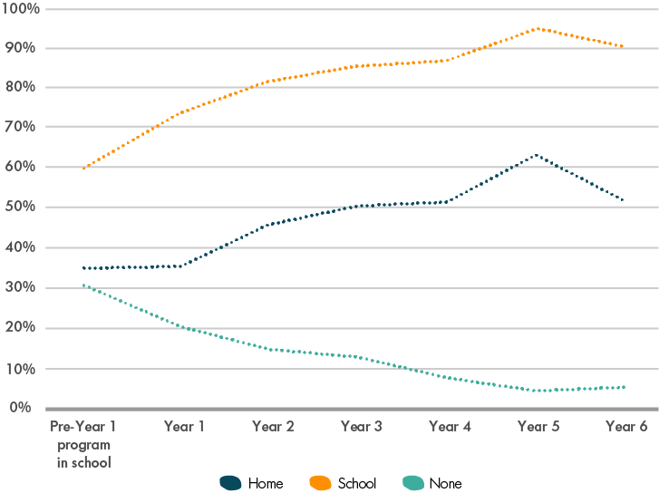
Note: The figure includes data on 1,386 study children combined across two time points, with a total of 2,346 observations.
Children’s access to technology at home was found to be significantly associated with the socio-economic characteristics of the family, such as the P1’s level of education and whether the family received income from wages and salaries. Remoteness was also a significant factor, with children in areas of high or extreme isolation having significantly lower rates of home access to technology compared with children living in urban areas: three times lower for computers and five times lower for internet access.
Computer and internet use have been found to be positively associated with children’s literacy and numeracy (Casey, Layte, Lyons & Silles, 2012; Fiorini, 2010). Analysis of the Footprints in Time reading (Wave 8, 2015) and mathematics (Wave 6, 2013) tests showed that, even after accounting for a range of child and family characteristics, the use of computers and the internet at home was associated with higher reading scores. Maths scores were also found to be higher for children who used the internet at home.

References
Australian Bureau of Statistics. (2013). Labour Force, Australia: Labour force status and other characteristics of families, June 2012, ABS Catalogue No. 6224.0.55.001.
Australian Bureau of Statistics. (2018a). Estimates of Aboriginal and Torres Strait Islander Australians, June 2016, ABS Catalogue No. 3238.0.55.001.
Australian Bureau of Statistics. (2018b). Household use of information technology, Australia, 2016–17, ABS Catalogue No. 8146.0.
Casey, A., Layte, R., Lyons, S. & Silles, M. (2012). Home computer use and academic performance of nine-year-olds. Oxford Review of Education, 38(5), 617–634.
Cooperative Research Centre for Aboriginal Health, the Telethon Institute for Child Health Research, and the Department of Families, Community Services and Indigenous Affairs. (2006). Occasional paper No.17—Growing up in the Torres Strait region: A report from the Footprints in Time trials. Canberra, ACT: FaHCSIA.
Cooperative Research Centre for Aboriginal Health, the Telethon Institute for Child Health Research, and the Department of Families, Community Services and Indigenous Affairs. (2008). Occasional paper No.20—Stories on ‘growing up’ from Indigenous people in the ACT metro/Queanbeyan region. Canberra, ACT: FaHCSIA.
Department of Families, Housing, Community Services and Indigenous Affairs. (2011). Footprints in Time: The Longitudinal Study of Indigenous Children—Key Summary Report from Wave 2. Canberra, ACT: FaHCSIA.
Department of Social Services. (2015). Footprints in Time: The Longitudinal Study of Indigenous Children—Report from Wave 5. Canberra, ACT: DSS.
Department of Social Services. (2019). Footprints in Time – The Longitudinal Study of Indigenous Children. Retrieved from https://www.dss.gov.au/lsic
Fiorini, M. (2010). The effect of home computer use on children’s cognitive and non-cognitive skills. Economics of Education Review, 29(1), 55–72.
McCain, M. & Mustard, F. (1999). Reversing the real brain drain: Early Years Study Final Report. Toronto, Canada: Ontario’s Children’s Secretariat.
National Research Council (US), Institute of Medicine (US), and Committee on Integrating the Science of Early Childhood Development. (2000). From neurons to neighborhoods: The science of early childhood development. Washington, DC: National Academies Press.
Penman, R. (2006a). Occasional paper No.15—The ‘growing up’ of Aboriginal and Torres Strait Islander children: A literature review. Canberra, ACT: FaHCSIA.
Penman, R. (2006b). Occasional paper No.16—Aboriginal and Torres Strait Islander views on research in their communities. Canberra, ACT: FaHCSIA.
Sanson, A., Nicholson, J., Ungerer, J., Zubrick, S., Wilson, K., Ainley, J., … & Wake, M. (2002). Introducing the Longitudinal Study of Australian Children: LSAC Discussion Paper No.1. Melbourne, VIC: Australian Institute of Family Studies.
Walter, M., Martin, K. & Bodkin-Andrews, G. (Eds.) (2017). Indigenous children growing up strong. London, UK: Macmillan Publishers Ltd.
Zubrick, S.R., Lawrence, D.M., Silburn, S.R., Blair, E., Milroy, H., Wilkes, T., … & Doyle, S. (2004). The Western Australian Aboriginal Child Health Study: The health of Aboriginal children and young people (Vol. 1). Perth, WA: Telethon Institute for Child Health Research.
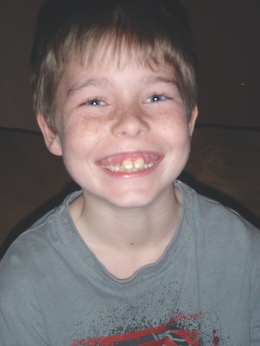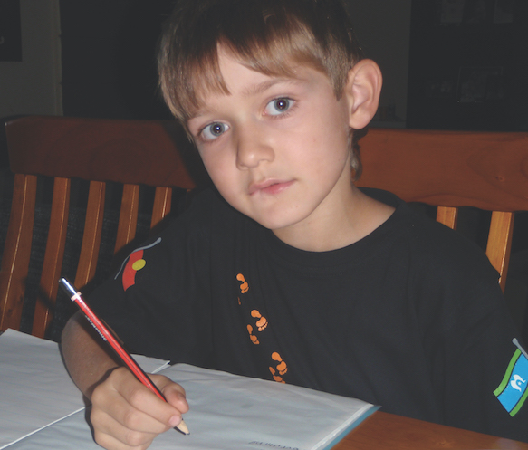
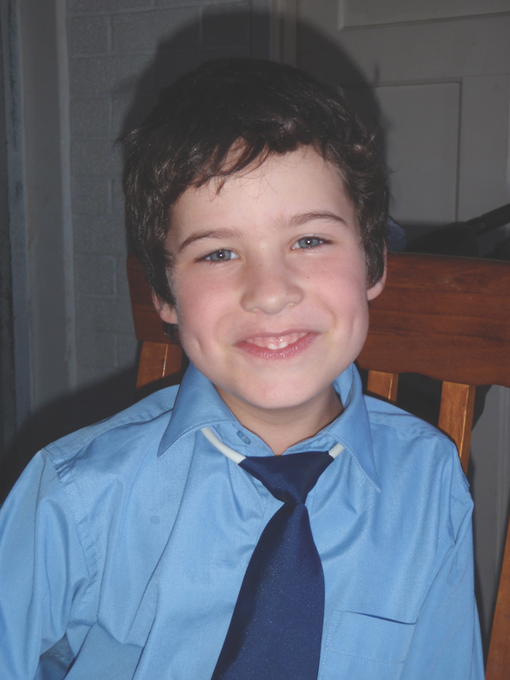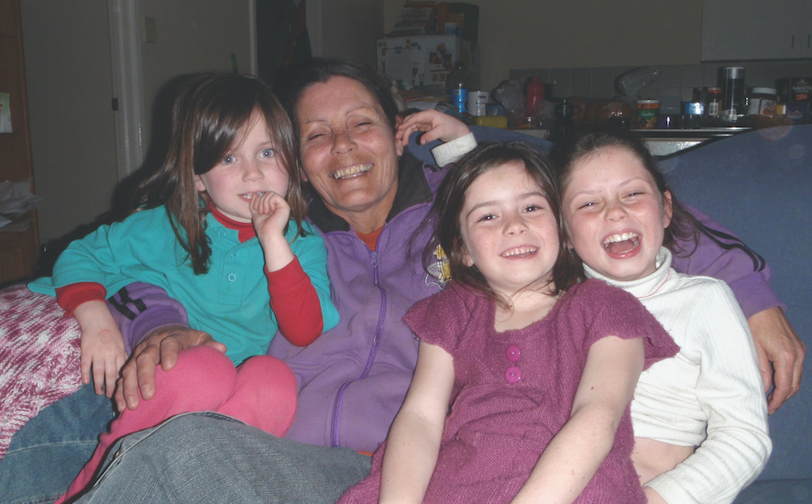
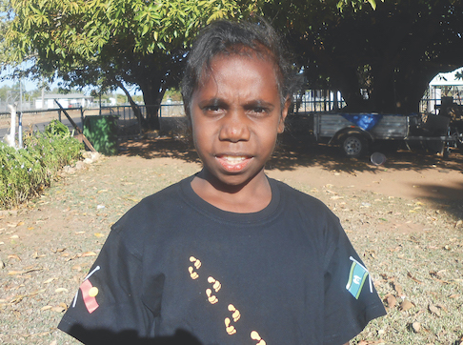
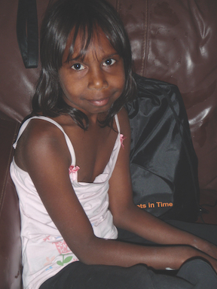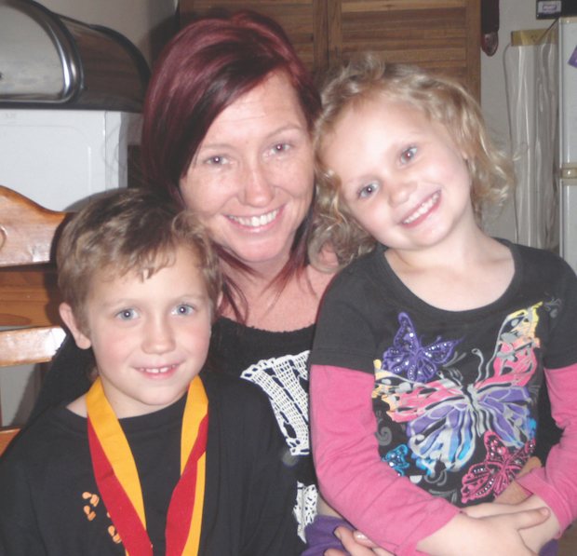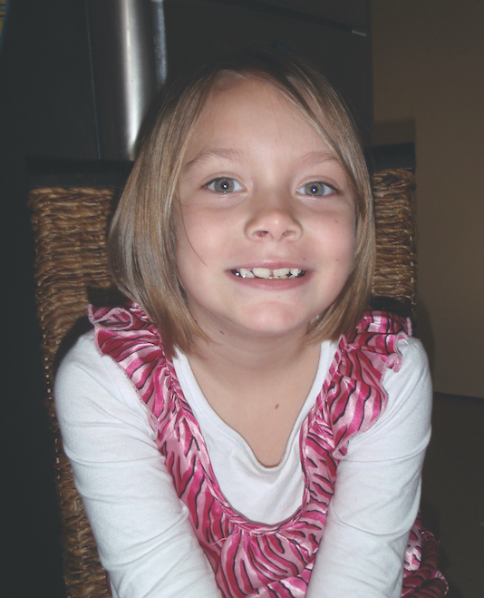

Part A—Data Collection
- Response rates
Wave 1 began in 2008, with 1,671 interviews with primary carers (P1). An additional 88 new P1 interviews were undertaken in Wave 2. There have been no additions since Wave 2. Therefore, when measuring retention or attrition, we usually measure the proportion of the original Wave 1 respondents who were re-interviewed with respect to the Wave 1 sample size (see the right-hand column of Table 1.1).
The total number of interviews completed in each wave is shown in Figure 1.1. While there was some attrition in the first few waves, the number of P1 and study child interviews has been stable since Wave 4.
Table 1.1 Footprints in Time re-interview rates, Waves 1–10 (2008–2017)
Wave | Re-interview rates of previous wave respondents, per cent | Re-interview rates of Wave 1 respondents, per cent
Wave 1 | – | –
Wave 2 | 85.9 | 85.9
Wave 3 | 86.1 | 79.8
Wave 4 | 81.9 | 72.8
Wave 5 | 85.5 | 71.8
Wave 6 | 84.9 | 70.7
Wave 7 | 86.7 | 71.6
Wave 8 | 87.2 | 71.6
Wave 9 | 89.0 | 72.4
Wave 10 | 87.9 | 72.2
Figure 1.1 Number of completed interviews/surveys, Waves 1–10 (2008–2017)
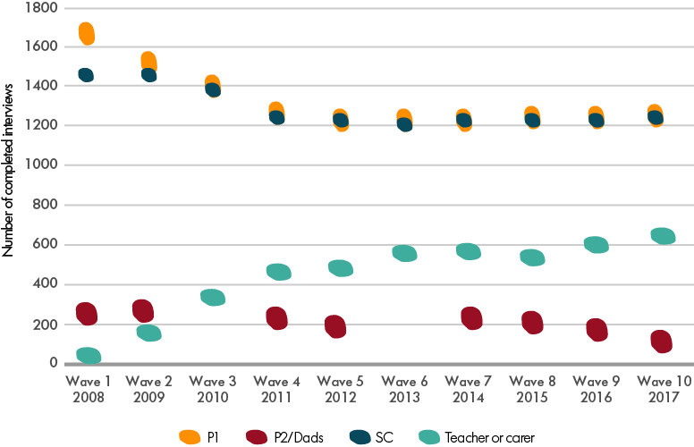
Note: No P2/Dads surveys were administered in Waves 3 and 6.
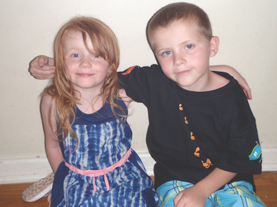
One of the most important factors in undertaking longitudinal analysis is the number of repeat observations for each person in the sample. Families who elect not to participate in one or more waves of the study (or those who we are temporarily unable to locate) can be re-interviewed in the future; however, the problem of missing data subsequently increases each time this occurs. Of those families who were interviewed in Wave 1 (2008), 36.7 per cent have completed an interview in all 10 waves (see Figure 1.2). Almost three-quarters have participated in seven or more waves.
If the characteristics of families who drop out of the study are different from the characteristics of families who continue to participate, attrition (dropout) bias may become a problem. Table 1.2 reports the percentages of children whose P1s participated in all 10 waves of Footprints in Time and the percentages of children whose P1s participated in Wave 10, by selected Wave 1 characteristics.
The highest re-interview rates occur for children who, in Wave 1, lived in urban areas or in locations that were less disadvantaged. P1s had higher re-interview rates if, in Wave 1, they were partnered, if they either owned their own home or were renting privately or if they lived in a wage-earning household.
Nevertheless, there is a relatively high level of participation among all groups. While respondents may not participate in every year of the study, they remain relatively well engaged from year to year, as demonstrated by the Wave 10 re-interview rates.
Figure 1.2 Proportion of participating families by number of waves re-interviewed—per cent
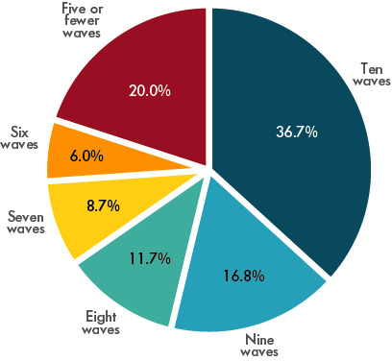
Note: Excludes Wave 2 top-up.
Table 1.2 Percentage of Wave 1 (2008) respondents re-interviewed in later waves, by selected Wave 1 characteristics
Wave 1 characteristics | Number in Wave 1 | Re-interviewed in all waves, per cent | Re-interviewed in Wave 10, per cent
Remoteness area
Major cities | 432 | 50.2 | 78.9
Inner regional | 420 | 48.1 | 79.5
Outer regional | 222 | 31.5 | 65.8
Remote | 252 | 20.2 | 61.5
Very remote | 339 | 20.9 | 66.7
Socio-Economic Indexes for Areas quintile of Index of Relative Disadvantage
First quintile (most disadvantaged) | 951 | 33.1 | 70.2
Second quintile | 301 | 42.2 | 73.1
Third quintile | 203 | 38.4 | 72.4
Fourth quintile | 115 | 48.7 | 74.8
Fifth quintile (most advantaged) | 42 | 47.6 | 81.0
Child’s sex
Male | 850 | 36.2 | 70.1
Female | 821 | 37.3 | 74.4
Child’s Indigenous status
Aboriginal | 1,463 | 37.9 | 72.2
Torres Strait Islander | 109 | 29.4 | 77.1
Both Aboriginal and Torres Strait Islander | 99 | 28.3 | 67.7
Child’s age group
Younger cohort | 964 | 37.9 | 75.0
Older cohort | 707 | 35.2 | 68.5
Primary carer’s sex
Male | 36 | 50.0 | 75.0
Female | 1,635 | 36.5 | 72.2
Primary carer’s Indigenous status
Aboriginal | 1,244 | 34.6 | 70.3
Torres Strait Islander | 110 | 24.5 | 75.5
Both Aboriginal and Torres Strait Islander | 71 | 19.7 | 62.0
Non-Indigenous | 246 | 58.1 | 83.7
Primary carer’s partnership status
Partner in household | 918 | 41.6 | 74.0
No partner in household | 753 | 30.8 | 70.1
Household has wages or salary as a main source of income
Wage-earning household | 675 | 43.7 | 76.7
Non-wage earning household | 968 | 32.0 | 69.1
Home ownership status
Home owner* | 283 | 55.1 | 78.1
Private rental | 325 | 45.5 | 77.5
Public or community housing rental | 1,012 | 29.3 | 69.1
Total
All responding to P1 interview | 1,671 | 36.7 | 72.2
Notes: Data are restricted to the 1,671 families who entered the study in Wave 1. Not all characteristics total 1,671 observations; small numbers of observations with missing data or categories with few values are excluded in some cases.
*Includes paying off the mortgage and owning outright.
- Why families stay in the study
The quality of the data collected in Footprints in Time relies on the continuity of participation. It is important to keep retention rates high and to ensure that the families involved are happy to continue participating in the study. In Wave 6, interviewers asked P1s, ‘Why do you stay in the study?’ Most P1s (91.4 per cent) answered this question, with the most common responses being the importance of providing a voice to the government, that the child looks forward to receiving gifts and birthday cards each year from the NCLD, and that they had positive relationships with the interviewers (RAOs). Many P1s indicated their belief in the study’s importance for building the government’s understanding of Indigenous cultures and providing positive stories.
Some reasons for respondents’ continued participation in Footprints in Time are presented in Table 2.1. The responses are diverse and often passionate, and come from primary carers across Australia who have dedicated many hours to answering questions on almost every topic in the study. They reflect the level of investment that many families feel they have in the study, as well as their hopes for the future.
‘Because I don’t want their Aboriginal to die. I want our culture to stay strong, and the only way to do that is to record the information that is out there.’
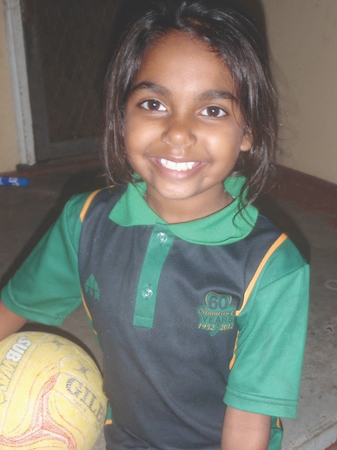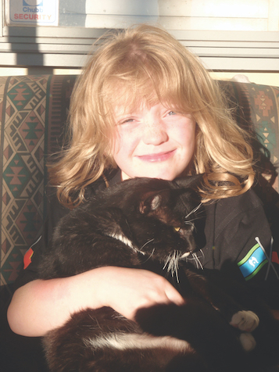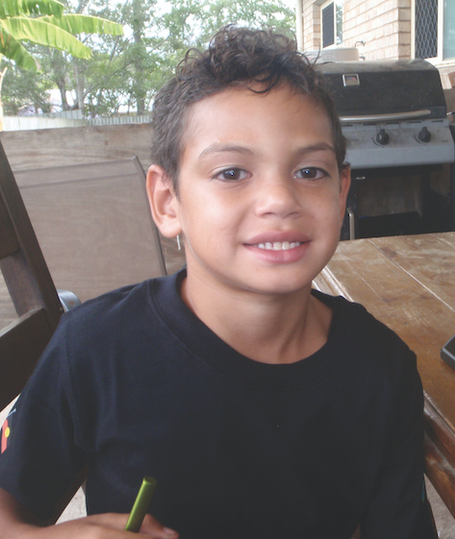
Table 2.1 Why Footprints in Time respondents stay in the study—Wave 6
[Study child] enjoys doing it and he gets excited when [RAO] comes.
Because I don’t want their Aboriginal to die. I want our culture to stay strong, and the only way to do that is to record the information that is out there.
Because I like yarning with you.
Because it needs to be done. If you don’t know what is broken, you don’t know how to fix it. If this study was around when [I] was a child [my] mother would have put [me] in it.
’Cause Aunty [RAO] does my survey and [study child] loves the incentives.
’Cause I think I want the general public to know that there is good statistics on Indigenous children.
’Cause we are all nice people.
[We] enjoy the study. It is a relaxing interview, and the interviews are conducted by Aboriginal and Torres Strait Islander people. [It] gives parents a better understanding of their children and it gives our children a better outcome.
For the government to put 100 per cent into the future of Aboriginal people.
Good information for government.
Great record of how Indigenous kids live, learn and grow.
Hoping it will help the government to use the information that parents are giving to provide better services to the Indigenous community.
I am more curious about what it is going to show; by the time they are in their teens, you will have more of an idea of what is needed.
I enjoy receiving the findings of the study and reading about different areas and circumstances. I like to see how much [study child] has progressed over the year and she also enjoys taking part.
I enjoy you mob coming out and you don’t realise the things you know about your kids until someone else asks the question.
I feel obliged because of my aunty.
I like that [study child] is excited about RAOs coming around, that the information is being kept for [study child] and it is making a difference.
I like that [study child] will have something to look back on and say to her children, ‘My mum did this’.
I like the feedback and I like the fact that [study child] is being followed, and I like the cultural connection because it is hard for me to make the connection, as I am white.
I love Footprints in Time. I love to have a yarn. I think the school being involved is just so good, and it will be good to have the teacher input.
I love it. I love the fact that you guys are collecting the information and that you go into our homes and that the information is being used to help everyone out. There needs to be more collecting of important information.
I reckon the survey is okay and the kids enjoy getting the gifts.
I think it benefits our mob. We are going to use data in the years to come. I would hope this will continue.
I think it is very informative and I love my RAO.
I think it’s good that there is longitudinal data being collected and that we need families involved to collect this data. [Study child] feels special and he looks forward to the visits each year.
Note: This table provides a selection of answers provided by primary carers, in no particular order.
- Waves 6–10: What’s new, what’s different
In Footprints in Time, there are many sets of questions (or modules) that repeat annually or every few years. In addition, new questions are introduced as they become age appropriate. Some items are introduced for a single wave—these are usually factors that are not expected to change frequently over time. The previously released Footprints in Time reports for Waves 1–5 extensively focused on the items in those waves of the survey. In Waves 6–10, we tracked the study children through primary school to their entry into high school. This section of the report provides a summary of topics, but the complete questions can be viewed in the data dictionary and in the study questionnaires. New items that are introduced only for the older (K) cohort are typically introduced for the younger (B) cohort three years later.

New topics and questions in Wave 6 included:
- the study child’s birth order and the ages of siblings living elsewhere (included in primary carer (P1) survey)
- the study child’s consumption of fruit and vegetables (included in P1 survey)
- perceived community safety (included in P1 survey)
- the language learning at school (included in P1 and study child surveys)
- the teacher’s style and the study child’s perception of school (included in the study child survey)
- the Progressive Achievement Test in mathematics (included in the study child survey).

New topics and questions in Wave 7 included:
- puberty, the study child’s after-school activities, cultural awareness at the school, and intentions for high school (included in P1 survey)
- children picking on other children, making friends, and the study child’s relationship with their parents (included in the study child survey)
- linkage to the National Assessment Program: Literacy and Numeracy (NAPLAN) test results.

In Wave 8, new topics and questions included:
- language(s) that the study child speaks at home, how parents teach the child to deal with sadness and anger, P1’s work (availability of cultural leave, what keeps P1 working, career aspirations and barriers), usefulness of financial counselling, how the study child learns to manage money, and cyber safety (included in P1 survey)
- family history (included in P1 and Dad surveys)
- the school environment, transition to high school, reading choices, aspirations and role models, peer characteristics, and spending/saving habits (included in the study child survey)
- the teachers’ views of the study children’s transition to high school (included in the teacher survey)
- linkage with My School data.

In Wave 9, new topics and questions included:
- P1’s and the study child’s caring responsibilities (included in P1 survey)
- gambling (included in P1 and study child surveys)
- boarding school (included in P1 and study child surveys)
- additional perceived community safety questions about suicide and gambling in the community (included in P1 and Dad surveys)
- nutrition, dental health, puberty and social and emotional wellbeing (included in the study child survey)
- the experience of changing schools, getting to school, school attendance and the sense of belonging at school (included in the study child survey).

In Wave 10, new topics and questions included:
- the closeness of relationships (included in P1, Dad and study child surveys)
- the experiences and perceptions of interpersonal racism, racism at school and in the media (included in P1, Dad and study child surveys)
- mental health (Kessler 10 scale; included in P1 and Dad surveys)
- the study child’s social skills (Social Skills Improvement System rating scale; included in P1 and study child surveys)
- the study child’s contact with the police and the justice system (included in P1 and study child surveys)
- executive functioning assessment (included in the study child survey)
- self-complete Strengths and Difficulties Questionnaire (SDQ) (included in the study child survey)
- risk behaviours (e.g. smoking, alcohol and drugs) and negative social behaviours (e.g. illegal activities and norm violations; included in the study child survey)
- seeking help for personal or emotional problems (included in the study child survey)
- after-school activities (included in the study child survey)
- boyfriends and girlfriends (included in the study child survey).
Detailed descriptions of these and other assessments, scales and measures used in Footprints in Time are included in the LSIC Data User Guide, which is available for download from the LSIC Dataverse website at https://dataverse.ada.edu.au/dataverse/lsic.
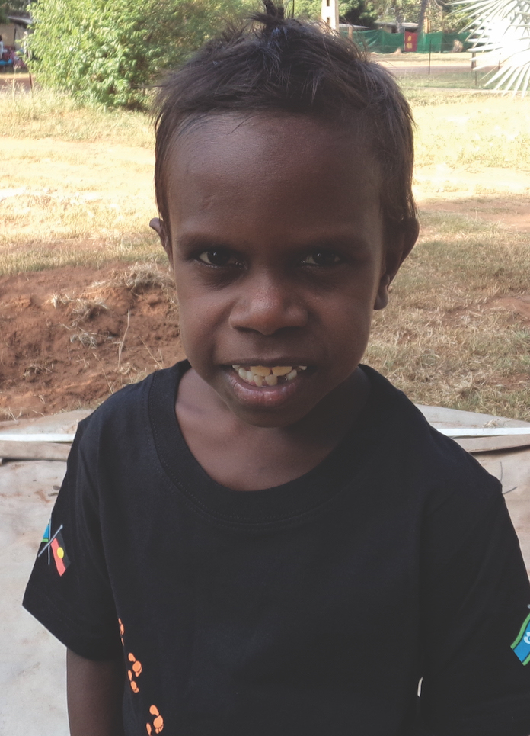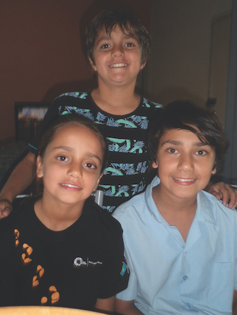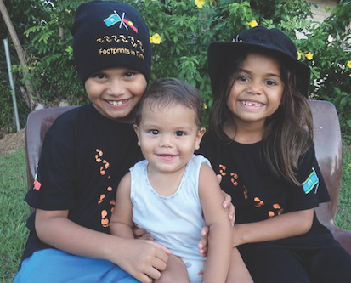
- Developing content for Footprints in Time
Footprints in Time interviews are conducted annually so that new content is considered, developed, ethically approved, piloted and revised for live surveys each year. The Steering Committee considers and provides advice about new content. Prior to Steering Committee meetings, the NCLD may convene a design advisory group and consult with policy area experts regarding specific topics. An example of how new content is developed can be found in the following section about racism.
If you think new content should be considered for Footprints in Time, please contact us via NCLDresearch@dss.gov.au.

Asking about racism
The experience of racism is known to have detrimental effects on Aboriginal and Torres Strait Islander people’s health and wellbeing (Department of the Prime Minister and Cabinet, 2017; Paradies, 2006; Priest, Paradies, Trenerry, Truong, Karlsen & Kelly, 2013).
Questions about discrimination and racism were included in Footprints in Time from the beginning of the study. Parents and carers were asked about their own experiences of unfair treatment or discrimination, how often their family has experienced racism, discrimination or prejudice and whether the study child has been bullied or treated unfairly at school because they are Aboriginal and/or Torres Strait Islander. Bodkin-Andrews et al. (2017) found that racism that was aimed at primary carers or at study children was experienced by a minority of Footprints in Time participants, but that nearly half of parents and carers reported the occurrence of at least some form of racism. Calma (2016) found that Footprints in Time parents who had experienced racism reported poorer health and that their children tended to have greater social and emotional difficulties. Shepherd et al. (2016) recently found that Footprints in Time parent, carer and child experiences of racism were associated with poorer mental health, sleep difficulties, obesity and asthma for study children.

New racism questions for study children and primary carers
In 2015, Steering Committee members considered whether to include discrimination-related questions that had been asked of children in the LSAC, along with questions about being picked on or bullied. The School Climate Bullying Scale questions were included in the Wave 9 pilots with a follow-up question: ‘Was this because you are Aboriginal and/or Torres Strait Islander?’ The answer options included ‘Always’, ‘Sometimes’, ‘Never’, ‘Don’t know’ and ‘Refused’. While no child in the pilot refused to answer the questions, quite a few selected ‘Don’t know’—which is a valid answer option, given that people often do not know whether others are being deliberately racist or whether they are being rude or mean for another reason; however, this response does not provide much information.
The Steering Committee believed Footprints in Time should consider questions about racism and cultural identity in greater depth and recommended seeking advice from Professor Gawaian Bodkin-Andrews. A design group was convened, chaired by Professor Bodkin-Andrews, and the group agreed to develop items specifically for the study.
Three sets of items were developed in relation to personal experiences of racism and where those incidents occurred, institutional racism (at school, which most study children attended) and macro-level racism. These items were refined via email with design group members. The proposed questions were discussed at the May 2016 Steering Committee meeting and 36 questions were piloted with ethical approval in urban, regional and remote locations, with primary carers and older cohort study children.

Pilot data, feedback from interviewers and design group advice were discussed at the November 2016 Steering Committee meeting. The members agreed on certain changes at the meeting, such as:
- adding ‘at work’ and ‘at school’ to the list of locations where racism may have occurred in the primary carer survey
- adding some open-ended questions
- removing news and politics items for study children (because there were many ‘Don’t know’ responses in the pilot)
- reducing the number of items to 17 for the study children and 16 for primary carers, based on what was best understood by participants and items that provided a range of responses.
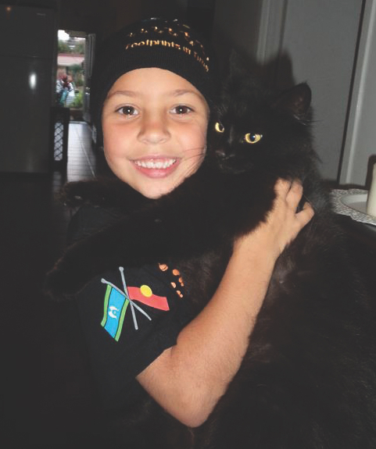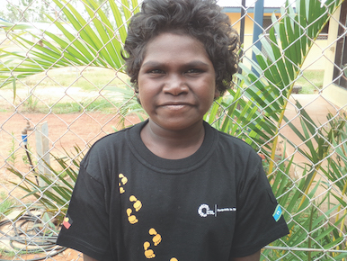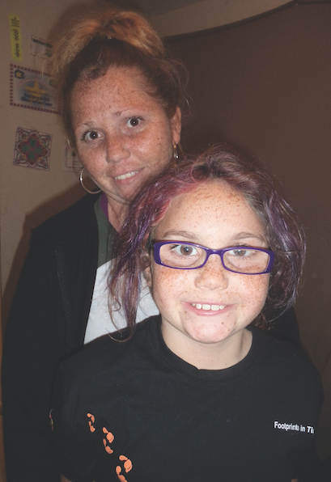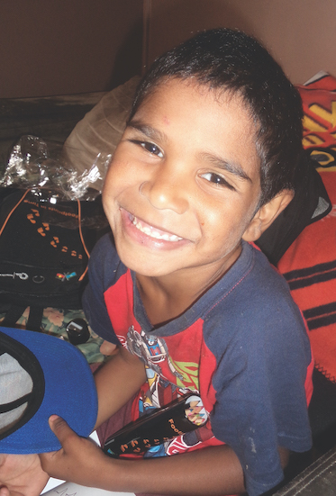
Once the revisions had ethical approval, the measures were included in Wave 10 interviews. This set of questions is available to researchers in the 2019 LSIC Release 10. Some descriptive findings are included below and show significant differences between the proportions of parents who report interpersonal experiences of racism (see Figures 4.1 and 4.2) and racism in the news and on social media (see Figure 4.3). In regard to the places where people experienced racism or discrimination, the most common locations that primary carers reported were services sites and public places (see Figure 4.4).
The statistics that are presented in this chapter describe parental experiences of racism. Chapter 11 briefly presents the selected findings that are related to study children’s experiences of racism at school. As the Footprints in Time study continues and the study children reach adulthood, the relationships between the childhood experiences of racism and later life outcomes may be traced.
Figure 4.1 Personal experience of racism and discrimination: Has something like this happened to you because you are Aboriginal and/or Torres Strait islander? (preliminary Wave 10 data—per cent)
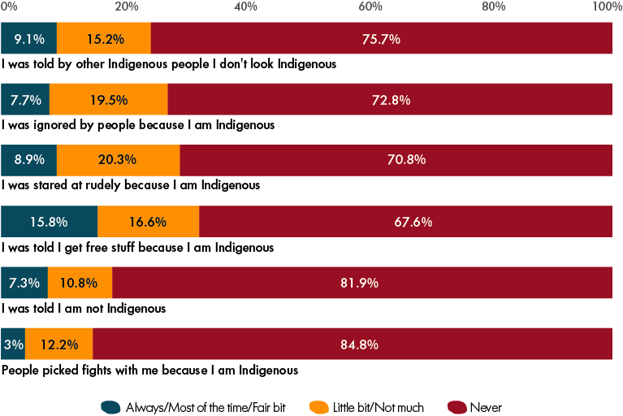
Note: Asked of Indigenous primary and secondary carers only; n = 1,032–1,061. Participants included in these results may not have been surveyed about or provided a response to every statement, hence n indicates the number of responses.
Figure 4.2 Witnessing racism and discrimination (preliminary Wave 10 data—per cent)
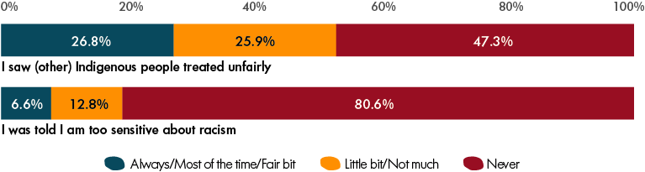
Note: Asked of both Indigenous and non-Indigenous primary and secondary carers; n = 1,318–1,323. Participants included in these results may not have been surveyed about or provided a response to every statement, hence n indicates the number of responses.
Figure 4.3 Racism in news and social media (preliminary Wave 10 data—per cent)
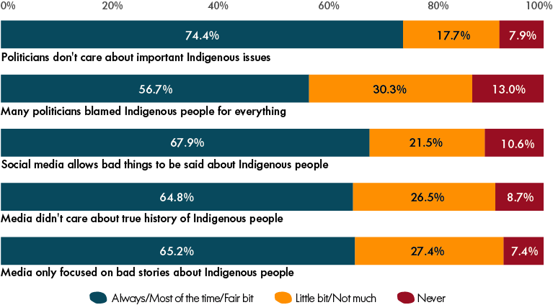
Note: Asked of both Indigenous and non-Indigenous primary and secondary carers; n = 1,109–1,208. Participants included in these results may not have been surveyed about or provided a response to every statement, hence n indicates the number of responses.
Figure 4.4 Where do people experience racism? (preliminary Wave 10 data—per cent)
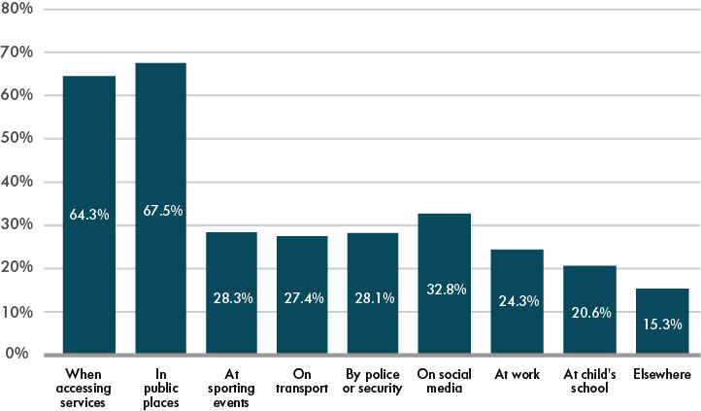
Note: Restricted to Indigenous primary and secondary carers who have reported experiencing interpersonal racism; n = 720.

References
Bodkin-Andrews, G., Lovelock, R., Paradies, Y., Denson, N., Franklin, C. & Priest, N. (2017). Not my family: Understanding the prevalence and impact of racism beyond individualistic experiences. In M. Walter, K.L. Martin & G. Bodkin-Andrews (Eds.), Indigenous children growing up strong. London: Macmillan Publishers Ltd.
Brockenbrough, K.K., Cornell, D.G. & Loper, A.B. (2002). Aggressive attitudes among victims of violence at school. Education and Treatment of Children, 25(3), 273–287.
Calma, T. (2016). How discrimination and stressful events affect the health of our Indigenous kids, The Conversation. Retrieved from https://theconversation.com/how-discrimination-and-stressful-events-affect-the-health-of-our-indigenous-kids-67548
Department of the Prime Minister and Cabinet. (2017). Aboriginal and Torres Strait Islander Health Performance Framework 2017 Report. Originally retrieved from pmc.gov.au; now accessible via https://www.niaa.gov.au/resource-centre/indigenous-affairs/health-performance-framework-2017-report
Paradies, Y. (2006). A systematic review of empirical research on self-reported racism and health. International Journal of Epidemiology, 35(4), 888–901.
Priest, N., Paradies, Y., Trenerry, B., Truong, M., Karlsen, S. & Kelly, Y. (2013). A systematic review of studies examining the relationship between reported racism and health and wellbeing for children and young people. Social Science and Medicine, 95, 115–127.
Shepherd, C.C.J., Li, J., Farrant, B., Hopkins, K. & Priest, N. (2016). Racism and its impact on the health of Aboriginal children: Insights from the Footprints in Time Study, paper presented at the 2016 Lowitja Institute International Indigenous Health and Wellbeing Conference, November, Melbourne, Australia.

Part B—Research Findings
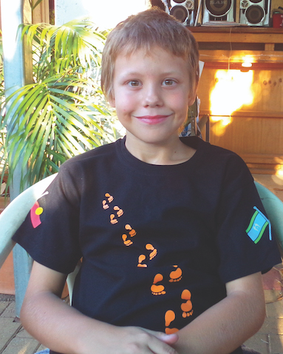
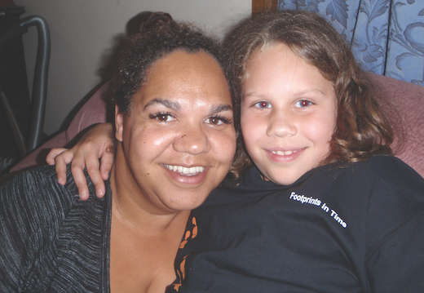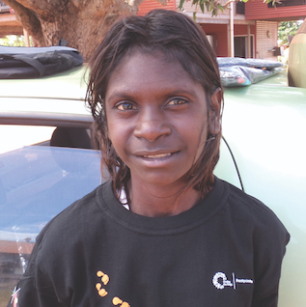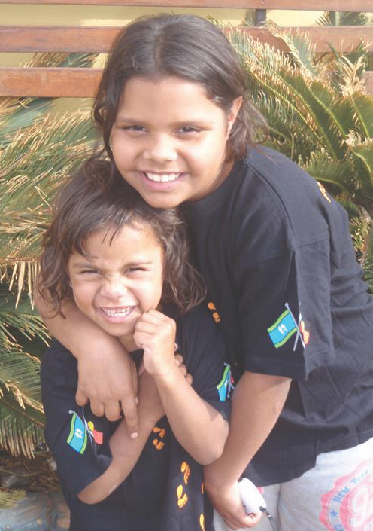
- ‘I wish I could learn my own language’ — Aboriginal and Torres Strait Islander languages and children’s wellbeing
The United Nations (UN, 2018) declared 2019 the International Year (IY2019) of Indigenous Languages:
In order to raise awareness of them, not only to benefit the people who speak these languages, but also for others to appreciate the important contribution they make to our world’s rich cultural diversity.
The second National Indigenous Languages Survey in 2014 found that around 120 Australian Indigenous languages are still spoken, but that only 13 can be considered strong (Marmion, Obata & Tory, 2014, p. xii). The situation is complex—some traditional languages are being transmitted by adult native speakers to their children, others are gaining more speakers as they undergo revival processes. The largest languages are ‘recently developed Indigenous languages, such as Kriol and Yumplatok’ (Marmion et al., 2014, p. xii), which are a blend of several traditional Indigenous languages and English. Marmion et al. (2014) specifically recommended further research to be conducted into the connection between language and wellbeing, as well as the implementation of Indigenous language classes in schools.
Footprints in Time children are clustered geographically. Consequently, certain language groups are overrepresented in the Footprints in Time data and others may not be represented at all. Therefore, the language use of Footprints in Time children cannot be understood in terms of population prevalence or the endangerment of particular languages. However, the Footprints in Time children constitute a large sample in a diverse range of urban, regional and remote areas. In the absence of data on children from every language group, the data collected provides unique insights into what appear to be the common language-learning experiences of Indigenous children in Australia. This report provides an overview of the home language environment, the school language environment and the relationship between children’s acquisition of Indigenous languages and their social and emotional wellbeing.
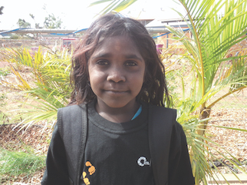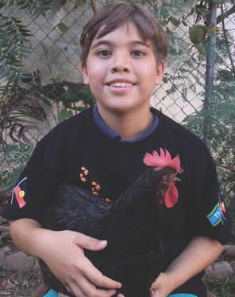

Home language use
In 2015 (Wave 8), 20.9 per cent of 1,232 Footprints in Time households reportedly spoke two or more languages in the home (up to four). Traditional Indigenous languages were spoken in 11.5 per cent of homes and creoles were spoken in 12.3 per cent of homes. Foreign languages were also spoken in 5.0 per cent of homes.
English was spoken as a home language in 94.3 per cent of households; however, it should be noted that some Indigenous people speak dialects of English along a continuum between standard Australian English and Aboriginal English. Thus, it is often difficult for individuals to estimate their own use of Aboriginal English.
Footprints in Time parents were asked whether the ‘kind of English spoken at home’ was:
- mixed with many Aboriginal and/or Torres Strait Islander words
- sometimes mixed with a few Aboriginal/Torres Strait Islander words
- spoken only with English words.
Responses to this question revealed that among the families that spoke English at home, 42.7 per cent of those families spoke some form of Aboriginal English (see Figure 5.1).
Figure 5.1 Children speaking languages other than English, Wave 8 (2015)—per cent
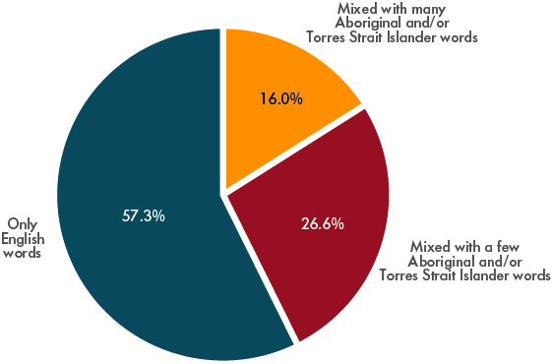
Note: n = 1,235. Excludes households that do not speak English at home.
Parents were also asked which languages their children could speak. This could include languages that their children have learned at home and languages that their children were learning at school (see Figure 5.2). The parents reported that approximately one quarter of the study children could speak an Indigenous language or a creole.
Figure 5.2 Children speaking languages other than English, Wave 8 (2015)—per cent
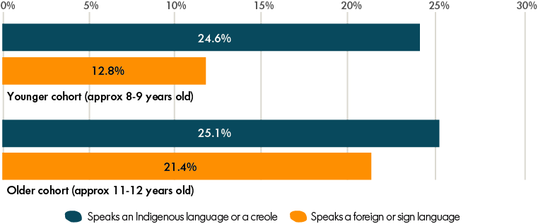
Note: The number of observations was 736 for the younger cohort and 487 for the older cohort.
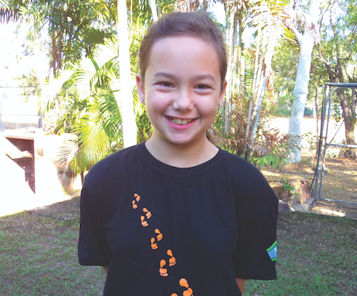
Understanding when and how transmission usually occurs outside the classroom may be beneficial to families who are considering how to maintain their Indigenous languages. In the Footprints in Time data, having dinner as a family was the most common domain for Indigenous language transmission
(see Figure 5.3).
Figure 5.3 When do children use Indigenous languages? Waves 8 and 9 (2015, 2016)—per cent
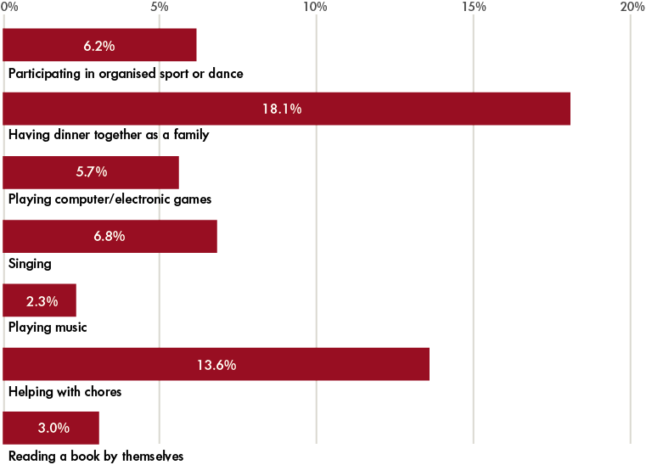
Note: The number of observations varied between 1,228 and 1,252 depending on the question. Questions about using Indigenous language while having a dinner together as a family and while engaging in sport or dancing were asked in 2016 (Wave 9); the remaining questions were asked in 2015 (Wave 8).
[I] would like to see Indigenous languages taught in the school … most of the Elders are passing away and [young people are] growing up with no Elders to teach them language.
—A response from a
Footprints in Time primary carer
In 2010, parents were asked whether they would like their children to learn an Indigenous language at school. At the time, 91.3 per cent of parents expressed a preference for their children to have the opportunity to learn an Indigenous language at school. There is a detailed plan for teaching Indigenous languages in the national curriculum; however, most Footprints in Time children do not currently learn Indigenous languages at school. Learning both foreign languages and Indigenous Australian languages was substantially higher among children in late primary school than among children in mid-primary school. Over a quarter of Footprints in Time children were learning an Indigenous language at school by Years 5–6 (see Figure 5.4).
Figure 5.4 Children learning languages at school, Wave 8 (2015)—per cent
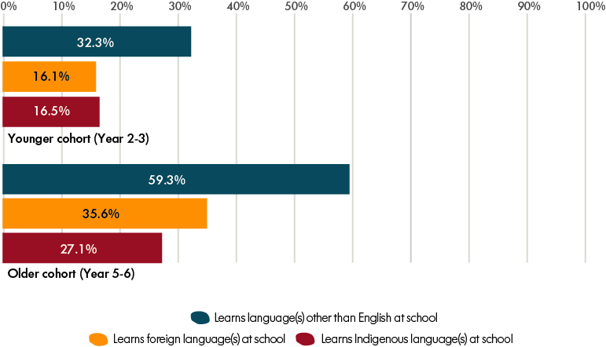
Note: The number of observations was 734 for children in the younger cohort and 487 for children in the older cohort. The analysis in the table includes small numbers of children in each cohort who were outside the indicated school year range. A small number of children were learning both a foreign language and an Indigenous language at school or were learning more than one Indigenous or foreign language.
The languages learned in the classroom were most commonly Japanese, Indonesian, Chinese and Italian (see Figure 5.5 for other commonly named foreign languages). Twelve foreign languages were represented in total, excluding English (nominated by a number of respondents who may not speak it at home). The variety of Indigenous languages was much greater (more than 30 different Indigenous languages were named by the children). The specific Indigenous languages are not released in the publicly available data set, as the risk of identifying locations would be too great. However, they are presented here in Figure 5.6. Those most commonly named were Wiradjuri, Djambarrpuyngu, Kala Lagau Ya, Yawuru and Dhurga.
Figure 5.5 Language learning at school: Most commonly named foreign languages learned by Footprints in Time children, Wave 8 (2015)—per cent
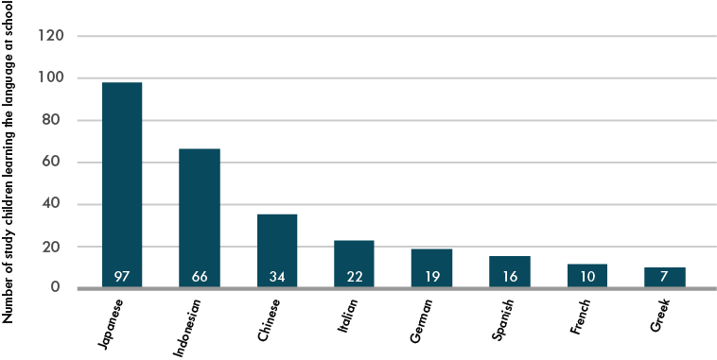
Note: The total number of children learning a foreign language in school in 2015 was 290. A small number of children were learning more than one foreign language.
Figure 5.6 Language learning at school: Most commonly named Australian Indigenous languages learned by Footprints in Time children, Wave 8 (2015)—per cent
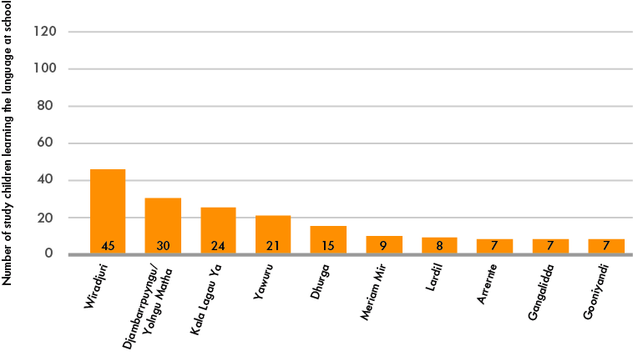
Note: The total number of children learning an Indigenous language in school in 2015 was 252. A small number of children were learning more than one Indigenous language.
In the Footprints in Time teacher-reported data, 21.3 per cent of teachers reported that their school had an Indigenous language program. This was higher in remote areas and lower in major cities (see Figure 5.7). Almost 16 per cent of the teachers who responded did not know if an Indigenous language was taught at their school. Twenty per cent of teachers stated that their schools encourage the use of Indigenous languages in the classroom (see Figure 5.8).
The Footprints in Time data conclusively showed that parents want Indigenous languages to be taught at school. The national curriculum has paved the way for Indigenous languages to be included in numerous ways (e.g. via first and second language learner pathways and language revival learner pathways and among students from foundation to Year 10) (ACARA, 2018).
Figure 5.7 School has an Indigenous language program, Wave 8 (2015) (teacher report)—per cent
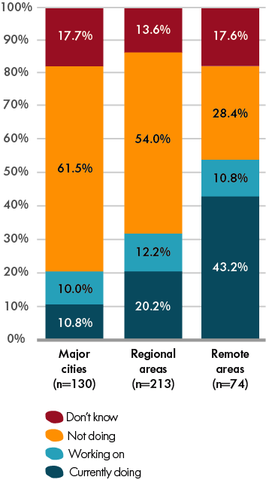
Notes: Total n = 417. Responding teachers may have had several Footprints in Time study children in their classrooms and more than one teacher may have responded from each school. The analysis in this table was restricted to one observation per teacher.
Figure 5.8 School encourages use of Indigenous languages in the classroom, Wave 8 (2015) (teacher report)—per cent
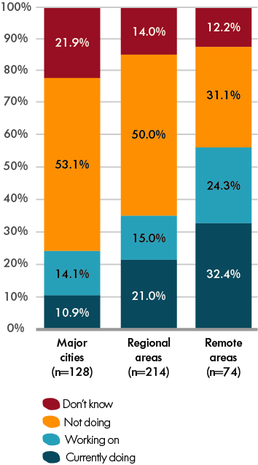
Notes: Total n = 416. Responding teachers may have had several Footprints in Time study children in their classroom and more than one teacher may have responded from each school. The analysis in this table was restricted to one observation per teacher.
Cobb-Clark, Harmon and Staneva (2018) published an analysis from the United Kingdom Millennium Cohort Study that indicated that bilingual status is associated with fewer social and emotional difficulties. A similar correlation was also found in Footprints in Time. Specifically, children who reported speaking an Indigenous language as their main language or speaking English and an Indigenous language equally well were significantly more likely to have lower social and emotional difficulties (see Figure 5.9).
Figure 5.9 Language skills and social and emotional difficulties among Footprints in Time children, Wave 8 (2015)—per cent
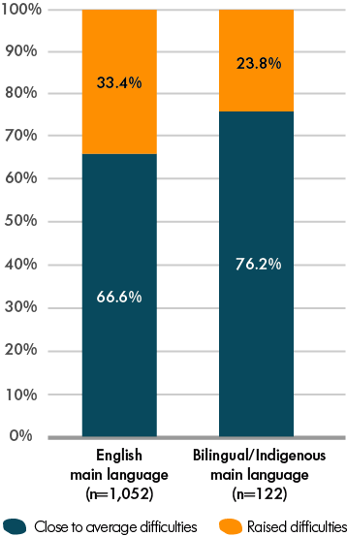
Note: Total n = 1,174. Children’s social and emotional difficulties were measured using primary carers’ responses to the Strengths and Difficulties Questionnaire (total difficulties score). The total difficulties score ranges from 0 to 40, a score of 0 to 13 represents close to average social and emotional difficulties, while a score of 14 or above represents raised difficulties.

References
Australian Curriculum, Assessment and Reporting Authority (ACARA). (2018). Framework for Aboriginal Languages and Torres Strait Islander languages. Retrieved from https://www.australiancurriculum.edu.au/f-10-curriculum/languages/framework-for-aboriginal-languages-and-torres-strait-islander-languages/
Cobb-Clark, D., Harmon, C. & Staneva, A. (2018). The bilingual gap in children’s language and emotional development. IZA Discussion Paper (DP. No. 11800). Bonn, Germany: IZA Institute of Labor Economics.
Marmion, D., Obata, K. & Tory, J. (2014). Community, identity, wellbeing: The report of the Second National Indigenous Languages Survey. Canberra, ACT: AIATSIS.
United Nations (UN). (2018). International year of Indigenous languages. Retrieved 02/07/2019 from https://en.iyil2019.org/
- Factors that influence affective engagement with school: Evidence from Wave 6 of Footprints in Time
Laura Dunstan,a Belinda Hewitta and Wojtek Tomaszewskib
a The University of Melbourne; b The University of Queensland
Education researchers have identified school engagement as an important factor that influences children’s learning, development and educational success (Jimerson, Campos & Greif, 2003; Libbey, 2004). Research suggests that a sense of belonging and support at school is associated with higher expectations of academic success in class, academic effort and grades (Goodenow, 1993). Voelkl (1997) found that identification with school significantly improved test scores among white students in Grades 4 and 7 in the United States; however, the same finding was not evident among African American students. In a review article, Fredricks, Blumenfeld and Paris (2004) concluded that the extant evidence suggests that school engagement creates ties to an institution and is positively associated with a student’s willingness to complete their school work.
School engagement is difficult to define; however, it is well established that school engagement is multidimensional and includes:
- behavioural dimensions, including school attendance and participation in school activities
- affective dimensions, including liking, belonging and identifying with their school
- cognitive dimensions, including students’ aptitude for and interest in learning (Appleton, Christenson & Furlong, 2008; Fredricks et al., 2004; Jimerson et al., 2003; Wang, Willet & Eccles, 2011).
Research into Indigenous Australians’ education outcomes has primarily considered the behavioural aspects of engagement (most particularly attendance) (Biddle, 2014; Purdie & Buckley, 2010). Such behavioural aspects are key to the ‘Closing the Gap’ target (Department of the Prime Minister and Cabinet, 2015). In this paper, affective engagement was examined as a key aspect of engagement for understanding educational outcomes (Lam et al., 2014).
In Wave 6, children in the older cohort (i.e. those aged 8 to 9 years) were asked a series of questions to capture their affective engagement with their schools, including whether they:
- find school fun
- feel happy about going to school when they get up in the morning
- wish they did not have to go to school
- try to find ways of avoiding going to school
- feel safe at school
- like all their school lessons.
The scores were summarised (and reversed as necessary) to create a scale of affective engagement. The reliability of the scale is indicated by a Cronbach’s alpha score of α = 0.75. Factor analysis with Varimax rotation and Kaiser normalisation produced a single-factor solution that accounted for 45 per cent of the total variance. We examined whether and to what extent a range of family background, demographic and social factors were associated with children’s affective engagement.

Affective engagement with school
After excluding children with missing data for any of the six questions, 461 children were included in the analysis. Table 6.1 presents the percentages of responses for each of the affective engagement items. The results in Table 6.1 revealed a mixed picture of affective engagement with school. Specifically, when asked if they found school fun, 76.9 per cent of the children responded, ‘Yes, always’ or ‘Yes, a little bit’. A slightly lower percentage of children felt happy about going to school in the morning; however, children who stated they always felt happy about going to school still constituted the largest category (31.8 per cent). Conversely, responses to the item, ‘Did the study child wish they didn’t have to go to school’ were divided almost evenly between responses of ‘no, never’ (26.9 per cent) and ‘yes, always’ (23.4 per cent). Nearly 14 per cent of children stated that they ‘always’ tried to find ways to avoid going to school. Most children felt safe at school (83.5 per cent responded, ‘Yes, always’ or ‘Yes, a little bit’ to this question) and most liked their school lessons (66.9 per cent responded, ‘Yes, always’ or ‘Yes, a little bit’ to this question). Overall, most children felt school was fun and safe and said they liked school lessons; however, some were ambivalent about whether they wanted to attend school or tried to avoid going to school. For this cohort, the average score of affective engagement on the combined 0–30 scale was 21 (with a standard deviation of 6.85). This indicates a positive level of affective engagement in the cohort; however, given the relatively high standard deviation, it was anticipated that the analysis would yield fairly diverse results.
Overall, most children felt school was fun and safe and said they liked school lessons
Table 6.1 Affective school engagement in the older cohort, Wave 6 (2015)—per cent
Does study child: | Yes, always | Yes, a little bit | Sometimes, more yes | Sometimes, more no | No, not much | No, never
Find school fun* | 54.2 | 22.7 | 8.3 | 4.1 | 5.4 | 5.4
Feel happy about going to school when they get up in the morning* | 31.8 | 22.5 | 11.3 | 6.4 | 14.4 | 13.6
Wish they did not have to go to school | 23.4 | 16.3 | 10.0 | 7.9 | 15.5 | 26.9
Try to find ways of avoiding going to school | 13.8 | 8.5 | 5.8 | 8.1 | 12.4 | 51.5
Feel safe at school* | 66.6 | 16.9 | 6.1 | 1.6 | 3.5 | 5.3
Like school lessons* | 44.2 | 22.7 | 10.2 | 5.1 | 10.4 | 7.4
Note: The number of observations varied between 479 and 491 depending on the question. Items marked with an asterisk* were reversed to calculate the affective engagement score.

Factors associated with students’ affective engagement with school
A relatively large body of research on school attendance has shown that numerous family background and socio-demographic characteristics are important. Bivariate regression analyses were conducted to investigate whether certain characteristics were also associated with students’ affective engagement with their schools, including the study child’s age, gender and health, if the study child had changed schools, P1’s education and employment status, household income and size, housing problems and Level of Relative Isolation of the area where the family lived. Some of these findings are discussed further in the section below.
Children’s affective engagement with school was found to vary by gender. Specifically, girls had significantly higher levels of affective engagement with school than boys by an average of 2.3 points (p < 0.001) (Figure 6.1). These preliminary findings need to be tested across a range of students of different ages (from childhood to adolescence); however, it should be noted that these findings differ from the mixed results found in the study on Indigenous school attendance (often no gender differences were found in relation to school attendance) (Bourke, Rigby & Burden, 2000; Zubrick et al., 2006). Additionally, when gender differences have been found, they tend to suggest that girls have lower levels of school attendance than boys (Biddle, 2014; Gray & Beresford, 2002).
Figure 6.1 Mean affective engagement score by gender, Wave 6 (2013)
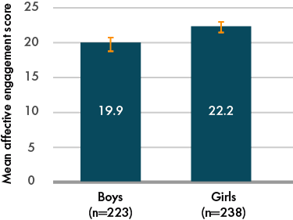
Note: Total n = 462. Error bars show 95 per cent confidence intervals; non-overlapping confidence intervals for the two groups indicate that there is a statistically significant difference between the means of the groups.
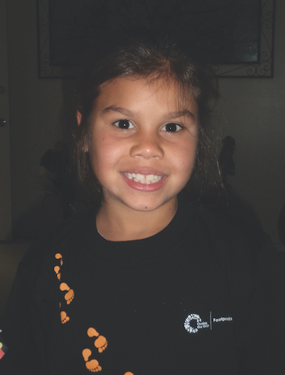
The results showed that affective engagement with school varied based on the Level of Relative Isolation. As Figure 6.2 shows, children in moderately isolated areas had significantly higher levels of affective engagement with school by an average of 3.2 points (p < 0.01) than those who lived in urban (no isolation) areas. Similarly, children in highly or extremely isolated areas had significantly higher levels of affective engagement with school by an average of 4.2 points (p < 0.001) than those who lived in urban areas.
Students in areas of low isolation had slightly higher levels of affective engagement with school than those in urban areas; however, these differences were not statistically significant. This pattern of results is interesting, as previous research on school attendance has found that Indigenous students who live in more remote areas had lower rates of school attendance (Biddle, Hunter & Schwab, 2004; Zubrick et al., 2006). Together, these important and unexpected findings suggest that children’s affective engagement tends to be higher on average as their level of isolation increases. Alternatively, this could also simply reflect cultural differences in participants’ responses to these types of surveys. Notably, it appears that the factors that have an effect on affective engagement may differ from those that shape attendance. Thus, more research needs to be conducted to better understand the patterns of affective engagement.
Figure 6.2 Mean affective engagement score by Level of Relative Isolation, Wave 6 (2013)
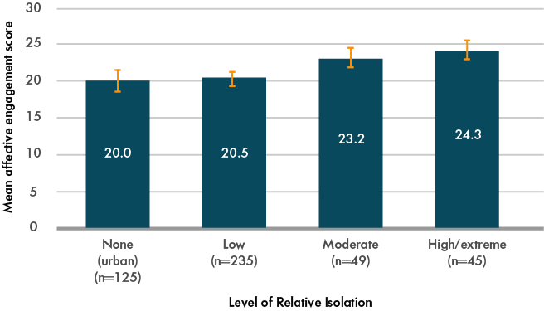
Note: Total n = 454. Error bars show 95 per cent confidence intervals; non-overlapping confidence intervals for any two groups indicate that there is a statistically significant difference between the means for the groups.
The number of people living in a child’s household was also important; every additional person in the household was associated with significantly higher levels of affective engagement by 0.38 points on average (p < 0.05). This may be because Indigenous people living in remote areas tend to have larger households due to poor housing accessibility (Biddle et al., 2004; Bourke et al., 2000; Purdie & Buckley, 2010; Zubrick et al., 2006). This is supported by the fact that when both relative isolation and the total number of people living in the household were included in the same regression model, the number of people in the household no longer significantly predicted affective engagement, while relative isolation remained significant (p < 0.001).
Thus, the number of people in the household may be a proxy measure of living in highly or extremely remote areas, which the results showed is positively correlated with Indigenous children’s affective engagement levels. Affective engagement is not the same as school attendance; however, interestingly, the findings of the present study contrast with previous research on school attendance that found that living in multi-family households and thus households with a larger number of occupants reduced the likelihood of school attendance (Biddle et al., 2004). It should also be noted that in the present analyses, affective engagement was significantly associated with higher levels of reported school attendance in the previous week (p < 0.05).
Additionally, children with better health also tended to have higher levels of affective engagement. As Figure 6.3 shows, compared with children who have poor or fair health, children with good, very good or excellent health have higher levels of affective engagement with school. In a bivariate regression analysis, affective engagement for children with good, very good or excellent health was compared to those with fair or poor health. The results showed that children with better health had significantly better affective engagement with school (p < 0.05).
Figure 6.3 Mean affective engagement score by study child health, Wave 6 (2013)
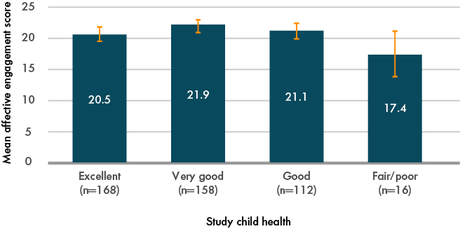
Note: Total n = 454. Error bars show 95 per cent confidence intervals; non-overlapping confidence intervals for any two groups indicate that there is a statistically significant difference between the means for the groups.
A further analysis of the relationship between health and affective engagement should be undertaken to solidify these important findings that mirror previous analyses of Footprints in Time children in relation to school attendance. Biddle’s (2014) analysis of children’s school attendance showed that poor child health is negatively associated with school attendance. The results of this study and Biddle’s (2014) study suggest that improving child health outcomes could improve Indigenous children’s school engagement. The ‘Closing the Gap’ policy includes health targets for children under 5 years old; however, the policy targets and strategies do not include health goals for school-aged children (Department of the Prime Minister and Cabinet, 2014, 2015). Further, the 2015 review of the ‘Closing the Gap’ policy highlights the need for greater focus on primary health care and improving health outcomes for the Indigenous population more broadly (Close the Gap Campaign Steering Committee, 2015).
Finally, in the context of the broader research literature on school engagement (e.g. Bourke et al., 2000; Gray & Partington, 2003; Zubrick et al., 2006), the finding that affective engagement is distinctive from behavioural school engagement indicates that the socio-structural factors that influence affective engagement may not influence other engagement dimensions—particularly school attendance—in the same way. These differences between affective and behavioural engagement reflect findings from the United States that showed important differences between the two types of engagement. In relation to social support, while behavioural engagement is associated with parental support, affective engagement is associated with peer support (Estell & Perdue, 2013). In contrast to research on school attendance, the results of the present study suggest that household income, parental education and employment, community socio-economic status and housing instability were not significantly associated with Indigenous children’s affective engagement.
Further, the results of a multivariate regression analysis, which considered all these factors together, largely confirmed the bivariate results (i.e. gender, Level of Relative Isolation and child health remained significant predictors of affective engagement). However, it should be noted the number of people in the household became non-significant when the Level of Relative Isolation was included in the model. As mentioned above, this may be because the number of people in a child’s household is correlated with higher levels of relative isolation.

Summary
A relatively large body of research has examined Indigenous children’s engagement with their schools; however, such research has mostly examined behavioural engagement, particularly the factors affecting school attendance. Far less research has been conducted on children’s affective engagement with school (a factor that encompasses how positively children feel about attending school) (Jimerson et al., 2003; Lam et al., 2014). Attendance is important; however, children may not have good learning outcomes and achievements if they do not also have a sense of enjoyment, belonging and identification with their schools (Fredricks et al., 2004).
The descriptive statistics for the items measuring affective school engagement suggest that most Footprints in Time children feel good about school; they find both school and their lessons fun and feel safe at school. This chapter examined several factors associated with the affective school engagement scale. The associations with some factors differed from what previous research on attendance has suggested. For example, the results in the present study suggested higher levels of affective engagement for girls, children who live in more remote areas or who have higher numbers of people living in their household and those with improved health. Notably, when included in the multivariate regression analysis, these results retained their significance. Further, despite the importance of, and focus on, socio-economic factors on attendance, including household income, parental education levels, parental employment, the socio-economic status of the community and housing instability, these factors do not appear to have a significant effect on Indigenous children’s affective engagement. This suggests that the processes associated with affective engagement with school may differ to the processes associated with behavioural engagement with school (Appleton et al., 2008; Fredricks et al., 2004; Jimerson et al., 2003; Wang et al., 2011). Given that the effects on, and patterns of, these two dimensions of engagement differ, further research needs to be conducted to better understand affective engagement outcomes.
In summary, while school engagement has an important effect on children’s schooling outcomes, it is complex and multidimensional. The dimensions affective engagement captures in relation to school engagement are quite different to the dimensions captured by attendance. These later results demonstrate a different understanding to that which previous research has found in relation to attendance and show the importance of understanding engagement as multidimensional and as an interaction between the individual and the environment. Such understandings will better enable us to comprehend the complexity of children’s experiences in school and design more specifically targeted and nuanced interventions that address the differing dimensions of school engagement (Fredricks et al., 2004).
This article was written by Laura Dunstan, a non-Indigenous PhD candidate at The University of Melbourne. She is currently completing her PhD in sociology. In her research, she is using LSIC data to examine the associations between Indigenous family life and child health and wellbeing outcomes. She has four years’ experience working with longitudinal studies and working with the LSIC in particular.
This article was co-authored by Belinda Hewitt, a non-Indigenous academic based at The University of Melbourne. She is a Sociologist who has been working with longitudinal quantitative data for over 15 years and has been using the LSIC survey data since 2010.
This article was co-authored by Wojtek Tomaszewski, a non-Indigenous academic based at The University of Queensland. He is a Sociologist who has been working with longitudinal quantitative data for over 10 years and has been using the LSIC survey data since 2016.

References
Appleton, J.J., Christenson, S.L. & Furlong, M.J. (2008). Student engagement with school: Critical conceptual and methodological issues of the construct. Psychology in the Schools, 45(5), 369–386.
Biddle, N. (2014). Developing a behavioural model of school attendance: Policy implications for Indigenous children and youth. CAEPR Working Paper No. 64. Canberra, ACT: Centre for Aboriginal Economic Policy Research, Australian National University.
Biddle, N., Hunter, B.H. & Schwab, R.G. (2004). Mapping Indigenous educational participation. CAEPR Discussion Paper No. 2004/267. Canberra, ACT: Centre for Aboriginal Economic Policy Research, Australian National University.
Bourke, C.J., Rigby, K. & Burden, J. (2000). Better practice in school attendance: Improving the school attendance of Indigenous students. Canberra, ACT: Commonwealth Department of Education, Training and Youth Affairs.
Close the Gap Campaign Steering Committee. (2015). Progress and priorities report 2015. Canberra, ACT: Close the Gap Campaign Steering Committee.
Department of the Prime Minister and Cabinet. (2014). Closing the Gap—Prime Minister’s Report 2014. Canberra, ACT: Department of the Prime Minister and Cabinet.
Department of the Prime Minister and Cabinet. (2015). Close the Gap—Prime Minister’s Report 2015. Canberra, ACT: Department of the Prime Minister and Cabinet.
Estell, D.B., & Perdue, N.H. (2013). Social support and behavioral and affective school engagement: The effects of peers, parents, and teachers. Psychology in the Schools, 50(4), 325–339.
Fredricks, J.A., Blumenfeld, P.C. & Paris, A.H. (2004). School engagement: Potential of the concept, state of the evidence. Review of Educational Research, 74(1), 59–109.
Gray, J., & Beresford, Q. (2002). Aboriginal non-attendance at school: Revisiting the debate. The Australian Educational Researcher, 29(1), 27–42.
Gray, J., & Partington, G. (2003). Attendance and non-attendance at school. In Q. Beresford, G. Partington, & G. Gower (Eds.), Reform and resistance in Aboriginal education (pp. 261–303). Crawley, WA: UWA Publishing.
Goodenow, C. (1993). Classroom belonging among early adolescent students: Relationships to motivation and achievement. Journal of Early Adolescence, 13(1), 21–43.
Jimerson, S.R., Campos, E. & Greif, J.L. (2003). Towards an understanding of definitions and measures of school engagement and related terms. California School Psychologist, 8(1), 7–28.
Lam, S.-f., Jimerson, S., Wong, B.P.H., Kikas, E., Shin, H., Veiga, F.H., . . . Zollneritsch, J. (2014). Understanding and measuring student engagement in school: The results of an international study from 12 countries. School Psychology Quarterly, 29(2), 213–232.
Libbey, H.P. (2004). Measuring student relationships to school: Attachment, bonding, connectedness, and engagement. The Journal of School Health, 74(7), 274–283.
Purdie, N. & Buckley, S. (2010). School attendance and retention of Indigenous Australian students. Issues Paper No. 1. Closing the Gap Clearinghouse, Australian Institute of Family Studies.
Voelkl, K. (1997). Identification with school. American Journal of Education, 105(3), 294–318.
Wang, M.T., Willet, J.B. & Eccles, J.S. (2011). The assessment of school engagement: Examining dimensionality and measurement invariance by gender and race/ethnicity. Journal of School Psychology, 49(4), 465–480.
Zubrick, S., Silburn, S., De Maio, J., Shepherd, C., Griffin, J., Dalby, R. & Cox, A. (2006). Western Australian Aboriginal child health survey: Improving the educational experiences of Aboriginal children and young people (Vol. 3). Perth, WA: Curtin University of Technology and Telethon Institute for Child Health Research.
- Socio-economic and dietary covariates of dental health for Indigenous children in Footprints in Time

Introduction
It is important that children learn from an early age the good habit of looking after their teeth. Dental problems can affect children’s everyday activities, such as playing, eating and sleeping. Dental problems can also cause children to miss school and may have a negative effect on children’s academic performance. Similarly, children’s dental problems may also cause parents to miss work or study (Australian Institute of Health and Welfare [AIHW], 2013). In the long term, dental problems may be associated with poor nutritional intake, gastrointestinal problems and diabetes (Indigenous Oral Health Unit, 2015). Traditionally, a number of dental behaviours have been promoted, including brushing your teeth at least twice a day, visiting the dentist regularly, eating or drinking dairy food and limiting sugar intake.
Available data suggest that dental health is worse among Indigenous than non-Indigenous Australians in both adults and children. For example, data from the 2010 Child Dental Health Survey found that among Aboriginal and Torres Strait Islander children aged 5–10 years, 24 per cent had no decayed, missing or filled deciduous teeth, compared to 45 per cent among their non-Indigenous counterparts (Australian Health Ministers’ Advisory Council [AHMAC], 2015). Further, the mean number of decayed or missing teeth among Indigenous children has been reported to be almost twice that of non-Indigenous children (AHMAC, 2015).
Research using data from the LSAC showed that poor oral health is associated with disadvantage, indicated by the lower socio-economic position of the family, Indigenous status and residential remoteness (Kilpatrick, Neumann, Lucas, Chapman & Nicholson, 2012). In their examination of a representative sample of adults in Australia, Sanders, Spencer and Slade (2006) found that while access to dental care differed based on socio-economic status, dental self-care (e.g. teeth-brushing habits) did not. The AIHW (2013) also noted that while regular teeth brushing can help reduce dental plaque, the most significant risk factor for dental decay is the frequency of exposure to fermentable carbohydrates, such as sugar, which is directly related to the consumption of sugar-sweetened foods and beverages.
The analysis in this chapter used data from the Footprints in Time study to examine the links between socio-economic factors, the presence of dental health problems, access to dental services and dental self-care among Indigenous children aged approximately 6 to 8 years. Since dietary factors, such as sugar consumption, are also likely to contribute to dental decay, the relationship between diet and dental problems was also explored, as was the question of whether dietary factors and dental health behaviours sufficiently explained dental problems.
It is important that children learn from an early age the good habit of looking after their teeth.
This chapter thus sought to answer the following questions:
- Are dental health problems, access to dental services and dental self-care among Aboriginal and Torres Strait Islander children in the Footprints in Time study related to the socio-economic disadvantage of individual families and communities?
- Do the dental health problems experienced by Indigenous children correlate with their dental care and dietary behaviours?
- To what extent can the dental problems experienced by Aboriginal and Torres Strait Islander children in the Footprints in Time study be explained by dental care and dietary behaviours?
- Do socio-economic factors continue to affect dental health once dental care and dietary behaviours have been accounted for?

Dental health and dental care in Footprints in Time
This analysis used data from the first six waves of the study. The information regarding the study children’s dental problems, their visits to the dentist and their teeth-brushing habits was collected from the P1s in most waves.
Figure 7.1 shows the numbers of Footprints in Time children with dental problems at different ages. The incidence of teeth problems rose quickly between the ages of 2 and 6 years; 40 per cent had problems with their teeth by the time they reached 6 years of age. Afterwards, the incidence of dental problems gradually levelled out. Figure 7.1 also shows the percentage of study children who had dental caries (e.g. cavities, decay and teeth falling out or being pulled out for those reasons). By 4 years of age, dental caries was the most common dental problem (more than 80 per cent of children with teeth problems had caries).
Figure 7.1 Dental problems by age, Waves 1–6 (2008–2013)—per cent
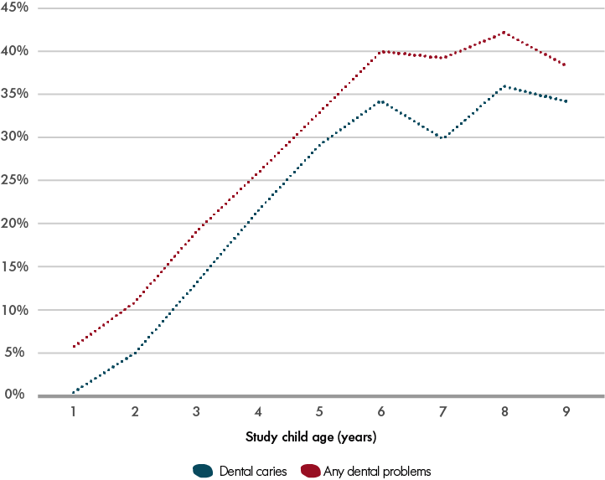
Note: The data was pooled across cohorts and waves of data collection. The figure includes data on 1,753 study children, with between one and six observations at different time points for each child.
As children grow, they tend to brush their teeth more regularly (see Figure 7.2). The number of children brushing their teeth ‘rarely’ or ‘never’ decreased with age and the number of children brushing their teeth twice a day increased with age. The number of children in the other two categories (brushing once a day or several times a week) remained roughly similar between ages 2 and 8.
Figure 7.2 Frequency of teeth brushing by age, Waves 1–6 (2008–2013)—per cent
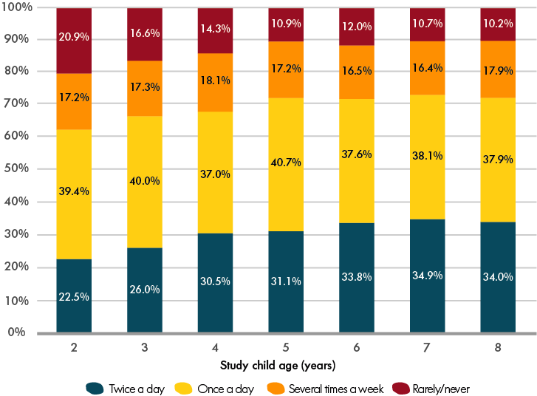
Note: The data was pooled across cohorts and waves of data collection. The figure includes data on 1,720 study children, with between one and six observations at different time points for each child.
Children were also more likely to visit a dentist as they grew up. Panel A of Figure 7.3 shows the proportion of children who had visited a dentist or a dental nurse in the 12 months prior to the interview by age (in years) and by Level of Relative Isolation. There was a gap in children’s dentist visits between urban areas or areas of low isolation and more remote areas (moderate, high and extreme levels of isolation). Notably, at 3 and 4 years of age, children in less isolated areas were approximately twice as likely to have visited a dentist in the year before the interview as children in areas of greater isolation. The gap narrowed between children aged 5 years and reversed among children aged 8 years.
Panel B of Figure 7.3 displays the percentages of children with dental problems by Level of Relative Isolation and age. In contrast to Panel A, it demonstrates that there was no gap in children’s reported dental problems up to 5 years of age; however, among children aged 6 to 8 years, the proportion of children reporting dental problems in the more isolated areas was significantly higher than for those from urban areas or areas of low isolation. Thus, preschool-aged children in more isolated areas appear to have dental problems that go undetected (and unreported) due to lower access to and/or uptake of dental services. Once the use of dental services levelled evenly between the regions, the percentages of children with dental problems in the more isolated areas were consistently higher than those of their counterparts in the cities and less isolated regional areas.
From 1 January 2014, families in receipt of Family Tax Benefit-A or certain other Australian Government payments became eligible for the Child Dental Benefits Schedule, which provides access to basic dental services (capped at $1,000 over two calendar years) for children aged 2 to 17 years. All states and territories provide publicly funded dental services to children and young adults; however, the availability of school dental clinics, community health centres and hospitals that provide publicly-funded dental care may vary between areas. In Footprints in Time, among children aged 3 to 4 years who had visited a dentist in the last 12 months, just under 30 per cent had done so at a school (regardless of the level of isolation); this figure rose to approximately 45 per cent among children aged 5 to 8 years. However, children in moderate or high-isolation areas who had visited a dentist were more than twice as likely to have done so at a hospital, compared to children in no or low-isolation areas. Conversely, almost no children from moderate or high-isolation areas had visited a dentist at a private practice.
Figure 7.3 Dentist visits and dental problems by age and Level of Relative Isolation, Waves 1–6 (2008–2013)—per cent
Panel A: Children who had visited a dentist during the 12 months before the interview
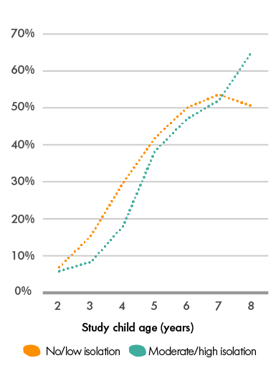
Panel B: Children with dental problems
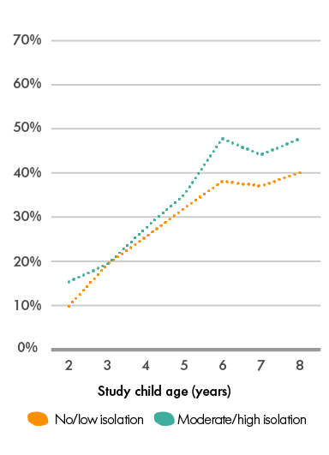
Note: The data was pooled across cohorts and waves of data collection. Panel A includes data on 1,708 study children and Panel B includes data on 1,721 study children, with between one and six observations at different time points for each child.
The Australian Dental Association (ADA, 2015) recommends that children first be taken to see a dentist at 12 months of age or shortly after the growth of their first baby teeth. The ADA further states that regular dental visits can help any problems to be diagnosed and help these problems to be managed before significant damage occurs.
Analysing the effect of dentist visits on dental health is complicated for two reasons:
- children with obvious teeth problems are more likely to be taken to a dentist; and
- children who have non-apparent dental problems are more likely to have these problems discovered as a result of a preventative dental visit.
Thus, dental visits can be expected to be positively correlated with the reporting of dental problems.
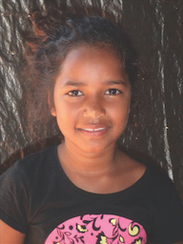

Socio-economic factors related to dental health and dental care
There is some evidence that socio-economic factors, both at the family and community level, are correlated with dental health and dental care among Footprints in Time children (see Table 7.1). Living in a more disadvantaged community (as measured by the Socio-Economic Indexes for Areas [SEIFA] Indicator of Relative Advantage and Disadvantage) was associated with a higher likelihood of dental problems, poorer dental self-care and less frequent dentist visits. Somewhat similar associations were observed in relation to Level of Relative Isolation; however, this association was weaker and less straightforward. For example, children living in areas of high or extreme isolation were as likely to regularly brush their teeth as children in urban areas and were more likely to do so than children living in areas of low or moderate isolation.
The socio-economic position of the family did correlate with dental health and dental health behaviours. Children whose parents had an education level below Year 12 were more likely to have dental problems, were less likely to brush their teeth regularly or to visit a dentist, compared to those whose primary carers had completed Year 12. Similar relationships were also found for other family characteristics, such as family income and joblessness (proxied by the non-receipt of wages or salaries). Children who lived in economically disadvantaged families were more likely to have problems with their teeth and were less likely to brush their teeth regularly and visit the dentist.
The Australian Dental Association (ADA, 2015) recommends that children first be taken to see a dentist at 12 months of age or shortly after the growth of their first baby teeth.
Table 7.1 Socio-economic covariates of children’s dental health, dental self-care and dental visits for children aged 5 years, Waves 1–6 (2008–2013)
 | Have dental problems,  per cent | Brush teeth twice a day or more often, per cent | Visited a dentist in the past 12 months, per cent
Community disadvantage (SEIFA Index of Relative Advantage and Disadvantage)
Bottom decile  (41 per cent of children) | 38.6 | 30.3 | 38.6
Deciles 2–6  (47 per cent of children) | 28.2 | 30.4 | 42.9
Deciles 7–10  (12 per cent of children) | 28.5 | 41.1 | 43.9
Level of Relative Isolation
No isolation (urban areas) | 26.4 | 38.7 | 39.1
Areas of low isolation | 35.2 | 26.6 | 43.1
Moderate | 38.6 | 27.4 | 36.5
High/extreme | 30.7 | 38.7 | 41.2
Parental education
Below Year 12 | 36.0 | 24.6 | 36.7
Year 12 or higher | 28.7 | 41.0 | 47.3
Family income
Less than $400 per week | 38.4 | 22.9 | 31.8
$400–$999 per week | 35.6 | 28.2 | 41.8
$1,000 or more per week | 27.5 | 38.0 | 46.4
Family draws income from wages and/or salaries
No wages/salaries | 37.3 | 23.1 | 36.5
Receive wages/salaries | 28.2 | 39.4 | 45.1
Note: The number of observations in the table varies between 1,205 and 1,378 depending on data item availability for individual covariates and outcomes.
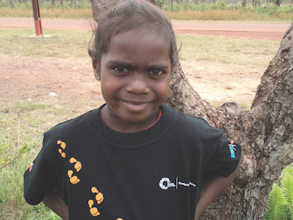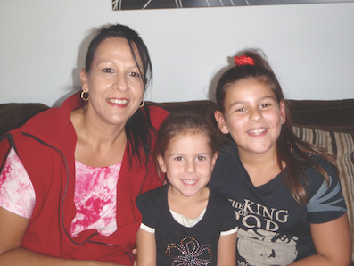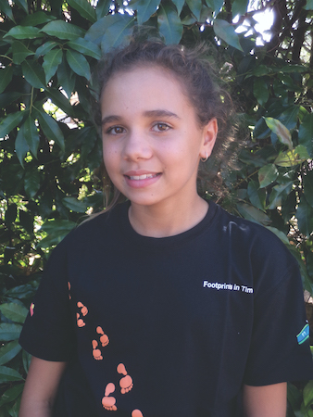

Relationship between children’s dental health and their dietary behaviours
This section begins by exploring the bivariate relationships between dental care (brushing and dentist visits), dietary behaviours (consumption of soft drinks and dairy products) and resultant dental health. The analysis is then expanded to a multiple model that simultaneously considers dental and dietary behaviours and demographic and socio-economic factors.
The outcome variable for this analysis was the presence of any dental problems among the older cohort children in Wave 5 (when they were aged around 8 years) and the younger cohort children in Wave 6 (when they were aged around 6 years). The initial sample comprised 1,264 children (735 in the younger cohort and 529 in the older cohort). Approximately four out of 10 children in the sample had dental problems (37.8 per cent of the younger cohort and 41.0 per cent of the older cohort). The final analysis sample was smaller due to item non-response on explanatory variables.
The explanatory variables on dental self-care and dietary behaviours were derived by considering all the responses of the study children’s P1s over the preceding four waves of the study (Waves 1–4 for the older children and Waves 2–5 for the younger children). This took advantage of the richness of this longitudinal data set and mitigated the effect of error or chance when measuring past behaviours.
The information about the study children’s diets was collected by asking the primary carer, ‘What food or drink did the study child have yesterday morning/afternoon/evening?’ This question was asked in Waves 2–5 for the younger cohort and Waves 1–4 for the older cohort of children. Cases with two or more missing waves of data were discarded from the analysis. Children who had not consumed a particular food or drink in any of the preceding years were grouped into the ‘never’ category, children who had consumed the food or drink in one or two of the four preceding years were grouped into the ‘some years’ category and the remaining children were grouped into the ‘most years’ category. The variable describing teeth-brushing habits was derived and categorised similarly to the dietary behaviour variables.
Figure 7.4 illustrates the likelihood that children will experience dental problems, depending on whether they have been brushing their teeth regularly or had consumed soft drinks or milk and dairy products over the previous years of the study. Children who had brushed their teeth twice a day, most years, were much less likely to have teeth problems than children who brushed their teeth less regularly. Of the children who brushed their teeth twice a day, 31.1 per cent had teeth problems. Conversely, approximately 41 per cent of children who had not brushed their teeth regularly over the previous four years of the study had teeth problems.
The consumption of soft drinks is an important determinant of several health issues, including weight gain and dental problems. Indigenous children have a higher per-person consumption of soft drinks than non-Indigenous children and earlier research using Footprints in Time data has demonstrated that disadvantage is correlated with higher chances of children consuming soft drinks (Thurber, Bagheri & Banwell, 2014). Figure 7.4 shows the correlation between dental problems and the history of soft drink consumption. Among children who, over the previous four years of the study, had not consumed any soft drinks on the day before interview, 26.3 per cent had teeth problems. Conversely, 44.0 per cent of children who had consumed soft drinks in most years on the day before the interview had teeth problems.
Children who, in preceding years, never consumed dairy products or milk on the day before interview had the highest proportion of dental problems (48.6 per cent). Of the children who consumed milk and/or dairy products in some of the years, 42.9 per cent had teeth problems. Conversely, the children who often consumed milk or dairy were the least likely to have unhealthy teeth (only 34.0 per cent of these children had teeth problems).
Figure 7.4 Likelihood of dental problems based on dental care and dietary habits in previous years, Waves 5–6 (2012–2013)—per cent
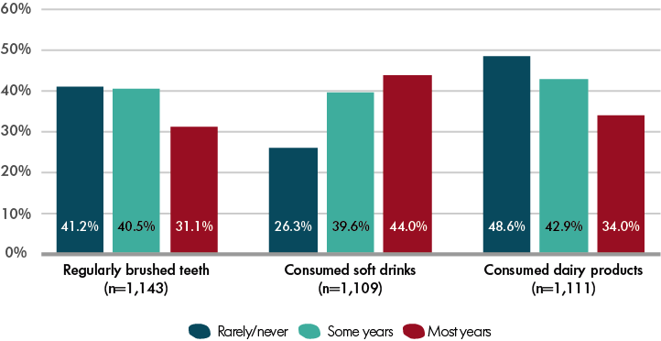
A comprehensive model was then developed that accounted for all the variables discussed thus far. The final section of this analysis addresses the last two research questions posed at the beginning of this chapter; that is, to what extent can the dental problems experienced by Aboriginal and Torres Strait Islander children in the Footprints in Time study be explained by dental care and dietary behaviours; and do socio-economic factors continue to affect dental health once dental care and dietary behaviours have been taken into account.
Table 7.2 displays the results of the multiple regression analysis on the likelihood that children will have dental problems. The model was estimated using probit regression and the table reports mean marginal effects that show how the probability of dental problems changes in percentage points in the presence of a particular characteristic. Two models were estimated. The first model included dental self-care and dietary variables only. The second (full) model also considered basic demographics and the socio-economic characteristics of each child’s family and community.
Table 7.2 Factors associated with dental problems among the Footprints in Time study children, Waves 1–6 (2008–2013)
 | Model 1 (diet and dental care only) | Model 2  (full)
Child’s dental care and diet
Brushed teeth regularly most years (ref ‘Never’ or ‘Some years’) | n.s. | n.s.
Consumptions of soft drinks in previous years (ref ‘Never’):
Some years | 0.116 | 0.104
Most years | 0.148 | 0.133
Consumed milk or dairy in most years (ref ‘Never’ or ‘Some years’) | –0.073 | –0.052
Basic demographics:
Child’s age in years | – | n.s.
Child is a girl | – | n.s.
Child is Torres Strait Islander or both Aboriginal and Torres Strait Islander (ref child is Aboriginal) | – | –0.173
Family and community characteristics:
Family receives income from wages and/or salaries | – | n.s.
Primary carer has Year 9 or below education | – | 0.092
Family lives in area of moderate,  high or extreme isolation | – | 0.128
Number of observations | 1,088 | 1,081
Note: The table reports mean marginal effects estimates from the probit regression models of the probability of a study child having dental problems taking into account dental care and dietary factors only (Model 1) or dental care, dietary, demographic and family characteristics (Model 2). n.s. indicates that the estimated coefficient is not significantly different from zero at the 10 per cent level
(p < 0.10).
A history of regular teeth brushing does not appear to have any effect on the likelihood of dental problems once the other variables have been taken into account. This is consistent with the AIHW’s (2013) findings that sugar exposure is a stronger predictor of tooth decay than tooth brushing or exposure to chemical teeth-cleaning solutions. Indeed, the frequent consumption of both soft drinks and milk and dairy products retain their significant (but opposite) relationship with the likelihood of dental problems. In the full model, children who had consumed soft drinks in most of the previous years were estimated to be 13.3 percentage points more likely to have dental problems than children who had never consumed soft drinks. Conversely, children who had consumed milk or dairy products in most of the previous years were 5.2 percentage points less likely to have problems with their teeth than children who had never or only occasionally consumed milk or dairy products.
Dental problems did not appear to depend on a child’s age and gender in this group of children; however, Torres Strait Islander status was associated with a significantly reduced likelihood of dental problems. Children who were Torres Strait Islander or both Aboriginal and Torres Strait Islander were 17.3 percentage points less likely to have dental problems than Aboriginal children. Thus, it appears that the presence of certain factors (e.g. regional aspects related to diet), which were unaccounted for in the present analysis, were associated with better dental health among Torres Strait Islander children.
Finally, there was evidence that the socio-economic characteristics of the family and the community were related to children’s dental health, even after dental care and children’s diet were considered. Children whose parents had lower levels of education and children who lived in more isolated areas were more likely to have dental problems than less disadvantaged children.

Conclusion
The analysis presented in this chapter examined the relationship between dental health, dental care and dietary behaviours, as well as the socio-economic characteristics of the families and communities of the Aboriginal and Torres Strait Islander children in the Footprints in Time study.
Dental health and dental care were found to be correlated with socio-economic disadvantage. Children who lived in more disadvantaged or more isolated communities or who had parents with lower levels of education, fared worse in terms of dental health and dental care.
There was some evidence that regular brushing of teeth contributed to lower dental problems; however, this relationship disappeared once other factors were taken into account. Concurrently, the regular consumption of milk and dairy products retained its positive correlation with good dental health, while the consumption of soft drinks was significantly associated with poorer dental health.
Finally, Torres Strait Islander children appeared to have better dental health than Aboriginal children. This finding may be due to some differences in the diet of Torres Strait Islander children, such as the consumption of certain types of bush foods specific to the region. Further research into this issue could contribute to a better understanding of children’s dental health and may yield positive solutions for improving the overall health outcomes of Indigenous children.

References
Australian Dental Association (ADA). (2015). Let’s talk baby teeth: Frequently asked questions.
Australian Health Ministers’ Advisory Council (AHMAC). (2015). Aboriginal and Torres Strait Islander Health Performance Framework 2014 Report. Originally retrieved from pmc.gov.au; now accessible via https://www.niaa.gov.au/resource-centre/indigenous-affairs/health-performance-framework-2014-report
Australian Institute of Health and Welfare (AIHW). (2013). Child and teenager oral health and dental visiting: Results from the National Dental Telephone Interview Survey 2010. Dental Statistics and Research Series Number 64. Canberra, ACT: Australian Institute of Health and Welfare.
Indigenous Oral Health Unit, Australian Research Centre for Population Oral Health. (2015). Indigenous Oral Health. Retrieved from https://www.adelaide.edu.au/arcpoh/iohu/indigenoushealth/
Kilpatrick, N.M., Neumann, A., Lucas, N., Chapman, J. & Nicholson, J.M. (2012). Oral health inequalities in a national sample of Australian children aged 2–3 and 6–7 years. Australian Dental Journal, 57(1), 38–44.
Sanders, A.E., Spencer, A.J. & Slade, G.D. (2006). Evaluating the role of dental behavior in oral health inequalities. Community Dentistry and Oral Epidemiology, 34(1), 71–79.
Thurber, K., Bagheri, N. & Banwell, C. (2014). Social determinants of sugar-sweetened beverage consumption in the Longitudinal Study of Indigenous Children. Family Matters, 95, 51–61.
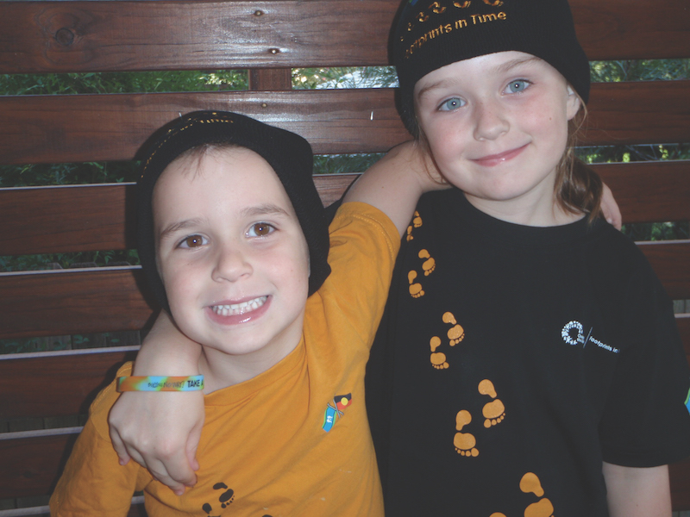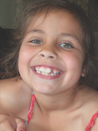
- Better literacy and numeracy in schools using the cross-curriculum priority of Aboriginal and Torres Strait Islander histories and cultures
Do Footprints in Time children benefit from having the cross-curriculum priority of Aboriginal and Torres Strait Islander histories and cultures (ACARA, 2017a) used in their schools? This question was explored using Footprints in Time data from teacher-completed surveys and interviews conducted with the study children and their parents and carers.
The cross-curriculum priority of Aboriginal and Torres Strait Islander histories and cultures is not a subject; however, it is taught across subjects and was designed ‘for all students to engage in reconciliation, respect and recognition of the world’s oldest continuous living cultures’ (ACARA, 2017b). Although the curriculum had not been implemented in all schools in 2013 when these data were collected, ACARA’s 2019 report indicated that the cross-curriculum priority is now being taught in all state, Catholic and Independent schools jurisdictions, and a version of the Australian curriculum has been implemented in all learning areas in state schools.
When the Footprints in Time children started school, parents’ and carers’ permission was sought for a questionnaire to be sent to the children’s school teachers. By 2013, most Footprints in Time children were in primary school: the older cohort were in Years 3 and 4 and the younger cohort were in pre-Year 1 and Year 1. More than 1,200 parents and carers gave their written permission for their children’s school teachers to complete a questionnaire in 2013 (Wave 6). Ultimately, 442 teachers completed one or more teacher questionnaires for a total of 543 study children.
In the questionnaire, teachers were asked a series of questions about themselves, the study child, their program and their school. Many of the questions, such as those from the academic rating scale (ARS), were the same as those used in the LSAC. Others, such as those regarding their cultural training and the cross-curriculum priority, were unique to Footprints in Time.
Teachers were provided with a series of statements about their school’s Aboriginal and Torres Strait Islander education focus, including the employment of Indigenous staff, whether Elders visit and whether the school was involved with the Indigenous community. One of the items stated:
This school is using the Australian Curriculum cross-curriculum priority of Aboriginal and Torres Strait Islander histories and cultures in its teaching.
Q: Tell us about a time you shared something, or felt good, about being Aboriginal and/or Torres Strait Islander in class.
A: When we have an Aboriginal story in class, I can pronounce the words.
—A response from a Footprints in Time study child.
In Wave 6, in response to this statement, 44.9 per cent of the study children’s teachers indicated that the children were attending a school that was ‘currently doing’ this, 28.6 per cent indicated that the children were attending a school that was ‘working on it’, 8.8 per cent indicated that this was ‘not done’ and 16.3 per cent of children had a teacher who did not know (a further 1.3 per cent did not provide an answer). The following analysis compares the responses of teachers whose schools had incorporated the Indigenous cross-curriculum priority (i.e. the ‘currently doing this’ responses) with those whose schools were not, were working on it or did not know.
The ARS language and literacy scale comprises 10 questions that participants are asked to respond to using a five-point scale; the score was then created by calculating the mean of the 10 ratings. In Wave 6, ARS literacy scores were calculated for 525 children (with a range of 1–5, a mean of 3.0 and a standard deviation of 1.2). Higher scores indicated greater language and literacy skills. The children with valid ARS scores were aged between 5 and 10 years with a mean age of 7.5 years.
The ARS language and literacy scale can be used across several year levels. Children’s scores naturally improve as they progress through year levels at school. The differences between the scores grouped into categories can be observed by comparing Year 1 students in schools implementing the cross-curriculum priority to those in schools not actively implementing the policy (see Figure 8.1). Of the Year 1 students, 58 were in schools that implemented the priority (with a mean score of 3.2) and 76 were in schools that had not implemented the priority (with a mean score of 2.7). This relationship appeared to be strongest among Year 1 students (see Table 8.1) whose mean ARS scores were higher when the cross-curriculum priority had been implemented.
Figure 8.1 Study children’s Year 1 literacy scores in relation to whether the school had implemented the cross-curriculum priority of Aboriginal and Torres Strait Islander histories and cultures, Wave 6 (2013) (teacher-reported)
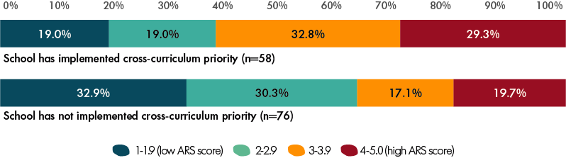
Table 8.1 Mean ARS literacy scores for children from pre-Year 1 to Year 4, Wave 6 (2013)
Year level | Pre-year 1 |  | Year 1 |  | Year 3 |  | Year 4
School implements cross-curriculum priority | No | Yes | No | Yes | No | Yes | No | Yes
Mean ARS score | 2.5 | 2.7 | 2.7 | 3.2 | 3.5 | 3.4 | 3.5 | 3.7
Number of observations | 74 | 74 | 76 | 58 | 73 | 50 | 37 | 40
Note: There were very few Year 2 students in the Wave 6 data, as most of the younger cohort were in a pre-Year 1 program or Year 1 and most of the older cohort were in Years 3 or 4.
A multiple regression model was constructed to test whether the cross-curriculum priority continued to show a relationship with literacy scores when controlling for other variables, known to be related to literacy, such as attendance and child health (Biddle, 2014; Hancock, Shepherd, Lawrence & Zubrick, 2013). Figure 8.2 shows that literacy scores were higher when the Indigenous cross-curriculum priority was used in the school, even when controlling for attendance, the child’s year level at school and the responding parent’s education. The model also controlled for clustering, as some teachers completed more than one form. The multiple regression model included 462 children and accounted for 23.6 per cent of the variation in literacy scores.
Figure 8.2 Factors associated with children’s ARS literacy scores, Wave 6 (2013)
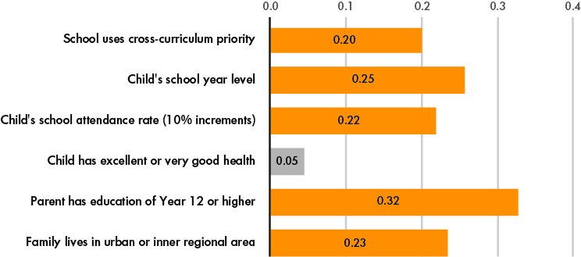
Note: Orange bars indicate statistical significance at p < 0.05. Grey bars indicate the characteristic is not significant. The figure shows the coefficient estimates from the OLS regression model for which ARS literacy score was the outcome variable. The model was estimated controlling for clustering at the teacher level. The model included children in school years ranging from pre-Year 1 to Year 4. Total n = 462.
No other responses to the series of questions about the schools’ Aboriginal and Torres Strait Islander education focus related to improved literacy scores when controlling for the same influences.
In addition to the teacher-reported ARS language and literacy questions, Footprints in Time interviewers conducted vocabulary and reading assessments with the study children. The results of these assessments were analysed to determine whether they supported the ARS regression findings. The vocabulary scores of the children in the younger cohort (aged around 6 years in 2013) were also 2.6 points higher (p < 0.01) if the teachers said their school used the Aboriginal and Torres Strait Islander cross-curriculum priority (see Figure 8.3).
Figure 8.3 Factors associated with children’s ARS vocabulary scores, Wave 6 (2013)
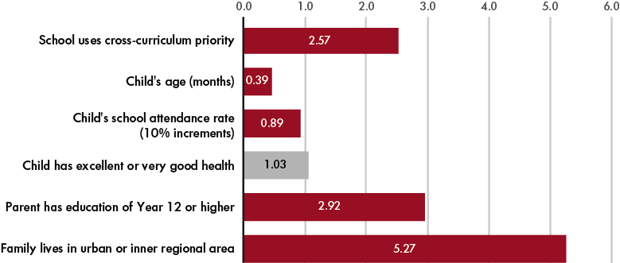
Note: Red bars indicate statistical significance at p < 0.05. Grey bars indicate the characteristic is not significant. The figure shows the coefficient estimates from the OLS regression model for which the Renfrew Word Finding Vocabulary test score was the outcome variable. The model included children in school years ranging from pre-Year 1 to Year 2. Total n = 266.
The same pattern was observed for teacher-rated ARS mathematical thinking scores. Similar to the ARS language and literacy scores, items were rated on a five-point scale and the score was created by calculating the mean of the eight ratings. Under the multiple regression model, which controlled for school attendance, child health, parental education, remoteness and year level, the implementation of the cross-curriculum priority predicted higher mathematics scores (significant at p < 0.05) (see Figure 8.4).
Figure 8.4 Factors associated with children’s ARS numeracy scores, Wave 6 (2013)
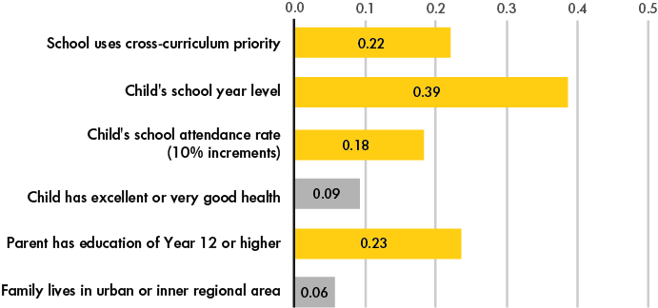
Note: Yellow bars indicate statistical significance at p < 0.05. Grey bars indicate the characteristic is not significant. The figure shows the coefficient estimates from the OLS regression model for which the ARS numeracy score was the outcome variable. The model was estimated while controlling for clustering at the teacher level. The model included children in school years ranging from pre-Year 1 to Year 4. Total n = 430.

Discussion
Footprints in Time children attending schools that use the cross-curriculum priority of Aboriginal and Torres Strait Islander histories and cultures in their teaching had higher average literacy, vocabulary and maths scores than children in schools that do not use the cross-curriculum priority (or schools in which the teacher was not aware of whether the cross-curriculum priority was being used).
As only one question in the teacher questionnaire asked about the inclusion of the Indigenous cross-curriculum priority, it was difficult to ascertain whether these results were related to the school’s inclusion of these priorities or whether each child’s literacy or numeracy score was more closely related to another factor, such as the individual practices of teachers. The summative evaluation of the Stronger Smarter Learning Communities project (Luke et al., 2013) found that teachers who had higher levels of engagement with Indigenous families, communities and cultures outside school were more likely to report that they were teaching Indigenous topics in the classroom. This scale has been included in the Footprints in Time teacher surveys from Wave 8 onwards. Consequently, further analyses can be undertaken to test this hypothesis in the future.
The school needs to find [out] what the community is all about, e.g. sacred sites, where to go and where not to go, knowing what languages are spoken on that community. They should abide by cultural protocols within the community. There should be cultural awareness for all staff members.
—A response from a Footprints in Time primary carer.
Despite being clear, the results in Figures 8.2, 8.3 and 8.4 need to be carefully interpreted. The sample is not representative of all areas within Australia and the characteristics of the teachers who responded may be quite different to the characteristics of the teachers who did not respond. However, it would be interesting to examine whether the results can be replicated in other studies or in later waves of Footprints in Time.
Schools that tailor their teaching practices to engage and target specific groups of students may also be early adopters of the cross-curriculum priority of Aboriginal and Torres Strait Islander histories and cultures. Consequently, it may not follow that adopting the policy will automatically result in immediate improvement in Indigenous students’ literacy and language skills. However, the results showed that the relationship between integrating Indigenous histories and cultures with other subject matter predicted better learning outcomes for Indigenous children. No other measures of a school’s Aboriginal and Torres Strait Islander education focus collected by the Footprints in Time study consistently predicted better outcomes. Thus, this is more than just an indicator of cultural competency.
These early findings may reflect the effect of establishing the act of learning as interesting and relevant to children. This will also enable children to experience their cultural backgrounds being respected and reflected in their classrooms. People tend to learn effectively when they are interested and able to relate to the subject matter. Thus, it should not be surprising that this works in the classroom for Aboriginal and Torres Strait Islander children.

References
Australian Curriculum, Assessment and Reporting Authority. (2017a). Aboriginal and Torres Strait Islander histories and cultures. Retrieved from https://www.australiancurriculum.edu.au/f-10-curriculum/cross-curriculum-priorities/aboriginal-and-torres-strait-islander-histories-and-cultures/
Australian Curriculum, Assessment and Reporting Authority. (2017b). Development of the Australian curriculum. Retrieved from http://www.acara.edu.au/curriculum/development-of-australian-curriculum
Biddle N. (2014). Developing a behavioural model of school attendance: Policy implications for Indigenous children and youth. CAEPR Working Paper No. 94. Australian National University, Canberra, ACT, Centre for Aboriginal Economic Policy Research.
Department of Social Services. (2017). Footprints in Time: The Longitudinal Study of Indigenous Children – Data user guide, Release 8.0. Canberra, ACT: DSS.
Hancock, H.K., Shepherd, C.C.J., Lawrence, D. & Zubrick, S.R. (2013). Student attendance and educational outcomes: Every day counts. Canberra, Australia: The Department of Education, Employment and Workplace Relations.
Luke, A., Cazden, C., Coopes, R., Klenowski, V., Ladwig, J., Lester, J., . . . Woods, A.F. (2013). A summative evaluation of the Stronger Smarter Learning Communities project: Vol 1 and Vol 2. Brisbane, QLD: Queensland University of Technology.
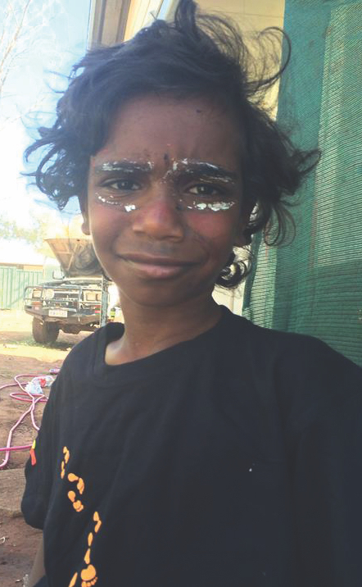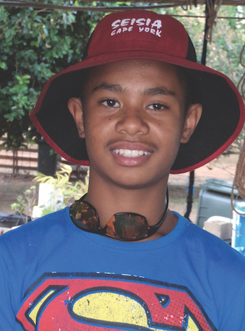
- Sleep health in Footprints in Time: The effects of stressful life events and sleep disturbance on social and emotional difficulties

Introduction
The link between sleep difficulties and adverse health outcomes is well established; poor sleep health in childhood is linked to obesity, emotional dysregulation, reduced academic achievement and diminished quality of life and wellbeing (Chaput et al., 2016). Although there is less evidence available regarding Indigenous Australians, the evidence that is available suggests that Indigenous Australian children have poorer sleep health than non-Indigenous Australian children (Woods et al., 2015). This contributes to poorer academic performance (Cooper, Kohler & Blunden, 2012) and negatively affects health and wellbeing (Blunden, Chervin & Benveniste, 2012).
Sleep health is particularly pertinent in the areas of physical health, mental health and academic achievement and, therefore, educational completion and employment (Blunden & Camfferman, 2013; Camfferman & Blunden, 2015; Cooper et al., 2012). Moreover, sleep is amenable to intervention, at least via individual treatment; this makes it a modifiable risk factor (Christensen et al., 2016; Pleister & Khayat, 2015; van Cauter, Spiegel, Tasali & Leproult, 2008).
Sleep health could be a vital, yet largely unaddressed, factor in closing the gap between Indigenous and non-Indigenous Australians.
However, effective strategies for promoting sleep health to the wider community have been less researched than individual approaches (Perry, Patil & Presley-Cantrell, 2013). Sleep health could therefore be a vital, yet largely unaddressed, factor in closing the gap between Indigenous and non-Indigenous Australians.
For children, life events experienced within the family have the potential to constitute major stressors and thus affect sleep health (Tsai et al., 2017). Consequently, knowledge of different sorts of life events and their effects on health outcomes should not only provide a proxy measure of the relative stress caused by these events, but should also show that children are likely to be at the highest risk of poor sleep health when such events/stressors occur and provide insight into any associated consequences. Similarly, knowledge of the predictive utility of sleep health in relation to social and emotional difficulties (and relative to other potential predictors, such as relative isolation, socio-economic disadvantage, child health and overcrowding) should enable prevention/early intervention strategies that focus on sleep health within this population to be better targeted. It has been suggested that higher isolation (i.e. geographical remoteness) is likely to increase sleep disturbance, as it tends to be associated with lower socio-economic profiles, higher rates of overcrowding, environmental factors, such as pollen and dust, and restricted access to health care (all of which are factors that might contribute to sleep disturbance) (Camfferman & Blunden, 2015).
The analyses presented in this chapter used data from Footprints in Time and Growing Up in Australia: LSAC to explore:
- The effects of stressful life events experienced by the study child’s family in the previous 12 months on the study child’s sleep.
- The longitudinal effects of persistent sleep disturbance from Waves 1–5 on social and emotional difficulties one year later (Wave 6).

Measures
Data on stressful life events are collected in Footprints in Time using a set of 15 questions covering a range of potentially stressful experiences in the child’s family life, including those related to illness/injury, pregnancy in the family, financial concerns, job loss, drug/alcohol problems, mugging/assault, family arguments/disharmony, death of family members, housing problems, family breakup, and family members being arrested or going to jail. This is completed by the study child’s P1. The measure of stressful life events used in this chapter is the count of different types of events that were experienced by each family in the Footprints in Time study in the year before the Wave 5 interview.
Social and emotional difficulties were measured at Wave 6 using the Strengths and Difficulties Questionnaire (SDQ) total difficulties score. The SDQ is a 25-item scale that covers five domains: emotional symptoms, conduct problems, hyperactivity/inattention, peer relationship problems and prosocial behaviour. The total difficulties score is created by combining the first four of these domains.
The SDQ has been translated into more than 75 languages and has been validated in both community samples and clinical settings (Moriwaki & Kamio, 2014). The SDQ has been used with Indigenous Australian populations (van Bockxmeer, McNamara & Green, 2015; Williamson et al., 2014) and has shown good internal consistency in this population; Cronbach’s alpha was equal to 0.85 (Williamson et al., 2014). The SDQ items in Wave 6 were completed by the P1s.
The following question was used to measure sleep disturbance, ‘In the last month has [the study child] usually had trouble getting to sleep or staying asleep?’ Response options included ‘Yes’, ‘No’, ‘Don’t know’ and ‘Refused’. The current analysis defined sleep disturbance as a response of ‘Yes’ to this question. Analyses that included sleep disturbance as the outcome variable used this single binary item at Wave 5. The analysis that included sleep disturbance as a predictor (of social and emotional difficulties) used a measure of persistent sleep disturbance compiled from the above question taken from Waves 1 to 5. Children who had experienced sleep disturbance in three or more waves were deemed to have persistent sleep disturbance.
Other predictors included primary carer’s global assessment of the study child’s health (‘In general, would you say [the study child’s] health is excellent, very good, good, fair or poor?’), the number of people living in the home, the remoteness and relative socio-economic advantage and disadvantage of the area, and the study child’s age and gender. Geographical remoteness was measured using Level of Relative Isolation (LORI), which was developed for the Western Australian Aboriginal Child Health Survey (Silburn et al. 2006) from the Accessibility/Remoteness Index of Australia (Department of Health and Aged Care, 2001). The LORI designates each study family to one of five remoteness levels, ranging from major metropolitan/urban areas to very remote communities. These five categories were none, low, moderate, high and extreme isolation.
The relative socio-economic advantage and disadvantage of the area of child’s residence was measured using deciles from the SEIFA developed by the ABS (2011).
The comparative prevalence of sleep disturbance in LSAC at ages 5 and 8 years for non-Indigenous children was taken from the question, ‘In the past one month, how often would you say this child has had a problem with … trouble sleeping?’ Response options included ‘Not sure’, ‘Never’, ‘Almost never’, ‘Sometimes’, ‘Often’ and ‘Almost always’. For ease of comparison with the question in Footprints in Time that asked whether the study child had ‘usually’ had trouble sleeping in the past month, the ‘Often’ and ‘Almost always’ options in the LSAC were taken to indicate that the study child usually experienced sleep disturbance.
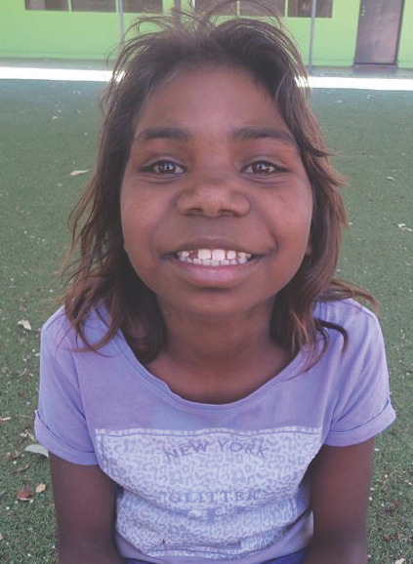

Results
Figure 9.1 shows the prevalence of sleep disturbance in the Footprints in Time population and compares this to the sleep disturbance reported for the general Australian population (as per the LSAC data). The prevalence of ‘Usually’ having trouble sleeping in the past month among Footprints in Time children at Wave 5 (18.7 per cent and 17.7 per cent for children aged 5 and 8 years, respectively) was more than double the prevalence of ‘Often’ or ‘Almost always’ having trouble sleeping in the past month among the LSAC non-Indigenous children at similar ages (7.1 per cent and 6.3 per cent for children aged 5 and 8 years, respectively).
The majority (59.1 per cent) of Footprints in Time study children with sleep disturbance experienced this disturbance at least four nights per week.
Figure 9.1 Sleep disturbance among Footprints in Time children (Wave 5, 2012) and LSAC non-Indigenous children (Release 6, Waves 1–6, 2014)—per cent
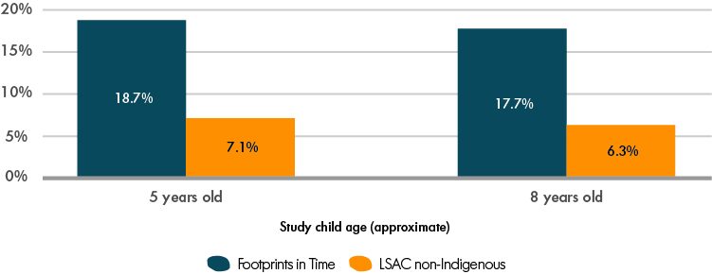
Note: The numbers of observations were: n = 679 for Footprints in Time children (402 5-year-old children and 277 8-year-old children) and n = 10,505 for LSAC children (7,753 5-year-old children and 2,752 8-year-old children).
Table 9.1 Number of stressful life events experienced by Footprints in Time study families in the past 12 months, Wave 5 (2012)
Number of life events | Number of observations | Per cent
No events | 65 | 5.2
1–3 events | 545 | 43.3
4–6 events | 454 | 36.1
7–15 events | 194 | 15.4
Total | 1,258 | 100.0
In Wave 5, the number of stressful life events ranged from zero to 15, with a median of four. Table 9.1 displays the distribution of events across the Footprints in Time sample. To assess the impact of family- and community-level factors on child sleep disturbance, a logistic regression analysis was conducted, focusing on the relationship between sleep disturbance, the number of stressful life events in the past 12 months, and the total number of people living in the house, while also controlling for study children’s health and the relative socio-economic advantage or disadvantage and the geographical isolation of the area. In this model, sleep disturbance was found to be significantly associated with the number of stressful life events (p < 0.001) and relative isolation (p < 0.001). A higher number of stressful life events predicted higher rates of sleep disturbance; however, greater relative isolation predicted lower rates of sleep disturbance. The relationships between sleep disturbance and study children’s overall health and the total number of people in the house were not found to be statistically significant.
It may be that certain types of life events may have a greater effect on sleep quality than others. To this end, the relationships between individual life events and sleep disturbance were assessed separately. Events found to have a significant connection to sleep disturbance included:
- injury or sickness in the family (p < 0.05)
- a family member losing their job (p < 0.05)
- the family worrying over money (p < 0.001)
- alcohol or drug problems in the family (p < 0.001)
- a mugging or assault in the family (p < 0.05)
- children in the family being upset by family arguments (p < 0.001).
Events or stressors that were not significantly associated with sleep disturbance were pregnancy in the family, death in the family, family members getting a job/returning to work or study, housing problems, family members being arrested or jailed, the family splitting up, experience of humbugging (i.e. being hassled for food, money or other things) and children being scared by other people’s behaviour.
Individual events or stressors that had a significant bivariate association with sleep disturbance were then accounted for simultaneously in a logistic regression model. In this model, only worries about money and children in the family being upset by family arguments remained significant predictors of sleep disturbance. Table 9.2 reports the odds ratios for each life event or predictor. In particular, it shows that children in families that experienced money worries had, on average, 2.1 greater odds of having sleep problems, compared to children whose families had no worries about money. Similarly, family arguments resulted in children having 1.5 greater odds of experiencing sleep disturbance.
Table 9.2 Stressful life events as predictors of sleep disturbance, Wave 5 (2012)
Stressful event | Effect on child’s sleep disturbance (odds ratios)
Family injury or sickness | n.s.
Family job loss | n.s.
Family financial worries | 2.11
Family alcohol or drug problem | n.s.
Family member victim of mugging or assault | n.s.
Family arguments upsetting child | 1.49
Number of observations | 1,223
Note: The table reports odds ratio estimates from multiple logistic regression model with sleep disturbance as the outcome variable, taking into account the experience of multiple stressful life events. Only the stressful events that were found to have a significant relationship with sleep disturbance in the bivariate regressions were included as predictors. Odds ratios greater than one represent a greater likelihood of sleep disturbance in the presence of the corresponding stressful event. n.s. indicates that the estimated odds ratio is not significantly different from one at the 10 per cent level (p < 0.10).
Finally, a linear regression analysis was undertaken to assess the relationship between persistent sleep disturbance in Waves 1–5 and social and emotional difficulties in Wave 6 (see Figure 9.2). This analysis also accounted for the overall health of the study child, the number of stressful life events experienced by the family, the relative socio-economic advantage or disadvantage and the relative isolation of the area of residence, the number of people living in the house, and the study child’s age and gender. Persistent sleep disturbance, the number of stressful life events, the relative socio-economic advantage or disadvantage of the area, and the child’s health and gender were all found to be significant predictors of social and emotional difficulties. Children experiencing persistent sleep disturbance had on average 2.3 points higher difficulties score. At the same time, each additional stressful life event experienced by a child’s family increased the child’s total difficulties score by approximately 0.5 points.
Figure 9.2 Relationship between social and emotional difficulties and persistent sleep disturbance, study child’s health and family experience of stressful life events, Waves 1–6 (2008–2013) compilation
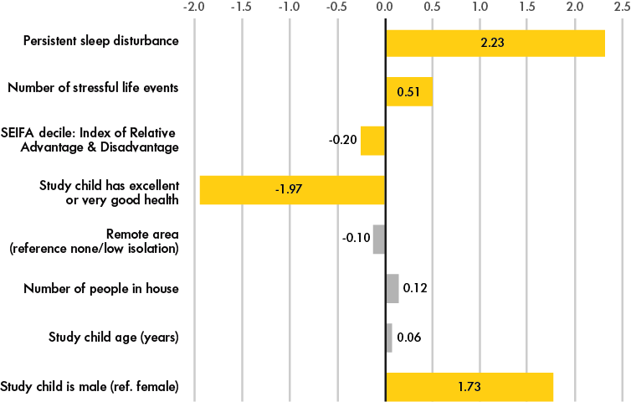
Note: Yellow bars indicate statistical significance at p < 0.05. Grey bars indicate the characteristic is not significant. The figure reports coefficient estimates from an OLS regression model with social and emotional difficulties as the outcome variable. Persistent sleep disturbance indicates that a child was recorded as having experienced disturbed sleep in three or more waves from Waves 1–5. All other variables were from Wave 6. Total n = 970.

Discussion
The importance of sleep health for the Aboriginal and Torres Strait Islander population is becoming more apparent. Sleep health could be a vital, yet largely unaddressed, factor in closing the health gap between Indigenous and non-Indigenous Australians.
The analysis in this chapter showed that the experience of stressful life events within a family is predictive of sleep disturbance and that worries about money (experienced by 25–30 per cent of the study population) and family arguments (experienced by 19–21 per cent of study children) had the largest effects on sleep disturbance among children in the Footprints in Time study. Across the two cohorts, financial worries within the family more than doubled the likelihood of sleep disturbance.
The Footprints in Time population had considerable sleep difficulties at more than double the prevalence for the general Australian population. Although this sample is not necessarily representative of all Indigenous Australian children, these results reinforce previous findings that sleep health is especially concerning for Indigenous Australians.
Relative isolation was negatively correlated with sleep disturbance; study children living in more isolated areas were less likely to experience sleep disturbance. This is contrary to suggestions in the literature that higher isolation should equate to poorer sleep. It is possible that the Footprints in Time sample somehow differs to the general Indigenous Australian population. Alternately, these results could also reflect differences in the use of screens and other electronic devices that have been found to perpetuate sleep disturbance (Olds, Ridley & Dollman, 2006) or could reflect the effects of other environmental stimuli (e.g. noise and light) that might be less problematic in more isolated regions. These possibilities require further exploration.
Social and emotional difficulties were not associated with relative isolation, the number of people in the home or the child’s age in the present analysis. Conversely, persistent sleep disturbance in the five years preceding Wave 6 (but not Wave 6 itself) significantly predicted social and emotional difficulties at Wave 6. Notably, this finding held when the effects of stressful life events, health and gender were considered. The results also showed that sleep disturbance was the strongest predictor of social and emotional difficulties in this model.
These findings provide important additional evidence for the notion that sleep health is highly important for Indigenous Australians. Further, these findings suggest that sleep disturbance might be a logical and powerful focus of interventions targeted at preventing later social and emotional difficulties and their consequences. Sleep health is relatively amenable to positive change (Camfferman & Blunden, 2015) and has wide-reaching benefits (Chaput et al., 2016). Thus, this area has great potential to contribute to closing the gap between Indigenous and non-Indigenous Australians.
It should be noted that this research has certain limitations, namely that the measurement of sleep disturbance was based on a single-item binary variable that varied between the Footprints in Time and LSAC samples. This issue was overcome to some extent when sleep was used as a predictor variable, as the analyses used a measure of persistent sleep disturbance across the five waves of data collection. A more detailed, sensitive and validated measure of sleep disturbance would be beneficial for future research.
As future waves of data become available, it would also be useful to take advantage of the longitudinal nature of the Footprints in Time study and to link the study children’s sleep health to other areas of health, development and academic achievement, including cognitive functioning (which was measured for the first time in Wave 10 [2017]). It should also be noted that the Footprints in Time study population is not a representative sample of Indigenous Australian children. Thus, a generalisation of prevalence rates to the wider Indigenous Australian population is not possible.
Further research is needed to identify optimal strategies for promoting sleep as a healthy behaviour not only among the broad population of young Australians, but via targeted programs for Indigenous children and youth. Such public sleep health programs have the potential to meaningfully contribute to closing the gap between Indigenous and non-Indigenous Australians in the areas of health, education and employment.
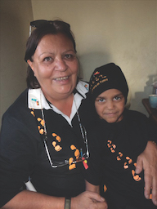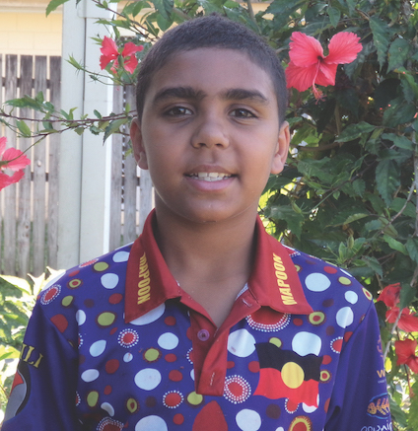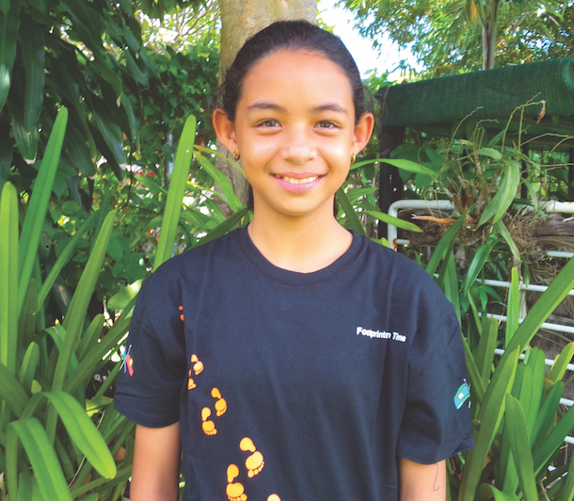
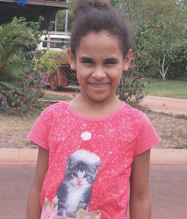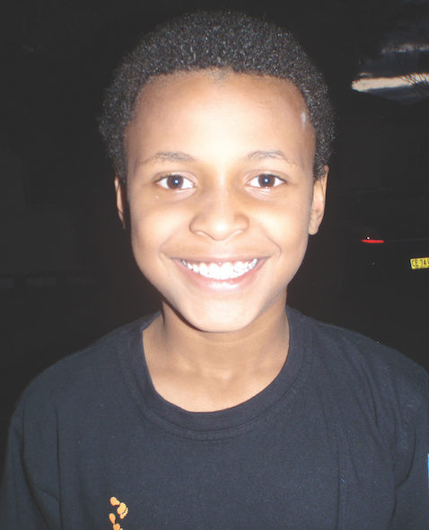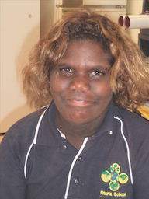

References
Australian Bureau of Statistics (ABS). (2011). Socio-economic indexes for areas. Retrieved from http://www.abs.gov.au/websitedbs/censushome.nsf/home/seifa
Blunden, S. & Camfferman, D. (2013). Can sleep contribute to “closing the gap” for Indigenous children? The Medical Journal of Australia, 199(1), 19–20.
Blunden, S., Chervin, R. & Benveniste, T. (2012). The sleep health of Australian Indigenous and non-Indigenous children in both urban and rural centres. Sleep and Biological Rhythms, 10(1), 1–74.
Camfferman, D. & Blunden, S. (2015). The contribution of sleep to ‘Closing the Gap’ in the health of Indigenous children: A methodological approach. Australian Indigenous Health Bulletin, 15(1).
Chaput, J.P., Gray, C.E., Poitras, V.J., Carson, V., Gruber, R., Olds, T., . . . Tremblay, M.S. (2016). Systematic review of the relationships between sleep duration and health indicators in school-aged children and youth. Applied Physiology, Nutrition, and Metabolism, 41(6), 266–282.
Christensen, H., Batterham, P.J., Gosling, J.A., Ritterband, L.M., Griffiths, K.M., Thorndike, F.P.,. . . Mackinnon, A.J. (2016). Effectiveness of an online insomnia program (SHUTi) for prevention of depressive episodes (the GoodNight Study): A randomised controlled trial. The Lancet Psychiatry, 3(4), 333–341.
Cooper, P., Kohler, M. & Blunden, S. (2012). Sleep and academic performance in Indigenous Australian children from a remote community: An exploratory study. Journal of Paediatrics and Child Health, 48(2), 122–127.
Department of Health and Aged Care. (2001). Measuring remoteness: Accessibility/Remoteness Index of Australia (ARIA). Occasional Paper New Series Number 14. Canberra, ACT: Department of Health and Aged Care.
Moriwaki, A. & Kamio, Y. (2014). Normative data and psychometric properties of the strengths and difficulties questionnaire among Japanese school-aged children. Child and Adolescent Psychiatry and Mental Health, 8(1).
Olds, T., Ridley, K. & Dollman, J. (2006). Screenieboppers and extreme screenies: The place of screen time in the time budgets of 10–13 year-old Australian children. Australian and New Zealand Journal of Public Health, 30(2), 137–142.
Perry, G.S., Patil, S. & Presley-Cantrell, L.R. (2013). Raising awareness of sleep as a healthy behavior. Preventing Chronic Disease: Public Health Research, Practice, and Policy, 10, E133.
Pleister, A.P. & Khayat, R.N. (2015). Sleep-disordered breathing a modifiable risk factor for cardiovascular disease. Sleeping and Breathing, 4(1), 34–41.
Silburn, S.R., Zubrick, S.R., De Maio, J.A., Shepherd, C., Griffin, J.A., Mitrou, F.G., . . . Pearson, G. (2006). The Western Australian Aboriginal Child Health Survey: Strengthening the capacity of Aboriginal children, families and communities (Vol. 4). Perth, WA: Curtin University of Technology and Telethon Institute for Child Health Research.
Tsai, K.M., Dahl, R.E., Irwin, M.R., Bower, J.E., McCreath, H., Seeman, T.E., Almeida, D.M. & Fuligni, A.J. (2017). The roles of parental support and family stress in adolescent sleep. Child Development, 89(5), 1577–1588.
van Bockxmeer, J., McNamara, K. & Green, J. (2015). The social and emotional benefits of yoga for Aboriginal Australian children: A pilot case series study. Australian Indigenous Health Bulletin, 15(4), 1–4.
van Cauter, E., Spiegel, K., Tasali, E. & Leproult, R. (2008). Metabolic consequences of sleep and sleep loss. Sleep Medicine, 9(1), 23–28.
Williamson, A., McElduff, P., Dadds, M., D’Este, C., Redman, S., Raphael, B., . . . Eades, S. (2014). The construct validity of the Strengths and Difficulties Questionnaire for Aboriginal children living in urban New South Wales, Australia. Australian Psychologist, 49(3), 163–170.
Woods, C.E., McPherson, K., Tikoft, E., Usher, K., Hosseini, F., Ferns, J., . . . Maquire, G.P. (2015). Sleep disorders in Aboriginal and Torres Strait Islander people and residents of regional and remote Australia. Journal of Clinical Sleep Medicine, 11(11), 1263–1271.
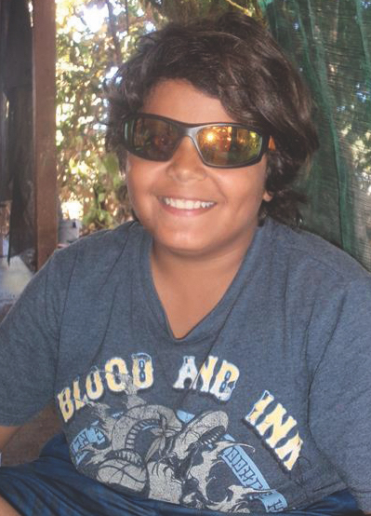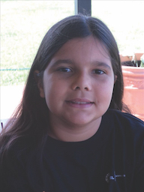
- Healthy lifestyle: Diet and exercise
The determinants of health are many and varied and include environmental, socio-economic, psychological and biomedical factors, as well as dietary health behaviours and physical activity. A healthy diet and sufficient exercise help to prevent and manage health risk factors, including those related to weight gain and obesity, high blood pressure, high cholesterol and associated chronic conditions, such as type 2 diabetes, cardiovascular disease and some forms of cancer (AIHW, 2018).
The National Health and Medical Research Council (NHMRC) provides guidelines for maintaining health and wellbeing through the Australian dietary guidelines (NHMRC, 2013). The five overarching guidelines are to:
- achieve and maintain a healthy weight through physical exercise and choosing the appropriate amount of nutritious food and drink to meet energy needs
- eat a range of foods from the five food groups each day
- minimise intake of saturated fat, salt, sugar and alcohol
- encourage, promote and support breastfeeding
- prepare and store food safely.
Of the five major food groups, the two that are most often lacking in the modern Australian diet are fruit and vegetables. Fruit and vegetables are rich in vitamins, minerals, dietary fibre and phytochemicals; they protect against several chronic diseases, including heart diseases and stroke, and lower the risk of some types of cancer. The NHMRC (2013, p. 42) guidelines recommend that children aged 9 to 11 years eat five servings of vegetables and two servings of fruit every day.
Under Australia’s physical activity and sedentary behaviour guidelines, children aged 5 to 17 years should do at least 60 minutes of moderate to vigorous intensity exercise every day (Australian Department of Health, 2019).
This analysis uses the data from the Footprints in Time study to examine the dietary and exercise patterns of children in the study.

Fruit and vegetable intake
The Footprints in Time study includes various questions that offer insight into the dietary patterns of the children participating in the survey. In Wave 9 (2016), primary carers (P1s) were asked about their children’s daily fruit and vegetable intake. Table 10.1 shows the number of serves of fruit and vegetables the study children had each day. For the purposes of this analysis, children aged 8 years or under were excluded, as dietary guidelines for children aged 4 to 8 years suggest a lower intake of fruit and vegetables.
Most children ate the recommended two or more serves of fruit each day. Only a small number of children ate less than one serve of fruit per day or no fruit at all. However, almost none of the children ate the recommended five or more serves of vegetables.
Q: How do you get the Study Child to eat fruit and vegetables?
A: [I] cook with vegies; soup, stew, bake and quiches. [With] fruit l just let the kids help themselves and also make ice blocks, fruit salad and juices.
—A response from a Footprints in Time primary carer
Table 10.1 Number of serves of fruit and vegetables per day for children aged 9–13 years, Wave 9 (2016)
Fruit (n = 895) |  |  | Vegetables (n = 896)
none | 4.4% |  | none | 4.2%
one serve | 24.7% |  | one or two serves | 60.8%
two or more serves | 70.9% |  | three or four serves | 30.5%
recommended |  |  | five or more serves | 8.7%
 |  |  | recommended
The very low proportion of children eating the recommended daily amount of vegetables may be because the recommended daily intake is much lower for fruit than it is for vegetables or because the sweetness of fruit makes it more attractive to children, due to a biological drive for sweet tastes (Mennella, Lukasewycz, Griffith & Beauchamp, 2011, p. 353). Footprints in Time interviewers have also anecdotally reported that fruit is much more accessible than vegetables in isolated areas.
Many Footprints in Time children are eating less than the recommended daily serves of fruit and vegetables; however, these figures are comparable to the general Australian population of similar aged children. The Australian Health Survey 2011–2012 showed that among Australian children aged 5 to 11 years, 68.6 per cent ate two or more serves of fruit on a usual day and 28.0 per cent ate three or more serves of vegetables (ABS, 2013).
P1s were asked whether they thought their children ate enough fruit and vegetables. A little over half (57.4 per cent) of P1s were satisfied with their children’s fruit and vegetable consumption; however, just under a fifth thought their child did not eat enough of either (see Figure 10.1). P1s were more likely to be concerned about their child’s intake of vegetables than of fruit, which is understandable given the discrepancy between children’s reported consumption and dietary guidelines.
Figure 10.1 Primary carers’ satisfaction with study children’s fruit and vegetable consumption, Wave 9 (2016)—per cent
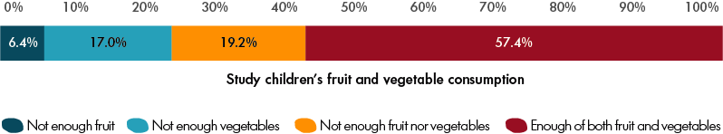
Note: Total n = 1,240.
P1s were also asked why their children did not eat more fruit or vegetables. An analysis of these data by Thurber et al. (2017) revealed that multiple barriers restrict Indigenous children’s consumption of fruit and vegetables. The most commonly reported barrier was children’s dislike of fruit and vegetables. Problems accessing fruit and vegetables were also common among parents and carers living in remote settings, disadvantaged parents and carers living in urban settings, and the cost, availability and quality of fruit and vegetables also created substantial barriers to access (Thurber et al., 2017).

Takeaway meals
Many manufactured and packaged foods (e.g. snack foods, take away foods, cakes, pies and sweet and savoury biscuits) contain high levels of saturated fats, salt and sugar (NHMRC, 2013).
Primary carers were asked in Wave 9 how often their child ate takeaway meals; however, as the question provided no definition of ‘takeaway meals’, the respondents had to decide themselves what to include in this category. Figure 10.2 shows that for 42.1 per cent of children, takeaway meals were not a common occurrence (less frequent than once a week). However, nearly six out of ten children ate takeaway meals once a week or more often and a very small number of children ate takeaway meals daily.
The frequency of takeaway food consumption was not correlated with children’s age, the level of education of their primary carer or with the relative disadvantage or level of isolation of the area in which they lived. However, children whose primary carers did not have a job were more likely to have takeaway meals only occasionally (45.9 per cent, compared to 36.9 per cent of children whose primary carers were employed).
Figure 10.2 How often study children ate takeaway meals, Wave 9 (2016)—per cent
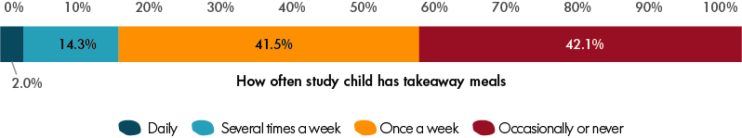
Note: Total n = 1,235.

Sugar-sweetened beverages
National data from 2011–2012 suggests that Australian children consume large quantities of sugar-sweetened beverages from an early age (ABS, 2014). This is particularly true of Aboriginal and Torres Strait Islander children. Results from the National Nutrition and Physical Activity Survey (ABS, 2014) showed that in 2011–2012 approximately 61 per cent of Indigenous children aged 4 to 8 years consumed sugar-sweetened beverages on the day prior to interview, compared to approximately 45 per cent of non-Indigenous children of the same age.
Research has shown that the consumption of fruit juice, particularly when consumed by children who are already overweight or obese, can lead to increased body fat (United States Department of Agriculture & United States Department of Health and Human Services 2010). Fruit juice provides certain vitamins, minerals and fibre but is usually high in sugar. It constitutes almost 40 per cent of the beverages commonly consumed by children, a larger proportion than any other type of beverage (including cordials, dairy- or soy-based drinks and carbonated drinks). Moreover, the majority of fruit juices consumed by children are higher in sugar than other types of beverages and derive more than 85 per cent of their total energy content from sugar (Chepulis, Mearns & Skinner, 2017, p. 321).
In almost all waves of Footprints in Time to date, P1s were asked what their children ate and drank in the morning and evening of the day before the interview; however, questions about the afternoon consumption of food and drink were only asked in Waves 1–5. To obtain a complete picture of the study children’s sugar-sweetened beverages consumption, this analysis was restricted to the waves that included data on children’s morning, afternoon and evening consumption of drinks. For soft drinks, cordial, sports drinks and fruit juice combined, the proportion of children drinking sugar-sweetened beverages ranged from 66.6 per cent at age 2 to nearly 80 per cent at ages 3 and 7 (see Figure 10.3).
Figure 10.3 Consumption of sugar-sweetened beverages on the day prior to interview by study child age, Waves 1–5 (2008–2012)—per cent
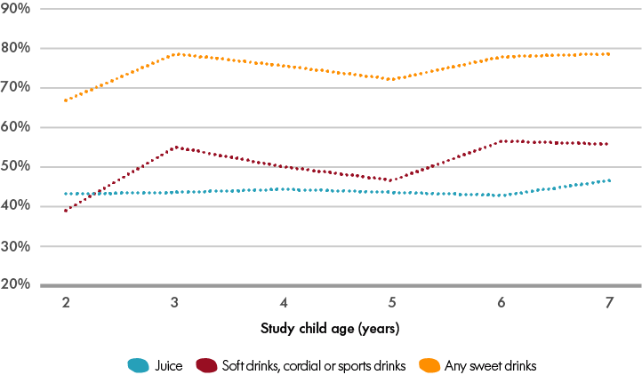
Note: The figure reports on the data that has been pooled across cohorts and waves. The number of observations varied between 489 and 1,304 depending on the study child’s age. Some children consumed both juice and soft drinks on the day prior to the interview.
Previous research using Footprints in Time data showed that body mass index increased more quickly for children with a high consumption of sugar-sweetened beverages (including fruit juice) compared to children with a low consumption of sugar-sweetened beverages. Thus, it appears that children with high intakes of sugar-sweetened beverages are at increased risk of developing obesity (Thurber, Bagheri & Banwell, 2014, p. 51).
Thurber et al. (2014, p. 55) examined the individual and area-level factors associated with the consumption of sugar-sweetened beverages among Aboriginal and Torres Strait Islander children participating in Wave 4 of Footprints in Time. They found that children were significantly more likely to consume sugar-sweetened beverages if their primary carer had a low level of education, if their family experienced housing instability, and if they lived in urban or disadvantaged areas.

Sport and physical activity
Sport is an important part of Australian life. It contributes to keeping children fit and healthy. In addition to its physical health benefits, sport can improve children’s control over the symptoms of anxiety and depression and can assist in social development (Eime, Young, Harvey, Charity & Payne, 2013).
In Wave 7 (2014), P1s were asked how often the study children engaged in an hour or more of physical activity, such as running, dancing, bike riding, football or netball. Nearly half (49.8 per cent) of the P1s said their children engaged in this level of activity 5 days a week or more often, and only 4.1 per cent of P1s said their children never engaged in this much activity. There were no significant differences between the two cohorts. Thus, daily physical activity did not appear to decrease between children in early and middle primary school. The number of hours children spent active on a weekday also did not differ greatly between the two cohorts; however, parents did report that younger children were slightly more likely to engage in four or more hours of active play or sport on the weekends (47.5 per cent of younger children compared to 39.0 per cent of older children).
Children who lived in the areas of moderate, high or extreme isolation were significantly more physically active than children who lived in urban areas or areas of low isolation. For example, 71.4 per cent of children in the more isolated areas engaged in prolonged physical activity (of more than one hour) at least five times a week, compared to 43.2 per cent of children in areas of no or low isolation. This is consistent with findings reported in the 2014 Aboriginal and Torres Strait Health Performance Framework Report, which showed that Indigenous people in remote areas were more active than both non-Indigenous children and Indigenous children in non-remote areas (AHMAC, 2015).
In addition to its physical health benefits, sport can improve children’s control over the symptoms of anxiety and depression and can assist in social development...
In Wave 7 (2014), P1s were asked how the study children usually travelled to school. Among children who attended school or preschool, 36.8 per cent walked and approximately 4 per cent rode a bicycle (it should be noted that parents could select multiple modes of transportation). Responses varied based on the Level of Relative Isolation of the area in which the children lived. Children who lived in areas of moderate, high or extreme isolation were nearly twice as likely as children in urban areas or areas of low isolation to walk to school (58.3 per cent compared to 30.4 per cent).
P1s were also asked about their children’s acquisition of physical skills, such as riding bicycles and swimming. At the age of 6 years, 64.3 per cent of children could ride a bicycle well (without training wheels). By age 8, this figure increased to 88.7 per cent.
There was a small but statistically significant difference in the proportions of boys and girls aged 6 to 8 years who could ride a bicycle well (79.7 per cent of boys could ride a bicycle well versus 75.8 per cent of girls). However, the differences by Level of Relative Isolation were much greater; 64.4 per cent of children in the urban areas were able to ride a bicycle compared to 90.5 per cent of children in highly or extremely isolated areas (see Figure 10.4).
Figure 10.4 Proportion of study children aged 6–8 years who can ride a bicycle by Level of Relative Isolation, Waves 3–8 (2010–2015)—per cent
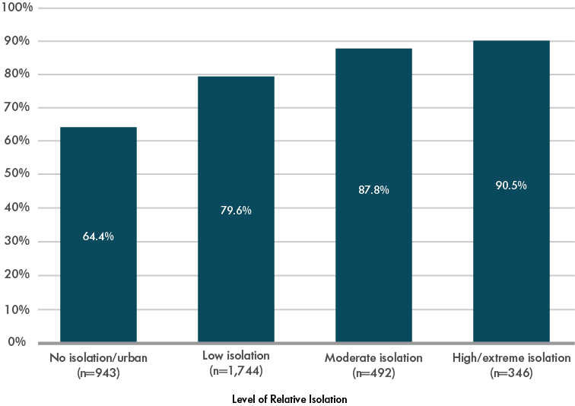
Note: The figure reports the percentages of children who could ride a bicycle well without training wheels. The data was pooled across Waves 3–8 and the two cohorts. Children with disabilities were excluded.
In Wave 6 (2013), the primary carers were asked whether the study children could swim. Nearly 80 per cent of the children aged 8 to 10 years, and nearly half (47.5 per cent) of the children aged 5 to 7 years could swim by themselves and most of the remaining children were able to swim with some help.
As with bicycle riding, the children who lived in more isolated areas were more likely to be able to swim at a younger age than those who lived in urban areas. For example, 49.3 per cent of children aged 5 to 7 years who lived in urban areas could swim unaided compared to 58.6 per cent of children who lived in areas of high or extreme isolation.
In Wave 6, P1s were asked if the study children had participated in organised sports or dance in the last month. Almost half of all Footprints in Time children (48.6 per cent) had participated in organised sports or dance in the month before the interview (see Figure 10.5). Older children were more likely to participate in such activities (40.8 per cent of children in the younger cohort participated in sports or dance compared to 59.9 per cent of children in the older cohort). Boys were also more likely to participate in sports or dance than girls. Similarly, children who lived in urban areas were also more likely to participate in sports or dance than children who lived in more isolated areas.
Figure 10.5 Study children’s participation in organised sports or dance, Wave 6 (2013)—per cent
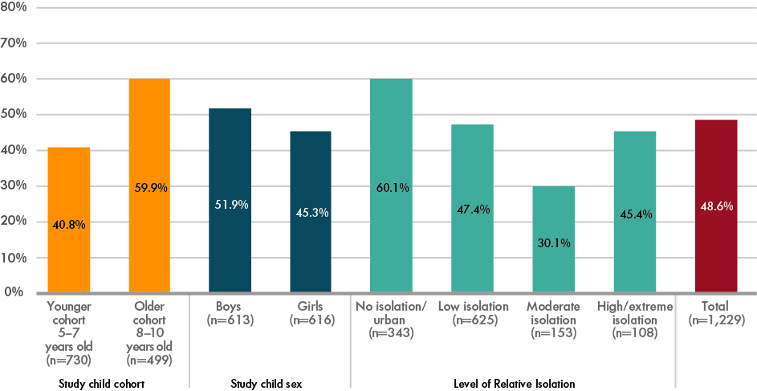
Table 10.2 displays, in order of popularity, the most commonly reported organised sports and dance activities by girls and boys. Despite some differences in the rankings of activities between boys and girls, four of the top six activities were common to both.
Among the younger cohort, the most commonly reported sports were individual sports, such as swimming, athletics and dance. Conversely, among the older cohort, the most commonly reported sports were team sports, such as soccer, netball and basketball. Notably, football was the firm favourite of both cohorts.
Table 10.2 Most common organised physical activities in rank order by study child gender, Wave 6 (2013)
Rank | Boys | Girls
1 | Football (rugby, AFL, Oz Kick, touch/tag) | Dance
2 | Soccer | Netball
3 | Swimming and surf life saving | Swimming and surf life saving
4 | Dance | Athletics
5 | Basketball | Basketball
6 | Martial arts | Soccer and football
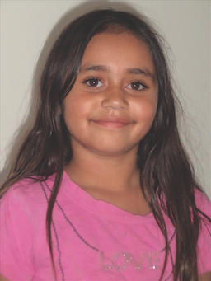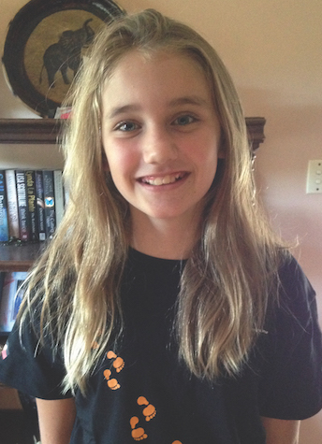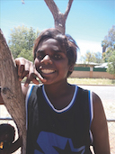
Participation in organised sport or dance was related to better social and emotional wellbeing of the study children. This relationship was evident even after controlling for children’s age, sex, general health, television watching, P1s’ psychological distress, the number of major life events experienced by the family in the past year, and the relative disadvantage of the area (see Figure 10.6). Participation in organised sports or dance was associated with lower social and emotional difficulties by approximately 0.8 points. The contribution of other factors was also as expected; children with very good or excellent overall health, girls (more so than boys) and children living in less disadvantaged areas had lower difficulties scores, while children who watched more than three hours of TV each day, whose P1 had greater psychological distress and children in families that had experienced three or more major life events in the past year had on average higher difficulties scores.
Figure 10.6 The contribution of organised sports or dance in reducing the social and emotional difficulties of study children, Wave 6 (2013)
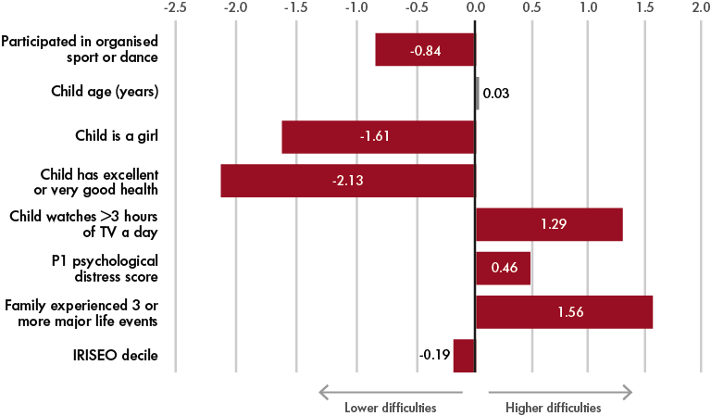
Note: Red bars indicate statistical significance at p < 0.05. Grey bars indicate the characteristic is not significant. The figure reports the coefficient estimates from the OLS regression model with social and emotional difficulties as the outcome variable. The social and emotional difficulties of the study children were measured using the total difficulties score from the SDQ (© Robert Goodman 1999). The total difficulties score ranges from 0 to 40; higher scores indicate greater social and emotional difficulties. In Wave 6, SDQ was collected from the primary carers of the study children. The primary carer psychological distress score is a continuous measure ranging from 0 to 21; higher scores indicate greater distress. Total n = 1,202.

References
Australian Bureau of Statistics (ABS). (2013). Australian Health Survey: Updated results, 2011–2012. ABS Catalogue No. 4364.0.55.003. Canberra, ACT: ABS.
Australian Bureau of Statistics (ABS). (2014). Australian Health Survey: Nutrition first results—Foods and nutrients, 2011–2012. ABS Catalogue No. 4364.0.55.007. Canberra, ACT: ABS.
Australian Department of Health. (2019). Australia’s physical activity and sedentary behaviour guidelines and the Australian 24-hour movement guidelines. Retrieved from: https://www1.health.gov.au/internet/main/publishing.nsf/Content/health-pubhlth-strateg-phys-act-guidelines#npa%2065
Australian Health Ministers’ Advisory Council (AHMAC). (2015). Aboriginal and Torres Strait Islander Health Performance Framework 2014 Report. Canberra, ACT: AHMAC.
Australian Institute of Health and Welfare. (2018). Australia’s health 2018. Australia’s health series No. 16 AUS 221. Canberra, ACT: AIHW.
Biddle, N. (2009). Ranking regions: Revisiting an index of relative Indigenous socioeconomic outcomes. Working Paper 50, Centre for Aboriginal Economic Policy Research, Australian National University, Canberra, ACT.
Chepulis, L., Mearns, G.J. & Skinner, K. (2017). Sugar content of supermarket beverages commonly consumed by children in New Zealand. Australian and New Zealand Journal of Public Health, 41(3), 321–322.
Eime, R.M., Young, J.A., Harvey, J.T., Charity, M.J. & Payne, W.R. (2013). A systematic review of the psychological and social benefits of participation in sport for children and adolescents: informing development of a conceptual model of health through sport. International Journal of Behavioral Nutrition and Physical Activity, 10, Article number: 98 (2013).
Mennella, J.A., Lukasewycz, L.D., Griffith, J.W. & Beauchamp, G.K. (2011). Evaluation of the Monell forced-choice, paired-comparison tracking procedure for determining sweet taste preferences across the lifespan. Chemical Senses, 36(4), 345–355.
Menzies School of Health Research. (2010). Strong souls assessment tool. Retrieved from https://www.menzies.edu.au/page/Resources/Strong_souls_assessment_tool/
National Health and Medical Research Council (NHMRC). (2013). Australian dietary guidelines. Canberra, Australia: National Health and Medical Research Council. Retrieved from https://www.eatforhealth.gov.au/sites/default/files/content/n55_australian_dietary_guidelines.pdf
Thomas, A., Cairney, S., Gunthorpe, W., Paradies, Y. & Sayers, S. (2010). Strong souls: Development and validation of a culturally appropriate tool for assessment of social and emotional well-being in Indigenous youth. The Australian and New Zealand Journal of Psychiatry, 44(1), 40–48.
Thurber, K., Bagheri, N. & Banwell, C. (2014). Social determinants of sugar-sweetened beverage consumption in the Longitudinal Study of Indigenous Children. Family Matters, 95, 51–61.
Thurber, K., Banwell, C., Neeman, T., Dobbins, T., Pescud, M., Lovett, R. & Banks, E. (2017). Understanding barriers to fruit and vegetable intake in the Australian Longitudinal Study of Indigenous Children: A mixed-methods approach. Public Health Nutrition, 20(5), 832–847.
Thurber, K., Walker, J., Walter, M., Dunbar, T., Guthrie, J., Batterham, P., . . . Lovett, R. (2019). Technical report: Measuring adult mental health, psychological distress, and social and emotional wellbeing in the Longitudinal Study of Indigenous Children. Canberra, ACT: ANU. In press.
United States Department of Agriculture & United States Department of Health and Human Services. (2010). Dietary guidelines for Americans, 2010. Retrieved from https://health.gov/dietaryguidelines/dga2010/dietaryguidelines2010.pdf
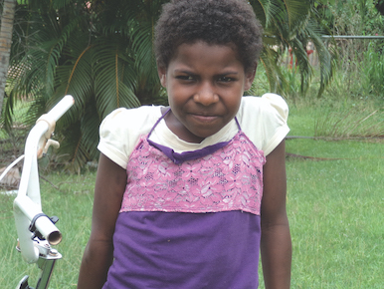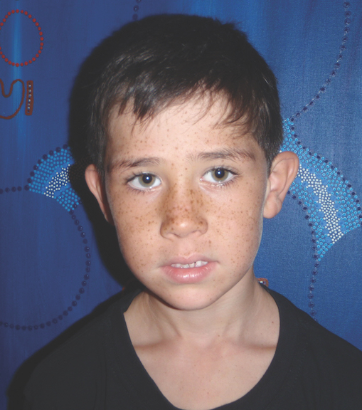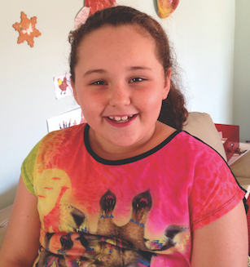
- School: Then and now

Introduction
Children’s experiences with the education system have an important influence on how they engage with education. Whether negative or positive, experiences with peers and teachers can shape the outcomes of students. Additionally, a parent’s experiences with schooling can influence their child’s education.
Barnett and Taylor (2009) have reported that mothers’ dispositions towards their own school experiences affected their level of engagement in activities to help their children’s transition into kindergarten. Additionally, qualitative research by Campbell (2011) described how a parent’s own negative experience at school made their engagement with the child’s school difficult. Trudgett, Page, Bodkin-Andrews, Whittaker and Franklin (2017) noted that the more educated a parent was, the more comfortable they were talking to their child’s teacher. Given these findings, it is important to understand parents’ own schooling experiences and how these experiences affect their children. This chapter examines the experience of parents and their children at school and how the experience of education has changed over time.
In Wave 6 of Footprints in Time, data was collected on the school experiences of both the parents and study children. This data showed how school had changed since the study children’s parents had attended school and revealed important themes in the school experiences of Aboriginal and Torres Strait Islander peoples. Most primary carers (P1s) reported having positive experiences at school. Where experiences of school were negative, racism and bullying were among the most reported reasons.
P1s commonly remarked that schools had become more culturally sensitive environments since they were children and noted that their children had more opportunities to learn about Aboriginal and Torres Strait Islander culture and history. It was also clear that Aboriginal and Torres Strait Islander adults who were educated in an environment with a strong Indigenous Australian community felt safer and had more positive or at least neutral perceptions of school.
In relation to the effects of racism on Aboriginal and Torres Strait Islander people, it is well established that racism negatively affects the emotional and physical wellbeing of those who experience it (Larson, Gillies, Howard & Coffin, 2007; Priest, Paradies, Stewart & Luke, 2011). The negative effects of racism extend to academic outcomes and aspirations, engagement in education and decisions to leave high school before completion (Bodkin-Andrews, Seaton, Nelson, Craven & Yeung, 2010; Bodkin‑Andrews, O’Rourke, Grant, Denson & Craven, 2010). Research indicates that positive psychology, resilience strategies and cultural respect do not necessarily mitigate the effects of racism (Bodkin-Andrews, Denson, Finger & Craven, 2013). In some cases, even cultural respect, when existing in the same environment as racism actually decreased academic performance (Bodkin-Andrews, Denson & Bansel, 2013).
Thus, it is important to explore the experience of parents and their children in the education system and consider how these experiences affect parents’ and their children’s engagement with education. This chapter also examines schools’ cultural awareness and children’s perceptions of racism in school.

Primary carers’ experiences of school and their perceptions of how school has changed
P1s of children in the younger Footprints in Time cohort were asked whether they liked primary school as a child. Notably, more than four out of five primary carers indicated they did like school (see Figure 11.1).
Figure 11.1 Percentages of primary carers who liked primary school as children, Wave 6 (2013)—
per cent
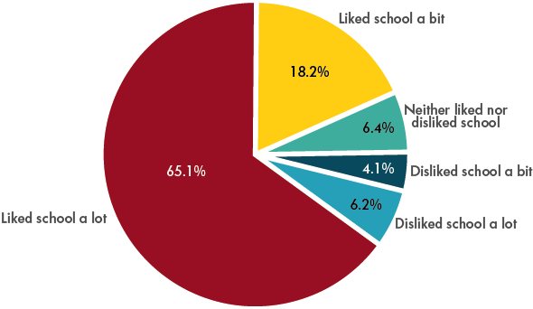
Note: n = 731. Restricted to primary carers of children in the younger cohort.
P1s of the older cohort of children in Footprints in Time were asked about their own experiences of primary school and were asked to compare their experiences with those of their children. Table 11.1 provides some examples of P1s’ responses about experiences at school and their thoughts in relation to how school has changed since they attended it. The responses in the table are diverse, but they are not necessarily the most common responses.
Overall, P1s’ responses were more positive if they mentioned attending a school that had many Aboriginal and Torres Strait Islander students or one in which students learned about Aboriginal and Torres Strait Islander culture. Some P1s noted that their children have more support and more opportunities for learning about Indigenous Australian history and culture than they themselves had at school. Others noted that racism was not as evident for their children as it was when they themselves were at school.
Table 11.1 Examples of primary carers’ experiences at primary school compared with those of their children, Wave 6 (2013) older cohort
What was it like being Aboriginal and/or Torres Strait Islander when you were at primary school? | Is it different for the study child now?
Good, because there were lots of Aboriginal children at the school. | I think it’s different for her now, not much help available.
I was proud to be an Aboriginal at school. I had a hard time—had people picking on me because of who I was—but I was strong and proud of who I was ... It’s sad, you say you are Aboriginal and they say, ‘No you’re not, you’re a half-caste’. | I don’t think the racism is as bad these days, or it’s dealt with more.
It was alright, but we did put up with racism at the time and handled it in our own way. | There is a lot of bullying at the school.
It was harder. Not in the way of being taught, I just got teased a lot. | More multiculturalism in schools, we didn’t learn about Indigenous history back then ... these days they are taught a lot about different cultures and how we are all people.
It was good and I had a lot of fun. No teasing. | A lot, she finds it hard to go to school.
Good, we had our own Indigenous school; it was awesome. | Yeah, in that he’s in a much more multicultural environment.
It was hard because I do not look Aboriginal, so I copped it from both sides. | Yes, there is a lot more awareness.
I was the only Aboriginal person at the school and I didn’t like it. | Yes, they teach Aboriginal culture at school now.
There were only two Aboriginal students, no programs at school. | A lot different she gets extra help with school work, people want to know more about her Aboriginality.
It was good because I went to a community school. | Good because there are Aboriginal education workers and other nationalities that go to the same school.
I got bullied because I was the only black kid in the school. I did not like school at all. | Yes, it is. There are so many more Aboriginal and Torres Strait Islanders at the school.
It was good, I found my feet and my mouth, so it was good. | Yes, I just think people are more relaxed and there are more other nationalities in this country.
It was good; I got along with most of the students. | It’s more out there now and they teach the language and more education in regards to Indigenous culture.
I don’t know, I didn’t know there was a difference back then. | I didn’t realise till I was in high school, but I reckon the kids these days find out earlier. Like, they teach more culture in primary school now and are exposed to it earlier.
It was pretty good; we had a lot of fun. | Yes, because they [have] an Aboriginal person working with the children one day per week telling them Dreamtime stories and Aboriginal culture.
Didn’t have any problems. | She is at a very good school and if there are any racial issues, the school acts appropriately.
It is evident from the P1s’ free-text responses that positive and negative experiences were just as common for the study children. When directly asked, many P1s indicated that their children’s experiences of school were better than their own. Several P1s said that recognition of Aboriginal and Torres Strait Islander culture had improved within the education system and that this helped improve their children’s experiences at school. One P1 stated, ‘It’s even better because there are Aboriginal teachers and Aboriginal Assistants in the school’. Another P1 stated, ‘There is a lot more taught about Aboriginal history and even to be able to celebrate NAIDOC.’
Despite strong opinions that school had improved, a substantial number of P1s observed that school had not changed much or that it was worse now. One P1 stated, ‘It hasn’t changed’. Another P1 observed, ‘Not really; the racism is still out there’.
Several P1s suggested that while racism may have decreased, the way it is expressed had also changed. In the past racism may have been overt; however, it has shifted to include covert, oblique or ‘hidden’ behaviours. As one P1 stated, ‘There is still racism, but it is different and hidden’.

Racism at school
Racism was certainly mentioned repeatedly by the P1s in their qualitative responses about their school experiences; however, the study children’s perceptions may differ. At age 11–14, the study children were asked about their own perceptions of racism at school. Figure 11.2 shows that most children did not perceive their teachers as being racist. For example, most children (55.9 per cent) said they never felt that their ‘teachers thought they knew everything about Aboriginal or Torres Strait Islander people even though they don’t’. However, 15.8 per cent of children responded that this was a common experience.
Experiences or perceptions of racism may be a significant factor in the educational outcomes of children. P1s who described positive experiences in school often also described a supportive and culturally relevant school environment.
For more information about the importance of the relationship between teachers and students see Chapter 6 of this report.
Figure 11.2 Children’s perceptions of racism by teachers at school, Wave 10 (2007)—per cent
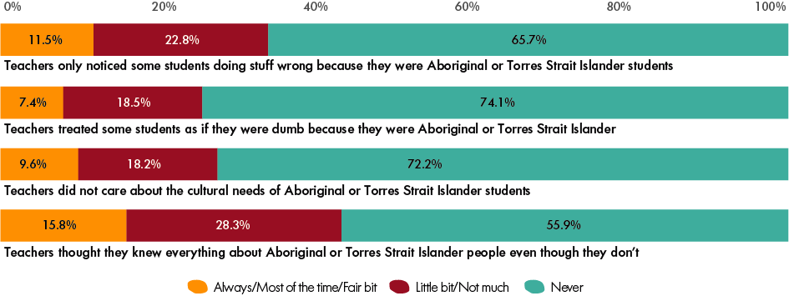
Note: Restricted to children in the older cohort. The number of observations varied between 406 and 434 depending on the question.

Cultural awareness
When asked about how school had changed since they attended, many P1s commented that schools had become more aware and more willing to acknowledge Aboriginal and Torres Strait Islander culture.
In Wave 7 (2014), the P1s were asked about various aspects of cultural awareness in schools (see Figure 11.3). Most P1s (61.9 per cent) felt that teachers always understood the importance of cultural identity and that most schools (77.7 per cent) always recognised days of cultural significance to Indigenous Australians. Almost two thirds (65.5 per cent) of children attended schools that had Aboriginal and Torres Strait Islander Elders visit the school at least occasionally and a similar number (67.2 per cent) had Aboriginal and Torres Strait Islander teachers or staff at the school at least some of the time. However, more than two thirds (67.5 per cent) of schools did not have an Indigenous language program.
Figure 11.3 Parent-reported cultural awareness in schools, Wave 7 (2014)—per cent
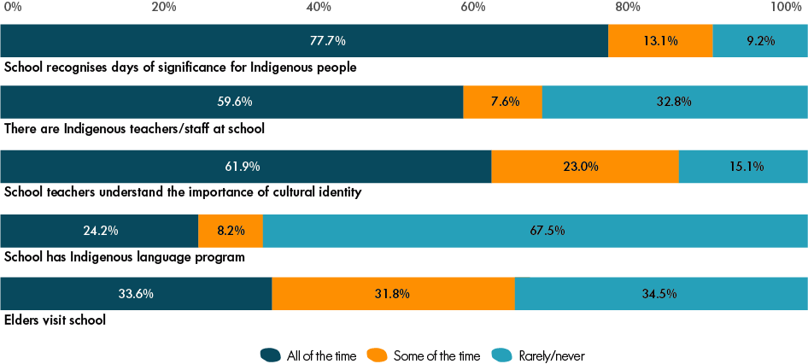
Note: The number of observations varied between 982 and 1,139 depending on the question.

Do parents’ experiences at primary school affect their children’s experiences?
As mentioned above, parents’ negative experiences at school may affect their attitudes towards their children’s education or their engagement with the school system (Barnett & Taylor, 2009; Campbell, 2011). This, in turn, could lead to diminished engagement with or liking of the school by the children themselves. To ascertain whether such a relationship exists for the Footprints in Time families, the responses given by the P1s about their enjoyment of primary school as children were compared to the responses provided by the study children in Wave 6. However, no significant relationship between parents’ and children’s enjoyment of school was found.
Future research could examine whether parents’ experiences of school affect their actions (e.g. their engagement with their child’s teachers, their willingness to help their children with homework and their aspirations for their children after primary school).

References
Barnett, M. & Taylor, L. (2009). Parental recollections of school experiences and current kindergarten transition practices. Journal of Applied Developmental Psychology, 30(2), 140–148.
Bodkin-Andrews, G., Seaton, M., Nelson, G., Craven, R. & Yeung, A. (2010). Questioning the general self-esteem vaccine: General self-esteem, racial discrimination, and standardised achievement across Indigenous and non-Indigenous students. Australian Journal of Guidance and Counselling, 20(1), 1–21.
Bodkin-Andrews, G.H., O’Rourke, V., Grant, R., Denson, N. & Craven, R. (2010). Validating racism and cultural respect: Testing the psychometric properties and educational impact of perceived discrimination and multiculturation for Indigenous and non-Indigenous students. Educational Research and Evaluation, 16(6), 471–493.
Bodkin-Andrews, G., Denson, N. & Bansel, P. (2013). Teacher racism, academic self-concept, and multiculturation: Investigating adaptive and maladaptive relations with academic disengagement and self-sabotage for Indigenous and non-Indigenous Australian students. Australian Psychologist, 48(3), 226–237.
Bodkin-Andrews, G.H., Denson, N., Finger, L. & Craven, R. (2013). Identifying the fairy dust effect for Indigenous Australian students: Is positive psychology truly a [Peter] Pan theory? In G.H. Bodkin‑Andrews, R. Craven & J. Mooney (Eds.) International advances in education: Global initiatives for equity and social justice, Charlotte, North Carolina: Information Age.
Campbell, C. (2011). How to involve hard-to-reach parents: Encouraging meaningful parental involvement with schools. Research Associate Full Report, Autumn 2011: National College for School Leadership.
Larson, A., Gillies, M., Howard, P. J. & Coffin, J. (2007). It’s enough to make you sick: The impact of racism on the health of Aboriginal Australians. Australian and New Zealand Journal of Public Health, 31(4), 322–329.
Priest, N., Paradies, Y., Stewart, P. & Luke, J. (2011). Racism and health among urban Aboriginal young people. BMC Public Health, 11, 1–9.
Trudgett, M., Page, S., Bodkin-Andrews, G., Whittaker, A. & Franklin, C. (2017). Another brick in the wall? Parent perceptions of school experiences of Aboriginal and Torres Strait Islander children. In M. Walter, K.L. Martin & G. Bodkin-Andrews. (Eds.), Indigenous children growing up strong. London, UK: Macmillan.
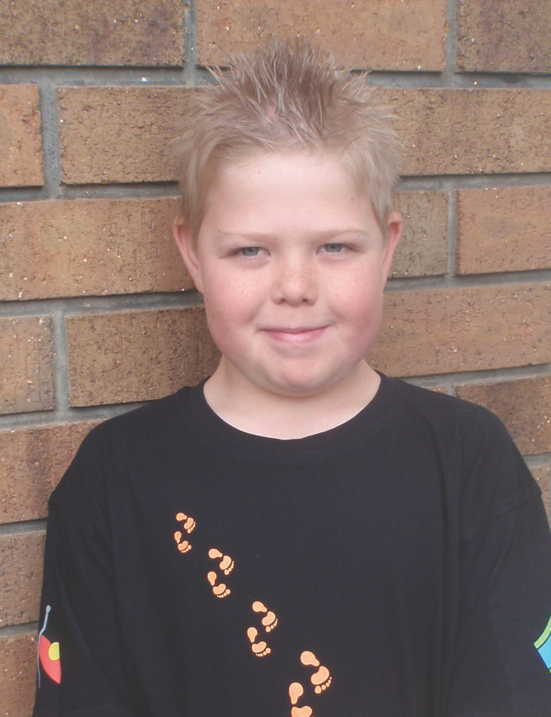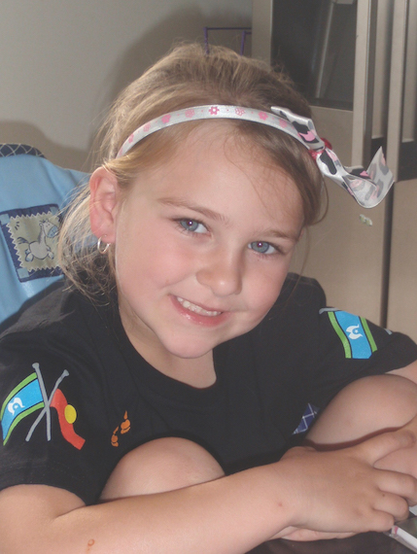

Glossary
ACARA—Australian Curriculum, Assessment and Reporting Authority.
AIATSIS—Australian Institute of Aboriginal and Torres Strait Islander Studies.
ARS—Academic Rating Scale.
BNLA—Building a New Life in Australia study.
Cross-curriculum priority for Aboriginal and Torres Strait Islander histories and cultures—Refers to the prioritisation of learning about Aboriginal and Torres Strait Islander histories and cultures in the classroom. This priority provides the opportunity for all young Australians to gain a deeper understanding and appreciation of Aboriginal and Torres Strait Islander histories, cultures, deep knowledge traditions and holistic worldviews.
DSS—Department of Social Services.
Footprints in Time—Refers to the Longitudinal Study of Indigenous Children.
HILDA—The Household, Income and Labour Dynamics in Australia Survey.
IRISEO—Index of Relative Indigenous Socioeconomic Outcomes. For further information see: Biddle, N. (2009), Ranking regions: Revisiting an index of relative Indigenous socioeconomic outcomes. Working Paper 50, Centre for Aboriginal Economic Policy Research, Australian National University, Canberra, ACT: CAEPR, ANU.
Kessler 10—Kessler Psychological Distress Scale.
Longitudinal—Refers to a type of research design that is conducted using repeated observations over an extended period of time.
Logistic regression—see Regression.
LORI—Level of Relative Isolation, measure of area isolation/remoteness originally developed for the Western Australian Aboriginal Child Health Survey. For further information see: Zubrick, S.R., Lawrence, D.M., Silburn, S.R., Blair, E., Milroy, H., Wilkes, T., … & Doyle, S. (2004). The Western Australian Aboriginal Child Health Survey: The health of Aboriginal children and young people
(Vol. 1). Perth, WA: Telethon Institute for Child Health Research.
LSAC—Longitudinal Study of Australian Children.
LSIC—Longitudinal Study of Indigenous Children.
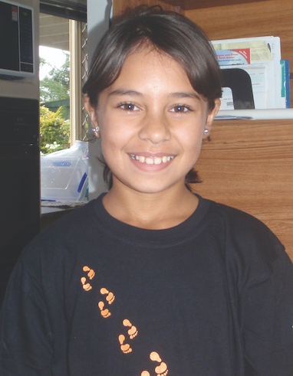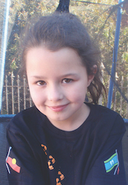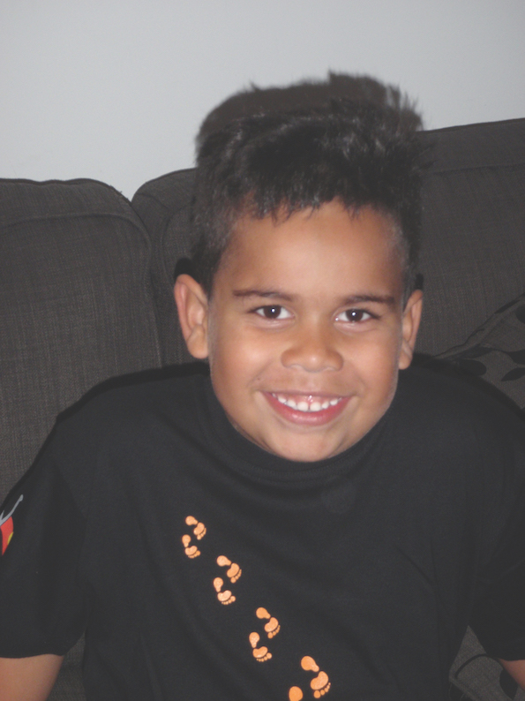
Mean marginal effect—A number (between 0 and 1) representing the average change in the probability of the outcome occurring in the presence of a certain characteristic, or when a continuous independent variable increases by one unit. Often used with probit regression models.
NAPLAN—National Assessment Program—Literacy and Numeracy.
NCLD—National Centre for Longitudinal Data.
NHMRC—National Health and Medical Research Council.
Odds ratio—A measure of the strength of association between an outcome and a characteristic (independent variable). It is calculated as a ratio of the odds of the outcome occurring in the presence of certain characteristic to the odds of the outcome occurring in the absence of that characteristic. Often used in logistic regression.
P1—Primary carer of the study child.
P2—Secondary carer of the study child.
PAT—Progressive Achievement Tests. A series of tests designed to provide objective, norm-referenced information about students’ skills and understandings in a range of key areas. PATs are developed by the Australian Council for Educational Research (ACER). The Footprints in Time study administers modified versions of the reading and mathematics PATs.
Probit regression—see Regression.
RAOs—Research Administration Officers (interviewers in the Footprints in Time study).
Regression—A regression model is used to identify associations between a dependent variable (also called an outcome variable), such as children’s social and emotional difficulties or parents’ mental health, and one (‘bivariate regression’) or more (‘multiple regression’) independent variables (also called explanatory variables), such as a child’s age, school year or the number of major life events experienced by a family. It shows how the typical value of the dependent variable changes when any one of the independent variables changes and all other independent variables remain fixed. The following types of regression models were used in this report:
- Ordinary Least Squares (OLS) or linear regression. This type of regression uses a continuous dependent variable, such as a reading or mathematics score or SDQ total difficulties score.
- Logistic regression and probit regression models are examples of limited dependent variable models, which are used with binary (or categorical) dependent variables, such as whether the child has sleeping difficulties or whether they have dental problems. In limited dependent variable models, the results are often reported using either odds ratios or mean marginal effects.
Renfrew Word Finding Vocabulary Test—A language assessment for children aged 3–8 years used to measure the extent to which pictures of objects, arranged in order of difficulty, can be named correctly. The Renfrew Word Finding Vocabulary Test was developed by the Australian Council for Educational Research (ACER).
SDQ—Strengths and Difficulties Questionnaire (© Robert Goodman, 1999).
SEIFA—Socio-Economic Indexes for Areas.
Statistical significance—indicates that the observed relationship between two or more variables is unlikely to be due to chance. The statistical significance is presented in this report using the probability value (p-value). Smaller p-values indicate stronger statistical relationship. This report most commonly uses significance threshold of 5 per cent (p < 0.05), however other thresholds may also be used to indicate the strength of observed relationships.
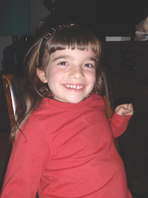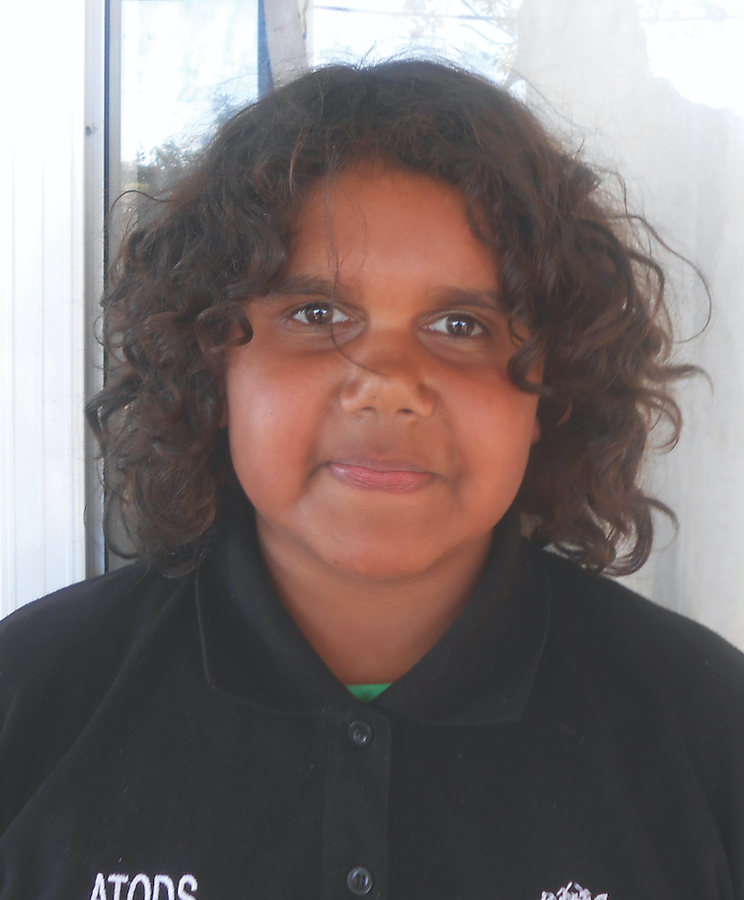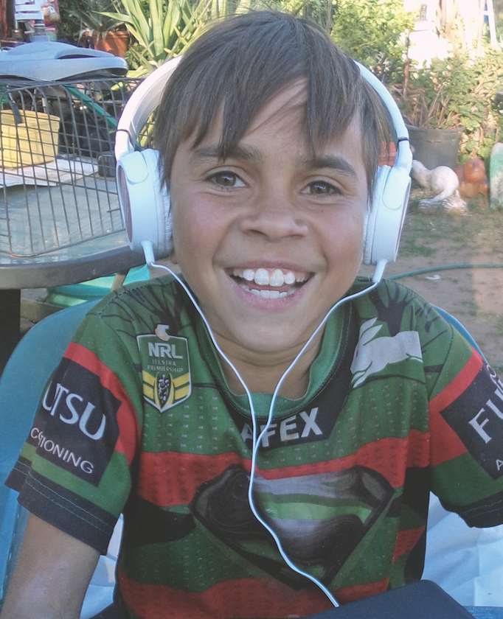
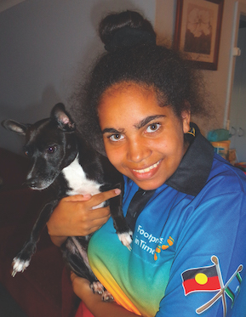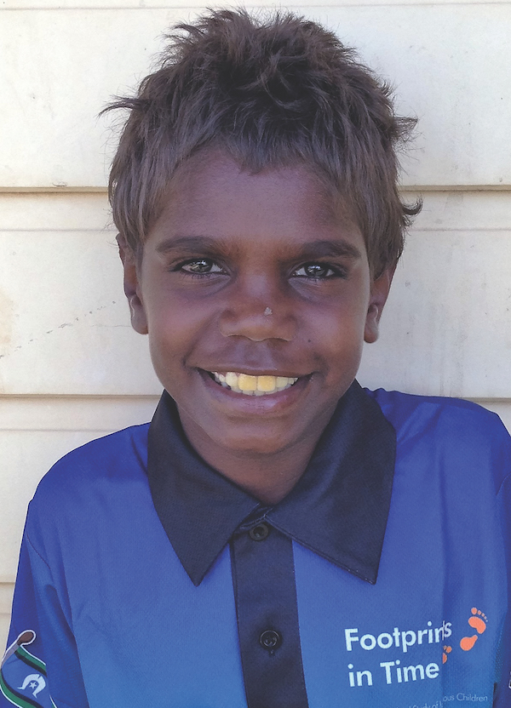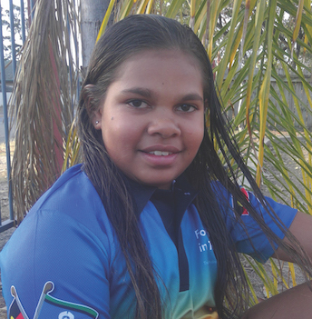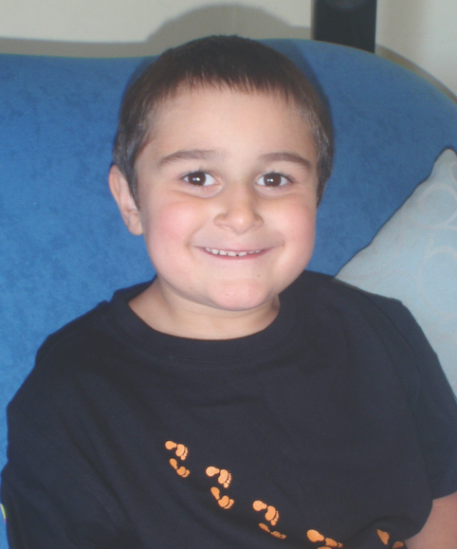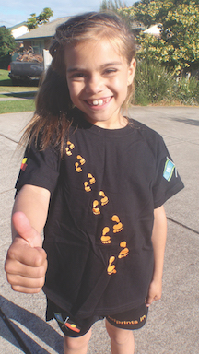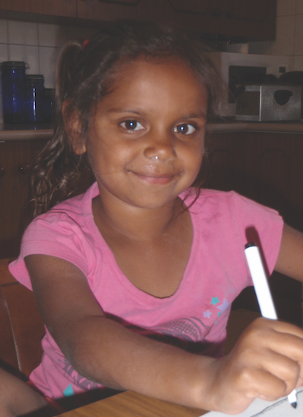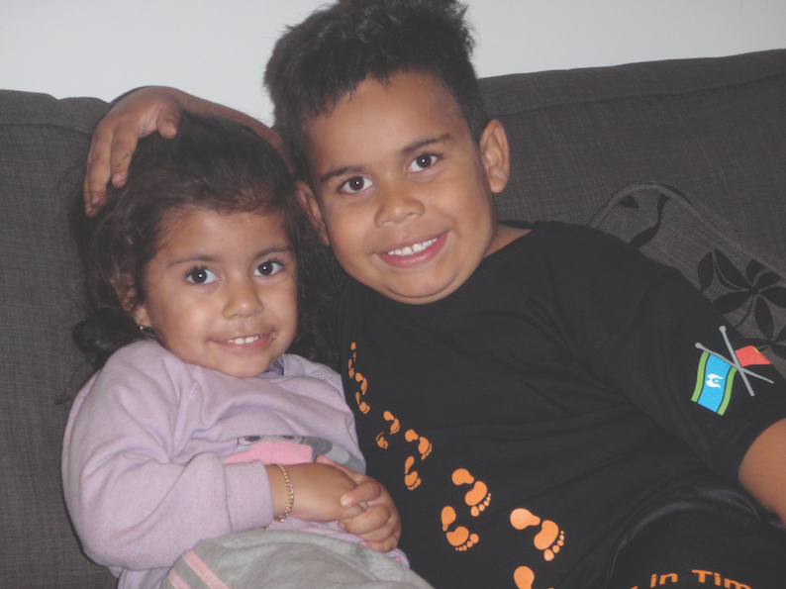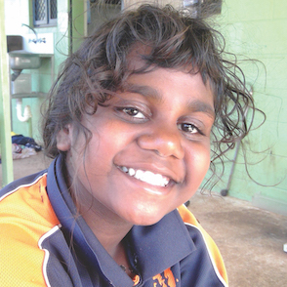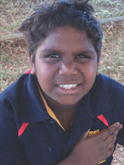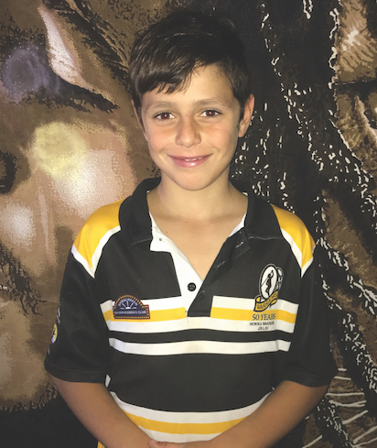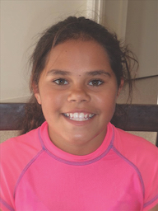

Figures 0.14 and 0.15 combine the data that primary carers reported in Waves 6 (2013) and 8 (2015). Since it can be expected that access to computers (as well as to the internet) increases over time, tests for the presence of positive time effects were conducted before combining the cohorts. However, no significant positive time effects were found.
These included the child’s age, the family experiencing multiple types of financial hardship, the family receiving income from wages or salaries (as opposed to government benefits or other types of income), the education of the primary carer, the level of relative isolation and the number of children’s books in the home.
© Robert Goodman 1999.
‘In the last six months, have you been treated unfairly or badly because of your: a. language or accent; b. skin colour; c. disability; d. religious beliefs; e. cultural background?’
Questions were sourced from the School Climate Bullying Scale (Brockenbrough et al., 2000); for example, ‘During the past month (30 days) at school, kids hit, kicked or grabbed me on purpose’, and ‘Kids threatened to hurt me or take my things’.
A study child’s response to the question: ‘What would you like to change at your school?’
Also referred to as Torres Strait Creole.
Dialects of English vary distinctly within different regions in the United Kingdom and across countries such as the United States, Canada, India and Australia. In Australia, the major dialectal difference is between standard Australian English and Aboriginal English; however, it is regarded as a continuum (and is sometimes referred to as heavy or light). Historically, non-standard forms of English have been referred to as ‘broken English’. However, similar to how Australian English developed over time, as these different varieties have stabilised over time, they have become dialects with their own phonological and syntactic rules and unique vocabulary items.
This chapter used Release 6 of the LSIC data.
Children who did not attend due to school holidays (or similar reasons) were excluded from this analysis.
Data from the 2010 Child Dental Health Survey are available for children from Northern Territory, Queensland, South Australia, Tasmania, Western Australia and the ACT.
The analysis in this chapter was performed using Release 6 data.
It should be noted that the consumption of food and drink measured in this chapter was based on whether a child had consumed a certain food or drink the day before the interview, not on number of times the food or drink had been consumed or the quantity consumed.
Children were considered to have brushed their teeth regularly in any given year if their P1 responded ‘Twice a day’ to the question about how often the study child brushed their teeth.
Teacher academic rating scale (TRATE), as used in the Early Childhood Longitudinal Study Kindergarten (ECLS-K) Cohort of 1998–99, United States Department of Education (spring teacher questionnaire).
Scores missing responses to two or more questions were excluded from this analysis.
Based on the R-squared statistic.
Vocabulary was measured using the Renfrew word finding vocabulary test (as cited in Department of Social Services [DSS], 2017).
Scores missing responses to two or more questions were excluded from the analysis.
There was a positive significant relationship between teachers knowing their Indigenous students and Renfrew vocabulary scores in the full model, but this did not extend to literacy and numeracy scores.
This chapter used the Footprints in Time data from Release 9.0, Waves 1–9 (2008–2016).
Sleep disturbance questions were not asked of both cohorts in Wave 6; thus, in the interests of statistical power and to enable the cohorts to be compared, the analyses used stressful life events, sleep disturbance and other predictor variables from Wave 5. Conversely, the questions used to derive the social and emotional difficulties score were asked in Wave 6 (and not Wave 5). Therefore, analyses involving social and emotional difficulties used Wave 6 social and emotional difficulties as the outcome variable and Wave 5 sleep disturbance and relevant Wave 5 covariates as predictors.
Any child with fewer than four waves of data was excluded from the analysis of persistent sleep disturbance.
In the regression analysis, ‘None’ and ‘Low’ were considered non-remote, while ‘Moderate’, ‘High’ and ‘Extreme’ were considered remote.
The LSAC data are from Release 6. Each age group includes both older and younger cohorts at ages 5 and 8 years.
Based on a study looking at children’s beverage consumption in New Zealand.
Data about study children’s bicycle riding was collected in Waves 3–5 for the older cohort and in Waves 6–8 for the younger cohort. For this analysis, the data from the two cohorts was combined to examine the bicycle riding skills of the study children between the ages of 6 and 8 years. Children with disabilities were excluded.
Organised sports and dance were asked about in a single question rather than separately.
Soccer and football were equally popular among girls.
Data on primary carers’ psychological distress was collected using items from the Strong Souls Index developed for the Aboriginal Birth Cohort Study (Menzies School of Health Research, 2010; Thomas, Cairney, Gunthorpe, Paradies & Sayers, 2010). Respondents are asked to evaluate seven statements about their mental health in the preceding three months, such as ‘Have you …’ ‘… stopped liking things that used to be fun?’, ‘… felt like everything was hard work?’ and ‘… felt so sad that nothing could cheer you up?’. Response options were ‘Not much/Never’, ‘Little bit’, ‘Fair bit’ and ‘Lots of times’. Responses to the seven statements were added together to create the Strong Souls: Distress score. Higher scores indicated greater psychological distress. For further information about the validity of these questions using the LSIC see Thurber et al. (2019).
In this analysis, the relative disadvantage of the area was measured using Index of Relative Indigenous Socioeconomic Outcomes (IRISEO) developed by Biddle (2009). For the Footprints in Time sample, IRISEO provides a more even distribution of families across the index deciles than what is provided by the SEIFA. As with the SEIFA, higher deciles of IRISEO indicate the lower disadvantage of the area.
Primary carers were asked about their enjoyment of primary school as children in Waves 6 (2013) and 8 (2015).

