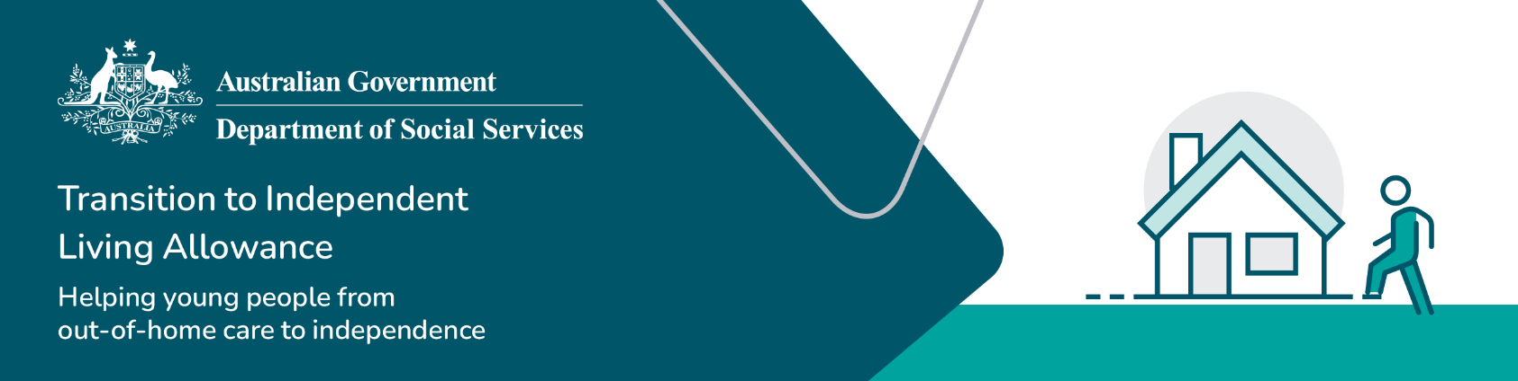

Guide for caseworkers

Transition to Independent Living Allowance

This guide is to assist you as the caseworker, support the young person you are working with to transition to independent living, apply for the TILA payment. We recognise that for a young person leaving out-of-home care to independent living can be a positive yet challenging time, and with your assistance young people with an out-of-home care experience can reach their goals.

If you require further information on TILA, please contact the TILA team at [tila@dss.gov.au](mailto:tila@dss.gov.au)

This guide should be read in conjunction with the [TILA Operational Guidelines.](https://www.dss.gov.au/towards-adulthood/resource/transition-independent-living-allowance-tila-operational-guidelines)

## Overview

Follow these steps to help the young person you are assisting apply for the TILA payment:

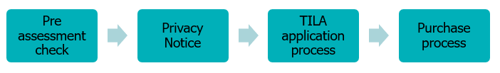

## Pre assessment check

Before completing a [TILA application form](https://www.dss.gov.au/families-and-children/benefits-payments/transition-to-independent-living-allowance-tila/tila-application-form), as a caseworker you must ensure:

* the young person meets all of the [eligibility](https://www.dss.gov.au/towards-adulthood/applying-transition-independent-living-allowance/eligibility-transition-independent-living-allowance?_gl=1*1dauyaa*_ga*NDIxMzkxNTQ1LjE3MjE2MTA3ODM.*_ga_9JJ1FJ00DK*MTczMzg3NDYxNi4xMDcuMS4xNzMzODc1NzQ2LjQ2LjAuMA..) criteria outlined in the [TILA Operational Guidelines](https://www.dss.gov.au/our-responsibilities/families-and-children/benefits-payments/transition-to-independent-living-allowance-tila/tila-operational-guidelines)
* the young person has not already accessed their full TILA entitlement
* the proposed amount, use of, and timing of the TILA funds are appropriate.

You must verify the young person’s [eligibility](https://www.dss.gov.au/towards-adulthood/applying-transition-independent-living-allowance/eligibility-transition-independent-living-allowance?_gl=1*1dauyaa*_ga*NDIxMzkxNTQ1LjE3MjE2MTA3ODM.*_ga_9JJ1FJ00DK*MTczMzg3NDYxNi4xMDcuMS4xNzMzODc1NzQ2LjQ2LjAuMA..) by sighting the following documentation that confirms the young person is:

* an Australian citizen by either birth or has been granted Australian citizenship (e.g. birth certificate, citizenship certificate)
* aged from 15 to 25 at the time of submitting application (e.g. birth certificate or driver’s licence)
* has been in, or is currently in, formal care as described in the [eligibility criteria](https://www.dss.gov.au/towards-adulthood/applying-transition-independent-living-allowance/eligibility-transition-independent-living-allowance?_gl=1*1dauyaa*_ga*NDIxMzkxNTQ1LjE3MjE2MTA3ODM.*_ga_9JJ1FJ00DK*MTczMzg3NDYxNi4xMDcuMS4xNzMzODc1NzQ2LjQ2LjAuMA..)
* has a transition to independence plan.

## Privacy notice

You must explain the following privacy notification to the young person as outlined in Section 3 of the [TILA Operational Guidelines:](https://www.dss.gov.au/our-responsibilities/families-and-children/benefits-payments/transition-to-independent-living-allowance-tila/tila-operational-guidelines)

**Privacy Notice for Claimant**

Your personal information is protected by law, including the Privacy Act 1988, and is collected by the Australian Government Department of Social Services and Services Australia for the assessment and administration of payments and services. This information is required to process your application or claim.

Your information may be used by the departments or given to other parties for the purposes of research, investigation or where you have agreed, or it is required or authorised by law.

You can get more information about the way in which the Department of Social Services will manage your personal information, including the department’s privacy policy at [dss.gov.au/privacy-policy](https://www.dss.gov.au/using-our-website/privacy-policy) or by requesting a copy from that department.

You can get more information about the way in which Services Australia will manage your personal information, including the department’s privacy policy at [servicesaustralia.gov.au/privacy](https://www.servicesaustralia.gov.au/your-right-to-privacy?context=22) or by requesting a copy from that department.

## TILA application process

Follow the below steps for a TILA application:

**Table 1**:TILA application process

| Steps | Details |
| --- | --- |
| Step 1:  Assessment | You will need to:   * Discuss the [transition to independence plan](https://www.dss.gov.au/our-responsibilities/families-and-children/publications-articles/transitioning-from-out-of-home-care-to-independence-a-nationally-consistent-approach-to-planning-2011) with the young person applying for TILA. * Assess whether the young person is [eligible](https://www.dss.gov.au/towards-adulthood/applying-transition-independent-living-allowance/eligibility-transition-independent-living-allowance?_gl=1*1dauyaa*_ga*NDIxMzkxNTQ1LjE3MjE2MTA3ODM.*_ga_9JJ1FJ00DK*MTczMzg3NDYxNi4xMDcuMS4xNzMzODc1NzQ2LjQ2LjAuMA..) for TILA and it is applicable at this time. * Agree on what TILA will be used for and whether a lump sum payment or instalments at a minimum of $250 is the best approach for the young person. * Do not apply for the full amount of $1500 if the young person does not need this amount at this time. * Items can include whitegoods, furniture, counselling, education and training courses, medical expenses, or a driver’s licence or lessons, plus much more. The [What can TILA be used for](https://www.dss.gov.au/families-and-children-benefits-payments-transition-to-independent-living-allowance-tila/what-can-tila-be-used-for) factsheet provides further information on the different goods and services TILA can be used for. * Only apply for what has been identified for the young person as an appropriate time and use of TILA funding to support the goals and activities of the young person’s transition or leaving care plan. * Complete and both sign the [TILA Application Form](https://www.dss.gov.au/families-and-children/benefits-payments/transition-to-independent-living-allowance-tila/tila-application-form). * Have evidence of agreement such as an email or a detailed file note of the conversation with the young person, including date, time and reason why there were unable to sign the form in person. Retain the TILA form and other documentation for your organisation's records.   **Note:** If a signature is not able to be obtained from the young person, i.e. the application is completed over the phone or the young person is unable to sign the application form due to a disability, the caseworker is to review if consent can be secured and documented in a way other than a signature on the application form. This should be clearly reflected in the caseworker and young person’s records. |
| Step 2:  Claim lodgement | Confirm with your [state or territory contact](https://www.dss.gov.au/towards-adulthood/applying-transition-independent-living-allowance) the TILA application arrangements in your jurisdiction and your role in the application process, as this varies between jurisdictions.   * Instructions for registering for PRODA Business Hub access can be found at [Appendix 3](https://www.dss.gov.au/our-responsibilities/families-and-children/benefits-payments/transition-to-independent-living-allowance-tila/tila-operational-guidelines) of the [TILA Operational Guidelines.](https://www.dss.gov.au/our-responsibilities/families-and-children/benefits-payments/transition-to-independent-living-allowance-tila/tila-operational-guidelines) * As per the TILA Operational Guidelines, Section 2.2 - Assessment of the TILA application, by submitting the TILA application in the Business Hub portal you are confirming you have:   + Sighted the young person’s identification and citizenship documents.   + Read the privacy notification to the young person.   + Obtained the young person’s signature on the form and signed the form yourself or if the young person’s signature cannot be obtained you have added a detailed file note on the young person’s record and referenced this on the TILA application form at the claimant’s signature block.   + Kept the completed TILA application form and expenditure details at your organisation. |
| Step 3:  Payment process | * TILA payments are electronically transferred to the organisation’s specified bank account provided at the time of PRODA Business Hub registration, for you to assist the young person in the purchases. * The young person will not receive the TILA payment themselves. * TILA funds cannot be paid directly to the young person either electronically or in cash. * If Services Australia is unable to match the young person to an existing Services Australia customer record, staff from Services Australia will contact you for further information. * Once the application has been processed, Services Australia will issue a payment advice letter. * Please allow up to five (5) working days for the application to be processed and longer for a response letter to reach the young person’s nominated mailing address.   If the amount claimed will exceed the young person’s TILA limit, Services Australia will issue payment of the remaining balance. |

Once the TILA claim has been submitted in the PRODA Business Hub, Services Australia will:

* match the young person to their existing Services Australia record
* check whether the young person has already been paid $1,500 of TILA
* check whether issuing the approved amount of TILA in the claim, it will exceed the TILA limit of $1,500.

## Purchase process

You are to purchase the agreed items and services for the young person and the receipts of the items purchased with TILA are not required to be submitted to the Australian Government. You are to monitor the use of TILA funds for the young person and maintain appropriate records.

## Record keeping process

For auditing purposes, please ensure you keep records for future reference of the TILA application form, leaving care plan and notes of discussions and actions for the application.