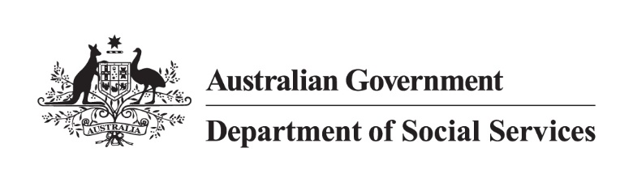

500 Workers Initiative   
Jurisdictional high-level status as of 31 March 2025

Note:

* + Data is as of 31 March 2025 and is subject to regular changes.
  + Not all state and territory data is updated monthly as this is dependent on individual jurisdictional contractual arrangements with service providers already in place.
  + States and territories have requirements to receive Commonwealth funding including annual reporting obligations to the Commonwealth under the [National Partnership on Family, Domestic and Sexual Violence Responses 2021-27](https://federalfinancialrelations.gov.au/agreements/family-domestic-and-sexual-violence-responses-2021-27).
  + Use of the word ‘commenced’ in the below table means workers who have started in their roles and are working with victim-survivors.
  + The 500 Workers Initiative has a phased approach, with 352.43 full-time equivalent (FTE) workers committed to by 30 June 2024, 462.61 FTE workers by 30 June 2025 and 500 FTE workers by 30 June 2026.

| **Jurisdiction** | **Commenced Workers** | **Commenced FTE** | **Next Steps** |
| --- | --- | --- | --- |
| **New South Wales (NSW)** | 151 | 138.4 | The recruitment of new workers is progressing in line with NSW’s plan:   * 151 workers (138.4 FTE) are now delivering domestic, family and sexual violence services (DFSV) across NSW. * The remaining 2024-25 quota have recruitment activity underway (10 FTE). * NSW has awarded contracts to 82 service providers to deliver 148.4 FTE. |
| **Victoria** | 61 | 57 | * The recruitment of new workers is progressing in line with Victoria’s plan:   + 61 workers have commenced across 57 FTE. * The filled roles include:   + 16 case managers at a multicultural agencies. Collectively, they speak Mandarin, Cantonese, Tamil, Hindi, Urdu, Arabic, Ukrainian and Russian, as well as all speaking English.   + 3 workers are employed at an Aboriginal Community Controlled Organisation. * An additional 2 positions are being advertised. * Family Safety Victoria is working with peak bodies on the next stage of this important project. |
| **Queensland** | 122 | 104.6 | * Queensland has now allocated all funding and FTE and has over-delivered on its target of 111.6 workers with funding allocated for a total of 113 FTE workers. * Queensland will continue to monitor the rollout and support organisations with their recruitment and service delivery. |
| **Western Australia** | 45 | 45 | * Service contracts with organisations were awarded for all workers in May 2024. * Recruitment to fill the 50 FTE is ongoing with WA providing advice and support to organisations to help navigate unanticipated challenges, including in regional and remote locations. * 11 of 13 organisations have filled their quota. |
| **South Australia** | 45 | 33.9 | * All service agreements for the 2023-24 allocation have been executed, totalling 29.6 FTE. * For 2024-25, an additional 7.2 FTE has been allocated, with all service agreements fully executed. * The total FTE allocation for SA across both years now stands at 36.8 FTE. * As of 31st March 2025, a total of 33.9 FTE (45 workers) has been successfully recruited. |
| **Tasmania** | 33 | 24.6 | * Tasmania has now met its total 500 Workers Initiative target of 24.6 FTE commenced workers across 13 services. |
| **Australian Capital Territory (ACT)** | 8 | 7.6 | * The ACT has delivered its total 500 Workers Initiative FTE target of 7.6 FTE. * 4 workers (4.0 FTE) have commenced with Canberra Rape Crisis Centre. * 2 workers (2.0 FTE) have commenced with YWCA. * 1 worker (1.0 FTE) has commenced with Multicultural Hub. * 1 worker (0.6 FTE) has commenced with DVCS. |
| **Northern Territory** | 16 | 15.6 | * Recruitment has increased with 16 commenced workers, including:   + 11 FTE Children’s safety workers   + 1 (.6 FTE) Children’s safety worker   + 3 FTE non legal support workers, and   + 1 FTE co-responder pilot victim-survivor case manager * Active recruitment is underway for 1 role including:   + 1 FTE co-responder pilot victim-survivor case manager * 3 FTE roles have been allocated with recruitment to commence once the program design phase concludes. |
| **TOTAL** | **481** | **426.7** |  |