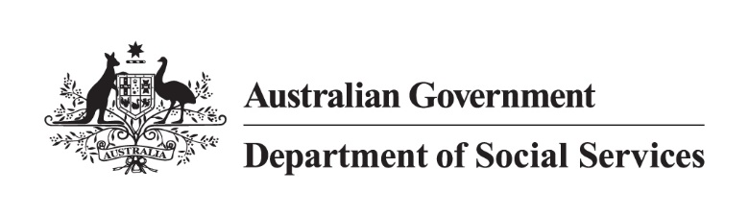

500 Workers Initiative   
Jurisdictional high-level status as of 28 February 2025

Note:

* + Data is as of 28 February 2025 and is subject to regular changes.
  + Not all state and territory data is updated monthly as this is dependent on individual jurisdictional contractual arrangements with service providers already in place.
  + States and territories have requirements to receive Commonwealth funding including annual reporting obligations to the Commonwealth under the [National Partnership on Family, Domestic and Sexual Violence Responses 2021-27](https://federalfinancialrelations.gov.au/agreements/family-domestic-and-sexual-violence-responses-2021-27).
  + Use of the word ‘commenced’ in the below table means workers who have started in their roles and are working with victim-survivors.
  + The 500 Workers Initiative has a phased approach, with 352.43 full-time equivalent (FTE) workers committed to by 30 June 2024, 462.61 FTE workers by 30 June 2025 and 500 FTE workers by 30 June 2026.

| **Jurisdiction** | **Commenced Workers** | **Commenced FTE** | **Next Steps** |
| --- | --- | --- | --- |
| **New South Wales (NSW)** | 145 | 132.4 | The recruitment of new workers is progressing in line with NSW’s plan:   * 145 workers (132.4 FTE) are now delivering domestic, family and sexual violence services (DFSV) across NSW. * The remaining 2024-25 quota have recruitment activity underway (16 FTE). * NSW has awarded contracts to 82 service providers to deliver 148.4 FTE. |
| **Victoria** | 55 | 53 | * The recruitment of new workers is progressing in line with Victoria’s plan:   + 55 workers (total 53 FTE) have commenced * The filled roles include:   + 16 case managers at multicultural agencies. Collectively, they speak Mandarin, Cantonese, Tamil, Hindi, Urdu, Arabic, Ukrainian and Russian, as well as all speaking English.   + 2 workers employed at an Aboriginal Community Controlled Organisation.   + The remaining 6 positions are being advertised.   + Of the 6 positions advertised 2 positions are in rural/regional areas. * Victoria is working with peak bodies on the next stage of this important project. |
| **Queensland** | 119 | 101.2 | * Queensland has now allocated all funding and FTE and has over-delivered on its target of 111.6 workers with funding allocated for a total of 113 FTE workers. * Queensland will continue to monitor the rollout and support organisations with their recruitment and service delivery. |
| **Western Australia** | 39 | 39 | * Service contracts with organisations were awarded for all workers in May 2024. * Recruitment to fill the 50 FTE is ongoing with WA providing advice and support to organisations to help navigate unanticipated challenges, including in regional and remote locations. * 8 of 13 organisations have filled their quota. |
| **South Australia** | 40 | 29.6 | * All service agreements for the 2023-24 allocation have been executed, totalling 29.6 FTE. * For 2024-25, an additional 7.2 FTE has been allocated. * Of this, all but one service agreement has been fully executed. * Providers have commenced recruitment processes. * The overall FTE allocation for SA is now 36.8 FTE across both years. * 29.6 FTE (40 workers) have been successfully recruited. |
| **Tasmania** | 31 | 24.4 | * Recruitment continues, with Tasmania on track to deliver 24.6 FTE workers by the end of 2024-25. * The number of FTE workers commenced has increased by 8.8 in 2024-25, with recruitment action underway for the remaining FTE workers. |
| **Australian Capital Territory (ACT)** | 8 | 7.6 | * The ACT has delivered its total 500 Workers Initiative FTE target of 7.6 FTE. * 4 workers (4.0 FTE) have commenced with Canberra Rape Crisis Centre. * 2 workers (2.0 FTE) have commenced with YWCA. * 1 worker (1.0 FTE) has commenced with Multicultural Hub. * 1 worker (0.6 FTE) has commenced with DVCS. |
| **Northern Territory** | 11 | 10.6 | * Service providers are continuing to recruit for the 18 allocated positions with 11 positions (10.6 FTE) already commenced. * Commenced workers include:   + 1 (1 FTE) worker with Wadeye Safe House   + 1 (1 FTE) worker with Galiwinku Women’s Space   + 1 (1 FTE) worker with Tennant Creek Women’s Refuge   + 1 (0.6 FTE) worker with Salvation Army   + 1 (1 FTE) worker with CatholicCare NT   + 1 (1 FTE) worker with Central Australian Aboriginal Family Legal Unit Aboriginal Corporation   + 2 (2 FTE) workers with Women’s Safety Services of Central Australia including the Co-Responder Pilot   + 2 (2 FTE) workers with YWCA   + 1 (1FTE) non legal support worker at Central Australian Womens Legal Service. * The 0.2 FTE worker allocation for 2023-24 has been carried over and allocated to additional children’s worker for the Salvation Army, reflected below. * Funding agreements have been executed, and active recruitment is underway for a further 8 roles including:   + 5 children’s DFSV workers   + 1 non-legal court support workers   + 1 co-responder pilot victim-survivor case managers   + 1 Men’s Behaviour Change Program partner contact worker * The Department has been working with service providers to provide support and navigate recruitment challenges. * A further 2 positions will be allocated to meet the 20 workers allocation from  2024-25 with the worker allocation to be determined based on identified need. |
| **TOTAL** | **448** | **397.8** |  |