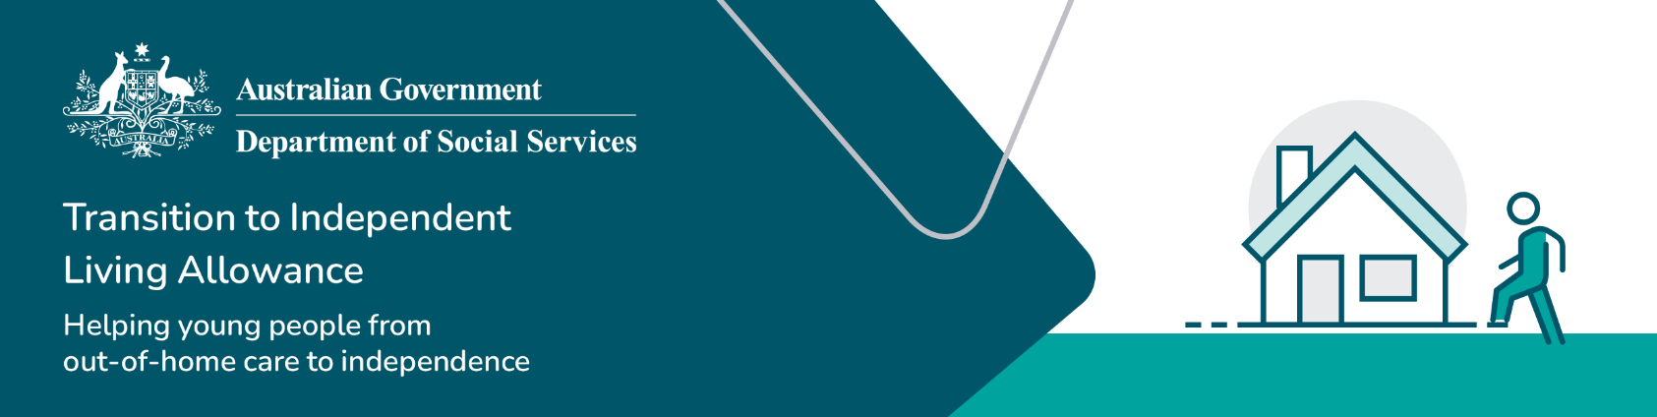

What can TILA be used for

The Transition to Independent Living Allowance (TILA) can be used on a variety of different goods and services to assist you moving from life in formal care to independent living.

## What TILA can be used for

## What TILA cannot be used for

There are some goods and services that TILA cannot be used for. Some of these include: