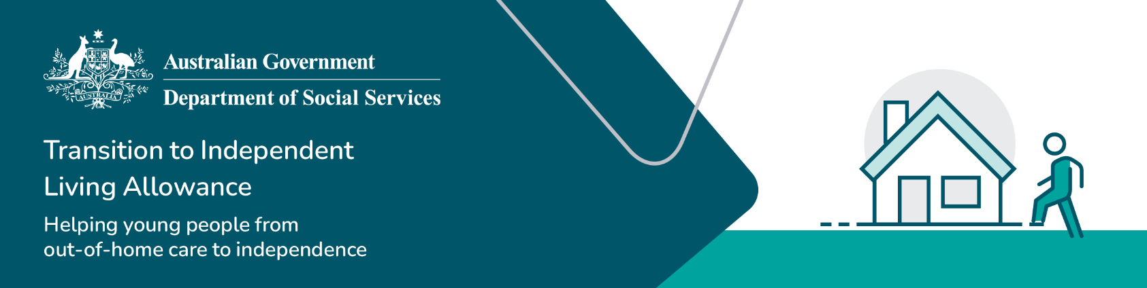

What can TILA be used for

## What TILA can be used for

The Transition to Independent Living Allowance (TILA) can be used on a variety of different goods and services to assist you moving from life in formal care to independent living.

**Housing**

* Support to connect to utilities such as electricity and gas
* Moving costs
* Payment of rental bonds
* Pre-payment of rent.

**Essential household items**

* Includes new or pre-loved household furniture and appliances such as lounges, TV, fridges, washing machines, microwaves or electrical items
* Portable air conditioner or heater that is not installed in your accommodation.

**Life skill programs**

* Financial or budgeting courses
* Cooking and nutritional courses
* Home maintenance courses.

**Employment and education**

* Purchase of books and computer/laptop
* Enrolment fees for education course
* Internet connection
* Clothing for work or a work interview
* Transport to attend studies or employment.

**Transport – Your own wheels**

* Purchase or part-payment of a car, motorbike or bicycle
* Driving lessons
* Car or motorbike registration and insurance
* Car or motorbike repairs.

**Public transport**

* Purchase of bus, ferry, train or tram passes
* Taxi fares to attend studies or employment.

**Counselling**

* Counselling costs to address issues identified in your transition from care plan i.e. Mental health counselling, physical or nutritional health.

**Other items**

* Other items not on this list will be considered on a case-by-case basis.

## What TILA cannot be used for

There are some goods and services that TILA cannot be used for. Some of these include:

**Reimbursement of previous purchases or costs**

* Cannot be used to reimburse the purchases or costs of items that were paid for before TILA was applied for such as moving and utility costs, or electrical equipment such as a laptop or mobile phone.

**Crisis assistance**

* Cannot be used to pay overdue bills or speeding, parking or other fines.

**Rent-to-buy**

* Cannot be used on rent-to-buy schemes for furniture or whitegoods.

**Overseas travel**

* Cannot be used for overseas travel.

**TV subscription or electronic games**

* Cannot be used to purchase or hire games consoles such as Nintendo Wii or Microsoft Xbox or subscriptions to paid TV services.

**Fixed housing items**

* Cannot be used to purchase items that are not portable and installed into a premise that is not owned by you, such as a fixed air conditioner or heater, garden shed or a permanent garden.

**Cash**

* Cannot be paid as a cash payment to you or transferred to your bank account.

## Reminder

It’s important to remember that you and your caseworker or support worker decide together on the best use and timing of TILA. Your purchase must meet the relevant life domains in your transition from care plan. TILA can be used to meet your needs outlined in the plan or needs that may not have been included in the plan. TILA must be the best way to fund the purchase taking into account other supports available to you.

Go to [www.dss.gov.au/TILA](http://www.dss.gov.au/TILA) for more information on TILA and [state and territory contact details](https://www.dss.gov.au/towards-adulthood/applying-transition-independent-living-allowance/eligibility-transition-independent-living-allowance?_gl=1*1dauyaa*_ga*NDIxMzkxNTQ1LjE3MjE2MTA3ODM.*_ga_9JJ1FJ00DK*MTczMzg3NDYxNi4xMDcuMS4xNzMzODc1NzQ2LjQ2LjAuMA..).