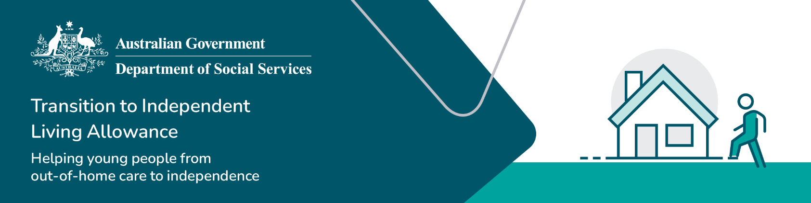

Return of unused TILA funds and reissuing of returned funds process

Transition to Independent Living Allowance (TILA)

|  |
| --- |
| This guide is to assist you in the return of unused TILA funds and process. If you require further information on TILA, please contact the TILA team at [tila@dss.gov.au](mailto:tila@dss.gov.au)  This guide should be read in conjunction with the [TILA Operational Guidelines, Section 2.7 Surplus of TILA funds held by the registered organisation and Section 2.8 Manual payment request.](https://www.dss.gov.au/towards-adulthood/resource/transition-independent-living-allowance-tila-operational-guidelines) |

## Return of unused TILA funds

### Overview

Organisations are encouraged to spend TILA funding on goods and services in line with a young person’s leaving care plan. At times young people may no longer require the TILA funding at that time or they may have disengaged from the organisations service. If this occurs, surplus TILA funding should not be carried over to the next financial year or held over several financial years.

Where unused TILA funds are unlikely to be expended soon into the new financial year, these funds need to be returned to the Department of Social Services (DSS), to ensure Commonwealth funds are used for their intended purpose.

### Reminders

Table 1 – Key reminders

|  |  |
| --- | --- |
| Item | Reminder |
| Record keeping | It is important for organisations to keep accurate records detailing any unused TILA funds they have returned to DSS, as the amounts returned are **not** displayed in the Services Australia payment system.  For example, if $1,500 was paid to an organisation for a young person but $200 was not spent or no longer required and was returned to DSS, the amount of $1,500 will still show as being expended in Services Australia payment system. |
| Amounts applied for | Organisations should only request the amount of funding required. TILA funding payment amounts are available in 6 x $250 amounts, and applying for funding in these amount block can make it easier in ensuring that high amounts of unused funds are not needed to be returned to DSS. |
| Age TILA funding should be used by | It is important the young person use all their TILA funding before they turn 26 years of age. They cannot use TILA funding after their 26th birthday, even if some of their TILA funding is remaining. |
| Who surplus TILA funding should be used for | TILA funding should only be used for the young person it was applied/received for. Surplus TILA funding should not be used for another young person. |

### Information required

It is important for an organisation to provide the following information to DSS to progress the return of unused TILA funds.

**Your organisations details**

* Full name of your organisation/department
* Address of your organisation
* Organisation ABN
* Contact name
* Contact phone number
* Contact email.

**Details for each young person**

* Name
* Date of Birth
* Centrelink Customer Reference Number (CRN)
* Amount to be returned
* Financial Year funds were applied for
* Financial Year funds were received
* Reason why received funding was not used
* Details on the contact attempts and different methods used to expend the young person’s funds in line with their leaving care plan.

Once these details have been provided, DSS will consider the information and may wish to meet with an organisation to discuss the details provided further.

After this, DSS will issue an invoice for the repayment of these funds back to the department.

At times DSS will request further information be provided from the organisation to ensure that every effort has been made to ensure the young person receives their TILA funding.

## Request for re-issuing of unused TILA funds

### Overview

At times a young person may advise an organisation they would like to use their unused TILA funds that have been returned to DSS and request a reissue of this funding.

In these instances, DSS makes a request to Services Australia for this to occur. This is called a manual payment.

### Reminders

Refer to *Table 1 - Key reminders* in this taskcard.

### Information required

It is important for an organisation to provide the following information to DSS to progress a request for manual payment.

**Your organisations details**

* Full name of your organisation/department
* Address of your organisation
* Organisation ABN
* Contact name
* Contact phone number
* Contact email.

**Young person’s details**

* Name
* Date of Birth
* Centrelink Customer Reference Number (CRN)
* Amount to be returned
* Financial year payment was made
* Financial year the funds relate to i.e. were the funds paid in 2022-2023 financial year or earlier or later
* Date the unused TILA funding amount was returned to DSS and attach the original email returning unused TILA funds if known.

Once these details have been provided, DSS will review the request and may wish to speak further with the organisation regarding the request to ensure it is in line with TILA eligibility guidelines.

After this, DSS will send the request to Services Australia for the manual payment to be made to the organisation for use on the young person as agreed to in the young person’s leaving care plan.