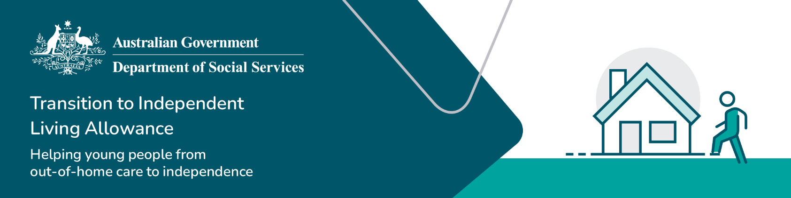

# TILA application reminders

These reminders should be read in conjunction with the [TILA Operational Guidelines](https://www.dss.gov.au/our-responsibilities/families-and-children/benefits-payments/transition-to-independent-living-allowance-tila/tila-operational-guidelines). Refer to the [TILA Guide for Caseworkers](https://www.dss.gov.au/towards-adulthood/resource/tila-guide-caseworkers) for step-by-step instructions on processing a TILA application.

## TILA application reminders

Confirm a young person’s [eligibility](https://www.dss.gov.au/towards-adulthood/applying-transition-independent-living-allowance/eligibility-transition-independent-living-allowance?_gl=1*1kbqz1u*_ga*NDIxMzkxNTQ1LjE3MjE2MTA3ODM.*_ga_9JJ1FJ00DK*MTczMzg2NjA5MS4xMDYuMS4xNzMzODY3MDE3LjQ1LjAuMA..) for the TILA payment **before** processing the application. Then follow these steps:

### Draft or update the young person's leaving care plan

* Discuss with the young person their [transition or leaving care plan](https://www.dss.gov.au/towards-adulthood/applying-transition-independent-living-allowance/leaving-care-plans?_gl=1*1knaxd9*_ga*NDIxMzkxNTQ1LjE3MjE2MTA3ODM.*_ga_9JJ1FJ00DK*MTczMzg2NjA5MS4xMDYuMS4xNzMzODY3MDYzLjYwLjAuMA..) and how TILA can be used to support their needs.
* TILA purchases **must** be in line with the young person's leaving care plan and be the right time and best use of TILA funds.
* Review the [What can TILA be used for](https://www.dss.gov.au/towards-adulthood/resource/what-can-tila-be-used) factsheet for more information.

#### Key reminders:

* A leaving care plan must be part of a young person's TILA application process.
* TILA can be used at any time as a young person leaves care and it does not need to be a payment of last resort.

### Complete the TILA application form

* Complete the TILA application form **with** the young person.
* The young person must be **aware o**f and **sign** **or approve** the application for TILA.
* Keep a copy of the TILA application form in the young person's file for a records and audit trail.
* Note: only request the amount required. 6 x $250 amounts can be requested depending on the amount required.

#### Key reminders:

* A caseworker **cannot** sign the TILA application on behalf of a young person without their knowledge

**OR**

* apply for TILA funding and hold this until the young person needs it.

### Submit the TILA application in Business Hub

* In some jurisdictions, your organisation and yourself must be registered and approved to submit applications for TILA in Business Hub.
* Contact your [state or territory](https://www.dss.gov.au/towards-adulthood/applying-transition-independent-living-allowance/eligibility-transition-independent-living-allowance?_gl=1*wctia8*_ga*NDA3OTI3MDIuMTczNTc2NzI2OA..*_ga_9JJ1FJ00DK*MTczODcxMTYyMS41MC4xLjE3Mzg3MTE3MjguMjMuMC4w) TILA representative for the Business Hub registration spreadsheet and how to complete the process.

#### Key reminders:

* Some jurisdictions have TILA administrators that will submit the TILA application for you.
* Contact your [state or territory](https://www.dss.gov.au/towards-adulthood/applying-transition-independent-living-allowance/eligibility-transition-independent-living-allowance?_gl=1*wctia8*_ga*NDA3OTI3MDIuMTczNTc2NzI2OA..*_ga_9JJ1FJ00DK*MTczODcxMTYyMS41MC4xLjE3Mzg3MTE3MjguMjMuMC4w) TILA representative for more information.

### Make purchases for the young person

* Decide with the young person what items or services they need, and then purchase the items/services as required in line with your organisation's procedures.
* You can accept handwritten receipts if purchasing goods from secondhand dealers such as garage sales, or Gumtree, etc.
* Save receipts to the young person's file which should reflect the needs identified in their leaving care plan.

#### Key reminder:

* All of the TILA funding must be used for the young person and no portion should be used to pay fees, even if your organisation is paying for goods and services by credit card.
* TILA funding is **not** to be paid directly to a young person by either a deposit into their bank account or as cash.