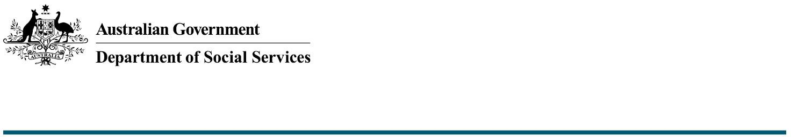

Inclusive Beaches

The Commonwealth Accessible Australia Initiative:

Increasing Inclusion in Australian Communities

The Australian Government is investing $17.1 million from 2024-25 to 2027-28 to increase inclusion in community spaces for people with disability across Australia through the Commonwealth Accessible Australia initiative (Accessible Australia).

The Australian Government will provide funding for up to **100 per cent** of the total build cost for **inclusive beaches** to state and territory governments via Federation Funding Agreements (FFAs). For information regarding funding, please refer to the [*Funding and Federation Funding Agreements* fact sheet](https://www.dss.gov.au/node/3322).

What are inclusive beaches?

Inclusive beaches are beaches that incorporate access for people living with disability and their carers. This allows all people to use Australia’s beaches, regardless of age or ability.

Inclusive beach amenities include:

* Beach wheelchairs: wheelchairs designed to access sand, mud, gravel and/or uneven terrain.
* Floating wheelchairs: wheelchairs that allow the user to be partially submerged in water, allowing the sensation of floating
* Mobi-matting: a roll-out access mat designed to provide a stable surface for people who use wheelchairs or have reduced mobility, allowing access to the beach.

What funding is available for inclusive beaches?

The Australia Government will provide up to 100 per cent of funding towards the purchase of proposed amenities. Applications for funding must be supported by an itemised quote.

Are all beaches eligible for Accessible Australia funding?

All beaches are eligible, and proposed locations will be determined by each state or territory government in consultation with relevant stakeholders (e.g. local councils, co-funders, community organisations). Factors to consider include community need, level of visitor patronage and proximity to other accessible amenities.

Final locations are subject to Commonwealth approval.

Is there a maximum amount that can be applied for?

While there is no maximum funding amount that can be applied for, all proposals will be considered based on their merits. This includes location, community impact and value for money.

Are there any costs associated with inclusive beaches that are not eligible for Commonwealth funding?

Not all costs* are eligible for Commonwealth funding, for example:

* Demolition costs
* Costs not directly related to the construction of the inclusive beaches (e.g. decorative elements, costs associated with a larger construction project)
* Ongoing maintenance costs.

All ongoing operational or maintenance costs are the responsibility of the funding recipient.

*The above list is not exhaustive. The Commonwealth reserves the right not to fund items it deems ineligible.

Is there a deadline for when accessible beach amenities must be purchased and installed?

Purchase of inclusive beach amenities must have commenced within 12 months of receiving funding. Proof of purchase must be provided to the Commonwealth.

Installation of amenities must be complete within 18 months of purchase. Inclusive beaches will be considered complete once amenities are installed and available for public use (acknowledging this may be weather dependent).

What needs to be included in a project plan for an inclusive beach?

Information regarding project plan requirements can be found in the [*Applications, Project Plans and Progress* *Reporting* fact sheet](https://www.dss.gov.au/node/3315).

Who can I contact for more information?

Further information and Frequently Asked Questions on Accessible Australia can be found on the [Department of Social Services website.](https://www.dss.gov.au/disability-support-services/changing-places)

The department can be contacted directly via email at [AccessibleAustralia@dss.gov.au](mailto:AccessibleAustralia@dss.gov.au).