Commonwealth, State and Territory Disability Ministers met on 21 February in Adelaide for the first DRMC meeting of 2025.

Disability Ministers welcomed the Hon Amanda Rishworth MP as the new chair and Commonwealth Minister for the National Disability Insurance Scheme (NDIS) and Minister for Social Services. Western Australia did not have a Minister in attendance due to the WA Government assuming a caretaker role and the Queensland Minister, the Hon Amanda Camm MP was an apology, however both jurisdictions were represented by officials.

Disability Ministers welcomed the Hon Dr Anne Aly MP to her first DRMC meeting as Minister Assisting the Minister for the National Disability Insurance Scheme.

Ministers discussed a range of priority disability reforms to progress in 2025.

A verbal update was provided by Ms Jane Spring AM, Chair of the Australia’s Disability Strategy Advisory Council. Ms Spring briefed Ministers on the Council’s work in 2024 and the opportunities in 2025 to drive better outcomes for people with disability through three new targeted action plans under the updated Australia’s Disability Strategy (ADS). Ministers endorsed the Council’s revised Terms of Reference and 2025 Work Plan.

Ministers endorsed the DRMC 2024 Annual Report to the National Cabinet. The report outlines key achievements of 2024 and priorities for 2025, this includes strengthening the involvement of the disability community in driving inclusion through the refreshed ADS; continuing to progress implementation of joint Disability Royal Commission recommendations; jointly shaping the design of Foundational Supports; working collaboratively to continue to reform and return the NDIS back to its original intent.

Ministers received an update on Foundational Supports and agreed to continue to work together to progress the design of Foundational Supports, continuing to take account of the views of people with disability, families and the sector, including those provided through national consultations in the second half of 2024.

Ministers also discussed the proposed approach to future reform of the Information, Linkages and Capacity (ILC) program to support a more viable and sustainable disability sector.

The development of national principles to improve consistency in the regulation of assistance animals was also discussed.

Ministers discussed Disability Royal Commission safeguarding measures and agreed to the development of a Joint Action Plan to reduce and eliminate the use of restrictive practices on people with disability, and to commence work on identifying opportunities for national consistency in the delivery of Community Visitor Schemes.

Ministers received a progress update on the development of NDIS Rules, including proposed consultation and engagement for future NDIS rules with the disability community. An engagement strategy will be published on the Department of Social Services website.

Co-chairs for the newly established NDIS Reform Advisory Committee (NDIS RAC),   
Ms El Gibbs and Mr Dougie Herd, joined the DRMC meeting to discuss their goals for the committee and welcomed Ministers’ input on priorities and expectations of the Committee. Ministers endorsed the NDIS RAC Terms of Reference, and agreed a national Expression of Interest process which will commence shortly to inform NDIS RAC membership.

Minister Aly provided an update on Younger People in Residential Aged Care. Ministers noted the ongoing commitment to reducing the number of younger people in residential aged care and that a concerted effort is needed.

Dr Janine Mohammed, Deputy Chief Executive Officer, First Nations, National Disability Insurance Agency, also provided an update on the NDIS First Nations Strategy.

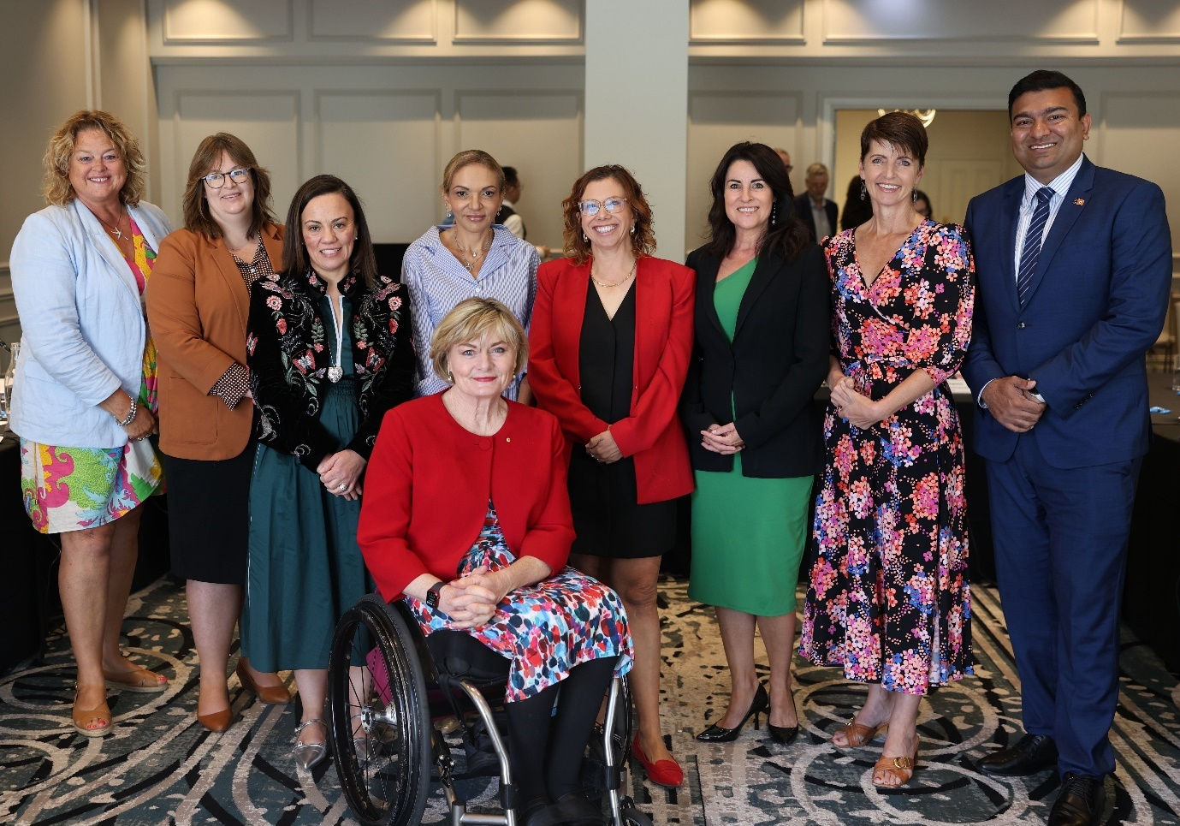Image – Clockwise from left:

Minister Cook (SA), Minister Orr (ACT), Minister Blandthorn (VIC), Minister Aly (Minister Assisting the Minister for the NDIS), Jane Spring AM, Chair of the Australia’s Disability Strategy Advisory Council, Minister Rishworth (Minister for Social Services and Minister for the NDIS), Minister Palmer (TAS), Minister Washington (NSW), Minister Charls (NT).