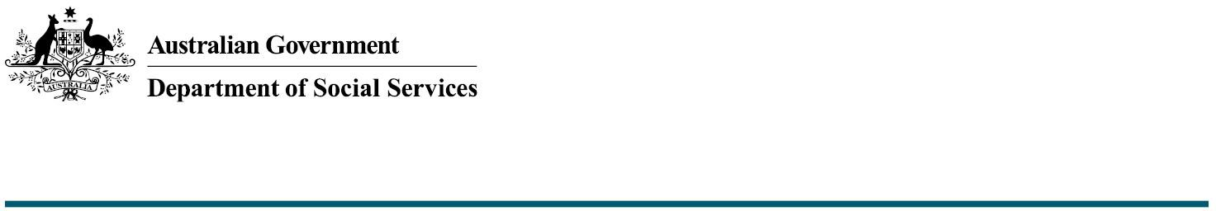

Funding and Federation Funding Agreements

The Commonwealth Accessible Australia Initiative:
Increasing inclusion in Australian communities

The Australian Government is investing $17.1 million from 2024-25 to 2027-28 to increase inclusion in community spaces for people with disability across Australia through the Commonwealth Accessible Australia initiative (Accessible Australia).
The Australian Government will provide funding to state and territory governments via Federation Funding Agreements (FFAs). This fact sheet includes key information regarding funding and FFAs for state and territory governments, local governments, co-funders, and other interested parties.

General Funding and FFA Information

What are Federation Funding Agreements?
Federation Funding Agreements (FFAs) are agreements between the Commonwealth Government and a state or territory government. FFAs allow the Commonwealth to provide funding to state and territory governments through the Federal Financial Relations (FFR) system.
FFAs are overseen by the Council on Federal Finance Relations (CFFR) and governed by the Federation Funding Agreement Framework. The Framework is underpinned by eight FFA Principles, which can be read about in further detail on the FFR website.

Who signs an FFA?
FFAs are signed by the Commonwealth Minister for Social Services and their respective state or territory counterpart on behalf of their respective governments.

Who can build or purchase Accessible Australia amenities under this funding offer?
There is no restriction on who can build or purchase Accessible Australia amenities funded by the Commonwealth. Accessible Australia projects can be undertaken by state and territory governments, local councils, community organisations or private enterprise. Applications will be submitted via states and territory governments, and all proposals will be considered on their merits.

Can builds be part of larger construction projects?
Yes. Builds and purchases can be standalone projects or can part of larger projects. However, only costs associated directly with the eligible amenity are eligible for Commonwealth funding.

Are there any restrictions regarding where remaining funding can be sourced for partially funded amenities?
No. The Commonwealth encourages funding partners to consider collaborative funding contributions. These may include funding via:
- state and territory government grants
- other Commonwealth grants
- LGAs/local councils, and
- appropriate third-party contributors (e.g. private businesses at tourism locations).
To remain eligible for funding under Commonwealth FFAs, state and territory governments must maintain overarching responsibility for project delivery and reporting.

Are there any location restrictions for amenities?
The location of each amenity will be determined by each state or territory government in consultation with relevant stakeholders (e.g. local councils, co-funders, community organisations). Factors to consider include community need, level of visitor patronage and proximity to other accessible amenities. Final proposals are subject to Commonwealth approval.

Information for State and Territory Governments

When will funds be paid to states and territories?
Commonwealth funding will be provided in two payments, as outlined below:
Stage | Percentage of Cwlth contribution | Conditions of Payment Release
1 | 50% | Upon receipt and Commonwealth approval of project plan for each eligible amenity.
2 | 50% | Upon Commonwealth receiving proof of construction commencement/proof of purchase.

Further information regarding funding release will be outlined in the FFA and discussed further in state and territory consultation.

How are funds provided to states and territories?
Once the relevant milestones are met, funds will be released on the next available payment date. Funds are released by the Commonwealth Treasury directly to the treasury of the receiving state or territory government. Funds may take several days to appear in the state or territory treasury accounts due to processing.

Once funds are received, it is at the discretion of the state or territory treasury and the responsible state or territory department to determine how funds are managed, including when they are provided to parties managing the build or purchase of amenities. Questions on handling of funds after they’ve been received by the state should be directed to respective treasuries.

Information for project managers, co-funders and builders

We are a council, organisation, or private enterprise. Are we able to sign an FFA or receive funding directly?
No. While your organisation may be the final recipient of funding, the Commonwealth can only enter into FFAs with and provide funds to a state or territory government. The state or territory government will release funds for approved projects to the relevant organisations at their discretion.

How does funding get to the organisation building or purchasing the amenity?
Funding for eligible amenities is released by the Commonwealth Treasury to the relevant state or territory’s treasury. Funds may then be subject to state or territory processes. It is the decision of the state or territory as to when and how the funds will be provided to the managing organisation. It is recommended that questions regarding this are directed to the appropriate state or territory contact.

Who can I contact for more information?
Further information on the Commonwealth Accessible Australia funding offer can be found on the DSS Website. Alternatively, please feel free to contact the department at AccessibleAustralia@dss.gov.au.

