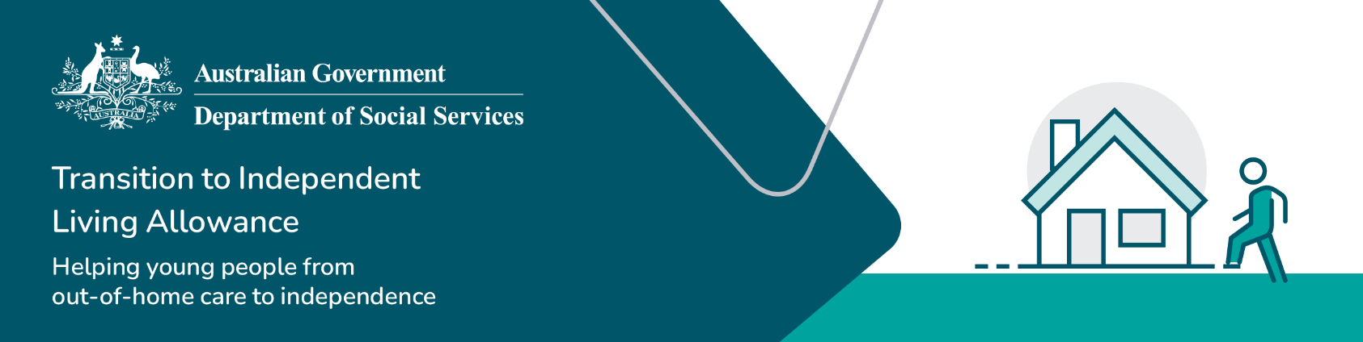

Guide for young people

Transition to Independent Living Allowance (TILA)

We understand that moving to independent living can be a positive time in a young person’s life as well as presenting challenges. With this in mind, we have designed this guide to help step you through the process of applying for the TILA allowance and help you settle in.

You will need a caseworker to help you apply for TILA. If you don’t have a caseworker you can contact your [local state or territory government department for child protection](https://www.dss.gov.au/towards-adulthood/applying-transition-independent-living-allowance/information-caseworkers?_gl=1*1rxcb55*_ga*NDA3OTI3MDIuMTczNTc2NzI2OA..*_ga_9JJ1FJ00DK*MTczNjgzNTg1OS4yMS4xLjE3MzY4MzU5MTcuMi4wLjA.) and they will find you one in the state or territory you are living in to support you in this process.

If you require further information on TILA, please contact the TILA team at [tila@dss.gov.au](mailto:tila@dss.gov.au)

## What is TILA?

The Transition to Independent Living Allowance (TILA) is a one-off payment of $1,500 to support young people like you, move from formal out-of-home care (OOHC) to independence by providing a contribution towards the costs involved in moving to independent living. You may also be eligible for TILA if you decide to stay at home with your non-parent carers after your care order expires.

TILA can be paid as a lump sum of $1,500 or in up to six instalments at a minimum of $250 per application, as agreed between you and your caseworker.

## TILA application process

Follow these steps to access the TILA payment:

Table 1: Steps to access TILA

|  |  |
| --- | --- |
| Steps | Details |
| Step 1:  Check your eligibility | To be eligible for [TILA](https://www.dss.gov.au/our-responsibilities/families-and-children/benefits-payments/transition-to-independent-living-allowance-tila) you must meet the following criteria:   * be an Australian citizen or permanent Australian resident who resides in Australia at the time of application for TILA * be aged from 15 to 25 years at the time of application * either has been in, or is currently in, [formal care](https://www.dss.gov.au/families-and-children/benefits-payments/transition-to-independent-living-allowance-tila/glossary) on a [court order](https://www.dss.gov.au/families-and-children/benefits-payments/transition-to-independent-living-allowance-tila/glossary) * left the care of the state or territory statutory department after the age of 15 years and was last in the department’s care for a continuous period of at least 6 months * either be approaching an exit from formal care (within twelve weeks of applying), experiencing an exit from formal care, or have exited from formal care * have the [transition to independence or leaving care plan](https://www.dss.gov.au/our-responsibilities/families-and-children/publications-articles/transitioning-from-out-of-home-care-to-independence-a-nationally-consistent-approach-to-planning-2011) * have not received the full amount of TILA assistance previously (i.e. can only receive up to a total of $1,500). |
| Step 2  Talk to a caseworker | You must talk to your caseworker if you think you might be eligible for TILA, as only the caseworker can apply for and manage the TILA payment for you.  Contact your [local state or territory government department for child protection](https://www.dss.gov.au/towards-adulthood/applying-transition-independent-living-allowance/information-caseworkers?_gl=1*1rxcb55*_ga*NDA3OTI3MDIuMTczNTc2NzI2OA..*_ga_9JJ1FJ00DK*MTczNjgzNTg1OS4yMS4xLjE3MzY4MzU5MTcuMi4wLjA.) to have a caseworker assigned to you if you:   * **don’t** have a caseworker * have **moved** interstate. |
| Step 3:  Create a leaving care plan | To receive TILA you will need to have a [transition to independence or leaving care plan](https://www.dss.gov.au/our-responsibilities/families-and-children/publications-articles/transitioning-from-out-of-home-care-to-independence-a-nationally-consistent-approach-to-planning-2011). This plan is a record of your goals and the support you need to achieve those goals. Your caseworker will work with you to develop your transition to independence or leaving care plan and it must include information on:   * Housing and accommodation – which should be safe and sustainable * Health – this includes your physical, emotional (including self-esteem), mental, sexual and dental health * Education * Employment and training * Financial security * Social relationships and support networks * Life (and after care) skills * Identify and culture * Legal matters.   There are also other [Support services for young people moving to independent living](https://www.dss.gov.au/towards-adulthood/help-and-support-young-people) which you might be eligible for as well. |
| Step 4:  Apply for TILA | If you are eligible for TILA, your caseworker will [apply for TILA](https://www.dss.gov.au/families-and-children/benefits-payments/transition-to-independent-living-allowance-tila/tila-application-form) on your behalf and manage the payment for you.  Your caseworker must also verify your eligibility by:   * sighting your birth certificate or Australian citizenship certificate * confirming you have been, or currently are in formal care.     Your caseworker will help you decide what the TILA payment will be used for and when, and help you purchase the items you both agree on.  Items can include a fridge, a couch, counselling, education and training courses, medical expenses, or a driver’s licence or lessons, and much more. Check out the [What can TILA be used for](https://www.dss.gov.au/families-and-children-benefits-payments-transition-to-independent-living-allowance-tila/what-can-tila-be-used-for) factsheet to find out what else TILA can be used for.  Once your TILA application has been processed, you will receive a letter which will be sent to the address you provided to your caseworker. |
| Step 5:  Receive TILA | You will **not** directly receive a TILA payment either in your bank account or as cash. The payment will be electronically transferred to the caseworker’s organisation’s bank account, and they will make the purchases on your behalf. |