New NDIS rule 5

Variations and Reassessment

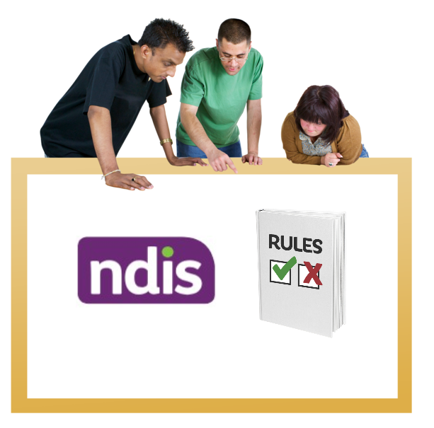

|  |  |
| --- | --- |
| Australian Government logo with Department of Social Services underneath | The Australian Government Department of Social Services wrote this.  We say **DSS** for short.  When you see the word **we** it means the DSS. |
| A person holding a white book with easy read on the cover | We wrote this in an easy to read way.  We use pictures to explain some ideas. |
| The word bold is in bold and the words not bold are in plain text | We have some words in **bold**.  This means the letters are thicker and darker.  These are important words. |
| An easy read document with pictures and lines for text. | This is an Easy Read summary of another document.  This means it has the most important ideas. |
|  |  |
| Two people with their arms around each other with thumbs up. | You can ask for help to read this document.  You can ask   * A friend * Family members * A support person. |
| cartoon of Aboriginal and Torres Strait Islander people with the Aboriginal and Torres Strait Islander flags in the background | We recognise Aboriginal and Torres Strait Islander peoples as the **Traditional Owners** of the land we live on. |
| teal map of australia | They were the **first peoples** to live on and use the   * Land * Waters. |

Contents

|  |  |
| --- | --- |
| Who can change an NDIS plan | 5 |
| What do the new rules do | 6 |
| Variations for emergency | 8 |
| Variations to add more money | 10 |
| Variations to change the date to make a new plan | 12 |
| Reassessments | 13 |
| Contact us | 15 |

## Who can change an NDIS plan

|  |  |
| --- | --- |
| NDIA logo | The **National Disability Insurance Agency** is the people who look after the NDIS.  We call them NDIA. |
| Person scratching head while looking at two notebooks labeled Plan A and Plan B. | NDIA can change an NDIS plan in two ways   * Add things to a plan * Make a new plan. |
| A spiral-bound notebook with 'Plan A' on the cover. | When the NDIA adds things to a plan we call it a **plan variation**.  Like adding more money or supports to your plan. |
| A spiral-bound notebook with 'Plan B' written on the cover. | When the NDIA makes a new plan we call it a **plan** **reassessment**. |

What do the new rules do

|  |  |
| --- | --- |
| Notebook cover with the word 'Rules' and a purple checkmark. | The new rules tell the NDIA what they need to think about when they do   * A plan variation * A plan reassessment. |
| a house with a cross | The new rules talk about 3 types of variations   * For an emergency   Like if you cannot live at home for a time. |
| Illustration of a stylised plan with graphics and a dollar sign. | * To add more money to the plan |
| Calendar with a clock showing 2:00 and a question mark. | * To change the date to make a new plan. |

## Variations for an emergency

|  |  |
| --- | --- |
| a house with a cross | NDIA can only make a variation for some emergencies. |
| A diverse group of six people standing together, including a young woman with Down syndrome in the foreground.  A brick house with an envelope addressed to it. | They can make it when you have had big change in   * What you can do * Who can help you * Where you live |
| Two men holding signs with thumbs up and thumbs down gestures. | They can make a variation if the big change means you need extra supports. |
| Three people sitting in front of a large stopwatch. | They can make it if the extra support is for   * A short time * 1 time only. |
| Ndis logo with green tick | NDIA can only make this variation if   * You need the extra support urgently * The NDIS is the best place to get the support. |

## Variations to add more money

|  |  |
| --- | --- |
| Illustration of four cloud shapes with striped poles and a question mark. the first with a big box and small box, finger pointing to the small box. second of a stopwatch and third of the number 1 | The NDIA can only add extra money or supports to your plan if they are for   * A small amount * A short time * 1 time only. |
| a person with 2 thought bubbles above their heads one with a 2 people one with a mobility walker. the other with a person getting into a car | The support must   * Be different from the supports you have already * Do a different job than the supports you have already. |
| Two people sitting at a table with cards and a mat, engaging in an activity. | The support must do 1 of these things   * Replace or fix **assistive technology** already in your plan   Assistive technology is equipment you need because of your disability. |
| Two men interacting, one standing and one seated in a wheelchair. | Assistive technology can help you do things more safely or easily.  Like a wheelchair |
| a yellow car with a taxi sign on top | * Give you urgent help to keep your job.   Like money for a taxi because you **cannot** catch the bus for a time. |
| Two people holding boxes in front of a white van. | * Give you **urgent** help to get more skills you need for a life change.   Like support to move out of home. |
| Illustration of four cloud shapes with striped poles and a question mark. the first is a house, second a car and third a wheelchair | The new rules also tell the NDIA what to do if the variation is about   * Changes to your house * Changes to your car * Assistive technology. |
| Person scratching head while looking at two notebooks labelled Plan A and Plan B. | Sometimes things about a support change after the NDIA makes your plan. |
| Illustration of a stylised plan with graphics and a dollar sign.  Three smiling healthcare professionals holding a sign with an information symbol. | The NDIA can make a variation if   * The support costs more than expected in your plan * You **cannot** get the support the way you expected in your plan * You need extra information or services to get the support.   Like you might need a doctor to write a report to get the support. |

## Variations to change the date to make a new plan

|  |  |
| --- | --- |
| Checklist of years from 2020 to 2024 with a pen. | The new rule says the NDIA can change the date they need to do a reassessment.  A plan cannot go longer than 5 years |

## Reassessments

|  |  |
| --- | --- |
| Man in a suit making notes with a checklist on a clipboard in the background. | The NDIA might decide to do a reassessment.  A participant can ask for one too. |
| A woman writing on a clipboard, a golden retriever, and a man in a suit with a speech bubble above. | The NDIA must think about some things when they do a reassessment.  They must think about why your support needs have changed. |
| A diverse group of six people standing together, including a young woman with Down syndrome in the foreground.  A brick house with an envelope addressed to it. | They must think about if the change is because   * What you can do * Who can help you * Where you live * other big life changes. |
|  |  |
| Young man with a thoughtful expression and a thought bubble above his head. | The NDIA must also think about anything else.  Like   * The participant thinks is important * The NDIA thinks is important. |

## Contact us

|  |  |
| --- | --- |
| teal circle with white i in the middle | You can contact us if you **need more information.** |
| teal envelope | You can send us an email.  [NDISConsultations@dss.gov.au](mailto:NDISConsultations@dss.gov.au) |
| teal arrow with lines | You can look at our website.  [www.dss.gov.au/national-disability-insurance-scheme-review-and-reforms/changes-ndis-act](http://www.dss.gov.au/national-disability-insurance-scheme-review-and-reforms/changes-ndis-act) |

  easyread.tech created these original illustrations. Please do not use these illustrations without permission. Visit [easyread.tech](https://easyread.tech) for more information.