New NDIS rule 4

Who can manage funds in an NDIS plan

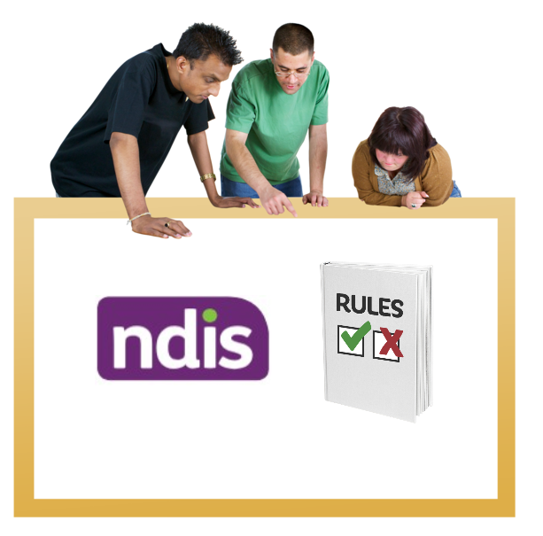

|  |  |
| --- | --- |
| Australian Government logo with Department of Social Services underneath | The Australian Government Department of Social Services wrote this.  We say **DSS** for short.  When you see the word **we** it means DSS. |
| A person holding a white book with easy read on the cover | We wrote this in an easy to read way.  We use pictures to explain some ideas. |
| The word bold is in bold and the words not bold are in plain text | We have some words in **bold**.  This means the letters are thicker and darker.  These are important words. |
| An easy read document with pictures and lines for text. | This is an Easy Read summary of a bigger document.  This means it has the most important ideas. |
| Two people with their arms around each other with thumbs up. | You can ask for help to read this document.  You can ask   * A friend. * Family members. * A support person. |
| cartoon of Aboriginal and Torres Strait Islander people with the Aboriginal and Torres Strait Islander flags in the background | We recognise Aboriginal and Torres Strait Islander peoples as the **Traditional Owners** of the land we live on. |
| teal map of australia | They were the **first peoples** to live on and use the   * Land. * Waters. |

Contents

|  |  |
| --- | --- |
| Who can manage an NDIS plan | 5 |
| What the NDIA must think about | 8 |
| What the NDIA must not think about | 10 |
| What else the new rule does | 11 |
| Contact us | 12 |

## Who can look after an NDIS plan

|  |  |
| --- | --- |
| NDIA logo | **The National Disability Insurance Agency** are the people who look after the NDIS.  We call them the **NDIA**. |
| Notebook cover with the word 'Plan' and three people discussing a large sheet of paper at a table. | TheNDIAdecides who looks after an NDIS plan.  Look after means care for the money in the NDIS plan and make payments for your services. |
| A group of five people standing together with a large 'Safe Guarding' shield in front of them. | A person can only look after an NDIS plan if they will keep the participant safe.  A participant is someone who has an NDIS plan. |
| Two people with their arms around each other with thumbs up. | A participant can ask for someone else to look after their NDIS plan. |
| Woman giving a thumbs-up gesture with a cheerful expression. | The new rule helps the NDIA decide if this person   * Can manage a plan. * Will keep the participant safe. |
| Group of five diverse individuals with disabilities smiling and standing together. | 5 kinds of people can look after an NDIS plan   * **A participant.** |
| Two people, one in a wheelchair and the other standing, with a supportive arm around the shoulder. | * **A nominee.**   A nominee is someone who helps a participant with their NDIS plan.  Like   * A family member. * A friend. |
| A woman and three children sitting on a black leather couch, smiling and posing for a photo. | * **A Child representative.**   Child representatives areadults who can look after a child’s NDIS plan.  Like a parent. |
| Two women discussing a form at a table with a computer and a phone. | * **Plan managers.**   Plan managersare people paid to look after an NDIS plan. |
| Three smiling individuals in white t-shirts giving thumbs-up gestures. | * **The NDIA**. |

What the NDIA must think about

|  |  |
| --- | --- |
| A person with a thoughtful expression and a thought bubble above their head. | When the NDIA decides who can look after a plan they must think about   * If the participant could get hurt. |
| Judge wearing traditional attire in a courtroom with a gavel in the foreground. | * If a judge said someone else must look after the participant’s money. |
| A person in a black vest and red shirt posing with arms raised in a triumphant gesture. | * If the person looking after the plan has the right skills.   Like if the person can make their own decisions.  This includes if the person has support to make decisions. |
| A man in a helmet giving a thumbs up in front of four healthcare workers in blue uniforms. | The NDIA must think about the kind of supports in the NDIS plan.  This includes   * Supports working now to keep the participant safe. * Supports that worked in the past to keep the participant safe. |
| A person with a thoughtful expression and a thought bubble above their head. | The NDIA must also think about anything else   * The participant thinks is important. |
| A diverse group of people interacting with speech bubbles overhead. | * The NDIA thinks is important. |

What the NDIA must not think about

|  |  |
| --- | --- |
| A person with a thoughtful expression and a thought bubble above their head. There is a cross through the thought bubble. | The new rules say some things the NDIA **must not** think about.  When the NDIA decides who can look after a plan, they **must** **not** think about |
| Group of five diverse individuals with disabilities smiling and standing together. | * The type of **impairment** a participant has.   Impairment is when you find it hard to do things.  Like   * See. * Walk. * Understand. |
| Illustration of a stylised plan with graphics and a dollar sign. | The NDIA **must** **not** think about   * How much money is in the NDIS plan. * If a participant has not spent all the money in their NDIS plan in the past. |

What else the new rule does

|  |  |
| --- | --- |
| Notebook cover with the word 'Rules' and a purple checkmark. | The NDIS already has 2 different rules about managing NDIS plans. |
| Three flip charts with numbers 1, 2, and 3 in blue circles with red arrows indicating sequence. | The new rules will group all the rules about looking after NDIS plans together. |
| Four diverse individuals in front of a white projection screen saying management of funding rules, two in wheelchairs, one with a white cane. | We are calling them the Management of Funding Rules. |

## Contact us

|  |  |
| --- | --- |
| teal circle with white i in the middle | You can contact us if you **need more information.** |
| teal envelope | You can send us an email.  [NDISConsultations@dss.gov.au](mailto:NDISConsultations@dss.gov.au) |
| teal arrow with lines | You can look at our website.  [www.dss.gov.au/national-disability-insurance-scheme-review-and-reforms/changes-ndis-act](https://www.dss.gov.au/national-disability-insurance-scheme-review-and-reforms/changes-ndis-act#changes-to-the-ndis) |

  easyread.tech created these original illustrations. Please do not use these illustrations without permission. Visit [easyread.tech](https://easyread.tech) for more information.