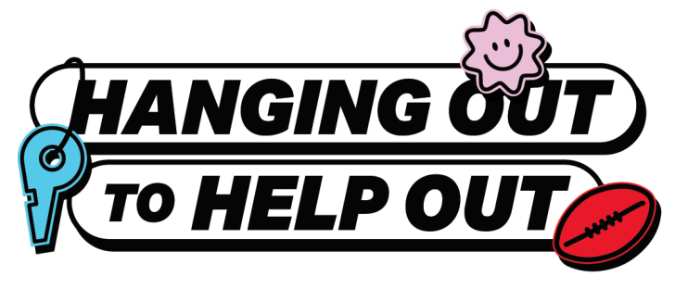

Volunteering 101: Your guide to making a difference
Whether you’re looking to build up your resume, meet new friends, or just want to give back to your community, being a volunteer can help you grow in more ways than one.
The best part? You’ll be able to make connections with like-minded people and even bring your mates along for the ride!

How to find the perfect gig
Not sure where to begin? It’s easier than you think. Volunteering doesn’t have to be a big commitment, just a few hours a month can make a world of difference.
Start here:
- Jump onto volunteering.gov.au and search for opportunities in your local area.
- Make a list of the ones that catch your eye and reach out to the organisations involved. Whether by email or phone, there’s sure to be a friendly team on the other end, happy to guide you.
Most of the time, you only need willing hands and a positive attitude. Any skills (or friends) you pick up along the way are just an added bonus!

Behind the scenes: hear from real volunteers

Noah, 17
Noah honed his surf lifesaving skills at South Maroubra Beach Club, where he now volunteers by patrolling the beach and coaching young nippers. He found a way to pair his passion with purpose and says, “If you’re interested in something, volunteering gives you a chance to really develop a love for it.”
Rebecca, 17
Rebecca’s journey began at Amnesty International, where she runs youth activist workshops. She’s proud of the impact her work has on young people. “Volunteering lets me do meaningful work! It feels good to be part of something bigger than yourself.”
To hear more inspiring volunteer stories and discover an opportunity near you visit volunteering.gov.au.

