# Parents and Carers Reference Group Meeting 1

**26 November 2024**

**Communique**

The Parents and Carers Reference Group (PCRG) held its first meeting in Canberra (Ngunnawal Country) on Tuesday 26 November 2024.

Co-chaired by Letitia Hope, Deputy Secretary Families and Communities, and Mr Jamie Crosby, Chief Executive Officer of Families Australia, the PCRG comprises 17 initial members, including 13 parents, who will provide advice to Government on how to best support children aged 0-12 years.

Minister for Social Services, the Hon Amanda Rishworth MP, delivered a welcoming address and thanked members for their commitment to put the voices of families and children at the centre of Australian Government policy, programs and services. The Minister reiterated the importance of the PCRG as a mechanism to hear directly from parents and caregivers on what matters to them.

Members discussed ways they will work as a group, including the Terms of Reference outlining the scope and priorities for the PCRG. The finalised Terms of Reference are published on the [Department of Social Services website](https://www.dss.gov.au/node/2402).

Members received an update on the current review of Children, Youth and Parenting Programs funded by the Department of Social Services, which is open for consultation until 24 January 2025 and available at [engage.dss.gov.au](https://engage.dss.gov.au/families-and-children-fac-activity-children-youth-and-parenting-programs-discussion-paper/). Members were asked about what kinds of supports have helped them the most and what the key ingredients are that families with young children need to thrive. Members were also asked for their reflections on the consultation discussion questions, and provided insights from their lived and professional experience of how well services have met the needs of children in their care.

Members agreed that the next meeting of the PCRG will be held before the end of March 2025.

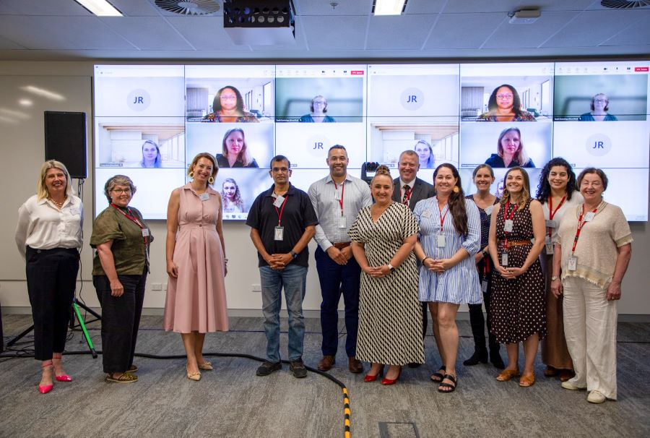

**Left To Right (On Screen): Ms Kristy Jones, Miss Malinda Savage, Ms Sarah Copland, Ms Eve Buckley,   
Mrs Sarah Cummings**

**Left To Right Front: Ms Samantha Page (Early Childhood Australia), Ms Wendy George, Mrs Dinah Thomasset, Mr Ravi Krishnamurthy, Mr Tomasi Ramanumanu, Ms Letitia Hope (Dss Co-Chair), Mr Jamie Crosby (Co-Chair, Families Australia), Ms Sara Barker, Ms Carly Grubb, Ms Lauren Binns, Ms Nicole El-Hage, Ms Prue Warrilow (Aracy)**