

National Carer Strategy Action Plan

2024 to 2034





**National Carer Strategy**

2024-2034

Action Plan 2024–2027

*This page is blank on purpose.*

**About this paper**

The Australian Government wrote this paper.

When you see the word ‘we’, ‘us’, or ‘our’, it means the Australian Government.

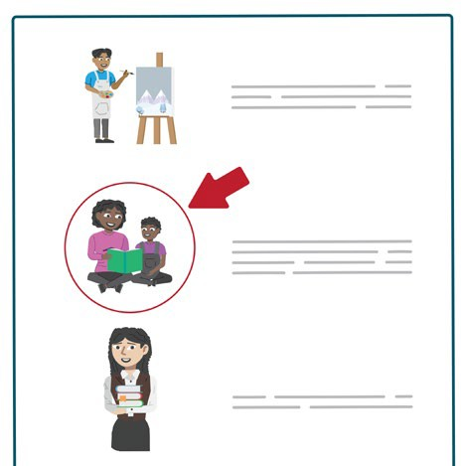We wrote this paper in an easy to read way. We use pictures to explain some ideas.

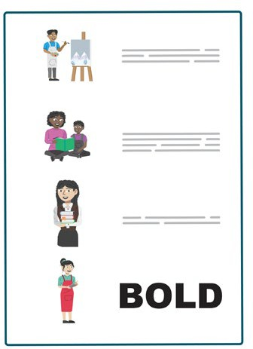This paper has some hard words.

The first time we write a hard word:

* We will write it in **bold**.
* We will explain what the hard word means.

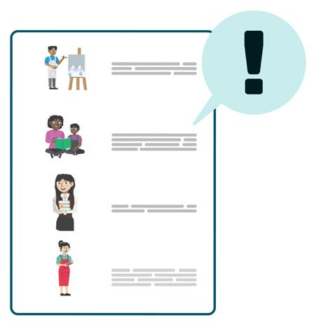This Easy Read paper tells you the most important ideas from another paper.

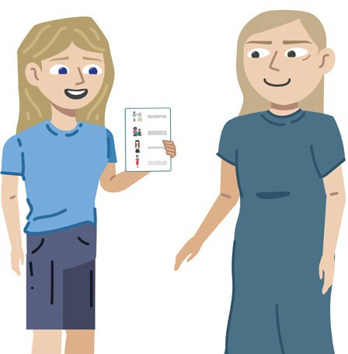You can ask for help to read this paper.

A friend, family member, or **support person**

can help you.

A support person is someone who helps you

with things you find hard to do by yourself.

This paper is for the **National Carer Strategy Action Plan**.

The National Carer Strategy Action Plan is a plan to help unpaid **carers** in Australia.

In this paper, we call it ‘the Action Plan’.

A carer is a family member or friend who looks after someone most days because they need lots of help.

Carers help:

* Children with extra needs.



This paper tells you about the **Action Plan**.

This is a plan about how we will make

carers’ lives better.

**5**

* People with disability.
* 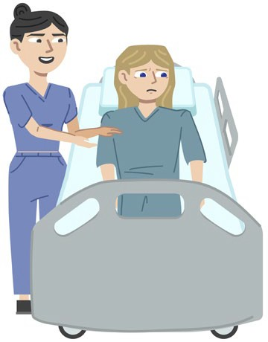People with a body or mind that is very sick.
* People who are older and need help to move around or to do things.

**Table of contents**

Respect for Country **7**

If you need help **9**

About this Action Plan **17**

Making Carer Gateway better **21**

Making Carer Gateway easy for everyone to use **25**

Helping more people know about carers **26**

Changing the Carer Recognition Act 2010 **28**

Listening to carers to keep making services better **29**

Helping carers to find a job or to learn new skills **30**

Learning more about carers **31**

How we will check that the Action Plan is working **32**

How to contact us **36**

# Respect for Country

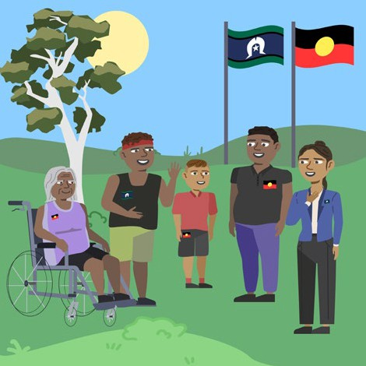We respect **Aboriginal and Torres Strait Islander** peoples.

Aboriginal and Torres Strait Islander means the first people in Australia who have **different cultures**.

This means that they have:

* Different ways of living.
* Speak languages other than English.

We know that Aboriginal and Torres Strait Islander peoples still have a special relationship with:

* Their land.
* Their water.
* 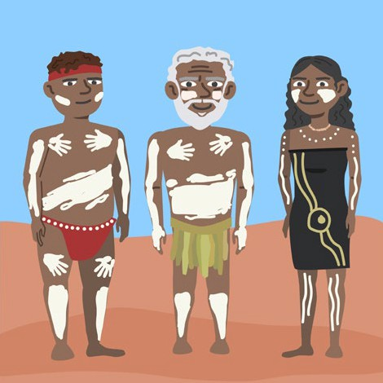Their culture.
* Other Aboriginal and Torres Strait Islander peoples.

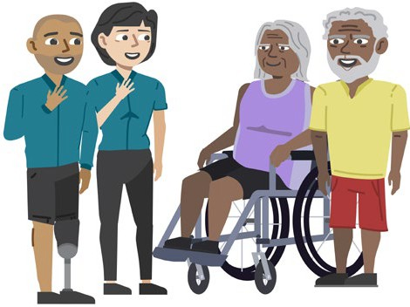We thank their leaders now and from a long time ago.

# If you need help

You may read information in this paper that upsets you.

If you need help to feel better after reading this paper, you can get help from these free services.

**Carer Gateway**.

They can help you to find services and

help for carers.

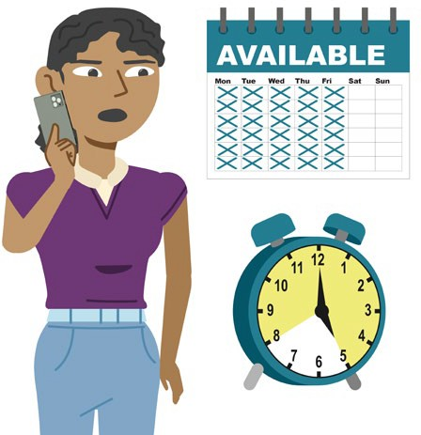You can talk to them on the phone from Monday to Friday between 8 am and 5 pm.

Their number is 1800 422 737.

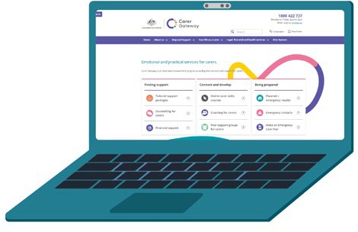You can visit their website at: [Carer Gateway.](https://www.carergateway.gov.au/) <https://www.carergateway.gov.au/>

**Beyond Blue**.

You can talk to them if you feel very sad or upset and the sad feeling does not go away for 2 weeks or longer.

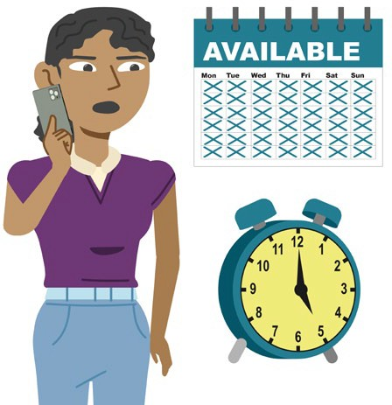You can talk to them on the phone anytime everyday of the week.

Their number is 1300 224 636.

You can talk to them online between 3 pm and

12 am **AEST** everyday of the week.

AEST means if you live in:

* New South Wales.
* Victoria.
* Australian Capital Territory.
* Queensland.
* Tasmania.

If you do not live in these states, you can ask a

support person to help you find out the right time.

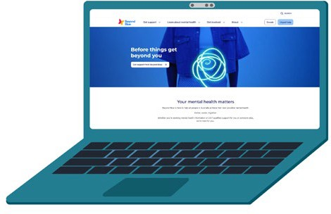You can visit their website at:

[Beyond Blue.](https://www.beyondblue.org.au/)

<https://www.beyondblue.org.au/>

**Lifeline Crisis Support**.

They can help you if life feels like too much and you want to hurt yourself.

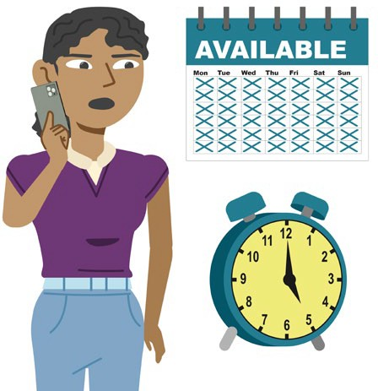You can talk to them on the phone anytime everyday of the week.

Their number is 13 11 14.

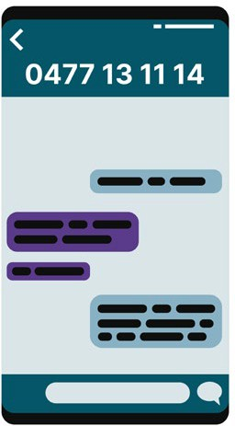You can send them a text message anytime. The text number is 0477 13 11 14.

You can talk to them online anytime.

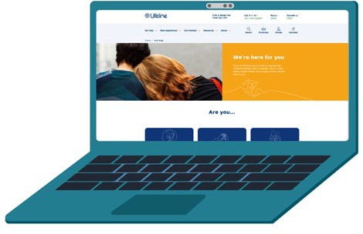You can visit their website at:

[Lifeline Crisis Support.](https://www.lifeline.org.au/get-help/)

<https://www.lifeline.org.au/get-help/>

**1800 RESPECT.**

You can talk to them about someone who has hurt you or touched you in a way you do not like.

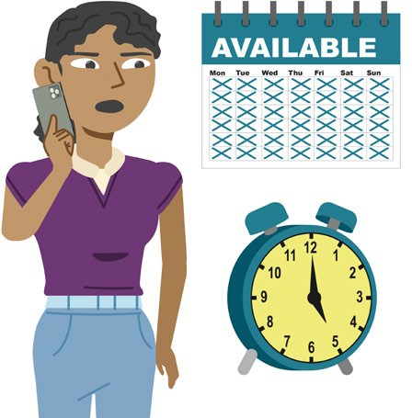You can talk to them on the phone anytime everyday of the week.

Their number is 1800 737 732.

You can talk to them online anytime.

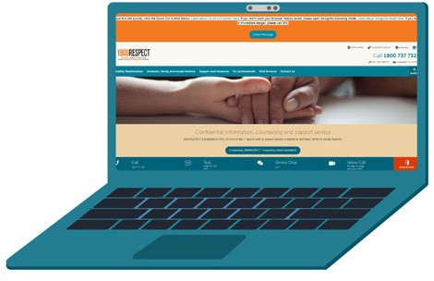You can visit their website at:

[1800RESPECT.](https://www.1800respect.org.au/)

<https://www.1800respect.org.au/>

**13 YARN.**

This is a service for Aboriginal and Torres Strait Islander peoples.

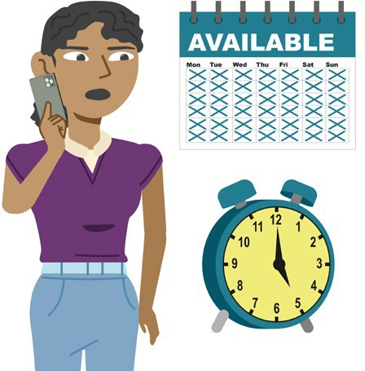You can talk to them on the phone anytime everyday of the week.

Their number is 13 92 76.

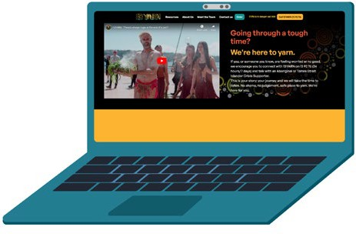You can visit their website at:

[13YARN.](https://www.13yarn.org.au/)

<https://www.13yarn.org.au/>

**QLife.**

This is a service for people who are

**LGBTQIA+.**

**LGBTQIA+** means:

* Lesbian.
* Gay.
* Bisexual.
* Transgender.
* Queer.
* Intersex.
* Asexual.
* People with other sexual feelings and genders.

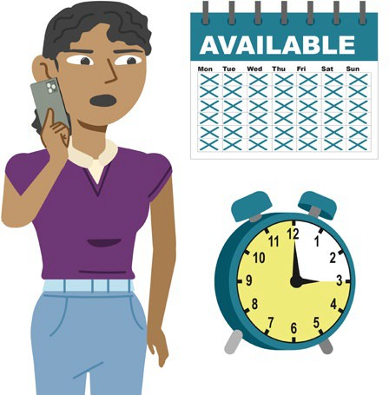You can talk to them on the phone between

3 pm and 12 am everyday of the week.

Their number is 1800 184 527.

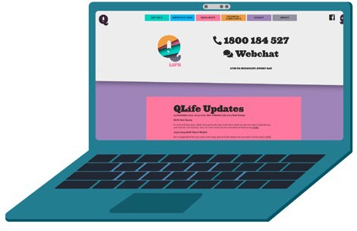You can visit their website at:

[QLife - Support and Referrals.](https://qlife.org.au/) <https://qlife.org.au/>

**Open Arms Veterans and Families Counselling.**

This is a service for:

* **Veterans** who are carers.
* People who are carers for veterans.

Veteran means a person who has fought in wars.

You can talk to them on the phone. Their number is 1800 011 046.

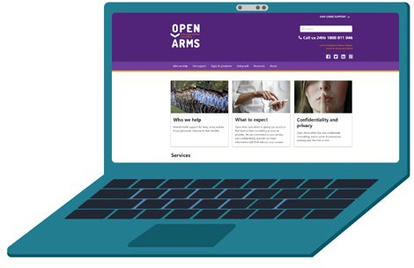You can visit their website at:

Open Arms – Veterans & Families Counselling.

[https://www.openarms.gov.au/](http://www.openarms.gov.au/)

**eheadspace.**

This is a service for young people between 12 and 25 years old.

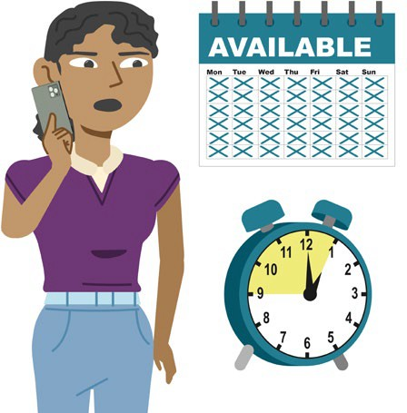You can talk to them on the phone between

9 am and 1 pm AEST everyday.

Their number is 1800 650 890.

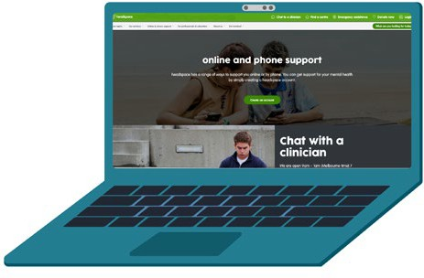You can visit their website at:

[Online and phone support | headspace.](https://headspace.org.au/online-and-phone-support/)

[https://headspace.org.au/online-and-phone-](https://headspace.org.au/online-and-phone-support/) [support/](https://headspace.org.au/online-and-phone-support/)

# About this Action Plan

We want this Action Plan to make the lives of unpaid carers better.

We want carers to be:

* Happier.
* Healthier.

We will:

1. Make services better for carers.

This includes:

* + Looking at Carer Gateway and how we can make it better.
  + 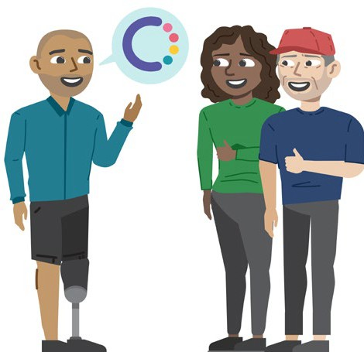Making sure Carer Gateway is easy for everyone to use.

1. Help more people know:
   * Who carers are.
   * That carers are important.
2. Change the **Carer Recognition Act 2010**

to be more useful today.

This is a rule made by the Government to help people understand that carers

are important.

1. Listen to carers to keep making services better.
2. Help carers with taking care of their money so they can pay for things they need.
3. Learn more about carers by getting better information.

The help that carers get from this Action Plan will help us come up with more plans after 2027.

To make carers’ lives better, we will work with:

* + Carers.
  + Other people who know a lot about carers.

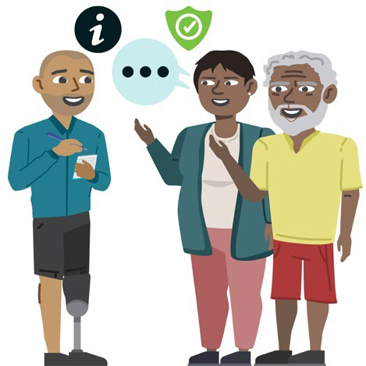We will help Aboriginal and Torres Strait Islander carers who live far away from cities to take more breaks.

We will work with Aboriginal and Torres Strait Islander peoples to make this happen.

# Making Carer Gateway better

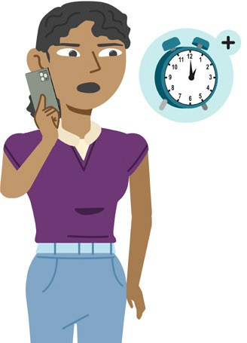We will make Carer Gateway better for

carers with:

* + 10,000 more hours of help for carers on the phone.
  + Longer opening hours.
  + Better help for carers to be happy and healthy.
  + Better help for carers to take breaks when they need them.
  + Better help for carers to talk to other unpaid carers.
  + Better help for carers to learn new skills.

This includes:

* + - How to move and lift someone in a safe way.
    - 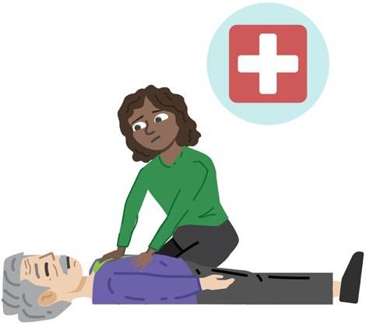How to help someone who is very hurt or sick before a doctor can help.
    - 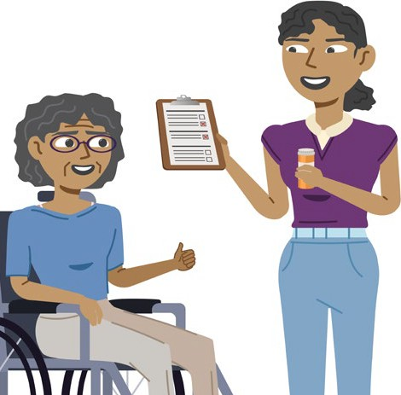How to help someone take their medicine or look after their body when they are sick or hurt.
    - How to use money better.
    - How to help someone who is very sad or wants to hurt themselves.
  + Better help for carers from different

groups of people.

This includes:

* + - Aboriginal and Torres Strait Islander carers.
    - Carers from different cultures.
    - LGBTQIA+ carers.
    - Carers with disability.
    - 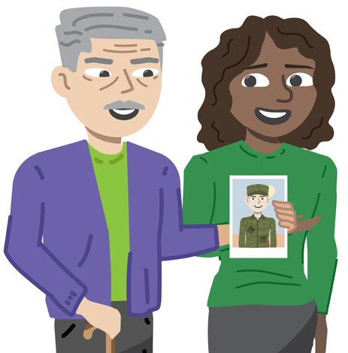Carers of veterans.
    - Young carers.

# Making Carer Gateway easy for everyone to use

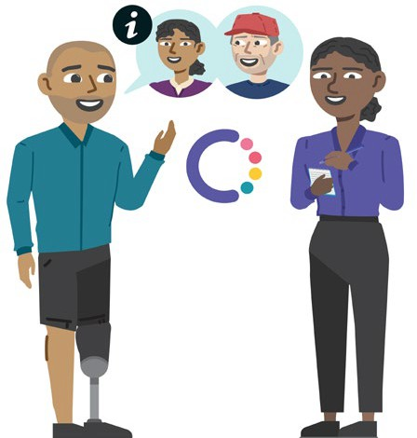We will make Carer Gateway easier for everyone to use.

We will:

* + 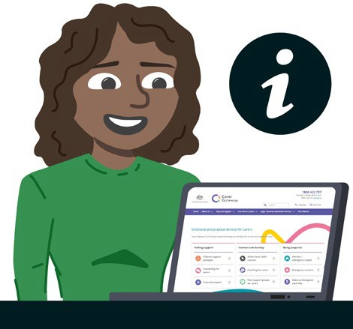Help Carer Gateway workers understand how to better help carers from different groups of people.
  + Talk to carers about how to make Carer Gateway easier to use.
  + Find and fix problems with

Carer Gateway.

* + Make a plan to make Carer Gateway better for all carers.

# Helping more people know about carers

We want more people to know:

* + Who carers are.
  + That carers are important.

We will:

* + Teach Australians about carers and the help they can get from Carer Gateway.
  + Work with doctors and schools to teach them about carers and the help they need.
  + Teach health workers about carers and the help they need.
  + Make sure carers can get help from Government services.
  + Learn how other countries help carers so we can help Australian carers in the best ways.

# Changing the Carer Recognition Act 2010

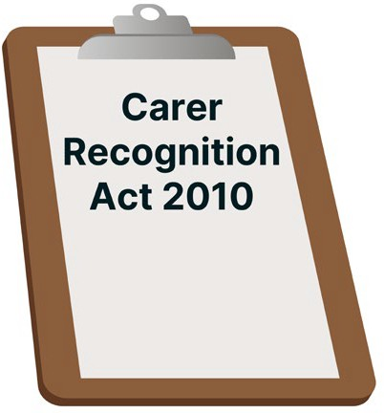We want the Carer Recognition Act 2010 to work in the best ways for all carers.

We will:

* + Talk to carers and other people about changes we should make to this rule so all carers can get the help they need.
  + Look at other rules about carers that might also need to be changed to work better for all carers.

# Listening to carers to keep making services better

We want to listen to carers about what they need to make services better for them.

We will:

* + Make a **Carer Advisory Committee**.

This is a group of people who will tell Government about how well this Action Plan is working.

The group will include:

* + - Carers from different groups

of people.

* + - Other people who know a lot about carers.

# Helping carers to find a job or to learn new skills

We want to help carers find a job or go to

school or training to learn new skills.

We will:

* + Help carers to get and keep jobs.
  + Help young carers to go to school.
  + Help carers learn new skills to get jobs.

# Learning more about carers

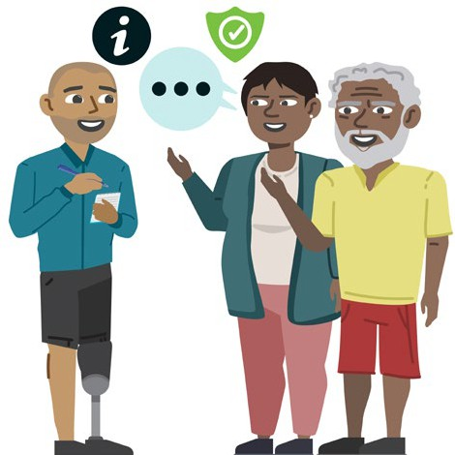

* Talk to Aboriginal and Torres Strait Islander peoples to make sure we get

information about them in a safe way.

**31**

We want to learn more about carers so we can help them better.

We will:

* + 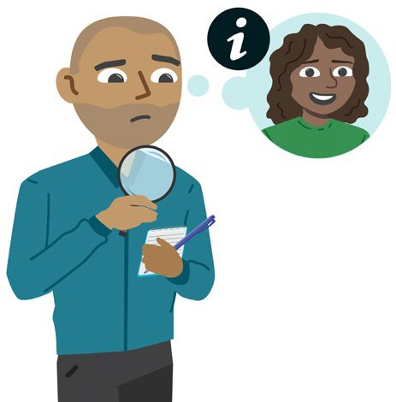Look at how we get information about carers.
  + 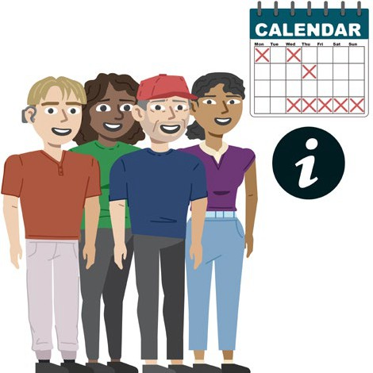Make a plan to get better information about carers more often.

# How we will check that the Action Plan is working

We want to make sure that the Action Plan is working well.

We will use information from the **Australian Institute of Family Studies** to check that the Action Plan is making things better for carers.

The Australian Institute of Family Studies is a group that looks at what families need to be happy and healthy.

This is so the Government can make better rules to help families.

To do this, we will:

* + Look at what we need to do to make things better for carers.
  + Look at how well we have done to make the important areas of the Action Plan happen.
  + Check if the Action Plan is making things better for carers.

This includes:

* + Counting how many carers get a job.
  + Talking to carers about the good things they feel have changed in their lives.

We will tell you about these checks and if the Action Plan is working.

We will do these checks in:

* + 2024 to 2027.

At the start, we will check if the Action Plan is working.

* + 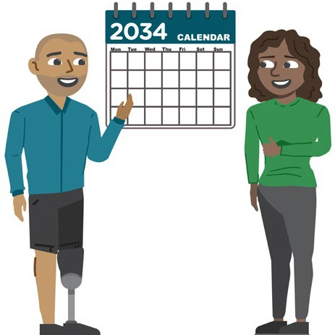2028 to 2034.

We will keep making the Action Plan better by talking to carers and other people who help carers.

* + 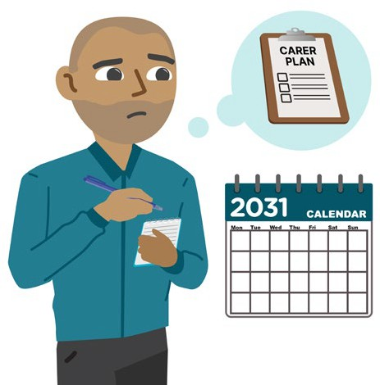2030 to 2031.

Halfway through, we will look at how the Action Plan is going and make changes if needed.

* + 2035 to 2037.

At the end, we will:

* + - Check how well the Carer Plan worked.
    - Look at what else needs to be done to help carers.

*This page is blank on purpose.*

## How to contact us



easyread.tech created this Easy Read document using original illustrations. Please do not use these illustrations without permission.

Visit [easyread.tech](http://easyread.tech/) for more information.

**36**

## For more information, you can email us at

[NationalCarerStrategy@dss.gov.au](mailto:NationalCarerStrategy@dss.gov.au)