Disability Royal Commission Interim Update

December 2024

Queensland

ISBN 978-1-921647-87-1

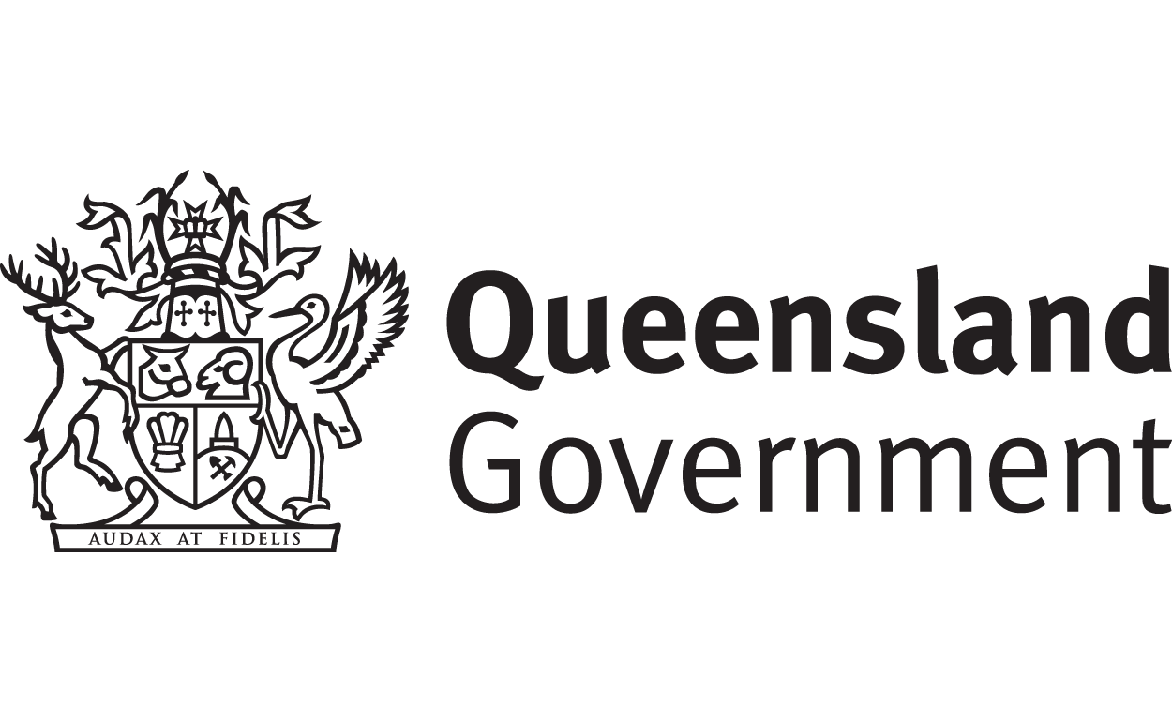

|  |  |
| --- | --- |
| Queensland Government logo | The Queensland Government wrote this.  We call it QLD Government for short.  When you see the word **we** it means the QLD Government. |
| A person holding a white book with easy read on the cover | We wrote this in an easy to read way.  We use pictures to explain some ideas. |
| The word bold is in bold and the words not bold are in plain text | We have some words in **bold**.  This means the letters are thicker and darker.  These are important words. |
| An easy read document with pictures and lines for text. | This is an Easy Read summary of another document.  This means it has the most important ideas. |
| A young woman with glasses holding a sign that says 'easy read'. | You can look at the other updates in Easy Read.  They have information about   * All governments working together * NDIS * States and territories.   [www.dss.gov.au/DRC-Aus-Gov-Response](http://www.dss.gov.au/DRC-Aus-Gov-Response) |
| Two people with their arms around each other with thumbs up. | You can ask for help to read this document.  You can ask   * A friend * Family members * A support person. |
| cartoon of Aboriginal and Torres Strait Islander people with the Aboriginal and Torres Strait Islander flags in the background | We recognise Aboriginal and Torres Strait Islander people as the **Traditional Owners** of the land we live on. |
| teal map of australia | They were the **first people** to live on and use the   * Land * Waters. |

Contents

|  |  |
| --- | --- |
| Disability Royal Commission | 6 |
| Government responses | 9 |
| Disability Plans | 11 |
| Health services | 15 |
| Contact us | 17 |

Disability Royal Commission

|  |  |
| --- | --- |
| Three people using magnifying glasses to examine something closely. | The **Disability Royal Commission** looked at how people with disability are treated.  We call it DRC for short. |
| An icon of a blue book and pen | DRC wrote a report.  The report was split up into 12 parts. |
| Smiling elderly woman in purple with a light bulb illustration. | The report had **recommendations**.  Recommendations are ideas to do things better. |
| An icon of a clipboard with a pen and checklist | The report had a lot of recommendations.  This will help things be better for people with disability. |
| A diverse group of five people standing closely together, smiling, and holding hands. with a banner with the Australian map and a kangaroo in teal and white | We want Australia to be a place where people with disability   * Are safe |
| A group of people in white t-shirts giving thumbs up | * Have their **rights** protected   Rights are **rules** about treating everyone   * Fair * Equally. |
| Two women smiling, one standing and holding the hand of the other seated in a wheelchair. | We want Australia to be a place where people with disability   * Are respected |
| A person in a striped shirt thinking with a checkmark and an 'X' in a thought bubble. | * Can take **risks**   Risks are doing things and something bad might happen. |
| A diverse group of five individuals, including a person in a wheelchair and a person with crutches, standing together and smiling. | * Live the lives that they want to. |
| people posing for a photo | This would make Australia an **inclusive** place for everyone.  Inclusive is when everyone   * Can **take part** * Feel like they **belong**. |

## Government responses

|  |  |
| --- | --- |
| An icon of a group of people in a circle | Governments read the recommendations.  Governments wrote what they think about the recommendations.  They put this in a report. |
| A teal icon of parliament house | The report was shared in 2024.  All governments worked on this report.  That is   * Australian Government * State and territory governments. |
| an icon of the map of Australia in teal with a kangaroo | State and territory governments also wrote their own reports. |
| Group of five diverse individuals with disabilities smiling and standing together. | To get ideas on what to do better the government will work with   * People with disability |
| A diverse group of people, including a woman in a wheelchair, seated around tables at a conference, with a woman standing and speaking into a microphone. | * Disability Representative Organisations |
| Five people sitting around a table discussing and reviewing papers. | * Disability **advisory** **groups**.   Advisory groups are groups of people who know a lot about something. |
| Queensland Government logo | This update talks about **some** things the **Queensland Government** has done so far.  It does **not** talk about **all things** the QLD Government is doing. |

## Disability Plans

|  |  |
| --- | --- |
| An icon of a blue book and pen | The QLD Government shared   * The Queensland Disability Reform **Framework** the Next Chapter.   We call it the Disability Framework for short.  A framework is a document saying how we will do something. |
| Two men interacting, one standing and one seated in a wheelchair. | The Disability Framework says what the QLD Government will be working on to support people with disability. |
| Woman in professional attire holding a notepad with a large green checkmark symbol beside her. | The Disability Framework will help the QLD Government to work on the recommendations from the DRC and the NDIS Review. |
| Man looking through a magnifying glass while wearing a blue checkered shirt. | The government did a **review** of the NDIS.  A review is when you **check** what   * Works * Needs to **change**.   We call it NDIS Review. |
| Two people standing next to a presentation easel with a checklist. | The Disability Framework has 3 important areas. |
| people posing for a photo | Area 1   * Inclusion * Rights   Like people have the right to live in a safe home. |
| An icon of a group of people with speech bubbles | * Voices.   Voices means we listen to what people with disability have to say. |
| Person holding a clipboard with a green checkmark giving a thumbs-up. | Area 2  Good supports and services. |
| Close-up of two people shaking hands.Three people sitting around a table giving thumbs-up gestures and smiling. | Area 3   * **Commitment**   Commitment means promising to do something.   * **Accountability**   Accountability means to be responsible for something. |
| An icon of a blue book and pen | The QLD Government shared   * The Queensland Disability Stakeholder Engagement and Co Design Strategy.   We call it the Co Design Strategy for short. |
| A group of people with a person in a wheelchair in the center, encircled by a 'Person Centred' banner. | The Co Design Strategy puts people with disability at the centre of any changes.  Co design means doing something with other people.  Like when the QLD Government make new plans. |
| A diverse group of people interacting with speech bubbles overhead. | They work with   * People with disability * The community. |
| Person with curly hair in a red shirt giving a thumbs-up. | The Disability Framework and the Co Design Strategy will help the QLD Government to make changes to support people with disability |

## Health services

|  |  |
| --- | --- |
| fanned out money  Three people at voting booths during an election; one person is in a wheelchair.  an icon of the map of Australia in teal with a kangaroo | Before the new QLD Government was picked at an **election** they said they would put lots of money to help people with disability in QLD.  An election is when the community chooses someone to represent them in the government.  This could be to represent their   * Community * State * Country. |
| A group of green and white calendar with 2025, 2026, 2027, 2028, 2029 on them. | The QLD Government agreed to make 8 **Neuro Wellness Hubs.**  It will take them 5 years to make them. |
| Entrance of a commercial building with an open glass door and 'Wear a Mask' sign.Two men in business attire filling out a form together at a wooden table. | Neuro Wellness Hubs are places for people with **neurological condition** to go.  They do things like   * Give support * Some therapies * **Peer support** groups.   Peer support is when people with disability get together to give each other support and advice. |
| Illustration of a brain inside a head silhouette with purple rays around it.Two people, one lying on the ground in recovery position, the other kneeling and providing support. | Neurological conditions are conditions that effect the   * Brain * Spine * Nerves.   They could be things like   * Epilepsy * Multiple sclerosis * Strokes. |

## Contact us

|  |  |
| --- | --- |
| teal circle with white i in the middle | You can contact us if you **need more information.** |
| teal envelope | You can send us an email.  [**DRCTaskforceSecretariat@dss.gov.au**](mailto:DRCTaskforceSecretariat@dss.gov.au) |
| teal arrow with lines | You can look at our website.  [**www.dss.gov.au/DRC-Aus-Gov-Response**](http://www.dss.gov.au/DRC-Aus-Gov-Response) |
| Woman at a desk with envelopes and papers, asking for help. | You can get help and support.  [**www.dss.gov.au/help-and-support-disability**](http://www.dss.gov.au/help-and-support-disability) |

 easyread.tech created these original illustrations. Please do not use these illustrations without permission. Visit [easyread.tech](https://easyread.tech) for more information.