**Introduction to the   
National Carer Strategy   
2024-2034**

In Australia there are **three million unpaid carers** who provide vital support to family members, friends and loved ones every day.

The National Carer Strategy (the Strategy) sets out a national agenda to support Australia’s unpaid carers to improve and maintain their wellbeing, to empower carers with the tools, skills and knowledge they need to reach their goals and aspirations, and to better balance their lives with their caring role.

The Strategy is set out in 5 parts to explain what it wants to achieve and why.

The Strategy articulates the Australian Government's commitment to carers now and into the future. It sets the direction and course for our collective efforts to drive positive change for carers.

The Strategy explains where the Australian Government will prioritise its efforts to support carers and their wellbeing. Building on existing measures, the Strategy will be implemented through a series of actions.

The experiences and perspective of carers will inform the development of actions, and an outcomes framework. This will set the pathway for future actions to be delivered over the life of the Strategy.

Progress in delivering these actions will be monitored and reported based on the outcomes framework to ensure visibility of the benefits to unpaid carers across the country.

# Who will deliver the Strategy

Carers do not see their role through a lens of which government agency delivers a service and neither should the Australian Government. The Strategy will foster a co-ordinated approach across the Commonwealth Government, to holistically support carers. To ensure the vision of the Strategy is realised, the Commonwealth will seek to work with state and territory governments who share responsibility for the delivery of services carers rely on.

Driving change for carers, and improving outcomes is a shared responsibility across the Australian Government, our carer support partners and all levels of government. This includes working together to break down silos between different government health and care agencies to address the duplication of systems and processes which force carers to navigate through and across multiple systems.

Consultations and other contributions to the development of the Strategy highlight the need to better collaborate and coordinate effort, to invest in, and work more effectively to achieve our vision for carers.

More information on the next steps to delivering change for carers is found in the 'Next steps' section of the Strategy.

## Who are carers?

The [Survey of Disability, Ageing and Carers (SDAC)](https://www.abs.gov.au/statistics/health/disability/disability-ageing-and-carers-australia-summary-findings/latest-release) found:

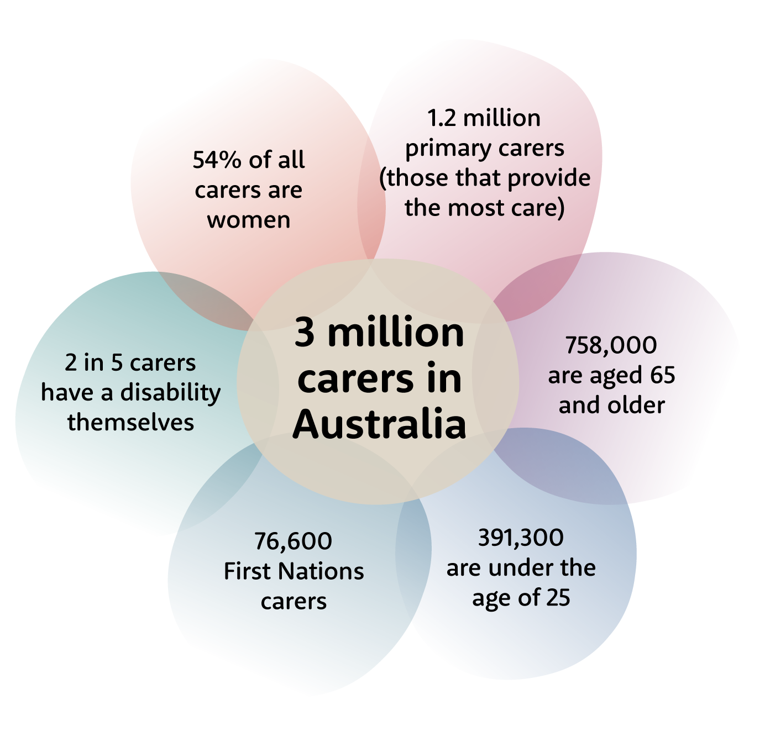

## Carers are diverse

The SDAC further revealed that in 2022, of primary carers, living in households:

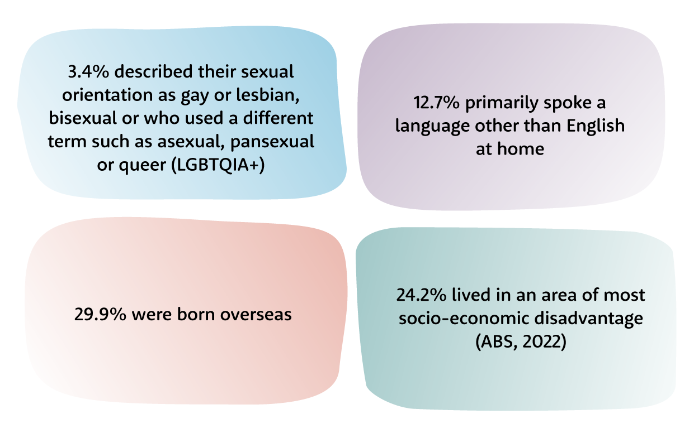

There are significant information gaps about the actual number of carers in Australia and we need a more inclusive demographic picture of the full carer landscape.

The Australian Institute of Family Studies (AIFS, 2024) identified that carers from First Nations, culturally and linguistically diverse communities and LGBTQIA+ are particularly under recognised and under identified in data collections.

Some people who provide care do not always identify themselves as carers. These ‘hidden’ carers may not be aware of, or seek, support services. AIFS notes that ‘existing data on unpaid care may significantly under-estimate the size of the cohort.’ There is also a gap in data for carers of people who are affected by trauma, such as veterans, refugees, and first responders (e.g. police, paramedics).

Carers may not identify as carers for a range of reasons, including cultural obligation or real or perceived stigma attached to the role of caring or to the person they are caring for, or because they do not feel the word appropriately describes their relationship.

## Why carers are important

Unpaid carers make significant personal sacrifices – forgoing careers, social lives, education and financial security to care for others. This often impacts the carer’s mental and physical wellbeing.

The skills carers develop are transferrable to the workforce, underscoring the economic value of their contribution.

Carers alleviate pressure on formal health and aged care systems while enhancing the quality of life and independence of those they care for.

As Australia’s population ages, the number of Australians providing unpaid care is expected to increase, highlighting the need for a comprehensive approach to recognise and support their efforts.

## Intersectionality of carers

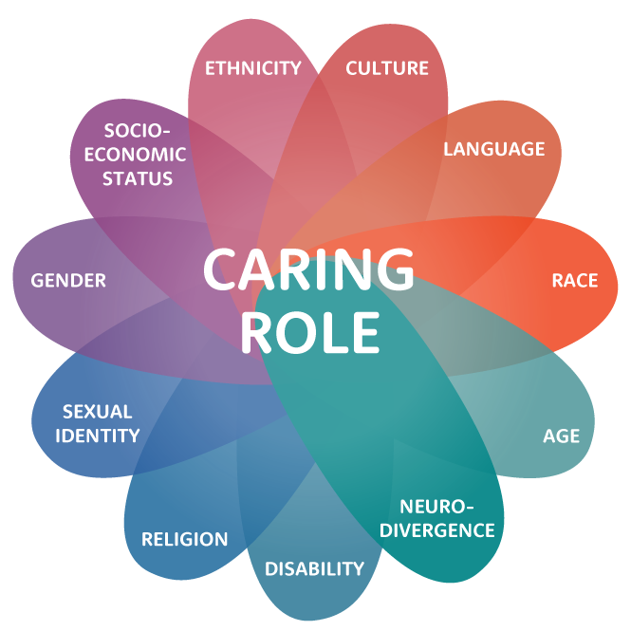The intersectionality of carers must be acknowledged. The additional barriers, challenges and discrimination carers experience is increased for those with overlapping identities such as ethnicity, culture, religion, age, sexual orientation, gender identity, disability, neurodivergence and socioeconomic status

# Vision



An Australian community in which all carers are recognised, valued and empowered with the support they need to participate fully in society and fulfil their caring role.

## How will we achieve our vision?

In developing and progressing actions to achieve this vision we will be guided by a set of principles which reflect what we have heard is important to carers.

The principles will underpin the design, development, and implementation of actions.

## National Carer Strategy Principles

|  |  |  |
| --- | --- | --- |
|  | **Carer-centred:** | The lived experience of carers will be included in the co-design, co-production, monitoring and evaluation of policies, supports and services for carers. |
|  | **Evidence-informed:** | Carer policies, supports and services are informed by evidence and innovation, to address challenges experienced by carers. |
|  | **Accessible, equitable and inclusive:** | Carer policies, supports and services are inclusive and tailored to reflect the needs of all carers, at all stages of caring, recognising the diversity of carers, and the importance of cultural and psychological safety. |
|  | **Supports  personal  agency**: | The design of policies, supports and services for carers will enable choices that suit them. |
|  | **Transparent** **and** **accountable**: | Federal government departments with policy responsibility for, or whose work affects, carers will be accountable in delivering the Strategy and transparent in their processes to better recognise and value carers. |

# Objectives

* Carers are identified, recognised, respected and valued.
* Carers are empowered to have fulfilling lives while engaging in their caring role.
* Carers’ physical and mental health, safety, wellbeing and financial security are supported.

# Priority outcome areas

The priority outcome areas are where we will direct efforts to achieve the Strategy’s vision and objectives. The priority outcome areas are not numbered in order of importance. They are numbered for ease of reference.

1. Government, community and services see and value carers, recognise their expertise and contribution, and create an environment that enables carers to identify at the earliest opportunity.
2. Carers can access supports, services and programs at the right time, right place and in the right way.
3. Ensure carers are able to develop knowledge and skills when needed to fulfill their caring role.
4. Carers can access and participate in employment and education or training, including to improve their financial well-being.
5. Carers have access to supports that safeguard their psychological, physical and social wellbeing.
6. Build the evidence base about carers to better understand who carers are, including their diversity, what their experiences are, what works for them and why.

# Next steps to delivering outcomes

Over the life of the Strategy, we will continue to identify opportunities for improvement, plan how we will address issues, implement actions and ensure their success in improving the lives of carers.

### Actions

Initial actions have been developed that will deliver on the vision and priority areas, and lay the foundations for future work, to achieve outcomes for carers. These are outlined in the accompanying Action Plan 2024-27.

As outcomes of other reforms become realised, new priority areas and practical actions for carers may emerge. Throughout the life of the Strategy, we will measure and evaluate the impact of actions put in place. This will inform development of future actions to achieve the Strategy vision.

The action plan, informed by the views, perspectives, expert advice and evidence collected during the development of the Strategy, will be implemented in the first 3 years.

### Review and evaluation

We will undertake a mid-way review and a final evaluation to assess the impact and effectiveness of the Strategy. Evaluation reports will be publicly available.