
National Carer Strategy
2024-2034

Improving the lives of Australia’s unpaid carers

ISBN: 978-1-921647-46-8 (Online)
ISBN: 978-1-921647-29-1 (Print)


The National Carer Strategy 2024-2034 is licensed under the Creative Commons Attribution 4.0 International Licence
Licence URL: https://creativecommons.org/licenses/by/4.0/legalcode
Please attribute: © Commonwealth of Australia (Department of Social Services) [2024]
Notice:
• If you create a derivative of this document, the Department of Social Services requests the following notice be placed on your derivative: Based on Commonwealth of Australia (Department of Social Services) data.
• Inquiries regarding this licence or any other use of this document are welcome.
Please contact: Branch Manager, Communication Services Branch,
Department of Social Services. Phone: 1300 653 227. Email communication@dss.gov.au
Notice identifying other material or rights in this publication:
• Australian Commonwealth Coat of Arms – not Licensed under Creative Commons, see https://www.pmc.gov.au/honours-and-symbols/commonwealth-coat-arms
• Certain images and photographs (as marked) – not licensed under Creative Commons.



Acknowledgement of Country

The Australian Government acknowledges Aboriginal and Torres Strait Islander peoples throughout Australia and their continuing connection to land, water, culture and community.

We pay our respects to the Elders both past and present.

Content warning | Aboriginal and Torres Strait Islander readers are advised this document may contain images of deceased persons.

Help and support
Please be aware that this document contains information that may be distressing to readers. It includes information about the experiences of Australia’s carers and the challenges they face. If you need support to deal with difficult feelings after reading this paper, there are free services available to help you.

Carer Gateway
• Telephone 1800 422 737, Monday to Friday, 8am to 5pm for support and services.
• Visit Carer Gateway.

Beyond Blue Support Service
• Telephone 1300 224 636, 24 hours, 7 days a week or chat online 3pm to 12am AEST, 7 days a week or visit Beyond Blue.

Lifeline Crisis Support
• Provides support if you are feeling overwhelmed, having difficulty coping or thinking about suicide.
• Speak to a crisis support worker by telephone on 13 11 14, 24 hours, 7 days a week.
• Text 0477 13 11 14 or chat online for support, 24/7. Or visit Lifeline Crisis Support.

1800RESPECT
• For support if you are affected by sexual assault or domestic and family violence or abuse.
• Telephone 1800 737 732, 24 hours a day, 7 days a week, chat online 24 hours a day,
7 days a week or visit 1800RESPECT.

13YARN
• First Nations service providing culturally safe crisis support. Call 13 92 76, 24 hours a day,
7 days a week or visit 13YARN.

QLife
• QLife provides anonymous and free LGBTQIA+ peer support and referral for people in Australia.
• Call 1800 184 527, open 3pm to midnight, every day or visit QLife - Support and Referrals.

Open Arms Veterans and Family Counselling
• As a carer of a veteran, or a veteran who is a carer, you can contact Open Arms to find out what support and services are available for you or your loved ones.
• Call on 1800 011 046 or visit Open Arms - Veterans & Families Counselling.

eheadspace
• eheadspace is a national online and phone support service for young people between 12 and 25.
Available 9am – 1am AEST every day.
• Call 1800 650 890 or visit Online & phone support | headspace.

A Statement from Australia’s Carers
From across Australia:
We acknowledge caring as fundamental to life: the essence of our connections.
We honour its many forms, embedded in Aboriginal and Torres Strait Islander kinship and Country, enriched by people of diverse backgrounds and outlooks.
To be a carer is to be a partner, a family member, a neighbour, a mate. Sometimes we don’t consider ourselves to be carers. It’s something we just do.
Whether it be out of love, tradition or necessity, our contributions are essential to daily life.

• • •
With ingenuity and resilience, carers keep Australia going.
For us to keep going, we must be recognised and supported as individuals with our own needs, who attend to the needs of others.
This includes:
– young carers who, out of fear or embarrassment, conceal that we look after our family members and others.
– lifelong carers who are ageing in anguish, wondering who will watch over our loved ones.
– carers sandwiched between generations, often forgoing our relationships, income, and wellbeing.
Such shortfalls are not ours as carers, but ours as a nation.

• • •
When our responsibilities are shared, our resolve and our communities grow.
We seek understanding, support and respect from the nation for the impact of caring, in all its forms, on our lives.
We seek to partner with the people we care for and with the organisations that support both them and us. We make this Statement from strength: appreciating the challenges and rewards of caring; knowing that demand for us is rising; believing that when Australians care for one another, we flourish.

Explanatory Note
The Statement from Australia’s Carers above was developed by a dedicated carer working group comprised of members from the National Carer Strategy Advisory Committee, led by Lachlan Rowe. Author and academic Kim Huynh was commissioned to craft it. Valuable input was received from carers, the people they care for, artists, scholars, relevant organisations, and members of the Australian public.

Readers guide
The document outlines the Strategy in five parts:
Vision
Principles
Objectives
Priority outcome areas
Next steps
Together these set the scene for what the Strategy wants to achieve, and why.
The Strategy will be delivered through action plans and measured against an outcome’s framework. The approach to developing these action plans and outcomes framework is outlined under ‘Next steps’.
Throughout the Strategy you will read case studies of real-life carers and quotes from carers shared during the Strategy consultation activities.
To support your understanding of the foundations and development of the Strategy and how carers were consulted, you can find supporting documents in the appendices.
In addition, you can read the carer consultation reports, and an evidence-base report used to inform the Strategy at National Carer Strategy (dss.gov.au) and National Carer Strategy | engage.dss.gov.au.

A brief guide on language
Throughout this document, ‘carer’ and ‘unpaid carer’ are used as defined in the Carer Recognition Act 2010 as an umbrella term for those who provide unpaid care, support and assistance for someone with disability, a medical condition, a mental illness or is frail due to age. Carers who receive financial support such as Carer Payment and/or Carer Allowance are included in this definition. Note: the terms ‘carer’ and ‘unpaid carer’ may not be recognised, accepted or acknowledged by some people, including First Nations people and those from culturally and linguistically diverse (CALD) communities.
Formal carers and paid support workers are those who provide care, support and assistance as a paid service, as part of a volunteer arrangement or as part of training or education for paid care services. Such formal care arrangements are not in scope for this Strategy. More information on the Australian Government’s support for the formal care economy can be found here: Care and support economy – state of play | PM&C (pmc.gov.au).

Please note that people undertaking normal day-to-day care of children, whether a parent or non-parent, kinship, grandparent or in foster care relationships (where the children do not have additional needs for support due to disability, medical conditions, or mental ill health) are not the focus for the Strategy. Tailored support for this group of carers can be found by contacting the Grandparent, Foster, and Kinship Carer Adviser at the Department of Social Services on 1800 245 965. Other relevant resources can be located on the Department of Social Services website.

Minister’s Foreword
Every day, three million Australians care for someone in their lives, such as a family member, a neighbour or a friend. They do this not for money, but out of love, kindness – or sometimes necessity and obligation.
Unpaid carers make a profound contribution not just to the lives of the people they care for, but also to broader Australian society.
We know, however, that too often the contributions of unpaid carers are overlooked, underappreciated or just not understood.
The Albanese Government is making sure we work to change this and that carers are recognised, valued, and empowered in both their caring roles and in their own lives.
To assist in that effort, as the Minister for Department of Social Services I’m proud to present the National Carer Strategy 2024–2034.
The Strategy was co-designed with carers and provides a vision and the foundation for Australia’s carers to be supported in all aspects of their lives.
The lived experience of carers is at the heart of the Strategy. Hundreds of carers shared their personal experiences in the development of the Strategy, detailing the demands of caring: the love, the anguish and the sacrifices.
I thank every carer who gave up their precious time to tell us about the challenges they face and their experiences, so, we can work towards better supports for unpaid carers.
We heard from carers of the need for the current services provided across the Commonwealth, States and territories to be easier to navigate and better targeted to provide the support that is required at the right time and right place.
We heard about the challenges of balancing their caring role with other aspects of their lives, such as work or study. Flexibility in the workplace and in how financial supports such as the Carer Payment are structured for carers can make a big difference.
This Strategy offers an opportunity to further this work. It will provide a framework for co-designing, developing and delivering a suite of actions over the next ten years.
The Strategy outlines priority areas where we will direct effort and deliver positive outcomes for carers. It will progress and support positive change to ensure carers have the right supports at the right time so they can better balance their caring role with all aspects of their lives.
Ultimately, the Strategy highlights that the wellbeing of carers is just as important as the wellbeing of those they care for. Their contribution is immeasurable and supporting their ongoing health, wellbeing and ability to participate in all aspects of their community deserves our attention and support.
To quote the Statement from Australia’s Carers, developed for this Strategy: “when Australians care for one another, we flourish”.



The Hon. Amanda Rishworth MP
Minister for Social Services

Contents
A Statement from Australia’s Carers 5
Readers guide 6
A brief guide on language 6
Minister’s Foreword 7
Introduction 9
Who are carers and why are they important? 11
What does a carer do? 13
What is a care relationship? 13
Why recognising carers matters? 14
Carers are diverse 16
Why do we need a Strategy? 20
What we heard 21
Who will deliver the Strategy? 24
National Carer Strategy on a Page 25
Vision 27
Principles 28
Objectives 30
Priority outcome areas 31
Next steps 38
Actions 39
Monitoring, evidence and evaluation 39
Snapshot: Diversity of carers 40
Appendices 49
Appendix 1: Evidence summary 49
Appendix 2: Glossary 50
Appendix 3: References 53

Introduction
In Australia there are three million unpaid carers who provide vital support to family members, friends and loved ones every day.
It is important to recognise the critical role carers play in society and the profound contribution they make to the lives of people they care for.
The National Carer Strategy (the Strategy) sets the direction and course for our collective efforts to drive positive change for carers.
This is the Strategy’s vision for carers:

An Australian community in which all carers are recognised, valued and empowered with the support they need to participate fully in society and fulfil their caring role.

The Strategy acknowledges and respects all carers. Caring is often not a choice and can impose a significant burden, particularly on young carers. The Strategy has been shaped by evidence and will support better decision-making on policies and programs that affect carers. The Strategy explains where the Australian Government will prioritise its efforts to support carers and their wellbeing.


National Carer Strategy 9


At just 9 years old, Layla became a young carer for her mother who suffers from multiple illnesses. Now aged 17, Layla continues to rise above the challenges as a strong advocate for young carers:
“I really want people to know what a young carer is, rather than seeing the words and thinking ‘I’m not that.’ I want the definition to be widely known.” – Layla, young carer

National Carer Strategy 10

Who are carers and why are they important?
Australia’s three million unpaid carers play a vital role in society, delivering significant social and economic benefits to individuals, their families and the broader community. They play an integral role in the nation’s health and social care systems, offering critical, unrecognised contributions.
The importance of carers cannot be overstated. Carers make significant personal sacrifices – forgoing careers, social lives, education and financial security to care for others. This often impacts the carer’s mental and physical wellbeing.
Their efforts alleviate pressure on formal health and aged care systems while enhancing the quality of life and independence of those they care for. Moreover, the skills they develop are transferrable to the workforce, underscoring the economic value of their contribution.
However, as Australia’s population ages, the number of Australians providing unpaid care is expected to increase dramatically, highlighting the need for a comprehensive approach to recognise and support their efforts. By acknowledging, raising awareness and recognising carers, Australia invests in more than individuals – it strengthens the resilience and sustainability of the entire healthcare system.



2 in 5 carers have a disability themselves
3 million carers in Australia

391,300 are under the age of 25

76,600 First Nations carers

758,000 are aged 65 and older
1.2 million primary carers
(those that provide the most care)

54% of all carers are women

In 2019 Deloitte Access Economics estimated the contribution of unpaid care. These estimates are outlined in the Value of Informal Care in 2020 report.


$77.9 billion
IN 2020 THE COST TO REPLACE UNPAID CARE WAS

provide 20+ hours unpaid care a week
>1/2 PRIMARY CARERS
provide 40+ hours unpaid care a week
1/3 PRIMARY CARERS

The report also revealed that the demand for informal care is set to increase by 23% by 2030, however the supply of unpaid carers is expected to only grow by around 17% over the same period.
A carer is a person who provides unpaid care to a person requiring additional support which may be a partner,
a family member, friend or neighbour. Most carers are women. Carers come from all sections of society, including young people and even children. People become carers in different ways. Sometimes they start helping someone in small ways and the role increases over time. Others have a child born with disability who needs additional support. Sometimes it happens suddenly, because of an accident or illness. Carers can be any age. Anyone can become a carer at any time.
The Survey of Disability, Ageing and Carers (SDAC), describes carers by the level of support they provide:
• Primary carers are classified as people aged 15 years and over who provide the most informal assistance with the core activities of mobility, self-care and communication. Their lives are often significantly impacted by their caring role.
• Secondary carers are classified as people aged 15 years and over who provide care with at least one of the core activities, for at least one hour per week, however they do not provide the most care (i.e. they are not the primary carer).
• Other carers are those people of any age who provide any other informal care (i.e. they are not the primary carer and not the secondary carer).
The SDAC found that in 2022, of primary carers, living in households:

24.2% lived in an area of most socio-economic disadvantage (ABS, 2022)
29.9% were born overseas
12.7% primarily spoke a language other than English at home
3.4% described their sexual orientation as gay or lesbian, bisexual or who used a different term such as asexual, pansexual or queer (LGBTQIA+)

What does a carer do?
Carers are an essential and important part of the Australian community – supporting, advocating for and empowering the people they provide care for.
Caring often means assisting someone with their day-to-day activities. Commonly, it is providing physical and personal care like showering, dressing, toileting, feeding and supporting mobility such as lifting and providing transport. It can also involve helping care recipients to manage their affairs, such as: organising and attending appointments and social activities, assisting with banking and finances, and dealing with unexpected situations and emergencies. It may also involve tasks like wound care or medication management. Importantly, it frequently involves providing vital emotional and social support.
Carers provide support complementary to, and often in place of, paid support. They are often involved in securing, coordinating and overseeing the delivery of paid supports. Carers frequently hold important history and knowledge about the circumstances and experiences of the people they care for, that can be valuable to those delivering paid supports. In many cases, carers’ contributions to conveying this information can be vital to ensure appropriate health care, treatment, and support.
Taking on a care role is an important and impactful commitment which is often made in the context of limited alternative options.

What is a care relationship?
Each caring situation is unique. Care relationships can be long-term – such as caring for a person with an intellectual or physical disability, a chronic mental illness; or short term – such as caring for a person
experiencing an illness or injury or requiring end–of-life care. Care relationships can also be episodic – such as caring for a person with sporadic pain symptoms of a chronic illness, or mental ill health.
Care recipients may include people with disability, people living with a chronic medical condition, terminal illness, people who are ageing or people experiencing mental ill-health, including alcohol and other substance addiction.
Care relationships vary according to the needs of the person(s) being cared for, and the carer’s own individual needs and changing circumstances. There may be multiple care relationships contributing to the support of an individual. Family members may provide different supports or otherwise share responsibility for the wellbeing of a person they are caring for. In other cases, there may be one single carer filling the role on their own.
According to SDAC, in 2022 the 3 most common reasons primary carers gave for taking on a caring role were:


an ability to provide better care than anybody else
(46.0%)
emotional obligation
(47.4%)
a sense of family responsibility
(64.7%)

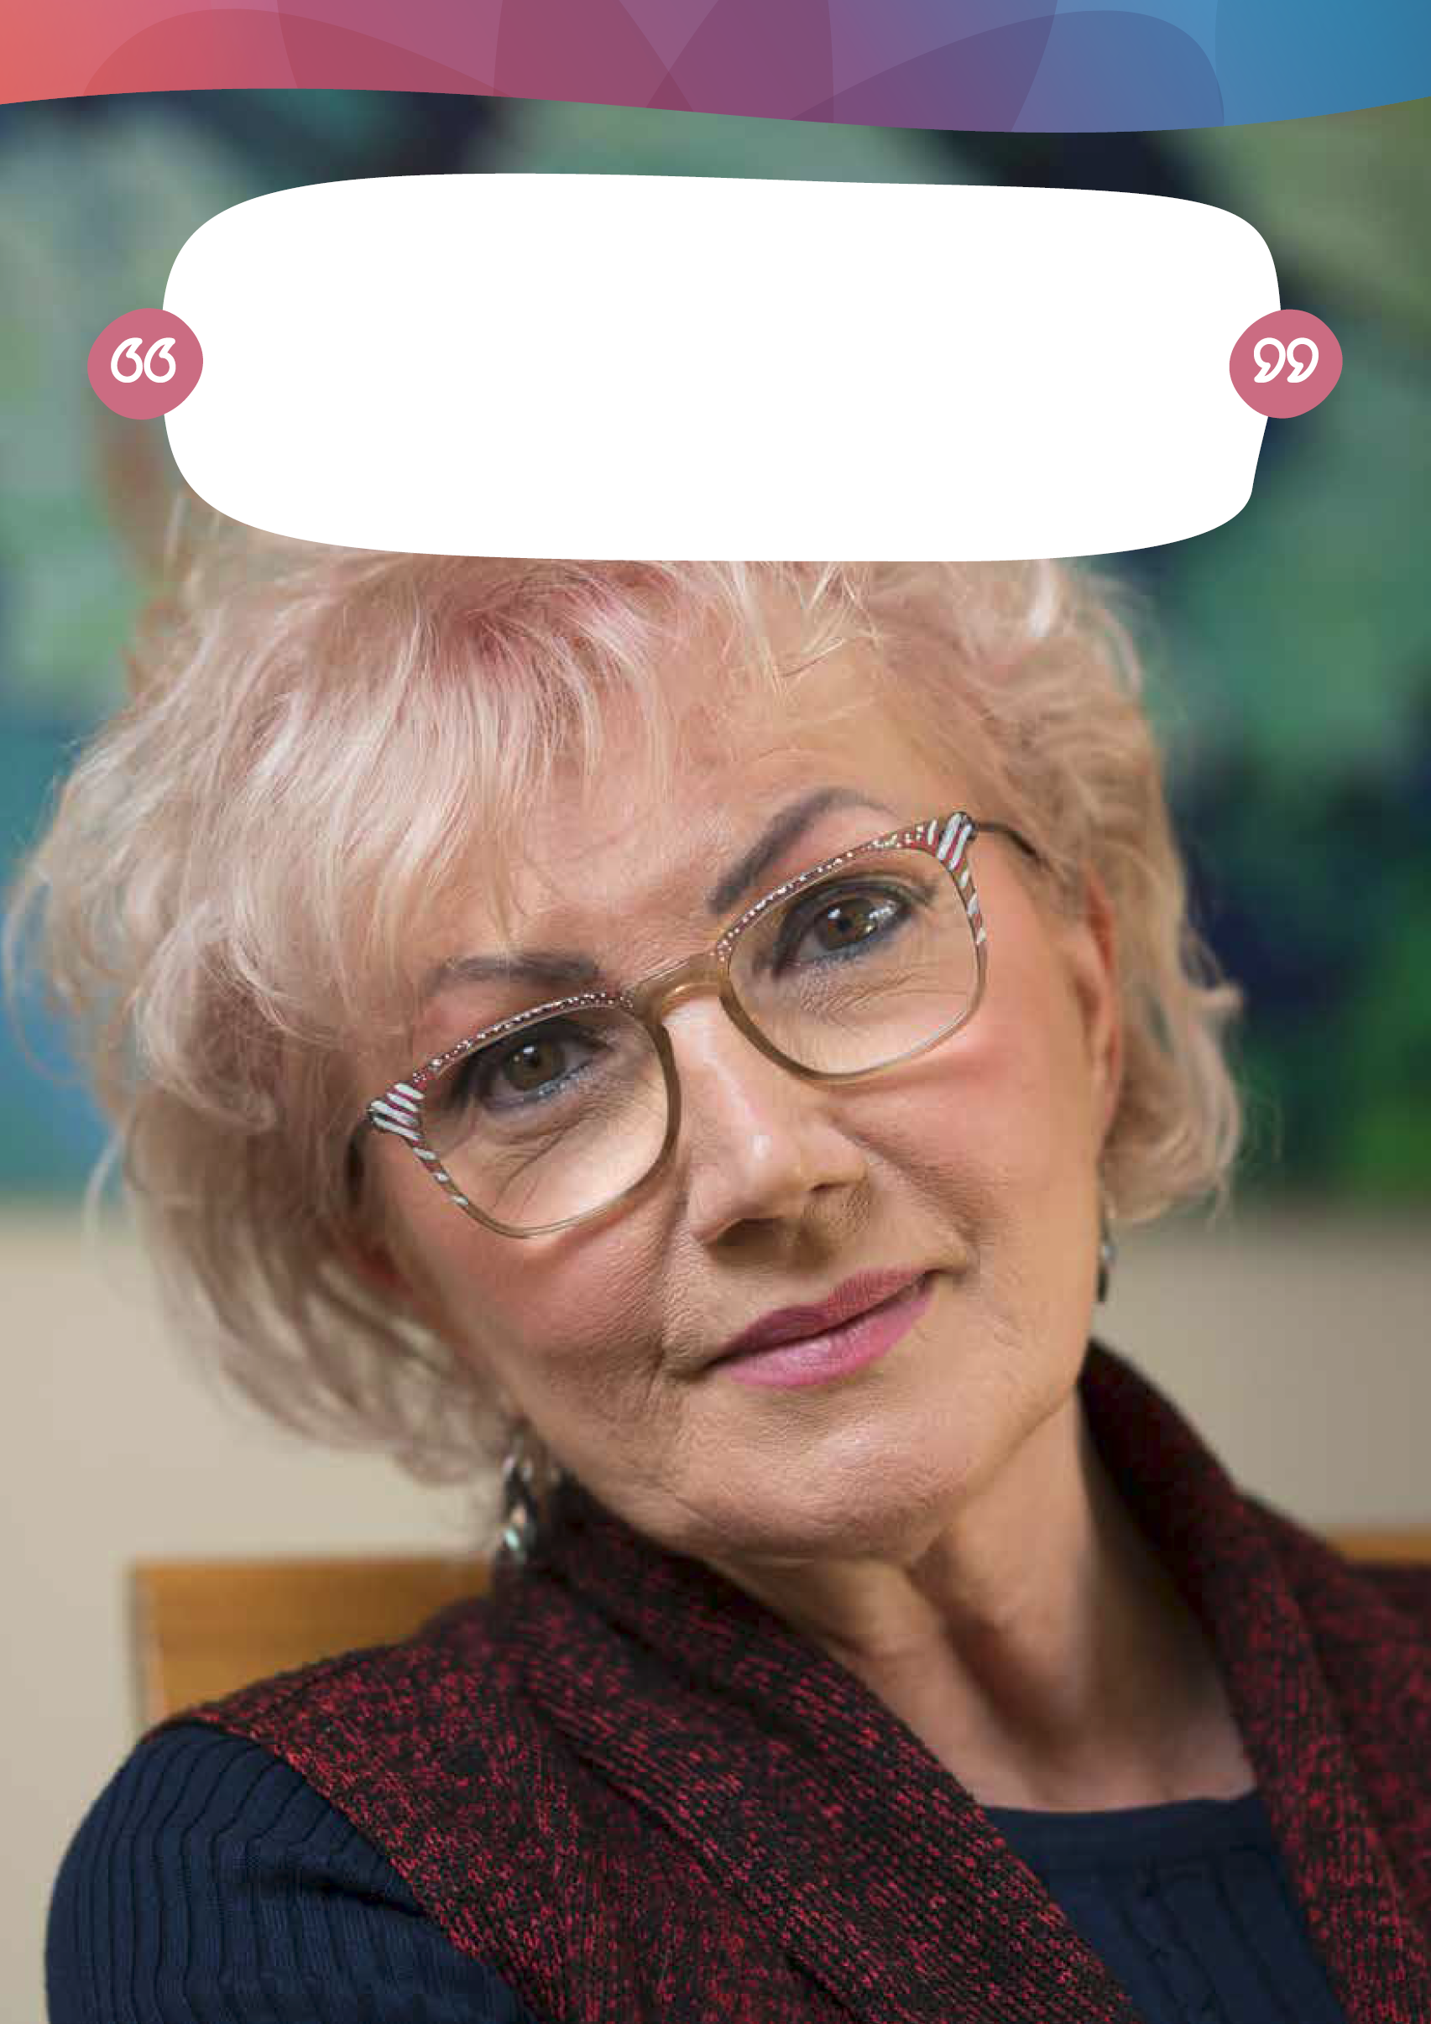

Mariana is a culturally and linguistically diverse (CALD) carer who looks after her husband, who lives with multiple sclerosis. She began caregiving 20 years ago:
“I didn’t know how not to be a carer,” says Mariana. “I mean, what do you do? You have a child. You have a husband; I loved him so much. It was not something I was thinking, ‘am I a carer?’ I was the wife, I was the mother, I just was.”

– Mariana, CALD carer, over 65 years

Why recognising carers matters?
National Carer Strategy 14
Caring can be a highly rewarding yet challenging responsibility which often goes unseen and unacknowledged.
Caring can take time away from other aspects of a carer’s life. It often requires a carer to learn new information about the person’s diagnosis or condition, and to acquire new skills and knowledge to enable them to provide the most informed support for the person they care for. Caring requires commitment and consistency.

“Sometimes, being a carer, you end up losing your own ambitions, job, income, financial security, relationships and your ability to choose what’s right for yourself, as your decisions will impact your child and siblings forever.”
– Kerrie, primary carer for her child with a disability
Taking on a caring role impacts a carer’s own quality of life and freedom of choice. For some people, it may mean giving up other activities or responsibilities, including work or study opportunities, which can significantly impact the carer’s life, physically, psychologically and financially. It can also mean adjusting to taking on domestic tasks, assisting someone to navigate their care and support needs and other responsibilities they have not typically undertaken previously. This can mean that for some carers, ensuring their own needs are met and their wellbeing is maintained can be challenging. Caring responsibilities can impact an entire family, placing relationships under stress and creating unmet needs for other family members, such as siblings and partners. For young carers the potential impact on long-term life opportunities requires additional focus.


“I have been caring for 20 years but I didn’t know I was a carer because I just saw myself as a son or a husband It wasn’t until a clinician pulled me aside in a hospital and asked, ‘how are you doing yourself?’ that I started my journey to identify with the term ‘carer’, and that led me to finding support, education and community.”
– Anonymous carer
The economic contribution that carers make is significant and supports the effective operation of the health and aged care systems. Additionally, the skills carers gain through caring are valuable and are transferable to the workforce.

Carers are diverse
Carers reflect the diversity of our communities, may be almost any age, are gender diverse, live in various locations, and come from diverse cultural and socio-economic groups. This includes First Nations People, carers from culturally and linguistically diverse communities – including those from multicultural, immigrant, different racial and ethnic backgrounds and refugee backgrounds, carers in rural and remote locations, carers of veterans, carers who identify as members of the LGBTQIA+ communities, young carers (under 25 years of age) and older carers (65 years and above), neurodivergent carers and carers with disability.
The Australian Institute of Family Studies (AIFS, 2024) identified that carers from First Nations, culturally and linguistically diverse and LGBTQIA+ communities are particularly under recognised and under identified in data collections.
Some people who provide care do not always identify themselves as carers. These ‘hidden’ carers may not be aware of, or seek, support services. AIFS notes that ‘existing data on care may significantly under-estimate the size of the cohort.’
There is also a gap in data for carers of people who are affected by trauma, such as veterans, refugees, and first responders (e.g. police, paramedics).
Carers may not identify as carers for a range of reasons, including cultural obligation or real or perceived stigma attached to the role of caring or to the person they are caring for, or because they do not feel the word appropriately describes their relationship.
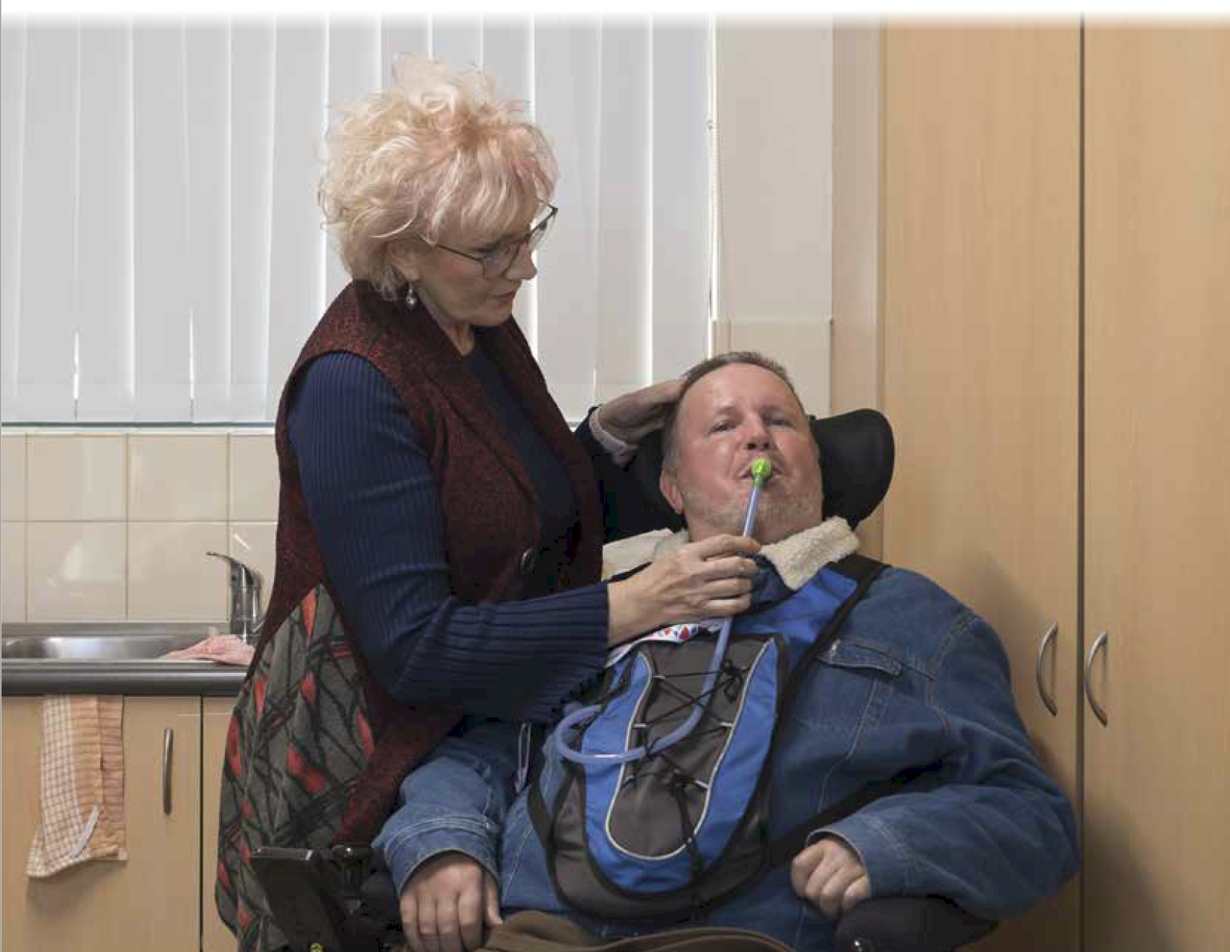

National Carer Strategy 16
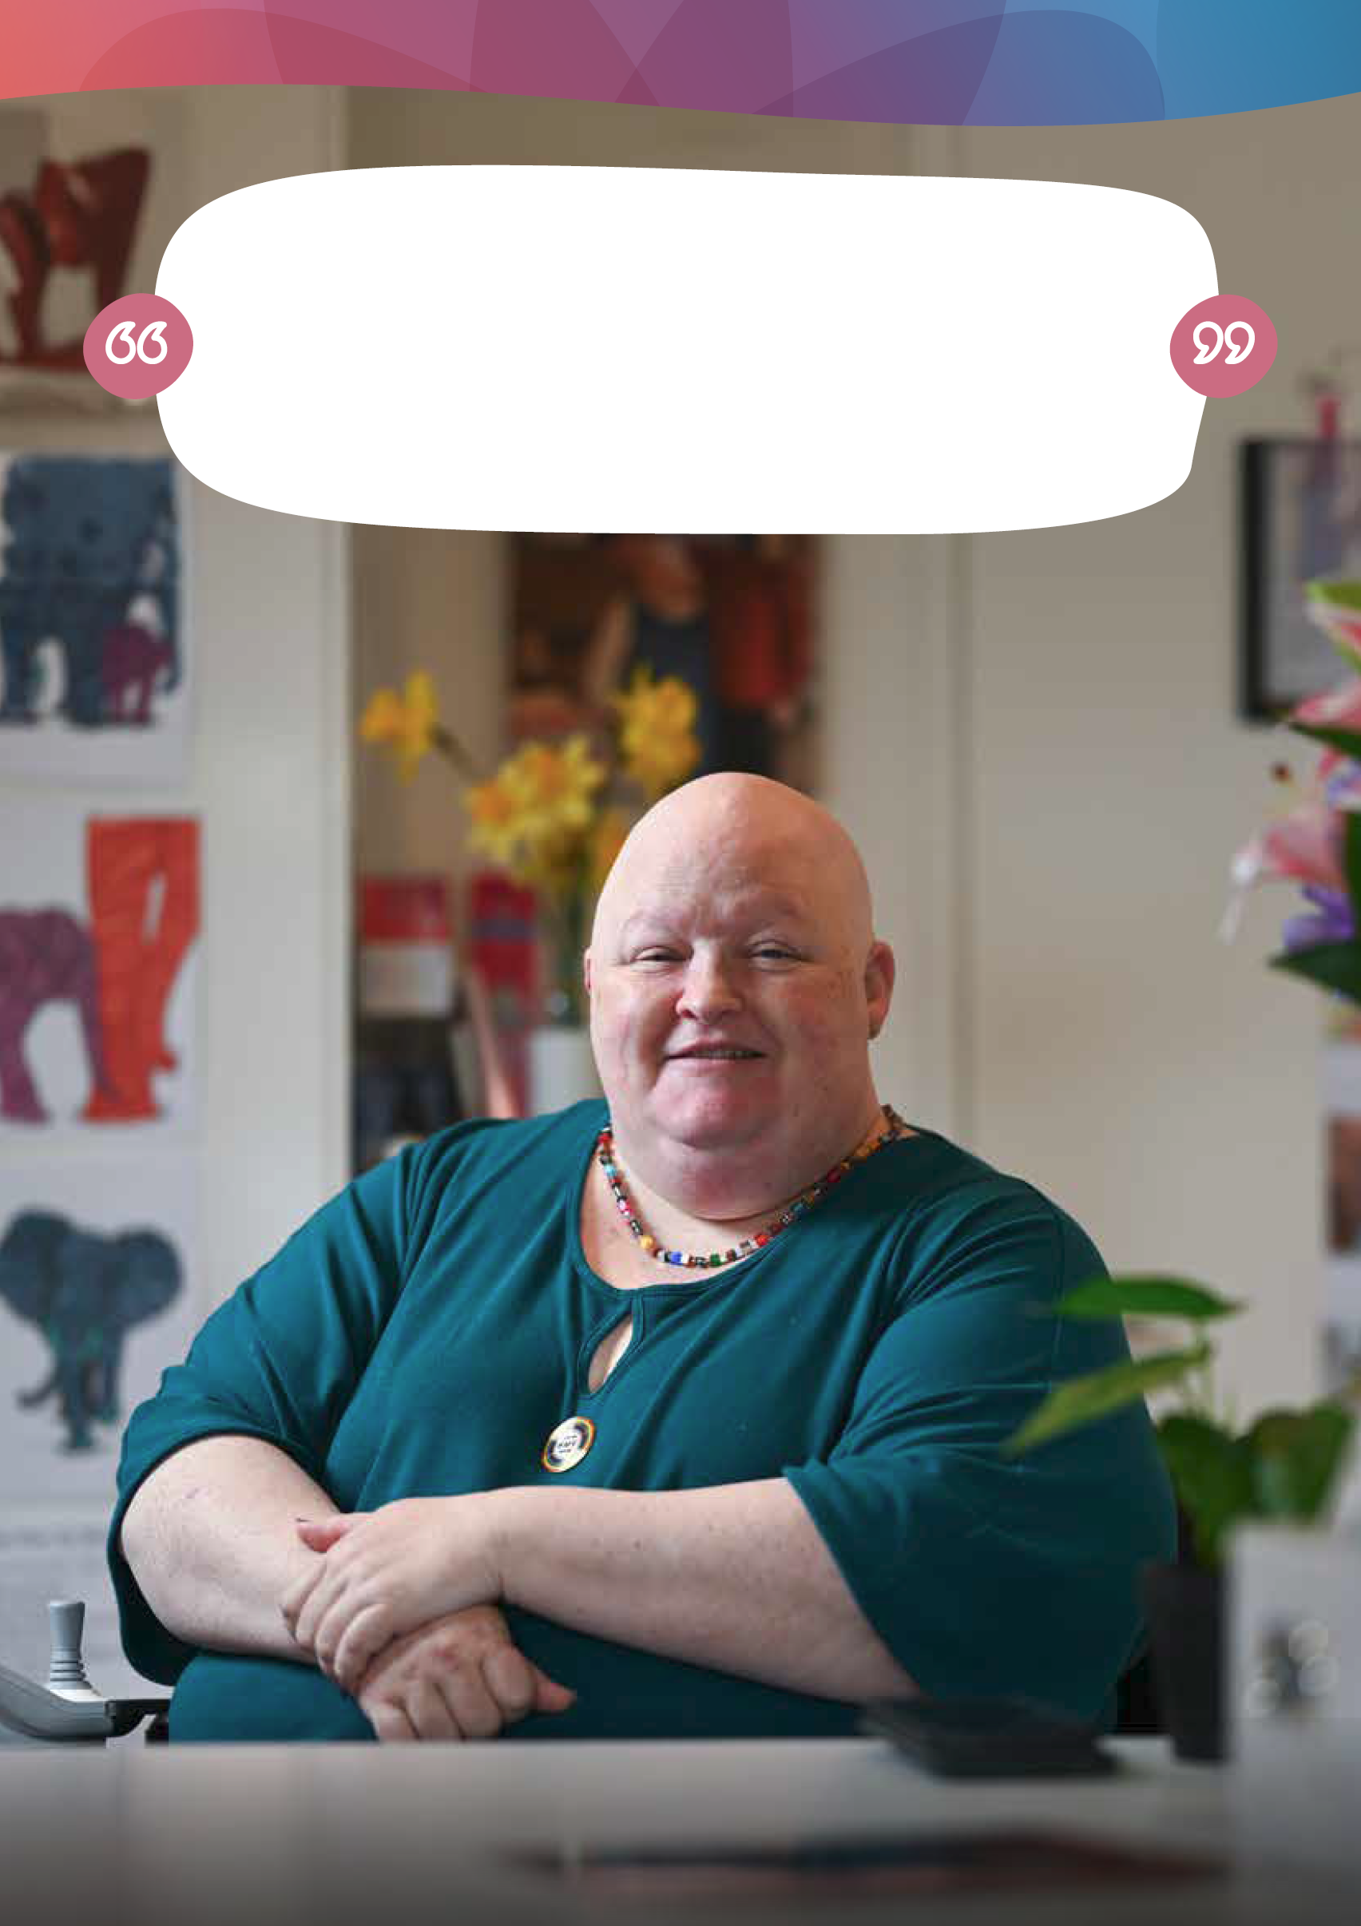

Nicci became a caregiver as a young person and has remained a carer throughout her adult life. She requires care herself. She currently cares for her ageing father, a partner in palliative care, a partner with neurodivergence, and her adult son who is autistic. She is a member of the LGBTQIA+ community.
“You just carry on,” says Nicci. “Because you have to. And that can be very heavy for some people.”
– Nicci, LGBTQIA+, carer with a disability

National Carer Strategy 17
Intersectionality of carers
The intersectionality of carers must be acknowledged. The additional barriers, challenges and discrimination carers experience is increased for those with overlapping identities such as ethnicity, culture, religion, age, sexual orientation, gender identity, disability, neurodivergence and socioeconomic status.


CARING ROLE
SOCIO- ECONOMIC STATUS
GENDER
SEXUAL IDENTITY
RELIGION
DISABILITY
NEURO- DIVERGENCE
AGE
RACE
LANGUAGE
CULTURE
ETHNICITY
While each group encompasses a rich tapestry of identities and experiences, it’s essential to recognise that many individuals may belong to more than one community, facing unique challenges that arise from the intersection of their multiple overlapping identities. This exploration not only deepens our understanding of their intersecting journeys but also sheds light on the vital importance of inclusion within the carer experience.
Knowing this it is essential to adopt an intersectional approach to policy and service design. This includes developing inclusive resources collaborating with all communities to ensure that diverse carers feel affirmed in all aspects of their identity. Strategies to recognise and include diverse carers need to be publicly promoted and widely available, to assist all carers to feel confident they can access supports that are psychologically safe, trauma informed and personalised to the carer’s needs.

We further explore the experiences and challenges of carers in Snapshot: Diversity of Carers.

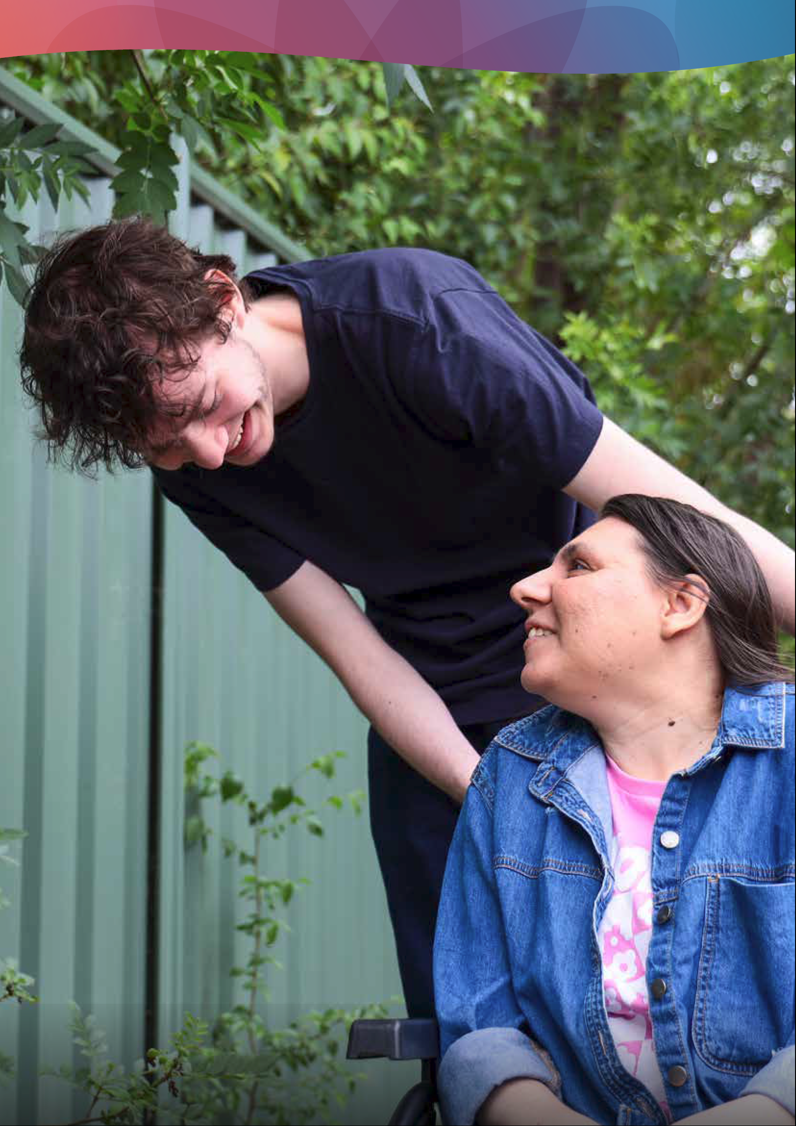

National Carer Strategy 19

Why do we need a Strategy?
Australia supports those requiring care through substantial funded support systems such as social security, aged care, the National Disability Insurance Scheme (NDIS), the health system and veterans’ support. As a society, we need to recognise that carers have needs and aspirations of their own, which also require support. Caring is an important and natural part of our lives. The contribution of unpaid carers strengthens the efficiency and effectiveness of these service systems and provides necessary additional support when funded hours are unable to meet a person’s needs. This enables those within our community who require assistance to live better lives and improve their wellbeing.

Carers have told us:
• Low levels of community awareness about carers, and what caring is (including among health and allied health professionals), contributes to a lack of identification in the community, and low levels of self- identification by carers, all of which can lead to delays in accessing support or not seeking support until a time of crisis.
• Carer supports and services can be difficult to access and navigate and may not be effective or fit for purpose.
• The caring role impacts carers’ health, safety and financial security. Physical and mental wellbeing can be impacted, and for some carers, to the point of ‘burnout’.
• Carers who are parents of a child or adult with additional needs shared that the impacts of their caring role are often lifelong.
• Some young carers are providing excessive levels of care, impacting their education, social participation, physical and mental wellbeing.
• Paid care and support sector staff shortages, training requirements, and retention issues have an impact on unpaid carers.
The previous National Carer Strategy was launched in 2011 and sat alongside the National Disability Strategy 2010–2020 and, in conjunction with the Carer Recognition Act 2010, formed part of the Australian Government’s National Carer Recognition Framework. The 2011 Strategy was superseded in 2015 by the commencement of the Integrated Plan for Carer Support Services (known as Carer Gateway).
Since the release of the previous Strategy, there have been significant reforms to major service systems providing for people with support needs including the roll out of the NDIS, Australia’s Disability Strategy 2021–2031 (ADS), the Disability Royal Commission and aged care reforms following the Aged Care Royal Commission. The increasing focus on person-centred planning and service delivery is changing how formal support services interact with the people who use them, their families, friends and carers. This has impacted on carers who are supporting the person they care for to access services and systems.
The Minister for Social Services referred an inquiry into the recognition of unpaid carers to the House of Representatives Standing Committee on Social Policy and Legal Affairs (the Committee) on 13 June 2023. In March 2024, the Committee tabled its report titled Recognising, valuing and supporting unpaid carers – Parliament of Australia (aph.gov.au). The Committee examined the challenges faced by unpaid carers and options for reform. The report contained 22 recommendations including a need for an increased focus on minority cohorts, including, but not limited to, First Nations carers, culturally and linguistically diverse carers and young carers. The report, including its underpinning data and evidence, and its recommendations have been considered as part of the development of this Strategy.

This Strategy provides an opportunity to review how we currently support carers, what is working and what do we need to better support carers, now and into the future.
By fostering a community that champions mental health, financial sustainability and quality services, Australia is not only investing in the future of its carers but also in the strength and resilience of the nation. Together, we can build a brighter, more inclusive future where every carer’s journey is acknowledged and supported.

What we heard
When talking to carers, we heard many perspectives on the caring role and how supports and services are working around Australia.

We heard that identification and recognition of carers is critical:
• There are low levels of community awareness about carers, and what caring is. This contributes to a lack of self-identification of people in caring roles, and a lack of identification in the community (particularly in education, training and employment settings).
• The expertise of carers should be valued and recognised by health care and other professionals, including service providers.
• There needs to be recognition of the impacts the caring role has on a carer.

Carers struggle to access the supports they need:
• Carers need to know how and where to find information and to access services. They need access to information early in their role to build knowledge, and access supports for both them and the person they are caring for. Awareness of services and supports for carers such as Carer Gateway needs to improve.
• Understanding and navigating the different systems carers have to access is time-consuming and complex.

Carers told us about the impacts caring has on their wellbeing:
• Carers experience emotional stress, anxiety, depression and compassion fatigue. There is considerable impact of caring on overall psychological wellbeing.
• Carers experience lower rates of physical wellbeing, often prioritising the person they care for over their own health issues or taking time for physical exercise.
• There can be significant challenges to accessing respite, often due to limited availability, geographical location and cultural barriers. Challenges to accessing appropriate respite are common, varied and complex. Carer breaks need to accommodate the needs of the carer and the care recipient. This complicates arrangements, such as the need to link available carer respite to care recipient respite, care recipient refusal and the ability of care replacement services to meet the high needs or cultural requirements of the recipient. This is not helped by variability in understanding of what respite services may comprise of for different cohorts of carers.

Carers are diverse and encompass all ages, backgrounds and cultures, however, we know that carer diversity is not always recognised:
• Services need to be culturally safe and informed for carers to access them and be appropriately supported.
• Services need to recognise the diversity of carers and how this affects them in their caring roles.

Providing care can have a life-long financial impact on the carer. Carers told us they need assistance to build their capacity and safeguard their future. This includes:
• Being supported to acquire or develop the knowledge and practical skills to maintain their own physical, psychological, emotional and financial wellbeing.
• For those carers who want or need to, being supported to participate in or re-enter the workforce, education and/or training in a way that accommodates their caring responsibilities.
Further detail on the consultation process and evidence summary is at Appendix 1.

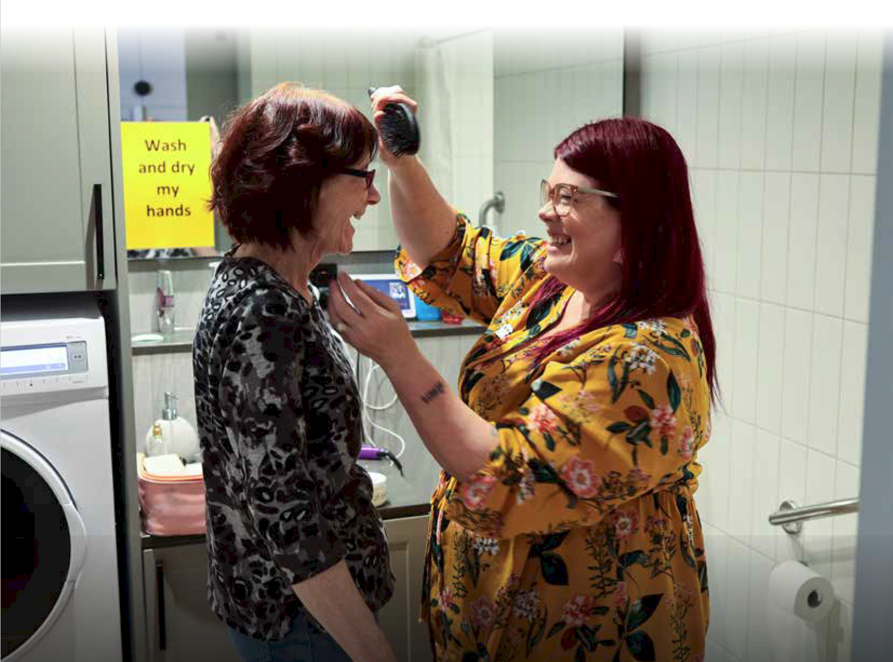

National Carer Strategy 22
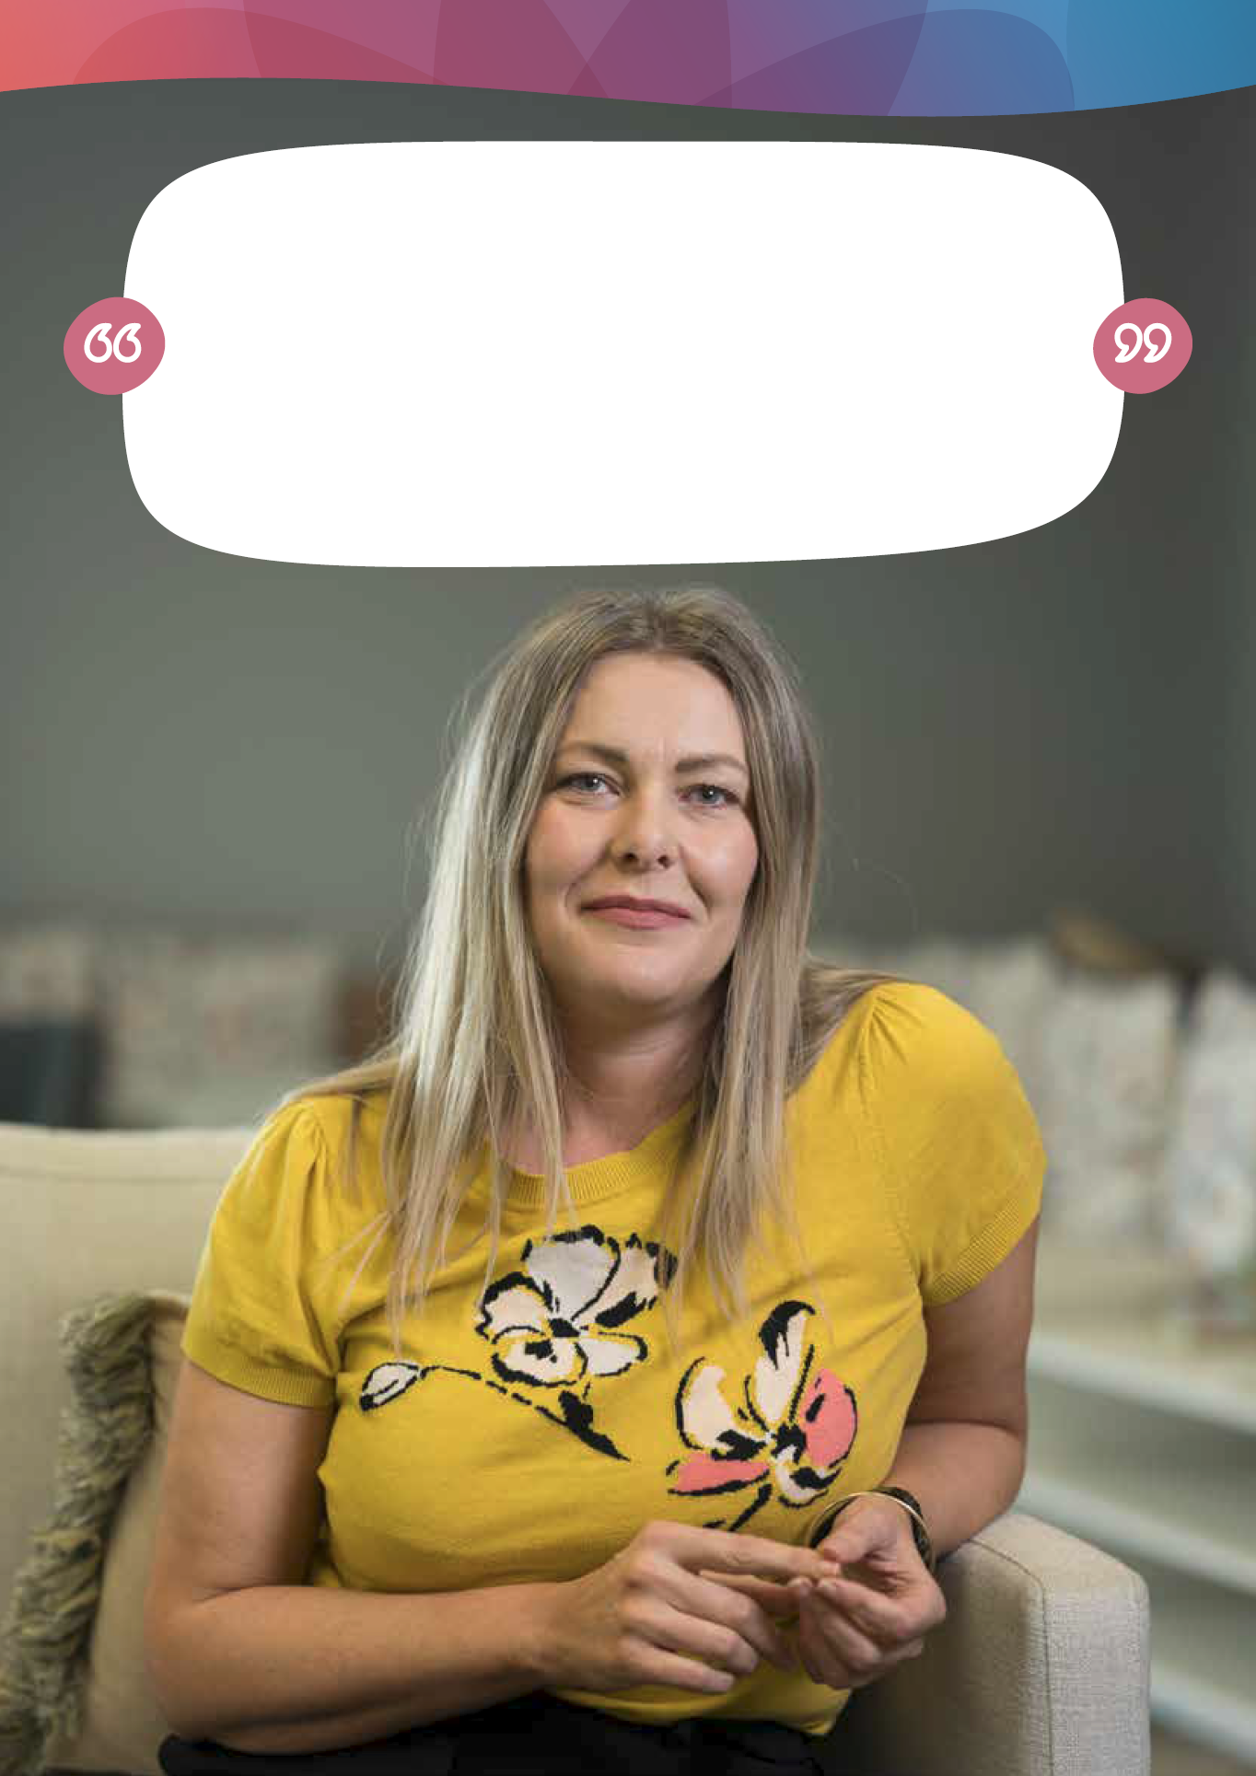

Diana’s caregiving role evolved into a central part of her identity, impacting her career and personal aspirations.
“You suspend a bit of yourself to serve the role”

Diana believes the future of caregiving depends on tapping into carers’ invaluable expertise.
“If we can respect that and access that knowledge, we can spread it. It doesn’t just build our capacity—it builds capacity across the board.”

– Diana, carer of her son with a medical condition

National Carer Strategy 23

Who will deliver the Strategy?
Carers do not see their role through a lens of which government agency delivers a service and neither should the Australian Government. The Strategy will foster a co-ordinated approach across the Commonwealth Government, to holistically support carers. To ensure the vision of the Strategy is realised, the Commonwealth will seek to work with state and territory governments who share responsibility for the delivery of services carers rely on.


“Lots of options that can pull together to help, but what’s missing is the glue to bring them all together for that person” – Anonymous carer
Driving change for carers, and improving outcomes is a shared responsibility across the Australian Government, our carer support partners and all levels of government. This includes working together to break down silos between different government health and care agencies to address the duplication of systems and processes which force carers to navigate through and across multiple systems.
Consultations and other contributions to the development of the Strategy highlight the need to better collaborate and coordinate effort, to invest in, and work more effectively to achieve our vision for carers.

“I feel like an octopus having to navigate multiple different organisations or people within the same organisation” – Anonymous carer

More information on the next steps to delivering change for carers is found in the ‘Next steps’ section of this Strategy.

National Agreement on Closing the Gap
The key challenges outlined above can be significantly pronounced for carers from Aboriginal and Torres Strait Islander communities. Addressing the priority outcome areas of the National Carer Strategy will be guided by the priority reforms of the National Agreement on Closing the Gap. The Strategy supports genuine conversations and partnerships between First Nations representatives and the Australian Government to ensure the Strategy drives positive change to improve the lives of First Nations carers across the country. The Strategy supports commitment to increase service provision through Aboriginal Community Controlled Organisations (ACCOs).

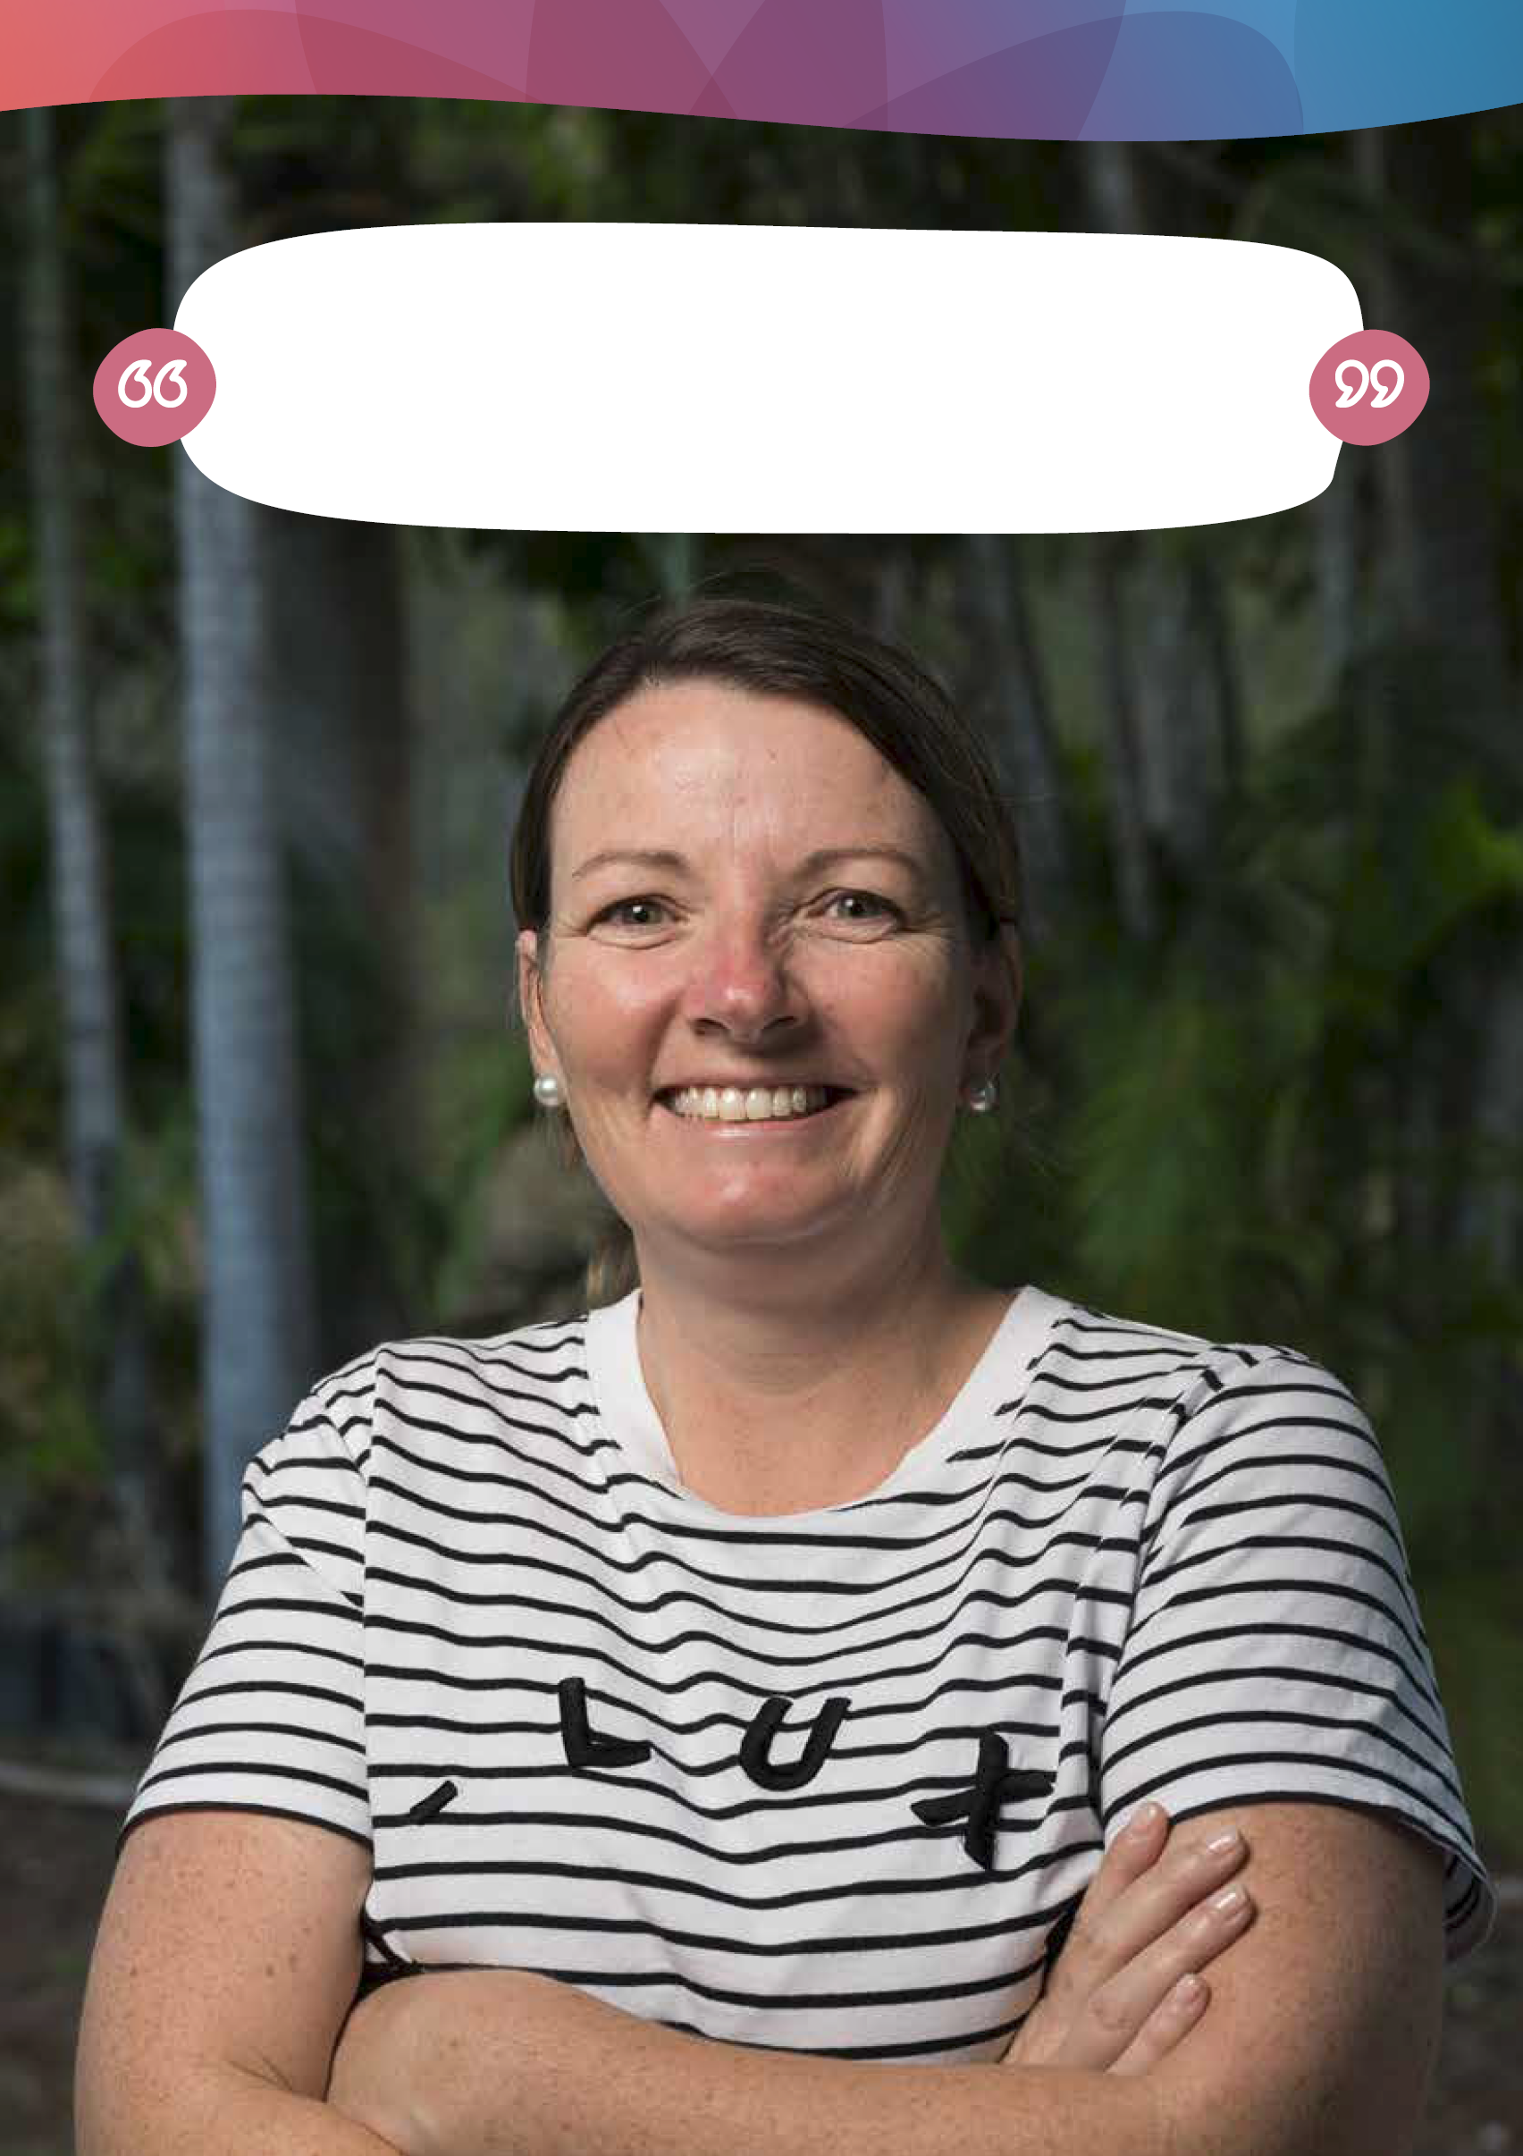

Living in a remote area presents its own obstacles:
“The limited access to services and essential care, the challenge of getting proper schooling and allied health professionals – it all makes the caregiving journey harder”
– Cat, carer for her son in a remote area

National Carer Strategy on a Page
National Carer Strategy 25
Vision
An Australian community in which all carers are recognised, valued and empowered with the support they need to participate fully in society and fulfil their caring role.
Principles
The co-designed principles will guide the coordination and delivery of carer-related and carer-impacting policies, programs and initiatives across Australian Government agencies.
• Carer-centred: The lived experience of carers will be included in the co-design and co-production of policies, supports and services for carers. Carers’ lived experience will be included in evaluation processes.
• Evidence-informed: Carer policies, supports and services will be informed by evidence, and innovation will be used to address challenges experienced by carers.
• Accessible, equitable and inclusive: Carer policies, supports and services will be inclusive and tailored to respond to the needs of carers, at all stages of caring, recognising the diversity of carers, and the importance of cultural and psychological safety.
• Supports personal agency: The design of policies, supports and services for carers will enable choices that suit them.
• Transparent and accountable: Federal government departments will be accountable in delivering the Strategy and transparent in their processes to better recognise and value carers.
Objectives
The objectives are the results we want to achieve for carers.
• Carers are identified, recognised, respected and valued.
• Carers are empowered to have fulfilling lives while engaging in their caring role.
• Carers’ physical and mental health, safety, wellbeing and financial security are supported.
Priority outcome areas
The priority outcome areas are where we will direct efforts to achieve the Strategy’s vision and objectives.
The priority outcome areas are not numbered in order of importance. They are numbered for ease of reference.
1. Government, community and services see and value carers, recognise their expertise and contribution, and create an environment that enables carers to identify at the earliest opportunity.
2. Carers can access supports, services and programs at the right time, right place and in the right way.
3. Ensure carers are able to develop knowledge and skills when needed to fulfill their caring role.
4. Carers can access and participate in employment and education or training, including to improve their financial well-being.
5. Carers have access to supports that safeguard their psychological, physical and social wellbeing.
6. Build the evidence base about carers to better understand who carers are, including their diversity, what their experiences are, what works for them and why.
Next steps
• Action – Action plans will be developed incorporating the feedback to date and theory of change
• Measuring success – A monitoring, evidence and evaluation approach will be implemented that includes a theory of change; an outcomes framework and a monitoring and evaluation framework.
• Co-design – The voices and perspectives of carers will inform and guide the Strategy implementation, monitoring and review to ensure outcomes are delivered and objectives are met.

Vision

An Australian community in which all carers are recognised, valued and empowered with the support they need to participate fully in society and fulfil their caring role.
Why do we need a vision?
In developing the Strategy, carers shared the key challenges they face.
For many, the lack of recognition of the impacts of their caring role on both their lives and their families’ lives was a significant concern. Carers also highlighted the lack of understanding about the necessity of the care and support they provide to the lives of care recipients and society. The language of ‘informal’ and ‘unpaid’ care implies the care provided is in fact not essential to the safety and wellbeing of care recipients. To keep people living in the community, unpaid care is essential to augment paid care and keep people safe and well. This is the case even when care recipients are in hospital or in residential care, where additional support is required.
Carers consider that the care and support they provide should be as highly regarded as the delivery of formal, paid care services. Carers contribute immensely to both the ability for people needing care to remain in the community, living as independently as possible, and to the economy through their caring role, and they want this contribution to be acknowledged and appreciated.
To continue fulfilling this vital role, carers have expressed the need for effective support and empowerment, with a recognition that their human right to a good life is equal to the rights of those they care for.
Carers want help in balancing their caring role with other important parts of their lives, so they can participate fully in society. This means opportunities to work, access education and training, have a social life and access rest and recreation. All of these things are important in promoting and maintaining wellbeing.
Alongside managing their own health and well-being, carers also want access to the necessary information, knowledge and skills to support their caring roles.
How was the vision created?
In the spirit of carer-centred co-design, the vision statement grew from in-depth consultation between the National Carer Strategy Advisory Committee (the Committee) and the Australian Government, drawing on what we heard from other carers through the consultation process. The Committee is made up of carer sector representatives and carers with lived experience from diverse backgrounds, all selected through an open process to ensure that the experiences and aspirations of carers across the country are reflected in the Strategy and its overarching vision. In crafting the vision statement, the Committee also drew on other evidence sources such as the recent Parliamentary Inquiry into the recognition of unpaid carers, reports and evidence from Australian carer advocacy organisations as well as international carer organisations, strategies and visions.

Why was our vision created?
The vision is a short over-arching declaration of the aspiration for the future for Australia’s unpaid carers, driving the Government’s strategic direction in support of the lives unpaid carers aspire towards. The vision has already supported the drafting of the new Strategy, by expressing a clear intention about our shared values of inclusion, recognition, co-design, equity, safety and well-being. Carers shared their aspirations to be supported to better balance their caring role with all aspects of their lives such as education, training, workforce participation and importantly social inclusion.
How will we achieve our vision?
In developing and progressing actions to achieve this vision we will be guided by a set of principles which reflect what we have heard is important to carers. The principles set out in this Strategy will underpin the design, development and implementation of actions.
Actions and their implementation will be shared with the community as they progress.

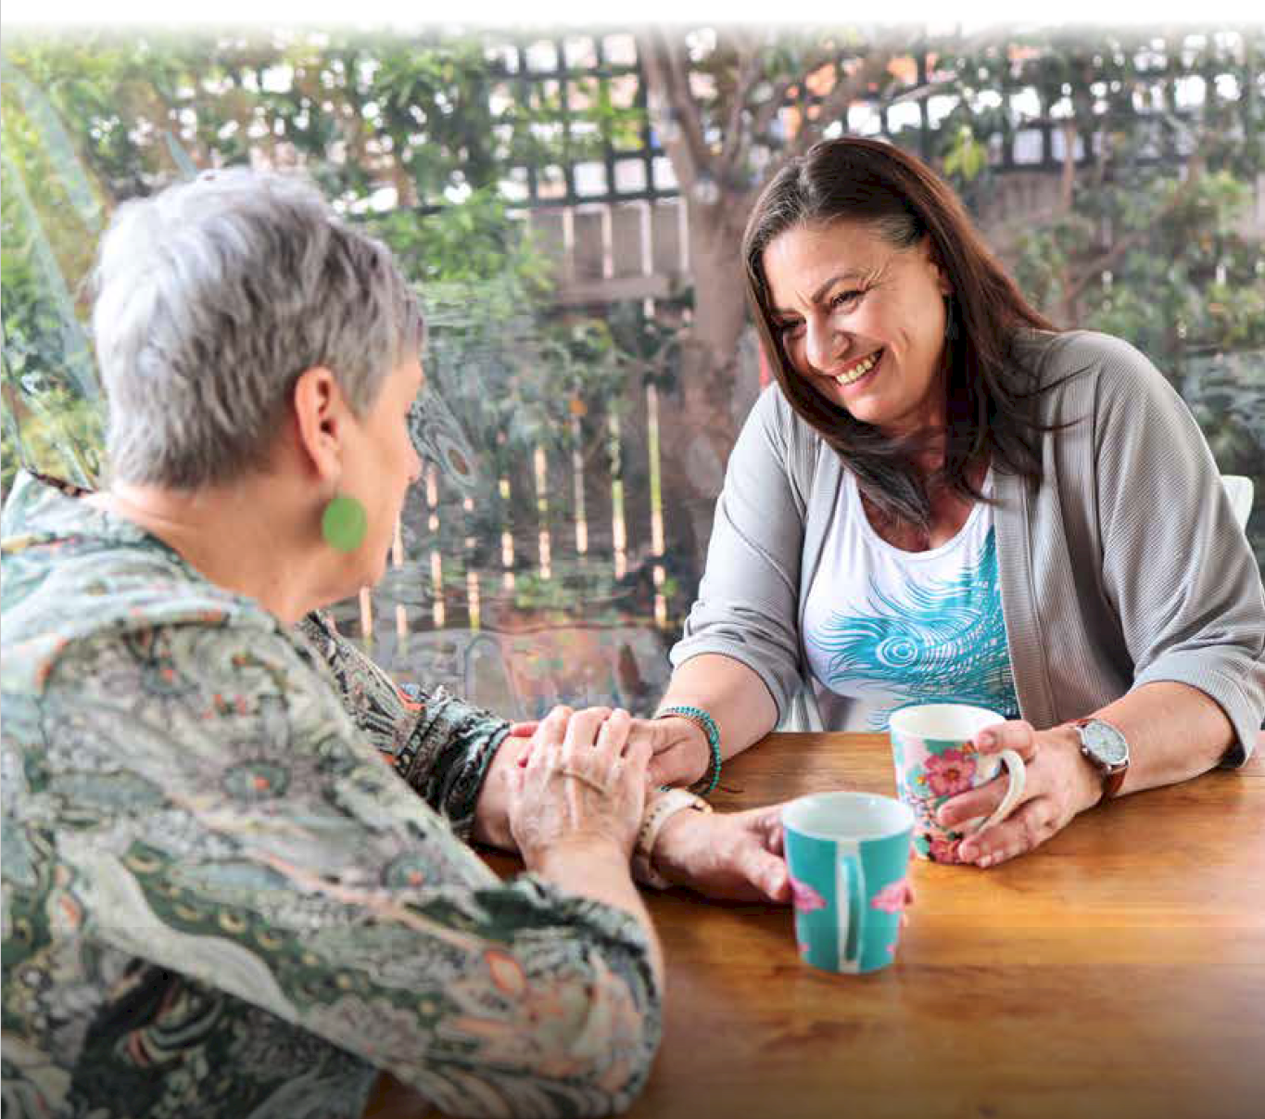

Principles
National Carer Strategy 28
These principles reflect what carers have told us is important to them, when we are co-designing ways to support them to participate fully in society, while also fulfilling their caring roles.
The principles provide a foundation for the coordination of carer policies, programs and initiatives across Australian Government agencies.
Principle | What we will do | How we will do it
Carer-centred | Include carer lived experiences in the co-design, co-production, monitoring and evaluation of policies, supports and services for carers. | Continue to seek out, listen to and act on carers' perspectives, including engaging with peer-led organisations and representatives from across diverse carer cohorts.  Focus on what they tell us they need. Be flexible and responsive when circumstances change.
Evidence-informed   | Ensure that carer policies, supports and services are informed by evidence and innovation, to address challenges experienced by carers. | Focus on building and improving an evidence base to better support the development, implementation and monitoring of tailored and responsive supports and services.  Enable data sharing and evidence for use by governments and communities to evaluate interventions and resources.
Accessible, equitable and inclusive   | Ensure carer policies, supports and services are inclusive and tailored to reflect the needs of all carers, at all stages of caring, recognising the diversity of carers, and the importance of cultural and psychological safety. | Use evidence-based data and lived experience to codesign innovative, accessible, tailored and inclusive services.  Recognise, respect and facilitate the vital role of non-government organisations in providing supports and services.
Supports personal agency | The design of policies, supports and services for carers will enable choices that suit them. | Acknowledge that carers know their needs and aspirations best. All have unique relationships, strengths, capabilities and resources, which may change over time.  Co-design policies, supports and services to empower and support carers to find and access the right supports at the right time and to ensure unintended consequences for carers are identified and remediated.
Transparent and accountable   | Federal government departments with policy responsibility for, or whose work affects, carers will be accountable in delivering the Strategy and transparent in their processes to better recognise and value carers. | Monitor, measure and evaluate in delivering on the priority outcome areas and achieving the objectives set out in the Strategy.  Include carers in the continued development of actions and implementation plans to support realising the vision of the Strategy.

Objectives
The objectives for the Strategy are grounded in the insights gathered from extensive consultations and supported by robust evidence. Through engaging with carers, service providers and community stakeholders, we have identified key themes and challenges that resonate with the carer community. By aligning our objectives with the voices of those directly impacted, we ensure that our approach is not only relevant but also effective in fostering a more supportive environment for carers across the nation.
Co-developed by carers, these objectives provide the overarching goals carers, and the Australian Government, want to see realised. Through monitoring improvements in these objectives, we will measure our progress toward achieving the Strategy vision.
Objective | What does this look like?
Carers are identified, recognised, respected and valued. | Carers are:  • able to identify they are in a caring role, and can access information of supports available to them  • acknowledged by others, and consulted, regarding the person/s for whom they are caring  • identified early and are offered information pathways to supports appropriate to their needs  • are valued for their expertise, care and contribution.
Carers are empowered to have fulfilling lives while engaging in their caring role. | Carers have:  • access to resources and skills training that enhances safe and effective caregiving  • access to forms of respite that are most relevant to the circumstances of different carers and those they care for  • flexible and adaptable learning options through carer-friendly education and training to support personal and professional development goals  • carer-inclusive workplaces that welcome and accommodate their caring responsibilities to support employment goals and financial security.
Carers' physical and mental health, safety, wellbeing and financial security are supported. | Carers can flexibly access the assistance they need to support their:  • physical well-being and safety  • psychological health  • social connection  • cultural and spiritual identity  • financial security.

Priority outcome areas
The priority outcome areas are where the Australian Government will direct efforts to achieve the objectives and the Strategy’s vision. The priority outcome areas encompass recognition and value, support and empowerment, and wellbeing. Through these priority areas, we will consider what actions can improve key challenges faced by carers such as pathways to information, workforce or education participation, access to appropriate respite, carer safety and wellbeing.
The priority outcome areas are not numbered in order of importance. They are numbered for ease of reference.
Priority outcome area 1: Government, community and services see and value carers, recognise their expertise and contribution, and create an environment that enables carers to identify at the earliest opportunity.

What we know
Carers are often overlooked by service providers and health professionals. Carers possess valuable history, context and knowledge regarding the person/s they support, which shapes how that person responds to interventions and support services.
Better integration of the role and function of the carer as a critical decision supporter, partnering with treatment and care teams is needed to enable good outcomes.
Carers are under-recognised in the community for a variety of reasons including due to a general lack of community awareness. They may not identify for cultural, relationship or social reasons. Carers can be ‘hidden’ due to service design barriers and inadequacies of current data collection approaches.
Many people providing care to others do not identify with or use the term ‘carer’, including young carers, carers from First Nations and culturally and linguistically diverse communities. In some communities the word ‘carer’ may not translate or be recognised effectively in their language.
Carers often do not identify or seek support until they are in crisis.
Women are disproportionately represented, often due to gender norms and men are less likely to identify as carers.
Caring is often seen as an important cultural responsibility in First Nations communities. A significant proportion are young carers and/or providing multi-generational care.

What we will do
We will improve awareness of carers, caring roles, the impacts of supporting others, availability of carer supports and services through strategic and culturally relevant communications, focussing our efforts on:
• reaching all carers, particularly those from diverse backgrounds, including First Nations carers, young carers, carers from culturally and linguistically diverse backgrounds and those in regional and remote locations
• working to reduce the negative stigma about caring by recognising and raising awareness of carers’ valuable contribution to society
• focus on addressing gender stereotypes in care
• working with those in care relationships to explore and develop more inclusive language for people providing care and support to others
• dentify key legislation and policy areas for review and address unintended policy consequences that may impact carers or further constrain their choices
• in partnership with First Nations stakeholders, carers and the carer sector, we will work to increase the recognition and self-identification of First Nations carers.
We will collaborate across government and the care and support sector to raise awareness of the necessity and value of carer expertise and knowledge and to determine what education other professionals require to improve recognition and integration of carers as a vital care partner.
We will explore innovative options to transform recognition and support for carers.

Objective supported:
Carers are identified, recognised, respected and valued.

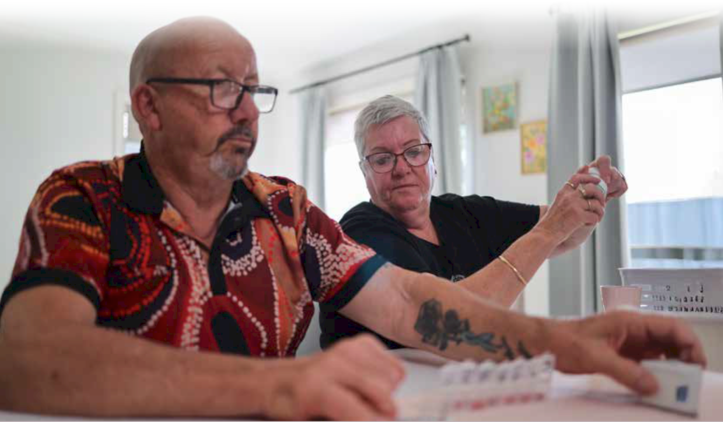
National Carer Strategy 32
Priority outcome area 2: Carers can access supports, services and programs at the right time, right place and in the right way.

What we know
Carers want better information about services and supports they can access.
Some carers are not aware of the services and supports that may be available to them.
Carers face several key challenges that impact their ability to understand and navigate the systems they need to access. These include:
• The complexity of these systems, including those they need to interact with on behalf of their care recipients, can be overwhelming.
• A lack of clear information and resources tailored specifically for carers often leaves them feeling uninformed, isolated and potentially at risk.
• The demands on carers and their wellbeing in caring roles may limit their capacity to research and engage with available services.
Carers want and need services and supports that are easy to find and easy to access.
Carers have consistently identified the importance of engaging with services when and where they need them and in a way that is tailored and responsive to diverse needs. This is particularly important for carers from culturally and linguistically diverse or First Nations communities and carers with intersecting characteristics.
Young carers also experience additional challenges. There is a need to ensure that they can achieve developmental milestones alongside their peers and are not overburdened with excessive care responsibilities for their age. Supports need to be appropriate and informed to safely deliver services to diverse carers.
Many carers don’t seek assistance until they are at a point of crisis. This is often due to not identifying as a carer sooner and/or being unaware of services and supports that may be available.
The introduction of Carer Gateway has assisted many carers. Feedback from some carers indicates that it has improved access to supports overall, however this hasn’t been the case for all carers.
Navigation assistance should be available from a carer’s first contact with systems and throughout the caring journey, particularly when carers are in crisis and/or burnout. This assistance needs to connect carers to appropriate supports and services available through other systems.
Carers encounter numerous obstacles when trying to access breaks from their caring role via respite options, which are vital for their health and the continuation of their caregiving responsibilities.
Carers need breaks to rest, manage stress or attend to personal tasks. This can mean different things to different carers. For example, this could be short-term alternative care, or assistance with tasks such as cooking, cleaning and running errands. It could mean a retreat or short break to prioritise their own wellbeing to continue providing support to someone else.
Availability of supports and services, particularly respite care, are limited in regional and remote regions. First Nations carers are particularly impacted by this issue which is more pronounced in remote communities.
Respite services are often oversubscribed and have limited availability, which may not be at the time the support is needed.
Some options may not offer the adaptability needed to suit the specific requirements of individual carers or the people they support, complicating the search for a fitting service.

What we will do
We will work with relevant government agencies, carers and the carer support sector to improve information pathways and referrals and streamline processes to access supports and services. This will mean early intervention and support is available to help carers access the information needed to make informed choices.
We will work with carers, the carer support sector, relevant government agencies and community- controlled organisations to explore and co-design navigation assistance options to support carers.
We will promote carer supports to the community.
We will seek to build on current supports to improve carers’ choice of services and providers and to provide greater choice and flexibility in tailored, culturally safe supports and services.
We will review and improve services offered through Carer Gateway to better support diverse carers.
In collaboration with carers and the carer support sector, identify, design and implement ongoing solutions for more flexible and accessible respite services and other supports for carers, linked to solutions for care recipients when required.
Work with other service systems, such as aged care and the NDIS, to advocate that services that provide support for the care recipient are designed and delivered in a way that takes account of the needs of carers and the care relationship.
Ensure support services recognise young carers have different needs.

Objectives supported:

Carers are identified, recognised, respected and valued.

Carers are empowered to have fulfilling lives while engaging in their caring role.

Carers’ physical and mental health, safety, wellbeing and financial security are supported.



National Carer Strategy 34
Priority outcome area 3: Ensure carers are able to develop knowledge and skills when needed to fulfill their caring role.

What we know
Carers may want to increase their knowledge and skills to enable the provision of effective and safe support to their care recipient and to also maintain their own wellbeing. This includes training for manual handling, financial/legal literacy, wound care, medication management and mental health training.
Training and development may be needed as circumstances change, such as ageing, a reduction in their health and wellbeing or other family members require increased support.
Carers need ongoing access to a library of resources, training opportunities, mental health resources and peer support. In addition, skills in time management and self-care enable carers to prioritise their own well-being while effectively supporting those in their care. By fostering a carer ecosystem that values both their caring role and personal life, carers can achieve a healthier balance and enhance their overall quality of life.
Ongoing access to upskilling to adapt to these changes needs to be available and accessible for all carers.
What we will do
We will identify appropriate training to support carers to build the knowledge and skills they need to fulfill their caring role and explore to better ways to connect carers to these resources.
We will support the development of information about pathways to other relevant training and skills development available to carers.
Training needs to be culturally safe and informed to respect the needs of diverse carers, using peer informed community-controlled training entities, particularly for First Nations carers, and carers from culturally and linguistically diverse and LGBTQIA+ communities.

Objectives supported:
Carers are empowered to have fulfilling lives while engaging in their caring role.
Carers’ physical and mental health, safety, wellbeing and financial security are supported.

Priority outcome area 4: Carers can access, and participate in employment and education or training, including to improve their financial well-being.

What we know
Providing care to another person often means carers need to leave work or education, and for some, this can be for a long period of time.
For many carers, this impacts their ability to find employment. Carers may need support to enhance their capacity to enter or re-enter the workforce or return to education. Likewise, school-aged carers need support to meaningfully engage, sustain and complete education.
Carers want to be supported to reach their own goals and safeguard their futures.
Carers often experience challenges to receiving support and recognition from workplaces and education and training institutions, which can significantly impact their ability to balance caregiving responsibilities with work or study.
Employers and education and training institutions may not fully understand the unique needs and challenges faced by carers. Workplace and educational policies often lack flexibility, making it difficult for carers to manage their commitments.
Improved financial wellbeing of carers also has benefits for those they are caring for.
What we will do
Taking a multifaceted approach to support carers to achieve financial security, we will:
- support carers to overcome barriers to participating in paid employment or education and training systems
- encourage and support workplaces and education and training institutions to better accommodate carers.
- support workplaces and education and training systems to be more inclusive and flexible for carer participation, through improved awareness and recognition of carers.
We will work with relevant government agencies to improve recognition of carers in the workforce and education and training systems and value the skills and knowledge they bring from their lived experience.

Objectives supported:
Carers are identified, recognised, respected and valued.
Carers are empowered to have fulfilling lives while engaging in their caring role.
Carers’ physical and mental health, safety, wellbeing and financial security are supported.

Priority outcome area 5: Carers have access to supports that safeguard their psychological, physical and social wellbeing.

What we know
The psychological impact of providing care is significant for many carers. For some, it can be a lifelong commitment.
Carers can experience psychological distress because of their caring role. This can be associated with becoming a carer; the cumulative demands of caring; and managing changes in care needs both episodically and over time.
Many carers face living with grief and loss for themselves and the person they are caring for daily. Carers face concerns over the ongoing care of the care recipient as the carer ages - who will take over care when they can no longer provide it.
Some carers face significant concerns for their safety whilst caring for someone. These concerns can arise from the physical demands of caregiving, the behaviours and symptoms of the person they care for, domestic and family violence, and the effects of social isolation on their mental health. Additionally, carers may experience issues related to suicide, including attempts and suicidal thoughts, which can stem from their caregiving situation as well as their own personal history.
Some carers may need support when they are no longer in a caring role, particularly if they were in a long- term caring role and experienced social isolation. This may include accessing supports that enable social participation.

What we will do
In collaboration with relevant stakeholders, including carers and the carer support sector, we will support the psychological wellbeing of carers by:
- improving the responsiveness and appropriateness of carer services
- working to better understand and address social isolation and loneliness for carers and improve services that support carers’ social participation.
- supporting carers to improve and maintain their physical wellbeing through training to support their caregiving responsibilities, and information and knowledge that will assist them to protect their wellbeing whilst providing care to others.
- undertaking work to better understand abuse against carers and how to improve the supports they can access.
- continuing to measure carers’ wellbeing through existing mechanisms while exploring options to measure wellbeing of carers guided by the theory of change and outcomes framework.

Objectives supported:
Carers’ physical and mental health, safety, wellbeing and financial security are supported.

Priority outcome area 6: Build the evidence base about carers to better understand who carers are, including their diversity, what their experiences are, what works for them and why.

What we know
There are significant information gaps about the actual number of carers in Australia and we need a more inclusive demographic picture of the full carer landscape.
There are significant data gaps for some cohorts of carers, particularly carers from LGBTQIA+ communities, First Nations carers and carers of veterans.
The circumstances of young carers are not fully visible due to current surveys only identifying carers 15 and over.
A better understanding of the diversity and intersectionality of carers, their challenges and the contribution of all carers is important to help build improved and integrated services and supports.

What we will do
In collaboration with all levels of government and the sector, we will undertake a stocktake of all carer- relevant data sources relevant with a view to develop a consistent national picture of carers’ experiences to inform the development of policies, services and supports.
We will work with Aboriginal and Torres Strait Islander communities and organisations to ensure data sovereignty and data governance is appropriately maintained.

Objective supported:

Carers are identified, recognised, respected and valued.

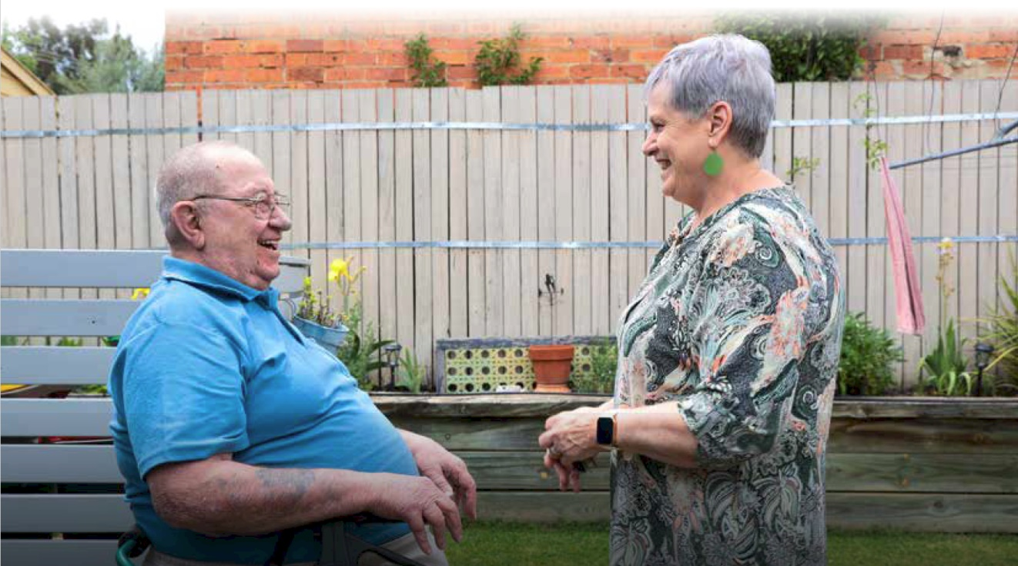

Next steps
National Carer Strategy 38
We will implement to Strategy through action plans. We will measure actions with an outcomes framework to assess progress and effectiveness.

Actions
Initial actions have been developed that will deliver on the vision and priority areas, and lay the foundations for future work, to achieve outcomes for carers. These are outlined in the accompanying initial Action Plan 2024-27.
As outcomes of other reforms relevant to carers become realised, new priority areas for carers and practical actions may emerge. Throughout the life of the Strategy, we will measure and evaluate the impact of actions put in place. This will inform development of any future action plans to achieve the Strategy vision.
The action plan, informed by the views, perspectives, expert advice and evidence collected during the development of the Strategy, will be implemented in the first 3 years.

Monitoring, evidence and evaluation
A robust monitoring, evidence and evaluation approach that aligns data, research and evaluation is integral to the development, implementation and impact of the Strategy.
The core components of the approach include:
The core components of the approach include:
a theory of change
an outcomes framework
a monitoring and evaluation framework.
A theory of change tells us why we need change and how our actions will help us meet our objectives.
An outcomes framework will outline how we will measure the outcomes of the Strategy and, where possible, provide measurable indicators.
A monitoring and evaluation framework will support the outcomes framework by tracking the progress and success of the actions taken and monitor progress against the objectives and vision.
The voices and perspectives of carers will inform and guide the Strategy implementation, monitoring and review to ensure outcomes are delivered. Evaluation will be culturally safe, acknowledging and embedding the principles of First Nations data sovereignty and governance.
We will undertake a mid-way review and final evaluation of the Strategy. Evaluation reports will be publicly available.

Snapshot: Diversity of carers
Carers are diverse. The intersectionality of carers often means some cohorts of carers experience additional challenges and barriers to accessing support. This section explores the challenges of carers through evidence gathered from data collection, outcomes of consultations, reports and other related activities described throughout the Strategy.
Young carers
In 2022, there were 391,300 carers under 25 years of age (ABS, 2024). This is likely an under-estimate due to limitations in data collection, social perceptions about what constitutes caregiving as well as a general lack of awareness about the contribution young people make to supporting and caring for family members. The Inquiry indicates young carers may not identify themselves as carers and may ‘see their caring roles as a normal part of family life’. A young person may be the primary carer or share caring responsibilities with others. They may care for siblings, take on additional responsibilities in the home to support a primary carer or juggle a combination of these roles.

“There’ve been times when I’ve said yes to going out to social outings, but then I’ve had to cancel at the last minute because Mum required my care”
– Anonymous young carer
This creates unique challenges for them in relation to participation in education and training, developing and maintaining meaningful social relationships and workforce participation. Caring responsibilities can contribute to social isolation for young people. Evidence shows that poor mental health in youth increases the risk of adult depression, anxiety and suicidality, and predicts low educational attainment and unemployment (Fleitas Alfonzo et al 2024). In addition to these risks, many young carers are coping with health conditions and disability themselves. SDAC data indicates that young people with disability are far more likely to be carers than young people without disability (ABS, 2024a).
Currently SDAC only collects information about carers aged 15 years and over, which does not fully capture information about young carers. We are aware there are young people under the age of 15 who are primary and secondary carers.
Addo et al (2021) highlighted the importance of age-appropriate, youth-friendly services and programs that reflect the life stage needs of the carer. Young carer consultations reflected this by raising a need for beneficial practical supports such as financial literacy courses to help manage household budgets or manage the care recipient’s affairs. They highlighted the need for recognition and understanding of young carers’ roles in education, training and employment settings with flexible arrangements, timelines, or the option to do studies online. Young carers may experience other barriers to accessing support such as requirements for parental consent, stigma and awareness of services available to them.
Young carers discussed their experiences with support and recognition from their education and training institutions. Social wellbeing initiatives delivered through schools is a welcome support for some, however this is inconsistent. Similarly, some young carers expressed that sometimes what they need is more flexibility for meeting academic deadlines or tailored one-to-one support to stay on top of their studies.



“Sometimes I feel like I am constantly two steps behind everyone else my age. I wish that I were able to have the same opportunities as everyone else my age”
– Anonymous young carer

Participants at the young carer consultations also indicated that connection and networking with other young carers was immensely valuable. This feedback reinforces the importance and value of peer support for carers.



Women who are carers
National Carer Strategy 41
According to SDAC (ABS, 2024a) just over half (54%) of carers are women and this increases to two-thirds (67.7%) for primary carers. There were a greater number of women who are primary carers than men who are primary carers across all age groups.

Table 1: Number of primary carers by age and sex (ABS, 2024a)
Age | Women | Men
15 to 24 | 24,300 | 17,000
25 to 34 | 70,400 | 35,100
35 to 44 | 156,000 | 38,900
45 to 54 | 191,200 | 58,400
55 to 64 | 150,100 | 74,500
65 to 74 | 116,900 | 91,500
75 and over | 66,100 | 59,500

It is widely acknowledged that the disproportionate levels of care that women provide as primary carers have significant impacts on their lifelong economic security. This includes negative effects on pay and lifetime earnings, resulting in lower superannuation accumulation and higher risks of poverty in older age. Unpaid care can also negatively impact women’s workforce progress and representation in leadership roles, especially for those who need to work part time and/or flexibility to manage their caring responsibilities.
Supporting choice and flexibility at all levels in the workplace ensures people are not financially disadvantaged by their carer roles and can help carers balance their work and care commitments. Challenging existing social structures and systems, and rigid gender norms, including through education and awareness raising, representation of carers in leadership positions and in the media, and providing flexible work policies is important to breaking down the gendered norms associated with caring and combatting the gendered impacts on care.
Working for Women: A Strategy for Gender Equality (Gender Strategy) is the Government’s 10-year strategy for advancing gender equality in Australia. Valuing unpaid and paid care is one of five priorities, and directly supports the Gender Strategy’s ambitions to balance unpaid work, close the gender pay gap, and close the retirement income gender gap. The Gender Strategy recognizes that unpaid and paid care are linked to each other and to the other priorities of the Gender Strategy: gender-based violence, economic equality and security, health, and leadership, representation and decision making. Addressing negative gender attitudes and stereotypes is a foundation of the Gender Strategy.

Men who are carers
Men are an important carer cohort, who are under-represented in the service system. SDAC data shows that in 2022, men aged 65 to 74 years and 75 years and over are more likely to provide unpaid care than men at younger ages (ABS, 2024a).
Gendered norms and patterns around care giving have created a persistent stereotype about who cares and what carers look like (WGEA, n.d.) and that stereotype is female. This means that men may not identify what they do as care, may not want to be labelled a carer, be less likely to seek support from the community or their workplace, experience more resistance or discrimination when seeking flexible working arrangements or struggle to be recognised as a legitimate and competent carer.


“I started out helping mum manage her appointments, her shopping and stuff.
I did not identify I was a carer until I was providing physical care. Now she is in aged care, and I am still managing her affairs, advocating for her and making sure they look after her, it doesn’t stop. I am still caring for her.”
– Anonymous young carer
In the workplace, men who are carers – including parents – are more likely than their non-caring counterparts to feel discriminated against and have their career aspirations dampened (WGEA, n.d.).
Men who are carers are more likely than women who are carers to be employed (74.8% compared to 66.5%) (ABS, 2024a). According to WGEA (n.d.) Australian research ‘found that normalising and modelling flexible working arrangements can assist men to balance work with their caring responsibilities’.

Representing caring as ‘everyone’s job’ and as a valued contribution to our community and our economy is important for supporting both to take up more care and to be supported, recognised and respected as carers. More equal sharing of care between men and women is also important for advancing gender equality.

Carers from LGBTQIA+ communities
National Carer Strategy 43
Note: We use the term LGBTQIA+ in the Strategy. In some cases, terms such as ‘LGBTQ+’ and ‘LGB+’ are used in references from a source study or report.
The LGBTQIA+ community has a rich history of caring for both biological and chosen family. Throughout the 1980s and the 1990s, the LGBTQIA+ community and their supporters established large volunteer-run care and support networks across Australia for people living with HIV/AIDS. International research shows that compared to their non-LGBTQIA+ peers, LGBTQIA+ people are 1.2 times more likely to be primary carers and 3.5 times more likely to provide care for friends and chosen family (Gipson et al., 2023).
Within Australia there is a lack of consistent, national data on LGBTQIA+ people who provide care. Input to date indicates that LGBTQIA+ carers experience additional challenges in their caring role, including experiencing greater social isolation, discrimination (particularly in accessing supports, and services that may not be inclusive), a lack of recognition of identity or experience (Mental Health Carers NSW, 2024), and ongoing declines in wellbeing (Carers Australia, 2023). This is reflective of a broader social context in which people in LGBTQIA+ communities often experience stigma, discrimination, bullying, violence and exclusion (ABS, 2024). This can have significant impact on health and wellbeing, as clearly demonstrated by the ABS report (2024b) on mental health findings for LGBTQ+ Australians.
In their 2024 report, Building the evidence base for the National Carer Strategy, AIFS noted that the 2022 SDAC was the first cycle of this survey to ask carers their LGB+ status. Around 3% of primary carers described their sexual orientation as gay, lesbian, bisexual or who used a different term such as asexual, pansexual or queer (LGB+).
The 2022 National Carer Survey found that the average age of LGBTQ+ carers was 47 years, and just under 1 in 3 young carers in the survey (29%) identified as LGBTQ+ (Carers NSW in AIFS, 2024). Furthermore, around 2 in 5 surveyed LGBTQ+ carers were caring for more than one person.


“We want peer led and community-controlled services.” – Anonymous LGBTQIA+ carer
At recent consultations, LGBTQIA+ carers shared the challenges and need to better recognise and support them in their caring roles, and to acknowledge ‘chosen family’.
Carers felt ‘invisible’ to the system due to inadequate data capture and therefore evidence bases to drive improvement do not accurately reflect this cohort of carers. Many carers felt isolated in their roles and that recognition and respect for ‘chosen family’ is lacking.
Peer support is important and effective for wellbeing, information and knowledge sharing. Carers experienced an increased level of initial trust and willingness to share in a group of LGBTQIA+ peers greater than would have been in a non-peer led support group.
Peer-led community-controlled services can provide supports that are safe, appropriate and informed. Training and awareness-building for providers is needed to address attitudes and barriers that may prevent LGBTQIA+ carers from being their fully authentic selves in their caring roles and enable them to feel safe and confident to engage.
“Everybody has done almost everything I’m trying to do before, it’s nice to know you’re not the only one facing a problem.” – Anonymous LGBTQIA+ carer
First Nations carers
First Nations people may not identify with the term ‘carer’. In recent consultations, carers told us that, as it is for other diverse communities, care is seen as an important cultural responsibility.
This means that First Nations carers are likely under-represented in national data collections, with flow-on implications for research and service planning. Noting these limitations, we know from the ABS Census of Population and Housing 2021 that 15% of First Nations people aged 15 years or over provided unpaid care. First Nations people are 1.3 times more likely to engage in caregiving compared to non-Indigenous Australians and take on caregiving at younger ages (AIHW, 2024b).

“It’s just part of what being a sister/brother/daughter/son/human comes with, and we value it. We value nurturing and caring as part of our culture.”
– Anonymous First Nations carer
We also know that First Nations carers are more likely to be providing multi-generational care. The 2022 National Carer Survey found that 43% of First Nations respondents cared for more than one person, and 17% cared for three or more people (Carers NSW, 2023).
Many First Nations carers undertake their caring roles whilst also dealing with a combination of socio- economic, health and wellbeing gaps, as a result of systemic disadvantage, racism and trauma associated with the impacts of colonisation. Geographic barriers impacting the accessibility and continuity of services is a further challenge for carers, particularly in regional and remote Australia.
There is growing recognition of the critical connection between culture, health and wellbeing. First Nations carers told us that services need to be culturally safe for them to be accessible. Carers need to feel trust and confidence in seeking support.
“Living remote, you are relying on people, who are relying on people, who are relying on people. It takes one person to leave, and everything falls over.”
– Anonymous male carer, remote location
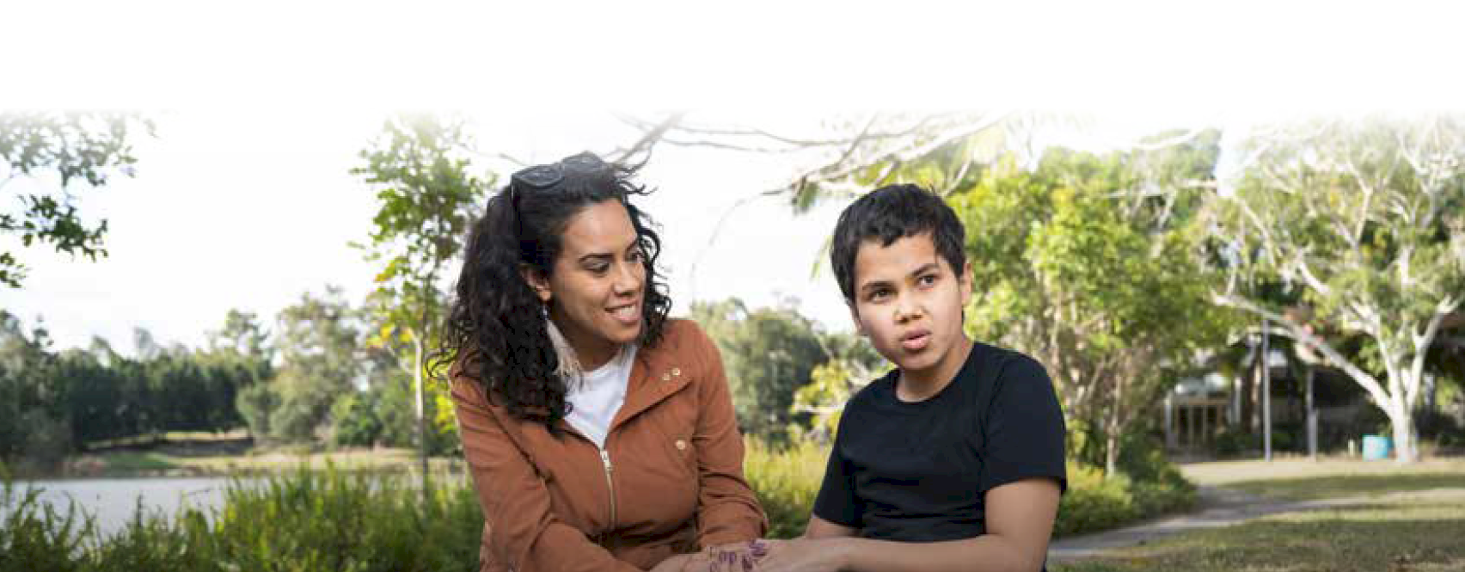
The challenges noted above are further evidenced in the 2023 Caring about care report (Klein et al., 2023) which makes seven recommendations to improve the lives of First Nations carers including ‘Supports for Aboriginal and Torres Strait Islander carers must be strengthened and/or created to ensure carers are also being cared for’. Additionally, the report recommends that ‘Governments at all levels must fully acknowledge and appreciate, as well as reflect in public policy, the intricate links between paid and unpaid care roles undertaken by Aboriginal and Torres Strait Islander women’.
The report reinforces the importance of recognising, valuing and empowering First Nations communities’ definition and experiences of care.
Culturally and linguistically diverse (CALD) carers
National Carer Strategy 45
It is estimated between 25% and 30% of carers are from CALD backgrounds (Parliament of Australia, 2024). However, this figure is likely under-estimated due to under-reporting and difficulties in identifying caring roles within the CALD community, especially when there can be multiple carers providing different supports. The relatability of these carers to their caring role may not fit into the ABS definitions of ‘primary, secondary, and other carers’ and therefore be under-represented.
CALD carers often face additional challenges such as limited access to translation services, difficulties navigating online resources, cultural barriers, lack of recognition of identity (MHCN, 2024), and experience of discrimination.
Consultations with carers from culturally diverse backgrounds indicated lower levels of English proficiency and confidence is a significant challenge for some carers and can impact on carers’ capacity to engage effectively and present their case across the support systems. There was a strong preference to access support through cultural community organisations rather than mainstream organisations. Such organisations are perceived as more understanding and trusted sources.
“Respite for me is having someone from my community back home here to help care for my daughter, so I can continue to work and provide for my family and community as well as contribute to the Australian economy.” – Anonymous CALD carer
Refugee carers raised other challenges. In Victoria, the hidden prevalence of young people with caring responsibilities from refugee and migrant communities was noted in the Centre for Multicultural Youth’s background paper ‘Who cares,’ highlighting young carers have unacceptably large caring loads and have low representation when seeking help from support associations (CMY, 2010).
Older carers
Older carers, aged 65 and above, play a crucial role in supporting family members or friends with disabilities, chronic illness or age-related issues. There are an estimated 758,000 carers aged 65 and above (ABS, 2024a). Older carers in Australia face numerous practical challenges related to their caregiving roles, including emotional strain, physical limitations, navigating complex systems as well as lack of knowledge in digital literacy. Additionally, older carers’ awareness of services such as legal and financial advice, mental health counselling and peer supports may be limited.
Older carers face the additional issue of who will provide care for the person they are supporting when they are no longer able to. Help is needed to plan the future support of their care recipient. Consultations with older carers revealed a need for additional support for transitioning care, particularly when moving from home-based care to residential care which can be challenging for both the carer and the person they are caring for. This includes not only the direct supports they provide but also the other caring responsibilities such as managing service systems and doing the necessary paperwork and planning for essential supports.
Carers also noted the need for ongoing training and updating of skills as the needs of care recipients change and specifically, as carers’ physical abilities change as they age.
“I’d like to know how to use technology and get more organised, so things work better for me.”
– Anonymous older carer

Participants at consultations offered insights into programs and initiatives they found valuable, for example intergenerational knowledge sharing. Older carers also reported that their knowledge of supports, services and advocacy organisations often come from each other through peer support avenues.
Carers with disability
Of the three million carers in Australia, almost two in five (39%) identified with disability, and young people with disability were far more likely to be carers than young people without disability.
Carers with disability or chronic health conditions report a lack of appropriate, accessible and timely services. This makes it hard to meet their own health-care needs. Needing to access multiple complex government systems to coordinate support, including MyGov, aged care and the National Disability Insurance Scheme on behalf of the person they care for and for themselves is time consuming and challenging.
Over the next decade, outcomes of the Disability Reform Agenda (DRA) will impact both carers and the lives of the people they care for, particularly carers with disability. Throughout the life of the Strategy, we will continue to align our efforts with the DRA.
“I am a deaf carer who cares for my ageing parents. As a part of my role as a carer I support my parents to access medical appointments. My needs as a NDIS participant are covered such as interpreter when I need it. But If I need to attend an appointment with my parents, I can’t access an interpreter when I need to support my parents.”
– Anonymous carer with disability

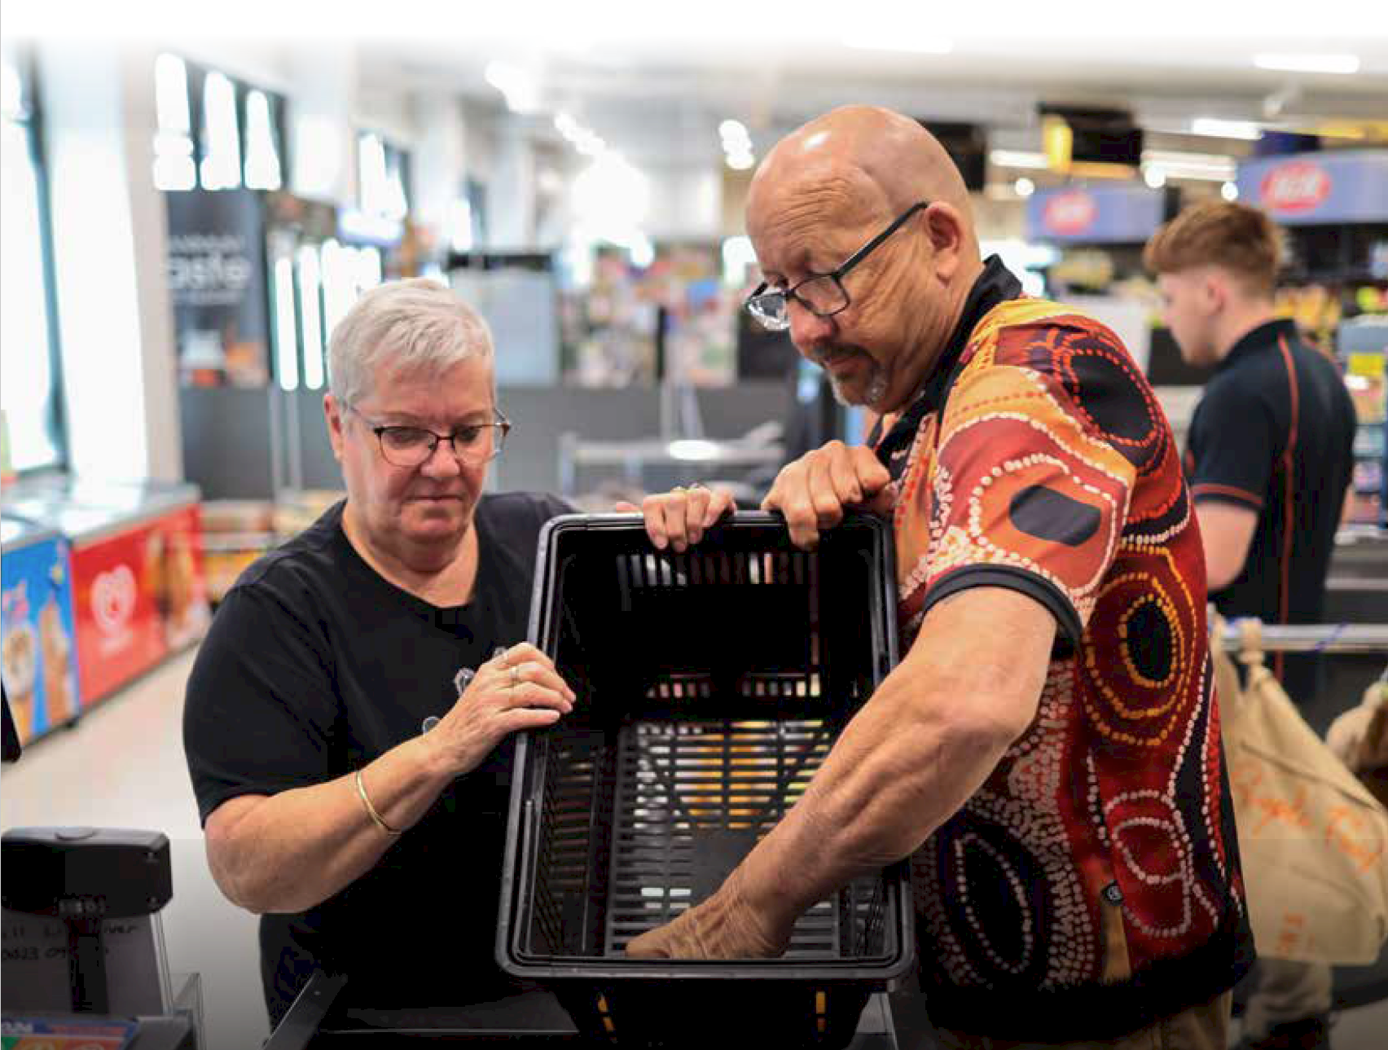

Defence family and veterans’ carers
National Carer Strategy 47
The very nature of service in the Australian Defence Force (ADF) can mean that service personnel have a greater likelihood of developing physical and mental health conditions compared to the general community. According to the 2021 Census, one in twenty (5.3%) Australian households (dwellings) had at least one person who had served in the ADF (that is, at least one person who was either currently serving or had previously served in the ADF). The Census found that among the 496,300 people who had previously served in the ADF aged 15 years and over, 13% needed assistance with the core activities of self-care, mobility or communication. Three in five (60%) previous service members had a long-term health condition (ABS 2022).
SDAC data shows that 4.4% of primary carers had, themselves, served in the ADF (ABS, 2024a). Alongside other cohorts of carers, the data regarding defence family carers and carers of veterans is likely under-represented.
Carers may be supporting a veteran, or they may be caring for other family members whilst they or their partner is still employed in the ADF. The number of men who are becoming carers of veterans is also increasing as the number of women serving in the ADF increases. The Royal Commission into Defence and Veteran Suicide (Royal Commission) considered the impact of service on defence personnel and their families. It aptly noted that when one person joins, the whole family serves. In consultations, we heard from carers a range of unique challenges including the complexity of navigating the various support systems associated with defence veterans and impacts accessing or continuing support because of postings.

“Carers are the primary support, advocate and enabler for their care recipient.”
– Anonymous carer for a veteran
Defence family carers are dealing with the impacts of separation due to unaccompanied postings or deployments and disruption to work and career due to caring. They navigate relocation impacts to education and training, services, care resources and support networks for themselves and their families when they do accompany a posting with their serving family member.
The support role of families and carers extends long after a person transitions from defence service. Veterans often have complex physical and mental health needs. The Royal Commission noted in its final report, that in the context of complex rehabilitation, support included family members attending appointments, participating in rehabilitation planning, remaining in contact with medical or rehabilitation professionals and actively participating in member rehabilitation exercises. Other forms of family involvement included practical care, emotional support and maintaining the member’s social, domestic and family life. Family members could become socially isolated due to anxiety about stigma and the pressures of the carer role (2024).

Appendices

Appendix 1: Evidence summary
From April to September 2024, a consultation campaign was undertaken to better understand perspectives of as broad range of carers and other stakeholders as possible about how the Strategy can have the strongest positive impact on the lives of carers. The voices and experiences of carers across the country was critical in the development of the Strategy. Over the 6-month consultation campaign over 100 activities were held, including in-person, online and by telephone. Through these consultations in every state and territory including metropolitan, regional, and remote areas we met and heard from over 1900 carers. Over 700 submissions were received in response to an online discussion paper and questionnaire.
Full consultation reports are available at National Carer Strategy | engage.dss.gov.au
Other evidence used to develop priorities and drive change for carers
Outcomes of these consultations built on an evidence base gathered from previous consultation activities such as the Carer Wellbeing Survey, the House of Representatives Standing Committee on Social Policy and Legal Affairs Inquiry into the recognition of unpaid carers submissions and final report, consultation outcomes from other relevant government processes and previous scoping research conducted in preparation for the development of the Strategy.
The Department of Social Services commissioned AIFS to undertake a scoping literature review of the current evidence base on carers in Australia. This included who are carers, how are they faring, and the supports available to them and how effective (or not) they are.

Key findings:
• There is relatively good data on carers and the care they provide. However, the definition of a carer in some key data sets is more restrictive than in the Commonwealth Carer Recognition Act 2010.
• Evidence shows that carers generally experience poorer wellbeing, income, employment and education outcomes relative to their non-carer peers, and these effects tend to be worse the greater level of caregiving.
• Evidence on what works to support carers is very scant.
• Progress has been slow in addressing the known deficiencies and gaps in the carer support system. Many of the issues are systemic.
Building the evidence base for the Strategy is available at: National Carer Strategy | engage.dss.gov.au

Appendix 2: Glossary
These definitions are provided specifically for the Draft Carer Strategy. They are not comprehensive, and variations may be found in literature and across various jurisdictions.
Term | Description
Accessible | People from a diverse range of backgrounds, abilities, locations and demographics are afforded the opportunity to acquire the same information, engage in the same interactions, and enjoy the same services in an equally effective and equally integrated manner, with substantially equivalent ease of use.
Action plan | The initial set of strategic actions to be implemented from 2024 to 2027 to support unpaid carers.
Awareness Raising | Aims to increase community and individual awareness of the vital role carers play in the communities, highlighting the challenges they face and the importance of supporting them through accessible resources and recognition.
Burnout | Emotional, mental and physical exhaustion caused by excessive and prolonged stress. Burnout can happen when a person feels powerless, overwhelmed, emotionally drained, and unable to meet constant demands.
CALD | Culturally and Linguistically Diverse: refers to individuals and communities from various cultural backgrounds who speak different languages.
Carer-centred | A carer-centred approach means a policy or program emphasises individual care, ensuring that services are tailored to the specific needs and preferences of each person. It promotes dignity, autonomy, and holistic well-being, while supporting carers with the necessary resources and training to deliver respectful and effective care.
Carer Gateway | Carer Gateway is an Australian Government program providing free services and support for carers. It can help if family member or friend with disability, a medical condition, mental illness, or who is frail due to age.
Carer landscape | The overall environment and context in which carers operate, including policies, services, and support systems available to them and to the people they care for.
Caring journey | The role of caring across the lifespan from pre, during and after a caring responsibility ends.
Consultation | The action or process of formally consulting or discussing.
Data governance | Indigenous/First Nations Data Governance is the enactment of Indigenous Data Sovereignty and refers to the mechanisms that support First Nations people's decision-making on how data is controlled, collected, interpreted, accessed, stored, and used.

These definitions are provided specifically for the Draft Carer Strategy. They are not comprehensive, and variations may be found in literature and across various jurisdictions.
Term | Description
Data sovereignty | Indigenous/First Nations Data Sovereignty is enshrined in the United Declaration of the Rights of Indigenous Peoples and is central to comprehensive and ethical data collective that supports Aboriginal and Torres Strait Islander people's rights to govern their own data, including its creation, collection, and use.
Empowered | Empowered means allowing carers to make decisions and take actions within specific guidelines to improve care and support, enhancing their ability to respond effectively.
Evidence-based | Evidence-based refers to a decision-making process that relies on the best available data and research to shape and implement policies. It involves systematically collecting, analysing, and applying evidence to ensure policies are effective, efficient, and grounded in information.
Equity | The quality of being equal or fair; fairness, impartiality, even-handed dealing.
First Nations | Indigenous peoples of Australia, including Aboriginal and Torres Strait Islander communities.
Gender Equality | Gender equality for carers means ensuring that all carers, regardless of gender, have equal access to support, opportunities, and resources. It aims to address and remove gendered barriers that may lead to unequal treatment or outcomes.
Inclusive | Inclusive approach for all carers by ensuring equal access to resources, support, and opportunities. It outlines how to accommodate diverse needs and backgrounds, fostering an environment where every carer can thrive and contribute effectively.
Inquiry | This establishes guidelines for managing inquiries within the organisation. It defines the process for submitting, tracking, and responding to inquiries to ensure time and accurately handling. It specifies responsibilities, response times, and communication methods to maintain transparency and efficiency.  A formal investigation or examination into a particular issue, in this case, the recognition of unpaid carers.
Intersectionality | The interconnected nature of social categorizations such as race, class, and gender as they apply to a given individual or group, regarded as creating overlapping and interdependent systems of discrimination or disadvantage:  “Through an awareness of intersectionality, we can better acknowledge and ground the differences among us”
LGBTQIA+ | Refers to people of diverse sexualities and genders, including lesbian, gay, bisexual, transgender, queer, intersex, and asexual.
National Agreement on Closing the Gap | An agreement signed by all governments and the Coalition of Peaks whose objective is to enable Aboriginal and Torres Strait Islander people and governments to work together to overcome the inequality experienced by Aboriginal and Torres Strait Islander people and achieve life outcomes equal to all Australians.

These definitions are provided specifically for the Draft Carer Strategy. They are not comprehensive, and variations may be found in literature and across various jurisdictions.
Term | Description
Peer led | An entity, program, or service is delivered or facilitated by a person with appropriate lived experience. In the context of the Strategy this refers to carer-led or demographic-led support. For example, an LGBTQIA+ support group led by a person who is a member of the LGBTQIA+ community. Another example is an advisory committee consisting of people with relevant lived experience.
Recognition | How the community acknowledges the contributions of carers, aiming to motivate and appreciate those who make this significant contribution to the community.
Respite Care | Respite care provides temporary relief, allowing carers a break to rest, manage stress, or attend to personal tasks.
Stakeholders | Individuals or organisations with an interest or investment in the outcomes of the Strategy, including carers, service providers, and advisory committees.
Theory of change | A comprehensive explanation of how and why a desired change is expected to happen, detailing the necessary actions, processes and conditions.
Unique needs | This addresses the specific needs of individual carers by recognising and accommodating the unique requirements. It outlines how to identify and address these needs to ensure effective support and care delivery. It aims to tailor assistance to each carer's circumstances, enhancing their ability to provide quality care.
Unpaid carer | A person who provides personal care, support and assistance to another person who needs it because that other person lives with disability, has a medical condition (including a terminal or chronic illness), a mental illness, or is frail and aged. Carers receiving financial support such as the Carer payment or Carer allowance are included under this definition.
Wellbeing | To support physical, mental, and emotional well-being of carers. Helps carer maintain a healthy balance between their caregiving responsibilities and personal life, aiming to reduce stress and enhance overall quality of life.
Working group | A collaborative team formed to focus on specific tasks or projects, in this case, to improve navigation assistance for carers.

Appendix 3: References
ABS (Australian Bureau of Statistics) (2024a) Disability, Ageing and Carers, Australia: Summary of Findings, ABS website,accessed 19 August 2024
ABS (2024b) Mental health findings for LGBTQ+ Australians, ABS website, accessed 5 September 2024
ABS (2022) Australian Defence Force service, ABS Website, accessed 9 October 2024
Addo IY, Aguilar S, Judd-Lam S, Hofstaetter L, Weng Ceong Poon A (2021) ‘Young Carers in Australia: Understanding Experiences of Caring and Support-Seeking Behaviour’, Australian Social Work, 77(9):60-73, doi: 10.1080/0312407X.2021.1971271
AIFS (Australian Institute of Family Studies) (2024), Building the evidence base for the National Carer Strategy Rapid review of the evidence, report prepared by Sibly C and Andersson C, Australian Government
AIHW (Australian Institute of Health and Welfare) (2024a) Dementia in Australia First Nations-specific health and aged care programs and caring roles among First Nations people, AIHW website, accessed 19 August 2024
AIHW (Australian Institute of Health and Welfare) (2024b) Tier 1 – Health and status outcomes 1.14 Disability, AIHW website, accessed 19 August 2024
Carers Australia (2023), Caring for other and yourself: The 2023 Carer Wellbeing Survey – full report, Carers Australia website, accessed 16 August 2024
Carers NSW. (2023), 2022 National Carer Survey: Full report. Available online at: 2022 National Carer Survey: Full Report (carersnsw.org.au), accessed 30 September 2024
CMY (Centre for Multicultural Youth) (2010) Who Cares? Refugee and Migrant Young People with Caring Responsibilities, CMY website, accessed 17 September 2024
Deloitte Access Economics (2020) The value of informal care in 2020 [PDF 652KB], Carers Australia, accessed 19 August 2024
Fleitas Alfonzo L, Disney G, Singh A, Simons K, King T (2024) ‘The effect of informal caring on mental health among adolescents and young adults in Australia: a population-based longitudinal study’, The Lancet Public Health, 9(1):26- 34, doi: 10.1016/S2468-2667(23)00299-2
Gipson L, Roman C, Joseph N, Flatt J (2023) LGBTQ+ Caregivers: Challenges, Policy Needs, and Opportunities, Center for Health Care Strategies, accessed 19 September 2024
Klein E, Hunt J, Staines Z, Dinku Y, Brown C, Glynn-Braun K, Yap M (2023) Caring about Care (Commissioned Report No.7/2023), Centre for Indigenous Policy Research, Australian National University, doi: 10.25911/7S8N-8C87
Lo Giudice D, Josif CM, Malay R, Hyde Z, Haswell M, Lindeman M, Etherton-Beer C, Atkinson D, Bessarab D, Flicker L, Smith K (2020) The Well-Being of Carers of Older Aboriginal People Living in the Kimberley Region of Remote Western Australia: Empowerment, Depression, and Carer Burden, Journal of Applied Gerontology, 40(7):693-702, doi: 10.1177/0733464819898667
MHCN (Mental Health Carers NSW) (2024) Culturally and linguistically diverse carers, MHCN website, accessed 19 August 2024
Parliament of Australia (2024) Chapter 2 – The Carer Recognition Act, Australian Parliament House website, accessed 16 August 2024
Royal Commission into defence and veteran suicide (9 September 2024) Final Report, Chapter 6: Families,data and research, and establishing a new entity. Available online at: Final Report - Volume 6: Families, data and research, and establishing a new entity (royalcommission.gov.au), accessed 9 October 2024
WGEA (Workplace Gender Equality Agency) (2024) The ABS data gender pay gap, WGEA website, accessed 11 September 2024
WGEA (Workplace Gender Equality Agency) (n.d.) Gender equality and caring, WGEA website, accessed 3 September 2024






