Commonwealth, State and Territory Disability Ministers met on 1 November 2024 in Adelaide. Ministers welcomed new Northern Territory Disability Minister, Jinson Charls. The Australian Capital Territory and Queensland did not have Ministers in attendance due to the recent elections.

Ministers were briefed on work by the National Disability Insurance Agency (NDIA) to better support participants by banning fraudulent and criminal providers. An update was given on progress by the NDIA’s Fraud Fusion Taskforce, including to execute an increasing number of search warrants and criminal convictions for those who defraud the NDIS.

Ministers were also briefed on two key NDIA initiatives underway to ensure the sustainability of quality providers who deliver critical services to vulnerable participants, including the new Quality Supports program and the Independent Pricing Committee.

Ministers received an update on the regulatory reforms being led by the NDIS Quality and Safeguards Commission (the Commission). The discussion centred on the main themes in the Regulatory Reform Roadmap, including the mandatory registration for platform and Supported Independent Living (SIL) providers, and support coordinators, and the recently announced NDIS Bill No.2. There was a particular focus on the planned consultation for the reforms and ensuring coordination between these consultation activities and consultation on broader reforms.

Ministers discussed ways of working together to develop and agree the new and amended NDIS rules enabled by the commencement of the NDIS Amendment (Getting the NDIS Back on Track No.1) Act 2024. Ministers agreed that rules would be shared with jurisdictions during the development process to ensure feedback was able to be integrated early – rather than after the rule had been developed. Ministers also agreed the importance of early consultation with the disability community and states and territories during rule development and agreed to develop an engagement strategy to ensure this occurred.

Ministers noted progress on the design, consultation and planning for Foundational Supports, building on the significant engagement and consultation underway across the country.

Ministers continued discussions on the approach to delivering a joint response to the 26 recommendations made by the Independent Review of the NDIS by the end of this year. Ministers agreed that the joint NDIS Review response will be considered at the next DRMC meeting before end of year, with the Commonwealth sharing its positions on the 26 recommendations in the week commencing 4 November and allowing for State and Territory Cabinet processes.

Ministers discussed ongoing work to engage with the community around implementation of Disability Royal Commission joint recommendations, including the development of an interim progress report to be published by the end of 2024.

Ministers endorsed the approach to updating Australia’s Disability Strategy (ADS), informed by this year’s planned review of ADS, which involved consultation with the ADS Advisory Council, representative organisations and people with disability. Ministers also endorsed the approach to the new Targeted Action Plans (TAPs) and the draft revised Data Improvement Plan (DIP) 2024.

The updated Strategy, new Targeted Action Plans, revised DIP and ADS Review Report will be published in December 2024. This will also be accompanied by a new Guide to Applying the ADS, which provides information for businesses, employers, community organisations and public servants on how to make policies, services, systems, workplaces and infrastructure work better for people with disability.

Ministers endorsed the updated Commonwealth, State and Territory Supported Employment Plan. Ministers also noted the Supported Employment Plan 2024 Progress Report, which outlines the significant amount of work underway across all levels of government to support the evolution of the supported employment sector in alignment with the Guiding Principles for the Future of Supported Employment.

Ministers noted the Australian Government has committed an additional $39.7 million over 4 years to develop and implement a new Commonwealth Individual Disability Advocacy program, in response to key findings from the Royal Commission.

Ministers agreed to publish an updated version of the Disability Reform Roadmap to reflect upcoming consultation on NDIS Bill No. 2 and commencement of the NDIS Amendment (Getting the NDIS Back on Track No.1) Act 2024.

The next DRMC meeting is scheduled in a month’s time and will be a dedicated session to discuss the joint response to the Independent Review of the NDIS.

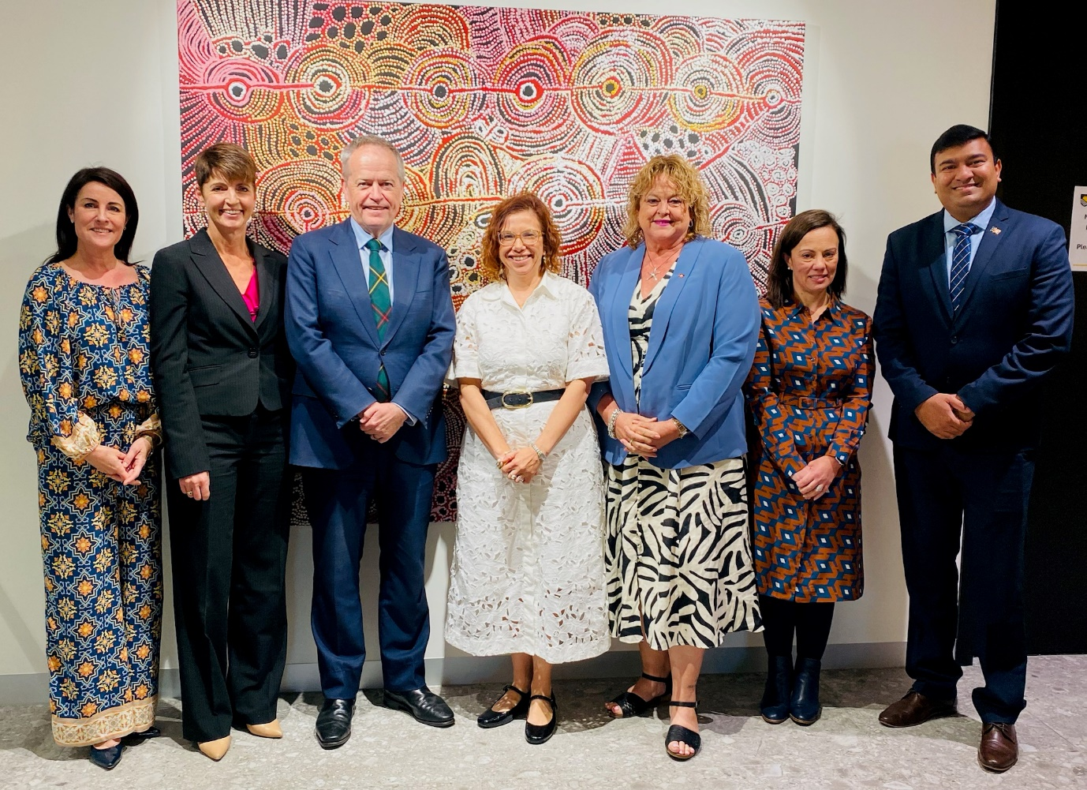

Image – Clockwise from left: Minister Palmer (TAS), Minister Washington (NSW), Minister Shorten (Minister for the NDIS), Minister Rishworth (Minister for Social Services), Minister Cook (SA), Minister Blandthorn (VIC), Minister Charls (NT).

Minister Punch (WA) attended online.