Families and Children Activity outcomes framework

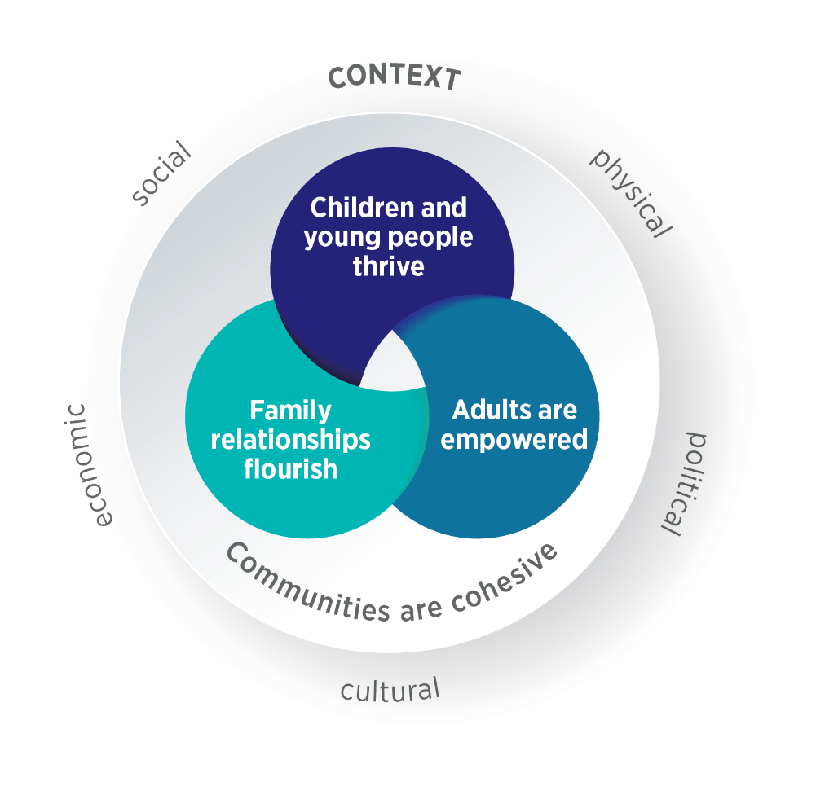

AIM: CHILDREN AND YOUNG PEOPLE THRIVE | AIM: ADULTS ARE EMPOWERED
OUTCOMES:  Positive mental health and wellbeing  Increased resilience  Positive relationships  Safe at home and in the community  Strong connections to social supports and community Strong connection to culture  Greater participation in decision making  Positive development  Positive engagement in education and training | OUTCOMES:  Positive mental health and wellbeing  Increased resilience  Positive relationships  Safe at home and in the community  Strong connections to social supports and community Strong connection to culture  Greater participation in decision making  Sense of self-efficacy and confidence
AIM: FAMILY RELATIONSHIPS FLOURISH | AIM: COMMUNITIES ARE COHESIVE
OUTCOMES:  Positive parenting/caregiver practice  Positive caregiver–child relationship  Respectful relationships  Family cohesion  Effective conflict management | OUTCOMES:  Communities are safe  Communities are inclusive  Communities understand issues facing children, young people and families  All community members are able to participate in decision making  Services are accessible and appropriate  Services are safe and inclusive  Services work together to support families

WHAT DO WE MEAN WHEN WE SAY FAMILY?
A family can be made up of anyone a person considers to be their family. Families can include children, but they may not. Family members contribute significantly to the wellbeing of each other and play essential roles in supporting each other through life’s transitions, stresses and celebrations.

WHAT DO WE MEAN WHEN WE SAY CONTEXT?
The context is the physical, social, cultural, economic and political environment that clients are located within. It can influence the extent to which clients’ basic needs, such as stable housing and food security, are met and, in turn, can affect their ability to engage consistently and effectively with services.

Suggested indicators

Outcome: Positive mental health and wellbeing
Proportion of children/young people with increased:  - Emotional wellbeing  - Prosocial behaviour  - Peer relationship quality  - Life satisfaction  - Sense of identity  - Participation in community activities such as sport or recreation  - Support to access needed services | Proportion of children/young people with decreased:  - Hyperactivity  - Behavioural/conduct problems  - Internalising/externalising behaviour  - Psychological distress  - Self-harm, suicidal ideation, attempted suicide or suicide

Outcome: Increased resilience
Proportion of children/young people with increased:
- Problem solving
- Coping strategies
- Help-seeking behaviours
- Ability to deal with stress
- Emotional regulation/self-control
- Prosocial behaviour, e.g. cooperation, empathy
- Support from family, peer, school or community networks

Outcome: Positive relationships
Proportion of children/young people with improved:  - Peer relationships  - Close and healthy relationships with family or friends | Increased proportion of children/young people who report:  - They can turn to others for support  - They can confide in family or friends

Outcome: Safe at home and in the community
Increased proportion of children/young people who:  - Feel safe moving around their local area (walking, cycling, using public transport, etc.)  - Feel safe at home  - Feel safe at school  - Feel safe at community activities such as sport and recreation  Increased proportion of families are supported to keep children and young people safe | Decreased proportion of children/young people who report:  - Bullying  - Discrimination  - Family violence  Decreased:  - Substantiated child protection notifications  - Rates of crime victimisation for children and young people

Outcome: Strong connections to social supports and community
Increased proportion of children/young people who:
- Feel connected to adults at school or in the community
- Participate in community groups
- Participate in volunteering in the community
- Are able to get support from outside the household in time of crisis
- Participate in community activities such as sport or recreation

Outcome: Strong connection to culture
Proportion of children/young people with increased:
- Connection to country
- Use of Aboriginal and Torres Strait Islander languages
- Knowledge of culture
- Participation in cultural practices
- Identity with cultural groups
- Use of language/s of family’s country of origin

Outcome: Greater participation in decision making
Increased proportion of children/young people who:
- Believe they can participate in decisions that affect them
- Engage in developing programs or policies that affect them
- Feel safe voicing their opinions
- Have support to participate in decisions that affect them

Outcome: Positive development
Increased proportion of children/young people who:
- Meet age-appropriate developmental milestones
- Are developmentally on track across the following domains: physical health and wellbeing, social competence, emotional maturity, language and cognitive skills (school based), communication skills and general knowledge
- Attend a quality pre-school program

Outcome: Positive engagement in education and training
Increased proportion of children/young people who:  - Are enrolled in early childhood education  - Attend early childhood education or school  - Enjoy early childhood education or school  - Attain educational achievement  - Feel safe at school  - Feel they belong at school  - Participate in decisions that affect their education and future  - Have parents that are engaged in their learning | Decreased proportion of children/young people who report:  - Bullying  - Discrimination

Outcome: Positive parenting/caregiver practices
Proportion of parents/caregivers with increased:  - Parental warmth and affection  - Consistency in disciplinary practices  - Parental confidence and self-efficacy in parenting role l and practices  - Awareness of, and access to, evidence-based parenting resources, parenting helplines and parenting programs | Proportion of parents/caregivers with improved:  - Parenting style  - Parental monitoring of children/young people

Outcome: Positive caregiver–child relationship
Proportion of family members with improved:
- Parent–child relationships
- Attachment to parent/caregiver
- Parent–child interaction
Increase in children/young people receiving emotional and practical support from caregivers

Outcome: Respectful relationships
Proportion of family members with increased:
- Understanding of healthy relationships and respect
- Knowledge of the attitudes, behaviours and structures that underlie violence
Improved attitudes towards violence against women and gender equality

Outcome: Family cohesion
Proportion of family members with improved:  - Parental relationship quality  - Family communication style  - Family goals and aspirations  - Family routines and roles, e.g. mealtimes, chores  - Family closeness | Proportion of family members with increased:  - Ability to cooperate and communicate when performing parenting duties  - Affective responsiveness and affective involvement  - Resilience/family hardiness  - Sense of belonging  - Positive time spent together with family members (talking, having fun or learning)

Outcome: Effective conflict management
Proportion of family members with decreased:  - Interparental conflict  - Parent–child conflict  - Family/sibling conflict  - Family stress | Proportion of family members with improved:  - Conflict resolution styles  - Family coping strategies and problem solving

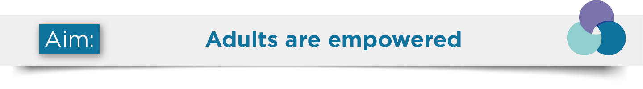

Outcome: Positive mental health and wellbeing
Proportion of adults with increased:  - Psychological health  - Life satisfaction  - Participation in community activities such as sport or recreation  - Support to access needed services | Proportion of adults with decreased:  - Psychological distress  - Self-harm, suicidal ideation, attempted suicide or suicide

Outcome: Increased resilience
Proportion of adults with increased:
- Problem solving
- Coping strategies
- Ability to deal with stress
- Persistence when faced with adversity
- Capacity to take on and overcome problems
- Self-belief in own ability
- Purpose in life
- Support from family, friends or community networks
- Help-seeking behaviours

Outcome: Positive relationships
Proportion of adults with improved:  - Close and healthy relationships with family or friends  - Peer relationships | Increased proportion of adults who report they can:  - ■ Turn to others for support  - Confide in family or friends

Outcome: Safe at home and in the community
Increased proportion of adults who:  - Feel safe moving around their local area (walking,  cycling, using public transport, etc.)  - Feel safe at home | Decreased proportion of adults who report:  - Bullying  - Discrimination  - Family violence  - Experience of crime victimisation

Outcome: Strong connections to social supports and community
Increased proportion of adults who:
- Can get help from family or friends when needed
- Can get help from neighbours when needed
- Participate in sport
- Participate in community groups
- Participate in community volunteering
- Are able to get support from outside the household in time of crisis

Outcome: Strong connection to culture
Proportion of adults with increased:
- Connection to country
- Use of Aboriginal and Torres Strait Islander languages
- Use of language/s of family’s country of origin
- Knowledge of culture
- Participation in cultural practices
- Identity with cultural groups

Outcome: Greater participation in decision making
Increased proportion of adults who:
- Believe they can participate in decisions that affect them
- Engage in developing programs or policies that affect them
- Have support to participate in decisions that affect them
- Feel safe to voice their opinions

Outcome: Sense of self-efficacy and confidence
Proportion of adults with increased:
- Ability to succeed in a task
- Resourcefulness
- Ability to identify and use available support
- Belief in their ability to achieve expectations

Outcome: Communities are safe
Increased proportion of community members who report:  - Feeling safe walking alone in their local area at night  - That most people in their community can be trusted  Decreased incidence of crime, such as family violence statistics | Decreased proportion of community members who report:  - Racism  - Abuse due to race/cultural background, age, physical health or ability, mental health, religion, sexuality, gender and/or gender identity  - Witnessing violence  - That family violence is a problem for their community  - That crime rates are an issue in their community

Outcome: Communities are inclusive
Increased proportion of community members who report:  - Supporting a society made up of people from different cultures  - Participating in community volunteering  - Participating in community groups  - Feeling they belong in their community  - They can get help from their neighbours when needed | Decreased proportion of community members who report:  - Racism  - Discrimination in relation to their race/cultural background, age, physical health or ability, mental health, religion, sexuality gender and/or gender identity

Outcome: Communities understand issues facing children, young people and families
Increased proportion of community members who have an understanding of:
- The factors that impact children and young people’s mental health and wellbeing
- Support options available to children, young people and families
- Child development and positive parenting practices
Increased availability of evidence-based resources to support families and children and young people

Outcome: All community members are able to participate in decision making
Increased proportion of community members who:
- Feel safe voicing their opinions
- Have opportunities to have a say in decisions that affect them
- Are engaged in developing programs or policies that affect them
- Are members of community organisations and decision-making bodies, e.g. in schools
Increased avenues for community members to have a say on issues that are important to them

Outcome: Services are accessible and appropriate
Services:  - Are accessed by their target groups  - Ensure children, young people and families receive the support they need  - Use systematic methods to engage families who may not be reached via the usual pathways  - Offer different access options, e.g. telehealth  - Are easy to navigate for children, young people and families, including transition between services  - Are easy to navigate for service providers  - Are affordable for clients  - Embed co-design principles in the design, delivery and evaluation of services, particularly for diverse communities  - Engage in effective partnerships with Aboriginal and Torres Strait Islander communities and organisations  - Are evidence-informed  - Are responsive to the needs of children, young people and families | Service providers:  - Have appropriate training  - Understand and respect the culture and diversity of clients

Outcome: Services are safe and inclusive
Services:  - Build and maintain cultural competency  - Engage in effective partnerships with Aboriginal and Torres Strait Islander communities and organisations  - To Aboriginal and Torres Strait Islander families and children and young people are deliver ed via Aboriginal Community Controlled Organisations  Service providers:  - Understand and respect the culture and diversity of clients  - Have appropriate training  - Are respectful and mindful of cultural and power differences | Service users:  - Have a say in decisions that affect them  - Are engaged in developing programs or policies that affect them
Decreased reports of discrimination in relation to race/cultural background, age, physical health or ability, mental health, religion, sexuality, gender and/or gender identity

Outcome: Services work together to support families
Services:  - Are easy to navigate for children, young people and families, including transition between services  - Are easy to navigate for service providers | Improved:  - Connections with other services that can support children, young people and families  - Communication about treatment and support plans between service providers

Definitions

Family | A family can be made up of anyone a person considers to be their family. Families can include children, but they may not.
Parent and Caregiver | These terms have been used interchangeably to mean parents and others involved in the primary care of a child, e.g. grandparents, foster parents, kinship carers.
Community | This can be people living in a particular area or people who are considered as a unit because of their common interest, social group or cultural background.

