

Volunteering and career pathway guide

Hey you mob!

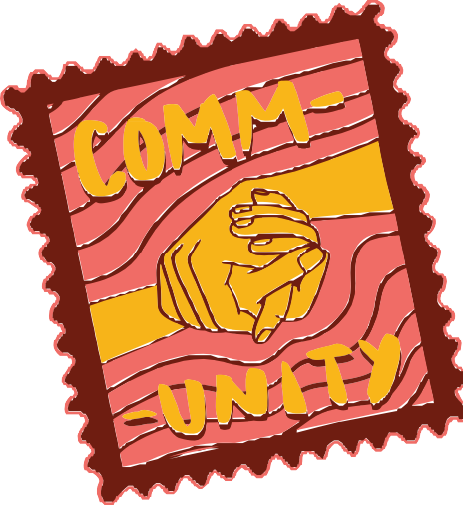Mapping out a career pathway can seem daunting, but it’s totally doable, especially if you use volunteering as a stepping stone. Volunteering helps you gain valuable skills, build your network, and boost experience for your resume.

This guide will help you identify how to turn your volunteering experience into job ready resume skills, or if you haven’t yet volunteered, find something that matches your interests.

# Discover your interests

***Step 1***

### What do you enjoy doing?

Volunteering is all about connecting to things you enjoy most, hanging out to help out. Use this checklist to think about the things you enjoy, and the skills you want to build.

|  |  |  |
| --- | --- | --- |
|  | **Types of opportunities** | **Skills to build** |
| Caring for Country  **I’m happiest when I’m on Country** | * Cultural centre * Gathering place * Garden maintenance * Planting * Local discovery centres * Greeting visitors * Native animal / pest management | * Administration * Education and training experience * Tour guides * Communication skills * Landscape gardening |
| Animals are life  **The furrier the better, I’m there** | * Search and rescue –   connecting lost pets to their owners   * Shelters and animal rescue * Dog walking * Preparing adoption packs for new owners * Coordinating food and shelter * Updating microchip information | * Communication skills * Teamwork * Working with animals |
| Sports is where it’s at  **All sports are my vibe** | * Coaching * Game day operations * Referee and umpire * Merchandise stalls * BBQ and canteen cooking and serving * Coordinating donations | * Teamwork * Leadership * Community role model * Cash handling * Food preparation and serving * Communication skills * Customer service skills |
| Community care  **I want it all, the people and the places** | * Fundraising appeals * Traffic marshals * Water station attendant * Registrations * Food safety * Transport | * Customer service skills * Events coordination * Organisation * Teamwork * Food preparation and service * Communication skills |
| I’m a people person  **Our people are our knowledge holders** | * Healthcare * Aged care visitor * Youth education * Tutoring and after school care * Retail and sales * Crisis support | * Working with Vulnerable People card * Customer service * Sales and cash handling * Handling stock * Communication skills |

There are a range of volunteering opportunities – find out what’s available near you at [volunteering.gov.au](http://volunteering.gov.au/).

# Identify required skills

***Step 2***

### What kind of skills do you already have and what do you want to build?

Think about what skills are needed for the career you want. You might be surprised to learn you already have quite a lot of skills and experience through engaging with your community and larger family networks.

Not all skills gained are from formal situations.

* What skills do you have from helping out with local sporting groups, school, hobbies, or previous jobs/volunteering?
* Write them down and see how they match up with the skills you want to build.

**Skills I want to build**

**Skills I currently have**

Examples:

» **Communication:** From organising family events using social media, school presentations, group projects.

» **Teamwork:** From sports teams, group activities.

» **Technical skills:** From using computers, social media, or helping elders with tech issues.

# Find the right opportunity for you

***Step 3***

### What volunteer roles can give you the best experience?

Find volunteer opportunities:

* Look for volunteer roles that help you develop the skills you need.
* Check local community centres, non-profits, or online platforms for opportunities.
* Have a look at websites for more information, including [www.volunteering.gov.au](http://www.volunteering.gov.au/)

Examples:

» **Healthcare:** Volunteer at a local hospital, clinic, or elder care facility.

» **Technology:** Help at a local library with computer classes, join a coding club.

» **Creative:** Volunteer for community art projects, local theatre groups or music hubs, or social media for local small businesses or non-profits.

***Tips***

* Keep a record of your volunteer work.
* Note down the tasks you did and the skills you gained.

# Build your resume and showcase them deadly skills!

***Step 4***

List your volunteer role, the organisation or type of group, and the skills you learnt.

* Working in community

Local community groups / cultural awareness, empathy, interpersonal skills

* Hospital Assistant

Local hospital / Communication, empathy, teamwork

* IT Support Volunteer

Community library / Troubleshooting, tech skills

* Social Media Assistant

Local small business or Non-Profit Organisation / Creativity, marketing, time management

* Sportsground Canteen Assistant

Local sports group / cash handling, multitasking, teamwork

## Mapping what you did to the skills you’ve learnt

It can be hard to translate what you’ve done and been a part of into real skills for the workplace. Use our resume builder to translate the things you’ve done into transferable skills and experience.

|  |  |
| --- | --- |
| Serving people  **(e.g. at a canteen, BBQ or shop)** | * Customer service * Complaints handling * Cash and sales experience * Strong oral communication skills * Presentable, neat and tidy |
| Answering the phone  **(e.g. reception or community group)** | * Customer service, friendly and approachable * Directing enquiries, working independently * Resolving issues and connecting people to what they need * Ability to prioritise tasks |
| Coaching  **(e.g. a sports team or tutoring)** | * Leadership skills * Time management * Organisation and coordination of a team * Ability to communicate effectively |

## Tips

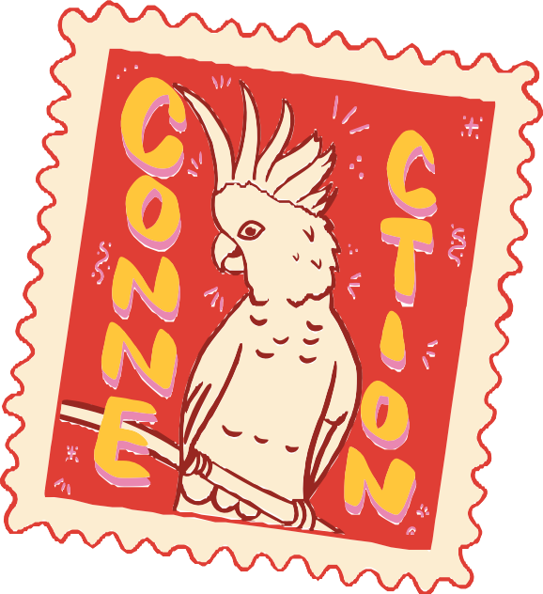

***for building your resume***

* Include your volunteer work and the skills you’ve gained.
* Highlight how these skills make you a good fit for the job you want.

Resume Example

##### Name:

[Your Name]

##### Contact Info:

[Your Address, Phone, Email]

##### Objective:

Passionate about [Career Field], with skills in [Key Skills].

Seeking to leverage volunteer experience to gain paid employment in [Specific Job].

#### Volunteer Experience

##### Role:

Hospital Assistant

##### Organisation:

Local Hospital

##### Duration:

[Dates]

##### Responsibilities

* Assisted with patient care, improving communication and empathy skills.
* Worked in a team to support hospital staff, enhancing teamwork abilities.

##### Skills:

* Communication
* Empathy
* Teamwork

##### Education

* [Your School or Training]
* [Qualifications or Courses Completed]

##### References:

Available upon request.

**Whether you are looking at volunteering for the short or long term, every step you take brings you closer to your career goals.**