# Public Interest Certificate - National Panel of Assessors Program

This public interest certificate is issued under section 22(1) of the Government Procurement (Judicial Review) Act 2018.

I hereby state that it is not in the public interest for the following procurement by the Department of Social Services to be suspended while complaints under section 18 of the Act are being investigated or while applications for injunctions under Part 2 of the Act are being considered.

|  |  |
| --- | --- |
| **AusTender ID(s)** RFT70019523 | |
| **RFT Closing** The closing date and time is as published in the Request for Tender (RFT), available | |
| **Date and Time** | on the AusTender website. |
| **Procuring Entity** | Department of Social Services |
| **Contact Officer** | [DE2025Purchasing@dss.gov.au](mailto:DE2025Purchasing@dss.gov.au) |
| **Category (UNSPSC)** | 93141805 - Unemployment Services |
| **Description** | In the 2024-25 Budget, the Australian Government announced that the National Panel of Assessors program would be renewed as part of the Disability Employment Reforms. The current National Panel of Assessors program will cease on 30 June 2025.  The new National Panel of Assessors program, to commence on 1 July 2025, will provide independent assessment services to support the needs of people with disability in employment. The National Panel of Assessors is an essential component of disability employment.  From October 2024 to June 2025 the department will undertake a procurement process to engage providers for the new National Panel of Assessors program to commence on 1 July 2025.  The procurement will be conducted via a single stage open tender process through which the department intends to enter into a Deed of Standing Offer with each successful tenderer.  For more information on the RFT, refer to the AusTender website: [https://www.tenders.gov.au/](http://www.tenders.gov.au/)  Further information on the new program is also available at:  <https://engage.dss.gov.au/a-new-specialist-employment-disability-program-consultation/> |

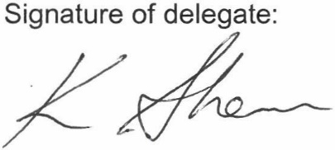

**Kellie Spence Group Manager**

**Department of Social Services**

27 September 2024