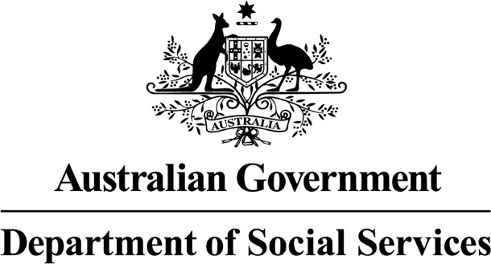 

Schedule A of the Bilateral Agreements between the Commonwealth of Australia and the states and territories



*This page is blank on purpose.*

**Table of contents**

About the agreements **4**

About the bilateral agreements **6**

Changes to sharing money **9**

# About the agreements

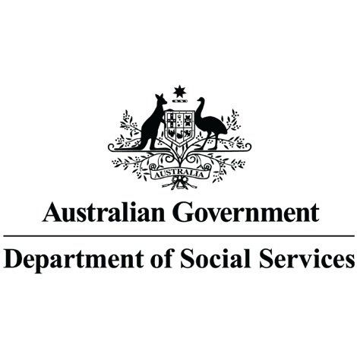The Department of Social Services

wrote the **bilateral agreements**. When you see the word ‘we’, it means the Department of Social Services.

A bilateral agreement is a paper that says two groups have promised to do things for each other.

Both the **Prime Minister**, the **Premiers** and the **Chief Ministers** have said that they will help each other with money.

The Prime Minister is the leader of the Australian Government.

The Premier is the leader of their state.

The Chief Minister is the leader of their territory.

Together they have decided on the rules for sharing money and must follow them.

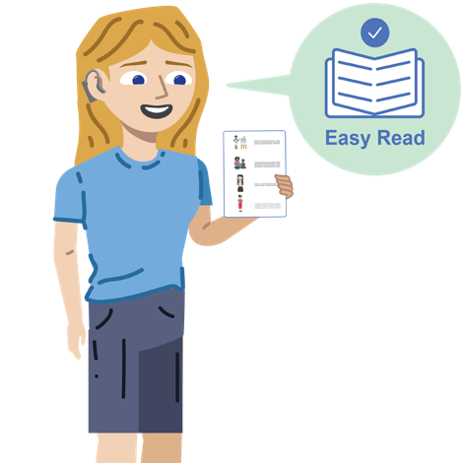We wrote the agreements in an easy to read way.

We use pictures to explain some ideas.

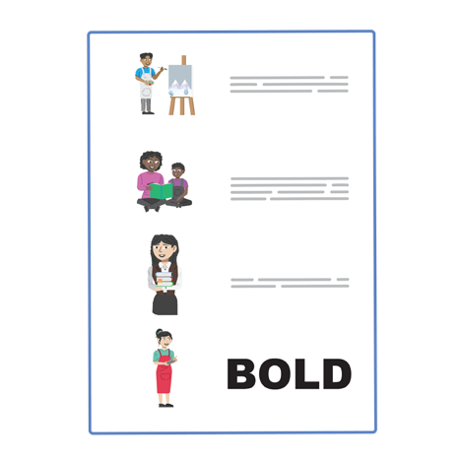The agreements have some hard words.

The first time we write a hard word:

* We will write it in **bold**.
* We will explain what the hard word means.

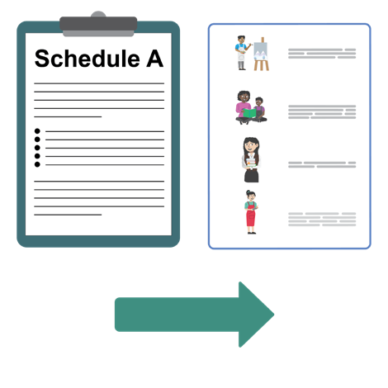The Easy Read agreements tells you the most important ideas from other agreements.

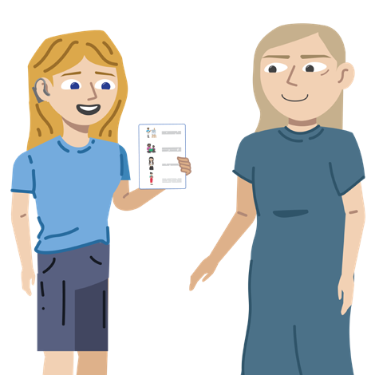You can ask for help to read the agreements. A friend, family member, or **support person** can help you.

A support person is someone who helps you

with things you find hard to do by yourself.

# About the bilateral agreement

We have made recent changes to the agreements about sharing money

between the Australian Government and the states and territories.

This is called **reallocation**.

We made changes to **Schedule A** of the agreements.

Schedule A is one part of the agreements.

It is about:

* How much money the states and territories and the Australian Government will give to the **National Disability Insurance Scheme**. We call it the **NDIS**.

The NDIS helps people with disability by paying for services they need to do the things they want to do.

* How much money the states and territories need to give to the NDIS.
* How much money the Australian Government needs to give to the NDIS.
* What changes to these amounts of money there will be when reallocation happens.

Schedule A explains how much money the Australian Government and the states and territories must give to the NDIS.

We have made these changes to Schedule A because the current agreement says that reallocation must happen on 1 July 2023.



y 5 s

ear

Reallocation will happen again every 5 years.

Western Australia does not have a full agreement with the Australian Government.

They do not have a Schedule A to change. But they will still follow the reallocations.

# Changes to sharing money

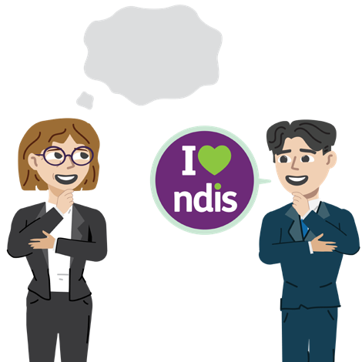Reallocation means that changes are made to how much money the states and territories pay the Australian Government for the NDIS.

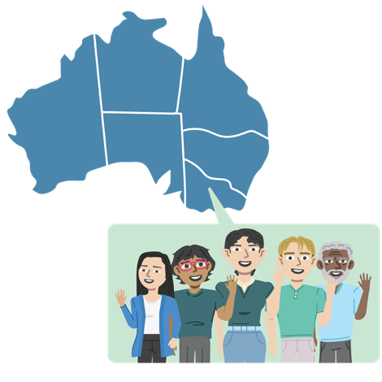These changes are decided based on how many people live in each state and territory compared to the rest of Australia.

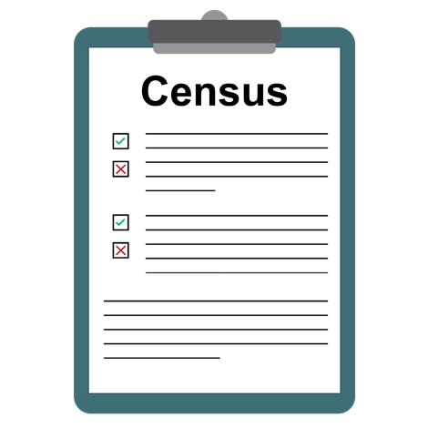The 2021 **Census** information tells us how many people live in each state and territory.

The Census is a list of questions that everyone answers about themselves every few years.

It helps the Australian Government to count how many people live in Australia.

Schedule A explains how much money the Australian Government and the states and territories must give to the NDIS.

Reallocation means that the amount of money the states and territories pay the Australian Government for the NDIS may:

* Get bigger.
* 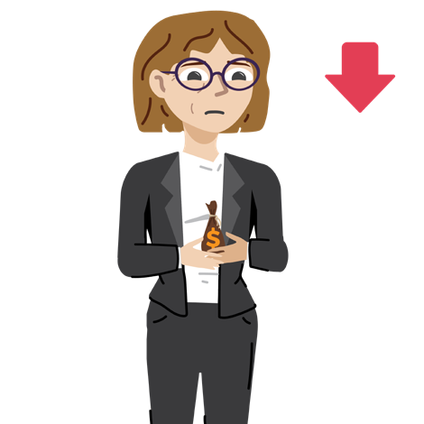Get smaller.
* Or stay the same.

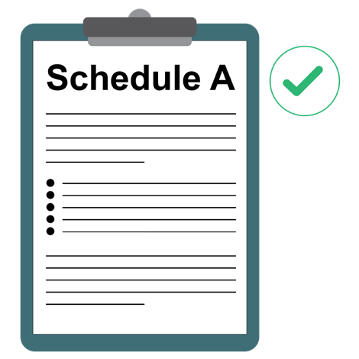Schedule A of the agreement changes to match the new amounts of money that are decided on.

The Prime Minister, the Premiers and the Chief Ministers then sign an agreement to say that they will follow these changes.

## How to contact us

**You can email us at**

[ndisfinancialpolicy@dss.gov.au](mailto:ndisfinancialpolicy@dss.gov.au)

easyread.tech created this Easy Read document using original illustrations. Please do not use these illustrations without permission. Visit [easyread.tech](http://easyread.tech/) for more information.