Commonwealth, State and Territory Disability Ministers met on 30 August 2024 in Hobart.

The meeting focused on efforts to improve outcomes for the 5.5 million Australians with disability through the continued coordination of governments’ efforts across the disability ecosystem and reforms underway.

Ministers discussed the passage of the National Disability Insurance Scheme (NDIS) Amendment (Getting the NDIS Back on Track No 1) Bill 2024 (the Bill) on 22 August.

This includes changes agreed with the Council for the Australian Federation that confirmed co-governance arrangements, rulemaking and approval processes for the NDIS.   
Ministers acknowledged that with the enabling legislation in place there was still significant work ahead to jointly design the finer, practical elements of implementing the reforms with Australians with disability, including Rules and instruments and the new definition of NDIS supports. There was discussion on how the Commonwealth and states and territories would work together as co-governors of the NDIS.

Ministers discussed ongoing work to progress the scope and design of additional foundational supports, as agreed at the December 2023 National Cabinet meeting.

Ministers discussed the importance of engaging with the disability community on service design and planning for a first tranche of consultation on general foundational supports in the coming months.

Ministers progressed discussions on the approach to delivering a joint response to the Independent Review of the National Disability Insurance Scheme (NDIS Review), which is intended to be published no later than early December 2024. Ministers noted the importance of providing clarity to the disability community on the joint government response to recommendations of the NDIS Review in a timely way.

Ministers agreed to maintain momentum around reforms that form part of the joint Commonwealth, state and territory Disability Royal Commission recommendations, working closely with the disability community. Ministers noted that the Commonwealth, states and territories are all responsible for responding in a meaningful way to the DRC.   
Ministers agreed to provide a progress report to National Cabinet in late 2024, with reporting on all recommendations to commence from mid-2025.

Ministers received an update on the progress of the *Australia’s Disability Strategy   
2021-2031* (ADS) Review, including early findings and recommendations for updates to ADS.

Ministers noted that public consultations are currently open and agreed that the final draft of the ADS Review Report and ADS Review Consultation Report go forward to the November 2024 DRMC for endorsement, following careful consideration of the feedback and views of people with disability.

Minister Palmer provided an update on the Australia’s Disability Strategy Forum 2024 ‘Your Say, Your Way’ hosted by the Tasmanian Government, which was held on the same day as the DRMC meeting.

Ministers also discussed the development of a National Plan for Accessible Information and Communications as an Associated Plan under Australia’s Disability Strategy, in response to joint recommendation 6.1 of the Disability Royal Commission.

Ministers welcomed the release of the Aviation White Paper, particularly the strong focus on improving the experiences of people with disability. Ministers noted the Aviation White Paper is another example of how *Australia’s Disability Strategy 2021-2031* is creating change across government to create a more inclusive society for Australians with disability.

Ministers agreed for an initial version of the Disability Reform Roadmap to be released on the Department of Social Services’ website. The roadmap provides the timing and sequencing of the key disability reforms. This is an important initial step in providing the disability community with further clarity on the work underway. It will be updated as further timelines are agreed.

The Ministers were updated on the National Disability Insurance Agency (NDIA) pricing initiatives underway following release of the 2023-2024 Annual Pricing Review (APR). Ministers noted the update on progress on the independent review of the NDIS pricing structure, Quality Supports Program, and preliminary work the Independent Health and Aged Care Pricing Authority, Department of Social Services and NDIA are doing on the   
long-term approach to pricing and payments in the NDIS. Ministers discussed challenges observed in the market following the APR.

Due to the timing of swearing in the new NT ministry following the recent election, the NT Minister was not able to attend. The WA Minister was also an apology for this meeting.

The next DRMC meeting will be held in November in Adelaide.

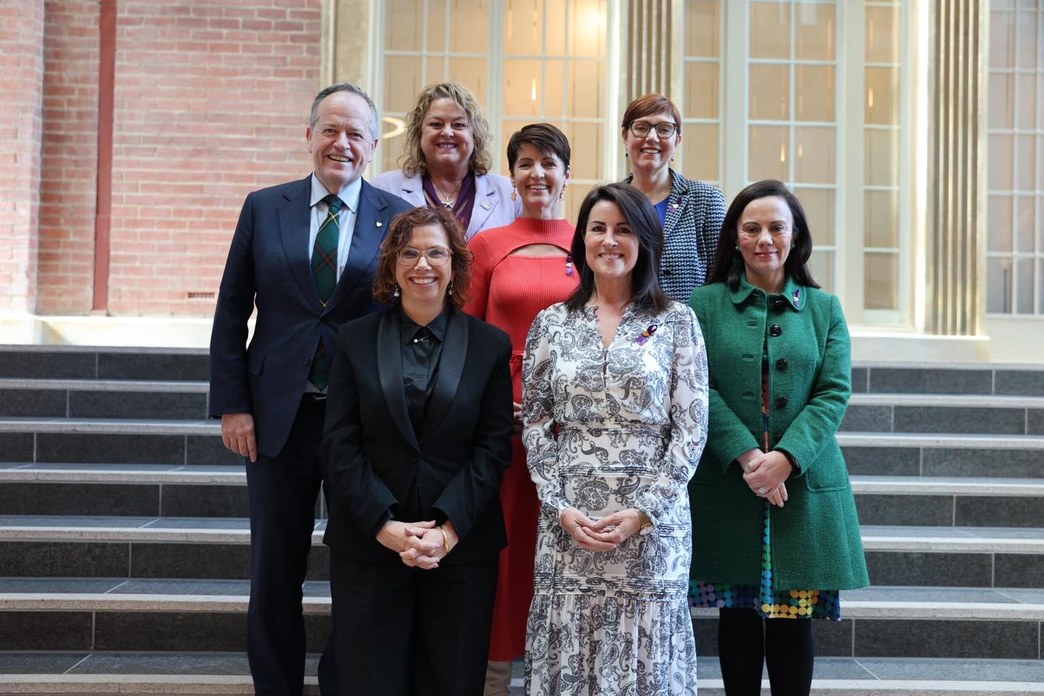

Image – Clockwise from left: Minister Shorten (Minister for the NDIS); Minister Cook (SA), Minister Washington (NSW) , Minister Stephen-Smith (ACT), Minister Blandthorn (VIC), Minister Palmer (TAS), Minister Rishworth (Minister for Social Services).

Online: Minister Mullen (QLD)

`