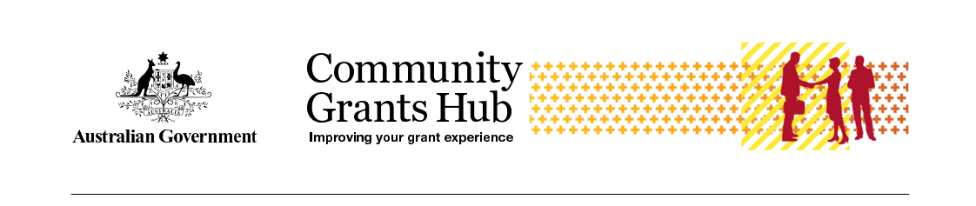

Child Safe Compliance
  - Frequently Asked Questions for Grantees

Why do we have a Child Safe clause in Department of Social Services grant agreement?
The Royal Commission into Institutional Responses to Child Sexual Abuse highlighted the need for organisations to adopt practices to provide an environment in which children and young people are safe, protected and respected, and where staff have the skills, confidence and knowledge to safeguard children.
In response, the Australian Government introduced the Commonwealth Child Safe Framework (the Framework), a whole-of-government policy that sets minimum standards for creating and embedding a child safe culture and practice in Commonwealth entities.
One part of the Framework is for Commonwealth entities to impose child safe obligations on grantees through grant agreements. The Department of Social Services (the department/DSS) includes Child Safe clauses in any grant that, in delivering the activity, may involve interaction with children.
Child Safe clauses articulate the requirements that grantees are to meet, committing them to their child safe obligations and driving better child safe outcomes.

How does DSS decide which Child Safe clause to use?
A Child Safe clause will be found in your grant agreement, either CB9 or G8A. The following criteria are used by the department to decide which clause to use:
CB9 - Direct contact is where there is direct access to a child, such as through care, training, counselling, consultation, administering medication, or as an employee or volunteer at the organisation, regardless of the level of employee supervision. For example:
- providing early childhood learning services to children, either face to face or online
- providing telephone counselling services to primary school aged children
- teaching children to abseil at an outdoor mentoring program
- delivering online or face to face music therapy sessions to children with autism.
More than incidental to the activity is contact or interaction with children as part of the activity that is more than irregular or unplanned and could occur if grant personnel are likely to be, for example:
- physically touching a child
- building a rapport with a child as an integral and ordinary part of performing the activity or having contact with multiple children.
G8A -Incidental contact happens in connection with, or resulting from, the main purpose of the activity that required the contact. It can be interpreted as contact that is likely to be irregular or unplanned, arising as a chance or minor consequence. For example:
- a plumber fixes a blocked drain at a junior sports club where children are training a child or children accompany their parents to an appointment at a consumer law centre where the parents are discussing problem gambling matters with a consumer lawyer and the child, or children are in the same room.

Where do I find the Child Safe clause?
Child Safe clauses can be found in the Supplementary Terms of your grant agreement, or in a Deed of Variation (where the clause was included after signing the initial agreement). A copy of both clauses can be found on the DSS website.

What if I can’t find a Child Safe clause in the agreement?
Child Safe clauses are found in the Supplementary Terms of your grant agreement under the heading ‘Child Safe’. The clause number will be either G8A or CB9, depending on the type of agreement you have with the department. You will also have a compliance milestone listed in your milestone list in the grant agreement.
The Child Safe clause may have been added to your agreement by a variation. If your original agreement was executed before March 2020, the clause and the compliance milestone will be in a variation.
If you still cannot find the Child Safe clause in your agreement documents, you can contact your Funding Arrangement Manager or you can use the following contacts provided below for further assistance.

State | Email Contact
NSW/ACT | NSWACTperformance@communitygrants.gov.au
​QLD | QLDperformanceDSS@communitygrants.gov.au
​VIC | VICperformanceDSS@communitygrants.gov.au
​​NT | NTperformanceDSS@communitygrants.gov.au
​SA | ​SAperformanceDSS@communitygrants.gov.au
WA | WAperformanceDSS@communitygrants.gov.au
​TAS | ​TASperformanceDSS@communitygrants.gov.au

What are my child safe obligations?
Specific obligations are set out in the Child Safe clauses in your agreement. However, in summary:
- You must comply with all legislation related to the employment (including volunteers) of child-related personnel.
- Child related personnel must have and maintain working with children checks.
- You must make an annual Statement of Compliance against the Child Safe clause.
If you have the CB9 Clause, you will also need to take a number of measures to implement and monitor the National Principles for Child Safe Organisations.
Grants varied or entered into during or after 2022 should also include a requirement to impose the same child safe obligations to subcontractors.

What is the compliance period?
The Statement of Compliance is retrospective and applies to the previous calendar year (1 January to 31 December). Statements are due 31 March the following year.

Do Child Safe clauses apply to subcontractors?
Grants entered into (or varied) after 2021 should also include a requirement to impose the same child safe obligations to subcontractors that may have interactions with children in delivering the activity. You should use the criteria in question 2 to impose these obligations on subcontractors.
A subcontractor Decision Tree at Diagram 1 has been developed for grantees to help them understand where subcontractors should adopt the same child safe obligations.
It is your responsibility to ensure subcontractors are compliant with child safe obligations. You will certify this in your annual Statement of Compliance to the department.
If a subcontractor is non-compliant then you will need to state that your organisation is also non-compliant in your annual statement. If this happens, you have the opportunity to explain these circumstances and what steps you are taking to remedy this in the Statement of Compliance form.
Further information on subcontractor arrangements is on the National Office for Child Safety website.

What if I do not work with children?
If you demonstrate that it is highly unlikely or there is a very remote chance of contact with children in the delivery of the grant, it is possible to have the Child Safe clause removed.
You need to consider that while your activity may not provide services directly to children, you may have ‘incidental contact’ with children so will have a Child Safe clause in your agreement (see question 2 for the criteria used to include Child Safe clauses in an agreement).
If you have been sent a Statement of Compliance form to complete, your agreement with the Commonwealth includes a Child Safe clause and associated compliance milestone. You must submit an annual Statement of Compliance to the department in line with this agreement. If you are not compliant you have the opportunity to explain that the activity you are delivering for DSS does not involve interaction with children.

What if I am not compliant?
The department takes non-compliance with Child Safe clauses seriously. If you cannot comply, the department may apply sanctions, such as:
- requiring the grantee to become compliant by a set date (this must be added to the agreement as a new milestone)
- additional reporting requirements for child safety (that is, new reporting milestones)
- blocked payments
- termination of the agreement
- being ineligible for future DSS grants
- being reported to the relevant authorities.
In the Statement of Compliance, you will be asked to provide details about why you are not compliant. You should refer to specific clause you are not compliant with and what you are doing to address this.
The department will be contact you after reviewing your explanation to discuss the situation and what actions to take.

What is the timing of Child Safe Compliance process?
Statements of Compliance will be issued on 1 March and are due by 31 March.

What is the Statement of Compliance form?
The Statement of Compliance is a declaration that you are compliant with the Child Safe clauses in your agreement. The statement is a copy of the text in your Child Safe clause and you will need to check a box indicating if you are compliant with the clauses.
The statement is an electronic template issued by the department via email. The email will contain instructions on accessing and completing the statement.
Grantees registered with the Grant Recipient Portal will be prompted to access the Statement of Compliance directly from the Portal. If your organisation is registered for the Portal, it is recommended you confirm you have a digital identity and are linked to your organisation so there is no delay in submitting your Statement of Compliance. If you need assistance accessing the Grant Recipient Portal, please visit the Grant Recipient Portal Access page.
Grantees not registered for the Grant Recipient Portal will receive a link and code to access the Statement of Compliance. Grantees should click on the link, copy and paste the access code (provided in the notification email), and enter their organisation ID (listed at the top of the grant agreement) as the password.
If you have multiple activities (with Child Safe clauses), you must submit a statement for each activity.

What if I fail to submit my Statement of Compliance?
You are required to submit your Statement of Compliance as a requirement of your grant agreement. Failure to submit the Statement of Compliance could result in a breach of the agreement and may impact current funding arrangements and future grant applications for DSS funding.

What has changed in the Statement of Compliance for 2024?
Alongside the check box responses in the Child Safety Compliance form, the department is interested in understanding how grantees meet their Child Safety clauses. This year a small number of grantees with the CB9 clause will be asked to answer an additional free-text question:
Please provide a description of how you have implemented the Child Safe clause (maximum 2,000 characters)
There will be no changes to the form or check box responses for grants with the G8A clause.

Who receives the Statement of Compliance reminder emails and notifications?
Both the reminder emails and the notification to submit the Statement of Compliance are issued to the grantee’s program schedule primary contact.

Who needs to sign the Statement of Compliance?
The Statement of Compliance must be completed by the head of the organisation, CEO or an authorised person in an equivalent position.

Is compliance declared for the funded activity or for the whole organisation?
Grantees must submit a Statement of Compliance for each funded activity. Therefore, when a grantee has multiple activities they will receive, and need to submit, a Statement of Compliance for each activity.
Up to 2022 we did ask grantees to provide a single statement for all grants. However, a review of the Commonwealth Child Safe Framework, Child Safe Clauses in the Clause Bank (Department of Finance) and consultation with the National Office for Child Safety (NOCS), identified that we cannot hold the whole organisation to the Child Safe clause, only the activities that they deliver.

Can I get an extension?
No, extensions to submit a statement of compliance will not be granted. If you are unable to submit the statement of compliance by 31 March, please contact your Funding Arrangement Manager as soon as possible. If you are non-compliant you must tell the department which measures in the Child safe clause you are non-compliant with and how and when you will become compliant. This advice should be included in the statement in the text box provided.
The department expects any non-compliance is addressed rapidly and may ask for evidence of compliance.

What if I cannot access or use the Smart Form (Statement of Compliance)?
The forms are accessed from a link in the notification email.
Grantees registered with the Grant Recipient Portal will be prompted to access the Statement of Compliance directly from the Portal. If you need assistance accessing the Grant Recipient Portal, please visit the Grant Recipient Portal Access page.
Grantees not registered for the Grant Recipient Portal will receive a unique link and code to access the Statement of Compliance. Grantees should click on the link, copy and paste the access code (provided in the notification email), and enter their organisation ID (listed at the top of the grant agreement) as the password.
For technical assistance with accessing, using or submitting the form, please contact the Community Grants Hub Helpdesk on 1800 020 283 (option 5).

What if I received an incorrect Statement of Compliance?
If you receive an email for the wrong Child Safe clause email childsafetycompliance@communitygrants.gov.au noting you have received the wrong form and provide your activity ID and organisation name. Can I submit my Statement of Compliance manually?
To request a manual lodgement form email childsafetycompliance@communitygrants.gov.au childsafetycompliance@communitygrants.gov.au and provide your activity ID, organisation name and the email address we need to send the Statement to.

What if I deleted the Child Safe Compliance email or it was sent to the wrong person?
If you need to request an email to be reissued, please contact childsafetycompliance@communitygrants.gov.au telling us if you’ve deleted the email or if it was sent to the wrong person. In that email provide your activity ID, organisation name and the email address where the Statement of Compliance should be sent.

What if I received an overdue notice but have already submitted my Statement of Compliance?
Overdue notices are triggered automatically. If you have received an overdue notice in error, please contact childsafetycompliance@communitygrants.gov.au so we can investigate your record.

Are there resources to help me to meet my obligations?
There are a range of resources available to help you understand and meet your child safe obligations.
- The National Office for Child Safety (link is external) has resources and information to assist grantees to implement, develop and meet their child safe obligations.
  - National Principles for Child Safe Organisations (link is external)
- Specific to child safety compliance requirements:
  - Child Safety Risk Management Resources (link is external) includes guides and templates to support grantees risk assessment.
  - Section 3.1 in the Commonwealth Child Safe Framework (link is external) lists relevant State and Territory legislation and policy.
- The Australian Human Rights Commission has:
  - 11 free professional learning units (link is external) on the National Principles
  - An introductory self-assessment tool (link is external) for child safe organisations
- The Australian Institute of Family Studies:
  - Pre-employment screening: Working With Children Checks and Police Checks.

Diagram 1: Decision Tree
Diagram of decision tree used to determine what level of child safety obligations will be applied to a grant.
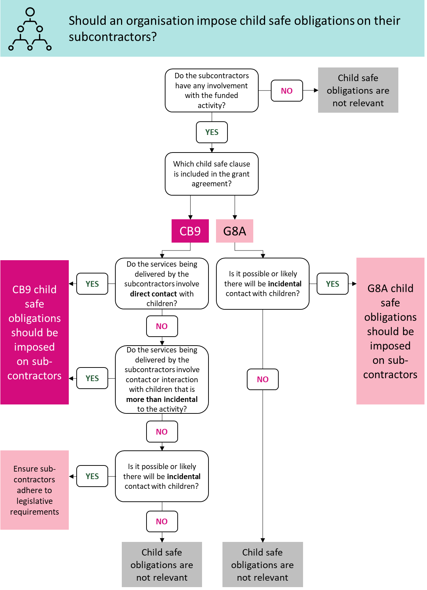

Long text for Decision Tree - should an organisation impose child safe obligations on their subcontractors?

Do the subcontractors have any involvement with the funded activity?
No - Child safe obligations are not relevant
Yes - Which child safe clause is included in the grant agreement?

CB9
Do the services being delivered by the subcontractors involve direct contact with children?
Yes - CB9 child safe obligations
No Do the services being delivered by the subcontractors involve contact or interaction with children that is more than incidental to the activity
Yes - CB9 child safe obligations should be imposed on subcontractors
No - Is it possible or likely there will be incidental contact with children?
Yes - ensure subcontractors adhere to legislative requirements
No - child safe obligations are not relevant

G8A
Is it possible or likely there will be incidental contact with children
Yes - G8A child safe obligations should be imposed on subcontractors
No - Child safe obligations are not relevant

Children/Child/Young Person refers to an individual under 18 years.
Child related personnel means officers, employees, contractors (including subcontractors), agents and volunteers of the Grantee involved with the Activity who as part of that involvement may interact with children.
If you have Clause G8A in your agreement you may still be compliant, as this clause applies to “Child Related Personnel’ (see question 4). You should still contact your Funding Arrangement Manager to discuss if this clause is appropriate to remain in your agreement.
Reporting at the activity level aligns with the National Office for Child Safety advice. Organisations funded by other Commonwealth agencies will report separately covering all funded programs/activities specific to that Commonwealth agency.

