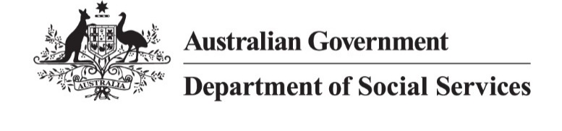

# NDIS Reform Community Catch Up

Sydney NSW

Wednesday 8 May 2024

## Overview

The Department of Social Services (DSS) held a community catch up so the people attending could ask questions about NDIS reforms with the Minister for the National Disability Insurance Scheme (NDIS), Hon Bill Shorten MP, on Wednesday, 8 May 2024, at the Sydney Masonic Centre.

**Speakers included:**

* Hon Bill Shorten MP, Minister for the NDIS
* Rebecca Falkingham, NDIA CEO
* Mike Phelan, Acting NDIS Quality and Safeguards Commissioner

**Event goals:**

* Provide information about the NDIS reform
* Answer questions from the community

**Opportunities for Participants:**

* Voice their concerns
* Ask questions for clarification
* Give input on the reform process

Minister Shorten explained that the overarching goal of any NDIS reform is to put people with disability back at the centre of the NDIS and to create a sustainable NDIS for future generations, together.

## Key points from the discussion

The NDIS reforms aim to improve the scheme's consistency, equity and sustainability while staying true to its original purpose.

Key points discussed:

* **Legislation –** the legislation introduced into the Commonwealth Parliament on 27 March sets up a framework for future implementation. It is ‘enabling legislation’ consistent with the NDIS Review recommendations. It is essential to a more personal, fair and sustainable NDIS.
* **Decision Making** – this is an important step in making sure all people with disability are receiving fair and consistent decision through a more transparent decision-making framework.
* **Making the NDIS Stronger** – through greater clarity on how you access the NDIS, and a new planning framework that is centred around participants needs receiving a ‘reasonable and necessary budget’. Greater clarity for participants that NDIS Supports are individual to each participant and the supports that they need. And additional quality and safeguard provisions to expand the powers of the NDIS Commission to mitigate the risk to participants of exploitation or coercion from another person.

## Questions answered

Participants asked questions live from the floor using microphones in the room. Minister Shorten, NDIS CEO Falkingham and Acting NDIS Commissioner answered questions about the NDIS reforms directly from the audience.

Key topics included:

* Concerns about changes to support coordination and navigation services
* Inquiries about foundational supports and their implementation
* Questions about approval delays for assistive technology and prosthetics
* Requests for more transparency in NDIS data, particularly around participant outcomes
* Concerns about provider conflicts of interest and quality of care.

## Closing remarks

Minister Shorten acknowledged that there is an enormous amount of work to do to implement the reforms, together, and this is just the start.

We’re in this together for the long term – its about getting the changes right to ensure the NDIS is the best it can be.

The goal is to humanise the NDIS for participants, and to stop the exploitation of the NDIS, to make sure the NDIS sustainable for the future.

There’s a lot to do, this is just the start, but we want to do it together, with you, for you.