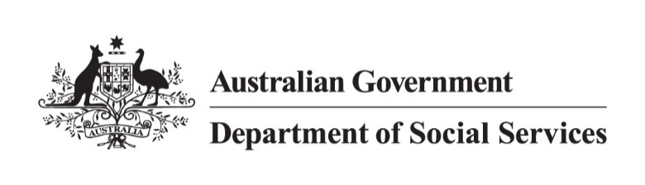

# NDIS Reform Community Catch Up

Perth WA

Tuesday 21 May 2024

## Overview

The Department of Social Services (DSS) held a community catch up so the people attending could ask questions about NDIS reforms with the Minister for the National Disability Insurance Scheme (NDIS), Hon Bill Shorten MP, on Tuesday 21 May 2024, at the Parmelia Hilton Hotel in Perth WA, it was also livestreamed to a virtual audience.

**Speakers included:**

* Hon Bill Shorten MP, Minister for the NDIS
* Rebecca Falkingham, NDIA CEO

**Event goals:**

* Provide information about the NDIS reform
* Answer questions from the public
* Help people understand the upcoming changes to the NDIS

**Opportunities for Participants:**

* Voice their concerns
* Ask questions for clarification
* Give input on the reform process

## Minister Shorten explained that the overarching goal of any NDIS reform is to put people with disability back at the centre of the NDIS and to create a sustainable NDIS for future generations, together.

## Key points from the discussion

The NDIS reforms aim to improve the scheme's consistency, equity and sustainability while staying true to its original purpose.

Key points discussed:

* **Sustainable Growth:** Working towards an 8 percent annual growth for the NDIS to ensure its long-term sustainability.
* **Foundational Supports:** Are part of a connected system of support for people with disability. The connected system includes inclusive and accessible mainstream services, general Foundational Supports for all people with disability, and targeted Foundation Supports for people with lower-level support needs who are not eligible for the NDIS.
* **Reducing Administrative Appeals Tribunal (ATT) Cases:** Efforts to decrease the number of cases going to the ATT.
* **Improving Agency Staffing:** Increasing NDIA staff numbers to better support NDIS participants in a more timely and consistent manner.
* **Remote Service Delivery:** Focusing on improving services in remote areas, particularly for Indigenous communities.
* **Communication and Accessibility:** Efforts to improve communication with participants and make plans more accessible.

## Questions answered

Participants asked questions live in the room. The minister answered questions about the NDIS reforms directly from the audience.

Key topics included:

* Concerns about changes to support coordination
* Questions about overcharging by service providers
* Inquiries about service delivery in remote areas
* Requests for improved communication and accessibility of information
* Concerns about approval delays and the AAT process

## Closing remarks

Minister Shorten emphasised that the NDIS is changing lives for the better but acknowledged that improvements are needed. He stressed the importance of making the scheme sustainable while ensuring it remains true to its original purpose of supporting people with disabilities.

NDIS CEO Falkingham highlighted efforts to improve the Agency's operations, including reducing AAT cases, addressing overcharging, and improving communication with participants.

The Minister highlighted the importance of continued consultation and co-design with the disability community as reforms are developed and implemented.

He also noted that this community catch-up is part of an ongoing consultation process, encouraging continued input from the disability community.​​​​​​​​​​​​​​​​

There’s a lot to do, this is just the start, but we want to do it together, with you, for you.