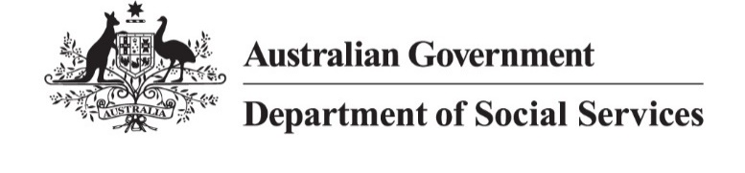

# NDIS Reform Community Catch Up

Brisbane QLD

Wednesday 24 May 2024

## Overview

The Department of Social Services (DSS) held a community catch up so the people attending could ask questions about NDIS reforms with the Minister for the National Disability Insurance Scheme (NDIS), Hon Bill Shorten MP, on Wednesday, 24 May 2024, at the Brisbane Convention Centre it was also livestreamed to a virtual audience.

**Speakers included:**

* Hon Bill Shorten MP, Minister for the NDIS
* Rebecca Falkingham, NDIA CEO
* Mike Phelan, Acting Quality and Safeguards Commissioner

**Event goals:**

* Provide information about the NDIS reform
* Answer questions from the public
* Help people understand the upcoming changes to the NDIS

**Opportunities for Participants:**

* Voice their concerns
* Ask questions for clarification
* Give input on the reform process

## Minister Shorten explained that the overarching goal of any NDIS reform is to put people with disability back at the centre of the NDIS and to create a sustainable NDIS for future generations, together.

## Key points from the discussion

The NDIS reforms aim to improve the scheme's consistency, equity and sustainability while staying true to its original purpose.

Key points discussed:

* **NDIS Growth:** The scheme has grown significantly, now serving 646,000 participants with a budget projected to reach over $50 billion in four years.
* **Equitable Access:** Concerns about inequitable access based on factors like location and socioeconomic status.
* **Outcome Focus:** Need to shift focus from inputs to outcomes for participants.
* **Provider Oversight:** Addressing issues with some service providers overcharging or misusing funds.
* **Foundational Supports:** Are part of a connected system of support for people with disability. The connected system includes inclusive and accessible mainstream services, general Foundational Supports for all people with disability, and targeted Foundation Supports for people with lower-level support needs who are not eligible for the NDIS.
* **Legislative Changes:** the legislation introduced into the Commonwealth Parliament on 27 March sets up a framework for future implementation. It is ‘enabling legislation’ consistent with the NDIS Review recommendations. It is essential to a more personal, fair and sustainable NDIS.

## Questions answered

Participants asked questions live from the floor. The minister answered questions about the NDIS reforms directly from the audience.

Key topics included:

* Concerns about assessment processes for degenerative conditions
* Questions about potential changes to NDIS access, particularly for autism and psychosocial disabilities
* Concerns about support for individuals with complex needs who don't qualify for NDIS
* Questions about improving planner understanding of specific conditions
* Concerns about abuse and neglect cases and provider accountability
* Questions about self-management options in future reforms

## Closing remarks

Minister Shorten acknowledged that there is an enormous amount of work to do to implement the reforms, together, and this is just the start.

We’re in this together for the long term – it’s about getting the changes right to ensure the NDIS is the best it can be.

The goal is to humanise the NDIS for participants, and to stop the exploitation of the NDIS, to make sure the NDIS sustainable for the future.

There’s a lot to do, this is just the start, but we want to do it together, with you, for you.