# What happened at the NDIS Review Town Hall events

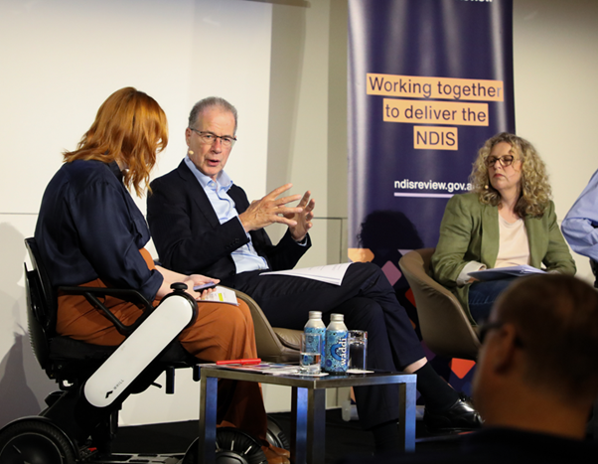

# 

## Contents



About this document Page 3



About the NDIS Review Page 4

NDIS Review Town Hall events Page 6

New types of support for people with disability Page 9

Navigators in the NDIS Page 13

Planning Page 16



Service provider registration Page 18

What happens next? Page 20

## About this document

|  |  |
| --- | --- |
|  | This document is about what happened at the **NDIS Review Town Hall** events. |
|  | This document is written in Easy Read. |
|  | It is a good idea to read this document with support. |
|  | Hard words are in **bold**.  We have written what they mean. |

## About the NDIS Review

|  |  |
| --- | --- |
|  | The NDIS Review looked at   * What works well in the NDIS * What needs to change in the NDIS * How to make the NDIS last a long time. |
| **10 thousand** | Over 10 thousand people told the NDIS Review what they think about the NDIS and how it could be better. |
|  | The **NDIS Review Panel** is a separate group that   * Looked closely at the NDIS * Came up with ideas to make the NDIS better. |
|  | The NDIS Review Panel gave a report to the Government in October 2023.  The report has ideas about how to make the NDIS better for everyone. |
|  | The Australian Government is still deciding what to do about the NDIS Review ideas. |

## NDIS Review Town Hall events

|  |  |
| --- | --- |
|  | The **NDIS Review Town Hall events** are a way for people to   * learn more about the ideas to make the NDIS better * ask questions about the NDIS Review ideas. |
|  | The events were run by the Department of Social Services. |
|  | The events were open to the disability community   * People with disability and their families * Supporters of people with disability * Disability organisations * Disability service providers. |
|  | The Town Hall events happened on   * 14 December 2023 in Melbourne * 18 December 2023 in Sydney * 25 January 2024 in Brisbane * 19 February 2024 in Perth * 5 March 2024 in Adelaide * 13 March 2024 in Darwin * 14 March 2024 in Hobart * 19 March 2024 in Canberra. |
|  | People came along to the events   * In person * Online. |
|  | Disability Minister Bill Shorten was a special guest at the events. |
|  | At the events the NDIS Review Panel talked about their ideas about how to make the NDIS better. |
|  | People asked the Panel lots of questions about their ideas to change the NDIS. |
|  | In this document you can read the answers to some of the questions. |
|  | At the end of each event Bill Shorten was joined by 2 people with disability to talk about what the Panel had said. |

## New types of support for people with disability

|  |  |
| --- | --- |
|  | The Panel wants all Australians with disability to get the support they need.  This means   * People on the NDIS   and   * People under 65 years old who cannot get the NDIS. |
|  | The NDIS is only meant for people with disability who have high support needs. |
|  | This means there are a lot of people with disability who cannot get NDIS. |
|  | It is hard for anyone who is not on the NDIS to get the support they need. |
|  | The Panel wants the Government to bring in 2 new types of support   * **Foundational supports** * **Targeted supports.** |
|  | The Panel says these changes will   * Help the NDIS focus on people with disability with high support needs * Make sure people who cannot get the NDIS still get the supports they need. |
|  | **Foundational supports** are supports that would be available for all Australians with disability. |
|  | **Foundational supports** are things like   * Advice and information * Employment support * **Advocacy** services   These are places that help people with disability to speak up and stand up for their rights   * **Peer support groups**   This is where people with disability get together to give each other advice and support. |
|  | Foundational supports would take over from what we call **Information, Linkages and Capacity Building**, or ILC for short. |
|  | **Targeted supports** are for people with disability who cannot get the NDIS.  Things like   * Support at home and in the community * Equipment * Mental health support * **Early intervention**   This is extra support for children with disability. |

## Navigators

|  |  |
| --- | --- |
|  | People told the NDIS Review that the NDIS is confusing and hard to understand without support. |
|  | The Panel wants to fix this by bringing people called **navigators** into the NDIS.  Navigators would support people with disability and their families to   * Get the NDIS * Understand their NDIS plan * Find good supports and services. |
|  | Navigators would also help people with disability who cannot get the NDIS to get the supports and services they need. |
|  | There would be navigators instead of the Support Coordinators and Local Area Coordinators that we have now. |
|  | There will be specialist navigators to support NDIS participants with **complex support needs.**  This means people who have more than 1 system in their life  For example   * The health system * The criminal justice system.   Specialist navigators will also   * help NDIS participants find and try out different housing options * support people with **psychosocial disability** to find the right supports   This means people who have a disability because of their mental health   * support children on the NDIS and their families. |
|  | The Panel says having navigators means   * it will be easier for people with disability and their families to understand the NDIS * people who cannot get the NDIS will still get help to find supports. |

## Planning

|  |  |
| --- | --- |
|  | The NDIS Review Panel wants NDIS planning to be better for people with disability.  This means NDIS participants will   * Get more say in what supports they get and who provides them * Get resources they can access * Be given enough time and information to make their own decisions about their NDIS plan * Be supported to make their own decisions about their NDIS plan. |

## Service provider registration

|  |  |
| --- | --- |
|  | The NDIS Review Panel says they think all NDIS service providers should be **registered.**  This means people and places that support NDIS participants will be checked to make sure they are doing a good job. |
|  | At the moment NDIS participants can choose to use registered or unregistered providers. |
|  | The Panel says registration would make the NDIS safer for participants. |
|  | People said they are worried that registration will take choice and control away from NDIS participants. |
|  | Bill Shorten said the NDIS will set up a team to help NDIS participants and service providers understand registration. |

## What happens next?

|  |  |
| --- | --- |
| **2024**  **2025** | Bill Shorten said he wants to see changes to the NDIS start in the next 12 months. |
|  | The Australian government will work together with   * State and territory governments * People with disability * First Nations people |
|  | Bill Shorten said they will make sure there is easy information to help people understand the NDIS changes |
|  | For more information go to <https://www.dss.gov.au/disability-and-carers-programs-services/ndis-reforms> |