Disability Employment Services (DES):

Provider Performance Framework
July 2024

Disclaimer
This document is not a stand-alone document and does not contain the entirety of Disability Employment Services (DES) providers' obligations. It should be read in conjunction with the DES Grant Agreement and any relevant guidelines or reference material issued by the Department of Social Services under or in connection with the DES Grant Agreement. If there is any inconsistency between this document and the DES Grant Agreement, then the DES Grant Agreement will have precedence.

Copyright notice
This document Disability Employment Services (DES): Provider Performance Framework is licensed under the Creative Commons Attribution 4.0 International Licence
Licence URL: https://creativecommons.org/licenses/by/4.0/legalcode
Please attribute: © Commonwealth of Australia (Department of Social Services) 2024
Notice:
- If you create a derivative of this document, the Department of Social Services requests the following notice be placed on your derivative: Based on Commonwealth of Australia (Department of Social Services) data.
- Inquiries regarding this licence or any other use of this document are welcome. Please contact: Branch Manager, Communication Services Branch, Department of Social Services. Phone: 1300 653 227. Email: communications@dss.gov.au
Notice identifying other material or rights in this publication:
- Australian Commonwealth Coat of Arms — not Licensed under Creative Commons, see https://www.itsanhonour.gov.au/coat-arms/index.cfm
- Certain images and photographs (as marked) — not licensed under Creative Commons

Table of contents
Disclaimer i
1. Introduction 2
1.1. A new provider Performance Framework 2
1.2. Designing a new DES model 2
2. Managing provider performance 4
2.1. Funding model 5
2.2. DES Grant Agreement 5
2.3. National Standards for Disability Services Certification 5
2.4. Provider Performance Framework 6
2.5. Scorecard Report 6
3. Provider Performance Framework 7
3.1. Guiding principles 7
3.2. Key performance measures 8
3.2.1 Effectiveness measures and indicators 9
3.2.2 Efficiency measures and indicators 10
3.3. Scorecard report 10
3.3.1 Participants 10
3.3.2 Providers 14
3.4. Management and review 16
Appendix A – Glossary 17

Introduction

A new provider Performance Framework
The Australian Government is committed to ensuring that Australians with disability have equal opportunities to improve social inclusion, participate in the community and gain mainstream and sustained employment.
To measure provider performance, the Department has developed a provider Performance Framework (Performance Framework) which replaces the DES 2018 Performance Framework, Star Ratings (2018) and Interim Performance Measures (2023). It includes measures on achieving outcomes for participants and encompasses the Quality Framework which was implemented on 1 July 2023.
The new Performance Framework will be in place from 1 July 2024. It will monitor, measure, and drive continuous improvement of providers against an agreed set of key performance measures and work with them to continuously improve the overall performance of the program. This will assist in achieving meaningful and sustainable employment outcomes for participants.
The Performance Framework is supported by a Scorecard, which communicates provider performance against the measures. The Scorecard aims to assist providers to assess their performance and continuously improve the quality of their services. Over time, the Scorecards will also be provided to participants to help them make an informed choice in choosing their preferred provider. The overarching objective of the Performance Framework is to measure and drive a high performing disability employment service that supports individuals to find and maintain sustainable employment.
This objective is achieved by delivering on the following four supporting objectives:
- Empower participants, their families, and carers to achieve better quality outcomes with providers.
- Enable employers to make informed choices on the providers they choose to work with.
- Enable Government to assess and manage the performance of providers and transparently communicate the quality of DES program services.
- Drive continuous improvement of provider performance and service quality.
Performance will be monitored and assessed regularly. Information will be publicly available (after an initial testing phase) for external stakeholders to view, with tailored information provided to participants and providers on a timely and frequent basis.

Designing a new DES model
The Australian Government knows that people with disability and employers require a service that meets their needs and provides the right support. To ensure the future model is best placed to meet the needs of participants and employers the Government has committed to reforming disability employment services.
As part of the 2024-25 Budget, the Australian Government announced that a new specialist disability employment program will commence on 1 July 2025. The new program will replace the current DES program.
The Department is working with people with disability, providers, employers and other stakeholder groups on the implementation of a new DES model which is designed to:
- Continue the Government’s focus on program service quality, including embedding the Quality Framework in overall performance.
- Enable greater transparency about the performance of services and the process to monitor performance.
- Implement a redesigned Performance Framework that assesses the quality of services delivered and the successful achievement of education and employment outcomes for participants.
- Facilitate flexible supports which meet the needs of people with disability.
- Revise the Funding Model to enable providers to invest in participants’, recognise and reward quality outcomes and maintain provider viability to deliver quality services.
- Strive for greater alignment and interoperability with other programs and services, such as Workforce Australia and the National Disability Insurance Scheme.

The Performance Framework will evolve in line with changes to the DES Program over time.

Managing provider performance
The objective of the DES program is to support people with disability to find and maintain sustainable employment in the open labour market. The DES program focuses on the needs of people with disability or injury to help them achieve greater social inclusion, boost employment participation, and better meet the needs of employers.
The DES program is delivered by a network of approved providers who deliver services in line with the Grant Agreement. The Department has a key role in managing approved provider performance including:
- The management of service providers against the DES Performance Framework and Grant Agreement.
- Program management, assurance, and ensuring providers maintain compliance with the National Standards for Disability Services (NSDS).
Figure 1 provides an overview of the key components of the DES program managed by the Department and broader Government. Together the Grant Agreement, NSDS, Funding Model, Performance Framework and Scorecard will assist the Department in managing provider performance and drive continuous improvement in performance and service quality. This will facilitate providers to better meet the needs of participants and employers and deliver on the program objectives.
Figure 1: Overview of the DES Program
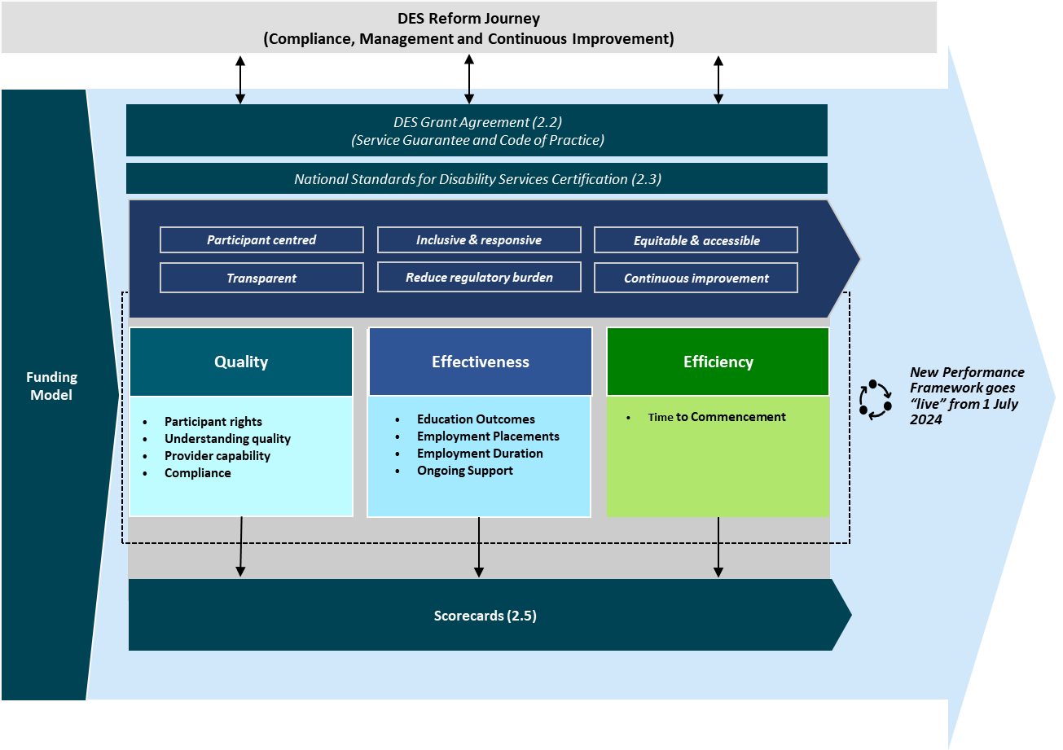
This section provides an overview of how the Department proposes to manage performance in the DES program and expands on Figure 1, which includes Funding Model, DES Grant Agreement, National Standards for Disability Employment Services Certification, Provider Performance Framework and Scorecards.

Funding model
The Department funds providers to deliver services to help participants gain skills, education, and meaningful and sustained employment. The risk-adjusted funding level (RAFL) model has been in place since 1 July 2018 which pays a differential fee to providers based on the propensity of a participant to find employment. The key factors that influence the propensity to find employment include:
- demographic characteristics
- duration variables
- labour market effects
- complexity of disability
- variables related to Job Seeker Classification Instrument (JSCI)
- barriers and condition flags

DES Grant Agreement
The DES Grant Agreement (2018) is a formal agreement between the Australian Government and service providers that deliver DES. The Grant Agreement outlines the terms, conditions, and expectations of providers in delivering services. This includes basic conditions, information and information management, administration services and fees.
The current Grant Agreement (Section 5Q) also states how the Department will monitor, measure, and evaluate a provider’s performance in accordance with Evaluation Activities and Key Performance Indicators: Quality, Effectiveness and Efficiency. The Department will also assess provider performance against a range of informal and formal assessments.
The Performance Framework has been developed to adhere to the current Grant Agreement. Future Grant Agreements will consider and align to the new DES Program and Performance Framework.

National Standards for Disability Services Certification
The National Standards for Disability Services (NSDS) outlines a set of standards that apply to disability service providers. It is intended to promote and drive a nationally consistent approach to improving service quality. The Standards focus on rights and outcomes for people with disability.
There are six National Standards that apply to disability service providers:
- Rights: The service promotes individual rights to freedom of expression, self-determination and decision-making and actively prevents abuse, harm, neglect, and violence.
- Participation and Inclusion: The service works with individuals and families, friends, and carers to promote opportunities for meaningful participation and active inclusion in society.
- Individual Outcomes: Services and supports are assessed, planned, delivered, and reviewed to build on individual strengths and enable individuals to reach their goals.
- Feedback and Complaints: Regular feedback is sought and used to inform individual and organisation-wide service reviews and improvement.
- Service Access: The service manages access, commencement and leaving a service in a transparent, fair, equal, and responsive way.
- Service Management: The service has effective and accountable service management and leadership to maximise outcomes for individuals.
Providers undergo an initial certification process to confirm compliance with the National Standards and conduct periodic self-assessments and audits over the life of the certification (three-years). The Quality Framework was developed to align with the NSDS and reduce the administrative burden placed on providers by incorporating the audit results and data into the Quality Framework and its assessment of provider performance.

Provider Performance Framework
The Performance Framework replaces the 2018 DES Performance Framework, Interim Measures and Star Ratings. It aims to monitor and measure the performance of providers against an agreed set of key performance measures and work with providers to continuously improve the overall performance of the program in achieving meaningful and sustainable employment outcomes for participants.
Section 3 provides further detail on the Performance Framework.

Scorecard Report
The Performance Framework will be supported by new Scorecards, which will help to report on provider performance against an agreed set of performance measures.
Data collected for the purposes of calculating the Scorecards will be used to support Government’s understanding of the performance of providers and broader program performance.
Further detail on the Scorecard Report and its application in practice is outlined in Section 3.

Provider Performance Framework
The Performance Framework has been designed to promote transparency and clarity in the way provider performance is assessed and communicated to stakeholders. It will drive the delivery of quality services to improve participant employment outcomes, social inclusion, and independence.
This section provides further information on the Performance Framework including Guiding Principles, Measures, Indicators, Scorecards, and implementation.

Guiding principles
In developing the Performance Framework, the Department has established nine guiding principles to assist in responding to the needs and priorities of program participants, employers, and providers to deliver on the broader program objectives.
The guiding principles for the Performance Framework align with the Quality Framework and have been informed by feedback from providers. They aim to provide a clear and concise direction for the design of the Performance Framework and reduce duplication.
Guiding principles
The Performance Framework is:
- Person-centred: Ensuring that participants are at the centre of service design, planning, procurement, delivery, monitoring, and evaluation.
- Transparent and accurate: Is simple to understand for all stakeholders and in particular, providers understand how performance is measured and assessed and have confidence in the accuracy of data.
- Inclusive and responsive: Promotes services that are inclusive and responsive.
- Equitable and accessible: Supports a service provision that is timely and accessible and is provided in a setting where supports are appropriate for meeting the needs and goals of people with disability.
- Outcomes focused: Focuses on outcomes and considers the activities and outputs that lead to sustained social, programmatic, and participant outcomes.
- Reduces administrative burden: Removes unnecessary administrative burden for providers, while still achieving its quality aims.
- Continuous improvement: Facilitates continuous improvement and innovation by promoting pathways to provide robust and timely feedback, including compliments and complaints.
- Accountable: Promotes accountability by clearly defining roles, responsibilities, and expectations of participants, providers, and Government.
- Flexible and collaborative: Enables the Performance Framework to evolve over time in-line with DES and stakeholders have the opportunity to be consulted in its evolution.

Key performance measures
From 1 July 2024 the Performance Framework will include three domains based on the Key Performance Indicators in the DES Grant agreement to assess provider performance. These measures are designed to provide a holistic view of provider performance and deliver insights that better match the needs of participants, employers, and Government.
The Performance Framework (Figure 2) comprises Domains, Measures, and Indicators. These are further defined as follows:
- Domains: There are three Domains: Quality, Effectiveness and Efficiency. The aim of each domain is to:
- Quality: Assess the quality of services delivered by providers as outlined in the Quality Framework and include participant rights, understanding quality, provider capability and compliance.
- Effectiveness: Assess the completion of education courses, the achievement of employment outcomes and the success of placing participants in sustainable employment.
- Efficiency: Assess the time taken for participants to commence in the DES program.
- Measures: Each Domain has one or more Measures that represent outcomes to be achieved.
- Indicators: Each Measure has one or more Indicators which determine how performance will be assessed. All indicators will be calculated at the individual contract level, provider level and program level.
Refer to the DES Quality Framework for further detail on the Measures and Indicators related to Quality.
A DES Performance Framework Methodology Report (Methodology Report) will supplement this Framework and will provide the detailed methodology and calculations that underpin the Performance Framework.
Figure 2: Provider Performance Framework
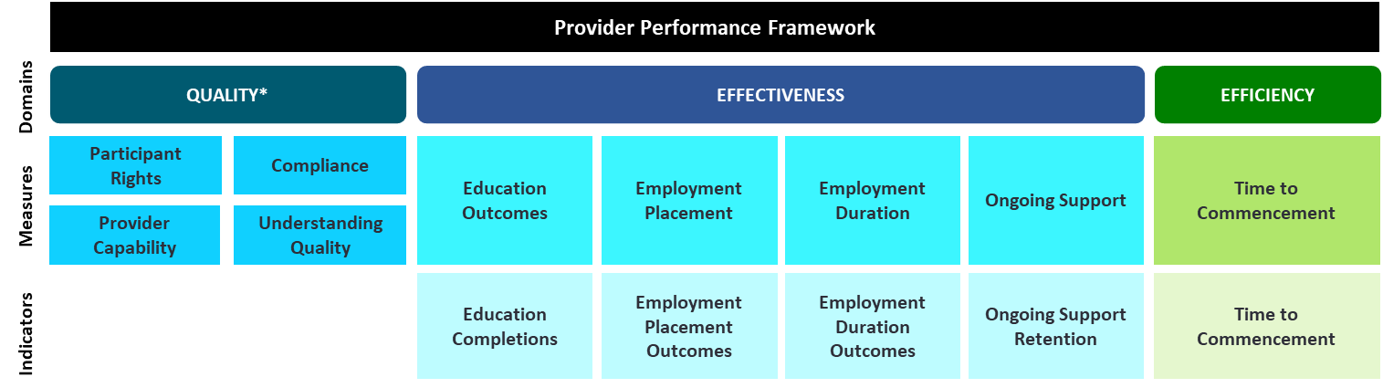

3.2.1 Effectiveness measures and indicators
Effectiveness measures the provider’s performance in assisting participants to complete education programs, the achievement of employment outcomes and the success of placing participants in sustainable employment. These indicators consider a participant’s readiness for employment and the potential investment required by providers to get a participant work ready. All indicators will measure performance over a 12-month rolling period.
Education Outcomes and Employment Placements are new measures with Employment Duration and Ongoing Support Measures previously captured under Star Ratings, however there may be differences in how the measures are calculated. These measures are presented in Table 1.
Table 1: Proposed Effectiveness measures and indicators
Measure | Indicator | Descriptions
Education Outcomes | Education Completions | Number of education outcome completions achieved by providers
Employment Placement | Employment Placements Outcomes | Number of 4-week employment outcomes achieved by providers
Employment Duration | Employment Duration Outcomes – 13 weeks | Number of participants with 4-week employment outcomes or anchors reaching 13-week employment outcomes
Employment Duration | Employment Duration Outcomes – 26 weeks | Number of participants with 4-week employment outcomes or anchors reaching 26-week employment outcomes
Employment Duration | Employment Duration Outcomes – 52 weeks | Number of participants with 4-week employment outcomes or anchors reaching 52-week employment outcomes
Ongoing Support | Ongoing Support Retention | Proportion of ongoing participants who remain in employment

The Education Completions indicator compares the actual numbers of participants achieving an education outcome to the number of people who started education. This indicator is not a count of the number of participants placed into training or education.
The Employment Placement Outcomes indicator compares the actual numbers of participants that achieve 4 weeks of employment to an estimated benchmark.
The Employment Duration Outcomes indicator compares the number of participants that achieve 13-week, 26-week and 52-week employment outcomes to an estimated benchmark for the same period (benchmarks are conditional on participants reaching a 4-week employment outcome or being in employment anchor for 4 or more weeks). In effect, the actual vs benchmark level is aiming to assess the proportion of participants in employment for 4 weeks that go on to achieve 13-week, 26-week and 52-week outcomes.
The Ongoing Support indicator is the proportion of Ongoing Support participants who have a current Ongoing Support assessment and remain in employment or exit Ongoing Support as an independent worker and have their employment verified.

3.2.2 Efficiency measures and indicators
Efficiency is designed to measure the time taken for a participant to commence with a provider (Table 2) and compares the actuals of the time taken from referral date to commencement with a provider to a fixed benchmark over the past year. 'Unique participants' is used to measure the first time each participant joins the provider.
Table 2: Proposed Efficiency measures and indicators
Measure | Indicator | Descriptions
Time to Commencement | Time to Commencement | For unique participants, the average time taken between referral and commencement with a provider

Scorecard report
The Performance Framework will be supported by new Scorecards, which will help report on provider performance against an agreed set of performance measures.
Data collected for the purposes of calculating the Scorecards will be used to support Government’s understanding of the performance of providers and broader program performance.
Weightings will be dynamic with respect to the caseloads of each provider, with thresholds to be set based on previous program performance and then used as a benchmark for 12 months.

3.3.1 Participants
A high-level Scorecard will be made available to participants to assist them in selecting a provider and understanding their provider performance. This Scorecard will be made available to participants to help inform provider selection.
Figure 3 provides an example of the Scorecard that will be made available to participants. The detailed design of the Scorecard will be tested with participants to ensure that it is easy to read and understand and provides the level of information they require to make an informed choice. The initial information to be provided includes in the Scorecard to be provided to participants includes:
- the name of the DES provider and the Employment Service Area (ESA) in focus, service type and any specialisations offered
- an overview of the provider’s performance in the reporting period, and the rating across each Domain
- a brief description of each Domain
- an explanation of the scoring including the definition of improvement required, meets expectations, and exceeds expectations.
Participant Scorecards will be published by the Department and will be accessible to a range of stakeholders.

Figure 3: Example performance Scorecard shared with participants
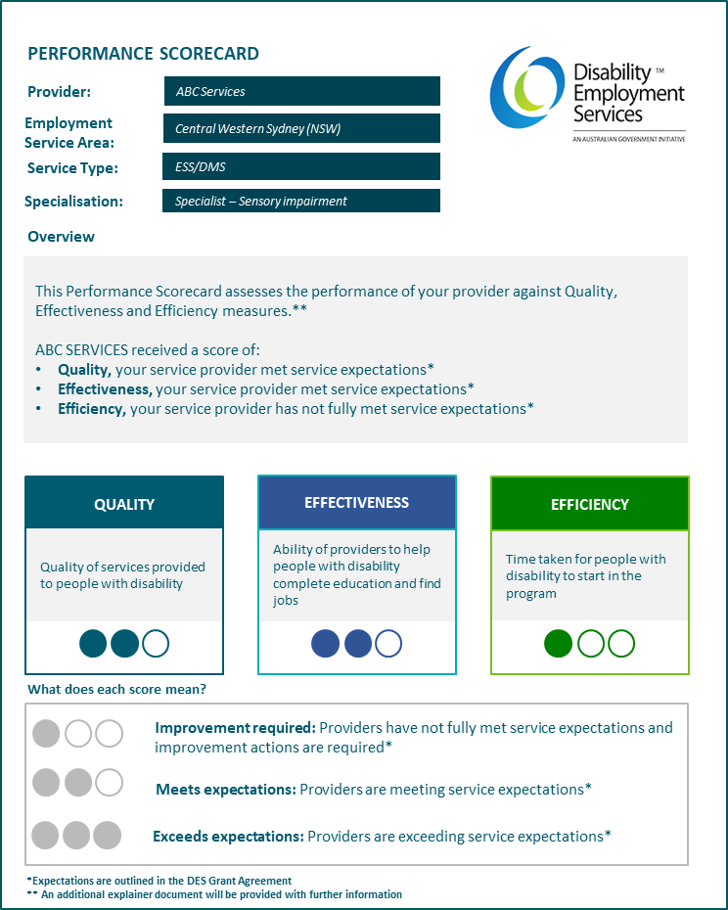

The participant Scorecard includes an additional page (Figure 4) which details the intent of the Scorecard, how to interpret it and who to contact in case of enquiries. Scorecards will be made accessible (e.g. vision impaired) and easy to read.
Figure 4: Example explanation document to be provided with the performance Scorecard shared with participants
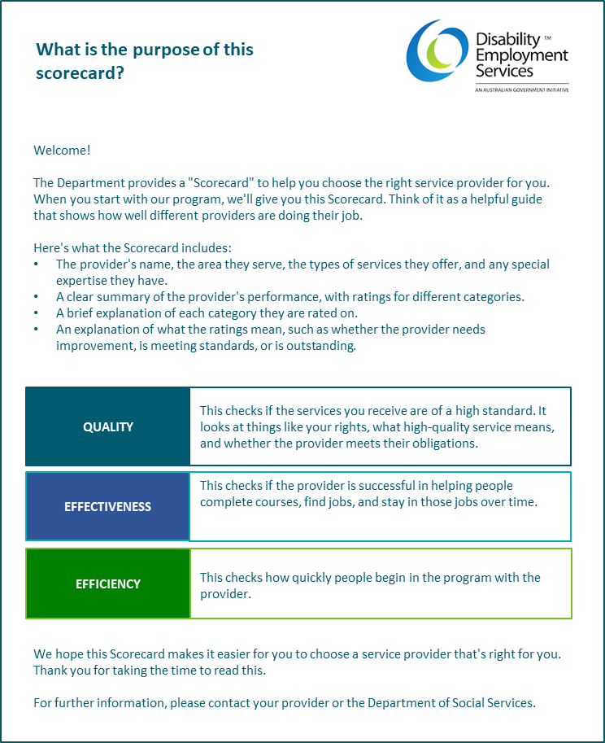

3.3.2 Providers
A more detailed Scorecard will be shared with providers to assist them in understanding, benchmarking, and improving their performance. Information collected for the purpose of monitoring provider performance will also be used by Government to monitor overall program performance. Each quarter, the Department will share with providers their performance rating for each Measure/Indicator by contract and organisation level.
Figure 5 provides an example of the Scorecard Report shared with providers on a quarterly basis. The Scorecard will include:
- Provider name, the Employment Service Area (ESA) in focus, service type and any specialisations offered
- An overview of the provider’s performance in the reporting period
- An explanation of the scoring, including the definition of improvement required, meets expectations, and exceeds expectations.
Providers will be given a score out of three for each Domain (Quality, Effectiveness and Efficiency) and for each Measure/Indicator. The Quality Domain score will only be available at the organisation level. The score for the Efficiency and Effectiveness Domains will be provided at contract and organisation level. No overall score is proposed.
The scoring aligns with the Quality Framework and is defined as follows:
- Improvement required: Providers have not met the service expectations and improvement actions are required. They received a score of less than 1.
- Meets expectations: Providers are meeting the service expectations and received a score of 1 or above but less than 2.
- Exceeds expectations: Providers are exceeding the service expectations and received a score of 2 or above.
Figure 5: Example performance Scorecard to be shared with providers
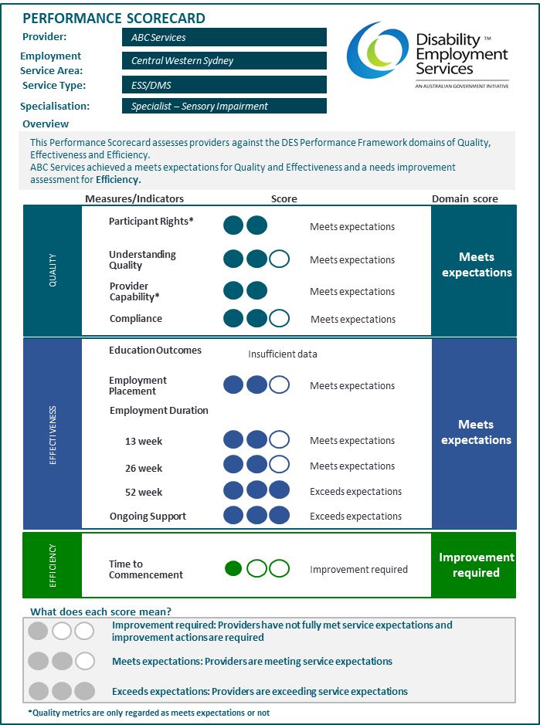
*Under the Quality Framework, participant rights and provider capability are assessed based on required or meets expectations. There is no assessment for exceeds expectations.

Management and review
To ensure the Performance Framework stays current, the Department will periodically review it to ensure that:
- measures and indicators are fit for purpose
- calculations underpinning the Scorecard are robust, accurate and transparent
- the Performance Framework drives quality service delivery and continuous improvement
- changes to policy settings (for example the new DES model) are incorporated into the Performance Framework.
The Department aims to collaborate with providers and stakeholders to improve compliance, monitor, and measure performance and continuously improve performance of providers in delivering on the objectives of the DES program. These are further outlined as:
- Service Standard Compliance: Review and assess on a regular basis whether providers are meeting the minimum requirements of the program such as the NSDS. Compliance is the minimum standard expected of providers with non-compliance potentially leading to further investigation, support, and potential exit from the program.
- Monitor: Assess the performance of providers against several measures outlined in the ‘Scorecard.’ The results from the assessment of performance assists the Department in understanding cohorts, regions and providers that are performing below or above expectations and where to provide additional focus or support.
- Continuous improvement: Develop and share case studies of best practice providers to lift the performance of the provider market over time, deliver improved outcomes for participants and employers and broader program level objectives.

Appendix A – Glossary

Acronym | Definition
DES | Disability Employment Services
Department | Department of Social Services
Effectiveness | Refers to the effectiveness domain within the Performance Framework, which assesses the achievement of training, education and employment outcomes and the success in placing participants in sustainable employment
Efficiency | Refers to the efficiency domain within the Performance Framework, assesses the time taken to place participants taking into consideration their propensity to find employment
Funding Model | Refers to the risk-adjusted funding model
JSCI | Job Seeker Classification Instrument is a tool used by employment companies to identify the required level of resources and support that are required for a job seeker
NDIS | National Disability Insurance Scheme
NSDS | National Standards for Disability Services
Participants | Individuals engaged in the DES program.
Performance Framework | The Disability Employment Services Performance Framework
Providers | An organisation that delivers Disability Employment Services
Quality | Refers to the Quality domain within the Performance Framework, which assesses the quality of services by considering participant rights, understanding quality, provider capability and compliance as stated in the DES Quality Framework
Quality Framework | Disability Employment Service Quality Framework
RAFL | The risk-adjusted funding level (RAFL) model has been in place since 1 July 2018 which pays a differential fee to providers based on the propensity of a participant to find employment
Scorecard | A report for participants and providers outlining the performance of a provider against an agreed set of measures outlined in the Performance Framework
Star Ratings | Former DES performance monitoring and reporting approach. Star Ratings assessed against two key indicators: Effectiveness and Efficiency
Workforce Australia | Workforce Australia is an Australian Government-funded network of organisations that are contracted by the Australian Government, through the Department of Employment and Workplace Relations, to deliver employment services to unemployed job seekers on Government income support payments and employers.

