Participant scorecard example (page 1 of 2)
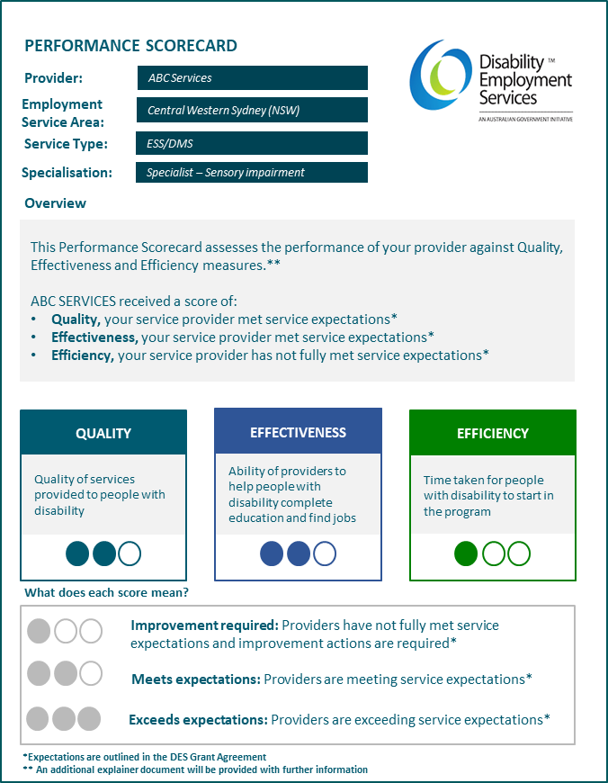

This example of the Scorecard will be made available to participants. The provider in this Scorecard is made up and is to demonstrate the Scorecard’s function. The Scorecard is includes:
- the providers name: ABC Services
- the employment service area: Central Western Sydney (NSW)
- the service type: ESS/DMS and
- the specialisation: Specialist - Sensory impairment.
The scorecard provides an overview of the ABC Services performance for each of the Domains of Quality, Effectiveness and Efficiency. In this instance, ABC Services has been assessed as:
- Quality: meets expectations, meaning your service provider met service expectations.
- Effectiveness: meets expectations, meaning your service provider met service expectations.
- Efficiency: improvement required, meaning your service provider has not fully met service expectations.
Further explanation of what each score means is provided:
- Improvement required: Providers have not full met service expectations and improvement actions are required.
- Meets expectations: Providers are meeting service expectations
- Exceeds expectations: Providers are exceeding service expectations.

Participant scorecard example (page 2 of 2)
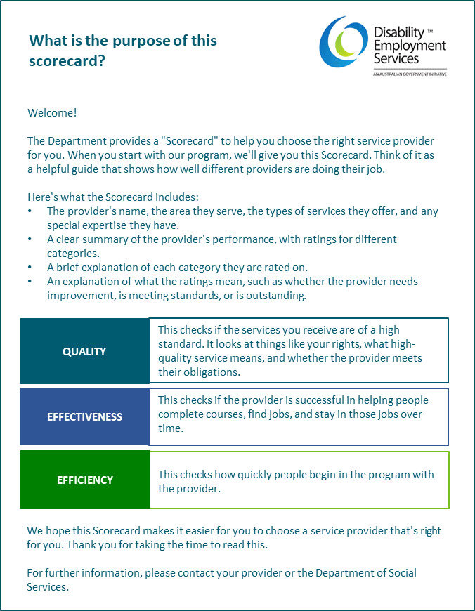

This second page of the Scorecard provides the meaning and purpose of the Scorecard, how to interpret it and who to contact in case of enquiries.
It provides explanations about what the scorecard includes (provider name, the area they service, the types of services they offer, and any special expertise they have).
This explainer document provides the following important explanations for each domain:
- Quality: This checks if the services you receive are of a high standard. It looks at things like your rights, what high quality service means, and whether the provider meets their obligations.
- Effectiveness: This checks if a provider is success in helping people complete courses, find jobs, and stay in those jobs over time.
- Efficiency: This checks how quickly people begin the program with the provider.

