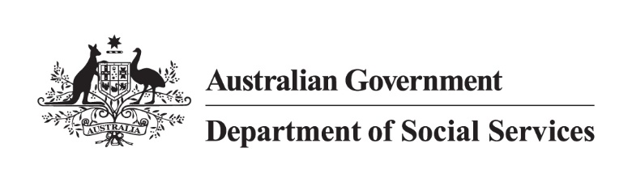

DSS 2024.05.31

500 Workers Initiative

Jurisdiction high-level Status as of 30 June 2024
Notes:
  - Data is as of 30 June 2024 and is subject to regular changes.
  - Not all state and territory data are updated monthly as this is dependent on individual jurisdictional contractual arrangements with service providers already in place.
  - States and territories also have annual reporting obligations to the Commonwealth under the National Partnership Agreement.
  - Use of the word ‘commenced’ in the below table for worker numbers means workers who have started in their role and are working with victim-survivors.

Jurisdiction | Commenced Workers | Commenced FTE | Next Steps
New South Wales | 6 | 4 | - New South Wales has progressed tender evaluations and contract negotiations for the full 2024-25 quota of workers in June.  - Contracts for the 2023-24 quota of workers will be in place by 30 June 2024, or shortly after.  - Recruitment will commence once contracts are in place.
Victoria | 11 | 11 | - The recruitment of new workers is progressing in line with Victoria’s plan:  - 11 workers have been employed,  - 4 further offers have been confirmed, and  - 20 further roles are currently being recruited.  - The filled roles include:  - three case managers at a multicultural agency. Collectively, they speak Mandarin, Cantonese, Tamil, Hindi, Urdu, Arabic, Ukrainian and Russian, as well as all speaking English.  - One worker employed at an Aboriginal Community Controlled Organisation.  - Family Safety Victoria is working with peak bodies on the next stage of this important project.
Queensland | 30 | 29 | - Queensland is implementing a range of Commonwealth and State funded workforce-related initiatives across the domestic, family and sexual violence service system to strengthen responses to victim-survivors and people who use violence.  - Queensland, like other jurisdictions, is experiencing challenges in attracting, recruiting and retaining appropriately qualified specialist frontline domestic, family and sexual violence workers.  - Given this, Queensland has implemented a phased approach to the rollout of all initiatives.  - In Phase 1 Queensland has allocated funding to employ 64 FTE workers.  - Recruitment of the remaining  35 FTE continues.  - Queensland is continuing to work with services who are experiencing recruitment challenges.  - A procurement process is nearing finalisation for Phase 2 to allocate funding to services for up to 45 additional FTE workers.  - A separate purchasing process for LGBTIQA+ community health organisations will also be undertaken later this year.
Western Australia | 7 | 7 | - As at mid-May, service contracts with organisations have been awarded for all workers.  - Recruitment is in progress with organisation progress ranging from positions advertised to organisations having offered employment contracts (workers not yet commenced).
South Australia | 25 | 15.8 | - All Service agreements now executed.  - Organisations are now recruiting and working towards having full FTE as soon as possible noting that workforce availability remains an ongoing challenge.
Tasmania | 17 | 15.6 | - Recruitment is underway with Tasmania expected to achieve close to their 2023-24 target and are on track to deliver their full FTE worker number of 24.6 FTE workers by end of 2024-25.
Australian Capital Territory | 5 | 5 | - The Australian Capital Territory are on track for 6 workers by 30 June 2024.  - 3 workers have recently commenced with Canberra Rape Crisis Centre, with another worker due to commence before 30 June 2024.  - 2 workers have commenced with YWCA
Northern Territory | 7 | 7 | - Grant agreements with 11 crisis accommodation services have been executed and funding paid out for 12 children’s workers (one of the services nominated 2 workers)  - Grant agreements with 2 service providers for 3 co-responder model workers have been paid.  - Grant agreements for 2 services for 2 victim survivor specialist court workers have been developed and are in the process of execution.  - The final worker is for the Women’s Safety Worker for the new Men’s Behaviour Change Program in Katherine, which is expected to commence in 2024-25. It is likely that this worker will be commissioned as part of the overall commissioning in early 2024-25.  - Services have reported significant recruitment challenges, with roles being advertised multiple times.
TOTAL | 108 | 94.4

