Public Interest Certificate - JobAccess
This public interest certificate is issued under section 22(1) of the Government Procurement (Judicial Review) Act 2018.
I hereby state that it is not in the public interest for the following procurement(s) by the Department of Social Services to be suspended while complaints under section 18 of the Act are being investigated or while applications for injunctions under Part 2 of the Act are being considered.
AusTender ID(s) | RFT70018457
Tender(s) Close Date and Time | 12/07/2024 at 2:00 PM
Procuring Entity | Department of Social Services
Contact Officer | Mike Hanbidge (02) 6146 6431  Mike.Hanbidge@dss.gov.au
Category (UNSPSC) | 80101505
Description | This procurement is planned to engage a Supplier to operate the established JobAccess Service.  JobAccess is the national hub for workplace and employment information for people with disability, employers, and service providers.  It aims to drive accessible and inclusive disability employment in Australia, and incorporates a number of key services:  - Advice and information service for jobseekers, employers and service providers  - Administration and management of the Employment Assistance Fund that helps remove barriers in the workplace by providing financial assistance to a person with disability or their employer for workplace modifications, equipment, disability awareness training and other services, including Auslan interpreting  Employer engagement service assisting employers to increase their disability confidence to enable them to employ more people  with disability.

Department of Finance
RMG-422: Handling complaints under the Government Procurement (Judicial Review) Act 2018

AusTender ID(s) | RFT70018457
The procurement includes:
- a single stage open market tender approach via a Request for Tender (RFT); and
- a contract with a planned initial period of two years (includes a period of transition and establishment activities).
- two (2) 12 month options for extension, enabling a maximum contract duration of four years. The timeframe of this contract is
based on the current funding authority for this service.

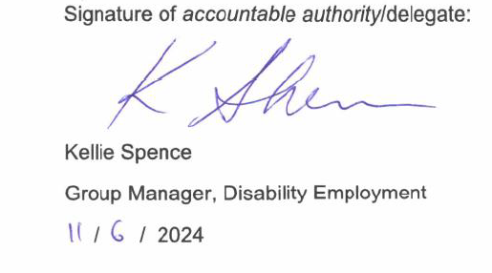

0

