Commonwealth, State and Territory Disability Ministers met on 28 June 2024 in Canberra.

The meeting was focused on ensuring a coordination of governments’ efforts across the entire disability service system – reflecting the shared accountability and governance arrangements for supporting all Australians with disability. This was a key area of discussion across each of the main agenda items for the meeting.

Ministers noted the further investment from the Commonwealth in the 2024-25 Budget to support people with disability and get the NDIS back on track. The discussion was focused on better understanding the design and consultation measure for the new navigation service model and architecture needed to implement the reforms. An update was also provided on the development of a new specialist disability employment program which will introduce key changes to the way employment services for people with disability are delivered to ensure quality services are provided that lead to improved employment outcomes.

Ministers received an update on progress of the National Disability Insurance Scheme Amendment (Getting the NDIS Back on Track No 1) Bill 2024, including amendments. Ministers also discussed a commitment for engagement and co-design across stakeholders on the delegated legislation that the Bill enables.

Ministers discussed the importance of an approach to bring together implementation efforts of the different elements of the disability reforms – across the NDIS, Foundational Supports and Disability Royal Commission. As part of this, the Ministers will share a high-level roadmap with disability representative organisations for initial feedback, with a view to then finalising a public facing version that could be released in July. The roadmap will continue to be updated with further detail as it is agreed by DRMC. This will be followed by a more detailed engagement plan on how people and organisations can be involved in design and consultation of the reforms.

The Ministers also discussed an approach to developing a joint response to the NDIS Review. Officials were tasked to develop a detailed workplan for governments to collaborate on a response before the end of the year – recognising that a response should be delivered within 12 months of the NDIS Review report being released.

The Commonwealth provided an update about its initial considerations relating to foundational supports as well as the need for community consultation to inform the approach. Ministers will work together to provide an update on timelines for community consultation.

Ministers discussed plans for the public release of the Joint Response to the 85 joint Commonwealth, State and Territory recommendations of the Disability Royal Commission, which is on track for release in mid-2024.

Ministers agreed to work together with the Commonwealth to update the Supported Employment Plan by November 2024.

Ministers endorsed the National Disability Data Asset (NDDA) Charter and NDDA Council Terms of Reference. The Charter and Council are key to supporting community co-governance of the NDDA. The NDDA, which is scheduled for its first release in the third quarter of this year, will bring together de-identified information from different government agencies about all Australians. The NDDA will increase understanding of the experiences of people with disability to support improved outcomes.

Ministers welcomed Ms Natalie Wade, Taskforce Chair, and the Hon Vicki O’Halloran AO CVO FAICD and Mr Michael Borowick JP, Taskforce Members of the NDIS Provider and Worker Registration Taskforce, to provide an update on the taskforce’s activities. Ministers heard about the engagement the Taskforce has undertaken in developing its advice, having consulted with more than 1000 individuals, across more than 160 one-on-one and small group meetings, 34 roundtables, five Advisory Working Groups and over 700 submissions.

The next DRMC meeting will be held in August.
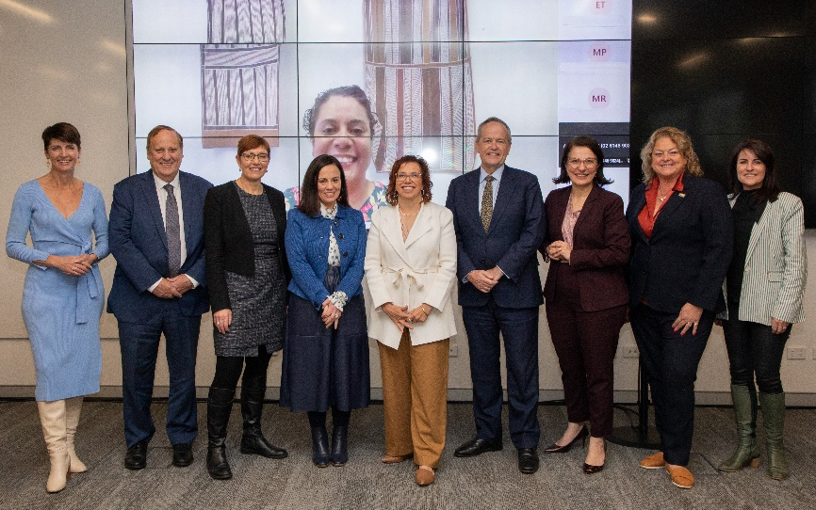
Image – Left to right - Minister Washington (NSW); Minister Punch (WA); Minister Stephen-Smith (ACT); Minister Blandthorn (VIC); Minister Rishworth (Minister for Social Services); Minister Shorten (Minister for the NDIS); Minister Mullen (QLD); Minister Cook (SA); Minister Palmer (TAS);
Online: Minister Ah Kit (NT).

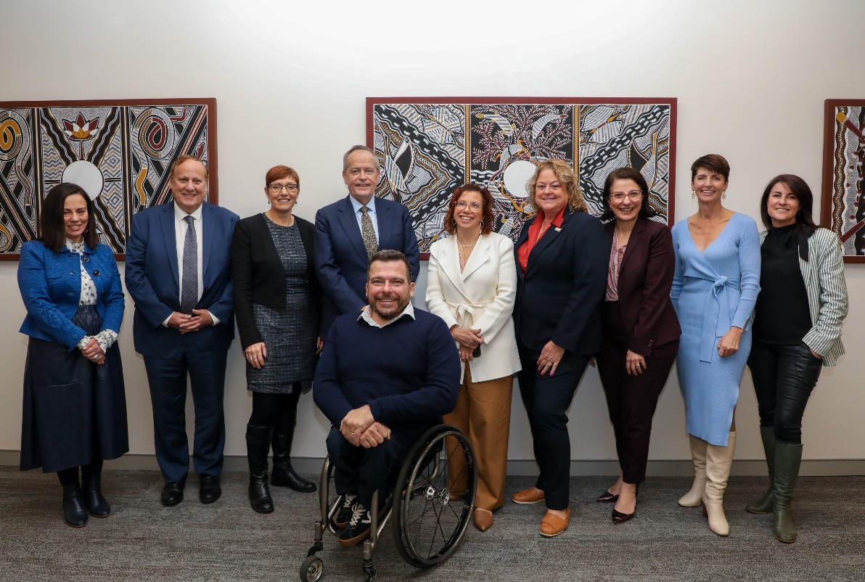
Image – Left to right - Minister Blandthorn (VIC); Minister Punch (WA); Minister Stephen-Smith (ACT); Minister Shorten (Minister for the NDIS); Minister Rishworth (Minister for Social Services); Minister Cook (SA); Minister Mullen (QLD); Minister Washington (NSW); Minister Palmer (TAS);
Mr Kurt Fearnley AO, NDIA Chair.

