

**Disability Employment Services (DES)**

# **DES Quality Framework**

**Easy Read version**

# **How to use this document**

The Australian Government Department of Social Services (DSS) wrote this document.

When you see the word ‘we’, it means DSS.

We wrote this document in an easy to read way. We use pictures to explain some ideas.

We wrote some words in **bold**.

This means the letters are thicker and darker.

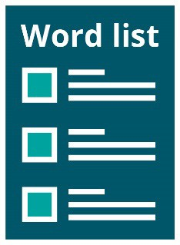We explain what these words mean. There is a list of these words on page **20**.

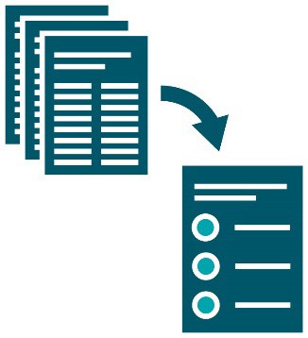This is an Easy Read summary of another document.

This means it only includes the most important ideas.

You can find more information on our website.

[**www.dss.gov.au/DES-Quality-Framework**](http://www.dss.gov.au/DES-Quality-Framework)

You can ask for help to read this document.

A friend, family member or support person might be able to help you.

# **What’s in this document?**

About this document 5

What quality means in our Framework 7

How we will check the quality of services people get 13

Making our Framework better 16

More information 17

Word list 20

# **About this document**

**Disability Employment Services (DES)** helps people with disability find and keep jobs.

We are improving the way DES works.

This includes making sure that DES:

* works well to find jobs for people with disability
* supports more people to find and keep a job
* provides good **quality** services.

Quality is about good services that:

* meet the needs of people with disability
* 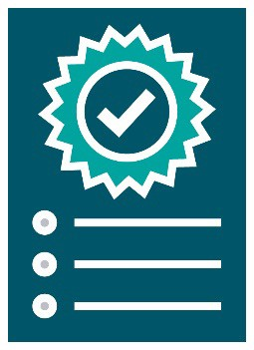give people with disability choice and control.

We made a **framework** to improve the quality of services that people get from DES.

A framework is a plan for how things should work.

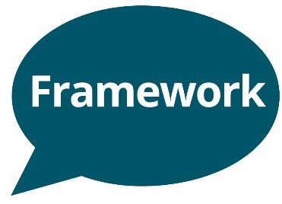It is called the DES Quality Framework.

In this document, we call it our Framework.

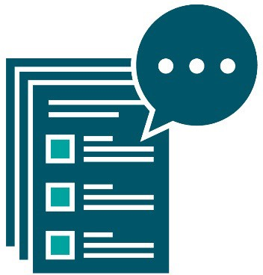We talk about our Framework in more detail on the following pages.

# **What quality means in our Framework**

**DES providers** deliver the services and supports that help people with disability find and

keep jobs.

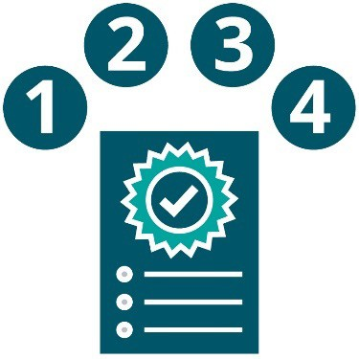Our Framework includes 4 parts that explain what it means for DES providers to give quality supports.



**1. People who use DES understand**

**their rights**

Rights are rules about how people must treat you:

* fairly
* equally.

This also means that people understand:

* what they must do
* how DES providers can support them.

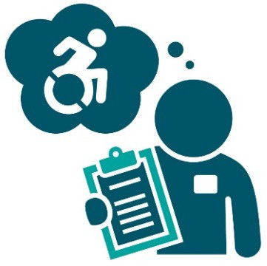

**2. DES providers understand how to support people with disability**

This means that DES providers understand:

* the types of support different people need to achieve their work goals
* how to work with community services
* the jobs that people might be able to get in their local area
* what **employers** are looking for.

An employer is a person who hires other people to work for them.



**3. DES providers do their job well**

This means that DES providers:

* provide good quality services
* know how to manage risk
* are always trying to improve how they work
* have rules that make sure they work well.

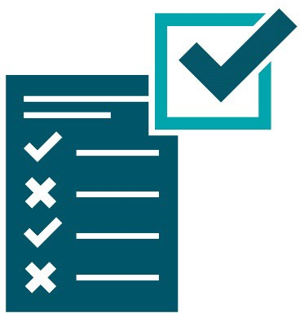

**4. DES providers follow the rules and laws, and manage feedback**

This means that DES providers follow our rules and laws about how to:

* provide good quality services
* improve the quality of their services.

It also means that DES providers manage

**feedback** from people who use their services.

When you give feedback, you tell someone what they:

* are doing well
* can do better.

## **The National Standards for Disability Services**

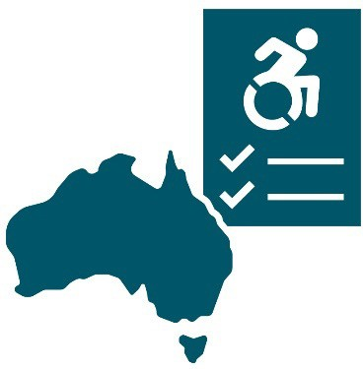These 4 parts are about quality and meeting the National **Standards** for Disability Services (NSDS).

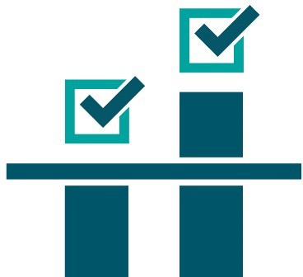Standards are rules about how to do things well. You can:

* meet standards
* go above standards.

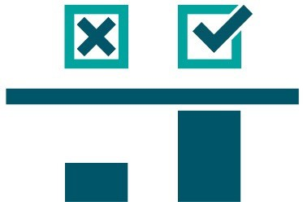You can also not meet standards.

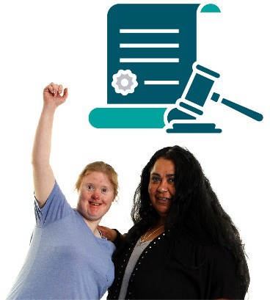The NSDS is part of a law called the Disability Services Inclusion Act 2023.

This law explains the ways people must provide services to people with disability.

# A person writing on a clipboard next to a magnifying glass. **How we will check the quality of services people get**

We will check the quality of services that all DES providers deliver to people with disability.

And we will give each DES provider a rating twice a year.

We will publish the rating each DES provider gets on our website.

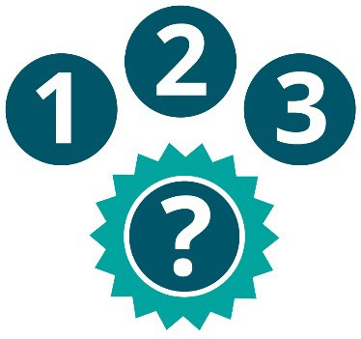There are 3 ratings that DES providers can get.



**1. Their services are at a higher quality than we expect**



**2. Their services are at the quality we expect**



**3. Their services are not at the quality we expect, and the DES provider will need to improve**

**How we will choose the rating we give each DES provider**

We will check different things when we choose the rating we give each DES provider.

We will check how well each DES provider understands and uses the NSDS:

* in their services
* in the way they improve their services.

Using the NSDS will be the main way we check the quality of services that DES providers deliver.

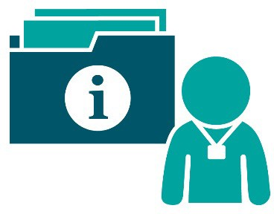We will also use information we already have about each DES provider.

We will also use information from a form that DES providers fill out.

This form is about how well they understand what quality means.

# A person giving a thumbs up next to the framework document. **Making our Framework better**

We will continue to make our Framework better.

To do this, we will:

* work to hear more from employers and people who get services through DES
* improve how we do things, including how we use the information we have about DES.

# **More information**

You can visit our website for more information.

[**www.dss.gov.au/des**](http://www.dss.gov.au/des)

You can email us if you have any questions about our Framework.

[**DEP.Engagement@dss.gov.au**](mailto:DEP.Engagement@dss.gov.au)

You can call us.

**1300 653 227**

## **National Relay Service**

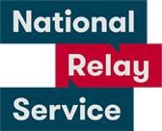You can call the National Relay Service if you:

* are deaf or hard of hearing
* find it hard to speak using the phone.

TTY (Type and Listen)

**1800 555 677**

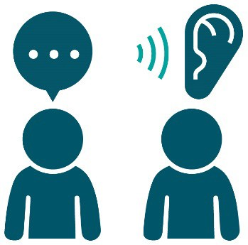Speak and listen

**1300 555 727**

You can ask them to connect you to our phone number.

**1300 653 227**

## **Translating and Interpreting Service (TIS)**

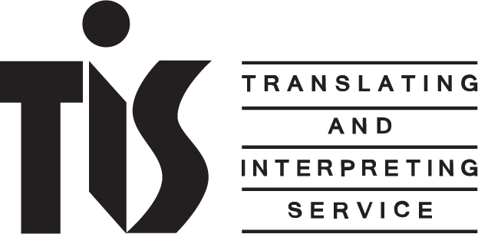If you need something in a language other than English, you can call the Translating and Interpreting Service (TIS).

**131 450**

You can ask them to connect you to our phone number.

**1300 653 227**

# **Word list**

This list explains what the **bold** words mean.

**DES provider**

DES providers deliver the services and supports that help people with disability find and keep jobs.

**Disability Employment Services (DES)**

DES helps people with disability find and keep jobs.

**Employer**

An employer is a person who hires other people to work for them.

**Feedback**

When you give feedback, you tell someone what they:

* are doing well
* can do better.

**Framework**

A framework is a plan for how things should work.

**Quality**

Quality is about good services that:

* meet the needs of people with disability
* give people with disability choice and control.

**Rights**

Rights are rules about how people must treat you:

* fairly
* equally.

**Standards**

Standards are rules about how to do things well. You can:

* meet standards
* go above standards.

This Easy Read document was created by the Information Access Group using stock photography and custom images. The images may not be reused without permission. For any enquiries about the images, please visit [**www.informationaccessgroup.com**](http://www.informationaccessgroup.com/).

Quote job number 5700.