

DSS 3265.02.24

Youth Allowance (Student)

2022 Priority Investment Approach Factsheet

## Overview

This factsheet provides insights on the 158,000 people [1]receiving Youth Allowance (Student)   
at 30 June 2022. These figures come from the 2022 Priority Investment Approach actuarial model. For more information, please refer to the [*2022 Valuation Report*](https://www.dss.gov.au/node/68706).

## Highlights

* Of those who **started** receiving Youth Allowance (Student) in 2021-22 (66,300 people), 91.4% were not previously receiving any form of income support at 30 June 2021.
* Of those who **stopped** receiving Youth Allowance (Student) in 2021-22 (107,000 people), 86.9% were not on any income support and 5.2% were on JobSeeker Payment at 30 June 2022.
* The projected **average** **Lifetime Cost** for people on Youth Allowance (Student) at 30 June 2022 is $251,000. The **total** **future** **Lifetime Cost** is $39.7 billion (0.7% of the total cost for all Australians).  
  * **Lifetime Cost** is the net present value of all **future** in-scope social security payments.

## The Youth Allowance (Student) 18-25 year old cohort

The following insights focus on future Lifetime Cost for people on Youth Allowance (Student):

Figure 1: Average Lifetime Cost for Youth Allowance (Student) recipients

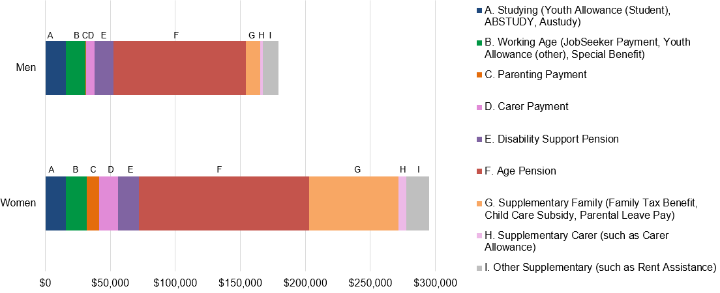

* The majority of Youth Allowance (Student) recipients are aged between 18 and 25 years.
* People receiving Youth Allowance (Student) at 30 June 2022 have a low average projected **Lifetime Cost** compared to other income support recipients.
* **Lifetime Cost** varies depending on gender. For men, the projected **Lifetime Cost** is $179,000, whereas for women the projections are 64.4% higher at $295,000.

Table 1: Projected Lifetime Cost and percentage of time on income support before retirement for people aged 18-25 receiving Youth Allowance (Student)

Table 1 contains different factors or characteristics that may drive Youth Allowance (Student) usage such as education sector, education level and indigenous status. It lists each factor, the proportion of the cohort associated with the factor, their projected average lifetime cost and percentage of time on income support before retirement.  
*Figures may not add to 100% due to rounding. [**Table 1 accessible version**](https://www.dss.gov.au/node/68731).

* Youth Allowance (Student) recipients are predicted to spend a relatively small amount of time on income support before retirement (11.1%) compared to those on other income support payments.
* People residing in the lowest 20% of socio-economic areas ($287,000) are projected to have a 32.3% higher average **Lifetime Cost** than those in the highest 20% ($217,000). They are also projected to spend more time on income support before retirement (14.1%) than those from higher socio-economic areas (8.9%).
* People receiving Youth Allowance (Student) with a Post Graduate qualification (6.1%) are projected to spend less time on income support before retirement compared to people receiving Youth Allowance (Student) who have an education level of Year 11 or less (18.2%).
* **Lifetime Cost** also varies by population cohort. For non-First Nations people, the projected **Lifetime Cost** is $246,000, whereas for First Nations people the projections are 74.4% higher at $429,000. First Nations recipients are projected to spend a higher percentage of time on income support before retirement (28.7%) compared to non-First Nations recipients (10.9%).

1. Note: These figures are from the Priority Investment Approach 2022 actuarial model. They will not match official or published recipient data due to different data extraction rules and timing. For official figures please refer to the [DSS Benefit and Payment Recipients Demographics reports](https://data.gov.au/data/dataset/dss-payment-demographic-data) or [DSS Income Support Recipients – Monthly Time Series](https://data.gov.au/data/dataset/dss-income-support-recipients-monthly-time-series) published on [data.gov.au](https://data.gov.au/data/dataset/cff2ae8a-55e4-47db-a66d-e177fe0ac6a0/resource/1188c950-542a-4ca6-9e3e-9f91f53d9314/download/dss-demographics-june-2022-final.xlsx).