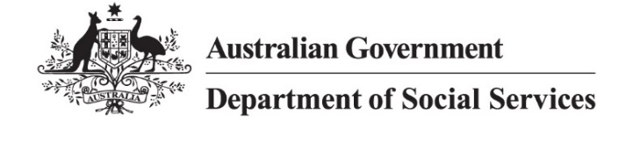
DSS 3260.02.24

2022 Valuation Findings
JobSeeker Payment: Outcomes and Projections
The Priority Investment Approach model is used to estimate the future lifetime social security costs of Australians. The 2022 modelling allows us to explore whether factors such as age and capacity to work change how people on JobSeeker Payment are likely to use income support in the future.

While the number of people receiving JobSeeker Payment has declined since 2020, the proportion with a partial capacity to work has been increasing.
The economic impact of COVID-19 resulted in an increased number of people aged 22 to 64 receiving JobSeeker Payment. In the following two years, employment conditions improved and eligibility for JobSeeker Payment returned to pre-COVID settings. The number of people receiving JobSeeker Payment dropped by 41% between 30 June 2020 and 30 June 2022. The increase in the number of people receiving JobSeeker Payment due to the economic impact of COVID-19 resulted in a decline in the share of recipients with a partial capacity to work to a temporary low of 25% at 30 June 2020. In the period to 30 June 2022, alongside the reduction of the JobSeeker Payment caseload as economic conditions improved, the proportion of JobSeeker Payment recipients with a partial capacity to work returned to 42%.

Younger people on JobSeeker Payment with a partial capacity to work are predicted to spend 3 of the next 5 years on income support, 29% longer than those with full capacity to work.
Figure 1: Projected and historical 5-year income support usage for people aged 22 to 30 receiving JobSeeker Payment at 30 June 2022
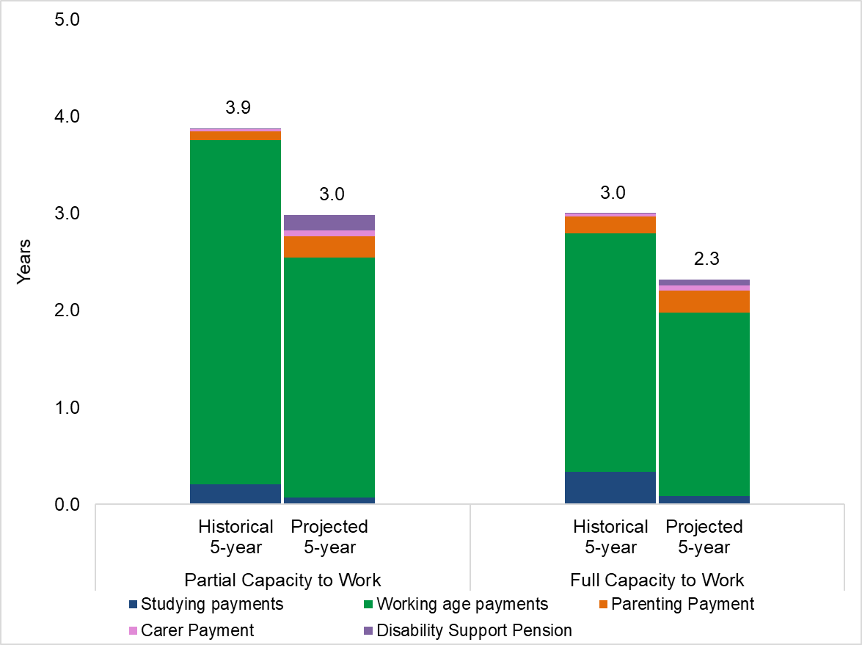
Figure 1 shows, on average, people aged 22 to 30 receiving JobSeeker Payment with a partial capacity to work spent 3.9 of the previous 5 years receiving income support. Over the next 5 years, this cohort is projected to spend more time on income support than those with full capacity to work; an average of 3 years compared to 2.3 years. This projected future usage is 29% longer on income support (0.7 years).

Younger people on JobSeeker Payment with a partial capacity to work are projected to spend 2.5 of the next 5 years on working age payments. By comparison, those with full capacity to work are projected to spend 1.9 of the next 5 years on working age payments.

Older people on JobSeeker Payment are projected to spend more time on income support in the next 5 years than younger people, regardless of their work capacity.
Figure 2: Projected and historical 5-year income support usage for people aged 55 to 64 receiving JobSeeker Payment at 30 June 2022
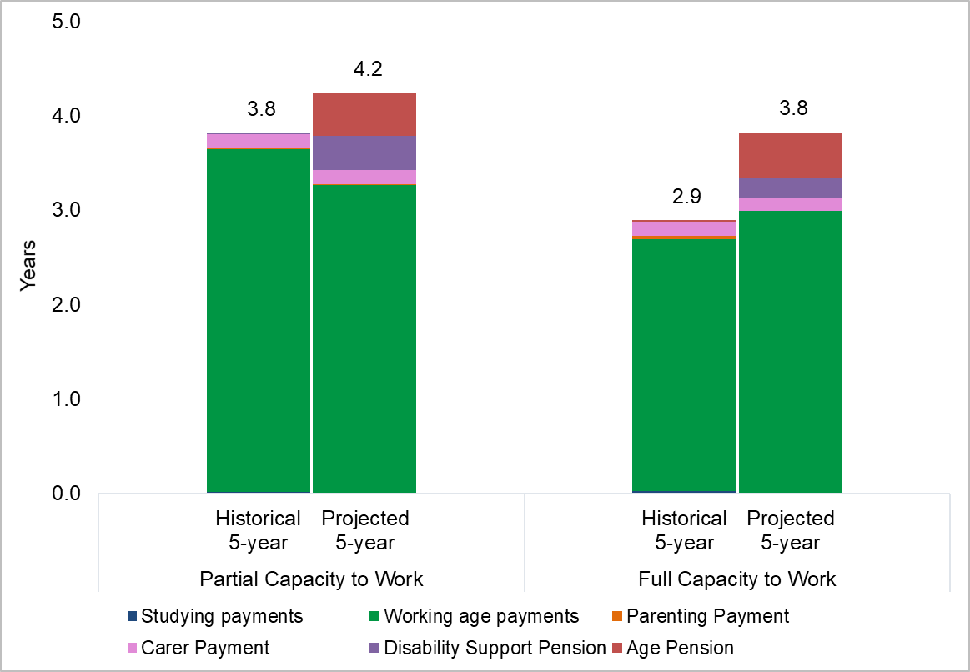
Figure 2 shows, on average, people aged 55 to 64 receiving JobSeeker Payment with a partial capacity to work are projected to spend 4.2 of the next 5 years receiving income support. This is an additional 0.4 years on income support, compared to those with full capacity to work. Most of this time will be spent on a working age payment (3.3 years).

On average, people in this age group are predicted to spend 0.5 of the next 5 years on Age Pension. Younger people on JobSeeker Payment are projected to spend less time on income support in the next 5 years than the previous 5 years. The opposite is true for older people on JobSeeker Payment.

Women, First Nations people, those living in lower socio-economic areas, and people with a partial capacity to work are predicted to spend the most time on income support over the next 5 years.
Table 1 shows the average time younger people aged 22 to 30 receiving JobSeeker Payment are predicted to spend on income support over the next 5 years by partial capacity to work, Socio-Economic Indexes for Areas (SEIFA), First Nations status and gender. The 5 groups predicted to receive the most income support over the next 5 years are highlighted in red, while the 5 groups predicted to receive the least income support are highlighted in green. First Nations women are projected to spend the longest time on income support over the next 5 years, with an average of 3.6 years.
Table 1: Projected average time (in years) on income support over the next 5 years for people aged 22 to 30 receiving JobSeeker Payment at 30 June 2022 by selected characteristics
 |  | Partial Capacity to Work |  | SEIFA |  |  |  |  | First Nations Status |  | Gender
 |  | Partial Capacity to Work | Full Capacity to Work | Lowest 20% | 20% to 40% | 40% to 60% | 60% to 80% | Highest 20% | First Nations | Non-First Nations | Female | Male
Partial Capacity to Work | Partial Capacity to Work | 2.98 | N/A | 3.17 | 3.01 | 2.90 | 2.82 | 2.64 | 3.43 | 2.92 | 3.15 | 2.85
 | Full Capacity to Work | N/A | 2.32 | 2.62 | 2.38 | 2.18 | 1.98 | 1.75 | 3.08 | 2.12 | 2.52 | 2.18
SEIFA | Lowest 20% | 3.17 | 2.62 | 2.77 | N/A | N/A | N/A | N/A | 3.23 | 2.60 | 3.05 | 2.59
 | 20% to 40% | 3.01 | 2.38 | N/A | 2.57 | N/A | N/A | N/A | 3.11 | 2.45 | 2.80 | 2.42
 | 40% to 60% | 2.90 | 2.18 | N/A | N/A | 2.39 | N/A | N/A | 3.06 | 2.28 | 2.59 | 2.25
 | 60% to 80% | 2.82 | 1.98 | N/A | N/A | N/A | 2.22 | N/A | 2.99 | 2.14 | 2.39 | 2.10
 | Highest 20% | 2.64 | 1.75 | N/A | N/A | N/A | N/A | 2.00 | 2.95 | 1.94 | 2.12 | 1.91
First Nations Status | First Nations | 3.43 | 3.08 | 3.23 | 3.11 | 3.06 | 2.99 | 2.95 | 3.15 | N/A | 3.60 | 2.90
 | Non-First Nations | 2.92 | 2.12 | 2.60 | 2.45 | 2.28 | 2.14 | 1.94 | N/A | 2.36 | 2.54 | 2.24
Gender | Female | 3.15 | 2.52 | 3.05 | 2.80 | 2.59 | 2.39 | 2.12 | 3.60 | 2.54 | 2.71 | N/A
 | Male | 2.85 | 2.18 | 2.59 | 2.42 | 2.25 | 2.10 | 1.91 | 2.90 | 2.24 | N/A | 2.37

Further analysis shows the group projected to spend the longest time on income support over the next 5 years is First Nations women with a partial capacity to work and living in the lowest 20% of socio-economic areas. Their projected time on income support over the next 5 years is 3.8 years on average, which is 53% more than the average of 2.5 years for all younger people receiving JobSeeker Payment at 30 June 2022. By contrast, non-First Nations men with full capacity to work and living in the highest 20% of socio-economic areas are projected to spend the least amount of time on income support over the next 5 years, averaging 1.6 years, or 36% less than the overall average.

Notes
- All figures are from the Priority Investment Approach 2022 actuarial model. Figures on number of people receiving JobSeeker Payment will not match official or published recipient data due to different data extraction rules and timing. For official figures please refer to the DSS Benefit and Payment Recipients Demographics reports or DSS Income Support Recipients – Monthly Time Series published on data.gov.au.
- Working age payments: The Priority Investment Approach model defines this as income support payments to assist working age people who are temporarily unable to support themselves through work. Working age payments mainly consist of JobSeeker Payment for people aged 22 and above, and Youth Allowance (Other) for people aged 16 to 21. Parenting Payment is projected separately.
- Partial capacity to work: A person who is unable to work for at least 30 hours per week, whether due to a physical, intellectual, or psychiatric impairment, is referred to as having a partial capacity to work. A person who is able to work for at least 30 hours per week is referred to as having full capacity to work.
- Socio-Economic Indexes for Areas (SEIFA): A product developed by the ABS ranking areas in Australia according to relative socio-economic advantage and disadvantage. The indexes are based on information from the five-yearly Census.
- Studying payments: Studying payments include payments provided to students to assist them with living costs while undertaking their studies. Payments in this category include Austudy, ABSTUDY and Youth Allowance (Student).

