

DSS 3264.02.24

Parenting Payment Single

2022 Priority Investment Approach Factsheet

## Overview

This factsheet provides insights on the 226,000 people[1] receiving Parenting Payment Single (PPS)   
at 30 June 2022. These figures come from the 2022 Priority Investment Approach actuarial model. For more information, please refer to the [*2022 Valuation Report*](https://www.dss.gov.au/node/68706).

## Highlights

* Of those who **started** receiving PPS in 2021-22 (38,900 people), 67.1% were not previously receiving any form of income support and 21.5% were receiving JobSeeker Payment at   
  30 June 2021.
* Of those who **stopped** receiving PPS in 2021-22 (49,100 people), 60.3% were not receiving   
  any income support, 29.4% were receiving JobSeeker Payment, and 8.0% were receiving   
  Carer Payment at 30 June 2022.
* The projected **average** **Lifetime Cost** for people receiving PPS at 30 June 2022 is $666,000.   
  The **total** **future** **Lifetime Cost** is $151 billion (2.7% of the total cost for all Australians).

* **Lifetime Cost** is the net present value of all **future** in-scope social security payments.

## The Parenting Payment Single 25-34 year old cohort

The following insights focus on future **Lifetime Cost** for people on PPS aged 25-34:

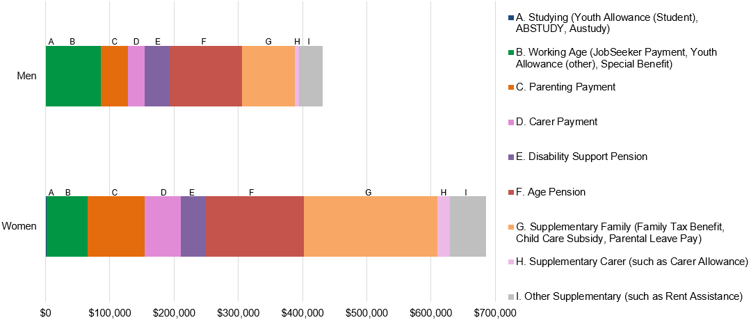**Figure 1: Average Lifetime Cost for people aged 25-34 receiving Parenting Payment Single**

* The average age of people receiving PPS at 30 June 2022 was 32 years.
* **Lifetime Cost** varies depending on gender. For men, the projected **Lifetime Cost** is $432,000, whereas for women the projections are almost 60% higher at $685,000.
  + For women, 30.4% of this cost is for Supplementary Family payments (such as Family Tax Benefit, Child Care Subsidy, Parental Leave Pay). For men, these payments represent 19% of future costs.

Table 1: Projected Lifetime Cost and percentage of time on income support before retirement for people aged 25-34 receiving Parenting Payment Single

Table 1 contains different factors or characteristics that drive Parenting Payment Single usage such as age of youngest child, number of children and earnings. It lists each factor, the proportion of the cohort associated with the factor, their projected average lifetime cost and percentage of time on income support before retirement.  
*Figures may not add to 100% due to rounding. [**Table 1 accessible version**](https://www.dss.gov.au/node/68726).

* People with more than 3 children ($790,000) have a future average Lifetime Cost 37.4% higher than those with only one child ($575,000). Those with more than 3 children are expected to receive income support for just over half the time before retirement (52.2%), while people with only one child are expected to spend just over a third of this time receiving income support (36.2%).
* People with no reported employment earnings are expected to spend almost half their time before retirement on income support (52.5%), whereas people with earnings are expected to spend a third of their time on income support (33.3%).
* Previous receipt of income support is also a strong driver of future cost. People who have received income support for 6 or more consecutive years are expected to receive further income support for just over half the time before retirement (50.6%). People who have received income support only in the 2021-22 financial year are expected to spend just under a third of the time before retirement receiving income support (28.5%).

1. Note: These figures are from the Priority Investment Approach 2022 actuarial model. They will not match official or published recipient data due to different data extraction rules and timing. For official figures please refer to the [DSS Benefit and Payment Recipients Demographics reports](https://data.gov.au/data/dataset/dss-payment-demographic-data) or [DSS Income Support Recipients – Monthly Time Series](https://data.gov.au/data/dataset/dss-income-support-recipients-monthly-time-series) published on [data.gov.au](https://data.gov.au/data/dataset/cff2ae8a-55e4-47db-a66d-e177fe0ac6a0/resource/1188c950-542a-4ca6-9e3e-9f91f53d9314/download/dss-demographics-june-2022-final.xlsx).