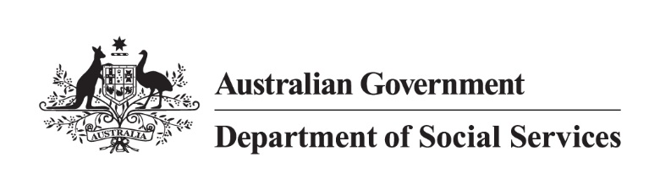

DSS 3263.02.24

JobSeeker Payment

2022 Priority Investment Approach Factsheet

## Overview

This factsheet provides insights on the 810,000 people[1] receiving JobSeeker Payment at 30 June 2022. These figures come from the 2022 Priority Investment Approach actuarial model. For more information, please refer to the [*2022 Valuation Report*](https://www.dss.gov.au/node/68706).

## Highlights

* Of those who **started** receiving JobSeeker Payment in 2021-22 (189,000 people), 74.1% were not previously receiving any form of income support, 9.2% were receiving Parenting Payment and 4.4% were receiving Carer Payment at 30 June 2021.
* Of those who **stopped** receiving JobSeeker Payment in 2021-22 (369,000 people), 81.1% were not receiving any income support, 5.3% were receiving Disability Support Pension, 3.8% were receiving the Age Pension, and 3.5% were receiving Carer Payment at 30 June 2022.
* The projected **average Lifetime Cost**\* for people on JobSeeker Payment at 30 June 2022 is $417,000. The **total future Lifetime Cost** is $338 billion (6.1% of the total cost for all Australians).

* **Lifetime Cost** is the net present value of all **future** in-scope social security payments.

## The JobSeeker Payment 22-30 year old cohort

The following insights focus on future **Lifetime Cost** for people starting on JobSeeker Payment:

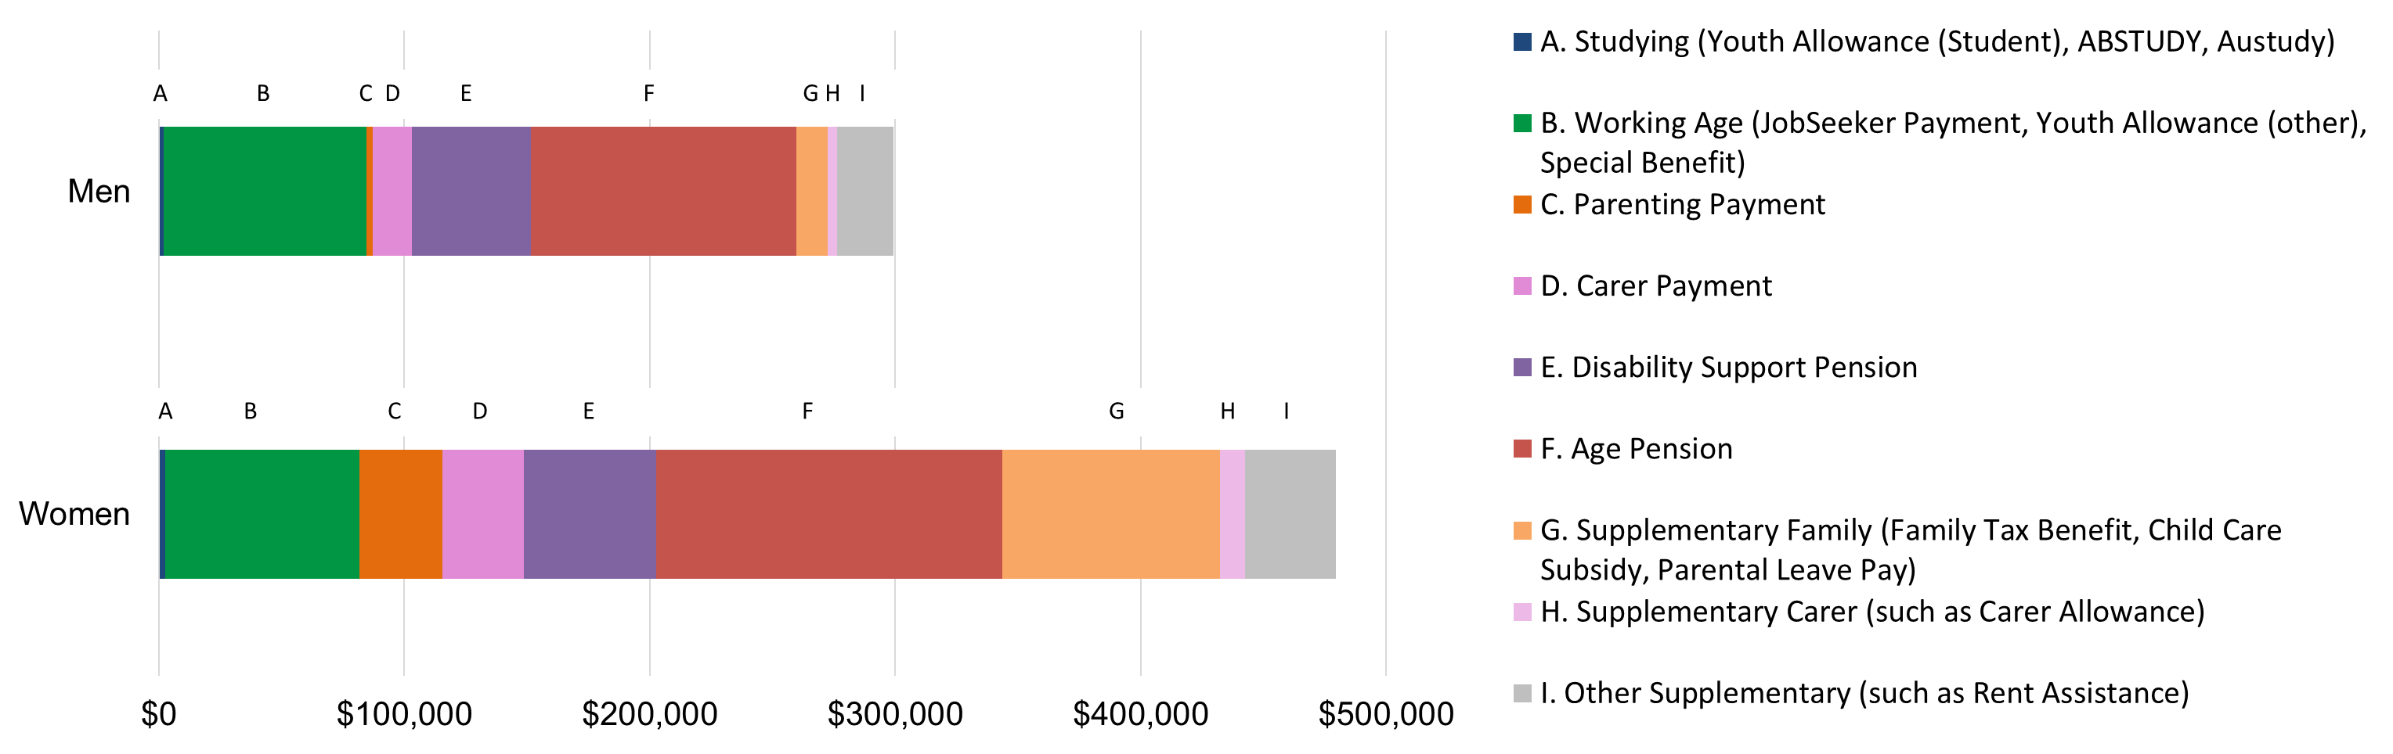Figure 1: Average Lifetime Cost for people aged 22-30 receiving JobSeeker Payment

* **Lifetime Cost** varies depending on gender. For men, the projected **Lifetime Cost** is $299,000, whereas for women the projections are 60.2% higher at $480,000.
  + For women, Supplementary Family payments (Family Tax Benefit, Child Care Subsidy, Parental Leave Pay) are 7 times higher, and Parenting Payment is 13 times higher than the amount projected for men.

Table 1: Projected Lifetime Cost and percentage of time on income support before retirement for people receiving JobSeeker Payment aged 22-30

Table 1 contains different factors or characteristics that drive JobSeeker payment usage such as earnings and First Nations status. It lists each factor, the proportion of the cohort associated with the factor, their projected average lifetime cost and percentage of time on income support before retirement.  
*Figures may not add to 100% due to rounding. [**Table 1 accessible version**](https://www.dss.gov.au/node/68721).

* People receiving JobSeeker Payment who have not reported any earnings from employment ($405,000) have a projected Lifetime Cost 20% higher than those with reported earnings ($337,000).
* More than triple the number of people receiving JobSeeker Payment were living in the lowest 20% of socio-economic areas (35.6%) compared to those in the highest 20% (9.7%).
* The average projected Lifetime Cost of people living in the lowest 20% of socio-economic areas ($407,000) is approximately 33.4% higher than those living in the highest areas ($305,000).
* **Lifetime Cost** also varies by population cohort. For non-First Nations people, the projected **Lifetime Cost** is $350,000, whereas for First Nations people the projections are 33.7% higher at $468,000. First Nations recipients are projected to spend a higher percentage of time on income support before retirement (48.6%) compared to non-First Nations recipients (26.6%).

1. Note: These figures are from the Priority Investment Approach 2022 actuarial model. These figures will not match official or published recipient data due to different data extraction rules and extraction timing. For official figures please refer to the [DSS Benefit and Payment Recipients Demographics reports](https://data.gov.au/data/dataset/dss-payment-demographic-data) or [DSS Income Support Recipients – Monthly Time Series](https://data.gov.au/data/dataset/dss-income-support-recipients-monthly-time-series) published on [data.gov.au](https://data.gov.au/data/dataset/cff2ae8a-55e4-47db-a66d-e177fe0ac6a0/resource/1188c950-542a-4ca6-9e3e-9f91f53d9314/download/dss-demographics-june-2022-final.xlsx).