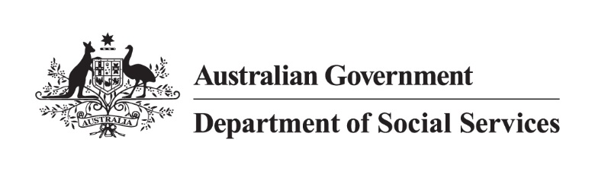

DSS 3261.02.24

Carer Payment

2022 Priority Investment Approach Factsheet

## Overview

This factsheet provides insights on the 304,000 people[1] receiving Carer Payment at 30 June 2022. These figures come from the 2022 Priority Investment Approach actuarial model. For more information, please refer to the *[2022 Valuation Report](https://www.dss.gov.au/node/68706)*.

## Highlights

* Of those who **started** receiving Carer Payment in 2021-22 (38,500 people), 47.7% were not previously receiving any form of income support, 33.5% were receiving JobSeeker Payment and 13.7% were receiving Parenting Payment at 30 June 2021.
* Of those who **stopped** receiving Carer Payment in 2021-22 (35,700 people), 49.4% were not receiving any income support, 23.1% were receiving JobSeeker Payment and 16.7% were receiving Age Pension at 30 June 2022.
* The projected **average Lifetime Cost**\* for people on Carer Payment at 30 June 2022 is $592,000. The **total future Lifetime Cost** is $180 billion (3.2% of the total cost for all Australians).

* **Lifetime Cost** is the net present value of all **future** in-scope social security payments.

## The Carer Payment 45-54 year old cohort

The following insights focus on future **Lifetime Cost** for people on Carer Payment aged 45-54:

Figure 1: Average Lifetime Cost for people aged 45-54 receiving Carer Payment 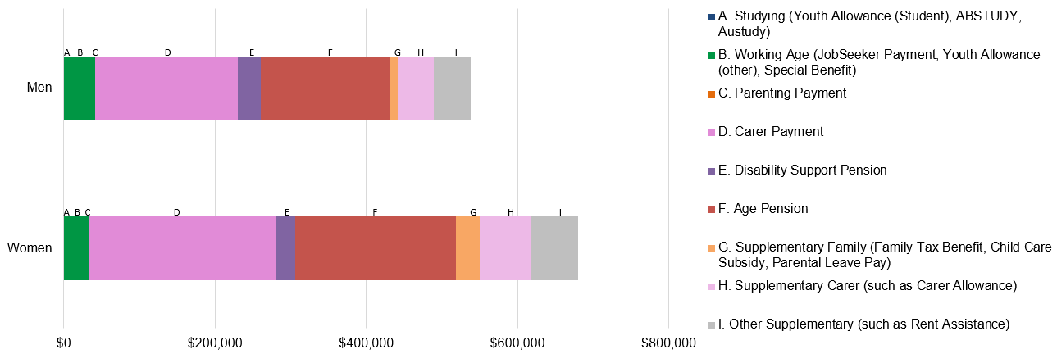

* The average age of people receiving Carer Payment at 30 June 2022 was 52 years.
* **Lifetime Cost** varies depending on gender. For men, the projected **Lifetime Cost** is $538,000, whereas for women the projections are 26% higher at $680,000.
* Around one third of the projected **Lifetime Cost** is for Carer Payment and another third for Age Pension.

Table 1: Projected Lifetime Cost and percentage of time on income support before retirement for people aged 45‑54 receiving Carer Payment

Table 1 contains different factors or characteristics that drive Carer payment usage such as carer relationship to person receiving care and medical condition of person receiving care. It lists each factor, the proportion of the cohort associated with the factor, their projected average lifetime cost and percentage of time on income support before retirement.  
*Figures may not add to 100% due to rounding. [**Table 1 accessible version**](https://www.dss.gov.au/node/68711).

* People aged 45-54 who are the parent of the person receiving care ($726,000), and/or care for a person with an intellectual/learning disorder ($716,000), have the highest projected **Lifetime Cost**.
* People aged 45-54 receiving Carer Payment and living in the lowest 20% of socio-economic areas have a projected **Lifetime Cost** 10% greater ($62,000) than those from the highest 20% of socioeconomic areas. People living in the lowest socio-economic areas will spend a greater percentage of time on income support (86.6%) before they reach retirement compared to those from the highest socio-economic areas (76.0%).

1. Note: These figures are from the Priority Investment Approach 2022 actuarial model. They will not match official or published recipient data due to different data extraction rules and timing. For official figures please refer to the [DSS Benefit and Payment Recipients Demographics reports](https://data.gov.au/data/dataset/dss-payment-demographic-data) or [DSS Income Support Recipients – Monthly Time Series](https://data.gov.au/data/dataset/dss-income-support-recipients-monthly-time-series) published on [data.gov.au](https://data.gov.au/data/dataset/cff2ae8a-55e4-47db-a66d-e177fe0ac6a0/resource/1188c950-542a-4ca6-9e3e-9f91f53d9314/download/dss-demographics-june-2022-final.xlsx).