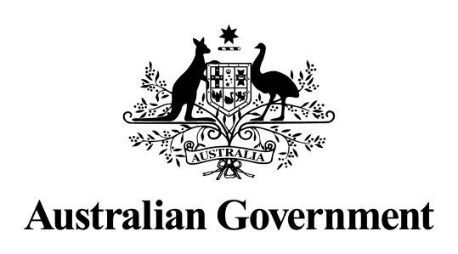

Australian Government response to the

Senate Community Affairs References Committee report:

Review of legislative instruments made under Part 3AA or Part 3B of the Social Security (Administration) Act 1999 – Review 1

May 2024

**Introduction**

The Australian Government welcomes the Senate Community Affairs References Committee’s (the Committee’s) report titled *Review of legislative instruments made under Part 3AA or Part 3B of the Social Security (Administration) Act 1999 – Review 1* (Review 1).

The Government notes this is the first such review by the Committee since the passage of the *Social Security (Administration) Amendment (Income Management Reform) Act 2023*, which inserted a requirement that the Committee review of any legislative instrument made under Part 3AA or Part 3B of the *Social Security (Administration) Act 1999* (the Administration Act).

The review examined the following six legislative instruments, made for the purposes of Part 3AA or Part 3B of the Administration Act:

* Instruments made on 1 September 2023 for the purposes of Part 3AA of the Act (eIM):
  + *Social Security (Administration) (Enhanced Income Management Regime – State Referrals) Determination 2023*;
  + *Social Security (Administration) (Enhanced Income Management Regime – Commonwealth Referrals and Exemptions) Determination 2023*; and
  + *Social Security (Administration) (Enhanced Income Management Regime – Volunteers) Determination 2023*.
* Instruments made on 14 September 2023 for the purposes of Part 3B of the Act (IM):
  + *Social Security (Administration) (Declared Child Protection State – New South Wales, Queensland, South Australia and Victoria) Determination 2023*;
  + *Social Security (Administration) (Recognised State or Territory – Northern Territory) Determination 2023*; and
  + *Social Security (Administration) (Specified Income Management Territory – Northern Territory) Instrument 2023*.

**Review of legislative instruments made under Part 3AA or Part 3B of the Social Security (Administration) Act 1999 – Review 1**

**Recommendations made by the Committee**

|  |
| --- |
| ***Recommendation 1***   1. The committee recommends that for any future legislative instruments made under Part 3B or Part 3AA of the Administration Act, the Australian Government give consideration to:    1. undertake genuine consultation;    2. provide adequate and relevant explanatory material to Parliament to enable appropriate scrutiny; and    3. provide a detailed report on the consultation process and outcomes regarding the proposed Determinations. |

**Noted**

The Government notes the recommendation. We continue to consult with affected communities on the future of Income Management and will give consideration to appropriate consultation for any future legislative instruments.

Consultation has been ongoing with First Nations people and leaders, communities, participants and key stakeholders since June 2023. The community consultation phase commenced in November 2023. Through to 14 March 2024, the Department of Social Services (the Department) has consulted with approximately 3,200 community members in 57 locations in the Northern Territory.

The Department has partnered with ETM Perspectives (ETMP), an Indigenous-led company, to ensure consultation with communities is culturally sensitive and meets the needs of communities. ETMP is leveraging existing local knowledge and relationships with communities to ensure the approach is respectful and reflective of community requirements.

The Government will continue to meet its obligations under the Administration Act and the *Legislation Act 2003*, including providing detail on the consultation process and outcomes within explanatory material.

**Additional Comments**

**Australian Greens**

|  |
| --- |
| ***Recommendation 1***  The Australian Government immediately abolish all forms of compulsory income management and fund place-based, community-driven support services developed in collaboration with First Nations-controlled organisations and people. |

**Not Supported**

The Government has heard from First Nations people, leaders and communities that they want a measured approach to reforming Income Management. Further, decisions that impact First Nations people must be made in partnership with them, and the Government has committed to ensuring First Nations people are involved in decisions which affect them.

The Government is committed to genuine consultation before decisions on the future of Income Management are made.

**Coalition Senators**

|  |
| --- |
| ***Recommendation 2***  The Australian Government legislates the Coalition’s Cashless Debit Card Scheme. |

**Not Supported**

The Government delivered on its election commitment to abolish the Cashless Debit Card in the *Social Security (Administration) Amendment (Repeal of Cashless Debit Card and Other Measures) Act 2022*.

|  |
| --- |
| ***Recommendation 3***  In the absence of the Coalition’s Cashless Debit Card Scheme, the current legislative instruments remain in effect. |

**Supported**