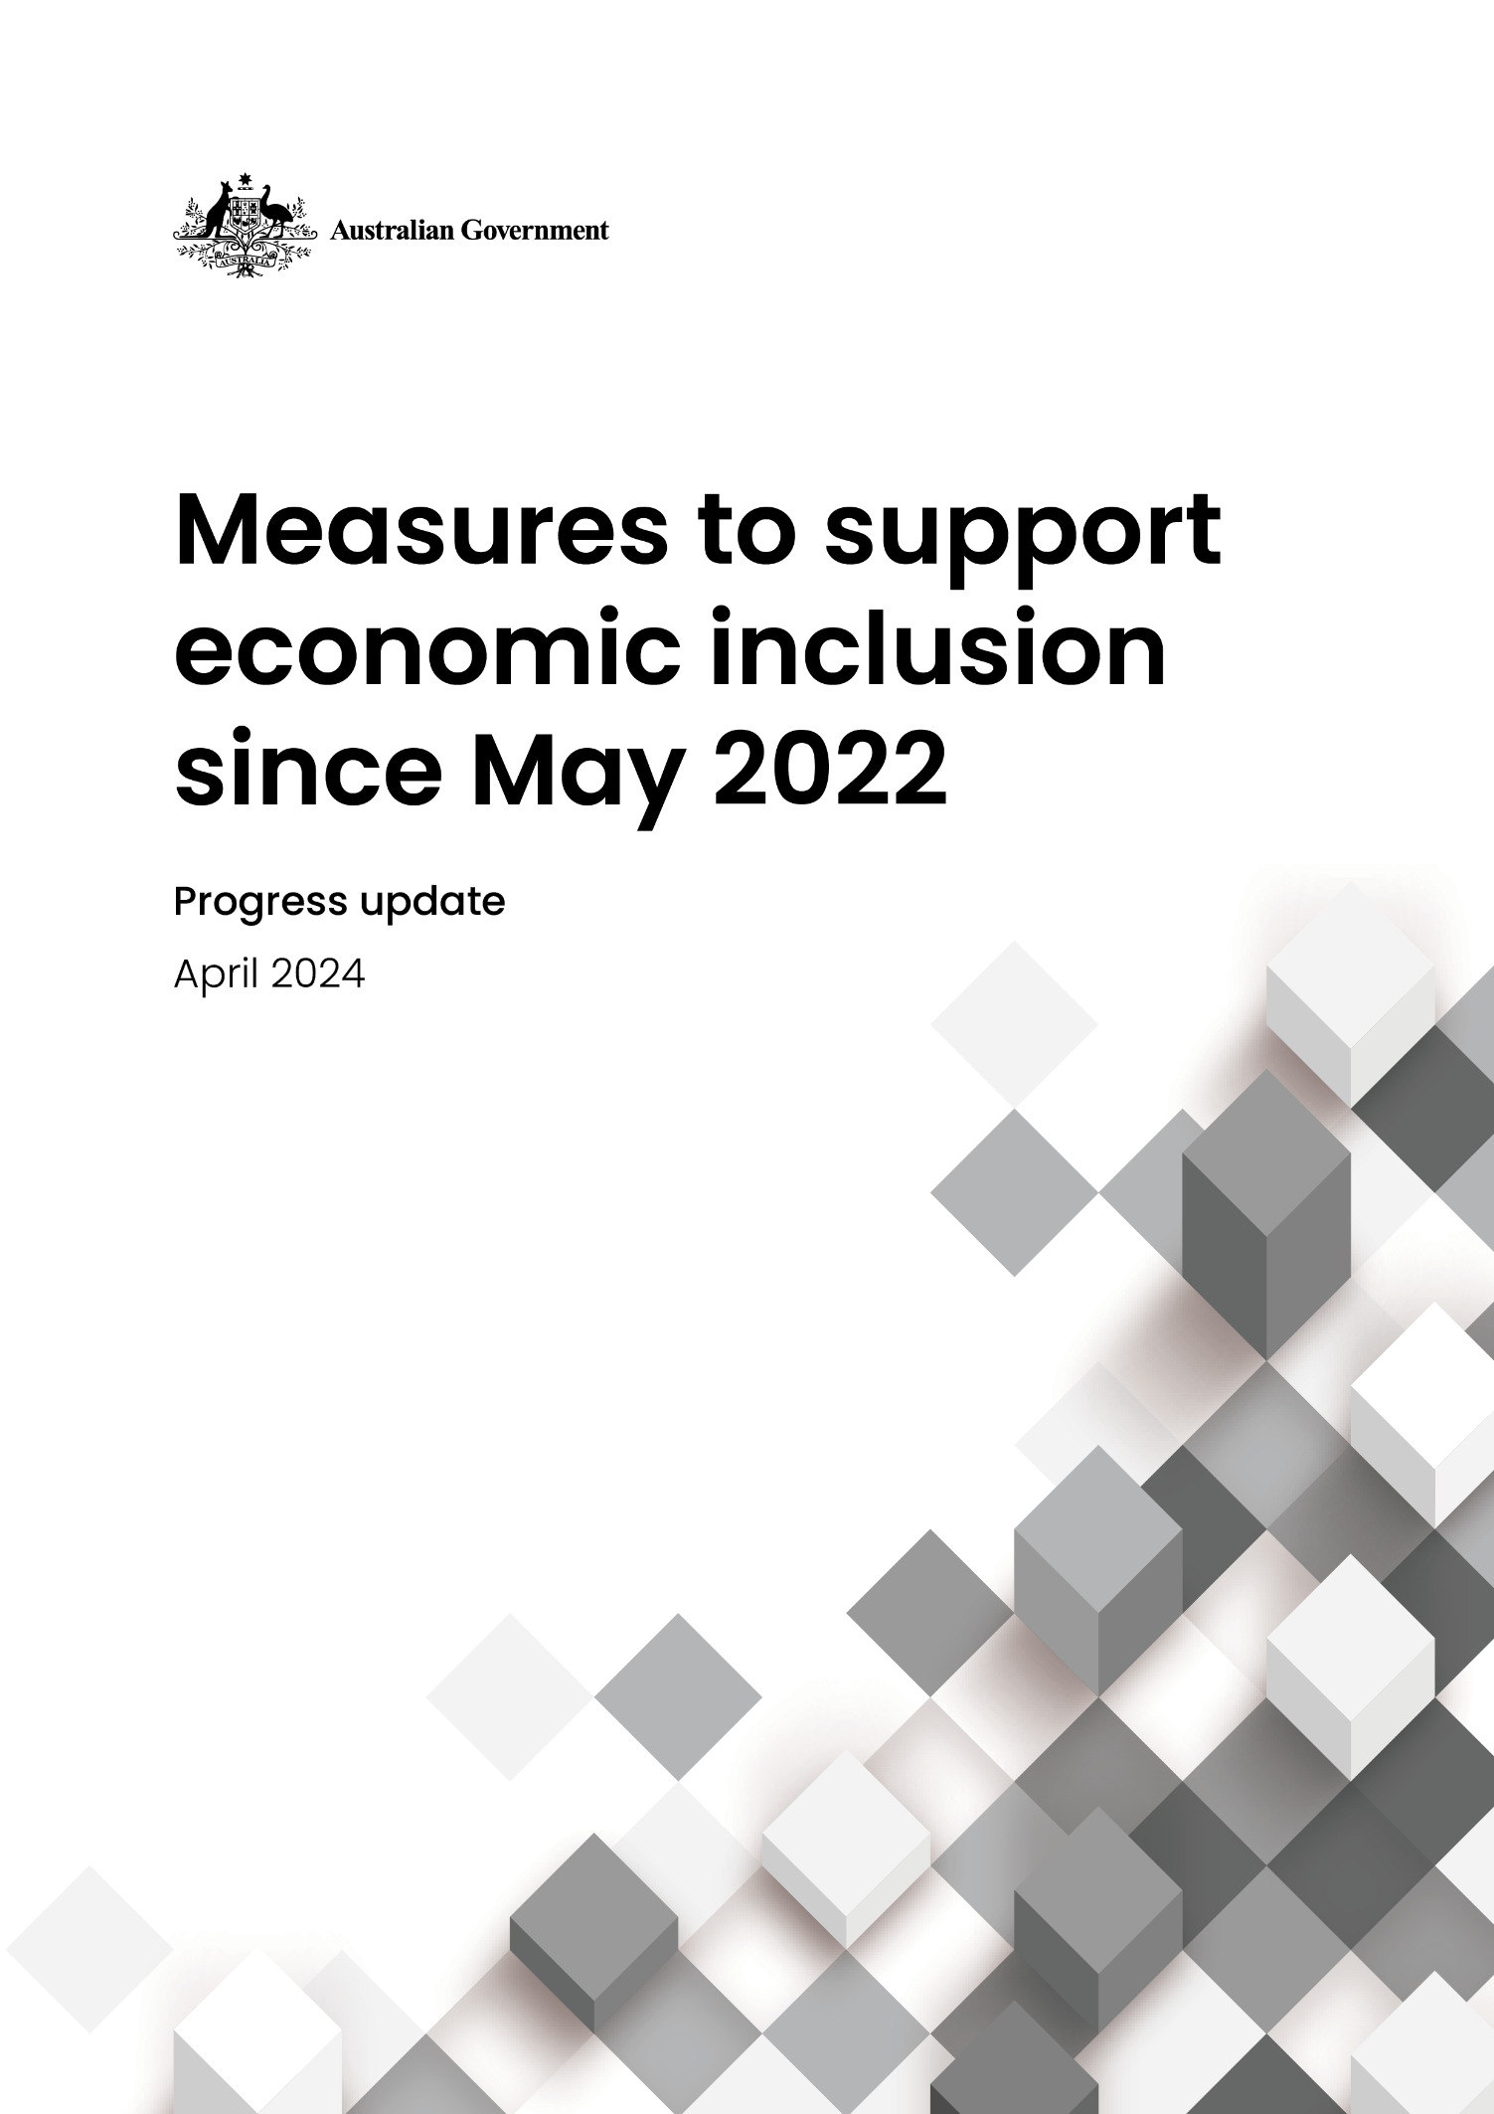

© Commonwealth of Australia 2024

ISBN: 978-1-925832-93-8

This publication is available for your use under a [Creative Commons Attribution 3.0 Australia](http://creativecommons.org/licenses/by/3.0/au/deed.en) licence, with the exception of the Commonwealth Coat of Arms, photographs, images, signatures and where otherwise stated. The full licence terms are available from <http://creativecommons.org/licenses/by/3.0/au/legalcode>.

Creative Commons attribution licence 3.0 icon. 

Use of Australian Government material under a [Creative Commons Attribution 3.0 Australia](http://creativecommons.org/licenses/by/3.0/au/deed.en) licence requires you to attribute the work (but not in any way that suggests that the Australian Government endorses you or your use of the work).

**The Australian Government material used ‘as supplied’.**

Provided you have not modified or transformed the Australian Government material in any way including, for example, by changing the Australian Government text; calculating percentage changes; graphing or charting data; or deriving new statistics from published Australian Government statistics – then the Australian Government prefers the following attribution:

*Source: The Australian Government*.

**Derivative** **material**

If you have modified or transformed the Australian Government material, or derived new material from those of the Australian Government in any way, then the Australian Government prefers the following attribution:

*Based on the Australian Government data*.

**Use of the Coat of Arms**

The terms under which the Coat of Arms can be used are set out on the Department of the Prime Minister and Cabinet website (see <https://www.pmc.gov.au/honours-and-symbols/commonwealth-coat-arms>).

**Other uses**

Enquiries regarding this licence and any other use of this document are welcome at:

Manager  
Media Unit  
The Treasury  
Langton Crescent   
Parkes ACT 2600  
Email: [media@treasury.gov.au](mailto:media@treasury.gov.au)

*In the spirit of reconciliation, the Australian Government acknowledges the Traditional Custodians of country throughout Australia and their connections to land, sea and community. We pay our respect to their Elders past and present and extend that respect to all Aboriginal and Torres Strait Islander peoples.*

# Contents

Contents iii

Overview 4

Measures to support economic inclusion since May 2022 4

Social Safety Net 4

Increase to working age payments and Commonwealth Rent Assistance 4

Extending Parenting Payment Single 5

Freezing social security deeming rates 5

Incentivising pensioners to downsize 5

Family payments 5

Paid Parental Leave including superannuation 5

Making the child support system fairer 6

Tax Relief 6

Tax cuts 6

Indexing the Medicare levy low-income thresholds 6

Wages 7

Submission to the Annual Wage Review and real wage growth 7

Workplace relations reform 7

Funding a wage increase for aged care workers 7

Paying for essentials 7

Energy Bill Relief Fund 7

Cheaper Child Care 8

Bulk billing incentive 8

Cheaper medicines 8

Expanding access to the Commonwealth Seniors Health Card 8

Frontline Services and Community Support 9

Targeting entrenched disadvantage 9

Financial wellbeing and capability 9

Ensuring access to government services 9

Social and Affordable Housing 9

Building more social and affordable homes 9

Household Energy Upgrades Fund – social housing component 10

Full Employment 10

Employment White Paper, *Working Future* 10

Fee-Free TAFE 11

New voluntary pre-employment service for parents 11

Supporting people with disability with the highest needs into employment 11

Career Pathways Pilot 12

Disability Employment Tourism Local Navigators Pilot 12

Disability Employment Services Quality Framework 12

Reform of Disability Employment Services 12

# Overview

The Government is working to build a stronger, fairer and more inclusive society where more Australians have the chance to contribute and share in our economic success.

Since coming to office, the Government has made ongoing investments to address disadvantage, promote economic inclusion and support some of the most vulnerable in the community.

The Government’s agenda includes strengthening the social safety net, providing tax relief, getting wages moving again, helping Australians pay for essentials, investing in frontline services and communities, and working to increase the availability of social and affordable housing.

The Government will continue to do what it responsibly can for Australians who need help the most.

# Measures to support economic inclusion since May 2022

## Social Safety Net

### Increase to working age payments and Commonwealth Rent Assistance

The Government is investing $4.9 billion over five years from 2022-23 to provide a boost of at least $40 per fortnight to eligible working age and student income support payments. This is delivering additional support to around 1.1 million Australians with low or no earnings.

As part of these changes, the Government has expanded eligibility for the higher rate of JobSeeker Payment to single recipients aged 55 and over on income support for nine or more continuous months, which previously applied from age 60. This change acknowledges the additional challenges older Australians face in re-entering the workforce, such as age discrimination or poor health and is already benefitting more than 51,000 people.

The Government is also investing $2.7 billion over five years from 2022-23 to deliver the largest increase to maximum rates of Commonwealth Rent Assistance (CRA) in more than 30 years, helping to address rental affordability challenges for around 1 million households.

These measures commenced from 20 September 2023 and occurred on the same day as regular indexation for relevant payments. These payments continue to be regularly indexed, which means bigger increases going forward because of the permanent increase to base rates.

Since the Government was elected, the rate of JobSeeker Payment for a single recipient with no dependent children (for example) has increased by $120 a fortnight or 18.7 per cent. This is providing recipients over $3,100 in additional support each year.

### Extending Parenting Payment Single

The Government is investing $1.9 billion over five years from 2022-23 to extend Parenting Payment Single (PPS) to eligible single parents until their youngest child turns 14 (previously 8 years old). To date, this measure has benefitted around 82,000 single principal carers, the majority of whom are women.

These changes are helping single parents balance caring responsibilities with looking for work, while also supporting the wellbeing of themselves and their children.

### Freezing social security deeming rates

The Government has frozen social security deeming rates at their current levels for two years until 30 June 2024. This benefits over 800,000 income support recipients, including around 450,000 Age Pensioners.

By keeping deeming rates low, the Government is supporting older Australians who rely on income from deemed financial investments in combination with a social security payment, to manage cost of living pressures.

### Incentivising pensioners to downsize

From 1 January 2023, the Government has doubled the period of the assets test exemption for principal home sale proceeds to a maximum of 24 months and is only applying the lower deeming rate (currently 0.25 per cent) to these proceeds when calculating deemed income.

This is reducing the financial impact of buying and selling a new principal home on pensioners and other eligible income support recipients and removes a potential barrier to downsizing by giving people more time to purchase, build, rebuild, repair or renovate a new principal home, without the worry of significant impacts on their payment rate.

## Family payments

### Paid Parental Leave including superannuation

The Government is investing $1.2 billion over five years from 2022-23 to support the biggest boost to Australia’s Paid Parental Leave scheme since its inception, giving eligible families with a new baby more choice, greater security and better support. The Paid Parental Leave scheme will expand by two weeks each year from 1 July 2024 to reach a total of 26 weeks by 1 July 2026, benefitting around 180,000 families.

For two-parent families, reforms to the scheme will also encourage shared care between parents while also providing flexibility for parents to take a portion of leave at the same time. Single-parent families will be entitled to the full number of weeks of leave available under the scheme.

The Government has committed to paying superannuation on Paid Parental Leave from 1 July 2025. This will help normalise parental leave as a workplace entitlement and reduce the impact of parental leave on retirement income.

### Making the child support system fairer

The Government has implemented legislation, effective from 1 July 2023, to improve the timely collection of child support owed to parents – who are overwhelmingly women – and help prevent future debt among low-income parents.

The Government is investing $5.1 million over five years from 2022-23 to build the evidence base for longer term improvements to the child support system, examining issues like noncompliance as a means of financial abuse, whether the child support formula reflects the current costs of raising children in Australia, and what can be done to support parents where private collect arrangements have broken down. The Government has established a Child Support Stakeholder Consultation Group and a Child Support Expert Panel to ensure the views of those with experience and expertise in the child support scheme inform future improvements.

## Tax Relief

### Tax cuts

The Government is delivering tax cuts to all 13.6 million Australian taxpayers from 1 July 2024, at a cost of $1.3 billion over the five years from 2023-24 (or a total impact of $107 billion compared to 2023-24 settings). The revised tax cuts will see 2.9 million Australian taxpayers with taxable incomes of $45,000 or less receive a tax cut of up to $804, compared to nothing under the former Government’s plan. Around 690,000 income support recipients are estimated to benefit. The revised tax cuts return bracket creep, boost labour supply, benefit more women and will not add to inflationary pressures compared to the former Government’s plan.

### Indexing the Medicare levy low-income thresholds

The Government has increased the Medicare levy low-income thresholds for 2023-24, at a cost of $640 million over the five years from 2022-23. Lifting the threshold at which the Medicare levy applies will ensure that 1.2 million low-income earners continue to be exempt from paying the Medicare levy or pay a reduced levy rate.

## Wages

### Submission to the Annual Wage Review and real wage growth

In its submissions to each of the last three Annual Wage Reviews, the Government has recommended that the Commission ensures the real wages of Australia’s low-paid workers do not go backwards.

Workers on the National Minimum Wage received a 5.2 per cent pay increase in 2022 and an 8.6 per cent increase in 2023 and are now earning $110 more a week than when the Government came to office. This resulted in record increases for award wage workers in both 2022 and 2023.

The Government’s efforts to bring down inflation have also supported a return to annual real wage growth sooner than expected, resulting in three consecutive quarters of real wage growth for the first time in more than five years.

### Workplace relations reform

The Government is providing $94.6 million over four years from 2023-24 to improve the workplace relations framework and close the loopholes that have been used to undercut fairness, pay and conditions and job security in the Australian labour market.

These reforms will benefit all workers covered by the Fair Work Act, particularly in industries which are characterised by low pay and insecure working arrangements. Key reforms include closing the labour hire loophole that allows employers to undercut an agreed rate of pay for a job through the strategic use of labour hire, criminalising wage theft and legislating a fair, objective test to determine when an employee can be classified as casual.

### Funding a wage increase for aged care workers

The Government is delivering $11.3 billion over four years from 2023-24 to fund pay rises for over 250,000 aged care workers following the Fair Work Commission’s interim decision for a 15 per cent increase which took effect on 1 July 2023. This is the largest pay increase ever for aged care workers and recognises the complex and undervalued work of the aged care workforce.

The Government strongly supports the increase. The Fair Work Commission will make a further decision on the phase-in of the wage increase shortly after the Budget.

## Paying for essentials

### Energy Bill Relief Fund

The Government is partnering with state and territory governments to deliver up to $3 billion of electricity bill relief. This initiative is providing up to $500 in electricity bill relief for around 5 million eligible households including concession card holders and up to $650 for around 1 million eligible small businesses.

### Cheaper Child Care

The Government is investing $4.7 billion over four years from 2022-23 to make child care cheaper for around 1.2 million families. The changes include lifting the maximum Child Care Subsidy rate to 90 per cent for families earning $80,000 or less, making early childhood education and care more affordable for around 96 per cent of families with children in care, and providing a minimum of 36 hours per fortnight of subsidised child care for First Nations children.

### Bulk billing incentive

The Government is investing $3.5 billion over five years from 2022-23 to address the decline in general practitioners’ bulk billing of patients on low incomes and children. This funding has supported a tripling of the bulk billing incentive for most GP consultations for children under 16, pensioners and other Commonwealth concession card holders, making it easier and cheaper for more than 11 million Australians to see a doctor for free.

### Cheaper medicines

The Government is delivering cheaper medicines through reforms to the Pharmaceutical Benefits Scheme (PBS), which reduced the maximum cost of a PBS prescription for general patients from $42.50 to $30 from 1 January 2023 (subject to annual indexation). This is the first time in the 75-year history of the PBS that the general co-payment under the PBS has been lowered.

The Government is also making PBS medicines cheaper through the introduction of 60-day dispensing. Australians with eligible prescriptions can now buy two months’ worth of medicines for down to the price of a single prescription, rather than the current 30-day supply. There are nearly 200 PBS medicines currently available for 60-day prescriptions, with around 300 medicines expected to be available by September 2024. This will cut the cost of medicines by up to half for more than 6 million Australians living with a chronic, stable condition.

### Expanding access to the Commonwealth Seniors Health Card

The Government has expanded access to the Commonwealth Seniors Health Card, with the largest increase to the income limits for eligibility in more than 20 years.

As a result of these changes, already more than 27,000 additional self-funded retirees have received access to the card, which provides cheaper healthcare, cheaper medicines and other benefits available to concession cardholders.

## Frontline Services and Community Support

### Targeting entrenched disadvantage

The Government is delivering a $199.8 million integrated package over six years from 2023-24 to address entrenched disadvantage and lay the foundations for community-led change.

Core components of the package include $64 million to extend place-based partnerships under the Stronger Places, Stronger People initiative and $100 million for a new Outcomes Fund. The Outcomes Fund will commence in 2024-25 and will see the Commonwealth partner with stakeholders to fund projects that deliver agreed, measurable outcomes.

### Financial wellbeing and capability

The Government is providing $114.8 million over five years from 2023-24 to strengthen support for Australians experiencing financial hardship. The funding will help address demand for critical frontline services over the next five years and ensure certainty and stability for a number of organisations including those delivering emergency relief and financial counselling.

The Government is also strengthening support available for Australians experiencing financial crisis with an additional $14.4 million in 2023-24 in funding for Emergency Relief and Food Relief across Australia. The added funding will be distributed between 192 Commonwealth-funded Emergency Relief providers and all three Commonwealth-funded Food Relief providers across Australia to help them meet the increased demand for their services.

### Ensuring access to government services

The Government is investing $228 million in 2023-24 in funding to Services Australia for frontline and service delivery staffing in the Agency to help reduce claim backlogs and to support more timely access for vulnerable Australians to government services. This will help the Agency facilitate easy and efficient engagement options suited to the circumstances of the customer.

## Social and Affordable Housing

### Building more social and affordable homes

The Australian Government is making significant new investments to increase the supply of social and affordable homes and is working with state, territory and local governments to improve housing outcomes. Significant measures include:

* Establishing the $10 billion Housing Australia Future Fund to support 30,000 new social and affordable rental homes over its first five years, including for women and children fleeing domestic violence, and older women at risk of homelessness.
* Expanding the National Housing Infrastructure Facility to make up to $575 million available to invest in social and affordable rental homes. The Facility will also receive an additional $1 billion in federal funding to support more social housing.
* Increasing the liability cap of Housing Australia by $2 billion to provide lower cost and longer-term finance to community housing providers.
* Contributing to a landmark $4 billion investment with the Northern Territory Government for housing in remote communities and for housing improvements and essential infrastructure upgrades on homelands. The investment will contribute to Closing the Gap socioeconomic target 9b – increasing the proportion of First Nations people living in appropriately sized housing.
* Supporting planning and zoning reforms through the National Housing Accord, as well as investing $350 million in additional federal funding to deliver 10,000 affordable rental homes over five years from 2024 – matched by the state and territories.
* Investing $2 billion through the Social Housing Accelerator to deliver thousands of new and refurbished social homes across Australia.
* Investing $3 billion through the New Homes Bonus to help incentivise states and territories to build 1.2 million homes where people need them over five years from 2024.

### Household Energy Upgrades Fund – social housing component

The Government is investing $1.3 billion in the Household Energy Upgrades Fund to help households save on energy bills.

This includes $300 million in targeted support to social housing, delivered in partnership with states and territories. With most social housing built before the minimum build standards, the energy efficiency of most social housing is amongst the lowest in Australia. The investment is expected to cut the energy needed by 60,000 social housing properties by one-third, providing tenants with savings on their energy bills.

## Full Employment

### Employment White Paper, *Working Future*

In the Employment White Paper, *Working Future*, the Government committed to a sustained and inclusive full employment target, where everyone who wants a job should be able to find one without having to search for too long.

The White Paper included two immediate actions in social security:

* permanently extending the pension Work Bonus measure for older pensioners and eligible veterans, by providing an upfront Work Bonus credit of $4,000 to all new pension entrants over Age Pension age, and permanently increasing the maximum Work Bonus income bank balance from $7,800 to $11,800. This built on the temporary measure announced at the 2022 Jobs and Skills Summit, and gives pensioners the option to earn more income from working without reducing their pension;
* smoothing the transition to work for many income support recipients by doubling the period they can receive a nil rate of payment from six to 12 fortnights, and expanding access to those who enter full-time employment. This allows people to stay active in the system – and retain supplementary benefits such as concession cards, child care subsidies and other supplementary payments, for longer. It provides more support for people to get back into work, without the fear that the social safety net won’t be there if they need it again.

### Fee-Free TAFE

The Government has committed to delivering 480,000 fee-free TAFE places, including 180,000 places in 2023 and a further 300,000 from 2024 to 2026. Enrolments have been prioritised for groups excluded or under-represented in the labour market including people with disability. In 2023, fee-free TAFE enrolments exceeded targets, with more than 355,000 Australians enrolling in a course. As of 31 December 2023, 26,000 people with disability had enrolled in a fee-free TAFE course.

### New voluntary pre-employment service for parents

The Government is providing $20.9 million over four years from 2023–24 to implement a new voluntary pre-employment service for disadvantaged parents of children under six years of age from 1 November 2024, following the abolition of ParentsNext.

The new program will support the economic security of parents by providing pre-employment and pre-vocational activities to assist them to enter or re-enter the labour market.

### Supporting people with disability with the highest needs into employment

The Government is providing $57 million over four years towards supported employment initiatives and measures, to support the evolution of the supported employment sector.

Supported employment is a type of job for people with disability who need substantial ongoing support to obtain or keep employment, and they receive extra support while at work. There are around 16,000 Australians with disability currently partaking in supported employment.

The first tranche of this funding was announced on 23 April 2024 and includes:

* $14.9 million to 32 organisations for the first round of the Structural Adjustment Fund.
  + The second round of the Fund is expected to open for applications in the second half of 2024.
* $9.8 million to Inclusion Australia and the Disability Advocacy Network of Australia (DANA) to deliver the Disability Employment Advocacy and Information Program.
* $1.4 million to the ImpactInstitute to deliver expos under a Disability Employment Expos grant opportunity.

### Career Pathways Pilot

The Government is providing funding for the Australian Disability Network to work alongside the Business Council of Australia to support its members to increase and develop the career progression of employees with a disability out of entry level roles and into leadership positions.

We know there is an over representation of people with disability in entry level roles and a lack of career advancement opportunities – this pilot aims to support employers to build their capacity to develop the leadership potential of employees with disability. The program is co-designed to be mutually beneficial for the employers and people with disability and will be scalable for other Australian employers to replicate.

### Disability Employment Tourism Local Navigators Pilot

The Government’s Tourism Local Navigators Pilot is designed to test new ways to connect job seekers with a disability to meaningful tourism jobs. Under the Pilot, 12 organisations are receiving funding for projects designed to support small and medium tourism businesses in recruiting, retaining and promoting employees with disability.

Local Navigators will act as a connector between tourism businesses and employment service providers along with people with disability. They will help to reform workplace cultures and employment practices along with building the confidence of employers to employ people with disability.

### Disability Employment Services Quality Framework

The Government has published a new Disability Employment Services (DES) Quality Framework as the first step in the redesign of a broader DES Performance Framework. The new Framework places the participant first by fostering a higher quality and performance standard for providers. This includes holding providers accountable for delivering tailored services to each participant that will meet their individual skills, goals, and ambitions.

Clear quality service expectations for providers will ensure the DES sector improves as a whole, providing better employment outcomes for people living with disability.

### Reform of Disability Employment Services

The Government is developing a new specialist disability employment services program to replace the current DES program. The reformed program will be one that unifies the needs of jobseekers with disability and employers. Key focus areas of the new model will be high service quality, increased flexibility and individualised supports to achieve increased employment and career outcomes for people with disability.