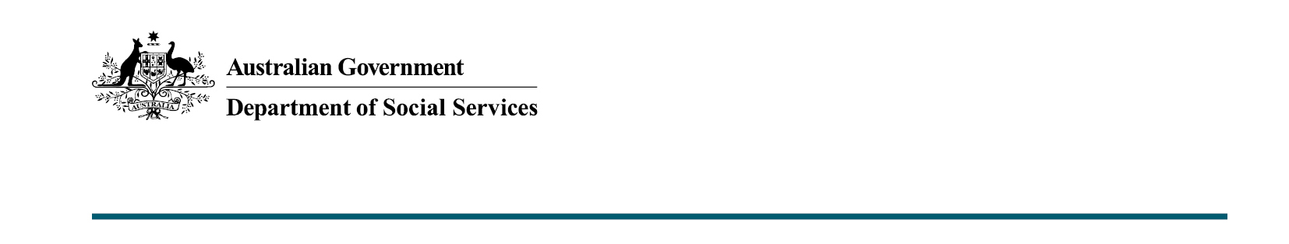

Safe and Supported Action Plans – Key messages

Safe and Supported sets out Australia’s 10-year strategy to reduce the rates of child abuse and neglect and its effects across generations. It recognises that all children and young people in Australia have the right to grow up safe, connected and supported in their family, community and culture.
Two sets of Action Plans will deliver on Safe and Supported:
  - Safe and Supported: First Action Plan 2023–2026 (First Action Plan)
  - Safe and Supported: Aboriginal and Torres Strait Islander First Action Plan
2023–2026 (Aboriginal and Torres Strait Islander First Action Plan).
The First Action Plan addresses the needs of all Australian children. It focuses on children and families who are experiencing disadvantage and/or are vulnerable.
The Aboriginal and Torres Strait Islander First Action Plan focuses on Aboriginal and Torres Strait Islander children and families who are experiencing disadvantage and/or who are vulnerable. This Action Plan:
  - Sets out the targeted actions and activities to address the over-representation of Aboriginal and Torres Strait Islander children in child protection systems.
  - Responds to the National Agreement on Closing the Gap (Closing the Gap) Target 12 (to reduce the rate of over-representation of Aboriginal and Torres Strait Islander children in out-of-home care by 45% by 2031).
Both Action Plans aim to protect children and young people from harm and neglect.
The voices of children, young people and families will be central to implementing the first Action Plans.
What will the action plans deliver on?
The Action Plans will deliver on the 4 focus areas under Safe and Supported:
  - a national approach to early intervention and targeted support for children and families experiencing vulnerability or disadvantage
  - addressing the over-representation of Aboriginal and Torres Strait Islander children in child protection systems
  - improving information sharing, data development and analysis, and
  - strengthening the child and family sector and workforce capability.
Governments, in partnership with Aboriginal and Torres Strait Islander leaders, will work with relevant sectors and communities to keep children safe and supported. This includes addressing the social determinants of child safety and wellbeing by better connecting child and family service systems.
How were the Action Plans developed?
The Action Plans were informed by the wider community via online consultation, the National Children’s Commissioner’s consultations with children and young people, as well as consultations undertaken by SNAICC – National Voice for Our Children (SNAICC) and Families Australia.
To finalise the Action Plans, the Department of Social Services worked in partnership with State and Territory Governments and an Aboriginal and Torres Strait Islander Leadership Group (Leadership Group). The department also worked closely with other Commonwealth agencies and the broader non-government sector through the National Coalition on Child Safety and Wellbeing (facilitated by Families Australia).
A Partnership Agreement between Commonwealth, state and territory governments and the Leadership Group is being developed. It will capture the commitment from governments to working in partnership and shared decision-making with Aboriginal and Torres Strait Islander leaders to achieve the goals of Safe and Supported. The Partnership Agreement will be finalised in early 2023.
Will the Action Plans link with other national initiatives to support change for Australian children, young people and families?
The Action Plans will align with other relevant national initiatives, such as:
- those under Closing the Gap, including the Early Childhood Care and Development Policy Partnership (ECPP), and Sector Strengthening Plans focusing on early childhood care and development, housing, health, and disability
- the National Strategy to Prevent and Respond to Child Sexual Abuse 2021–2030
- the National Plan to End Violence against Women and Children 2022–2032
- Australia’s Disability Strategy.
How will we know if the Action Plans are working?
A Monitoring and Evaluation Strategy is under development and expected to be completed by the end of 2023. It will set out how Safe and Supported will be evaluated. This includes how progress towards outcomes will be tracked and reported.
Where can I find out more about the action plans?
To find out more about the Action Plans visit Safe and Supported action plans, email NationalFramework@dss.gov.au or call the Department of Social Services on 1300 653 227.

